

Arson and Explosives Programs Division

Customer Questionnaire



The Centre at Purchase
One Manhattanville Road
Purchase, NY 10577-2128
(914) 696-4700 Fax (914) 696-3401

Dear Client of the Arson and Explosives Programs Division:

Carl J. Truscott, the Director of ATF, recently wrote to you about a customer survey we are conducting for ATF. The purpose of the survey is to give ATF information about how well they are serving their customers. They want to know the areas that need change and improvement as well as their strengths in bringing you the services you need. They intend to use the survey results to make those changes necessary to improve their services. We hope you will complete the survey.
The survey can be completed on the enclosed questionnaire, or electronically. You may choose to identify yourself and /or your organization, or to be anonymous. We will not report names of individuals or organizations in any reports we write. The access code number at the top of the questionnaire is to ensure that each responder answers the questionnaire in only one of the two formats provided.
ATF has also instructed us to notify them if a customer has a need for their immediate attention and identifies himself/herself.
If you choose to complete the enclosed questionnaire, please return it to us in the self-addressed, stamped envelope. When we receive your questionnaire, we will immediately record your response in our secure computerized database.
If you choose to respond to the survey electronically, please follow these instructions:
1. Enter the link to our website (WWW. ATF/Sirota/Survey).
2. Enter your access code, as instructed. The access code is at the top of this letter and on the top of the printed questionnaire.
3. Follow the instructions on how to respond to each question.
4. Submit the questionnaire.
If you have any questions, please call me at 1-800-777-8196, ext. 213, or e-mail me at Wreichman@sirota.com. Your participation in this survey is appreciated.

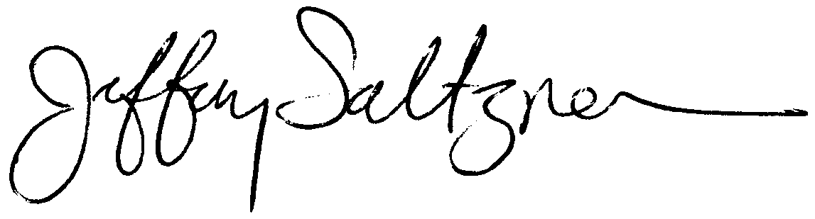
Sincerely,
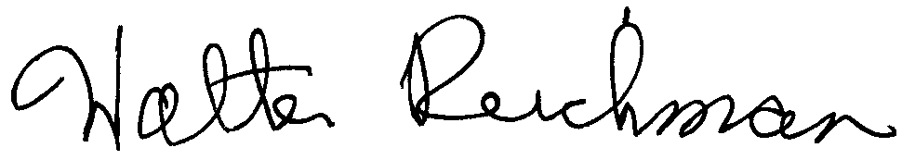
Jeffrey Saltzman Walter Reichman
CEO/Chairman Vice President
Sirota Consulting LLC Sirota Consulting LLC

Name (optional):
Organization or Department (optional):
City: |  |  |  | State:

 | During the past year did you request assistance and/or support from ATF for a fire or explosives incident?
 |  |  | 1. | Yes
 |  |  | 2. | No (If No, this concludes this questionnaire)

Did you receive the assistance and/or support you requested from ATF?
 | 1. | Yes (proceed to question 4)
 | 2. | No (proceed to question 3)

If no, please explain why you didn’t receive the assistance and/or support you requested. (Respond in the space below. This will conclude the questionnaire.)

 | Was the assistance and/or support you requested for … Check all that apply.
 |  |  | 1. | Canine detection (proceed to question 45)
 |  |  | 2. | Incident- and/or device-specific queries (proceed to question 62)
 |  |  | 3. | Other (proceed to question 5)
 | Which office or person did you contact for assistance or support? Check all that apply.
 |  |  | 1. | Local ATF Office
 |  |  | 2. | A particular individual in my local ATF office
 |  |  | 3. | ATF Headquarters
 |  |  | 4. | A particular individual at ATF Headquarters
 |  |  | 5. | ATF office in a distant location
 |  |  | 6. | A particular individual in an office at a distant location
 |  |  | 7. | Other (explain below)

For which of the following did you receive ATF assistance and/or support? Circle yes (Y) or no (N) for each service. For each “Y” response, indicate your level of satisfaction by circling the appropriate response.

 |  |  |  | Very Satisfied | Moderately Satisfied | Neither Satisfied nor dissatisfied | Dissatisfied | Very Dissatisfied | Did Not Receive Support requested
 | Determination of origin/cause of fire/explosion | Y | N | 1 | 2 | 3 | 4 | 5 | 6
 | Fire explosion/scene investigation | Y | N | 1 | 2 | 3 | 4 | 5 | 6
 | Post blast investigation | Y | N | 1 | 2 | 3 | 4 | 5 | 6
 | Explosives recovery | Y | N | 1 | 2 | 3 | 4 | 5 | 6
 | Destruction of explosives | Y | N | 1 | 2 | 3 | 4 | 5 | 6
 | Identification of explosives | Y | N | 1 | 2 | 3 | 4 | 5 | 6
 | Device or component part determination | Y | N | 1 | 2 | 3 | 4 | 5 | 6
 | Profiling | Y | N | 1 | 2 | 3 | 4 | 5 | 6
 | Expert witness | Y | N | 1 | 2 | 3 | 4 | 5 | 6
 | Vulnerability assessment | Y | N | 1 | 2 | 3 | 4 | 5 | 6
 | Training | Y | N | 1 | 2 | 3 | 4 | 5 | 6
 | Other (Describe)_______________________ | Y | N | 1 | 2 | 3 | 4 | 5 | 6

What could ATF have done better to give you the assistance or support you needed?

 | Did the assistance of ATF save your personnel hours of work?
 |  |  | 1. | Many hours
 |  |  | 2. | A few hours
 |  |  | 3. | No hours

 | In your judgment how important was the assistance of ATF in bringing investigations to a successful conclusion during the past year?
 |  |  | 1. | Very important
 |  |  | 2. | Moderately important
 |  |  | 3. | Minimally important
 |  |  | 4. | Not important
 |  |  | 5. | Not applicable

How important was ATF in the following. Circle ONE answer for each line across:

 |  | Very Important | Moderately Important | Minimally Important | Not Important | Not Applicable
 | Identifying the cause of the incident | 1 | 2 | 3 | 4 | 5
 | Identifying a suspect(s) for the incident | 1 | 2 | 3 | 4 | 5
 | Bringing about the arrest of the perpetrator(s) | 1 | 2 | 3 | 4 | 5
 | Bringing about a conviction of the perpetrator(s) | 1 | 2 | 3 | 4 | 5

 | Have you recently experienced any problem or difficulties with ATF’s fire and/or explosives investigative services?
 |  |  | 1. | Yes, but I didn’t contact anyone
 |  |  | 2. | Yes, and I contacted someone about it
 |  |  | 3. | No (skip to question 27)
 |  |  | 4. | Not applicable (skip to question 27)

 | If you answered yes to the previous question, please indicate your satisfaction with the way the problem was resolved.
 |  |  | 1. | Very satisfied
 |  |  | 2. | Satisfied
 |  |  | 3. | Neither satisfied nor dissatisfied
 |  |  | 4. | Dissatisfied
 |  |  | 5. | Very dissatisfied
 |  |  | 6. | Too early to tell
 |  |  | 7. | My problem was not resolved

Please rate ATF’s performance on each of the following. Circle ONE answer for each line across:

 |  | Very Good | Good | So-So | Poor | Very Poor | Don’t Know/  Not Applicable
 | Overall value of service | 1 | 2 | 3 | 4 | 5 | 6
 | Providing useful written materials (up-to-date) | 1 | 2 | 3 | 4 | 5 | 6
 | Having a good reputation | 1 | 2 | 3 | 4 | 5 | 6
 | Being innovative in terms of the types of services provided | 1 | 2 | 3 | 4 | 5 | 6
 | Responding to your inquiries in a timely manner | 1 | 2 | 3 | 4 | 5 | 6
 | Training, seminars, and courses provided | 1 | 2 | 3 | 4 | 5 | 6
 | The assistance provided to help you get your work done | 1 | 2 | 3 | 4 | 5 | 6
 | Commitment to you by their personnel | 1 | 2 | 3 | 4 | 5 | 6
 | Easy to work with | 1 | 2 | 3 | 4 | 5 | 6
 | High standards of quality | 1 | 2 | 3 | 4 | 5 | 6
 | Knowledgeable about the product you work with (e.g., explosives) | 1 | 2 | 3 | 4 | 5 | 6
 | Works as a team member with you | 1 | 2 | 3 | 4 | 5 | 6
 | Provides guidance for resolving problems and issues | 1 | 2 | 3 | 4 | 5 | 6
 | Is available when needed | 1 | 2 | 3 | 4 | 5 | 6
 | Doing accurate work | 1 | 2 | 3 | 4 | 5 | 6
 | Resolving problems | 1 | 2 | 3 | 4 | 5 | 6
 | Technical ability and knowledge | 1 | 2 | 3 | 4 | 5 | 6

How could the ATF improve its services to you?
If you did not request canine support and/or data or information, this completes this questionnaire.
Thank you.

 | Which department are you associated with? Indicate ONE answer:
 |  |  | 1. | Police Department
 |  |  | 2. | Fire Department
 |  |  | 3. | U.S. State Department
 |  |  | 4. | Other (describe) _____________________

 | What is your position/title in the department? Indicate ONE answer:
 |  |  | 1. | Handler
 |  |  | 2. | Supervisor of a K-9 unit/handler
 |  |  | 3. | Head/Chief of the department
 |  |  | 4. | Other (describe) ______________________

 | How many times has your department used an ATF-certified canine in the past year for explosives? Indicate ONE answer:
 |  |  | 1. | 0 Times
 |  |  | 2. | 1 Time
 |  |  | 3. | 2 Times
 |  |  | 4 | 3 Times
 |  |  | 5. | 4 or More Times

 | How many times has your department used an ATF-certified canine in the past year for fire? Indicate ONE answer:
 |  |  | 1. | 0 Times
 |  |  | 2. | 1 Time
 |  |  | 3. | 2 Times
 |  |  | 4 | 3 Times
 |  |  | 5. | 4 or More Times

 | Does your department own an ATF-certified canine? Indicate ONE answer:
 |  |  | 1. | Yes
 |  |  | 2. | No (proceed to question 52)
 |  |  | 3. | Unsure
 |  |  | 4. | Not applicable (proceed to question 52)

 | Would you like to have additional ATF-certified canines in your department? Indicate ONE answer:
 |  |  | 1. | Yes
 |  |  | 2. | No
 |  |  | 3. | Unsure

 | Do you believe your department needs subsidies from ATF to maintain the canine(s) properly? Indicate ONE answer:
 |  |  | 1. | Yes
 |  |  | 2. | It would help, but we can do it without subsidies
 |  |  | 3. | No
 |  |  | 4. | Unsure

Thinking back over your experiences with ATF-certified canine handlers, to what extent do you agree or disagree with each of the following? The ATF-certified canine handler…Indicate ONE answer for each line across:
 |  | Strongly Agree | Agree | Neither Agree Nor Disagree | Disagree | Strongly Disagree | Don’t Know/Not Applicable
 | Acted in a professional manner | 1 | 2 | 3 | 4 | 5 | 6
 | Understood your needs | 1 | 2 | 3 | 4 | 5 | 6
 | Explained the canine’s abilities | 1 | 2 | 3 | 4 | 5 | 6
 | Treated you as a partner in the procedure | 1 | 2 | 3 | 4 | 5 | 6

If you would like to comment on your experience with the ATF-certified canine handler, please do so below:

 | Have you experienced difficulty with an ATF-trained canine? Indicate ONE answer:
 |  |  | 1. | Yes
 |  |  | 2. | No

If yes, please describe the difficulty you had.

 | Did ATF provide you with the services you requested? Indicate ONE answer:
 |  |  | 1. | Yes, all of them
 |  |  | 2. | Yes, some of them
 |  |  | 3. | Very few of them
 |  |  | 4 | None of them
 |  |  | 5. | Not applicable

If you would like to comment on your experience with the canine support services provided, please do so below:

What can ATF do better to serve you?
If you did not call upon ATF for data or information, this concludes the questionnaire. Thank you for participating.

 | How much do you know about ATF’s Arson and Explosives National Repository?
 |  |  | 1. | Nothing
 |  |  | 2. | Very little
 |  |  | 3. | Something
 |  |  | 4. | A good deal

 | Have you ever provided information to the National Repository?
 |  |  | 1. | Yes
 |  |  | 2. | No
 |  |  | 3. | Unsure

 | Have you ever requested information from the National Repository?
 |  |  | 1. | Yes, often
 |  |  | 2. | Yes, on occasion
 |  |  | 3. | No (If no, please go on to Q.69)

When you contacted the National Repository …
 |  | Strongly Agree | Agree | Neither Agree Nor Disagree | Disagree | Strongly Disagree | Don’t Know/Not Applicable
 | You were received courteously by personnel | 1 | 2 | 3 | 4 | 5 | 6
 | Your needs were understood | 1 | 2 | 3 | 4 | 5 | 6
 | You received the information you requested | 1 | 2 | 3 | 4 | 5 | 6
 | You were treated as a professional | 1 | 2 | 3 | 4 | 5 | 6

In what ways could the National Repository better serve your needs?

Is there any type of information or data not captured by the National Repository that you would want captured?
Thank You

PAPERWORK REDUCTION ACT NOTICE. This request is in accordance with the Paperwork Reduction Act of 1995. The information collected is to capture data that permits the accurate assessment of program activities. The Government Performance and Results Act (GPRA) of 1993 requires that each Government agency maximize resources, develop more realistic goals or more innovative measurements, and permit the allocation and use of available resources for specific priorities.
The estimated average burden associated with this collection of information is 15 minutes per respondent, depending on individual circumstances. Comments concerning the accuracy of this burden estimate and suggestions for reducing this burden should be addressed to Reports Management Officer, Document Services Branch, Bureau of Alcohol, Tobacco, Firearms and Explosives, Washington, DC 20226.
An agency may not conduct or sponsor, and a person is not required to respond to, a collection of information unless it displays a currently valid OMB control number.

