

Bureau of Alcohol, Tobacco,
Firearms and Explosives

Explosives Industry

Customer Questionnaire



The Centre at Purchase
One Manhattanville Road
Purchase, NY 10577-2128
(914) 696-4700 Fax (914) 696-3401

Dear ATF Customer:

Carl J. Truscott, the Director of the Bureau of Alcohol, Tobacco, Firearms and Explosives (ATF), recently wrote to you about a customer survey we are conducting for ATF. The purpose of the survey is to give ATF information about how well they are serving their customers. They want to know the areas that need change and improvement as well as their strengths in providing you the services you need. They intend to use the survey results to assess the need for potential improvement in the services they provide. We hope you will complete the survey.
The survey can be completed on the enclosed questionnaire, or electronically. You may choose to identify yourself and /or your organization, or to be anonymous. We will not report names of individuals or organizations in any reports we write. The access code number at the top of the questionnaire is to ensure that each responder answers the questionnaire in only one of the two formats provided.
We have provided a self-addressed stamped envelope if you choose to mail the survey. When we receive your questionnaire, we will immediately record your response in our secure computerized database.
If you choose to respond to the survey electronically, please follow these instructions:
1. Enter the link to our website (WWW. ATF/Sirota/Survey).
2. Enter your access code, as instructed. The access code is at the top of this letter and on the top of the printed questionnaire.
3. Follow the instructions on how to respond to each question.
4. Submit the questionnaire.
If you have any questions, please call me at 1-800-777-8196, ext. 213, or e-mail me at Wreichman@sirota.com. Your participation in this survey is appreciated.

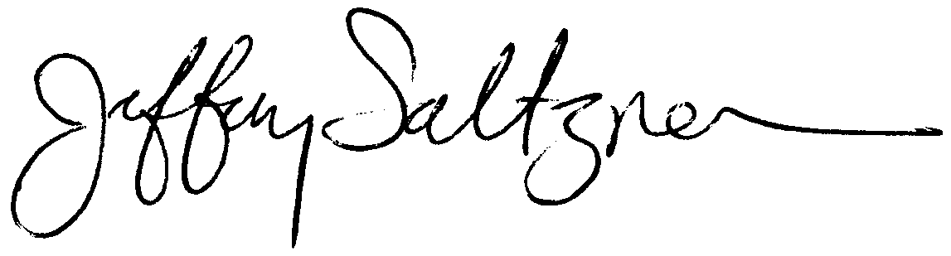
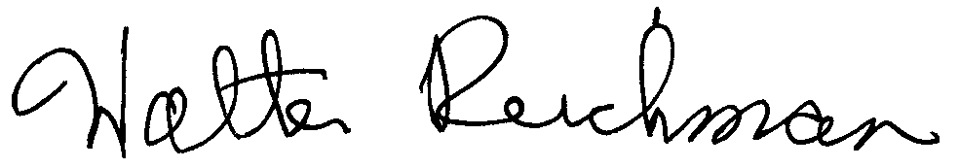
Sincerely,
Jeffrey Saltzman Walter Reichman
CEO/Chairman Vice President
Sirota Consulting LLC Sirota Consulting LLC

Name (optional):
Organization or Company (optional):
City: |  |  |  | State:

The following section applies to instances in which an inspector was at your site.

 |  | Strongly Agree | Agree | Neither Agree Nor Disagree | Disagree | Strongly Disagree | Don’t Know/Not Applicable
 | The inspector was knowledgeable | 1 | 2 | 3 | 4 | 5 | 6
 | The inspector was courteous | 1 | 2 | 3 | 4 | 5 | 6
 | The inspector helped you resolve a problem | 1 | 2 | 3 | 4 | 5 | 6
 | The inspector supplied you with information that was important to your work | 1 | 2 | 3 | 4 | 5 | 6

 | When you need INFORMATION on explosives and/or regulations, which office are you most likely to call? Indicate ONE answer.
 |  |  | 1. | Local ATF field office
 |  |  | 2. | ATF Headquarters in Washington, DC
 |  |  | 3. | Local ATF field office and ATF Headquarters in Washington, DC equally often

The following section applies to instances in which you call your local field office. Indicate ONE answer for each statement.
 |  | Strongly Agree | Agree | Neither Agree Nor Disagree | Disagree | Strongly Disagree | Don’t Know/Not Applicable
 | You are able to reach an inspector quickly | 1 | 2 | 3 | 4 | 5 | 6
 | The inspector is courteous and respectful | 1 | 2 | 3 | 4 | 5 | 6
 | The inspector has the answer for you within a reasonable amount of time | 1 | 2 | 3 | 4 | 5 | 6
 | The inspector is knowledgeable | 1 | 2 | 3 | 4 | 5 | 6
 | You call the ATF Headquarters or another inspector to check out the answer you receive from the inspector | 1 | 2 | 3 | 4 | 5 | 6
 | You are generally satisfied with your relationship with the local field office inspectors | 1 | 2 | 3 | 4 | 5 | 6
 | The local inspectors are aware of your commercial needs | 1 | 2 | 3 | 4 | 5 | 6

The following section applies to your experience when you call the ATF office in Washington, DC directly. Indicate ONE answer for each statement.

 |  | Strongly Agree | Agree | Neither Agree Nor Disagree | Disagree | Strongly Disagree | Don’t Know/Not Applicable
 | You quickly reach a person who can help you | 1 | 2 | 3 | 4 | 5 | 6
 | You receive a response within a reasonable time | 1 | 2 | 3 | 4 | 5 | 6
 | You believe the response given is accurate | 1 | 2 | 3 | 4 | 5 | 6
 | You are treated courteously and respectfully | 1 | 2 | 3 | 4 | 5 | 6
 | You check the response received with an inspector in the local field office | 1 | 2 | 3 | 4 | 5 | 6
 | Personnel in Headquarters are knowledgeable about explosives | 1 | 2 | 3 | 4 | 5 | 6
 | Personnel in Headquarters are aware of your commercial needs | 1 | 2 | 3 | 4 | 5 | 6
 | You prefer to work with someone from Headquarters rather than from the local ATF field office | 1 | 2 | 3 | 4 | 5 | 6
 | There is too much turnover in Headquarters to establish a working relationship with anyone | 1 | 2 | 3 | 4 | 5 | 6
 | You believe the personnel in Headquarters deal effectively with your questions and concerns | 1 | 2 | 3 | 4 | 5 | 6

The following section applies to your experiences when requesting variances and/or determinations, in writing, from ATF Headquarters. If you have never requested a variance or determination, please skip to question 27. Indicate ONE answer for statement.

 |  | Strongly Agree | Agree | Neither Agree Nor Disagree | Disagree | Strongly Disagree | Don’t Know/Not Applicable
 | I know what I need to submit in order to request a variance or determination | 1 | 2 | 3 | 4 | 5 | 6
 | I receive a response to my variance or determination request in a timely manner | 1 | 2 | 3 | 4 | 5 | 6
 | If my variance is not approved, I am given an adequate explanation | 1 | 2 | 3 | 4 | 5 | 6
 | In the case of a determination request, I am given an adequate explanation as to why my product is or is not regulated | 1 | 2 | 3 | 4 | 5 | 6

The following section pertains to your experience with ATF’s National Licensing Center (NLC). (Note the change in wording of choices in questions 27, 28, and 29). Indicate ONE answer for each statement.

When contacting the National Licensing Center in Atlanta about the status of an explosives license or permit … |  | Always | Almost Always | Half the Time | Seldom | Never | Don’t Know/Not Applicable
 | I am easily able to reach the examiner handling my license/permit | 1 | 2 | 3 | 4 | 5 | 6
 | The examiner returns calls promptly and courteously | 1 | 2 | 3 | 4 | 5 | 6
 | The examiner is able to answer my questions in a reasonable period of time | 1 | 2 | 3 | 4 | 5 | 6

 |  | Strongly Agree | Agree | Neither Agree Nor Disagree | Disagree | Strongly Disagree | Don’t Know/Not Applicable
 | The instructions on the license/permit application are straightforward and provide satisfactory guidance | 1 | 2 | 3 | 4 | 5 | 6
 | The information requested on the license/permit application is clear and concise | 1 | 2 | 3 | 4 | 5 | 6
 | The instructions on the license/permit renewal application are straightforward and provide satisfactory guidance | 1 | 2 | 3 | 4 | 5 | 6
 | The information on the renewal application is clear and concise | 1 | 2 | 3 | 4 | 5 | 6

When you think of ATF as a whole, (including both local offices and Headquarters), to what extent do you agree with each of the following. Indicate ONE answer for each statement.

 |  | Strongly Agree | Agree | Neither Agree Nor Disagree | Disagree | Strongly Disagree | Don’t Know/Not Applicable
 | I have a positive relationship with ATF | 1 | 2 | 3 | 4 | 5 | 6
 | Communication between my company and ATF has been improving over the past few years | 1 | 2 | 3 | 4 | 5 | 6

 | What would you consider a reasonable amount of time in which to receive a response to a telephone inquiry? Indicate one answer:
 |  | 1. | 1 day
 |  | 2. | 2 to 3 business days
 |  | 3. | 4 to 5 business days
 |  | 4. | More than 5 business days

 | What is the average time it now takes to receive a response to a telephone inquiry? Indicate one answer:
 |  | 1. | 1 day
 |  | 2. | 2 to 3 business days
 |  | 3. | 4 to 5 business days
 |  | 4. | More than 5 business days

In what way could ATF serve you better than it currently does? Please write in the space provided below:

Thank You

PAPERWORK REDUCTION ACT NOTICE. This request is in accordance with the Paperwork Reduction Act of 1995. The information collected is to capture data that permits the accurate assessment of program activities. The Government Performance and Results Act (GPRA) of 1993 requires that each Government agency maximize resources, develop more realistic goals or more innovative measurements, and permit the allocation and use of available resources for specific priorities.
The estimated average burden associated with this collection of information is 15 minutes per respondent, depending on individual circumstances. Comments concerning the accuracy of this burden estimate and suggestions for reducing this burden should be addressed to Reports Management Officer, Document Services Branch, Bureau of Alcohol, Tobacco, Firearms and Explosives, Washington, DC 20226.
An agency may not conduct or sponsor, and a person is not required to respond to, a collection of information unless it displays a currently valid OMB control number.

