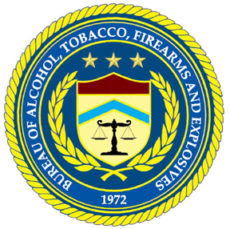

Arson and Explosives Programs Division
Arson and Explosives Enforcement
Branch



The Centre at Purchase
One Manhattanville Road
Purchase, NY 10577-2128
(914) 696-4700 Fax (914) 696-3401

May 2004

Dear Client of the Arson and Explosives Programs Division:

Carl J. Truscott, the Director of ATF, recently wrote to you about a customer survey we are conducting for ATF.The purpose of the survey is to give ATF information about how well they are serving their customers. They want to know the areas that need change and improvement as well as their strengths in bringing you the services you need. They intend to use the survey results to make those changes necessary to improve their services. We hope you will complete the survey.
The survey can be completed on the enclosed questionnaire, or electronically. You may choose to identify yourself and /or your organization, or to be anonymous. We will not report names of individuals or organizations in any reports we write. The access code number at the top of the questionnaire is to ensure that each responder answers the questionnaire in only one of the two formats provided.
ATF has also instructed us to notify them if a customer has a need for their immediate attention and identifies himself/herself.
If you choose to complete the enclosed questionnaire, please return it to us in the self-addressed, stamped envelope. When we receive your questionnaire, we will immediately record your response in our secure computerized database.
If you choose to respond to the survey electronically, please follow these instructions:
1. Enter the link to our website (WWW. ATF/Sirota/Survey).
2. Enter your access code, as instructed. The access code is at the top of this letter and on the top of the printed questionnaire.
3. Follow the instructions on how to respond to each question.
4. Submit the questionnaire.
If you have any questions, please call me at 1-800-777-8196, ext. 213, or e-mail me at Wreichman@sirota.com. Your participation in this survey is appreciated.

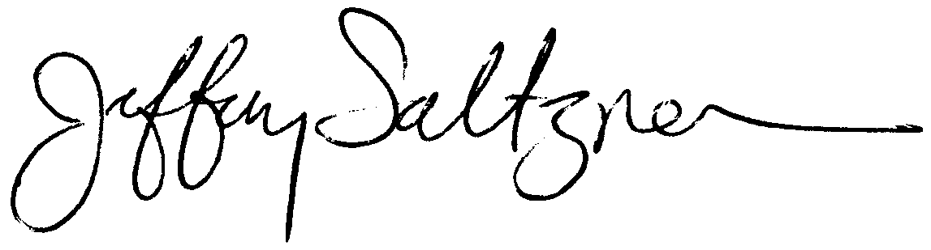
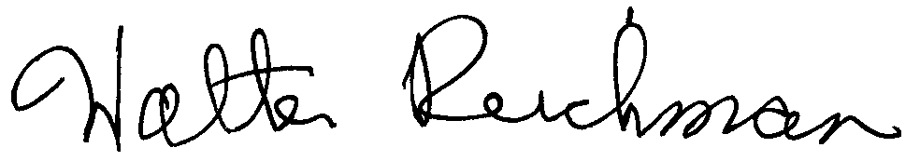
Sincerely,

Jeffrey Saltzman Walter Reichman
CEO/Chairman Vice President
Sirota Consulting LLC Sirota Consulting LLC

Name (optional):
Organization or Department (optional):
City: |  |  |  | State:

 | Are you a member of a … Indicate ONE answer:
 |  |  | 1. | Police Department
 |  |  | 2. | Fire Department
 |  |  | 3. | U.S. State Department
 |  |  | 4. | Other (describe) _________________________

 | How many times have you worked with the National Response Team (NRT) in the past year? Indicate ONE answer:
 |  |  | 1. | Once
 |  |  | 2. | Twice
 |  |  | 3. | Three times
 |  |  | 4. | Four times
 |  |  | 5. | Five times
 |  |  | 6. | More than five times

Thinking back over your experiences with the NRT, to what extent do you agree with each of the following? Indicate ONE answer for each line across:
 |  | Strongly Agree | Agree | Neither Agree Nor Disagree | Disagree | Strongly Disagree | Don’t Know/Not Applicable
 | Overall, the NRT has been effective in serving your needs | 1 | 2 | 3 | 4 | 5 | 6
 | The NRT arrived on the scene after a reasonable amount of time | 1 | 2 | 3 | 4 | 5 | 6
 | The NRT showed a willingness to work with local authorities | 1 | 2 | 3 | 4 | 5 | 6
 | The NRT was thorough in its investigation | 1 | 2 | 3 | 4 | 5 | 6
 | The NRT worked quickly and completed its investigation in a timely manner | 1 | 2 | 3 | 4 | 5 | 6
 | The NRT has good investigative skills | 1 | 2 | 3 | 4 | 5 | 6
 | The NRT has good interviewing skills | 1 | 2 | 3 | 4 | 5 | 6
 | The NRT provided good and fast laboratory work | 1 | 2 | 3 | 4 | 5 | 6
 | The NRT shared its plans with the local authorities | 1 | 2 | 3 | 4 | 5 | 6
 | There was a great diversity of expertise on the NRT | 1 | 2 | 3 | 4 | 5 | 6
 | The NRT and local investigators worked cooperatively | 1 | 2 | 3 | 4 | 5 | 6
 | The NRT debriefed the local authorities every day | 1 | 2 | 3 | 4 | 5 | 6
 | The NRT completed its final report before leaving the scene | 1 | 2 | 3 | 4 | 5 | 6
 | Local officials learned from the NRT | 1 | 2 | 3 | 4 | 5 | 6
 | Local officials changed procedures as a result of their interaction with NRT | 1 | 2 | 3 | 4 | 5 | 6
 | The NRT took precautions to enhance the safety of the scene they were investigating | 1 | 2 | 3 | 4 | 5 | 6
 | We could not have completed the investigations without the NRT | 1 | 2 | 3 | 4 | 5 | 6
 | The NRT members were professional in their approach to the investigation | 1 | 2 | 3 | 4 | 5 | 6
 | The NRT Team Leader was an effective leader | 1 | 2 | 3 | 4 | 5 | 6
 | The NRT made it easier to apprehend those responsible for the event | 1 | 2 | 3 | 4 | 5 | 6

23. Describe your overall experience with the NRT. Please write in the space provided below:

Thank you.

PAPERWORK REDUCTION ACT NOTICE. This request is in accordance with the Paperwork Reduction Act of 1995. The information collected is to capture data that permits the accurate assessment of program activities. The Government Performance and Results Act (GPRA) of 1993 requires that each Government agency maximize resources, develop more realistic goals or more innovative measurements, and permit the allocation and use of available resources for specific priorities.
The estimated average burden associated with this collection of information is 15 minutes per respondent, depending on individual circumstances. Comments concerning the accuracy of this burden estimate and suggestions for reducing this burden should be addressed to Reports Management Officer, Document Services Branch, Bureau of Alcohol, Tobacco, Firearms and Explosives, Washington, DC 20226.
An agency may not conduct or sponsor, and a person is not required to respond to, a collection of information unless it displays a currently valid OMB control number.

