Supporting Statement
Energy Efficiency and Conservation Block Grant Program
OMB Control Number: 1910-5150

B. Collections of Information Employing Statistical Methods
- Describe (including a numerical estimate) the potential respondent universe and any sampling or other respondent selection methods to be used.

The potential respondent universe is 35 grantees. This is the entire population, no sampling or other respondent selection methods will be used.

- Describe the procedures for the collection of information including:

The BetterBuildings reporting process has been standardized to provide database collection and retrieval of program, utility, and financial information through the Better Buildings Information System (BBIS). BBIS is a BetterBuildings specific system that will accept grantee reporting data in machine readable format and will enable grantees and their partners to automate the reporting of program, utility, and financial information to limit the amount of manual entry. A formatted excel worksheet and online web portal will also be provided to grantees to upload data if the grantee is incapable of using BBIS.

Energy savings estimates and project cost data collected for the BetterBuildings program will be utilized to capture a rough snap-shot of progress and assess the efficacy of individual programs relative to each other for continuous improvement in program delivery. First, the self-reported estimated energy savings and project cost data will be evaluated to ensure that the basis of reported data is comparable between programs. Then the cost per unit of energy saved will be calculated from the data to cross-compare programs. Programs that are highly cost-effective will be scrutinized to better understand why they are performing well – are differences in program performance a result of differences in climate, housing type, occupancy, program design, technologies, etc.? This information will be shared with all programs to improve program delivery. The metric in Figure 1 is derived from grantee-reported per unit estimated savings (kwh per year, therms per year, gallons of heating oil) and installation costs.

Figure 1. Cross-program comparison of cost per unit of energy saved (example data).

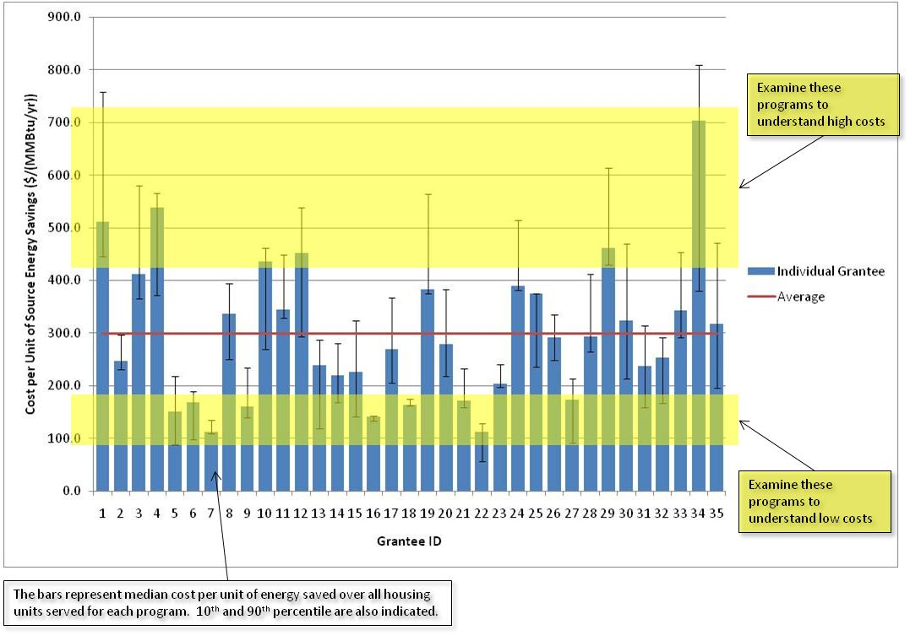

Predicted energy savings will be examined across all measures reported to be installed in the home. Multiple linear regressions will be used to determine the relative contribution of the independent efficiency measures to the whole-house predicted savings.
PES = β₁x₁ + β₂x₂ + … + β_{n}x_{n} + ε
Where:
PES = Predicted Energy Savings
β_{n} = Regression coefficient – relative contribution to the predicted energy savings
x_{n} = independent, dichotomous variable
ε = Constant

Dichotomous (1/0) independent variables that will be tested stem from retrofit measures defined in the BBIS data collection tool. The list of measures includes:

- Refrigerator
- Furnace
- Water Heater
- Air Conditioner
- Boiler
- Wood Stove
- Windows
- Ceiling Insulation
- Wall Insulation
- Floor Insulation
- Ventilation System
- Air Sealing
- Duct Sealing

The estimated contributions from individual measures will be compared across programs, illuminating those programs and measures resulting in the largest predicted savings.
It is recognized that collinearity may exist across the measure variables. To determine the extent of multicollinearity in the data, the measure predictor variables will be systematically added and removed from the multiple linear regression model to assess the impact on individual estimated regression coefficients. Large swings in the estimated coefficients indicate significant collinearity. To the extent that multicollinearity exists in the data, it will be acknowledged and discussed along with reported results.
It is also recognized that heteroscedasticity may exist in the data. Heteroscedasticity can result in bias in the standard error estimation, which in turn can affect confidence intervals and other conclusions drawn from the regression and data. The data will be tested for heteroscedasticity using the Time-Honored Method of Inspection (THMI) and the results of those tests will be reported along with any reported conclusions stemming from the multiple linear regression.
Empirical energy savings will be estimated from pre- and post-retrofit energy bill data and compared to predicted energy bills. Utility bills will be weather-normalized to account for yearly differences in weather and normalized against general energy consumption trends from EIA’s Monthly Energy Review driven by other factors outside the program – ie. e.g., general economy, changes in efficiency standards, changes to end-uses brought about by new consumer technologies, etc.
Empirical energy bills will also be used as a quality assurance tool to verify the accuracy of reported energy predictions as well as used to calibrate energy models and other methods for predicting energy savings.

3. Describe methods to maximize response rates and to deal with issues of non-response.
Continuous contact with the grantees will be established to help promote the data collection process. Data requests will be made to minimize the demand on respondents. For example, requests to the same party for multiple data installments will be coordinated to minimize the workload. Electronic data delivery will be encouraged, but data will be accepted in any standard format.
Data reported will go through a series of data cleaning steps to ensure quality control. Analytics will be applied to test data elements for tolerance values, correct units, formatting, etc. Missing data elements will be automatically flagged and sent back to the grantee, and personally identifiable information will be stripped out before entering the database. A data analyst will review data and follow-up with grantees individually to capture any missing or erroneous data.

4. Describe any tests of procedures or methods to be undertaken.
The source of estimated savings reported in the field Sources or method of prediction in BBIS will be evaluated for robustness and accuracy. An inventory of the range of tools, their capabilities, and expected accuracy will provide program managers with an understanding of how the energy savings estimates are being generated.
The percentage of records completed for each field will be calculated and reported to indicate completeness of the BBIS dataset. These data will be reported for the entire database and by individual Grantee.
Data will be examined to find and report erroneous data (i.e. outliers). This will provide the opportunity to solicit corrections from Grantees and identify possible systemic problems.

- Provide the name and telephone number of individuals consulted on statistical aspects of the design and the name of the agency unit, contractor(s), grantee(s) or other person(s) who will actually collect and/or analyze the information for the agency.

David R. Roberts, P.E.
Senior Engineer
Residential Buildings Research Group
Electricity, Resources & Building Systems Integration Center
National Renewable Energy Laboratory (NREL)
303.384.7496

