- From where does the data come from to populate these forms, such as for CREST – are the data being extracted from a Institutional database? It raises questions about things like where the disability categories are coming from.

I assume you mean, in the CREST example, the PI name, institution, address, etc. This is the only information that is pre-populated and is taken from the NSF institutional record for a particular award mostly concerning the PI, the institution and the partners on the grant if applicable. We do not pre-fill any personal characteristics variables of PI information from NSF institutional data. All other input below that level is supplied by the respondent. Some of the screen shots in the CREST example include dummy data as an example, they are not prefilled items from any source.

- For self report surveys, the race question should read “Mark one or more” NOT “select all that apply.” NSF shouldn’t offer a “not reported” option in cases like this.

In reviewing the ten task collections under the EHR Generic, we found that three (CPATH, STEP, and TUES) do not collect race data on individuals, so this issue doesn’t apply to them. Of the seven remaining task collections, only CREST and GK-12 used the incorrect wording.
Both the CREST and GK-12 systems have been updated to reflect the correct wording (“Mark one or more”) for the race question. Attached are screenshots of the question from the GK-12 Award, Teacher, and Fellow surveys, and below is a screenshot of the question from CREST (which appears on the Edit PI, Edit Faculty Postdoc, Edit Student, and Edit Other Personnel screens). All occurrences of the question have been updated in both systems.

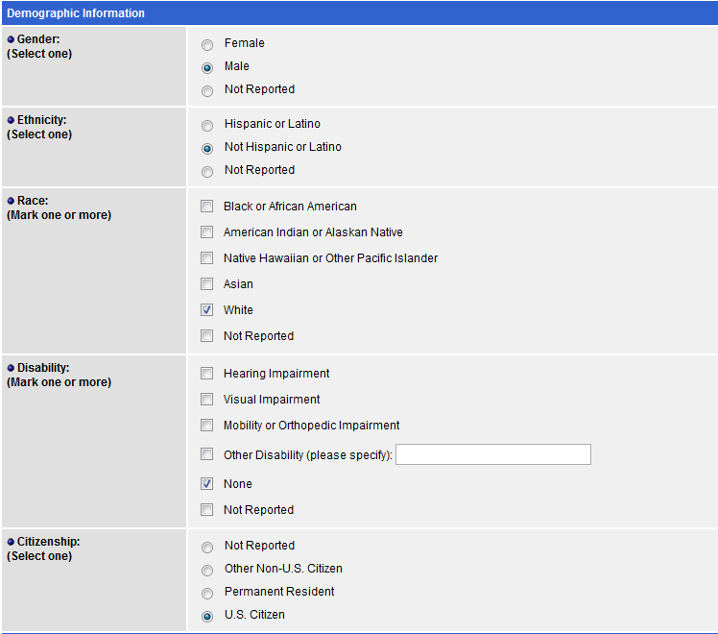
- Confidentiality language- The forms don’t have the standard privacy act language and reads too strongly (ie, there’s nothing that says “except as provided by law” or other way to say that there are exceptions under the Act).

