Appendix F4: Nondisclosure and Confidentiality Form

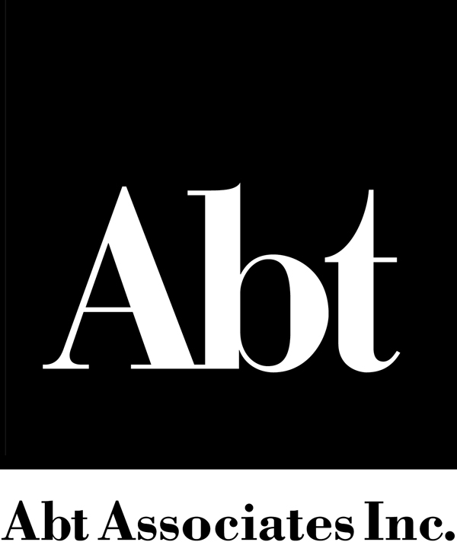

NON-DISCLOSURE AND CONFIDENTIALITY AGREEMENT
I understand that, during the performance of the WIC Peer Counseling Study: Phase 2, under contract AG-3198-D-06-0105 to the Food and Nutrition Service of the U.S. Department of Agriculture, I may be given access to information of a confidential, proprietary, sensitive, or private nature, including information that is protected under the Privacy Act of 1974 as amended, 5 U.S.C. I agree that I shall only use this information to carry out my work on the study and will follow procedures to protect the information from unauthorized release or disclosure. I further acknowledge that, while this information is in my possession, I shall take all reasonable measures to protect it from unauthorized disclosure and to restrict access to those who have a bona fide requirement for such access.
I understand that violation of this Agreement may be cause for dismissal from Abt Associates Inc. or Abt SRBI without notice, and that furthermore I may be subject to civil or criminal penalties. I solemnly swear (or affirm) that I have read and understand the content of this document.
Printed Name: Signature: Date:
Copies of this signed document will be retained as required by the Project Director, Carter Epstein and with Abt Associates’ Institutional Review Board.

