

##### 2010 Census Traffic Analysis Zone Program

MAF/TIGER Partnership Software Participant Guidelines

**March 2011**

Table of Contents

1 Introduction 3

2 Installation and Starting the TAZ MTPS 5

2.1 Downloading Census Data 5

2.2 Installing the TAZ MTPS 6

3 TAZ/TAD Overview and Criteria 9

3.1 TAZ Criteria 10

3.2 TAD Criteria 11

4 Delineation Options 12

4.1 TAZ Delineation Options 12

4.2 TAD Delineation Options 13

5 Starting a Project 15

5.1 Startup Options 15

5.2 Example of Starting a Project 21

6 Delineating TAZs/TADs 24

Do not exit or shut down the TAZ MTPS while it is processing. Doing so will cause the project to corrupt and your work will be lost. 24

6.1 Delineating New TAZs 24

6.1.1 Adding or Removing Area from Existing TAZs 30

6.1.2 Changing Attributes of Existing TAZs 31

6.1.3 Resetting TAZ Delineations 32

6.2 Delineating New TADs 34

6.2.1 Adding or Removing Area from Existing TADs 41

6.2.2 Changing Attributes of Existing TADs 43

6.2.3 Resetting TAD Delineations 43

7 Verification 46

7.1 TAZ Verification 46

7.2 TAD Verification 50

8 Submitting TAZ/TAD Delineations 53

8.1 Report Changes 53

8.2 Submitting Files via the File Transfer Protocol (FTP) 54

Appendix A. TAZ MTPS Tools 55

*TAZ/TAD Delineation Tools* 55

*Map Tools* 56

*Working with Map Layers* 59

*Standard MTPS Tools* 61

*Standard Dataview Toolbox* 63

*Imagery Tools* 64

Appendix B. Creating Multiple Work Areas 66

Appendix C. Creating Set-up Files for Multiple Whole County-Based Delineations 70

Appendix D. Creating Block Equivalency Files 71

Appendix E. Block Resolution Guidelines 76

Appendix F. Disclosure to Respondents 80

# Introduction

The Traffic Analysis Zone (TAZ) Program is a specialized program used for delineating TAZs and Traffic Analysis Districts (TADs) in support of the Census Transportation Planning Products (CTPP). This program is designed to allow Metropolitan Planning Organization (MPOs) and/or State Departments of Transportation (State DOTs) to define zonal systems and geographic summary layers suitable to their planning. Participating MPOs and State DOTs will use TAZ MAF/TIGER Partnership Software (TAZ MTPS), provided by the Census Bureau, to create geographic summary layers based on population, worker counts, and other criteria. Participants will have the ability to delineate TAZs and/ or TADs based on 2010 census tabulation blocks, block groups and tracts. Participant updates will be part of the CTPP[1] and will include tabulations for both TAZs and TADs.

This document will provide participants with the following information:

* TAZ MTPS Installation and Data Download Procedures
* TAZ/TAD Overview and Criteria
* TAZ/TAD Delineation Options
* How to use the TAZ MTPS for TAZ/TAD delineations
* How to use the TAZ MTPS to Verify delineations
* How to submit final delineations to the Census Bureau
* TAZ MTPS tools and functionality
* How to create multiple work units out of one State DOT/MPO TAZ/TAD delineation project.
* Block Resolution Guidelines

If there are questions regarding TAZ/TAD delineation or about downloading materials, please email the GEO TAZ team at [geo.taz.list@census.gov](mailto:geo.taz.list@census.gov), or call the Census Bureau at 301.763.1099 and ask to speak to one of the following GEO TAZ Team members:

Dennis Gray

Michael Clements

Sam Barrick

Shonin Anacker

Participating State DOT/MPO representatives will have three months to submit all delineations to the Census Bureau after they have downloaded essential materials.

**Participation in the TAZ program is voluntary. However, if you do decide to drop out of the program, we do ask that you contact the GEO TAZ team as soon as possible to let us know. Along similar lines, participants are welcome to delineate TAZs only, TADs only, or both. However, if you will only be delineating TAZs for your area, please contact the GEO TAZ team as soon as possible to let us know, as it may be necessary for us to follow special procedures for these areas.**

# Installation and Starting the TAZ MTPS

The following installation guidelines are for State DOT/MPO participants who will be using provided county data and TAZ MTPS software to delineate and submit TAZs and TADs to the Census Bureau. All TAZ/TAD delineations must be based off of 2010 Census population and worker data[2], tracts, block groups or blocks.

## Downloading Census Data

In order to create a project with the TAZ MTPS that defines the predetermined coverage area for which you are responsible, you will need county-level shapefile layers, provided by the Census Bureau, that contain all of the necessary data for the counties that you have agreed to cover. (For a complete list of provided layers see section 3 of Appendix A, located toward the end of this document).

If you do not know the FIPS county codes of the counties you have agreed to cover, find them here:

<http://www.census.gov/geo/www/ansi/countylookup.html>

1. Navigate to the following website:

<http://webdev.ssd.census.gov/geo/www/pvs/TAZ_PVS.html>

1. Select a state from the list. State folders will contain all counties within a state.
2. Place a check mark by all of the counties you plan on delineating. Check “All Counties” if you plan on delineating TAZs and/or TADs in every county of a state. **Do not select counties that are not part of your coverage area. Furthermore, the Census Bureau will not accept delineation submissions located in territories beyond a participant’s coverage area boundaries.**
3. After selecting all counties that will be worked, click “Submit.”
4. A “File Download” screen will then appear. Save the .zip file to a new folder on your C: drive. Give this folder the name “TAZ_Layers.”
5. Open the “TAZ_Layers” folder and extract the contents of the .zip file to the “TAZ_Layers” folder.
6. You will be receiving an email that will include a customized setup file. The TAZ MTPS will need this file to create a project. Move this file into your TAZ_Layers folder.

## Installing the TAZ MTPS

The TAZ MTPS will be downloaded from the Census Bureau website. The Census Bureau will provide a password for the software (via phone) as the software download is password protected. To obtain a password, contact one of the Census Bureau staff members from the list provided in the Introduction.

1. Once you have received a password, navigate to the following website:

<http://webdev.ssd.census.gov/geo/www/pvs/TAZ_PVS.html>

Note: This will take you to the same page where Census shapefiles are located.

2. At the top of the screen, select:

[Download the MAF/TIGER Partnership Software (MTPS)](http://webdev.ssd.census.gov/geo/www/pvs/TAZ_PVS.html#nogo1). Type the password that was provided to you over the phone (case sensitive).

3. Save the .zip folder and extract it in your C: drive.

4. Locate and double-click on the SETUP.EXE file. The setup.exe file should be available once participants have extracted the zip file.

5. On the “Welcome” screen, click “Next.”

6. For “Installation Type” choose “Single User” and click “Next”.

7. The installation guide suggests how to best set up the TAZ MTPS software. It is best to accept the default settings (including the installation of the TAZ MTPS application and data on the C: drive). If there are files in the directory, the setup program will ask if you want to remove these files.

Continue to follow the tutorial steps in the installation process. Installation may take several minutes.

1. If there are files in the directory, the setup program will ask if you want to remove these files. If you click “Yes”, the files are removed; if you click “No”, you can choose another directory. Note: Installing the TAZ MTPS data will delete any previous MTPS data installations and any work you have already completed in the TAZ MTPS. Be sure to relocate any files associated with work done with the MTPS for other Census Bureau projects such as LUCA or PSAP.

Once the program is installed, the setup indicates that “Setup Needs the Census Data” and prompts you to insert the Census Data CD or to browse and select the data from a file on your computer.

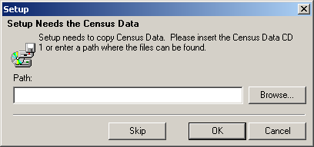

Browse to the “TAZ_Layers” folder containing the county data that you recently downloaded from our webpage. Click on this folder to highlight it and click “OK.” Notice the Destination Folder at the bottom of the following screen; **The TAZ MTPS software will automatically create an MTPSData folder during installation and will store all necessary files for your project within this folder**. Click “Next.”

9. Click “Finish” on the following screen.

10. Click the Windows taskbar “Start” button, and from the Programs menu choose the “MAF-TIGER Partnership Software” and then “MAF-TIGER Partnership Software 5.8”.

It may take several hours for the TAZ MTPS to create a project. The amount of time depends on the amount of territory included in your coverage area.

11. Please log in with your case sensitive User Name: “TAZ”

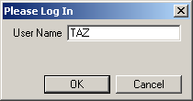

12. The “Participant Verification” box will also appear. Please verify and correct (if necessary) the information in the box and press OK when complete.

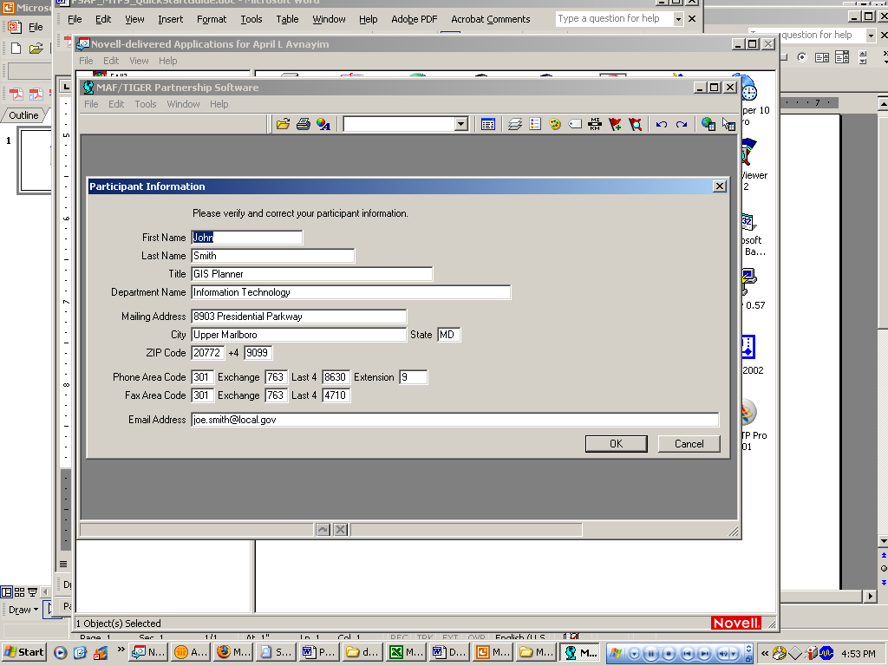

The participant information is provided for the “official” TAZ participant contact, and therefore may not be the same as your contact information. Only provide contact information updates for the official TAZ contact. It is not necessary to provide the contact information for each individual working on the project.

If you select “Cancel” and close the program, the software will force you to go through installation processes again. Make sure to hit “OK” at this point.

13. Once you select OK, the following Startup Choices box will appear:

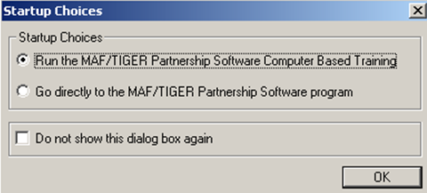

14. Click by the radio button by “Run the MAF/TIGER Partnership Software Computer Based Training.” The Census Bureau encourages participants to take the time to complete the TAZ Training Tutorial before delineating any TAZs or TADs. The Computer Based Training (CBT) will provide instructions and exercises that will prepare participants for delineating TAZs and TADs using the TAZ MTPS.

15. A webpage will appear, listing all of the CBT tutorials that are used for many Census projects. Please locate the “Basic Skills” and “TAZ” categories and explore all of the sections listed under each by clicking on their links. Once you have completed the tutorials, click the X in the top right corner of the page to exit.

**Once you have reached this point, do not proceed until reading Section 3.**

# TAZ/TAD Overview and Criteria

**TAZs** are special purpose geographic entities delineated by state and local transportation officials for tabulating traffic-related data, especially journey-to-work and place-of-work statistics. TAZs are built from 2010 tabulation blocks. They nest within a county and are delineated on a county basis. If participants wish to delineate TAZs, they are not required to assign TAZs to all counties within a coverage area, but all areas within a county that will be delineated must be assigned to a TAZ (there cannot be any gaps in TAZ coverage within a county). If there are counties within a coverage area that will not be delineated, please notify the Census Bureau as soon as possible. Participants may define TAZs by grouping together 2010 tabulation blocks, 2010 census tracts, and/or 2010 block groups. Participants who defined TAZs for the 2000 TAZ program will have the additional option of using their 2000 TAZs as a starting point for their 2010 TAZ delineation[3].

**TADs** are a new, higher-level geographic entity for traffic analysis. TADs are built by aggregating TAZs. TADs may cross county boundaries, but they must nest within MPOs. State DOT/ MPO officials are not required to delineate TADs, but if TADs are delineated for an MPO, all area in that MPO must be assigned to a TAD (there cannot be any gaps in coverage). If a participant chooses not to delineate TAZ’s, they still have the option of delineating TADs as aggregates of 2010 default TAZs set as either 2010 census tracts or block groups.

|  |  |  |
| --- | --- | --- |
| *Criteria* | **TAZ** | **TAD** |
| **Aggregates Of…** | 2010 Census blocks | 2010 TAZs |
| **Overlap** | TAZs may not overlap (one TAZ assigned/ block) | TADs may not overlap (one TAD assigned / TAZ) |
| **Nest Within & Cover Entire Area Of…** | Counties | State DOT / MPO coverage ( may be multiple counties) |
| **Codes** | Unique within County; Codes are up to 8 characters, Alphanumeric, Automatically padded with zeros | Unique within State DOT/ MPO coverage; Codes are up to 8 characters, Alphanumeric, Automatically padded with zeros |
| **Suggested Minimum Thresholds** | Resident or Worker Population> 600; Data reliability and availability improves as population and workers increase | Resident Population > 20,000; Data reliability and availability improves as population and workers increase |

## TAZ Criteria

*TAZs should be delineated to meet the following criteria:*

**No Overlapping:** A TAZ may not cover all or part of the same area as another TAZ.

**Complete Coverage:** All blocks within a county must be assigned to a TAZ. Completed delineations that will be reported back to the Census Bureau must not contain unassigned areas.

**Unique Codes**: Each TAZ must be assigned a code which must be unique within a county and consist of 8 alphanumeric characters (letters and numbers only).

*The following are suggested guidelines:*

**Minimum TAZ Population Threshold:** Each TAZ should have at least 600 residents *or* at least 600 workers.

**Shape/Compactness:** There is no shape requirement for TAZs. However, participants may wish to examine TAZs that are oddly shaped. TAZs with a shape index ratio value of less than 0.15 can be investigated by participants to ensure that no delineation error was made.

S=Ap/Ac, where S is the shape index, Ap is the area of the TAZ and Ac is the area of a minimal enclosing circle. The minimal enclosing circle is the circle with the smallest radius where all of the points in the TAZ are contained within or on the boundary of the circle.

S=Ap/Ac

TAZ

Ap

Ac

Minimal Enclosing Circle

**Contiguity:** Generally, TAZs should be contiguous (i.e. not in multiple pieces). Participants should examine any non-contiguous TAZs to make sure that they were not created unintentionally.

## TAD Criteria

*TADs should be delineated in a way that will meet the following criteria:*

**No Overlapping:** A TAD may not cover all or part of the same area as another TAD.

**TAZ Nesting:** TADs are aggregates of select TAZs. When TAZs are delineated for a given area, TAD boundaries must follow the outermost boundaries of the TAZs they are intended to encompass and may not extend into other areas.

**Complete Coverage:** All blocks within a county must be assigned to a TAD. Completed delineations that will be reported back to the Census Bureau must not contain unassigned areas.

**Unique Codes:** Each TAD must be assigned a code that must be unique within a county and consist of 8 alphanumeric digits (Upper case letters and numbers only).

**TAD Population Thresholds:** Each TAD must have at least 20,000 residents.

*The following are suggested guidelines:*

**Shape/Compactness:** See shape index description above.

**Contiguity:** Generally, TADs should be contiguous (i.e. not in multiple pieces). Participants should examine any non-contiguous TADs to make sure that they were not created accidentally.

# Delineation Options

## TAZ Delineation Options

**TAZ delineation is not required. If participants plan to delineate only TADs, continue to Section 4.2.**

Participants have the following options for delineating TAZs using the TAZ MTPS:

**Option 1:** Start with 2000 Traffic Analysis Zones. This option gives the users the ability to create their 2010 TAZs based on 2000 TAZs. The TAZ MTPS will create a 2010 TAZ for each 2000 TAZ (TAZs will have the 2000 TAZ codes). The participant will be able to modify the boundaries and attributes of these 2000 TAZs. Note: Blocks that are not completely contained by a 2000 TAZ will not automatically be delineated by the TAZ MTPS and will appear as gaps in the TAZ coverage.

**Option 2:** Create default TAZ layers from 2010 Block Groups. This option gives the users the ability to create 2010 TAZs based on 2010 Census block groups. The software will create a 2010 TAZ for each 2010 block group (TAZs will have the 2010 block group codes). The participants will be able to modify the boundaries and codes of these block group-based TAZs.

**Option 3:** Create default TAZ layers from 2010 Census tracts. This option gives users the ability to create 2010 TAZs based on 2010 Census tracts. The TAZ MTPS software will create a 2010 TAZ for each 2010 census tract (TAZs will have the 2010 tract codes). The user will then be able to modify the boundaries and attributes of these tract-based TAZs.

**Option 4:** Create an empty TAZ layer. This option gives participants the ability to create a completely new set of 2010 TAZs from a blank slate. 2010 Census tracts, block groups or blocks can used to create TAZs.

**Option 5:** Import a Block Equivalency File (s) (BEFs). Participants have the option of using their own files (.csv, .txt, or .dbf) files to build TAZs in the TAZ MTPS. If participants will be using multiple BEFs, .dbf files cannot be used. In order for a BEF to be imported into the TAZ MTPS, they must be placed in the MTPSData folder.

BEFs must contain two attribute fields in each file. The first field (named BLOCKID) contains concatenated state, county, tract and block codes and must consist of fifteen text characters. For example, the BLOCKID would appear as 110010002003004, where the 11 is the state FIPS code, 001 is the county FIPS code (COUNTYFP below), 000200 is the TRACT number and 3004 is the BLOCK number. If your BEF currently shows those geographic areas as separate fields, they will need to be concatenated into a single field before performing the import. The second field is the TAZCE10 code which must consist of eight text characters (This record will be automatically padded with zeros by the TAZ MTPS if it is less than 8 digits long.) Below is an example of an acceptable TAZ record within a BEF file:

|  |  |
| --- | --- |
| **BlockID** | **TAZCE10** |
| 310076075041003 | 06079041 |

For additional information about creating Block Equivalency Files and an example, refer to Appendix D.

## TAD Delineation Options

**Participants are not required to delineate TADs. They may decide to only delineate TAZs, in which case this section can be ignored.**

**If participants want to delineate TAZs and TADs, they must complete TAZ delineation before creating TADs.**

Participants have the following options for delineating 2010 TADs:

**Option 1:** Create 2010 TADs from an empty TAD layer. Build 2010 TADs from 2010 TAZs that the participant created with the TAZ MTPS software.

**Option 2:** Import a Block Equivalency File (s) (BEFs). Participants have the option of using their own files (.csv, .txt, or .dbf) files to build TADs in the TAZ MTPS. If participants will be using multiple BEFs, .dbf files cannot be used. In order for a BEF to be imported into the TAZ MTPS, they must be placed in the MTPSData folder.

The BEFs must contain two attribute fields in each record. The first field (named BLOCKID) contains concatenated state, county, tract and block codes and must consist of fifteen text characters. For example, BLOCKID would appear as 110010002003004, where the 11 is the state FIPS code, 001 is the county FIPS code (COUNTYFP below), 000200 is the TRACT number and 3004 is the BLOCK number. If your BEF currently shows those geographic areas as separate fields, they will need to be concatenated into a single field before performing the import. The second field is the TADCE10 code which must consist of eight text characters (This record will be automatically padded with zeros by the TAZ MTPS if it is less than 8 digits long.) Below is an example of an acceptable TAD record within a BEF file:

|  |  |
| --- | --- |
| **BlockID** | **TADCE10** |
| 310076075041009 | 02093041 |

For additional information about creating Block Equivalency Files and an example, refer to Appendix D.

**Option 3 (Available if participant is only delineating TADs.):** Create 2010 TADs from TAZs that are set as 2010 block groups by default. The TAZ MTPS will create a TAZ layer from aggregates of 2010 Block Groups. This TAZ layer will be used for delineating TADs. Note: These TAZs can not be edited to change a TAD at this point.

**Option 4 (Available if participant is only delineating TADs):** Create 2010 TADs from TAZs that are set as 2010 Census tracts by default. The TAZ MTPS will create a TAZ layer from aggregates of 2010 Tracts that will be used for delineating TADs. Note: These TAZs cannot be edited to change a TAD at this point.

# Starting a Project

## Startup Options

Note: Participants can exit the TAZ MTPS at any time; delineations will be saved automatically. In order to reopen the TAZ MTPS, locate and open it from Start menu/Programs/MAF-TIGER Partnership Software/MAF-TIGER Partnership 5.8.

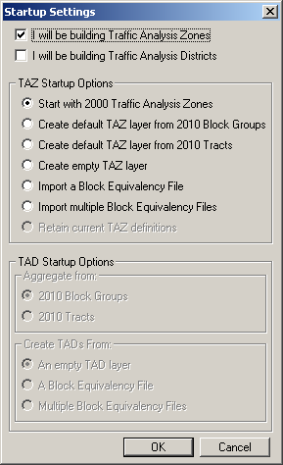

1. To begin, place a check mark by the entities that you plan on delineating.

The radio buttons within the TAZ Startup Options and the TAD Startup Options sections become active, indicating the options that are available depending on the entities selected.

If delineating Traffic Analysis Zones only, only TAZ Startup options become available:

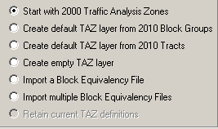

If delineating Traffic Analysis Districts only, only TAD Startup Options are available:

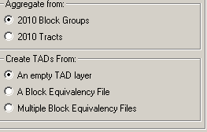

*In the screenshot above, notice that even though TADs are aggregates of whole TAZs, they can be defined by 2010 block groups or 2010 census tracts. Here, participants will choose which default layer they will use to define TADs (Creating by an empty layer will use TAZs).*

If delineating both TAZs and TADs, place a checkmark by both TAZ and TAD options. Both TAZ and TAD options will become available as shown in the following screen shot. However, note that if delineating TAZs, participants may not build TADs from aggregates of 2010 block groups or 2010 census tracts. TADs will be created from the TAZs that participants create. Similarly, if TAZs are not created, TADs are created based on 2010 block groups or census tracts. The block group/tract “TAZs” that are created by the MTPS for TAD delineation may not be edited.

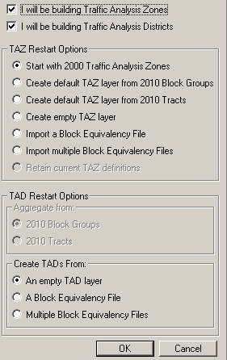

**For participants using Block Equivalency Files to delineate TAZ and/or TADs:**

**TAZ:** If participants are only delineating TAZs:

From the Settings screen, place a check mark by “I will be building Traffic Analysis Zones” and click in the radio button by “Import a Block Equivalency File.” If multiple files will be used for a final project (refer to Appendix B to learn how to create and merge multiple projects per MPO), select “Import multiple Block Equivalency files.” Click “OK.”

**TAD:** If participants are only delineating TADs:

From the Settings screen, place a check mark by “I will be building Traffic Analysis Districts” and click in the radio button by “A Block Equivalency File.” If multiple files will be used, select “Multiple Block Equivalency Files” (refer to Appendix B to learn how to merge multiple projects per MPO); select “Import multiple Block Equivalency files.” Click “OK.”

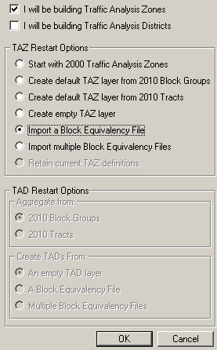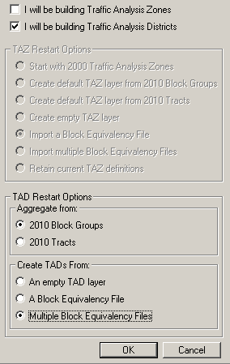

**If participants are delineating both TAZs and TADs** they may choose to delineate both using BEFs. From the Startup Settings screen, select to build Zones and Districts and to Import a BEF for both. If multiple files will be used for a final project (refer to Appendix B to learn how to create multiple projects), select to import multiple BEFs under TAZ and TAD startup setting.” Click “OK.

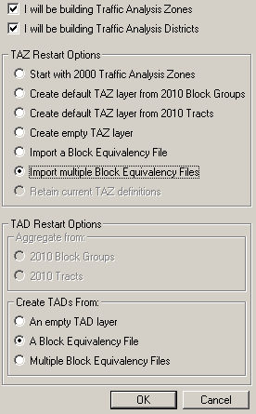

(1)In the “Choose TAZ/TAD BEF To Import” window (s), find and select your BEF file (s). Click “Open”. Note: If you do not see your BEF files in the MTPSData folder where they should be located, select its file type. If it is of any acceptable file type it should now appear as an option in the file box.

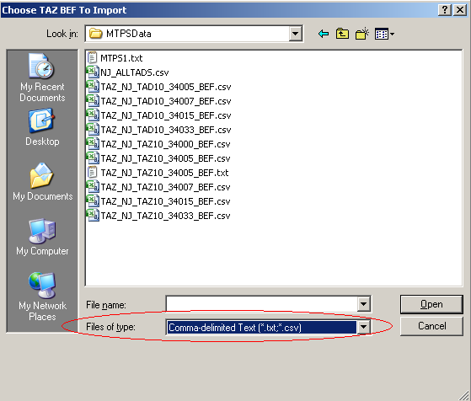

(2) In the “TAZ/TAD: Import Block Equivalency File” window (s), select the appropriate fields for each field to build from. Click “OK.”

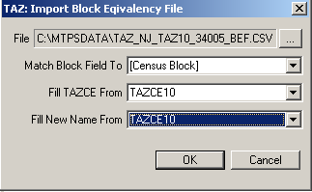 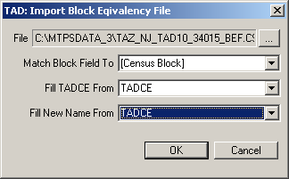

After making selections in the Startup Settings window and clicking on “OK,” the TAZ MTPS will create a map and a TAZ toolbox with functions that are relevant to the entities and the start options that were selected.

Immediately after the project has been created, click on the “Zoom to Area Layer” tool in the TAZ toolbox. This will zoom to a map at the full extent of the project area, which will include data for all counties that are being worked.

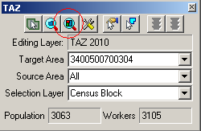

## Example of Starting a Project

The following example demonstrates an initial set up process.

**Example:**

We opt to build only 2010 TAZs that are going to be initially built on 2000 TAZs:

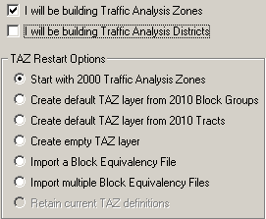

The TAZ MTPS then builds a project based on these selections:

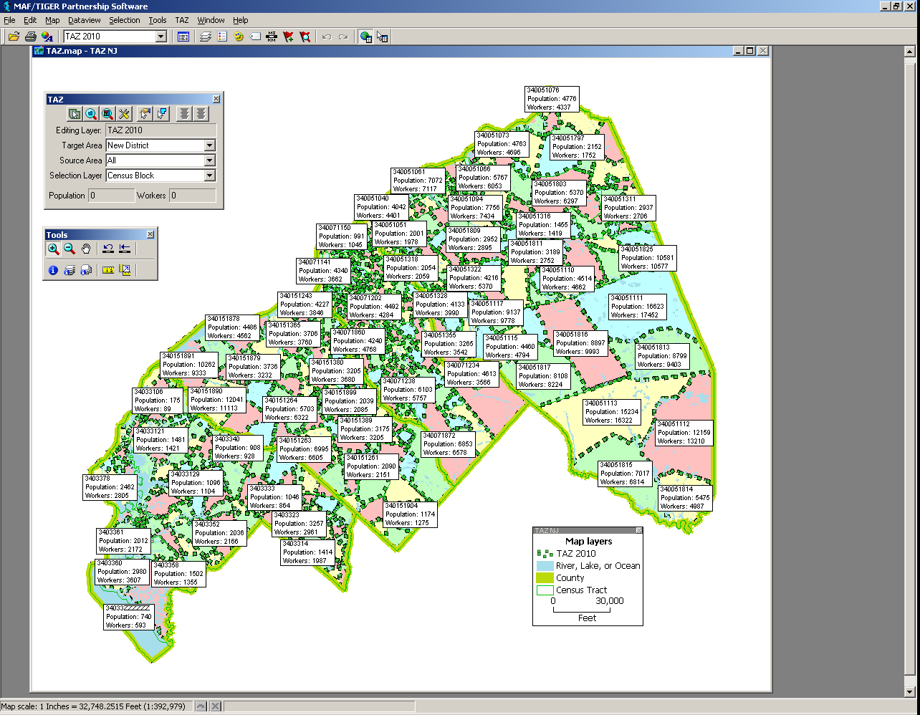

In the map above, 2010 TAZs are displayed using the 2000 TAZ boundaries. The dotted green line and unique shading show the 2010 set of TAZs if you were to accept them “as is.” Never assume that the 2000 TAZ boundaries create 2010 TAZs that meet the 2010 criteria outlined in Section 3. You will want to review these areas and revise as needed.

The solid, bright green lines in our map represent the boundaries of the Census Bureau’s 2010 counties. County boundaries will be built regardless of your selections in the Startup window.

Within the TAZ toolbox, the Editing Layer is set to “TAZ 2010,” and we have three layers to choose from in the Selection Layer: Census Blocks, Census Block Groups, and Census Tracts. If we were to have only selected “ I will be building 2010 Traffic Analysis Districts” from the Startup Settings window, the Editing Layer would be set to “TAD 2010” and the Selection Layer drop down box would only have 2010 TAZs as an option.

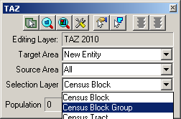

If we had opted to build both TAZs and TADs, the TAZ MTPS would have built a map and a TAZ toolbox based on TAZs. If a participant is going to delineate both entities, they must first delineate TAZs before TADs. Section 6.2 will discuss how to transition from TAZ to TAD delineations.

# Delineating TAZs/TADs

This section provides procedures for delineating TAZs and TADs using the TAZ MTPS. Prior to delineating TAZs and/or TADs, refer to criteria in Section 3.

The MTPS tools needed for TAZ/TAD delineation are described in Appendix A, located near the end of this document.

**If participants ever receive a note window including the following block error message during delineation, do not take any further actions until reading procedures provided in Appendix E, located at the end of this document.**

Text that will be within a TAZ MTPS block error message. 

## Do not exit or shut down the TAZ MTPS while it is processing. Doing so will cause the project to corrupt and your work will be lost.

## Delineating New TAZs

After participants have gone through the Startup Options, a map will be created. A map toolbox and TAZ toolbox will also appear. The map tool (Tools) and TAZ toolbox (TAZ) will contain all of the tools you will need to delineate TAZs and TADs.

Take a moment and hover the mouse over one of the tool icons within the toolboxes, wait a second, then notice that a text box will appear, describing what the tool will do.

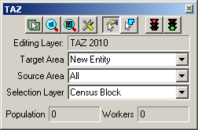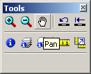

1. To begin creating a new TAZ, select “New Entity” at the bottom of the drop down Target Area list. This will allow participants to create new entities based only on blocks, block groups or tracts. The Target Area drop down menu will list all entities that are available for building delineations on. If desired, participants can simply add blocks, block groups or tracts belonging to a TAZ that was built by the MTPS and later edit the code.

Select a Selection Layer that will be used for adding area into the new TAZ (Census Block, Census Block Group, or Census Tract).

Also, select a Source Area. Areas can only be added from territory within the source area. Select “All” if you will be selecting from multiple TAZs that were built by the MTPS.

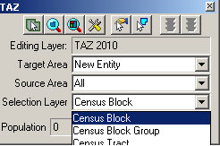

2. Use zoom and pan tools (from the map toolbox) to move around in the MPO coverage area. Locate an area to begin a TAZ Delineation. If the map toolbox is not already on the screen, open it by pressing F8, or by selecting it from the Tools tab located at the top of the screen.

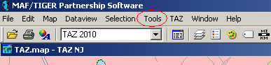

Participants may bring in outside layers to assist delineation. There are several types of files that the TAZ MTPS will allow participants to add as additional layers. These layers may be shapefiles, imagery files, or several other GIS layer file types (Refer to section 5 of Appendix A to learn more about using imagery with the MTPS. To bring in an outside layer into the TAZ MTPS, follow the steps below:

* Click on the map layers icon to open up the Layers window.

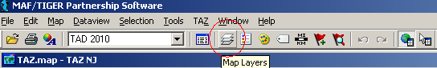

* Click “Add Layer” from within the Layers window.

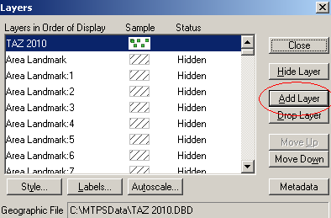

* Locate and open a file to be used as a reference layer. Drop down to the file type of your imagery layer if it is not already available in the file box.

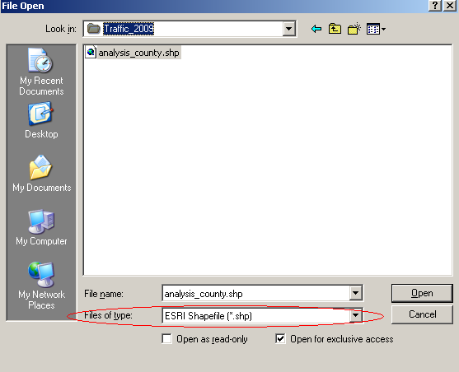

* Click on the “Autoscale” tab near the bottom of the Layer window and adjust accordingly.

Note: Layers provided by the Census Bureau may not line up exactly to feature boundaries provided by outside sources, but TAZ/TAD delineations must follow the boundaries provided by the Census Bureau.

3. To begin adding area to a new TAZ, Click on the “Select by pointing from an area layer” button in the TAZ toolbox.

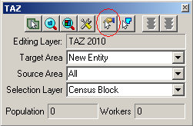

*In the above image we are using Census Blocks as the selection layer, so the TAZs will be built on the blocks we select.*

4. Select areas by placing the cross hairs over an area and left clicking. This will add the selected areas to the new TAZ (“New Entity”). After an area is added to the TAZ, the fill pattern of that newly added area will be stippled. The population and worker totals of the TAZ being modified are updated to reflect the changes.

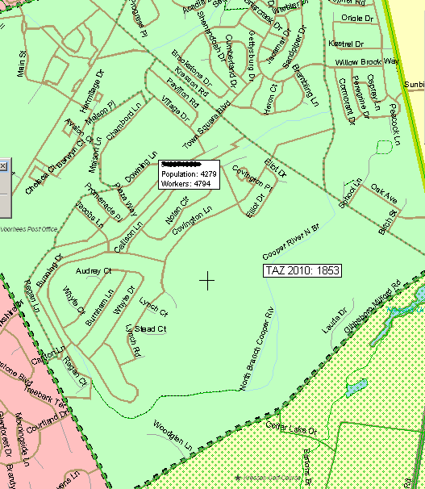 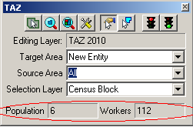

Continue to add areas to the TAZ until the boundary and totals meet MPO approval and the delineation criteria.

Note: While adding areas, participants may unselect areas by holding down the Ctrl key and left clicking (Ctrl + Left Click).

The TAZ MTPS software does not allow users to delineate TAZs that cross county boundaries. If population and workers totals do not change after selecting, verify that changes do not cross the county boundary (thick green line).

Participants may also select areas to add to a TAZ by using the “Select by shape from the area layer” tool. This tool will allow drawing a polygon around an area and adding it to the Target Area. It is a time saving tool for adding multiple areas at once or for capturing smaller areas that may be difficult to click on when using the “Select by pointing from an area layer” tool. To use, left click on the icon, begin drawing a polygon around an area and double-click to complete the polygon.

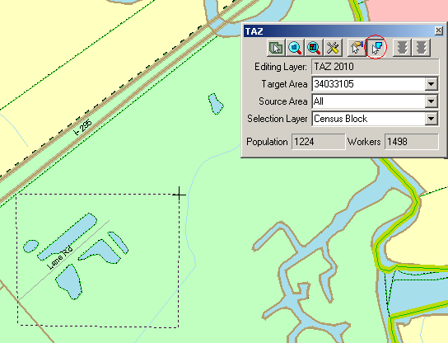

*Notice that only shapes completely within a drawn polygon will be selected.*

5. To save edits, click the “Green Light” icon located in the top right of the TAZ toolbox. To cancel the edits, click on the “Red Light” icon that is located in the TAZ toolbox. This will only roll back the changes made since the last time edits were saved.

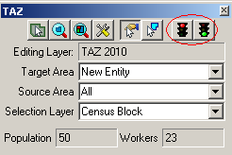

6. After clicking the save button, a “TAZ 2010 Attributes” window will appear. Provide up to an 8 digit alphanumeric code that does not duplicate any other TAZ code within the current county. No spaces or special characters will be allowed to be entered, and codes less than 8 characters will be automatically padded with zeros. **Do not identify entities as ‘00000000’ or ‘99999999.’** Click “OK.”

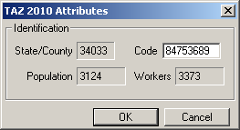

*This is also a good time to double check Population and Worker totals.*

Note: Participants can also create TAZs that have a blank, “null” code. Refer to section 6.1.1 for a description of the “null” code. To create TAZs with null codes, leave the Code box blank and click on “YES” in the Confirm window:

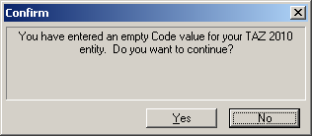

The Census Bureau urges program participants to review any 2000 TAZ areas and codes before delineating 2010 TAZs. Consult with others at the MPO or geographic area served by the MPO to determine which changes to TAZs are expected and/or acceptable. If a numbering scheme was important for 2000 TAZs, try to maintain the code scheme for 2010 delineations.

7. Proceed with delineating the next TAZ by resetting the Target Area in the TAZ toolbox to “New Entity”.

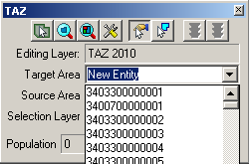

### Adding or Removing Area from Existing TAZs

In order to add or remove area from an existing TAZ, set the Target Area to a specific TAZ by selecting it from the Target Area Drop Down list or click on the “Target Area Pointer”, and then select the desired TAZ within the map.

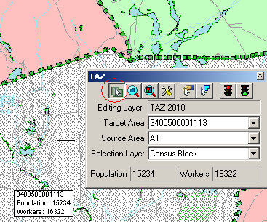

This action will result in a stippled fill pattern indicating the Target TAZ (i.e. the TAZ to which you will be assigning area).

Now you can use either of the two selection tools to choose areas to assign to the TAZ in the “Target Area” box

Removing area from a TAZ delineation

There are two ways one can remove area from a TAZ delineation: through the assignment of a “null” code or adding area to the “unassigned” target area. We have allowed these possibilities so that program participants can opt to distribute work units located within one county to multiple staff technicians. (Refer to appendices B and C to learn about creating multiple work units.)

If areas need to be removed (unassigned) from the TAZ delineation, do the following:

* 1. If the “unassigned” target area exists: Area may be removed from the TAZ delineation by adding area to the existing unassigned area within the county by selecting “unassigned area” as the target area, and adding blocks, block groups, and/or tracts to that unassigned area. This situation should occur when the empty TAZ layer (and possibly the 2000 TAZ and BEF) was selected as the startup option, and TAZs have not been delineated to cover the entire county.
  2. If the “unassigned” target area does not exist: Area may be removed from the TAZ delineation by creating a TAZ that covers the area that should be unassigned, and providing a *null* code for the TAZ (i.e., entering no value in the TAZ 2010 Attribute window “Code” box). This area is now considered “unassigned area”, and the unassigned area can be added to as necessary (as described in “a” above), using the same methods as described for creating and editing TAZs. This situation should occur when the 2010 tracts or 2010 block groups (and possibly BEF) was selected as the startup option, or TAZs have been delineated to cover the entire county.

### Changing Attributes of Existing TAZs

To edit a TAZ code, click on the “Display Area Data” tool from within the TAZ toolbox.

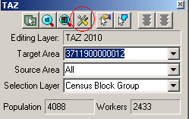

A TAZ 2010 Attributes window will appear. Click within the Code box and edit the code. **Again, make sure never to use the codes ‘00000000’ or ‘99999999.’** Click “OK” to complete.

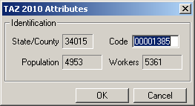

### Resetting TAZ Delineations

If, at any time, participants want to reset their TAZ delineations, select “Reset TAZs,” located under the “TAZ” heading at the top of the MAF/TIGER Partnership Software screen. **Warning: if you choose this option, all the work you have done on your delineation will be lost!**

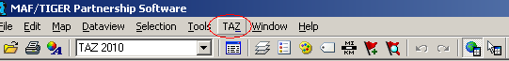

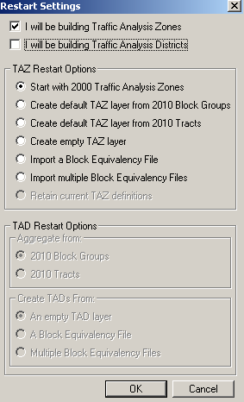

Select a layer to use to rebuild the TAZs on under “TAZ Restart Options” and click “OK.” If participants are sure that they want to delete TAZs that they may have already created, click on “YES” in the Confirm window. This will build a new TAZ project and adjust the initial TAZ boundaries to follow the layer participants have selected. Click “NO” in the Confirm window if restarting is not desired. None of the recent TAZ delineations will be lost and the restart options will be ignored.

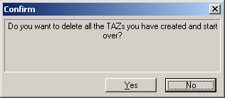

Once all TAZs are delineated, run the Verification Tool and review section 7 of this document. If participants have opted to delineate TAZs and TADs, they must first run the Verification Tool on TAZs and resolve any problems before delineating TADs.

## Delineating New TADs

Refer to Section 3 for TAD criteria.

Participants opting to delineate TAZs and TADs must complete TAZ delineation and verification before beginning TAD delineations. If participants opted to delineate both, begin delineating TADs by clicking on “Delineate TADs” from within the TAZ tab, located on the MAF/TIGER Partnership Software menu bar.

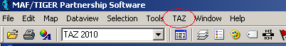

The following “Confirm” window will appear:

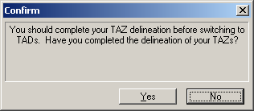

Click “No” if TAZ delineation is not complete. This will keep the map and TAZ toolbox set for TAZs.

Click “Yes” if TAZ delineation is complete. This will adjust the map and TAZ toolbox for TAD delineation.

**Steps to Delineate TADs:**

After picking TAD options in the Startup Settings window or selecting to Delineate TADs from the TAZ tab, a map tool, legend, and a TAZ toolbox will appear on screen. The map tool (Tools) and TAZ toolbox (TAZ) will contain all of the tools needed to delineate TADs. (For a better understanding of the tools and their functionalities within each toolbox, refer to Appendix A, located at the end of this document).

Take a moment to hover the mouse over one of the tool icons in the toolboxes, wait a second, then notice that a text box will appear, describing what the tool will do. Experiment with the zoom tools in the Tools toolbox and move around in your coverage using the Pan tool.

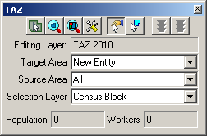

If the toolboxes do not appear, select the TAZ toolbox after clicking on the TAZ tab, and select the Tools toolbox (Tools) from the Tools tab, both located near the top of the MAF/TIGER Partnership Software screen.

**The Tools and TAZ tabs within the MAF/TIGER Partnership Software screen.**

1. To begin a New TAD, drop down to and select “New Entity” as the Target Area (within the TAZ toolbox) if it is not already set. “New Entity” will be listed at the bottom of the drop down list. If “Unassigned” is selected as the Target Area, the TAZ MTPS will zoom out to the entirety of the unassigned TAD territory, indicating unassigned territories to add from by a grey, stippled fill.

Select “All” as the Source Area when creating your first TAD. The set Source Area limits the entities that area can be added to a TAD.

The Selection Layer should already be set as the TAZ 2010 layer.

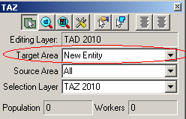

2. Use the zoom and pan tools (from the map toolbox) to navigate within in the map. Locate an area to begin delineating a TAD.

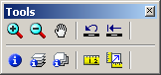

Participants may bring in outside layers to assist delineation. There are several types of files that the TAZ MTPS will allow participants to add as additional layers. These layers may be shapefiles, imagery files, or several other GIS layer file types (Refer to section 5 of Appendix A to learn more about using imagery with the MTPS. To bring in an outside layer into the TAZ MTPS, follow the steps below:

* Click on the map layers icon to open up the Layers window.



* Click “Add Layer” from within the Layers window.



* Locate and open a file to be used as a reference layer. Drop down to the file type of your imagery layer if it is not already available in the file box.



* Click on the “Autoscale” tab near the bottom of the Layer window and adjust accordingly.

Note: Layers provided by the Census Bureau may not line up exactly to feature boundaries provided by outside sources, but TAZ/TAD delineations must follow the boundaries provided by the Census Bureau.

3. Click on the “Select by pointing from an area layer” icon in the TAZ toolbox.

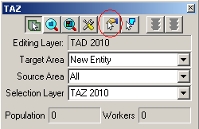

4. Select individual TAZs by placing the cross hairs over an area and left clicking. After a TAZ is added to the “New Entity”, the fill pattern of the added TAZ will be stipple. The population and worker totals of the TAD being modified will be changed to reflect the new TAD.

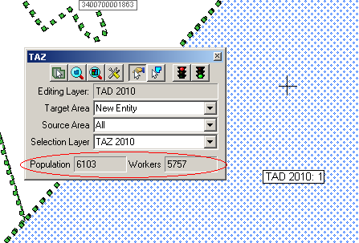

While in the process of selecting TAZs to add to your TAD, participants may unselect them by holding down the Ctrl key and left clicking (Ctrl + Left Click).

Although there are no limits to how many TAZs can be included within a TAD, the Federal Highway Administration (FHWA) insists that the total resident population for a TAD is at least 20,000.

Participants may also select multiple TAZs to add to a TAD by using the “Select by shape from an area layer” tool. This tool allows drawing a polygon around an area and adding to the Target Area. It is a time saving tool for adding multiple areas at a time or for capturing smaller areas that may be difficult to click on when using the “Select by pointing from an area layer” tool. To use, left click on the icon, begin drawing a polygon around an area, and then double-click to complete the polygon.

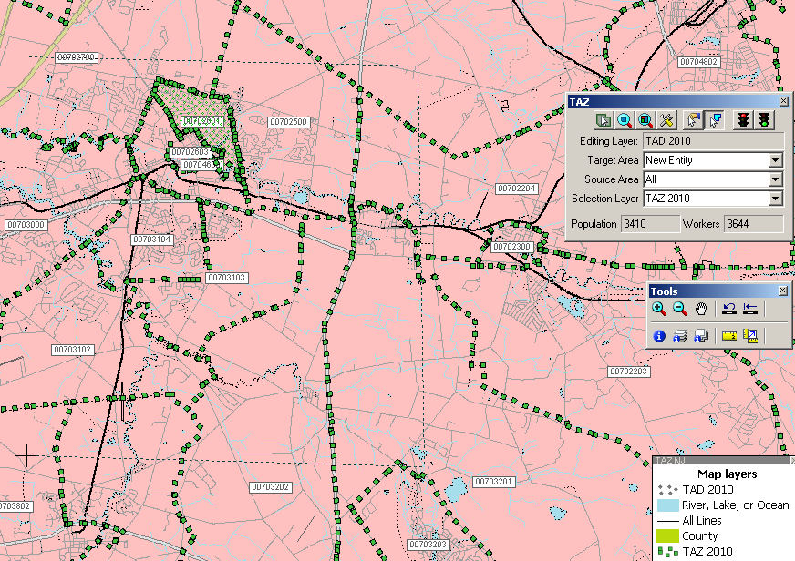

*Notice that only shapes within the drawn polygon will be selected.*

5. To save a delineation, click the green light located in the top right of the TAZ toolbox.

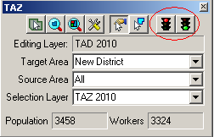

To cancel edits, click the red light that is located in the TAZ toolbox. Cancelling edits will only roll back the changes made since the last time changes were saved.

6. A “TAD 2010 Attributes” window will appear. Provide a code of up to 8 alphanumeric characters that will not duplicate any other TAD code in the State DOT/MPO coverage. Zeros will automatically be included to codes that are less than 8 characters. **Do not identify entities as ‘00000000’ or ‘99999999.’** To complete new TAD delineation, click on “OK” after a code is entered.

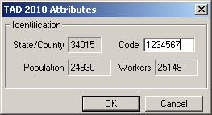

*This is also a good time to double check the Population and Worker totals.*

Note: Participants can also create TAZs that have a blank, “null” code. Refer to section 6.2.1 for a description of the “null” code. To create TADs with null codes, leave the Code box blank and click on “YES” in the Confirm window:

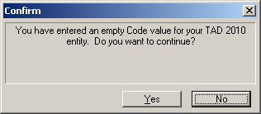

Note: The Census Bureau urges State DOT/MPO staff to consult with each other to determine and maintain a numbering scheme for 2010 TAD delineations. This is particularly important if it is decided that work will be divided. A numbering scheme will make it easier for each staff member to keep track of their delineations, and, if work will be broken down and later merged, will make it easier on a final reviewer.

7. Proceed with creating another TAD by changing the Target Area to “New Entity.”

Selecting "New Entity" as a target area in the TAZ toolbox.


Select a new area for a new TAD from the map: Click on the Target Area Pointer in the TAZ toolbox and click within an area in the map:

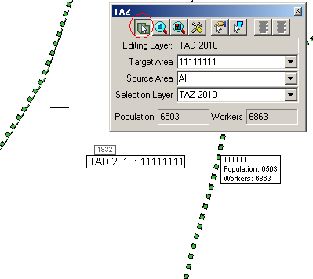

1. Follow the above steps to create other TADs.

### Adding or Removing Area from Existing TADs

In order to edit an existing TAD, set the Target Area to a specific TAD by selecting it from the Target Area Drop Down list or by clicking on the “Target Area Pointer” and then using the map cursor to set the target TAD.

Be sure to select a Source Area before editing. You will only be able to add area from entities that are set as the Source Area.

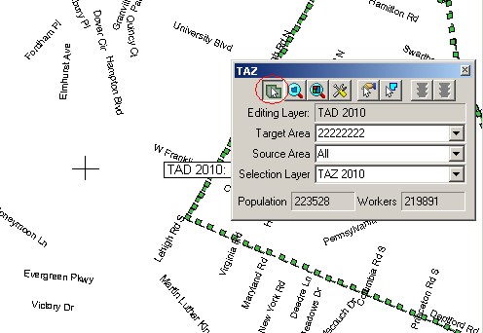

Use one of the two selection tools to add TAZs to the TAD that is shown in the “Target Area” box.

Removing area from a TAD delineation

There are two ways one can remove area from a TAD delineation: through the assignment of a “null” code or adding area to the “unassigned” target area. We have allowed these possibilities so that program participants can opt to distribute work units located within one county to multiple staff technicians. (Refer to appendices B and C to learn about creating multiple work units.)

If areas need to be removed (unassigned) from the TAD delineation, do the following:

1. If the “unassigned” target area exists: Area may be removed from the TAD delineation by adding area to the existing unassigned area within the county by selecting “unassigned area” as the target area, and adding TAZs to that unassigned area. This situation should occur when the empty TAD layer (and possibly BEF) was selected as the startup option, and TADs have not been delineated to cover the entire coverage.
2. If the “unassigned” target area does not exist: Area may be removed from the TAD delineation by creating a TAD that covers the area that should be unassigned, and providing a *null* code for the TAD (i.e., entering no value in the TAD 2010 Attribute window “Code” box). This area is now considered “unassigned area”, and the unassigned area can be added to as necessary (as described in “a” above), using the same methods as described for creating and editing TADs. This situation may occur when the BEFs are selected as the startup option, or TADs have been delineated to cover the entire coverage.

Do not forget to commit your changes when complete.

### Changing Attributes of Existing TADs

To edit the TAD code, click on the “Display Area Data” tool from within the TAZ toolbox.

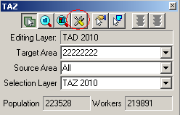

A TAD 2010 Attributes window will appear. Click within the Code box and edit the code. **Do not identify entities as ‘00000000’ or ‘99999999.’** Click “OK” to complete.

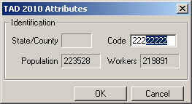

### Resetting TAD Delineations

If, at any time, a participant wants to reset their TAD delineations, click to select “Reset TADs” from within the TAZ tab, located at the top of the MAF/TIGER Partnership Software screen, and select a method to re-build TADs.



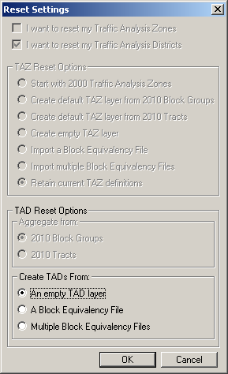

Select a method of re-creating TADs in the “Create TADs From” options. Click “OK” to continue.

If participants are sure that they want to delete any TADs that they may have already created, click on “YES” in the Confirm window. This will build a new TAD project and adjust the initial TAD boundaries to follow the layer that has been selected. Click “NO” in the Confirm window if re-starting TAD delineations is not desired. None of the recent TAD delineations will be lost and the Reset Options will be ignored.

The TAZ MTPS Confirm window.


Once the TADs are delineated, run the Verification Tool and review section 7 of this document.

# Verification

Both TAZs and TADs will need to be run through the TAZ MTPS Verification before submitting the TAZ/TAD plan.

## TAZ Verification

After participants have completed TAZ delineations they will need to run the Verification Tool in order to check for TAZs that do not meet criteria. The verification tool will check for the following failures:

**Unique Codes**: The TAZ MTPS will check for TAZs with codes that are not unique within a county.

**Unassigned Areas:** The TAZ MTPS will check forblocks within a county that are not covered by a TAZ. The goal of this check is to ensure that no unassigned areas are reported back to the Census Bureau. Because some participating officials may divide the work among several staff members, the TAZ MTPS does not enforce this rule. However, a final reviewer **must** verify that no unassigned areas remain (See Appendix B for more details on splitting up work administratively).

**Minimum Population**: The TAZ MTPS will find any TAZs that do not have at least 600 residents or 600 workers. Census 2000 resident and worker estimates are interpolated to 2010 block groups that are used in the TAZ MTPS. If participants have more current or relevant resident population data, it should be used to make the most accurate delineations. If the minimum population verification check fails in an area where your data indicates an acceptable population, ignore this failure and notify the Census Bureau of this issue when you submit final delineations.

**Contiguity**: The TAZ MTPS will search for non-contiguous TAZs.

**Compactness**: The TAZ MTPS will check for TAZs that have a shape index ratio value of less than 0.15. The compactness check is intended to find any TAZs that may be oddly shaped. Even though there are no shape requirements for delineation, an odd shape could indicate an error in delineation (For example, a TAZ may not be following the boundaries of block aggregates that it is intended to contain).

1. Locate and click on the Verification Toolbox, located in the TAZ tab near the top of the screen. The Verify Traffic Analysis Zones window will appear.

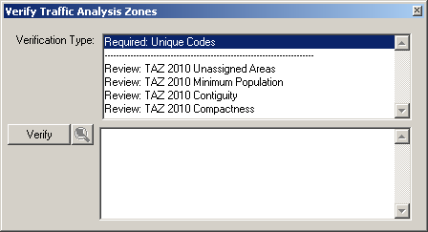

Notice that there are two types of verifications: “Required” verifications and “Review” verifications. Required verification failures must be fixed before the user can report changes back to the Census Bureau. “Review” verification failures do not need to be fixed, but it is recommended to adjust these if doing so will result in a cleaner delineation. Even though unassigned areas are not a “Required” verification type, a completed county should have a complete TAZ coverage.

2. Highlight a single Verification Type and Click on the “Verify” button, located at the lower left of the window. If the software discovers any failures for any specific validation, the failures will appear in the bottom-half of the window. Click to highlight a single failed TAZ and click the magnifying icon to zoom to that TAZ.

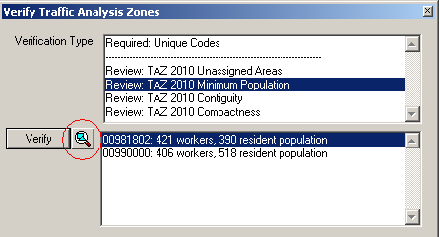

1. Using the TAZ tools, adjust a TAZ so that it meets requirements. The TAZs that are highlighted and zoomed to will be identifiable in the map by their unique stippled fill-compared to immediate adjacent TAZs.

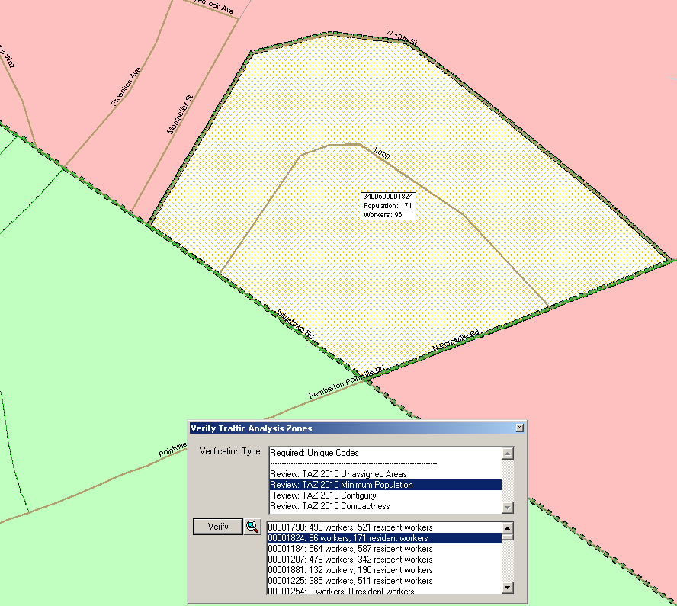

To fix a Unique Code failure:

1. Zoom to the failed TAZ.
2. Click on the “Target Area Pointer” tool in the TAZ toolbox, and then click on the TAZ in order to set it as the Target Area.

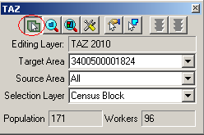

1. Click on the “Display Area Data” tool.

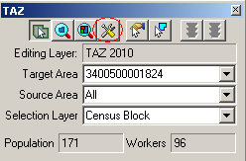

1. A TAZ 2010 Attributes window will appear. Type an acceptable code in the Code box. Note: If a duplicate code is typed, participants will be notified by the software and will not be able to continue until an acceptable code is entered.

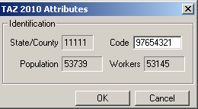

1. Click “OK”

To fix Unassigned Area, Minimum Population, Contiguity and Compactness failures:

1. Zoom to the failed TAZ.
2. Add areas from the failed TAZ to an adjacent TAZ. To do this, set an adjacent TAZ as your target area and use the “Select by pointing from an area layer” tool or the “Select by shape from an area layer” tool to select areas, rather they be blocks, block groups or tracts of the failed TAZ. Continue to adjust TAZs until population totals are reasonable, all areas have been assigned, there are no undesired non-contiguous TAZs or no compactness failures.

The Verification failures list can be refreshed after attempting to fix one TAZ by clicking on “Verify” from within the “Verify Traffic Analysis Zones” window. Running the verification tool after each attempted TAZ fix is a good way to keep track of the failures, and will also let participants know if their fixes resolve the verification error/s.

## TAD Verification

After participants have completed TAD delineations they will need to run the verification tool in order to check for possible TADs that do not meet criteria. The verification tool will check for the following failures:

**Unique Codes**: The TAZ MTPS will check for invalid TAD codes and duplicate code entries.

**TAZ Nesting:** The TAZ MTPS will search for TADs that contain any area located in multiple TADs.

**Unassigned Areas:** The TAZ MTPS will check forblocks within a county that are not covered by a TAD. The goal of this check is to ensure that no unassigned areas are reported back to the Census Bureau. Because some participating officials may divide the work among several staff members, the TAZ MTPS does not enforce this rule. However, a final reviewer must verify that no unassigned areas remain (See Appendix B for more details on splitting up work administratively).

**Minimum Population**: The TAZ MTPS will check for TADs that have a resident population total less than 20,000. Census 2000 resident and worker estimates are interpolated to 2010 block groups that are used in the TAZ MTPS. If participants have more current or relevant resident population data, it should be used to make the most accurate delineations. If the minimum population verification check fails in an area where your data indicates an acceptable population, ignore this failure and notify the Census Bureau of this issue when you submit final delineations.

**Contiguity**: The TAZ MTPS will search for TADs that are non-contiguous and/or contain slivers.

**Compactness**: The TAZ MTPS will search for TADs that have a shape index value of less than 0.15. The compactness check is intended to find any TADs that may be oddly shaped. Even though there are no shape requirements for delineation, an odd shape could indicate an error in delineation.

1. Locate and click on the Verification Toolbox, located in the TAZ tab at the top of the screen. The “Verify Traffic Analysis Districts” window will appear.

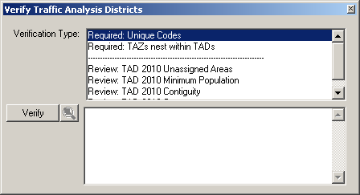

2. Notice the “Required” and “Review” Verification Types. Highlight a single Verification Type and click on the “Verify” button, located in the left side of the window. If any errors appear in the bottom-half of the window, highlight a single failed TAD and click the magnifying icon to zoom to that failed TAD.

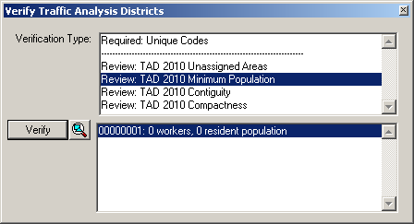

Clicking on the magnify icon will navigate to the failed TAD in the map. The TAD failure will be identifiable by its identification box, and by its unique stippled fill- compared to adjacent TADs.

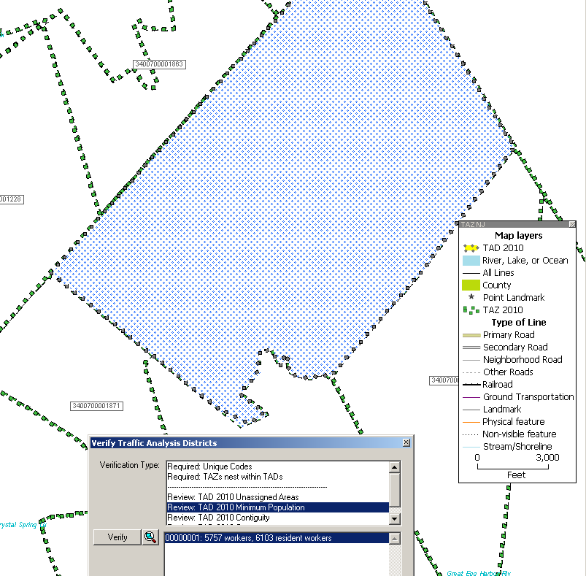

Using the TAZ toolbox tools, adjust the TAD so that it meets requirements.

To fix Nesting, Unassigned Area, Minimum Population, Contiguity and Compactness failures:

1. Zoom to the failed TAD.
2. Add areas from the failed TAD to an adjacent TAD. To do this, set the adjacent TAZ as the target area and use the “Select by pointing from an area layer” tool or the “Select by shape from an area layer” tool to TAZs belong to the failed TAD. Continue to adjust TADs until there are no nesting failures, all areas are assigned (if this is for final submission), TAD populations are reasonable; there are no undesired non-contiguous areas and there are no compactness failures.

# Submitting TAZ/TAD Delineations

## Report Changes

After the plan passes the MTPS verification process, participants will “report changes,” and the software will create county-based output files and shapefiles with the TAZ/TAD updates. Separate county-based BEFs and shapefiles will be created for both TAZs and TADs. Each file should contain the BLOCK ID (15 character code concatenated from the 2-digit state code, 3-digit county code, 6-digit census tract code, and 4-digit block code) for all 2010 blocks within the county, and all unique TAZCE/TADCE codes associated with each BLOCKID.

1. Run the “Verify” tool again for each TAZ/TAD area plan before selecting “Report Changes” to assure that any failures have been fixed or approved of since you last ran “Verify.”
2. Choose **“**Report Changes” from the TAZ menu to display a “Confirm” dialog to make sure you want to create a ZIP archive of changes that can be sent to the a Final Review or the Census Bureau.
3. Click “Yes.” If there are no changes to report, TAZ MTPS displays a message. Click “OK.”

Otherwise, within the MTPSData folder, the TAZ MTPS creates a ZIP archive named “TAZ_<EntityID>_Return.zip,” where <Enity ID> is the is the Entity ID within your setup file. Click “OK” to close the message.

1. Participants must report changes for each county within their area of responsibility within 3 months of receiving their username/password. **Again, the Census Bureau will not accept delineation submissions located in territories beyond a participant’s coverage area boundaries.**

**If participants will only be submitting TAZ delineations or decide not to complete the TAZ MTPS program, please contact us as soon as possible!**

## Submitting Files via the File Transfer Protocol (FTP)

We request that you submit delineations through the Census Bureau’s “Send A File” FTP utility. The “Send A File” utility is located at:

<https://secure.census.gov/cgi-bin/sendfile>

**User Name:** geotaz

**Password:** taz4usboc

*Source Information* >> *File to Send:* >> *Browse*

* Browse to your MTPSData folder and select the TAZ_<EntityID>_Return.zip file. If participants would like to include any additional information pertaining to delineations, please add it within this zip file that we will receive.

*Notify by Email* >> *Sender’s E-Mail Address:*

* Please include your e-mail address in the *Sender’s E-Mail Address* field so that we can notify you that we have received your file.

*Notify by Email* >> *Census Bureau Employee’s E-Mail Address:*

* Notify the TAZ team by including our email, geo.taz.list@census.gov – we will receive an e-mail when your file is uploaded.
* Please send an additional email to the Geo TAZ team (geo.taz.list@census.gov) including a message title that indicates what you are submitting. Use the following example:

“TAZ Submission_<Entity ID>” (The Entity will be provided to you and is also included in the name of the TAZ Setup File that the primary participant downloaded.)

* Within the message, please include a list of counties in your coverage area that have been delineated, along with a list of counties that have not been delineated (if any). Please include county lists for both TAZ and TAD delineations. It is extremely important to list any counties within your coverage area where you may have intentionally not made delineations. During our final evaluation, the Census Bureau does not want to inaccurately assume that participants have accidentally forgotten to delineate any counties in within their coverage area.

# Appendix A. TAZ MTPS Tools

# *TAZ/TAD Delineation Tools*

These tools will be most helpful to you when delineating TAZs/TADs.

**TAZ Toolbox**

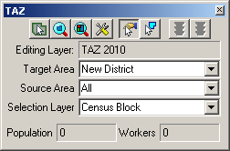

TAZ Toolbox Tools Does this…

The Target Area Pointer tool, located in the TAZ toolbox. **Target Area Pointer** Selects Target Area for editing

The Zoom to Area tool, located in the TAZ toolbox. **Zoom to Area** Zoom to an area within map that is of interest

The Zoom to Area Layer tool, located in the TAZ toolbox. **Zoom to Area Layer** Zooms out to the entire TAZ/TAD project area

The Display Area Data too, locatedl in the TAZ toolbox. **Display Area Data** Displays data that is specific to a TAZ/TAD

**The "Select by pointing from an area" tool, located in the TAZ toolbox. Select by pointing from an area** Selects an area to add to a TAZ/TAD

**The "Select by shape from an area layer" tool, located in the TAZ toolbox. Select by shape from an area layer** Allows user to draw a polygon around an area. After double-clicking to complete polygon, selects area within polygon

**The Cancel Edits tool, located in the TAZ toolbox. Cancel Edits** Cancels TAZ/TAD delineation

***Ctrl + Left Click*** *Unselects area that user just added to TAZ/TAD.*

*Unselected area will change fill color/pattern.*

The Save Edits tool, located in the TAZ toolbox. **Save Edits** Completes and saves edits to a TAZ/TAD.

After clicking the save edits button an Attributes window will appear.

**Target Area** Drop down to select an entity to edit

**Source Area** Drop down and select an entity to target edits

**Selection Layer** For TAZ delineation only; drop down and select a layer that

will be used for adding area to a TAZ.

# *Map Tools*

**Tools Toolbox**



Tools Toolbox Tools Does this…

**The Zoom In tool, located in the Tools toolbox. Zoom In** Zoom closer to an area of interest

**The Zoom Out tool, located in the Tools toolbox. Zoom Out** Zoom out to a larger map scale

**The Pan Tool tool, located in the Tools toolbox. Pan Tool** Pan around the map. Move the map in any direction

**The Previous Scale tool, located in the Tools toolbox. Previous Scale** View an area at the previous scale

The Initial Scale tool, located in the Tools toolbox. **Initial Scale** View an area at the initial scale

The Info icon, located in the Tools toolbox. **Info** Will give you information specific to geographic layer. Click

Info, then click on a TAZ/TAD. A similar info window will

Appear:

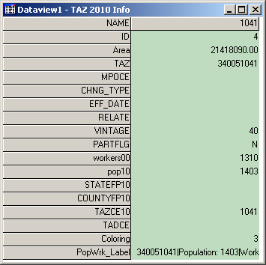

** Multi-Layer Information** Allows user to get info on any layer that is available. Click on

button, then click within area on map. The Multi-Layer Information will appear:

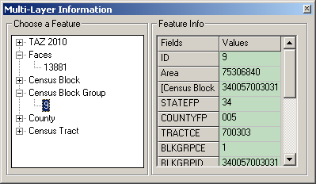

Choose a feature from the left box. Use the scroll tool at the right or stretch the window to view all feature info.

** Multi-Layer Area Information** Similar to the Multi-Layer Information tool,

but lists available layers by their name. User can change the field for each layer to view field specific information in the Value column

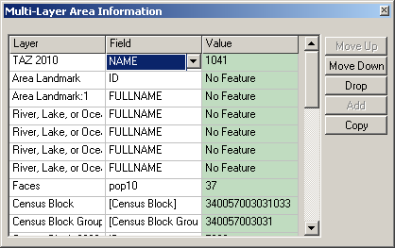

**The Measure Distance Tool icon, located in the Tools toolbox. Measure Distance Tool** Measure the distance of an area within the map. Hover the cross hairs over an area and left click to begin a measurement. Double click to end a measurement. Determine the distance and convert to desired units.

The Measure Size tool, located in the Tools toolbox. **Measure Size** Click on and draw a polygon. Double-click to end measurement and receive the size and perimeter length of area.

# *Working with Map Layers*

The TAZ MTPS will allow users to view and distinguish between the boundaries and names of the following entities:

* County

* County subdivision (Minor Civil Division and Census County Division)

* Incorporated Place

* Census Designated Place

* American Indian reservations and off reservation trust lands

* American Indian tribal subdivisions

* Alaska Native Regional Corporations

* Hawaiian home lands
* Alaska Native Regional Corporations
* Congressional Districts
* State Legislative Districts upper
* State Legislative Districts lower chamber
* TAZ boundaries (Census 2000)
* School Districts (Elementary, Secondary and Unified)
* D class area landmarks (Military institutions and state and national parks)

Additionally, the following linear features will be available:

* Roads
* Hydrography
* Railroads

Open the layers dialog box by going to “Map: Layers” or selecting the “Map Layers” icon layers in the “Standard” toolbar.

Use the Layers dialog box to view and edit the map layers and settings:

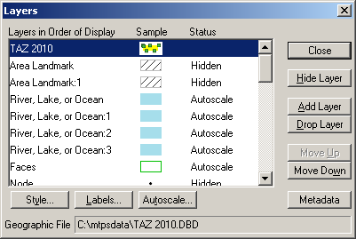

Note: The content within the layers dialog box above is an example of the layers that may be present in the layers dialog box.

To do this… Do this…

**Open the Layers dialog box** Go to **Map: Layers** or click the **Map Layers** icon layers on the “Standard toolbox”, or click the right mouse button on the map window and choose **Layers** to open the Layers dialog box.

**Choose a layer** Highlight the layer in the scroll list, which shows the layers in the order they will be drawn, from first to last, a sample of the style, and the status (Hidden means the layer will not be drawn, Autoscale means the layer will be drawn between certain scales, and blank means the layer will be drawn at all scales). You can also hold the Shift key and click on another layer to highlight a range of layers, or hold the Ctrl key and click on a layer to toggle the highlight on or off.

**Hide/Show a layer** Click **Hide Layer**. The button will change to **Show** so that you can reshow the layer.

**Add a layer** Click **Add Layer** to display the File Open dialog box. You can choose the type of file and one or more files to add. Click **Cancel** to close the dialog box without adding any layers. Note:If you add additional files to your TAZ MTPS project, you must notmove or delete those files on your PC until you “drop” them from the TAZ MTPS project. Failure to drop the files from the project before moving or deleting them will render the project unable to open.

**Drop a layer** Click **Drop Layer** to display a Confirm dialog box. Click **Cancel** to close the dialog box without dropping the layer. Note: **Only drop layers that you have imported from your own digital files. If you do not want to see a layer that is included in the TAZ MTPS, you should “Hide” the layer.**

**Change the order of the layers** Click **Move Up** or **Move Down** to move the highlighted layer up or down.

**Change the style settings for a layer** Click **Style** to display the **Style dialog** box, which is different for point, line, and area layers. Edit the style settings and click **Apply** if you want to make the changes to style settings. Click **Cancel** to close the dialog box without changing the settings.

**Change the label settings for a layer** Click **Labels** to display the Automatic Labels dialog box. Edit the label settings and click **Apply** if you want to make the changes to label settings. Click **Cancel** to close the dialog box without changing the settings.

**Change the autoscale settings for a** Click **Autoscale** to display the Autoscale dialog box. The

**layer** largest drop down menu, if not blank, shows the “largest” scale at which the layer is displayed, as you zoom in. The “smallest” drop down menu, if not blank, shows the smallest scale at which the layer is displayed, as you zoom out. Edit the autoscale settings and click **Apply** if you want to make changes to the autoscale settings. Click **Cancel** to close the dialog box without changing the settings.

**Close the Layers dialog box** Click **Close**.

# *Standard MTPS Tools*

Most of the TAZ/TAD delineation work can be completed using tools available in the TAZ toolbox and in the Tools toolbox. However, participants are also equipped with many other tools that are available in the Standard toolbox.

**Standard toolbox and Map layers**

The standard toolbox is docked by default below the menu bar and contains many of the functionalities within the menus.

**Standard Toolbox:**

Main

Toolbox

Manage Bookmarks

Map Layers

Add a Bookmark

Open

File

Working

Layer

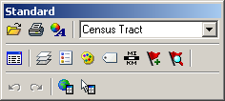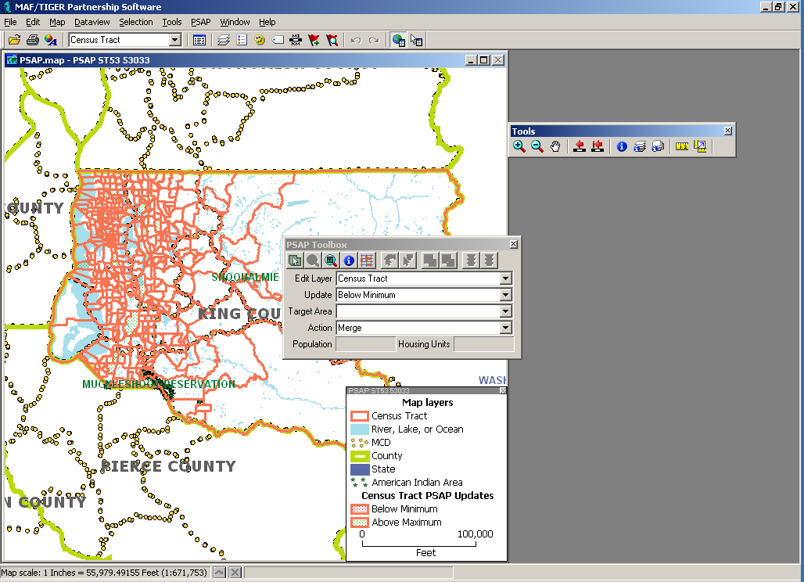

Automatic Labels

Set the Map Scale

Layer

Style

Show or Hide the Legend

Selection

Toolbox

Note: The layer displayed in the “Working Layer” is the featured layer that will be displayed in the dataview if the dataview is opened, in the attribute table if a feature is selected using the “Info” tool in the Tools toolbox, etc.

To do this… Do this…

**Open a file** Go to **File: Open** or click the **Open File** icon 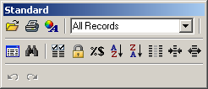 on the Standard toolbar.

**Print a map** Go to **File: Print** or click the **Print** icon  on the Standard toolbar.

**To view map properties** Go to **File: Properties** or click the **Properties** icon  on the standard toolbar.

**To change the working layer** Select the **Working Layer** drop down menu 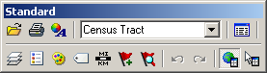and navigate to and select the name of the layer that you would like to select as the working layer.

**To open the dataview for the working** Click the **New Dataview** icon  to open the dataview

**layer** (or data table) for the layer displayed in the **Working Layer** drop down menu.

**To edit the map layers** Go to **Map: Layers**, click the **Map Layers** icon The Map Layers icon on the Standard toolbar. on the Standard toolbox, or click the right mouse button on the map window and choose **Layers** to display the Layers dialog box. **To show or hide the legend** Click the **To Show or Hide Legend** icon  to show the legend (if hidden) or hide the legend (if displayed).

**To edit the layer style** Click the **Layer Style** icon  to edit the style of the layer displayed in the **Working Layer** drop down menu.

**To display or edit labels** Click the **Automatic Labels** icon  to display or edit labels for the layer displayed in the **Working Layer** drop down menu.

**To edit the map scale** Click the **Map Scale** icon  to edit the map scaling method.

**To add a bookmark** Click on the **Add a Bookmark** icon  to save a map extent.

**To manage bookmarks** Click on the **Manage Bookmarks** icon  to edit or apply a bookmark.

**To show/hide the tools toolbox** Click on the **Main Toolbox** icon  to display the Tools toolbox (if hidden) or hide the Tools toolbox (if displayed)

**To show/hide the selection toolbox** Click on the **Selection Toolbox** icon  to display the Selection toolbox (if hidden) or hide the Selection toolbox (if displayed) for the layer displayed in the “Working Layer” drop down menu. Note: The selection toolbox contains specific selection and selection review tools.

# *Standard Dataview Toolbox*

When a Dataview is open the Standard toolbox with dataview-specific tools is available.

Working Layer

Properties

Print



Increase Width

Open File

New Dataview

Dataview Fields

Lock Columns

Column Settings

Sort Increasing

Sort Decreasing

Hide Columns

Reduce Width

Find

To do this… Do this…

**Open a file** Go to **File: Open** or click the **Open File** icon  on the Standard toolbar.

**Print a map** Go to **File: Print** or click the **Print** icon  on the Standard toolbar.

**View map properties** Go to **File: Properties** or click the **Properties** icon  on the Standard toolbar.

**View all or a selection set of the** Select **All Records** or a specific selection set in the

**dataview records** **Records to Display** drop down menu.

**Open the dataview for a different layer** Click the **Open Dataview** icon  and select the layer with the dataview you would like to display

**Find a specific record in the dataview** Click the **Find** icon  to search for a specific record in the open dataview.

**Change the display of the dataview** Select **Dataview: Fields** or click the **Dataview Fields** icon

**fields**  to display the **Dataview Fields** dialog box, which allows you to edit the fields and the displayed order of the fields in the dataview.

**Lock a field in the dataview** Select a cell or column heading of the field(s) you want to lock, and select **Dataview: Lock Columns** or click **Lock Columns** icon .

**Change column settings in the dataview** Go to **Dataview: Column Settings** or click the **Column Settings** icon  to edit the column formats and settings.

**To sort the fields in the dataview** Select a cell or column heading of the field(s) you want to sort and click on the **Sort Increasing** icon  or **Sort Decreasing** icon .

**Hide columns in the dataview** Select a cell or column heading of the field(s) you want to hide and click on the **Hide Columns** icon .

**Change the column width in the** Select a cell or column heading of the field(s) you want to

**dataview** increase or decrease the column width size, and click the **Reduce Width** icon  or the **Increase Width** icon .

# *Imagery Tools*

It is possible to bring imagery and topographic maps into the TAZ MTPS from the TerraServer USA Imagery internet service. These images can function as layers in your maps in almost the same way as any other type of layer. There are two technical prerequisites to using this tool; there must be an active broadband internet connection, and the Microsoft .NET framework must be installed. The Microsoft .NET framework can be downloaded from Microsoft at: <http://www.microsoft.com/downloads/details.aspx?FamilyID=0856eacb-4362-4b0d-8edd-aab15c5e04f5&displaylang=en> . Moreover, if your system operates behind a firewall, please ensure that you are outside the firewall before using this feature.

Follow these steps use a Terra-Server-USA map image:

1. 1. Zoom to the area for which you want the map image
2. 2. Select “Tools: Imagery: TerraServer-USA toolbox” to open the TerraServer-USA toolbox.

Drop

Image

Save

Image

Image

Information

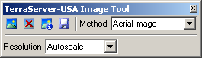

Get image

1. 3. Choose one of the following options from the “Methods”drop down menu:

* Aerial image– nationwide black and white digital orthophoto quadrangles (DOQs)
* Topographic map– nationwide digitally scanned images of USGS topographic maps, also called digital raster graphics (DRGs)
* Urban color maps– color DOQs for the 133 most populated metropolitan areas of the United States. Refer to the USGS Fact Sheet at: gisdata.usgs.net/IADD/factsheets/fact.html.

1. 4. Choose the image resolution from the “Resolution”drop down menu. If you choose Autoscale, the TAZ MTPS will choose an appropriate resolution.
2. 5. Click on the “Get image” icon  to get the image. The TAZ MTPS requests, receives, and displays the image in the map window.
3. 6. Click on the “Save image” icon  to display the Save Image As dialog box. Choose a folder, choose a file type, type a name, and click Save to save the image in JPEG format.

Click on the “Drop image” icon  to drop the image layer from the map. The metadata for the image can be displayed by clicking on the “Image information” icon . Click “OK”when you’re done reading the metadata.

When finished, click on the close button in the top right-hand corner of the toolbox to close the toolbox.

**Participants may also use other outside imagery as a layer:**

Acceptable imagery files that may be brought into the TAZ MTPS as layers are:

Geographic Files (.cdf, .dbd), ESRI Shapefiles (.shp), ESRI Geodatabase File (.mdb), MapInfo TAB File (.tab), ODBC Table, Oracle Spatial Layer, Image Library (.cil), TIFF Image (.tif), JPEG Image (jpg), MrSID Image (.sid), JPEG 200 Image (jp2), ECW Image (.ecw), SPOT Image (.bil, .tif), Digital Orthophoto (DOQ/DOQQ)

1. Click on the map layers icon to open up the Layers window.



1. Click “Add Layer” from within the Layers window.
2. Locate and open an image layer to be used as a reference layer. Drop down to the file type of your imagery layer if it is not already available in the file box.
3. Click on the “Autoscale” tab near the bottom of the Layer window and adjust accordingly.

# Appendix B. Creating Multiple Work Areas

The Census Bureau realizes that some participants are responsible for multiple counties that cover an extensive area or densely populated areas, and that it is difficult for a single participant to complete a project within the allotted time. Below are steps that can be used to break the workload into multiple work units.

Workload can be divided up by giving whole counties to multiple staff technicians, or individual counties may be broken down and assigned as smaller working units to multiple staff technicians.

For TAZ MTPS installation, all staff technicians should always use the same password and user information that was sent to the main participant representative.

1. The primary participant will be responsible for dividing territory and assigning smaller geographic areas to staff technicians. The smaller geographic areas for which staff technicians are responsible for should be clearly-defined, especially if the primary participant will be splitting a single county amongst multiple staff technicians. Never assign the same area to more than one staff technician and always make sure that technicians do not delineate outside of their assigned area.
2. If the workload is divided by giving whole counties to multiple staff technicians, the setup file must be edited to reflect the county/counties assigned to the individual staff technician. **For instructions on creating set-up files for multiple whole-county based projects for your area, see Appendix C.**
3. If the workload is divided by assigning multiple work areas within single a county, the staff technicians will use the same set-up files, and the workload will be administratively divided so that each staff technician delineates TAZs/TADs in their assigned area of the county only, and no TAZs/TADs are defined outside of that area. In some situations, areas may need to be removed from a TAZ/TAD delineation (e.g., if one mistakenly delineates outside their assigned area, or if one chooses the 2010 tract or 2010 block group startup options). See 2a and 2b for instructions on how to remove (unassign) area from a TAZ/TAD delineation
4. Each technician will complete their assigned delineations, run all verification checks and report changes. Note: When you split a single county among multiple staff members, the unassigned verification will always fail, because each staff member has intentionally only delineated TAZs/TADs in their assigned geographic area, leaving the areas assigned to other staff technicians unassigned.

If areas need to be removed (unassigned) from the TAZ/TAD delineation, do the following:

* 1. If the “unassigned” target area exists: Area may be removed from the TAZ/TAD delineation by adding area to the existing unassigned area within the county by selecting “unassigned area” as the target area, and adding blocks, block groups, and/or tracts to that unassigned area. This situation should occur when the staff technician chooses the empty TAZ layer or empty TAD layer startup option (and possibly the 2000 TAZ and BEF startup options), and has not delineated TAZs/TADs to cover the entire county (TAZs) or coverage (TADs).
  2. If the “unassigned” target area does not exist: Area may be removed from the TAZ/TAD delineation by creating a TAZ/TAD that covers the area outside their assigned area, and providing a *null* code for the TAZ/TAD (i.e., entering no value in the TAZ 2010 Attribute window “Code” box or TAD 2010 Attribute window “Code” box). This area is now considered “unassigned area”, and the unassigned area can be added to as necessary (as described in “a” above). This situation should occur if the staff technician starts with 2010 tracts or 2010 block groups (and possibly the BEF startup options), or the staff technician has delineated TAZs/TADs to cover the entire county (TAZs) or coverage (TADs).

1. Once all technicians have completed their assigned work areas, the output BEF files that were created during Report Changes should be collected and be provided to a final reviewer.
2. A single final reviewer (most likely a manager or senior staff member) should create a new project using the original unedited setup file. Note: the original setup file with all counties within the delineation coverage should be present in the final reviewer’s project. Within the startup settings window of the new project, they will opt to “Import Multiple Block Equivalency Files” under the TAZ start up options and select “Multiple Block Equivalency Files” under the TAD start up options. The final reviewer will then import all collected TAZ BEFs to build TAZs and import all TAD BEFs to build TADs.
3. The final reviewer will run the Verification checks on TAZs, then TADs. All “Required” and “Review” checks should be run to verify that State DOT/MPO approves of all delineations. During the final review stage, the “Complete Coverage” check becomes mandatory. While each individual staff member’s project will have unassigned area, the final reviewer must ensure that no unassigned areas remain in the combined final project before reporting changes. Final submissions must not have unassigned areas.
4. After fixing all required verification check failures (and re-running the verification to ensure that the fixes did not create new issues), the final reviewer will “Report Changes”.
5. Finally, the State DOT/MPO representative will send the Census Bureau a zip file that contains the output files resulting from the final project.

**Optional project layout:**

TAZ Program Primary Participant downloads Census layers

TAZ Program Primary Participant distributes TAZ MTPS and provides county data, assignment areas and optional edited setup files to staff

TAZ Program Primary Participant determines workload, TAZ/TAD code scheme and assignment areas

Staff Technicians create a project with TAZ MTPS

Staff Technicians delineate TAZs and/or TADs in assigned areas

Staff Technicians “Verify” and “Report Changes”

Final Reviewer collects all delineation BEF files from staff

Final Reviewer creates final project with Multiple BEF option and imports all collected BEFs

Final Reviewer submits final delineations to Census Bureau’s FTP site

Final Reviewer reviews delineations,

“Verifies” and “Reports Changes” (All areas within the coverage must be assigned)

# Appendix C. Creating Set-up Files for Multiple Whole County-Based Delineations

In cases where participants wish to administratively break up delineation coverages and assign work units by whole counties[4] to staff technicians, one will edit each staff member’s setup file located in the MTPSData folder to list only specific counties (The county coverage section within the SetupFile tells the TAZ MTPS what codes to look for when building a project):

1. In the MTPSData folder within your C: drive, locate and double click to open the setup file: SetupFile_TAZ_<Enityt ID>.xml
2. Open the File menu located at the top of your internet toolbar and select “Edit with XML Editor”
3. Manually remove county codes from the Core County Coverage section so that the setup file only contains the county codes of the assignment area:

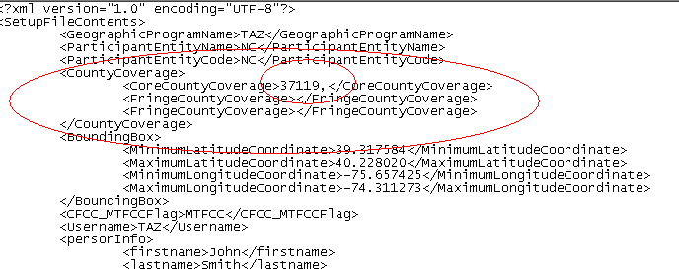

1. Save the edited SetupFile (Use the “Save As” option; do not change the original Setup file), changing the name of the file to include the technician’s initials (do not remove “SetupFile” from the name). Save it within the MTPSData folder and move the original file to another designated folder.

Example: Setupfile_TAZ_SC.xml

A final reviewer’s SetupFile should not be edited; it should cover all counties covered by a State DOT/MPO.

From this point on, follow the steps in Appendix B (these steps are the same regardless of whether you have divided up your work by Whole County or by sub-county areas).

# Appendix D. Creating Block Equivalency Files

Participants have the option of delineating TAZs and TADs that are based on their own files. These files are known as Block Equivalency Files (BEFs). If used, BEFs will be loaded into the TAZ MTPS using the Import functionalities discussed in the main document.

**Example of one possible BEF creation methodology**

There are many ways a BEF can be created for import into the TAZ MTPS. The following is an example of one methodology that could be used to create a TAZ BEF using ESRI ArcGIS software[5]. BEF files can be created using other types of GIS software packages.

1. To download 2010 census block shapefiles for the county(s) in which you will be delineating TAZs/TADs, navigate to the following website: <http://www.census.gov/cgi-bin/geo/shapefiles2010/main>
2. This will take you to the 2010 TIGER/Line [6] Shapefiles web page. Under “Select a layer type”, select **“Blocks”**, click Submit.

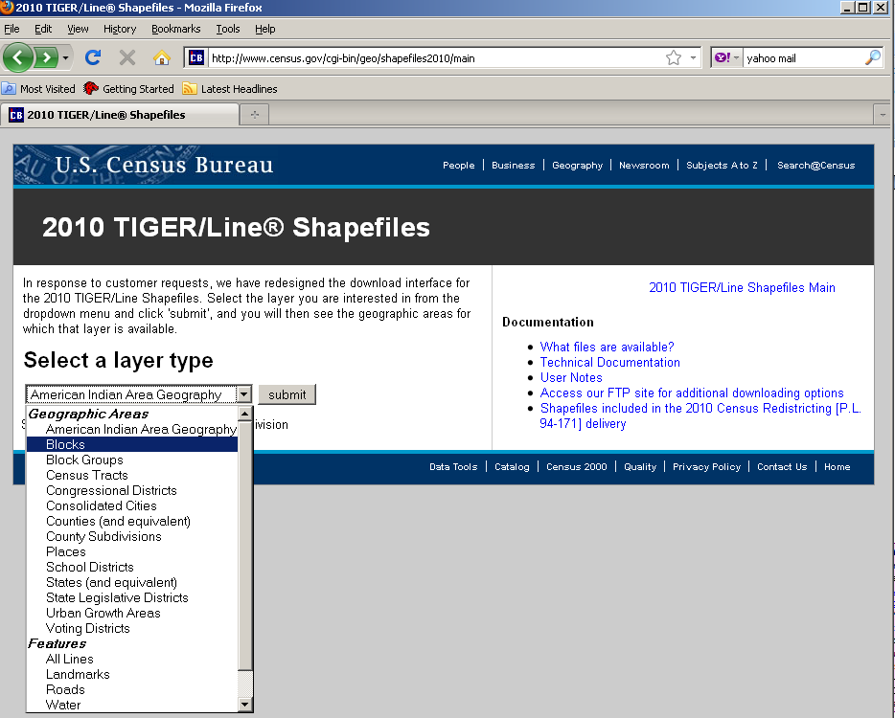

1. On the following screen under **Block (2010)** Select the state from which you would like to download data, click submit.

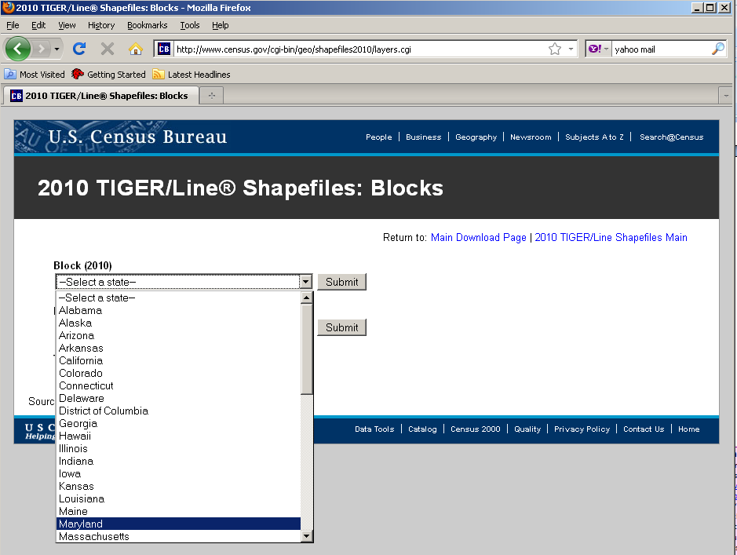

1. On the following screen, select which counties you would like to download, and click download. You can download all counties in one state-based file, if desired. Note: There are many blocks within a state, ranging from 6,507 to 914,231.

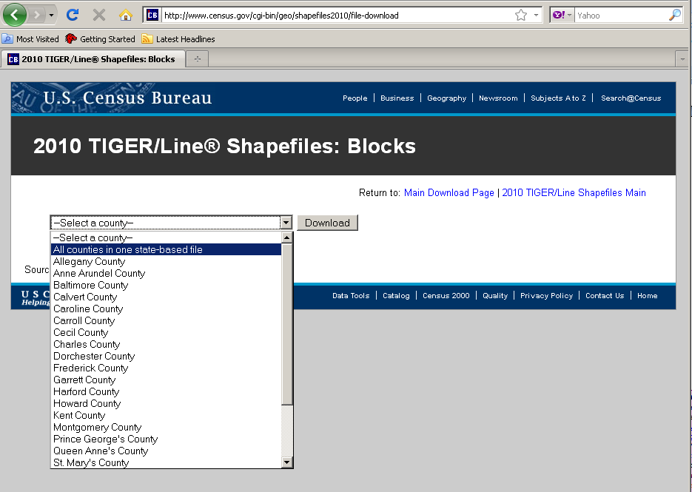

1. Save the Zip file on your local drive in a designated folder on your C: drive. Name this folder “TAZ_Layers.”

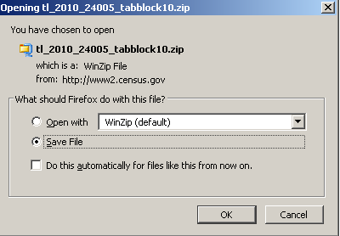

1. Once you have downloaded all selected shapefiles, unzip the files the in the “TAZ layers” folder. The file name for the county-based shapefiles will be **tl_2010_SSCCC_tabblock10** where SS is the 2-digit state FIPS code, and CCC is the 3-digit county FIPS code, e.g., 24031 for Montgomery County, MD.
2. Import **tl_2010_SSCCC_tabblock10** shapefiles into your GIS software. Again, for this example we are using ArcGIS 9.2.

Optional: If you choose to use an existing geography to inform your TAZ/TAD delineation (e.g., if you have a file containing recent traffic analysis zones for your area), import that file into the project as well. We recommend that you make this “selection layer” hollow with a thick outline to distinguish between the tabblock layers.

1. In the **tl_2010_SSCCC_tabblock10** attribute table (.dbf) add a field named TAZCE10. TAZCE10 must be set as an 8-character text field. (This field will be needed so the TAZ MTPS can correctly read your created BEF file.)

1. Select the tab blocks within the desired area using select tool  (or select by location based on your “selection layer”).

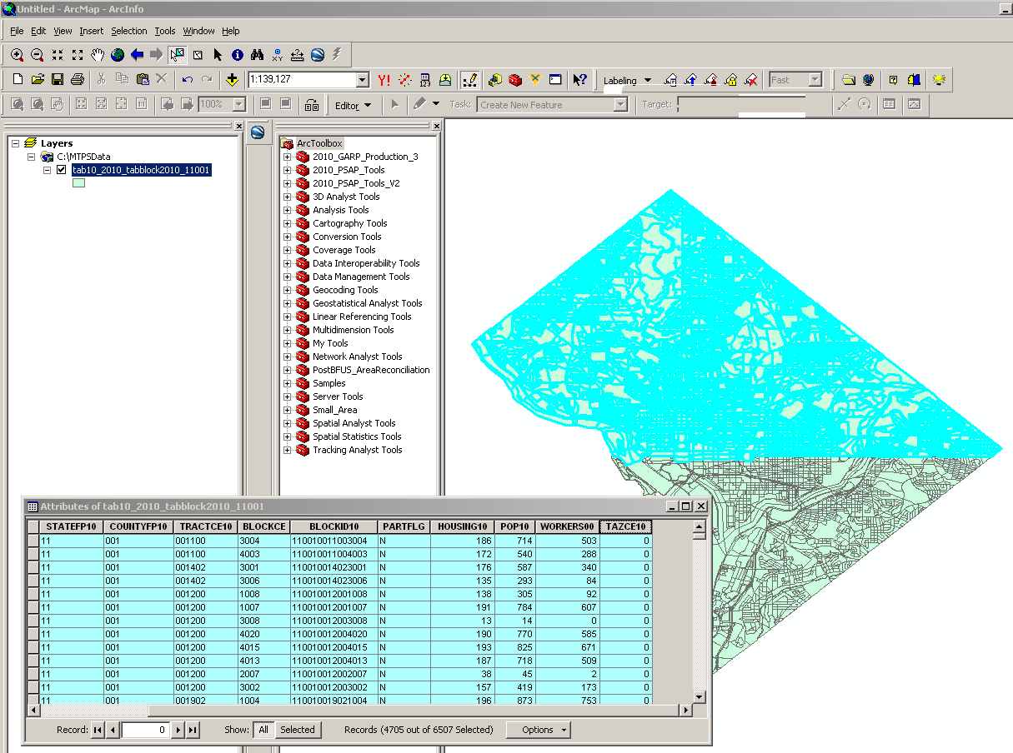

1. Open the **tl_2010_SSCCC_tabblock10** attribute table. Right click on the TAZCE10 field and open Field Calculator. Assign the TAZCE10 the 8 character TAZ code for the selected area.

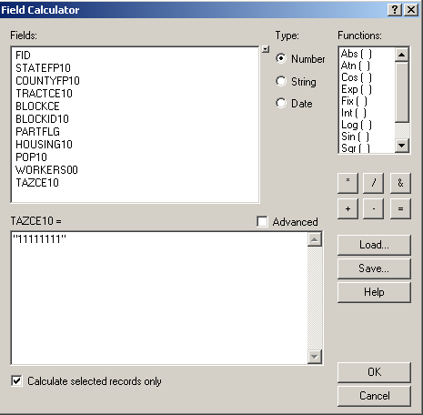

1. Repeat this for each unique TAZ you want to create assigning a unique 8 character code until all records no longer have a TAZCE10 value of “null”.

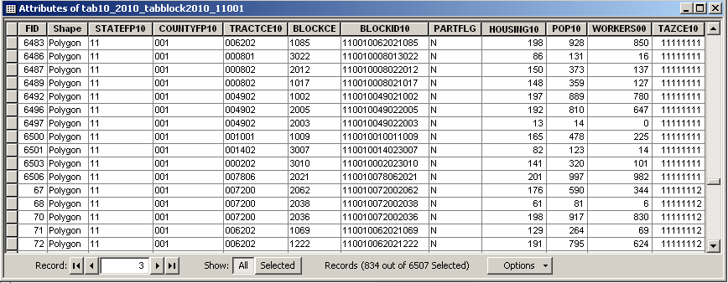

1. Once you have all you TAZCE10 codes assigned, merge all the **tl_2010_SSCCC_tabblock10 files** together into one shapefile (within Arc Toolbox: Data Management Tools: General).
2. Delete all fields within the merged shapefile ***EXCEPT*** for **BLOCKID10, TAZCE10, TADCE (if created), FID,** and **Shape** (FID and Shape can not be deleted). The BLOCKID10 and TAZCE10 fields are crucial for importing the BEF into the TAZ MTPS otherwise they will not load.
3. Export layer as a comma-delimited, text, or dbase (.csv, .txt, or .dbf) file, renaming it as BEF_TAZ[7] (.csv, .txt, or .dbf). (Alternately, you can just use the .dbf from your shapefile as your BEF. **If participants will be appending TAZ and TAD fields to a DBF, remove the Population and Worker fields from the DBF**).

**NOTE:** To create a TAD BEF, a similar methodology would be employed, however, one would need to assure that the TADs were created based on complete TAZs, i.e., all TAZs will nest within TADS (e.g., the TAZ file could be used as the “select by location” features in creating TADs).

**Do not modify a BEF in CSV format in Microsoft Excel. Doing so may change the formatting of the file and it will not be accepted by the TAZ MTPS. If records within a BEF need to be modified after creating them, we recommend using Microsoft Access, WordPad, or Notepad.**

If a BEF will not import into the TAZ MTPS, check for the following scenarios:

* Duplicate block IDs within BEF
* BEF is not of the correct file type or the name is not formatted correctly
* BEF is not in the MTPSData folder
* Multiple BEFs in DBF format
* Modified CSV in Excel

# Appendix E. Block Resolution Guidelines

Though it is uncommon, while performing updates in the TAZ MTPS you may encounter the following error message:

Text that will be within a TAZ MTPS block error message: " The MTPS has encountered a problem with one or more blocks in the project and cannot continue processing any additional updates.  The work you have completed so far will be saved.  However, due to the nature of the problem, Census Bureau staff must correct the issue before the MTPS can accept additional updates.  Follow the instructions in the MTPS Block Resolution Procedure, with is within the TAZ MTPS Participant Guidelines."

If you encounter the aforementioned message, it is imperative that you 1) stop all updates immediately and 2) read and follow information below, so the Census Bureau can resolve this issue as quickly as possible.

**MTPS Error Message**

The error message above is triggered by the MTPS when a participant selects a small block to use as a TAZ boundary where the block boundary contains points within a millionth of a degree of each other. These tiny blocks represent a spatial anomaly in our database that can cause problems in the MTPS only when a participant uses one as a TAZ boundary. Many of these blocks are not visible to the naked eye, so you may not even know you have selected one until it's too late. When you receive this error message, it is important to discontinue updates in this county and send the problem files to the Census Bureau for repair.

**Resolution**

Because the MTPS does not contain tools to fix this issue and the fact many of these tiny blocks are difficult to resolve, the Census Bureau is requesting that you send the damaged files to Census Bureau staff via File Transfer Protocol (FTP), so we can quickly correct the problem. We will return corrected spatial files back to the TAZ program participant via FTP within a couple of days of receiving the files (Note: If the participant cannot obtain data via FTP site, this data can be sent to TAZ program participant on a CD).

**FTP Instructions**

The following are instructions for sending the problem MTPS Caliper-based files to the Census Bureau for repair:

1. Locate the MTPSData folder on your C: drive (C:\MTPSData).
2. Select the MTPSData folder, and using any ZIP software, compress the data into a ZIP file called:

<EntityID>.zip

Where ‘EntityID’ is <EntityID> in the SetupFile file name SetupFile_TAZ_<EntityID>.xml. The Setup File is located within your MTPSData folder.

1. Upload the <EntityID>.zip file using the Census Bureau’s Send a File Utility at:

<http://www2.census.gov/cgi-bin/sendfile>

1. Copy and paste the above URL into the browser address bar or use these following steps to access the utility:

* Type [www.census.gov](http://www.census.gov) in your browser address bar;
* Click on **Data Tools** in the dark blue column on the left-hand side of the screen;
* Scroll down to the bottom of the **Data Access Tools** page;

1. Click on the Public file send utility link.
2. In the **Source Information (Local)** section, click on the **Browse** button to navigate to the completed file that is to be submitted.
3. Select the file from the **Choose file** window by clicking on it. Click **Open**. The **File to Send** field now contains the file name. **Note:** Only one file can be sent at a time.
4. In the **Target Information (Remote)** section, enter /**geo/2010_PSAP_TSAP** in the Directory to Receive File
5. No entry should be made in the **New File Name** field.
6. Under **Notify by E-mail**, type your e-mail address in the Sender’s Email Address field. In the Census Bureau Employee’s E-Mail Address field, enter **geo.taz.list@census.gov**.
7. We are asking you to please send a **second** e-mail to **geo.taz.list@census.gov** using your regular e-mail account, to notify us when you have submitted files.
8. The last thing you need to do is type in the Verification Code that you see (or hear) in the field below the code.
9. After filling in all the fields correctly, click on the **Upload** button. If you find an error, click the **Clear** button and start the process again from the beginning.

**Important Note!!** If you must resubmit a file for any reason, you **must rename the file**. If not, the utility will produce an error message. Please retain the default naming convention of **<EntityID>.zip** when you rename it.

Here are examples for re-naming a file:

<EntityID>_revised.zip

<EntityID>_revised2.zip

**Census Bureau Return Files**

Once the Census Bureau repairs your file(s), we will FTP the repaired MTPSData folder to you.

If you cannot receive data via FTP, the data will be burned on a data CD. The CD will be shipped via FedEx to the TAZ program participant. On the CD you will find following named folder~~s~~:

MTPSData_<EntityID>

Follow the instructions below for updating the repaired data back onto your C: drive: Locate your current C:\MTPSData folder, and rename it C:\MTPSData_old. Download the updated MTPSData_<EntityID> folder from the FTP site (or , if provided via CD, place CD in your computer’s CD drive); it will not be zipped,

1. Copy the new MTPSData_<EntityID> folder into your C: drive. You should see the following on your C: drive:

…

C:\MTPSData_<EntityID>

C:\MTPSData_old

…

1. Rename C:\MTPSData_<EntityID> to C:\MTPSData (you are just removing the <EntityID> code from the name of the folder, so the MTPS will recognize it.)
2. Open the TAZ MTPS and resume your TAZ updates. The TAZ software will pick-up where you last encountered the error message; no work will be lost.

**Contact Information**

If you have any questions regarding this particular issue or you are unsure how to proceed, please contact one of the following Census Bureau employees:

Patrick Jurgens

Phone: (301) 763-1692

Email: Patrick.A.Jurgens@census.gov

Ryan Short

Phone: (301) 763-9047

Email: Ryan.L.Short@census.gov

Brian Brlansky

Phone: (301) 763-8992

Email: [Brian.L.Brlansky@census.gov](mailto:Brian.L.Brlansky@census.gov)

Shonin Anacker

Phone: (301) 763-9052

Email: Shonin.Anacker@census.gov

The Census Bureau apologizes for any inconvenience that this issue has caused, and we will work quickly to resolve it. Thank You.

# Appendix F. Disclosure to Respondents

The Geography Division manages programs to continuously update features, boundaries, addresses, and geographic entities in the Master Address File/Topologically Integrated Geographic Encoding and Referencing System (MAF/TIGER) database that is used to support programs and to conduct the census and surveys. The Traffic Analysis Zone Program (TAZ) Program was developed to give participating Metropolitan Planning Organizations (MPOs) and State Departments of Transportation (DOTs) an opportunity to delineate TAZs and Traffic Analysis Districts (TADs); these districts will be used to report data in the 2006-2010 Census Transportation Planning Products.

Public reporting burden for this collection of information is estimated to average 160 hours per respondent, including time for reviewing instructions, assembling materials, organizing and reviewing the information, and reporting all delineations. We anticipate that an estimated 350 MPOs and State DOTs will make and report delineations. Please send comments regarding this burden estimate or any other aspect of this collection of information, including suggestions for reducing this burden to:

Paperwork Project

0607-0795

U.S. Census Bureau

4600 Silver Hill Road

Room 3K138

Washington, D.C. 20233

You may e-mail comments to [Paperwork@census.gov](mailto:Paperwork@census.gov). Use “Paperwork Project 0607-0795 as the subject.

Responses to this survey are voluntary. The authority for conducting these activities is covered under the legal authority of Title 13 U.S.C. Sections 141 and 193.

No agency may conduct and no person may be required to respond to a collection of information unless it displays a valid Office of Management and Budget (OMB) approval number. The OMB approval number for this information collection is 0607-0795 and this approval is valid until April 30, 2012.

1. For additional information about the CTPP, follow this link:

   [AASHTO - CTPP - Home](http://ctpp.transportation.org/Pages/default.aspx)
2. Census 2000 block-level worker estimates were interpolated to 2010 block boundaries. Participants may use their own, more current or relevant data to assist delineations.
3. Delineation coverage/counties can be worked on by more than one person. In these cases, all areas within a delineation coverage/county will not have to be delineated in one project, but final TAZ and TAD files (files that incorporate all independent delineations) should have complete county coverage.
4. If you do not know the FIPS county codes of the counties you have agreed to cover, find them here: <http://www.census.gov/geo/www/ansi/countylookup.html>
5. 4ArcGIS™ is a Trademark of Environmental Systems Research Institute, Inc. (ESRI). Note: The location of menus and tools is highly customizable in ArcGIS. Therefore, the way the screen looks in the graphics may not be the same as your settings.
6. 5 TIGER/Line® is a Registered Trademark of the US Census Bureau.
7. We recommend that you create only one BEF_TAZ for initial import into the TAZ MTPS. If you create more than one BEF file, then append the state and county FIPS code, or another identifier, to the file.