Update and Maintenance of Congressional and State Legislative District Boundaries Coincident to Other Geographic Entities

As we move forward throughout the decade, we will need to know how to manage any permanent relationships that your congressional districts (CDs) and state legislative districts (SLDs) have to other governmental unit boundaries, such as incorporated places and minor civil divisions (MCDs). If your CDs or SLDs currently share boundaries with incorporated places or MCDs, we request that you tell us if you would like the Census Bureau to maintain those relationships by moving the CD or SLD boundary when the place or MCD boundaries move, so that they will continue to share the boundary.

There are two main reasons why the Census Bureau moves MCD and incorporated place boundaries:

Drafting Correction: A boundary is moved slightly to a more spatially accurate location. The area does not contain housing units or population.
Legal Annexation: This is a legal boundary change. These often include housing units and population.

For your reference, graphic examples can be found at the end of this document.

Currently, if a CD or SLD boundary is following a Minor Civil Division (MCD) or incorporated place boundary, and the MCD or incorporated place boundary is 1) moved due to a drafting correction, and 2) it is not on a physical feature such as a road or river, the Census Bureau moves the CD or SLD boundary so it will continue to follow the MCD or place boundary. Please indicate in the tables below, how you would like the Census Bureau to handle these situations in the future.

Congressional Districts

- County Subdivisions and Congressional Districts (CD)

If the CD is following a county subdivision (MCD) boundary and the MCD boundary moves due to a:
Move CD boundary to new MCD boundary | Drafting Correction | Legal Annexation
Yes
No

- Incorporated Place and Congressional Districts (CD)

If the CD is following an incorporated place boundary and the place boundary moves due to a:
Move CD boundary to new place boundary | Drafting Correction | Legal Annexation
Yes
No

State Legislative Districts (Upper)

- County Subdivisions and State Legislative Districts Upper (SLDU)

If the SLDU is following a county subdivision (MCD) boundary and the MCD boundary moves due to a:
Move SLDU boundary to new MCD boundary | Drafting Correction | Legal Annexation
Yes
No

- Incorporated Places and State Legislative Districts Upper (SLDU)

If the SLDU is following an incorporated place boundary and the place boundary moves due to a:
Move SLDU boundary to new place boundary | Drafting Correction | Legal Annexation
Yes
No

State Legislative Districts (Lower)

- County Subdivisions and State Legislative Districts Lower (SLDL)

If the SLDL is following a county subdivision (MCD) boundary and the MCD boundary moves due to a:
Move SLDL boundary to new MCD boundary | Drafting Correction | Legal Annexation
Yes
No

- Incorporated Places and State Legislative Districts Lower (SLDL)

If the SLDL is following an incorporated place boundary and the place boundary moves due to a:
Move SLDL boundary to new place boundary | Drafting Correction | Legal Annexation
Yes
No

Legal Boundary Change Example
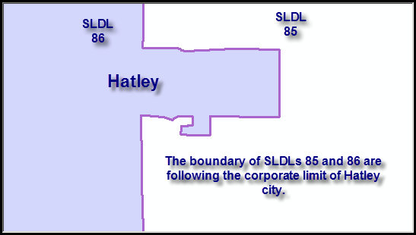

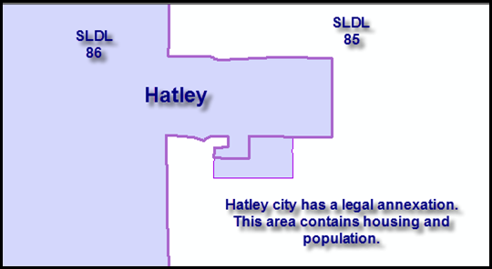

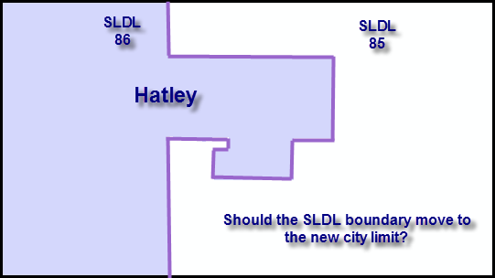
Boundary Correction Example
