“Fishing Around Sea Turtles”
Products and Services Survey

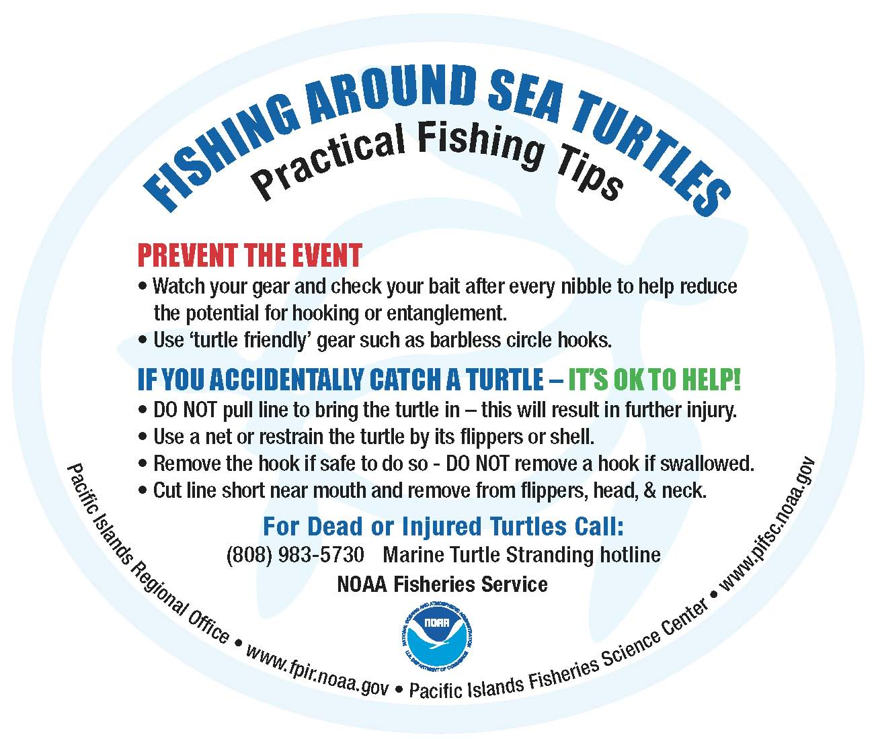

Your participation in this survey is voluntary and responses are anonymous and confidential. Any material that might identify you will be destroyed at the end of the study. Public reporting burden for this collection of information is estimated to average 10 minutes per response, including the time for reviewing instructions, searching existing data sources, gathering and maintaining the data needed, and completing and reviewing the collection of information. Notwithstanding any other provisions of the law, no person is required to respond to, nor shall any person be subjected to a penalty for failure to comply with, a collection of information subject to the requirements of the Paperwork Reduction Act, unless that collection of information displays a currently valid OMB Control Number.

This survey is being conducted to gather information about the “Fishing Around Sea Turtles” reflective sticker and webpage. The results of the survey will help NOAA Fisheries and its partners evaluate the success of the program and how they may improve on this outreach tool for the future. The survey also offers an opportunity for you to provide suggestions for other sea turtle and fishing outreach products and programs you would like to see developed. Thank you for your participation. Your feedback is valuable. When you have completed the survey, please return it in the addressed postage paid envelope provided. Mahalo!

- Did you receive Fishing Around Sea Turtle stickers? ____Yes ____No

If yes, about how many stickers have you given away over the last six months? (CHECK ONE)

___ 1-50 ___51-100 ___101-150 ___151-200 ___More than 200

- Prior to taking this survey, were you aware of the NOAA Fisheries Service Fishing Around Sea Turtle webpage?
____Yes ____No

- What are your suggestions for how NOAA Fisheries Service can improve the Fishing Around Sea Turtle sticker and / or webpage? (Please use the back of the sheet if necessary) ______________________________________________________________________________________________

- What other sea turtle-fisheries interactions awareness products/services would you like to see produced? ______________________________________________________________________________________________

- What media or format would you like to see these products / services offered in? (CHECK ALL THAT APPLY)

 | Paper/brochure |  | Television Public Service Announcement (PSA) |  | Signs
 | Online |  | Radio PSA |  | Other ________________
 | Community meetings |  | Trainings

- What other languages would you like to see the current sticker and any new products / services translated into? (CHECK ALL THAT APPLY)
 | Filipino |  | Korean |  | Chinese |  | Micronesian
 | Japanese |  | Vietnamese |  | Hawaiian |  | Other __________________

- Would you be interested in receiving and distributing more Fishing Around Sea Turtle stickers (supplies will be dependent on availability)? ____Yes ____No

If yes, please provide a mailing address where they can be sent (your name and address will remain confidential and will only be used for the purpose of sending you additional stickers):

Name or Organization: ___________________________________
Street Address: ________________________________
City, State ______________________________ Zip Code: _______________

- What is your occupation?

 | State government |  | University student |  | News media
 | University faculty/staff |  | Other research institution |  | Other __________________
 | NOAA |  | Other Federal government
 | Non-profit / NGO |  | Business/industry

- What organizations, events or businesses do you recommend NOAA Fisheries Service to partner with to distribute Fishing Around Sea Turtles products? ____________________________________________________________________________________
Please return this survey in the addressed postage paid envelope provided - Mahalo!

