List of Screens

Log In 3

Program and Contact Information 4

Personnel 5

Key Partners 6

Key Contractors 7

State Plan 9

Burden Report 11

Standard Data Sources 13

Other Data Sources 14

Policy and Environmental Assessment 15

Capacity Building Work Plan Activity 18

Capacity Building Work Plan Activity Progress 20

Capacity Building Work Plan Activity Product 21

Intervention Work Plan Long Term Objective 23

Intervention Work Plan Long Term Objective Progress 25

Intervention Work Plan Supporting Objective 26

Intervention Work Plan Supporting Objective Progress 29

Intervention Work Plan Supporting Objective Product 30

Intervention Work Plan Supporting Objective Activity 32

Intervention Work Plan Supporting Objective Activity Progress 34

# Log In

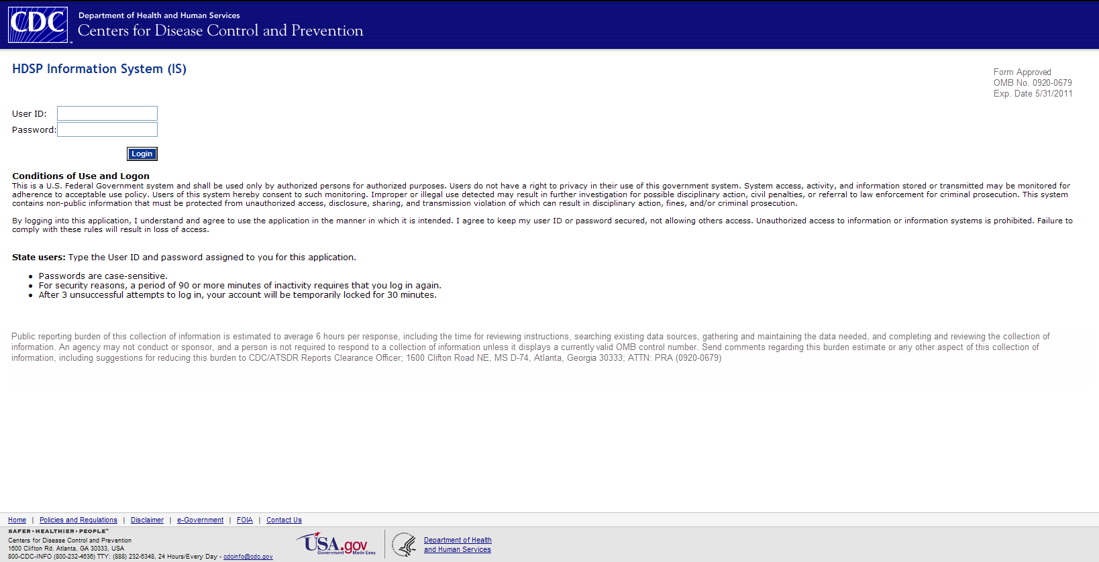

# Program and Contact Information

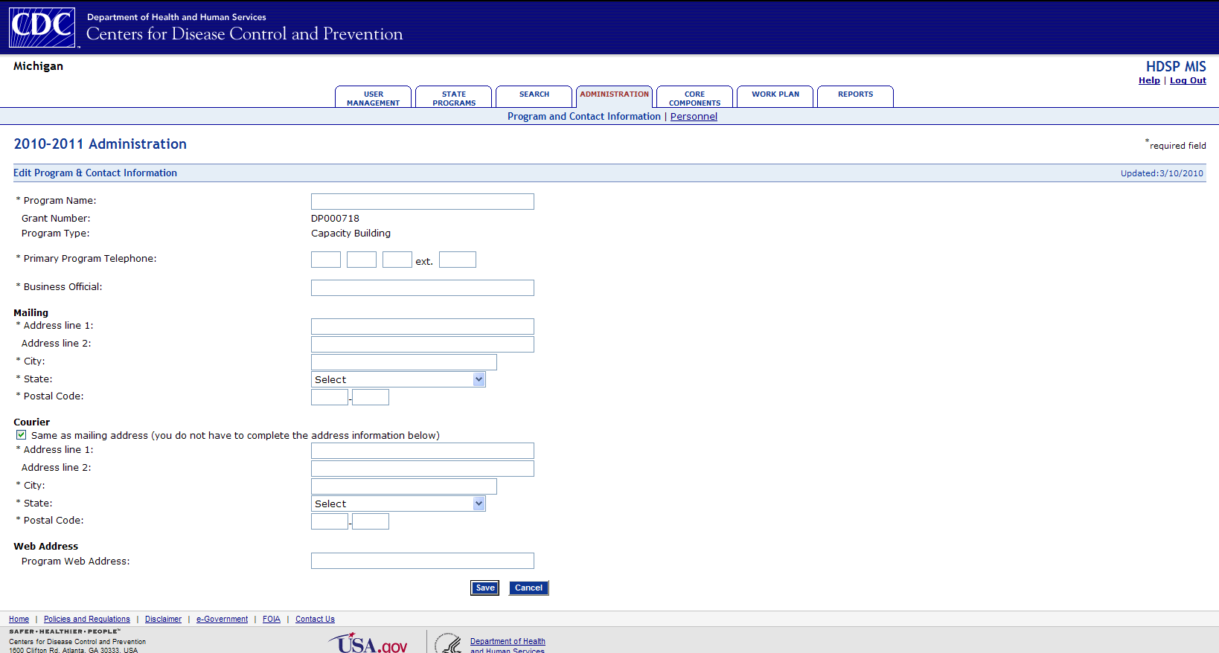

# Personnel

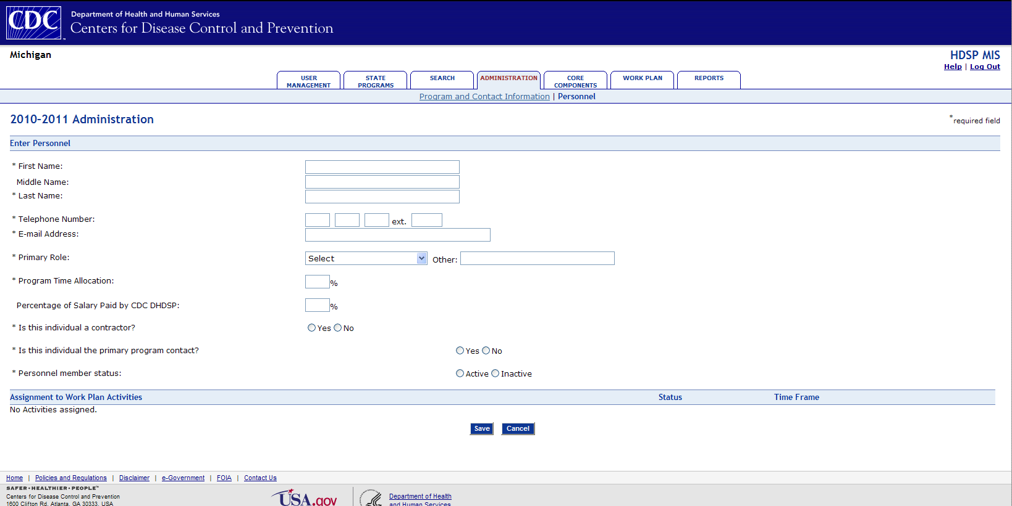

# Key Partners

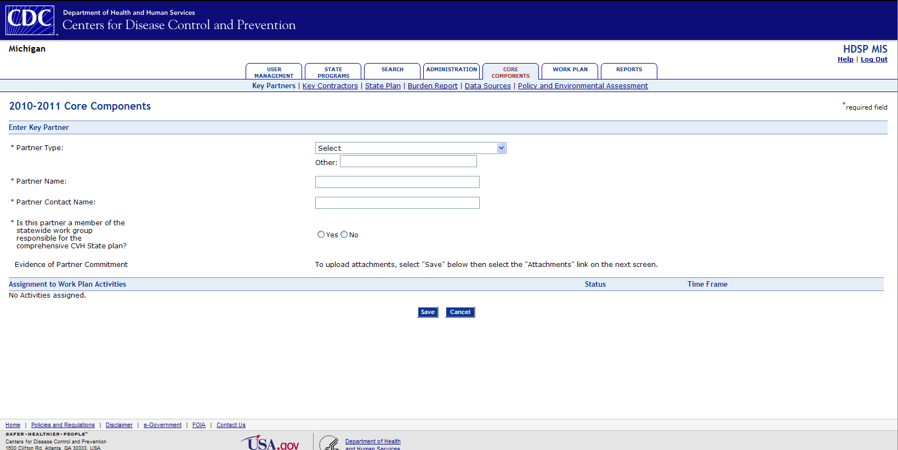

# Key Contractors

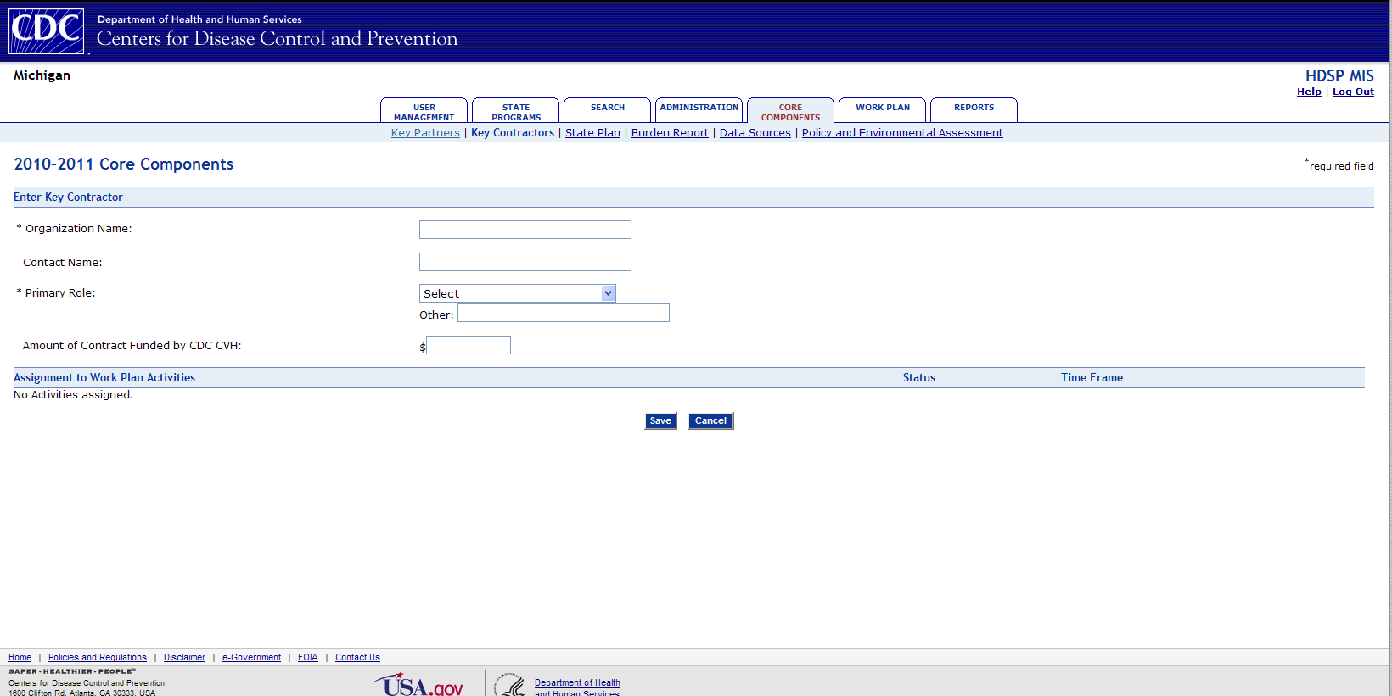

# State Plan

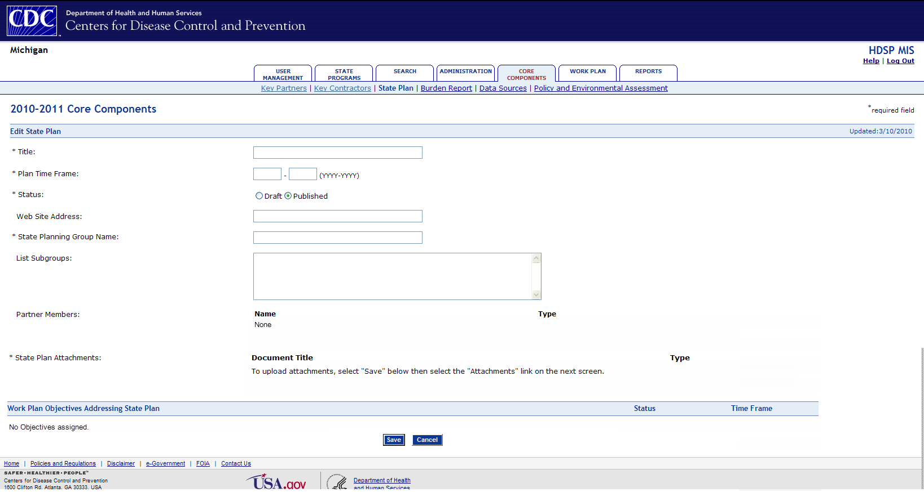

# Burden Report

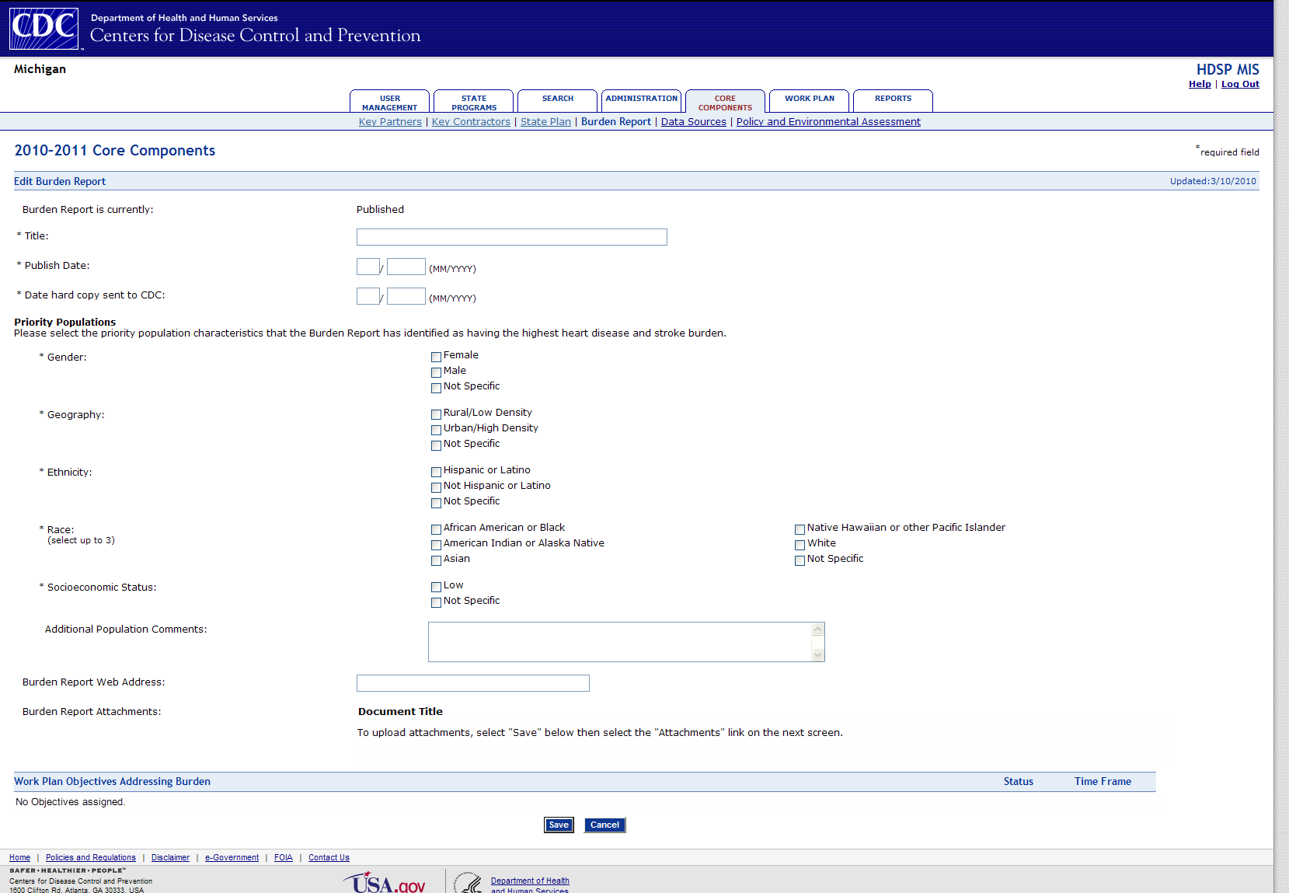

# Standard Data Sources

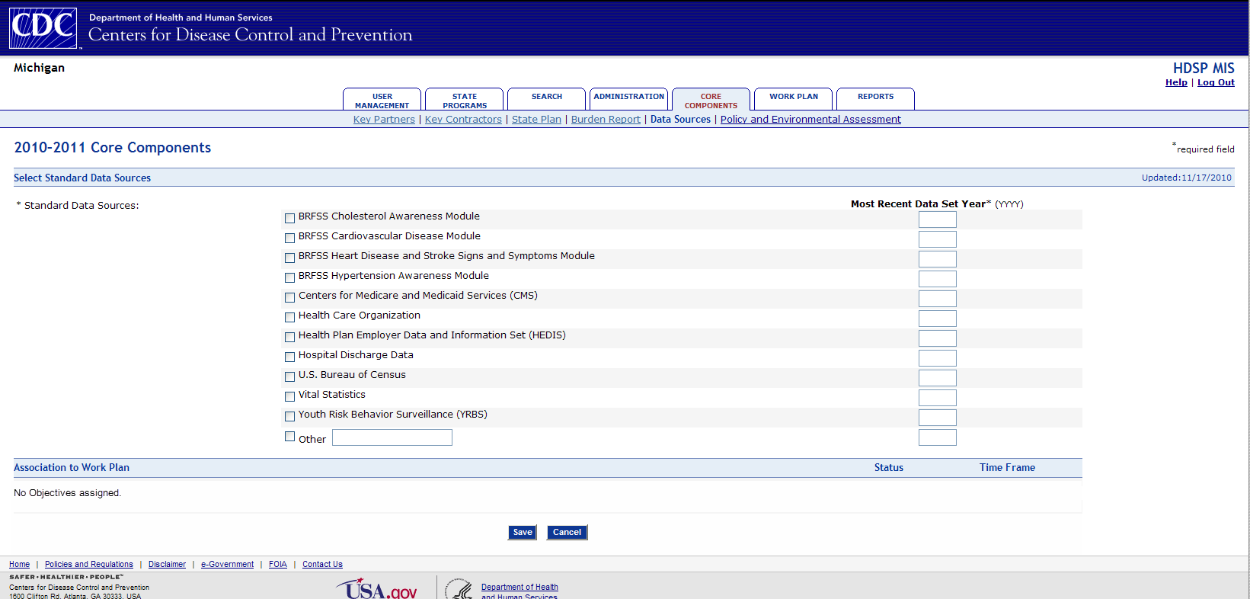

# Other Data Sources

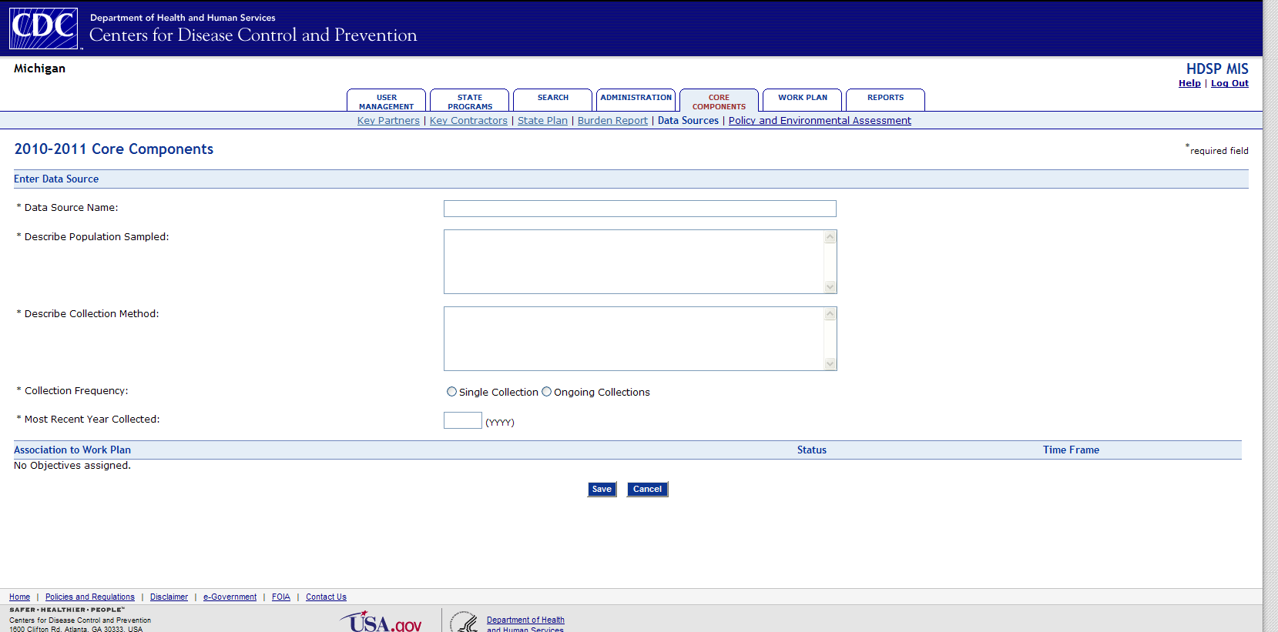

# Policy and Environmental Assessment

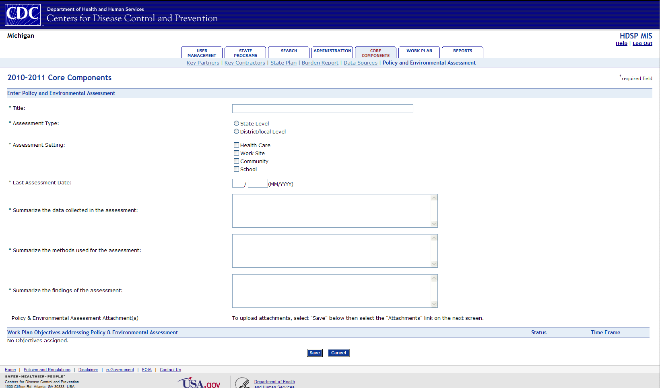

# Capacity Building Work Plan Activity

# 

# Capacity Building Work Plan Activity Progress

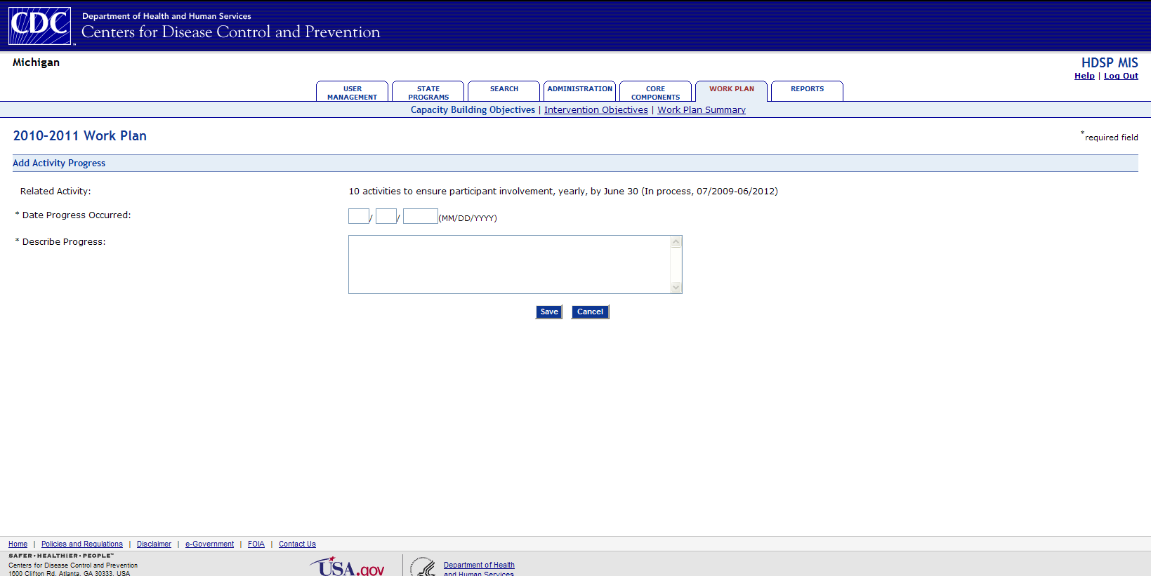

# Capacity Building Work Plan Activity Product

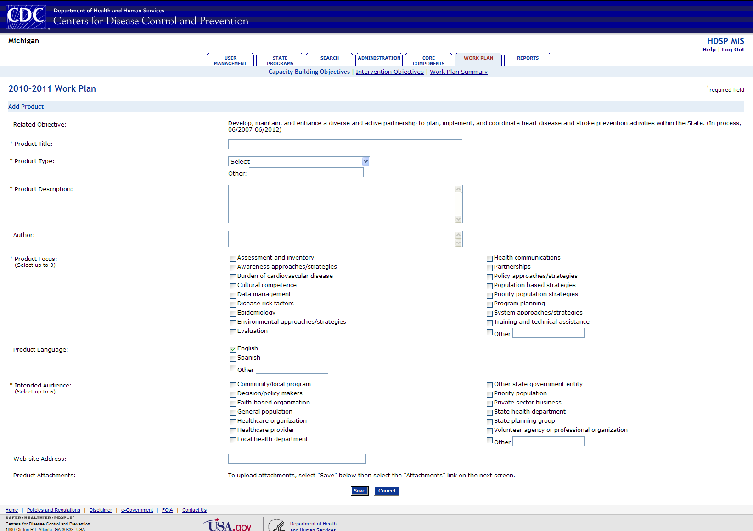

# Intervention Work Plan Long Term Objective

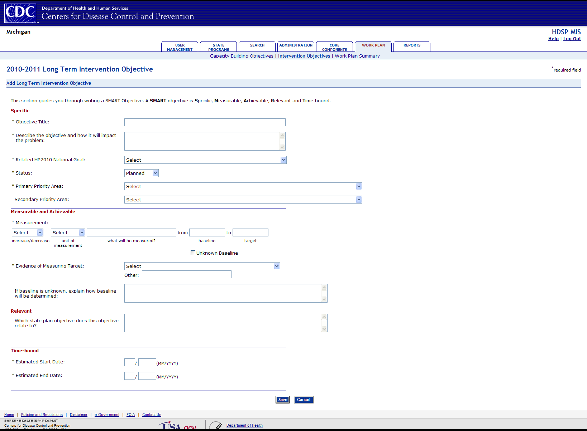

# Intervention Work Plan Long Term Objective Progress

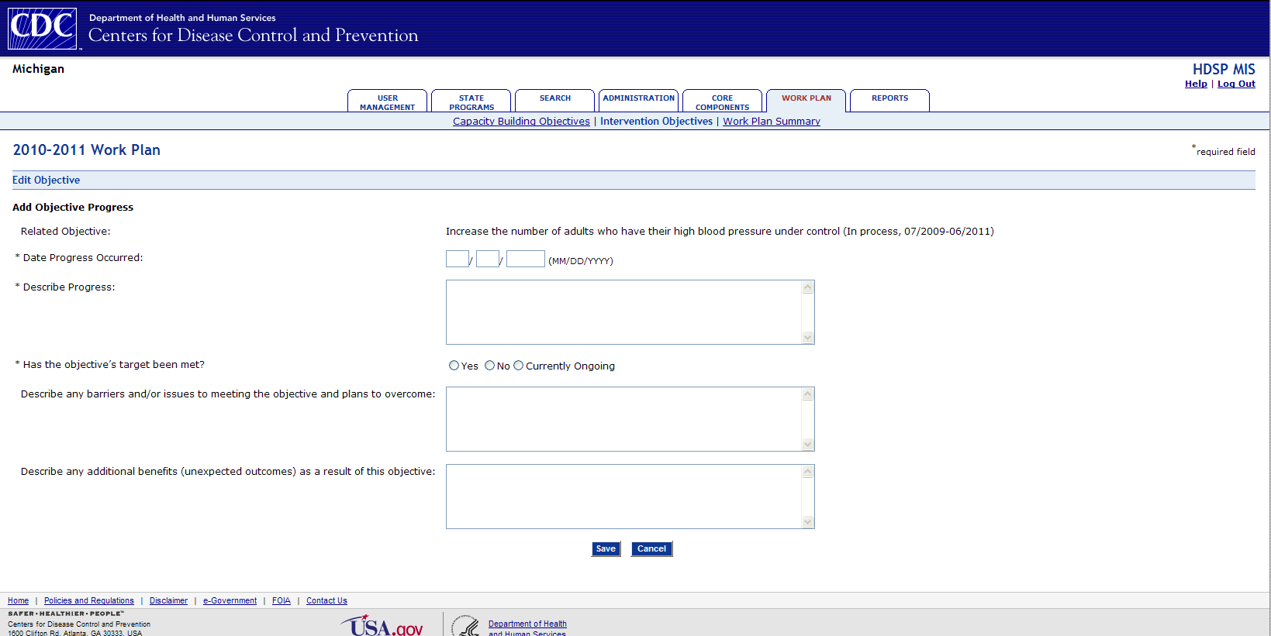

# Intervention Work Plan Supporting Objective

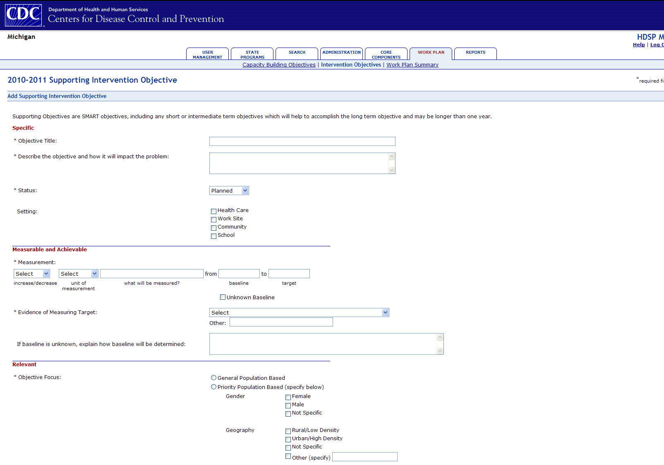

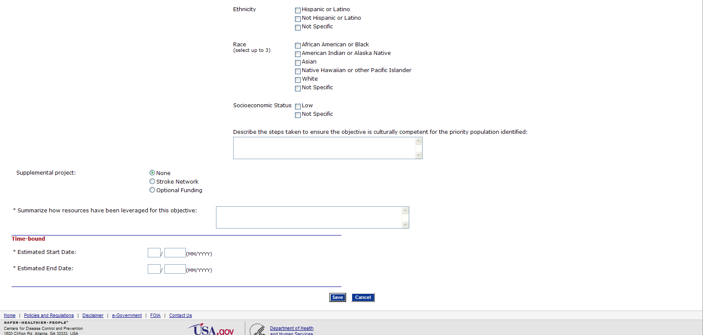

# Intervention Work Plan Supporting Objective Progress

# 

# Intervention Work Plan Supporting Objective Product

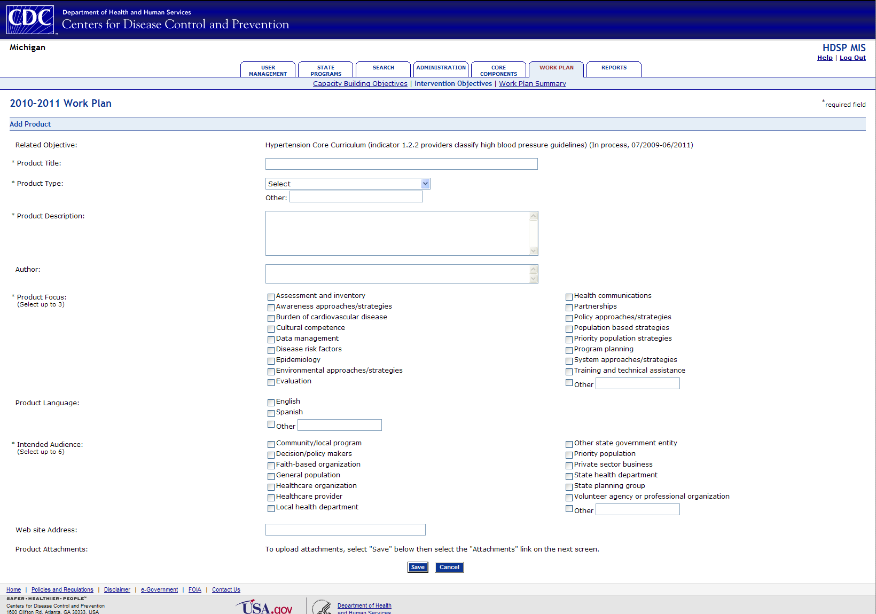

# Intervention Work Plan Supporting Objective Activity

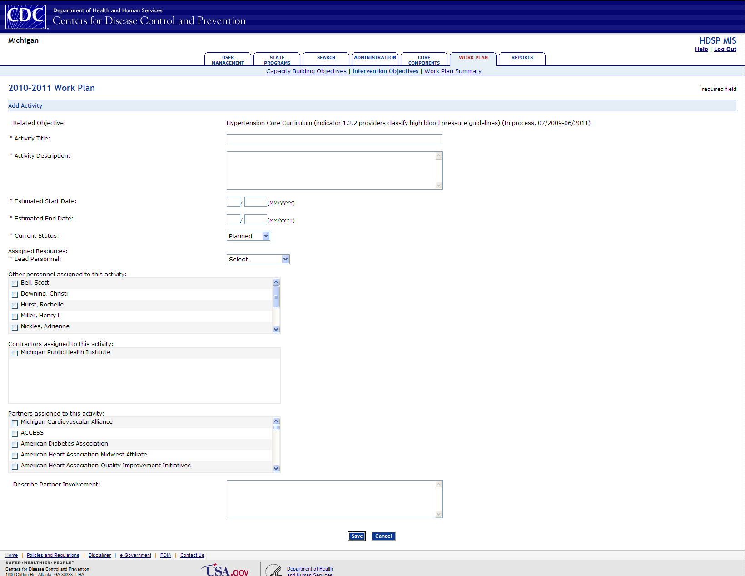

# Intervention Work Plan Supporting Objective Activity Progress

