What You Should Know About Joining
the National Children’s Study
Vanguard Study

Informed Consent Form

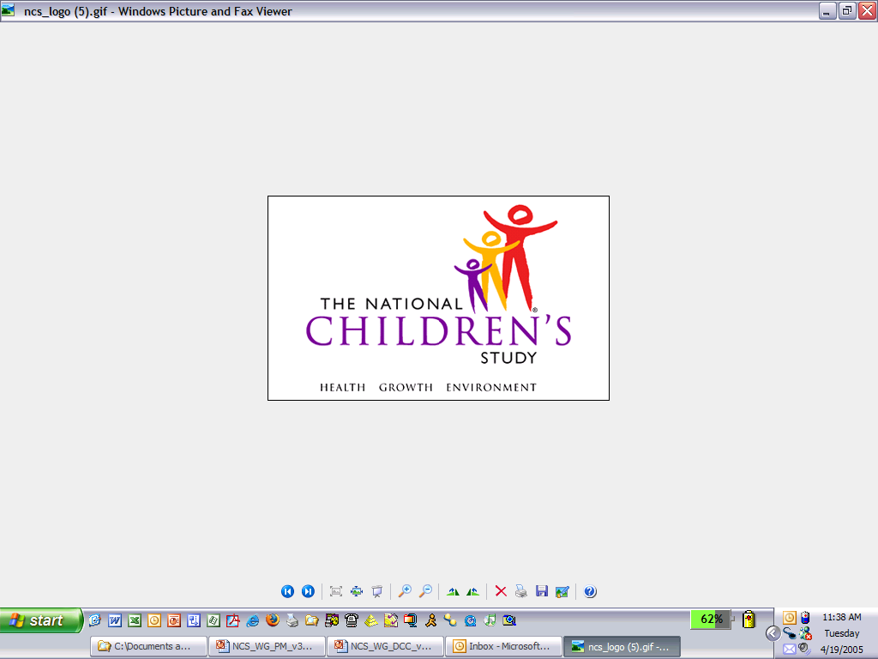

Public reporting burden for this collection of information is estimated to average 30 minutes per response in conjunction with the signature page, including the time for reviewing instructions, searching existing data sources, gathering and maintaining the data needed, and completing and reviewing the collection of information. An agency may not conduct or sponsor, and a person is not required to respond to, a collection of information unless it displays a currently valid OMB control number. Send comments regarding this burden estimate or any other aspect of this collection of information, including suggestions for reducing this burden, to: NIH, Project Clearance Branch, 6705 Rockledge Drive, MSC 7974, Bethesda, MD 20892-7974, ATTN: PRA (0925-0593). Do not return the completed form to this address.

- Your neighborhood is one of many communities across the country taking part in the National Children’s Study.
- The goal of the Study is to improve the health and well-being of all children.
- We need pregnant women and women who are not pregnant to join the Study.
- With your help, the National Children’s Study will help us learn more about how our physical, social, and family environments affect the health, growth, and development of our children.
- The National Children’s Study has several stages. Different stages of the Study will run at the same time. We are currently in the first stage, called the Vanguard Study. The Vanguard Study will help us decide on the design of the next stage, called the Main Study.
- We hope you will join thousands of women from across the United States in helping us to learn information that will help improve our children’s health. Although what we learn in the Vanguard Study may not help you or your family right now, the things we learn may help people in the future.
- Joining the Vanguard Study is your choice. You can decide to join or not to join. If you do join, you can leave at any time for any reason. You can decide not to answer certain questions.

Sponsors
The National Children’s Study is led by the Eunice Kennedy Shriver National Institute of Child Health and Human Development of the National Institutes of Health (NIH) in collaboration with a consortium of Federal government partners. Study partners include the National Institute of Environmental Health Sciences of the NIH, the Centers for Disease Control and Prevention, and the Environmental Protection Agency.

What is the goal of the National Children’s Study?
• The goal of the National Children’s Study is to improve the health of all children in the United States.
- The Study will help us learn more about how our community and our physical environment (including air and dust), social environment (our neighborhoods and communities), and family environment :
- Affect how children grow, and
- Help children stay healthy.
• The Study will look at our genes act together with our surroundings to influence health, growth, and development.
- The National Children’s Study has of several stages. The first stage is called the Vanguard Study. The next stage is called the Main Study.
- What we do–the questions we ask and the procedures we use–during the Vanguard Study may be different from what we do in the Main Study.
- The Vanguard Study will help us decide what questions and procedures will work best in the Main Study.
• As we progress through the Vanguard Study, we will use what we learn to help us decide what will work best for the rest of the Vanguard Study. That is why what we do as part of the Vanguard Study will change over time.
- We will use what we learn in the Vanguard Study and in the Main Study to achieve our goal of improving the health of all children.

Why is the National Children’s Study important?
- The National Children’s Study is important because it will help us understand how we can improve our children’s health.
- The National Children’s Study is the largest research study of children’s health and development in the history of the United States.
- With your help, we can learn more about how our physical environment, social environment, and family environment affects children’s health, growth, and development while they are young and when they become adults.
- The Study may also help us better understand why some children develop obesity, diabetes, autism, learning disabilities, or heart disease.

What kind of study is the National Children’s Study?
- The National Children’s Study is an observational study. That means we will follow children from birth to age 21 by:
- Asking questions about you and where you live and work. If you are pregnant or become pregnant, we will also ask questions about your baby and your baby’s experiences.
- At some point, we might ask you to take part in additional Study activities, such as visits in your home by Study staff.
- As an observational study, we will not:
- Ask you to change what you normally do.
- Ask you or your child to take any medicines or drugs.

How many children will be in the National Children’s Study?
- About 5,000 children will be in the Vanguard Study.
- About 100,000 children from all over the United States will be in all parts of the Study.
- We are also asking mothers and fathers to join the Study.

How long will the National Children’s Study last?
- The National Children’s Study will get information from women before, during, and after pregnancy.
- The Study will follow children until they are 21 years old.

What is involved in taking part in the National Children’s Study Vanguard Study?
- If you join the questionnaire group of the National Children’s Study, we will give you questionnaires to fill out and return to us. We will send you two or three questionnaires a year. The questionnaires will ask you for information about your health as well as your home and work environment.
- Because the Study will change over time different families may be asked to take part in different Study activities.
- Every time we contact you we will explain what we will do and ask your permission to do it.
- In the future, we may ask you if you would like to take part in additional Study activities.

What will the National Children’s Study do with all this information?
- The National Children’s Study may use the information we get from you in several ways.
- We will store your information along with that of other people in the Study indefinitely.

- Researchers may use this information to find out:
- How experiences during pregnancy or early life may affect our children’s health.
- How conditions that appear later in childhood and adulthood begin in early childhood.
- What we learn early in the Study may lead to more questions about our children’s health. We may use the information we get from you to answer those questions, too.
- In the future, scientists could develop new technologies or products based on the information that we collect from you and store for the Study. You will not receive any money that may result from such new technologies or products.
- We may also combine the information we receive from you for this Study with information from other research studies to answer our research questions.
- By agreeing to be in the Study, you are agreeing to allow possible use of your information for future studies on child and maternal health and disease.
- These studies might be done by other approved researchers. The goals of these future studies will be similar to the goals of the National Children’s Study.
- An independent group of doctors, scientists, and community members will make sure that your information will only be used to meet the goals of the National Children’s Study. The Independent Safety Monitoring and Oversight Committee, or iSMOC, will make sure that your information will only be used to:
- Help us better understand children’s health and growth.
- Answer questions about why some children are more likely to get certain diseases.

How can I find out about the results of the Study?
- We will share what we learn from the Study as a whole. We will keep in touch through newsletters, on our website, and in other ways.
- We will share some information we learn about you and your child with you when it is available.

How will the Study protect my information?
- We will protect your privacy and keep your information safe by:
- Using a number code to label your information.
- Keeping your number code separate from your name, address, and other personal information. We will look at your information using the number code and not your personal information.
- Keeping your information in a secure computer database.
- Researchers who want to use your information must:
- Get certified by the National Children’s Study and the Federal government.
- Get permission to use your information. A group of doctors, scientists, and community members (the iSMOC) will make sure that your information will only be used to meet the goals of the Study. The goals are to better understand child health and growth and to learn why some children are more likely to get diseases.
- Sign an affidavit of nondisclosure. This means promising to use your information only for research. They must also agree not to share your information with anyone who has not made this same promise.
- Protect your information by reporting it only as part of a group.
- We will track researchers to make sure they are keeping your information safe.
- We will regularly review all of the ways we keep your information safe to keep improving how we protect your privacy.
- The U.S. Department of Health and Human Services (HHS) gave the National Children’s Study a legal document, called a Certificate of Confidentiality. This means the Study cannot be forced by a court order or subpoena to give out information that might identify you in any court.

When might the Study have to give out my information?
- If we learn that you or someone else is harming you, your child, or others around you, we may be required by law to report this to the police or a social services agency in your community.
- If you give someone or an organization written permission to see the information you gave the Study, we cannot use the Certificate of Confidentiality to protect your information from that person or organization.

What are the possible benefits of being in the National Children’s Study Vanguard Study?
- Taking part in the National Children’s Study may not help you or your family right now. But the Study may help us learn things about health that could benefit all of us–including your children and grandchildren–in the years to come.
- If you need medical or social services, we will give you names and contact information for people and agencies that can try to help. But the Study cannot and will not pay for your health care or mental health services.

What are the possible risks or burdens to me and my child and to my community from being in the National Children’s Study Vanguard Study?
- The risks from taking part in this Study are low.
- Some of the questions we ask may be uncomfortable. If you are uncomfortable, you can skip any part of the Study. You are in charge.
- Completing the questionnaires and forms that we give you may take anywhere from thirty minutes to an hour.
- Although we are taking many steps to protect your information, there is always a chance that your information or identity could be disclosed. We will continue to review and improve the ways we keep your information private. To protect your information, we will keep your name and address separate from your information files.
- We will get information about your health, your community, and your race and ethnicity. We will make files with this information available to approved researchers. In addition to the risks to individuals, the risks of providing information about racial or community groups are unknown. There is a possibility that specific Study findings will be associated with particular racial and ethnic groups.

Will I be paid for being in the National Children’s Study?
- We will give you about $25 in cash or gift cards to thank you each time you complete Study questionnaires.
- From time to time, we may also give you small gifts like a tote bag, picture frame, or other small items to thank you for being in the Study.

What if I want to leave the National Children’s Study?
- You can leave the Study at any time. You also can leave the Study for a short time and come back.
- If you leave the Study, we will not ask for any new information, but we will keep using the information you have already given us.
- Leaving the Study will not affect your access to health care or any other benefits you may be receiving, like those from Social Security, Medicaid, WIC, or the Supplemental Nutrition Assistance Program.

What if I move?
- We hope you will tell us if you are planning to move so you can still be part of the Study in your new home.
- If you move and forget to tell us, we will try to get in touch with you. We will use the information you have given us about family members and friends, as well as publicly available information.
- If we get in touch with you, we will ask if you want to continue to be part of the Study.

Will it cost me anything to be in the National Children’s Study?
- No. There is no cost to you for being in the National Children’s Study.

Does the National Children’s Study pay for health care for my family or me?
- The Study cannot and will not pay for health care or mental health services for you or your family. If you need medical or social services, we will give you names and contact information for people and agencies that can try to help.
- The information we collect is for research purposes only. Being part of the Study does not take the place of your usual doctor or clinic visits.

If I join the National Children’s Study, will I have to join other studies?
- If you join the National Children’s Study, you do not have to join any other studies. We may invite you to be in other studies connected with the National Children’s Study.
- If you are invited to be in other studies, you can always say no.

Will the media be interested in my participation and my child’s participation in the National Children’s Study?
- The National Children’s Study will not tell the media anything about the identities of Study participants.
- Because of the importance of the Study, reporters may go to communities where the Study is being done. They may ask participants if they want to talk about their experiences with the Study.
- If you are contacted by reporters, you can decide if you want to talk to them. If you do talk to a reporter, they can write about anything you tell them. What you say will be public information. The organization that the reporting works for will have control over any information and material you give them.
- If you talk with the media about your or your child’s experience with the Study, your role and your child’s role as Study participants will be public knowledge. When this information becomes public, it will be harder for the Study to protect the privacy of your information and information about of other participants from your community.

Who can I contact if I have questions about the National Children’s Study?
- If you have any questions about your or your child’s rights as a Study participant, now or in the future, you can contact the people listed on the bottom of this page.

Thank you for taking the time to learn about the National Children’s Study.

[Study Centers will provide contact information for local Principal Investigator and IRB in this space.]

