Public reporting burden for this collection of information is estimated to average 20 minutes per response, including the time for reviewing instructions, searching existing data sources, gathering and maintaining the data needed, and completing and reviewing the collection of information. An agency may not conduct or sponsor, and a person is not required to respond to, a collection of information unless it displays a currently valid OMB control number. Send comments regarding this burden estimate or any other aspect of this collection of information, including suggestions for reducing this burden, to: NIH, Project Clearance Branch, 6705 Rockledge Drive, MSC 7974, Bethesda, MD 20892-7974, ATTN: PRA (0925-0627). Do not return the completed form to this address.

Introduction Page:
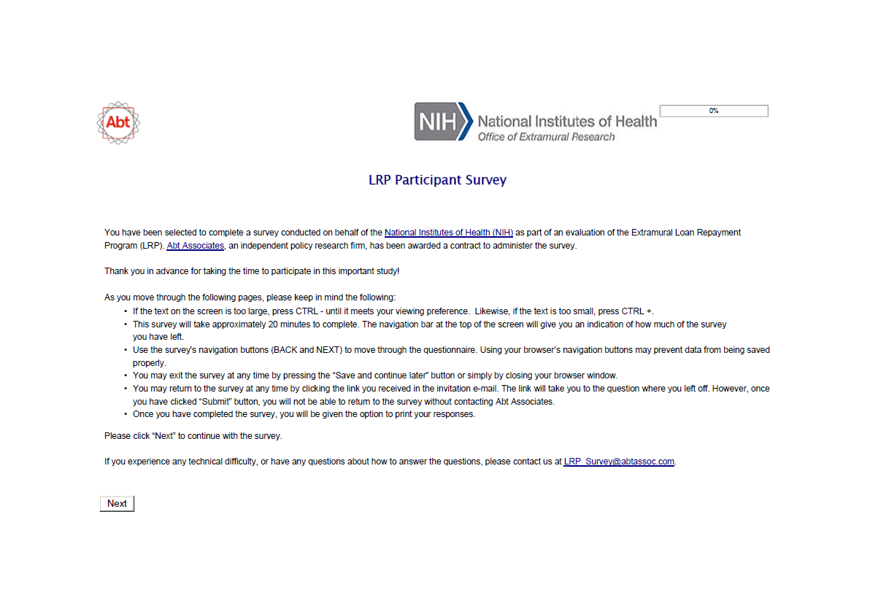
Question 1:
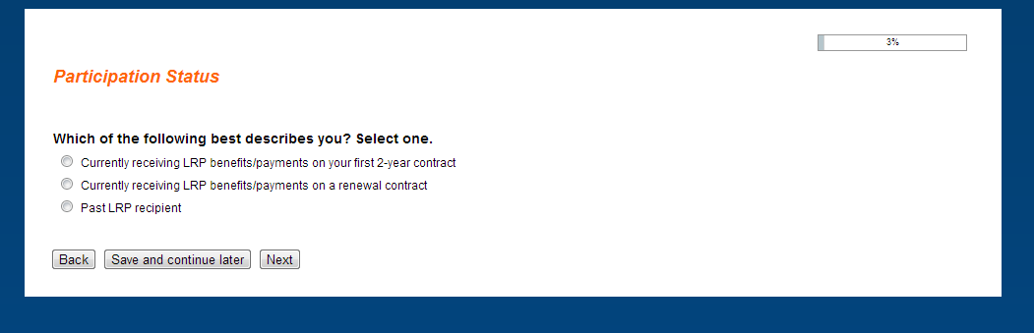

Question 2:
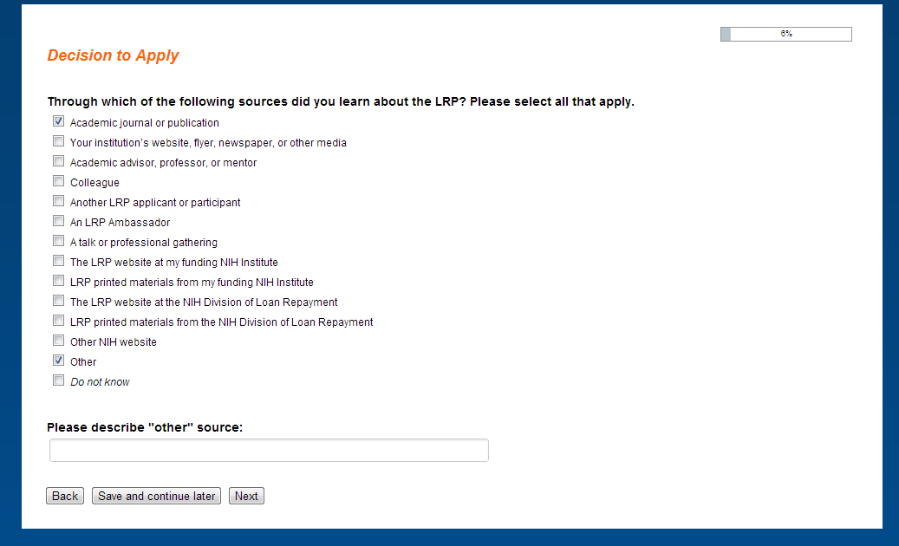
Note: Text box only appears if “Other” is selected.
Question 3:
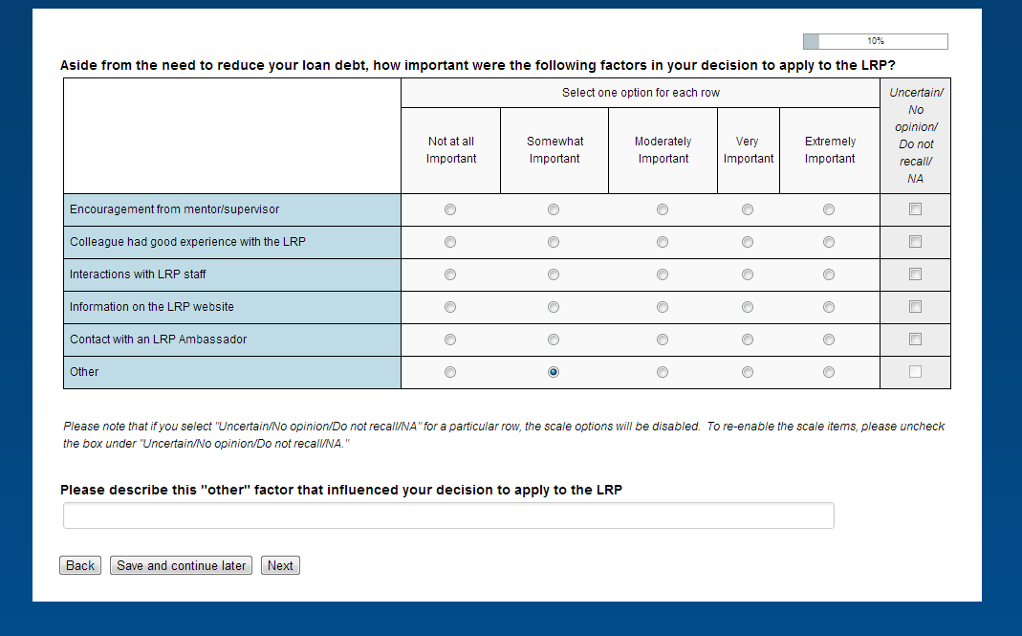
Note: Text box only appears if “Other” is selected as at least “Somewhat important.”
Question 4:
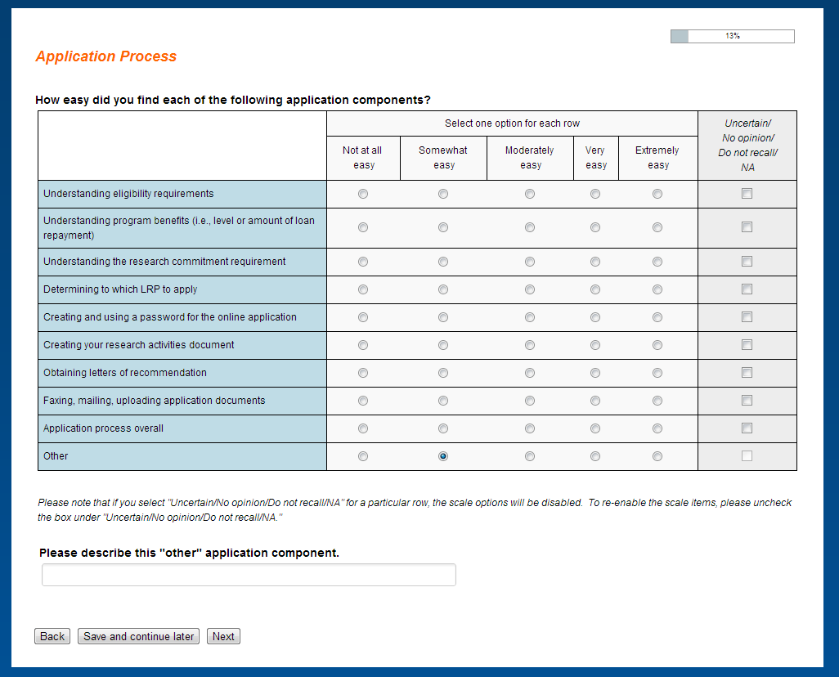
Note: Text box only appears if “Other” is selected as at least “Somewhat easy.”
Question 5:
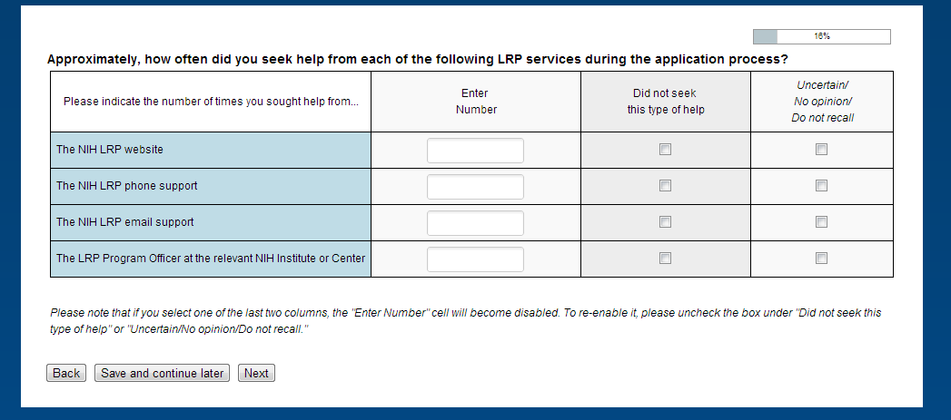

Question 6:
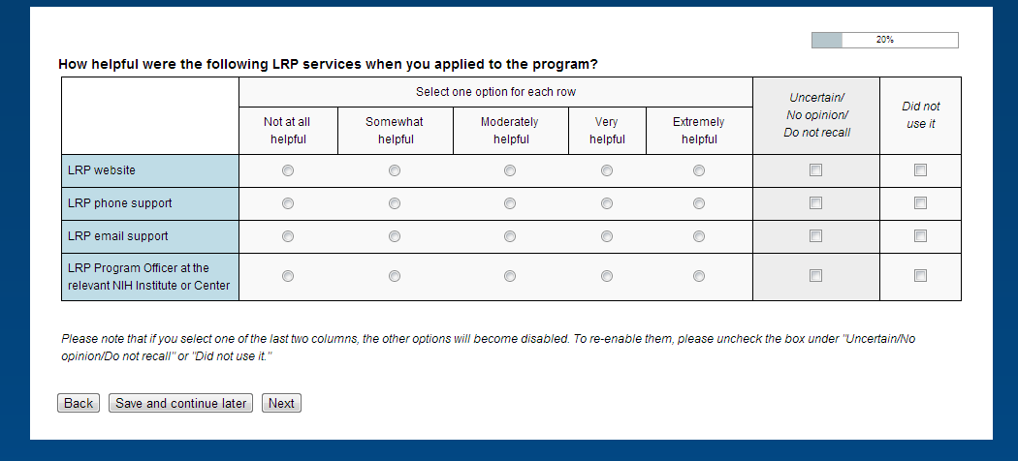
Note: Services are not displayed in this matrix if corresponding service in question 5 is not greater than zero.

Question 7:
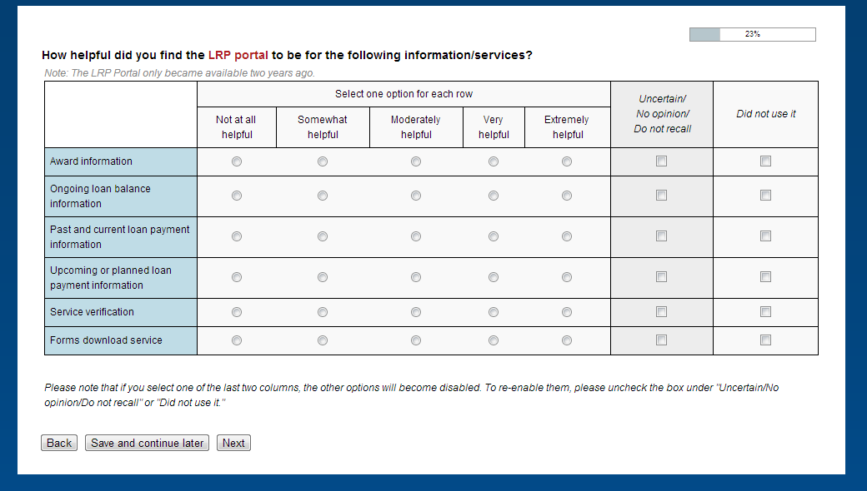
This question only appears for current participants (i.e., question 1 = “Currently receiving LRP benefits/payments on your 1st 2-year contract” or “Currently receiving LRP benefits/payments on a renewal contract”).
Question 8:
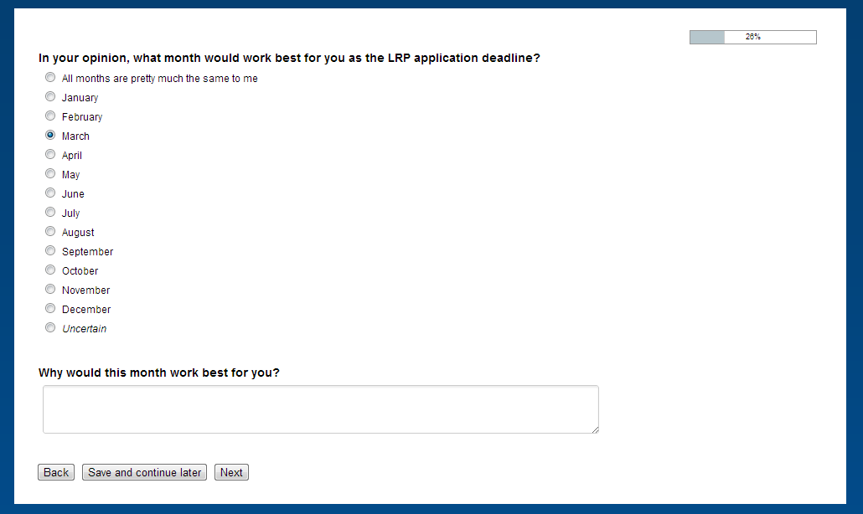
Note: Text box only appears if respondent selects a month (January – December) for this question.
Question 9:
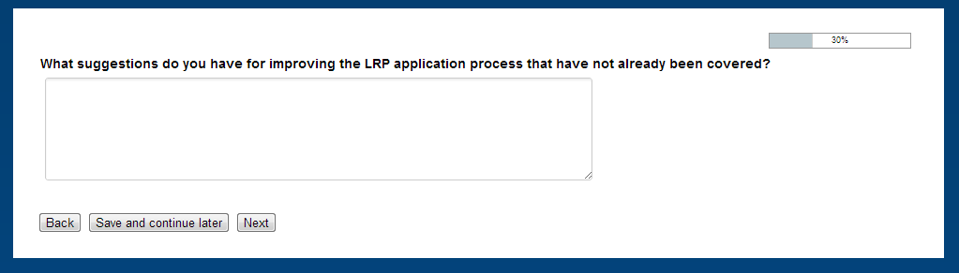

Question 10:
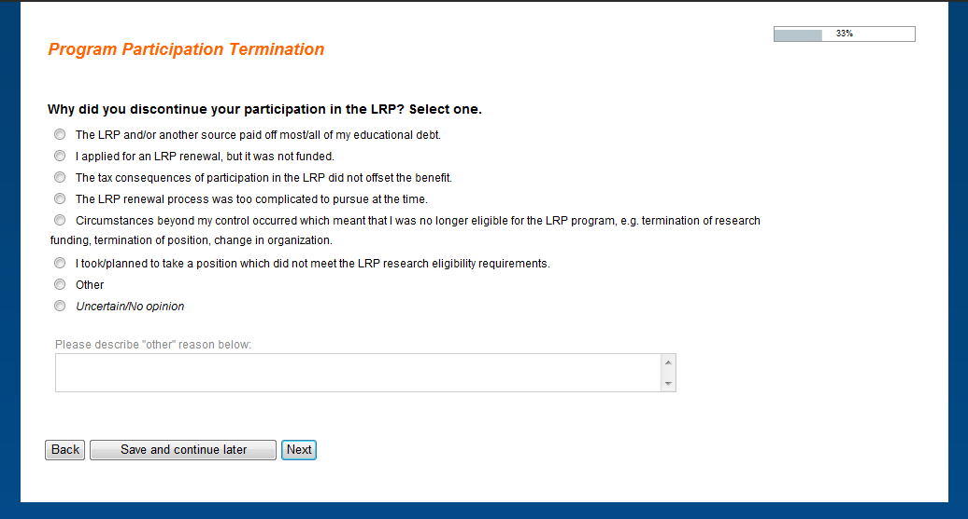
This question only appears for past participants (i.e., question 1 = “Past LRP recipient”).

Question 11:
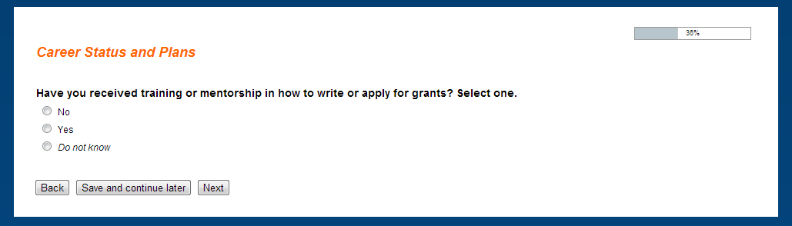
Text for the follow-up question is dependent on response to the above yes/no question.

If the respondent answers “No” or “Do not know” to question 11, the following is displayed: 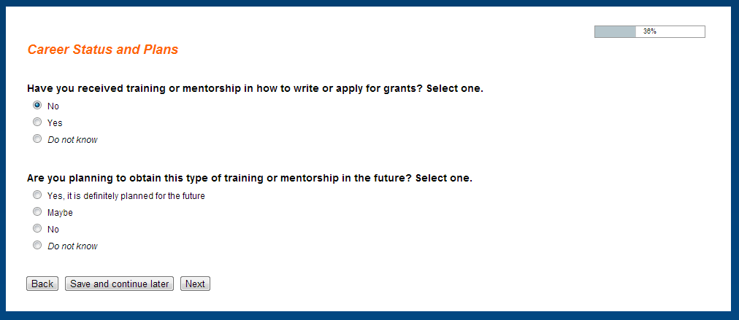
If the respondent answers “Yes” to question 11, the following is displayed:
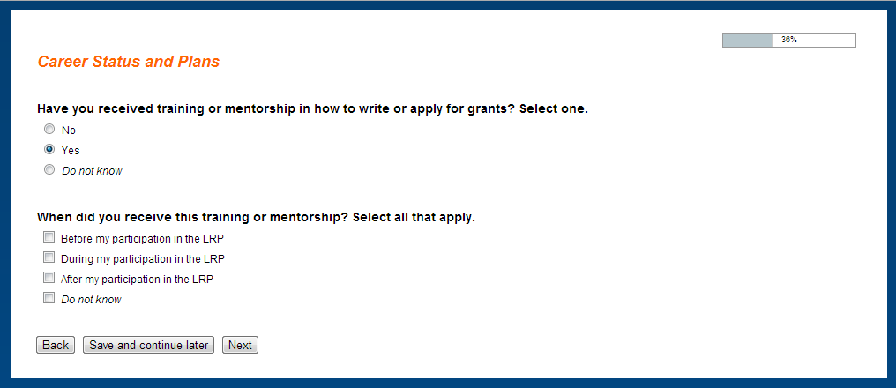
Question 12A:
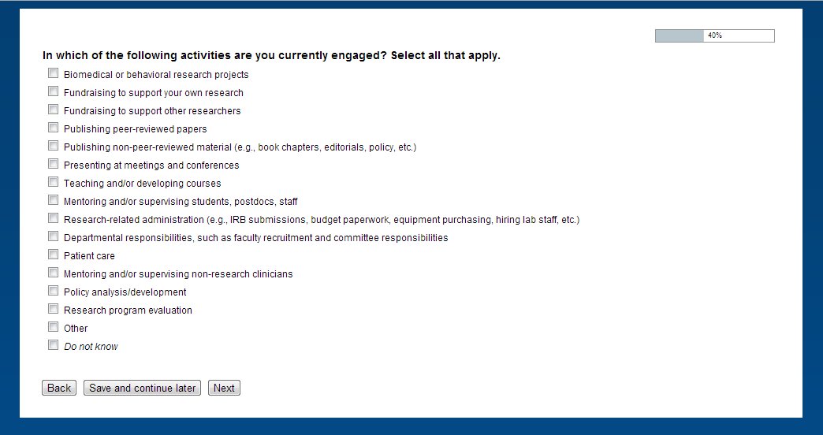
This question only appears for current participants (i.e., question 1 = “Currently receiving LRP benefits/payments on your 1st 2-year contract” or “Currently receiving LRP benefits/payments on a renewal contract”).

Question 12B:
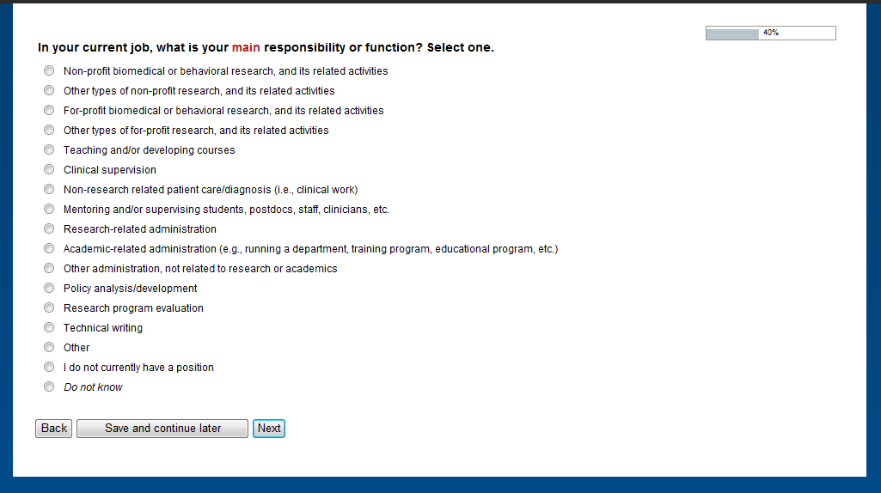
This question only appears for past participants (i.e., question 1 = “Past LRP recipient”).

Question 13:
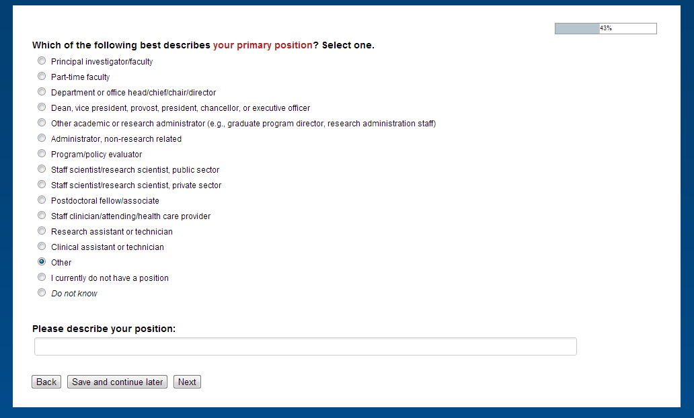
Note: Text box only appears if “Other” is selected.
Question 14:
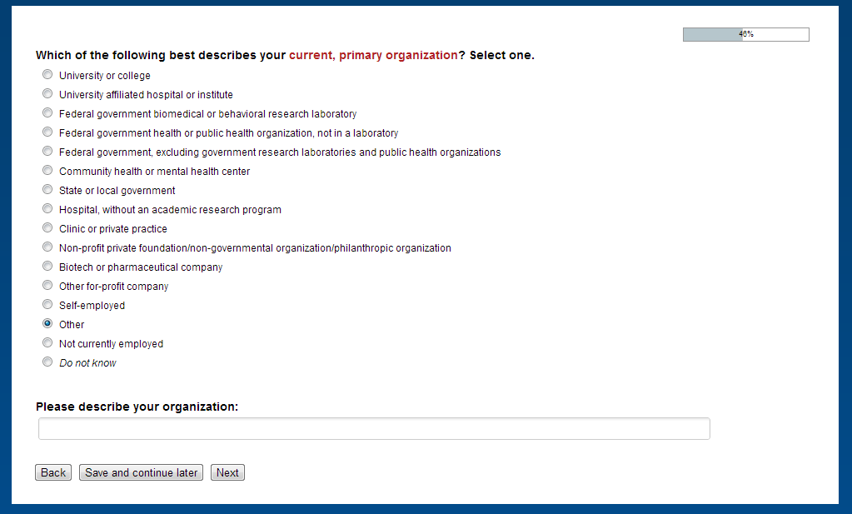
Note: Text box only appears if “Self-employed” or “Other” is selected.
Question 15A:
The wording for question 15 is slightly different for current vs. past participants. The following is displayed for current participants:
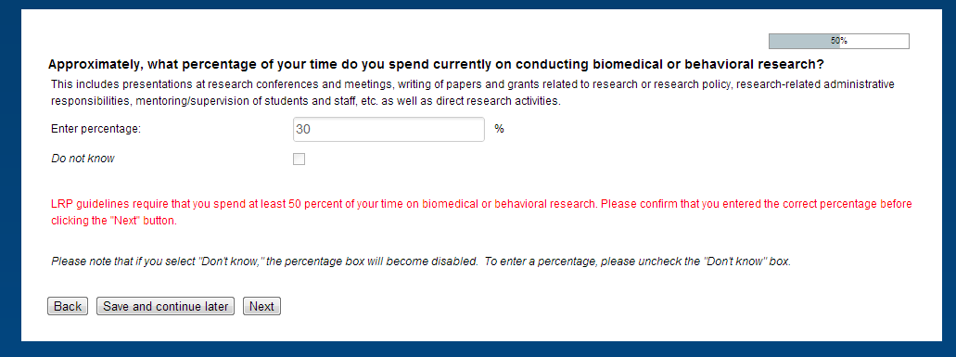
Note: The message in red only appears if the respondent entered a number that is less than 50%.

Question 15B:
The following is displayed for past participants:
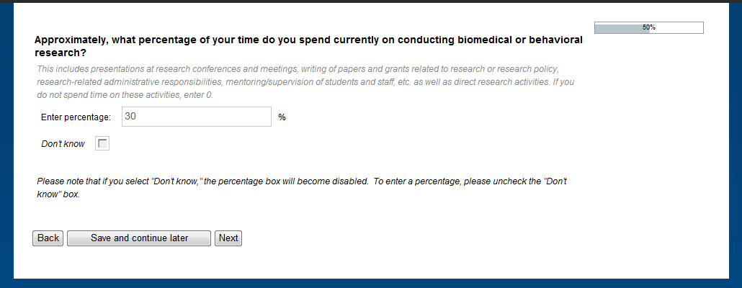

Question 16:
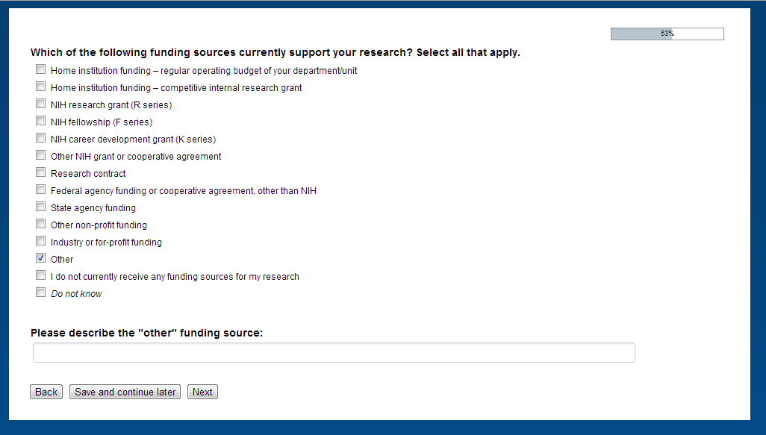
Note: Text box only appears if “Other” is selected.

Question 17:
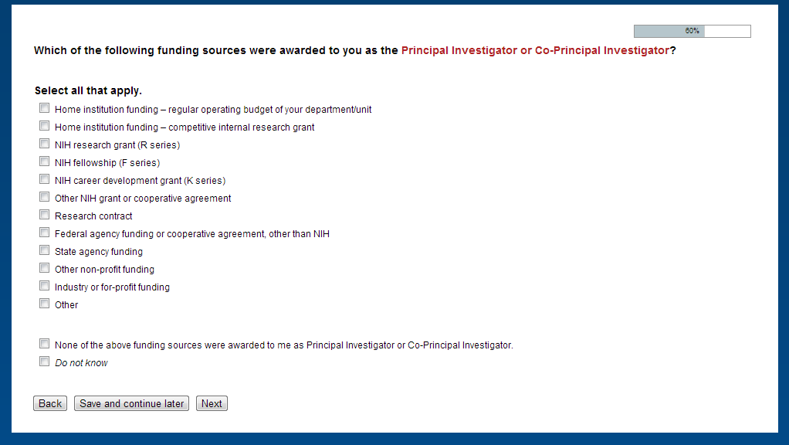
Only the options selected under question 16 are displayed under question 17.

Question 18:
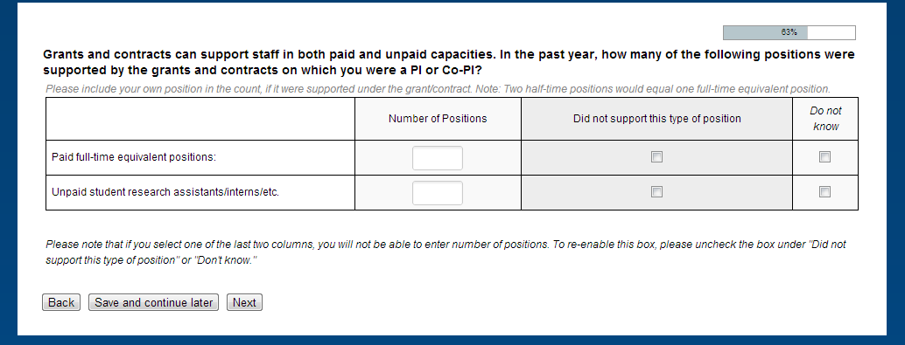
This question only appears if at least one source was selected under question 17.
Question 19:
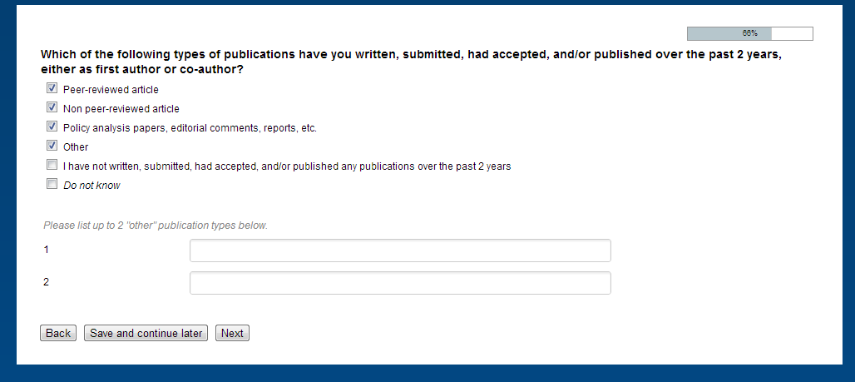 Note: Text boxes only appear if “Other” is selected.

Question 19 (follow-up):
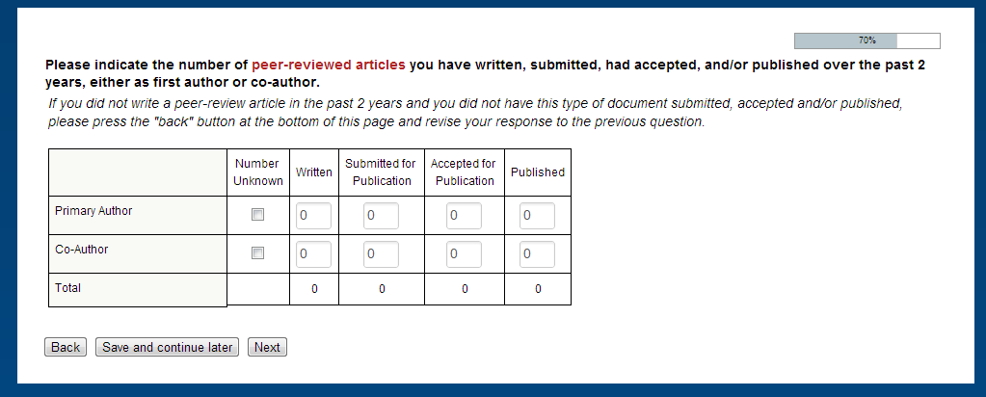
Note: This question is asked for each publication type selected under question 19. The zeros are pre-filled.

Question 20:
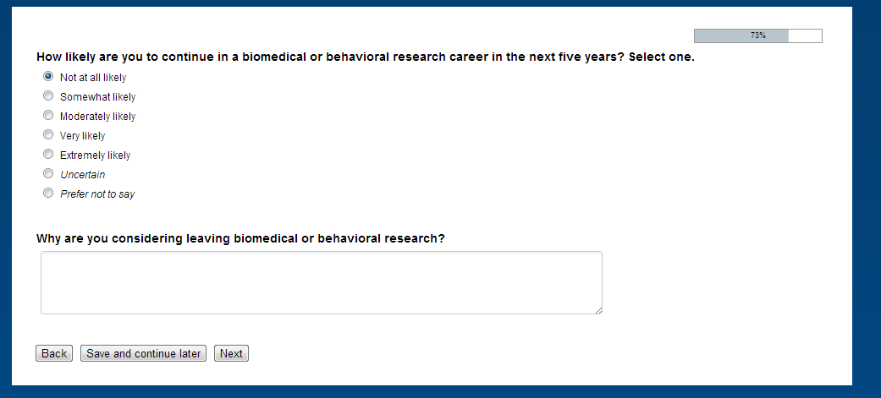
Note: This text box only appears if respondent selects “Not at all likely” or “Somewhat likely.” If the respondent selects “uncertain,” a question pops up that asks “Why are you uncertain about continuing your biomedical or behavioral research career”?

Question 21:
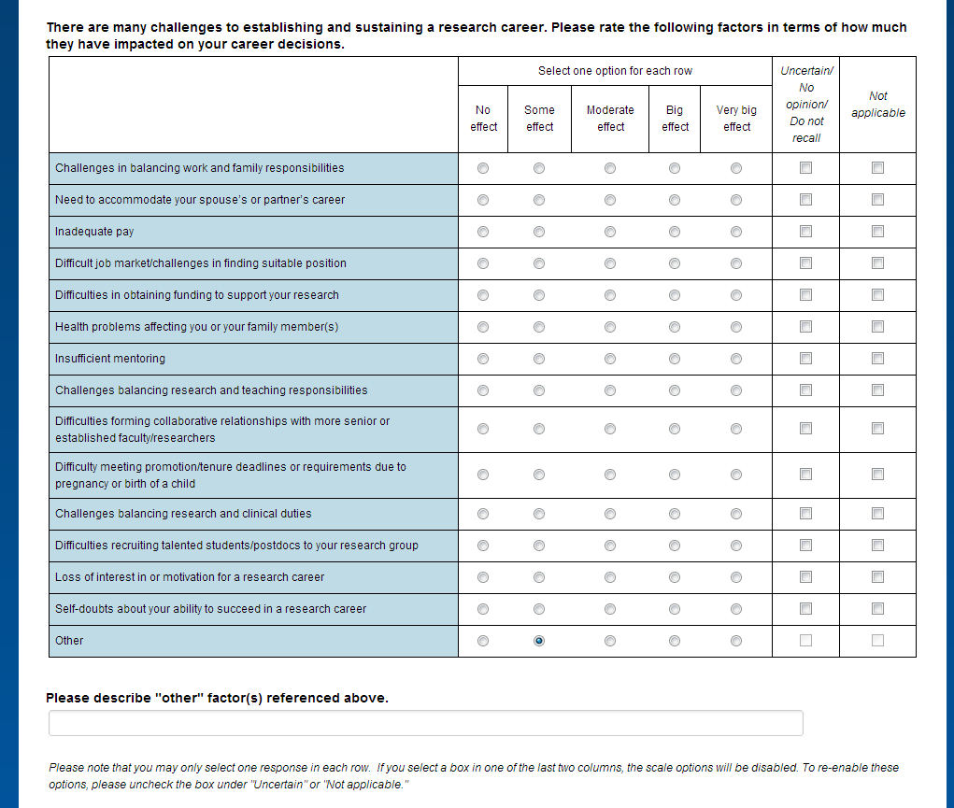
Note: Text box only appears if “Other” = “Some effect” or higher.
Question 22:
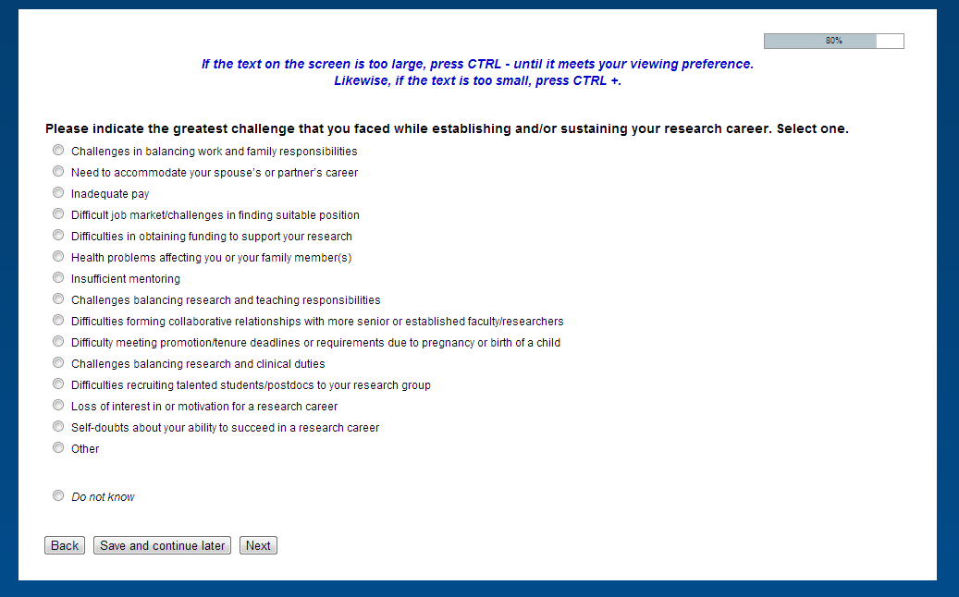
Only challenges selected under question 21 (“Some effect” or higher) are displayed under question 22.
Question 23:
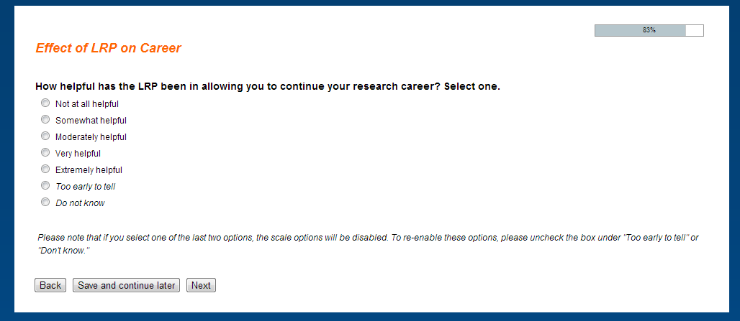

Question 24:
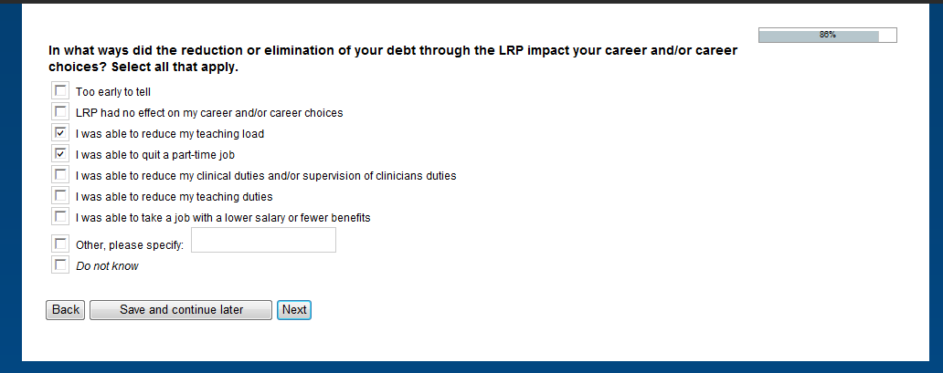
This question only appears for past participants (i.e., question 1 = “Past LRP recipient”).

Question 24A:
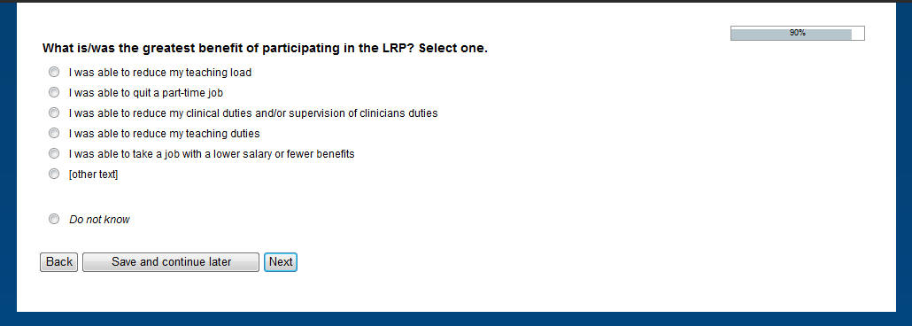
This question only appears for past participants (i.e., question 1 = “Past LRP recipient”). The only response choices that are displayed are those selected under question 24.

Question 25:
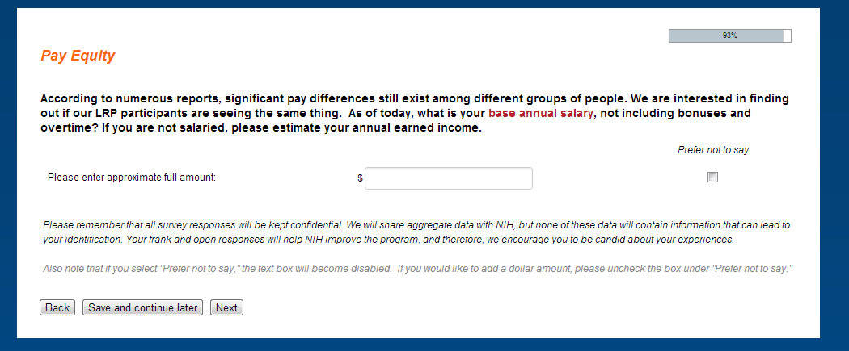

Question 26:
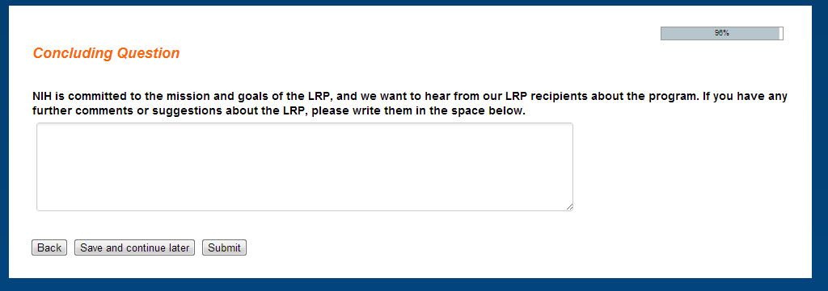

Final Screen:
