Warning screen

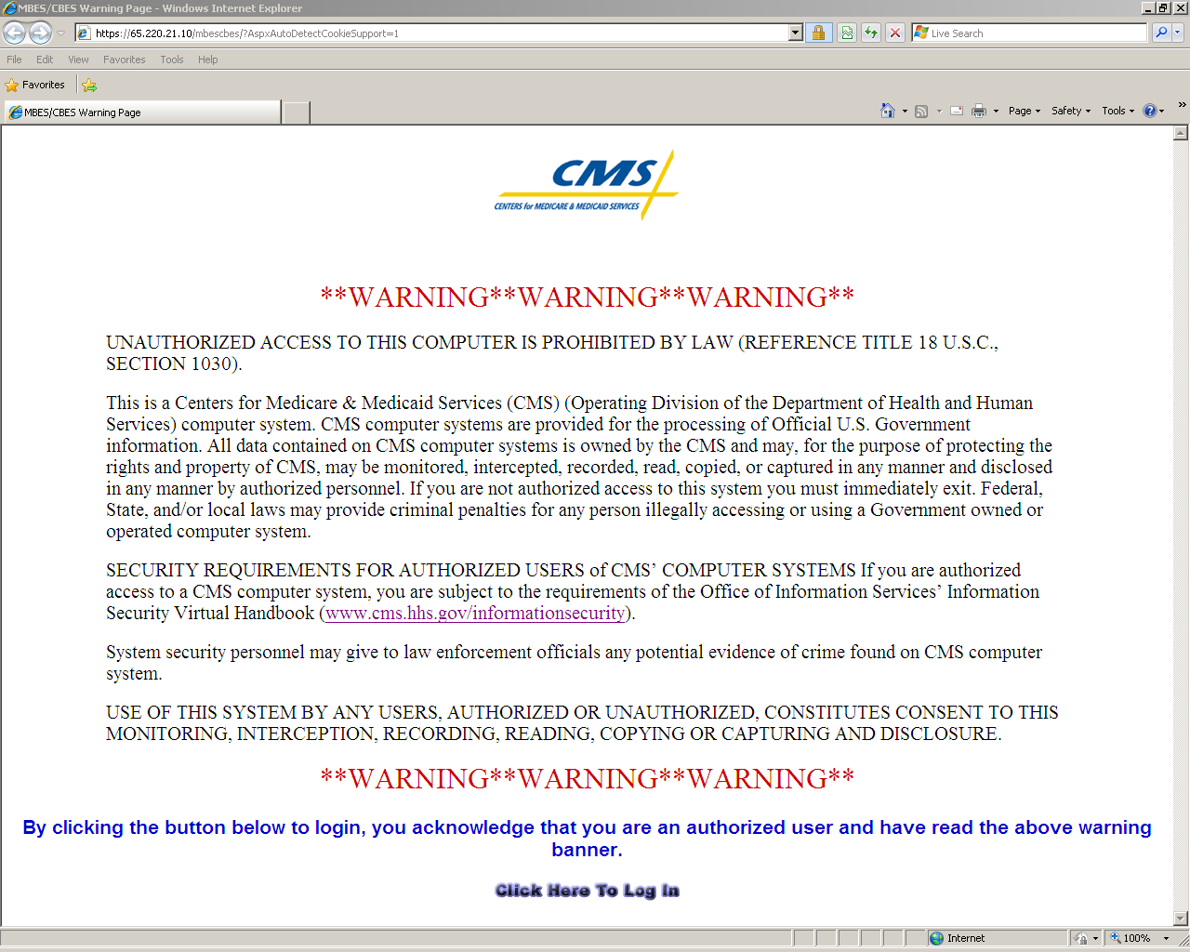

Login screen

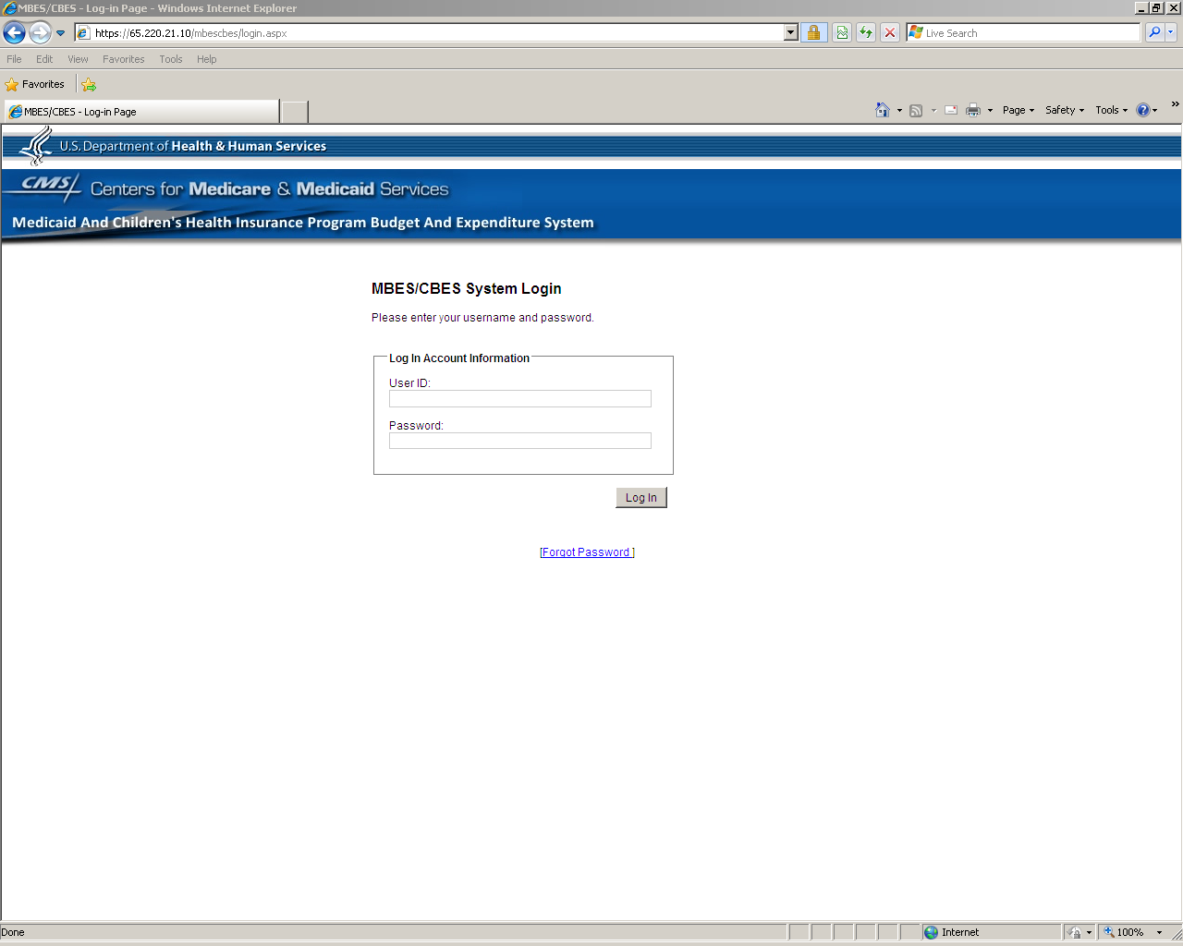

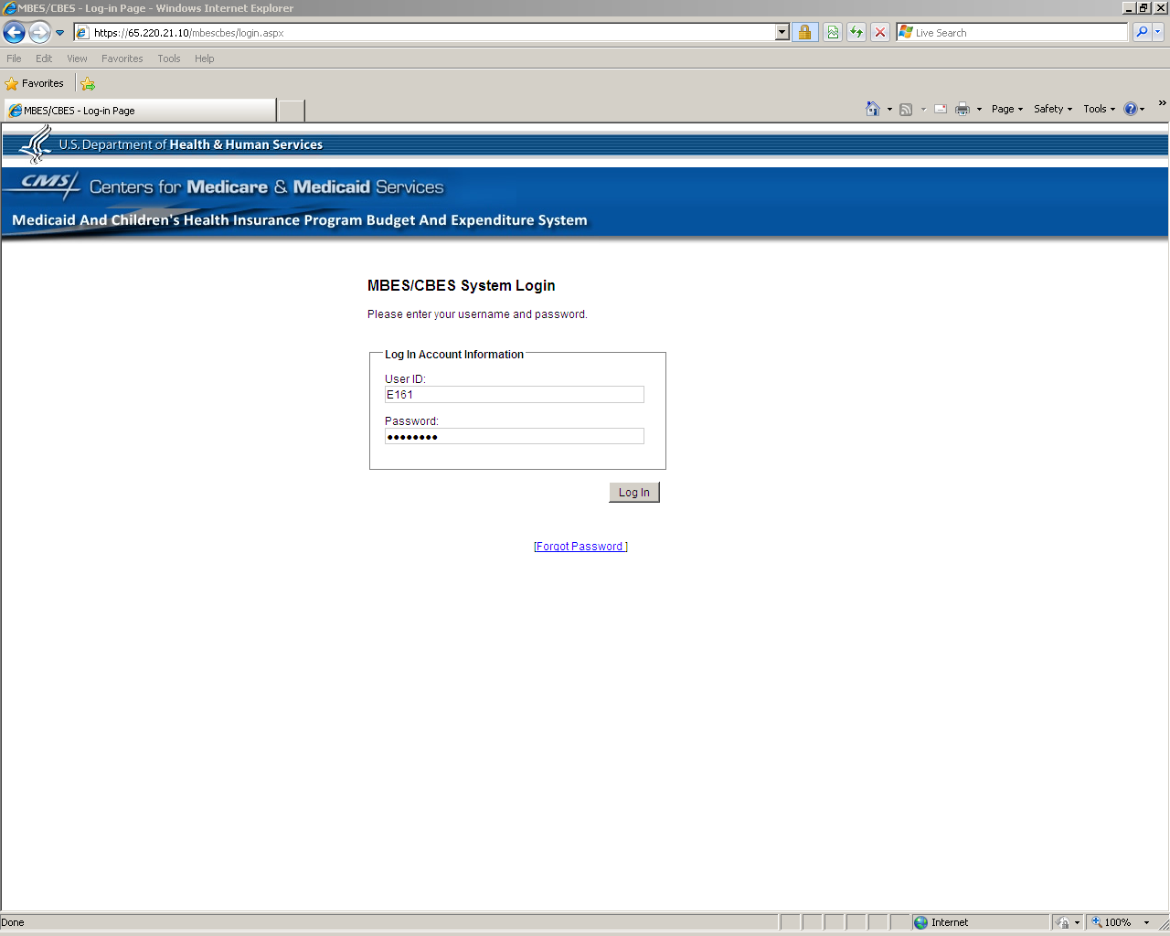

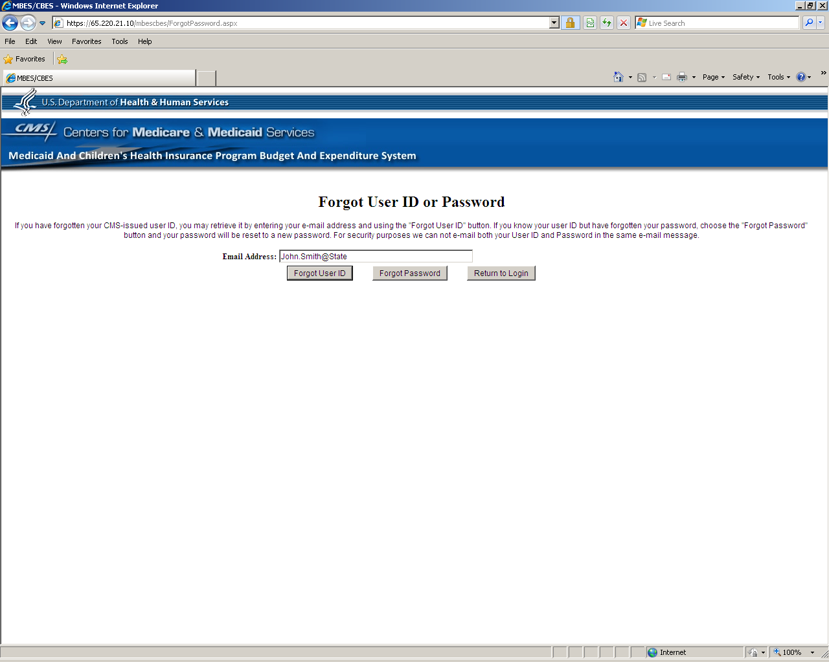

Upon logging in, a message alert window is brought to user’s attention, providing system related notifications and updates.

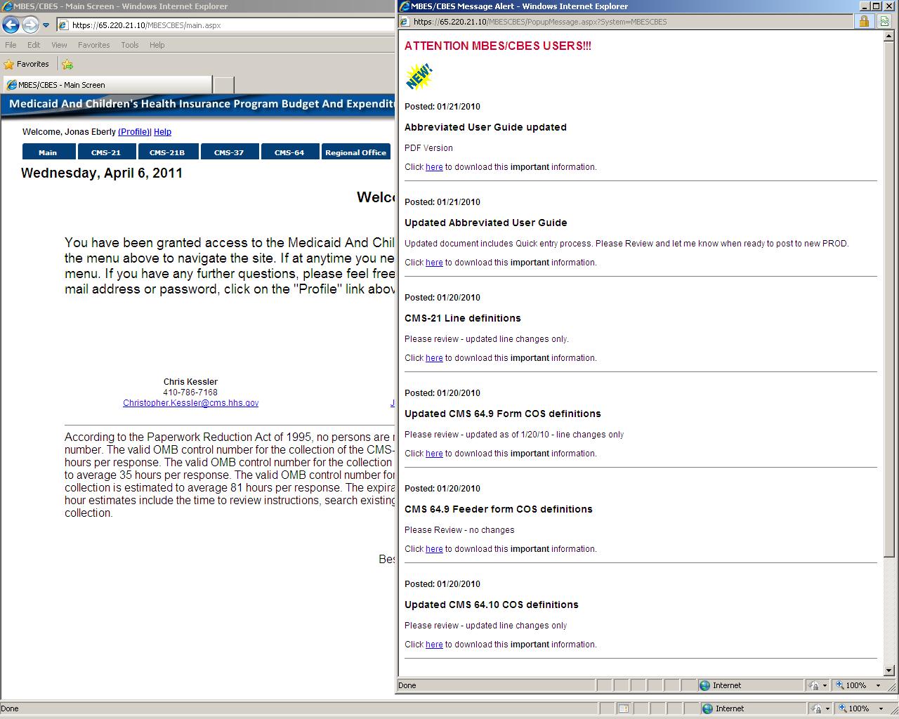

Main Window (Home page) – On the Navigation Bar State users would only have permissions and therefore could only view the Main, CMS-21, CMS-21B, CMS-37, CMS-64, and Report Queue buttons.

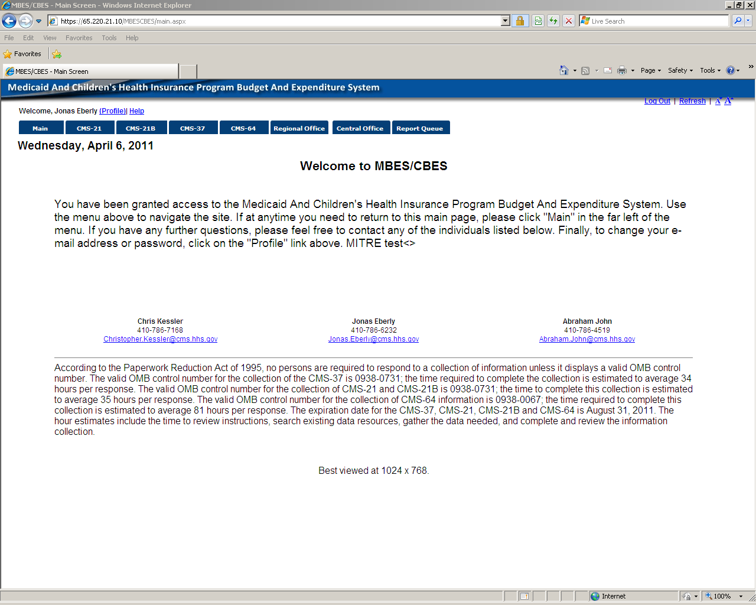

CMS-37 no entries.

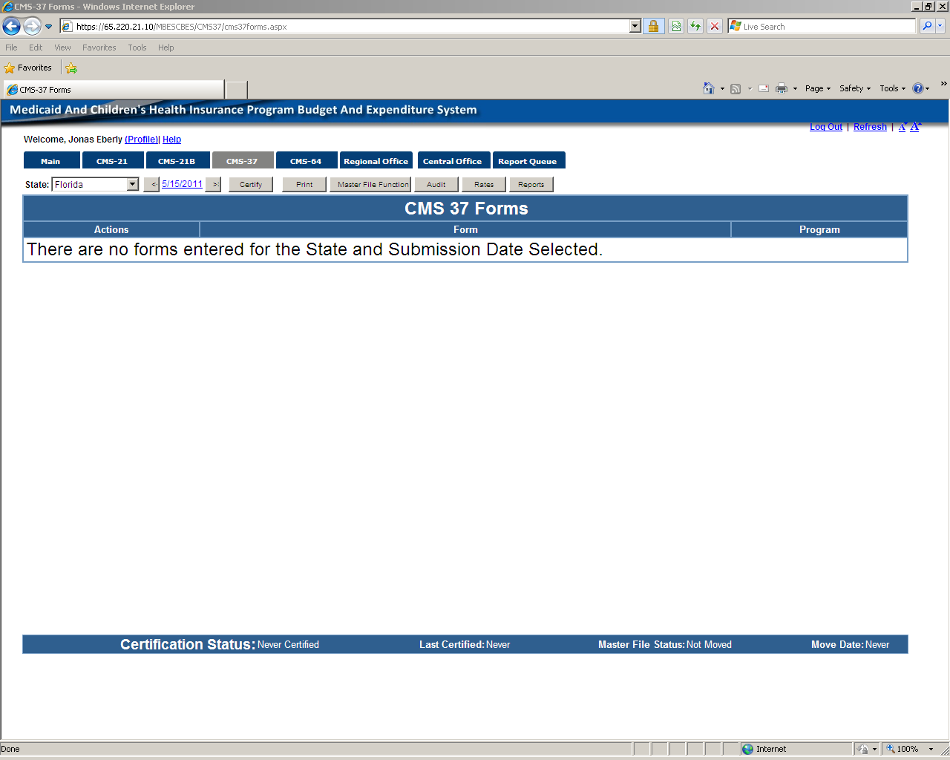

CMS-37 dropdown selected to add forms.

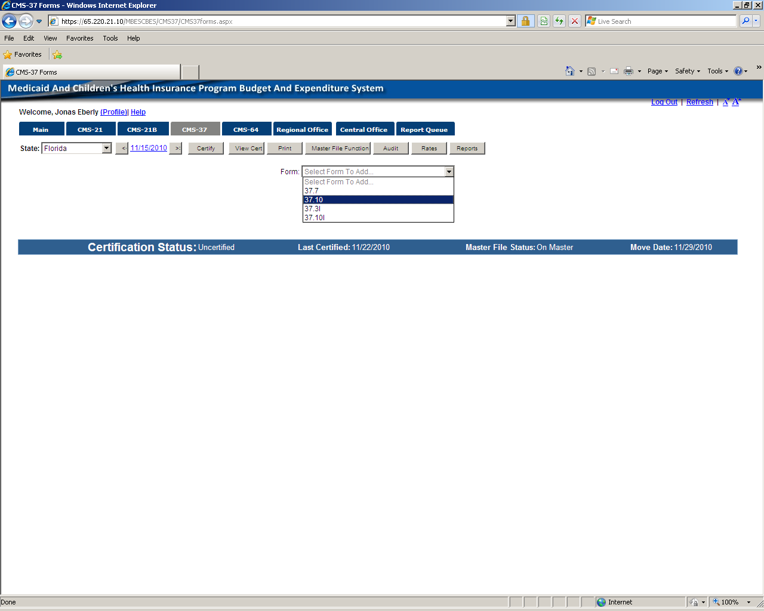

Added forms – Under action column Browse/Edit/Delete function icons.

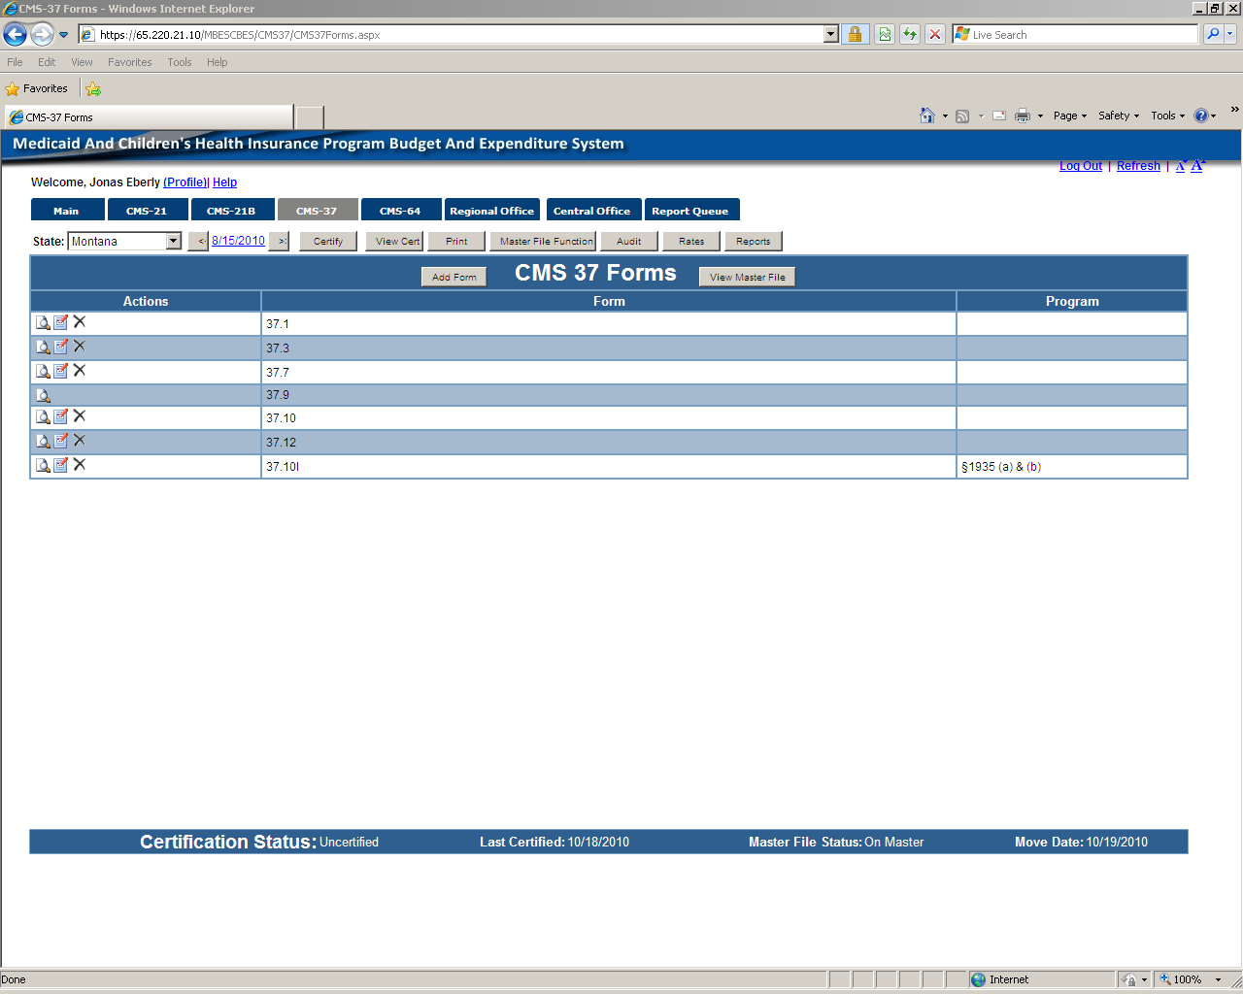

Adding and populating 37.10 form

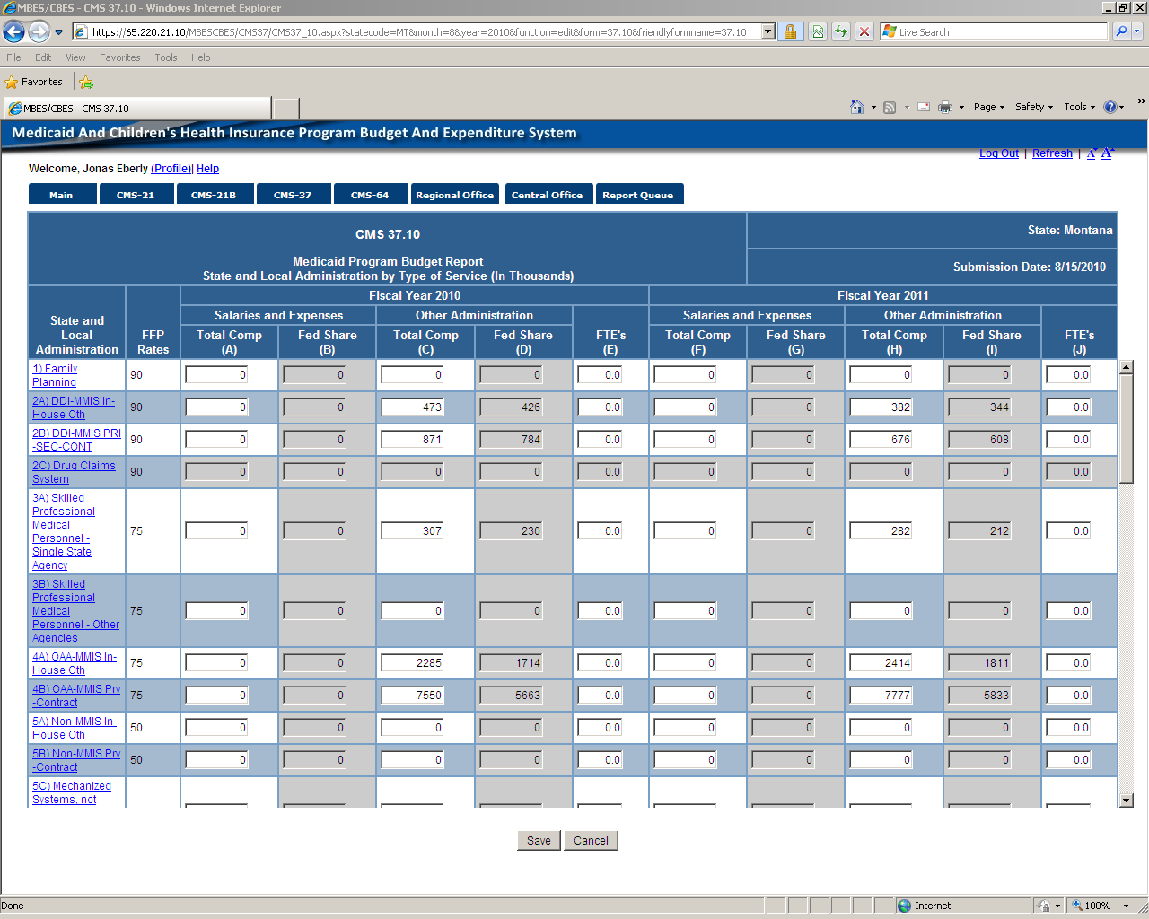

37.10 continued on next screen.

CMS-37.10 continued from previous screen.

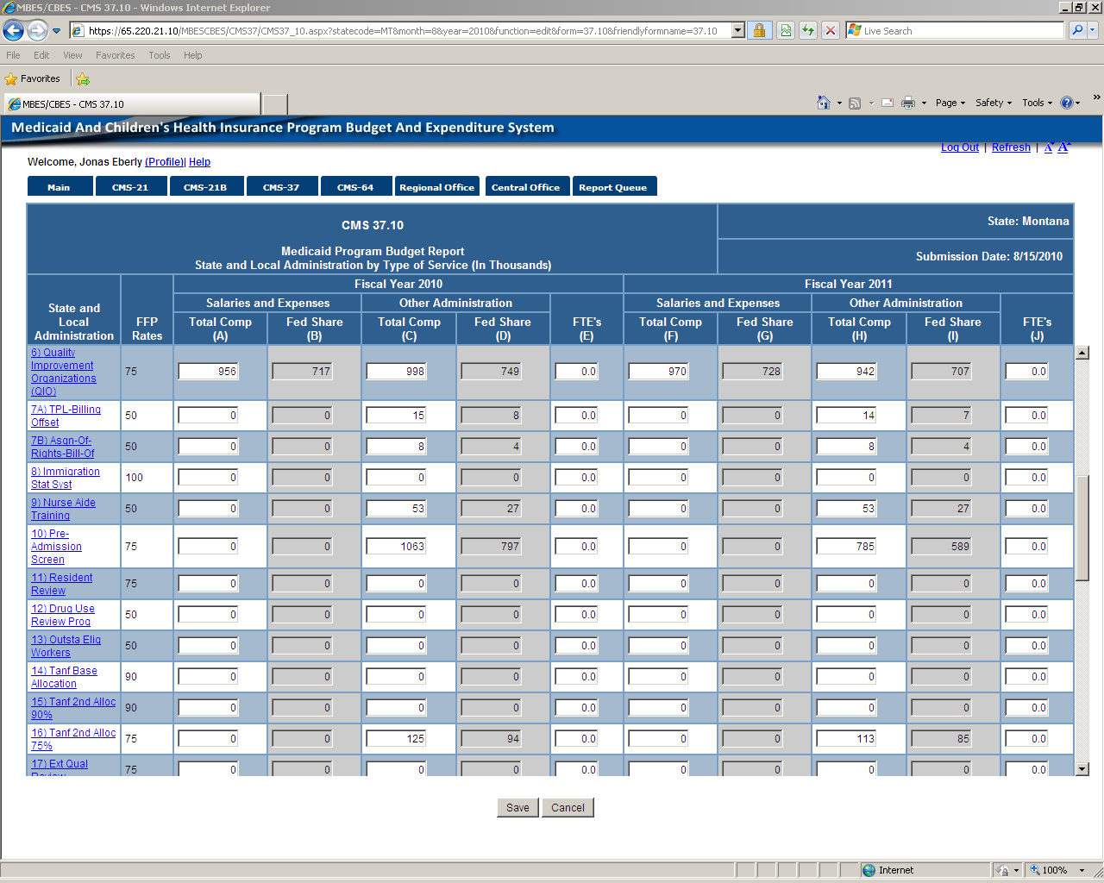

Continued to next page.

37.10 continued from previous page.

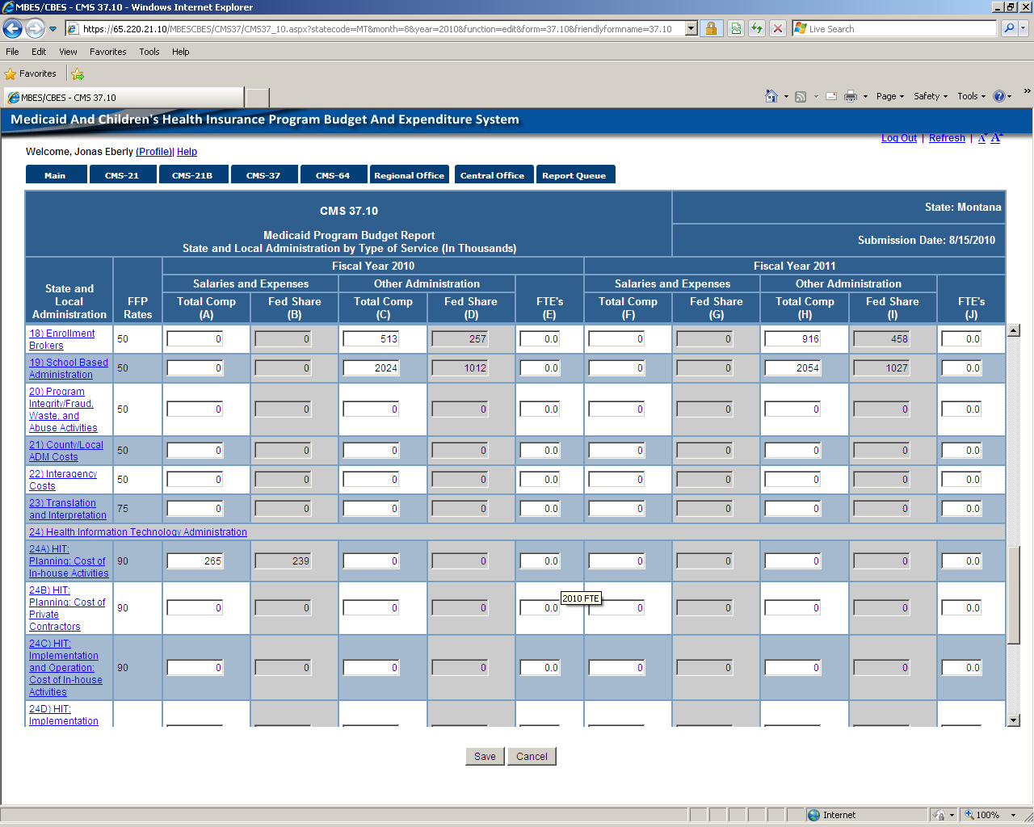

37.10 continued on next page.

37.10 continued from previous page.

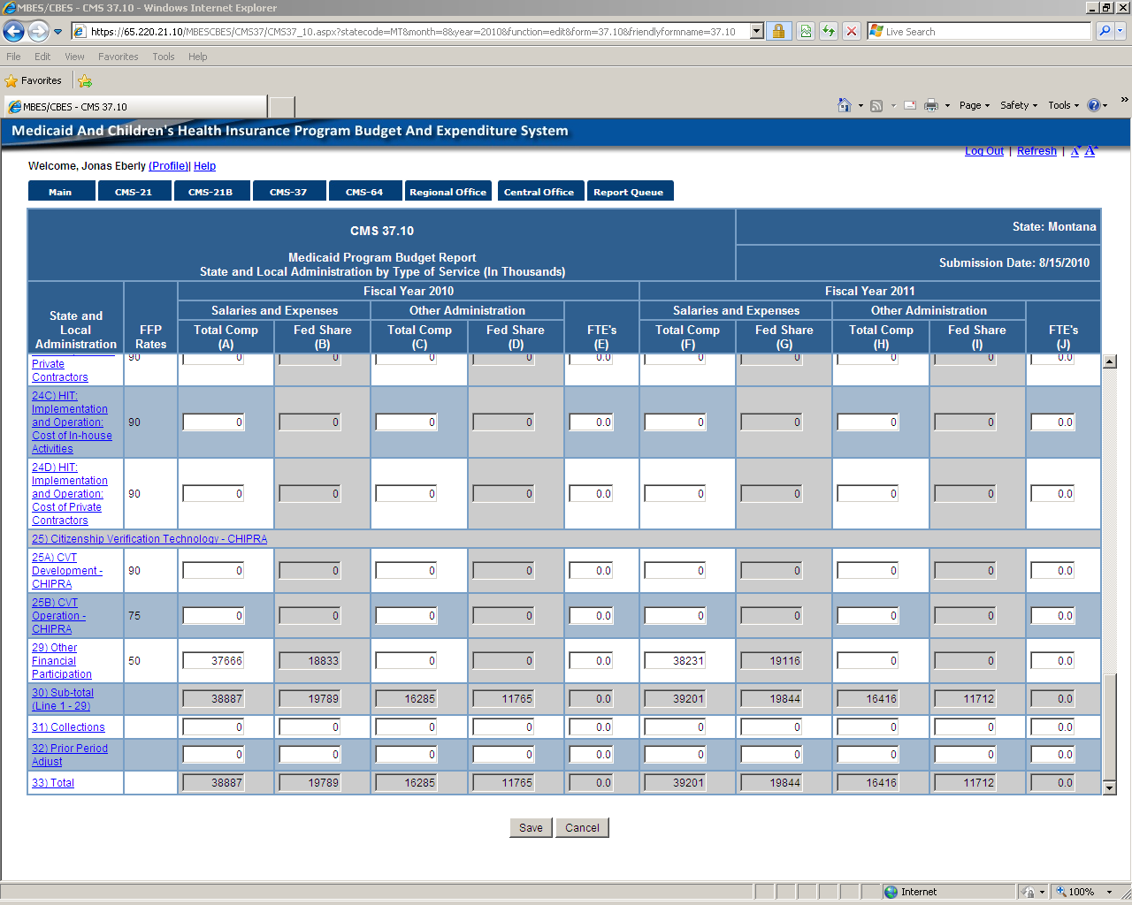

End 37.10

37.12 Narrative – A PDF or Excel can be created in browse mode for all forms.

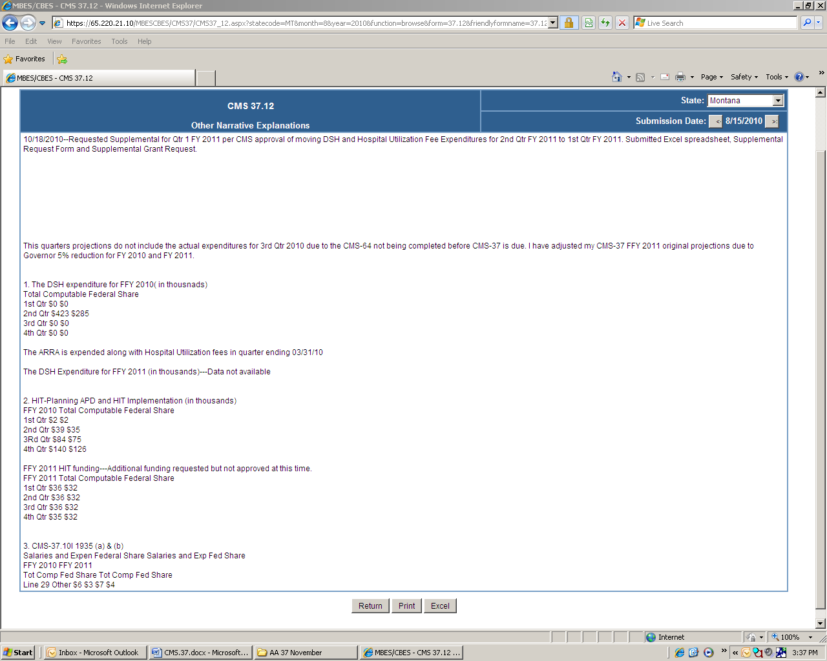

End of CMS-37.12

CMS 37.1 in browse mode

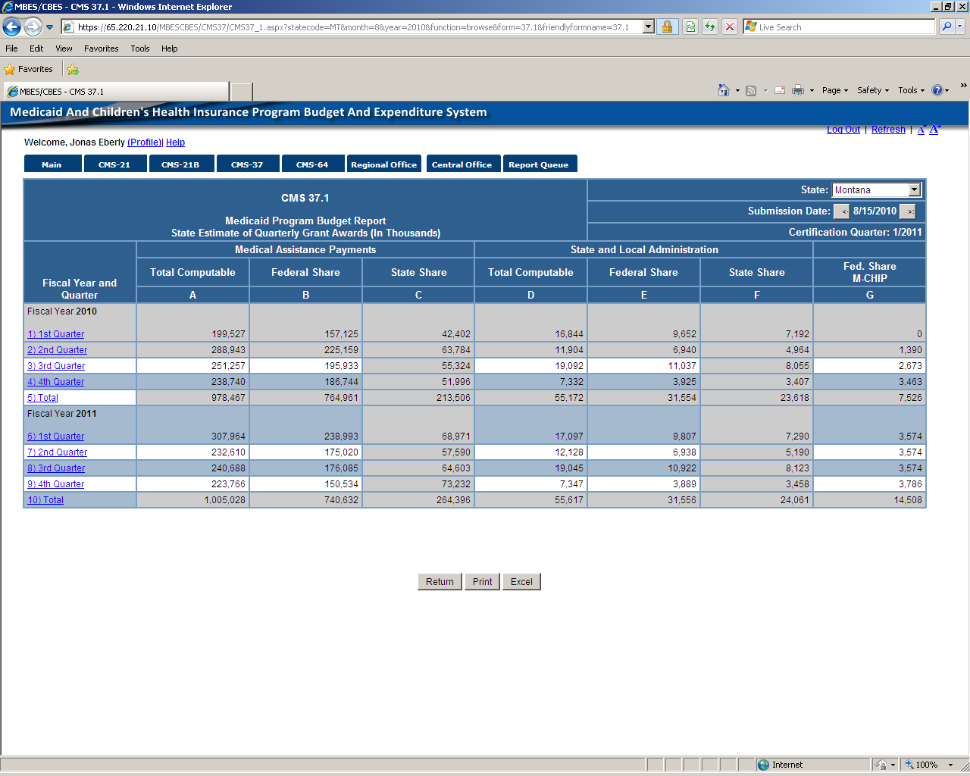

End of CMS-37.1

CMS-37.3

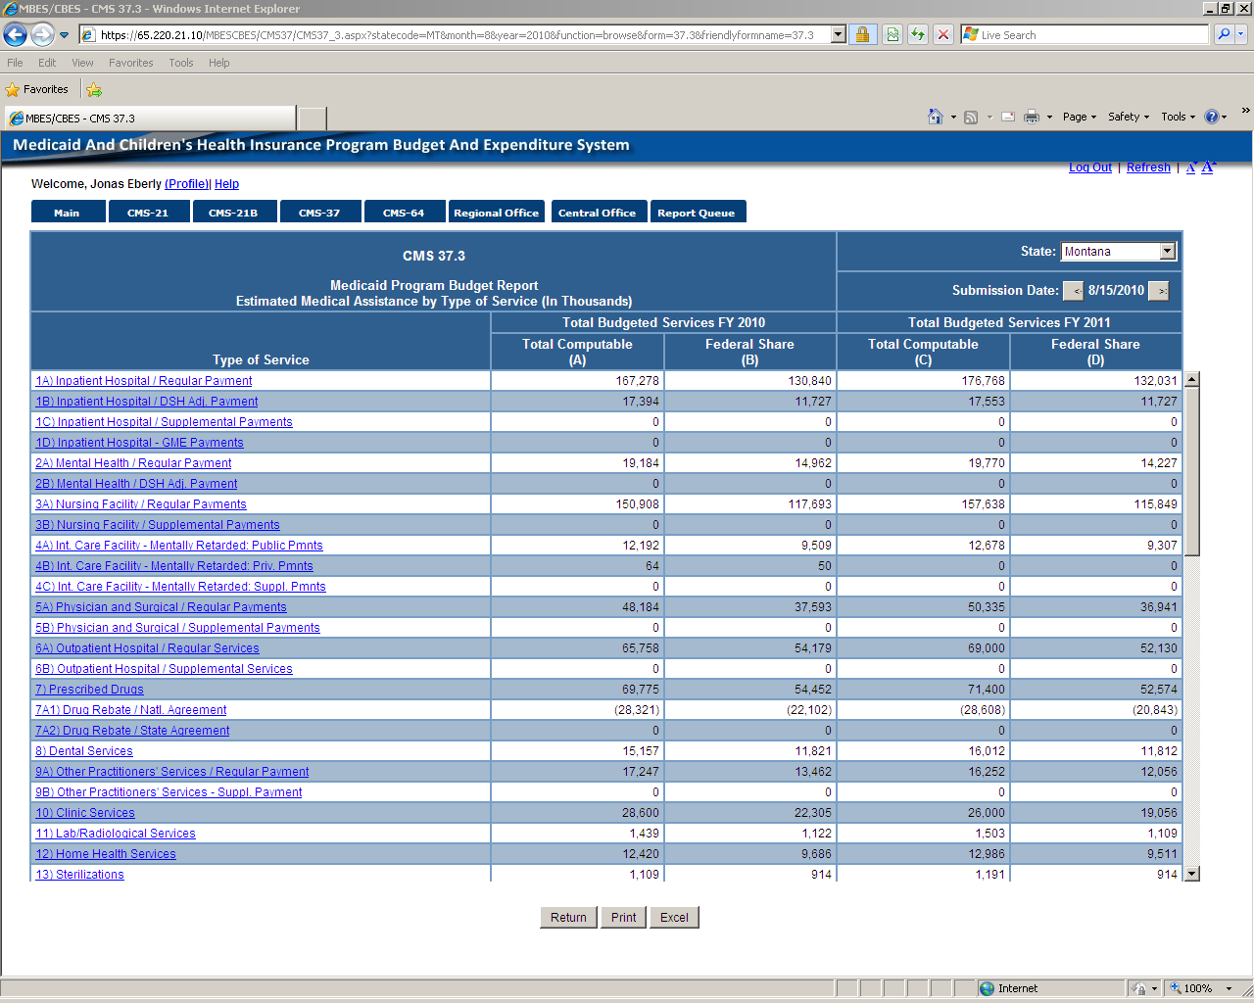

CMS-37.3 continued on next page.

CMS-37.3 Continued

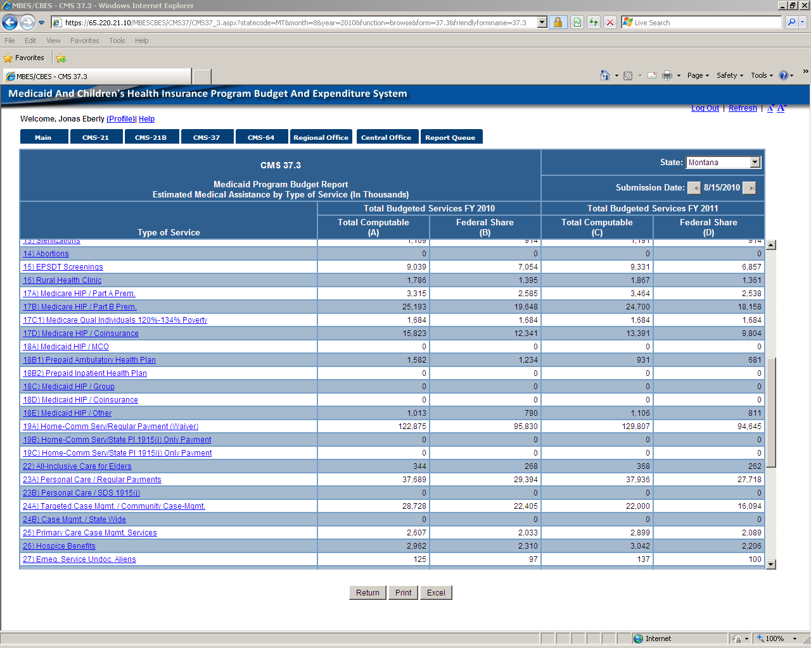

CMS-37.3 Continued on next page.

CMS-37.3 Continued on next page.

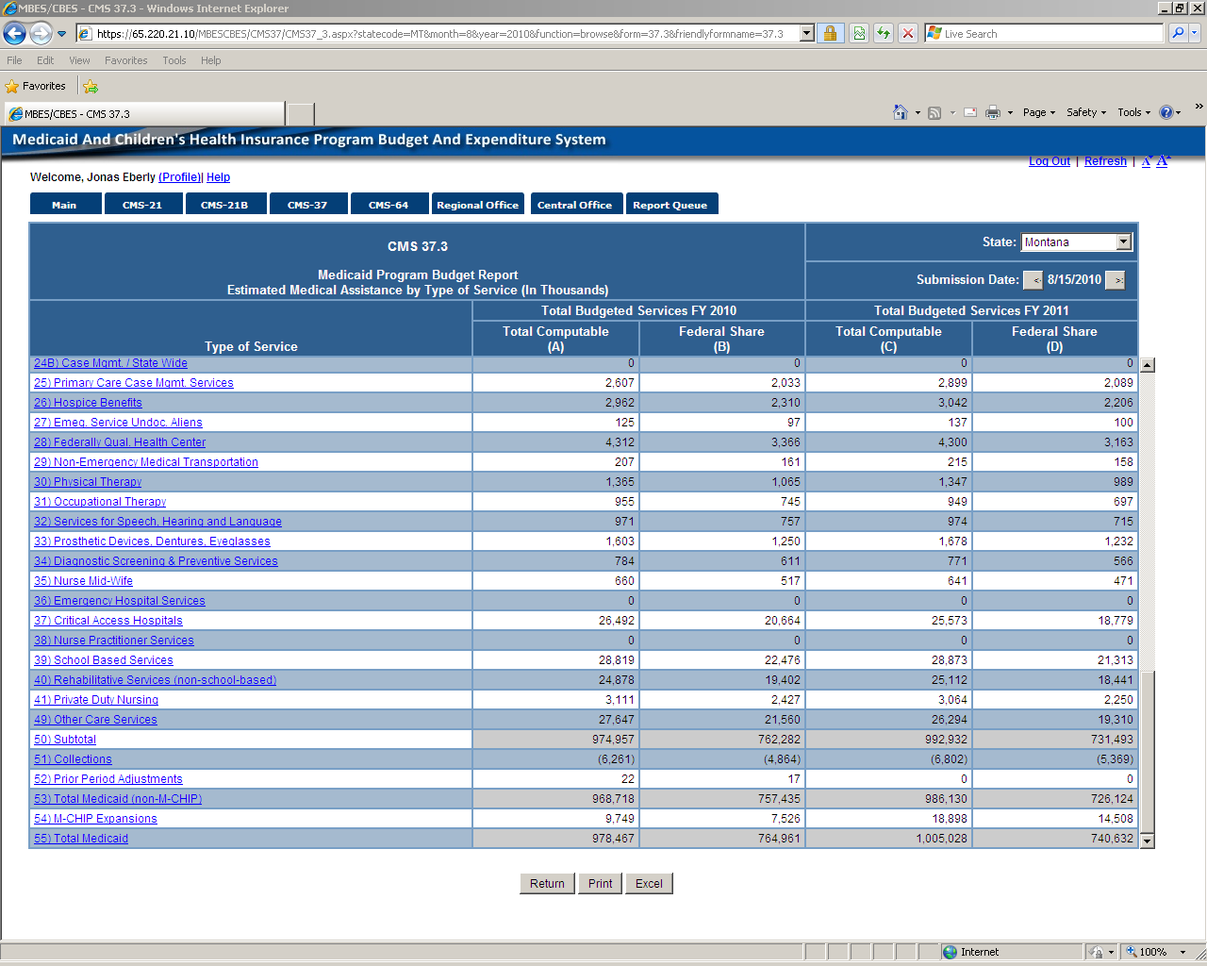

End of CMS-37.3.

CMS 37.7

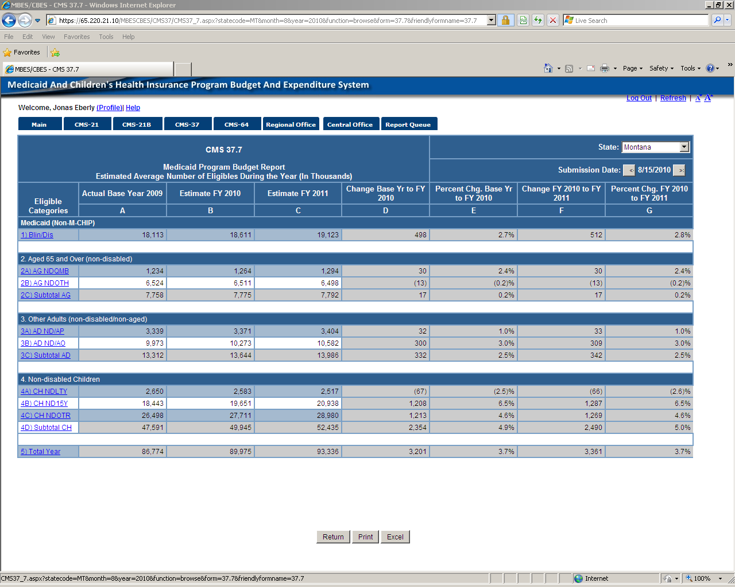

End of CMS 37.7

CMS-37.9

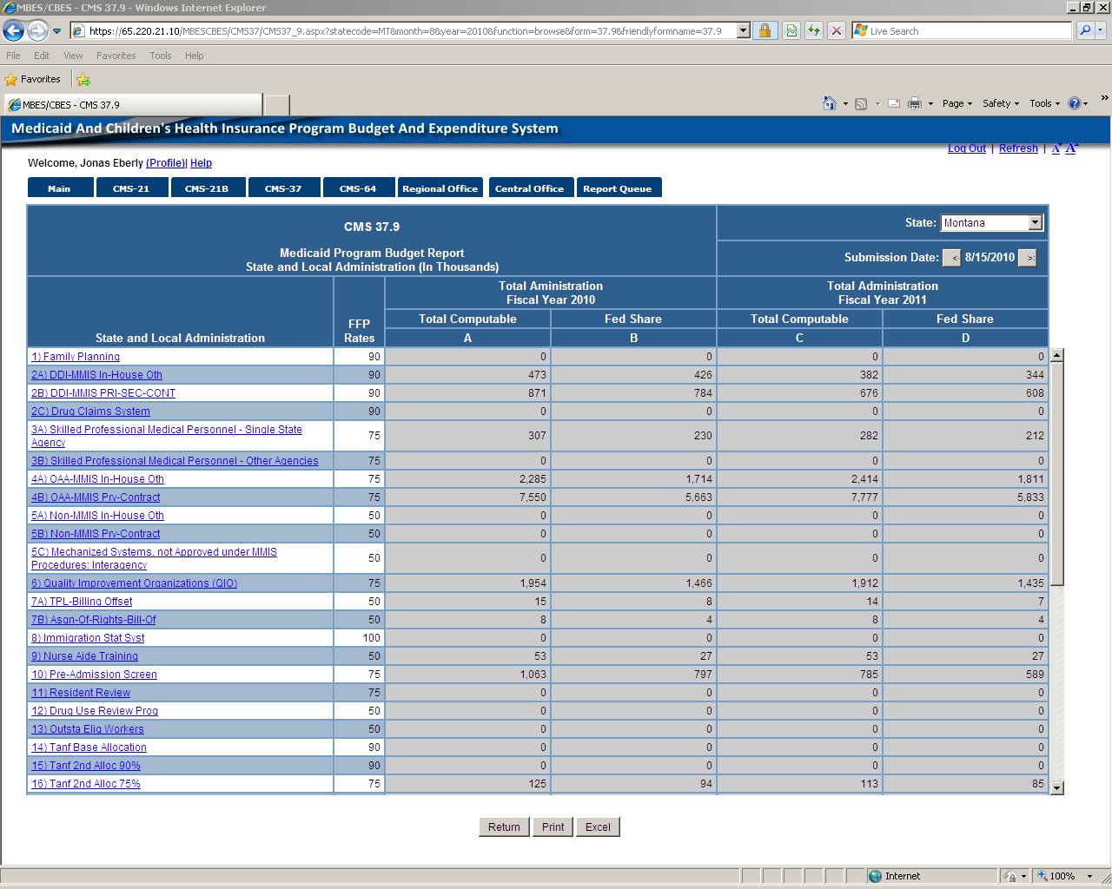

CMS-37.9 Continued on next page.

CMS-37.9 Continued .

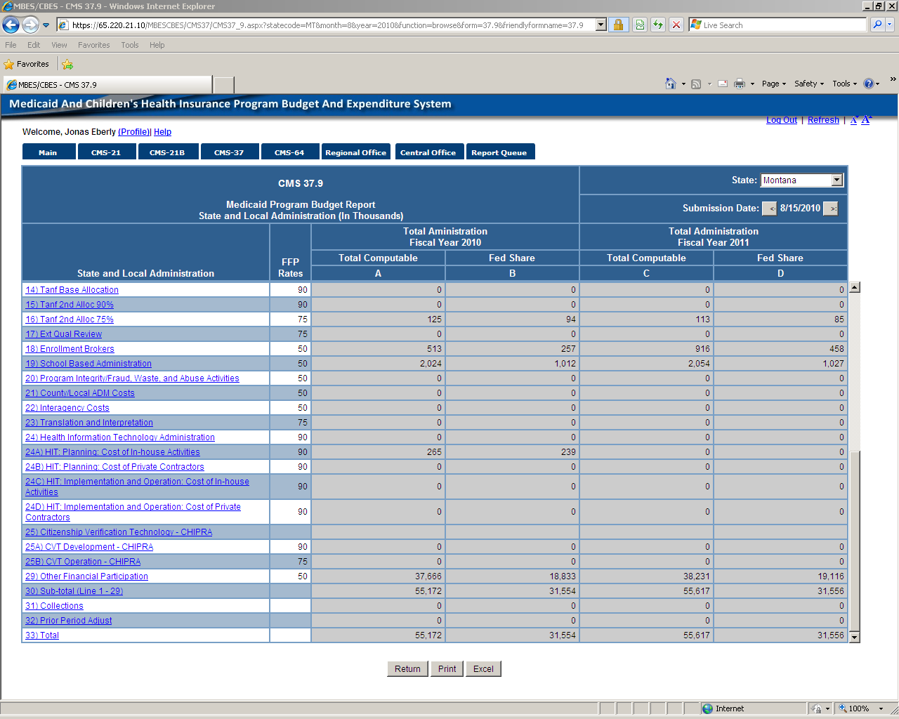

CMS-37.9 End

CMS 37.10I

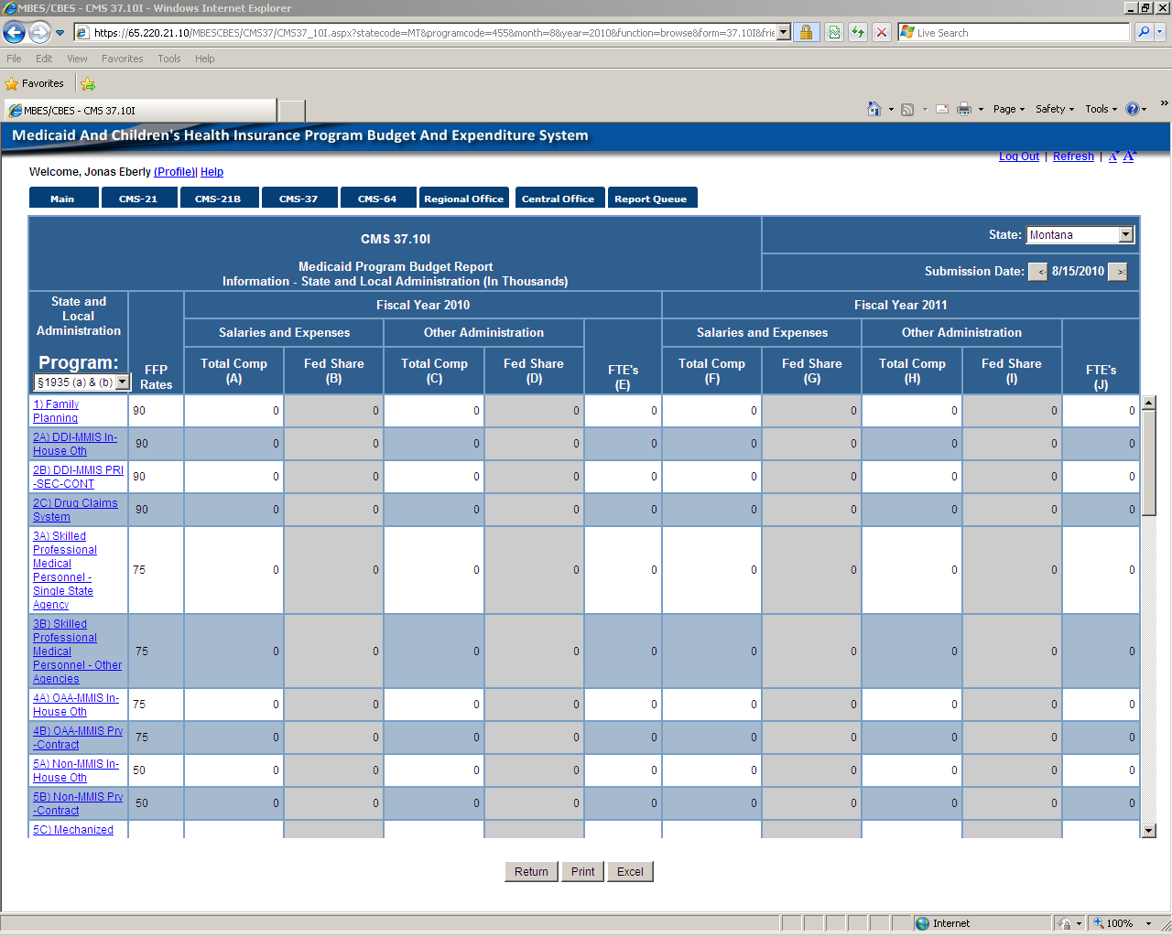

CMS-37.10I Continues to next page

CMS-37.10I Continued.

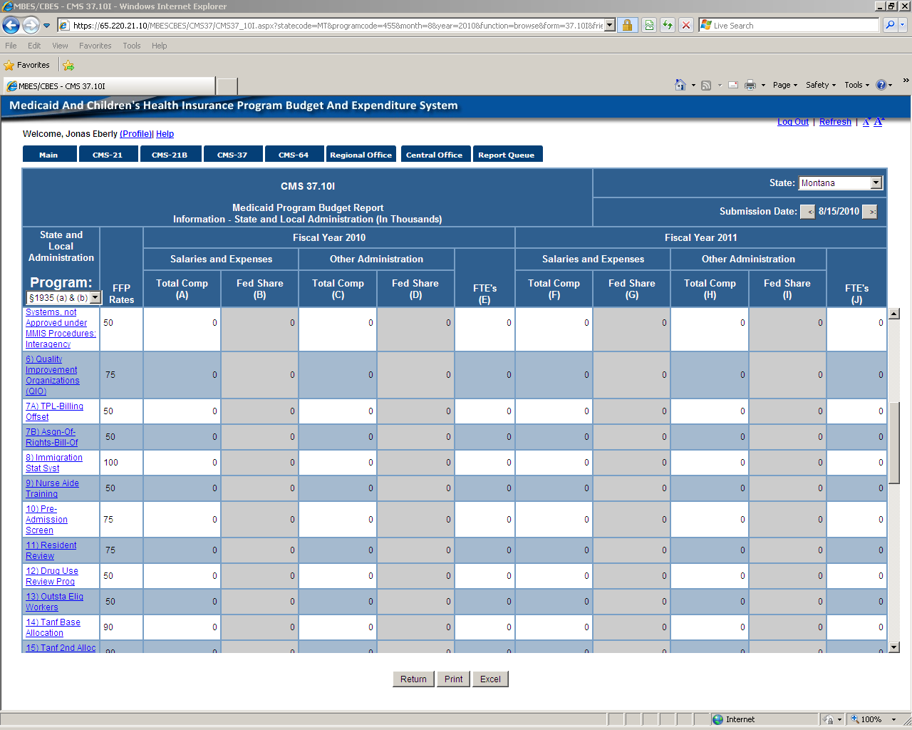

CMS-37.10I Continued.

CMS-37.10I continued from previous page.

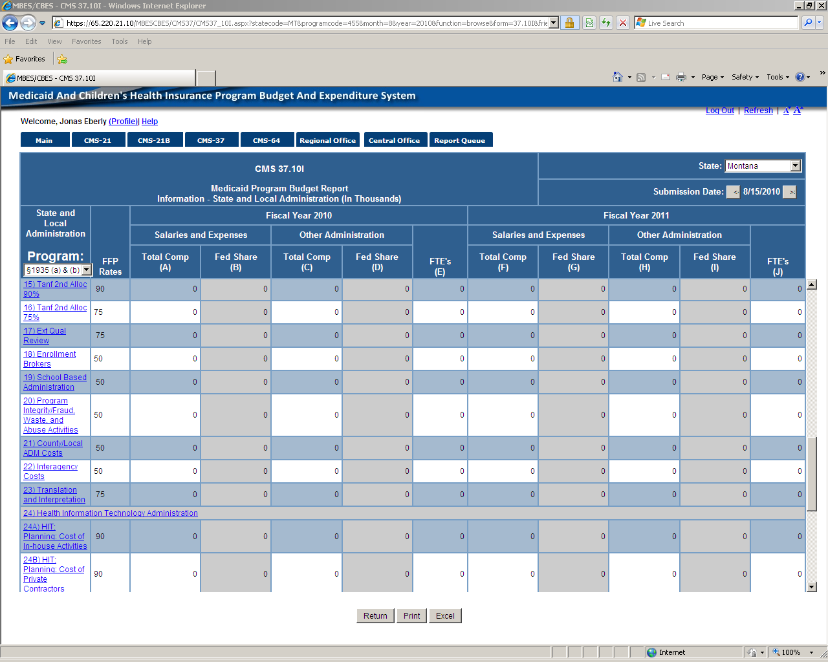

CMS-37.10I Continued.

CMS-37.10I continued

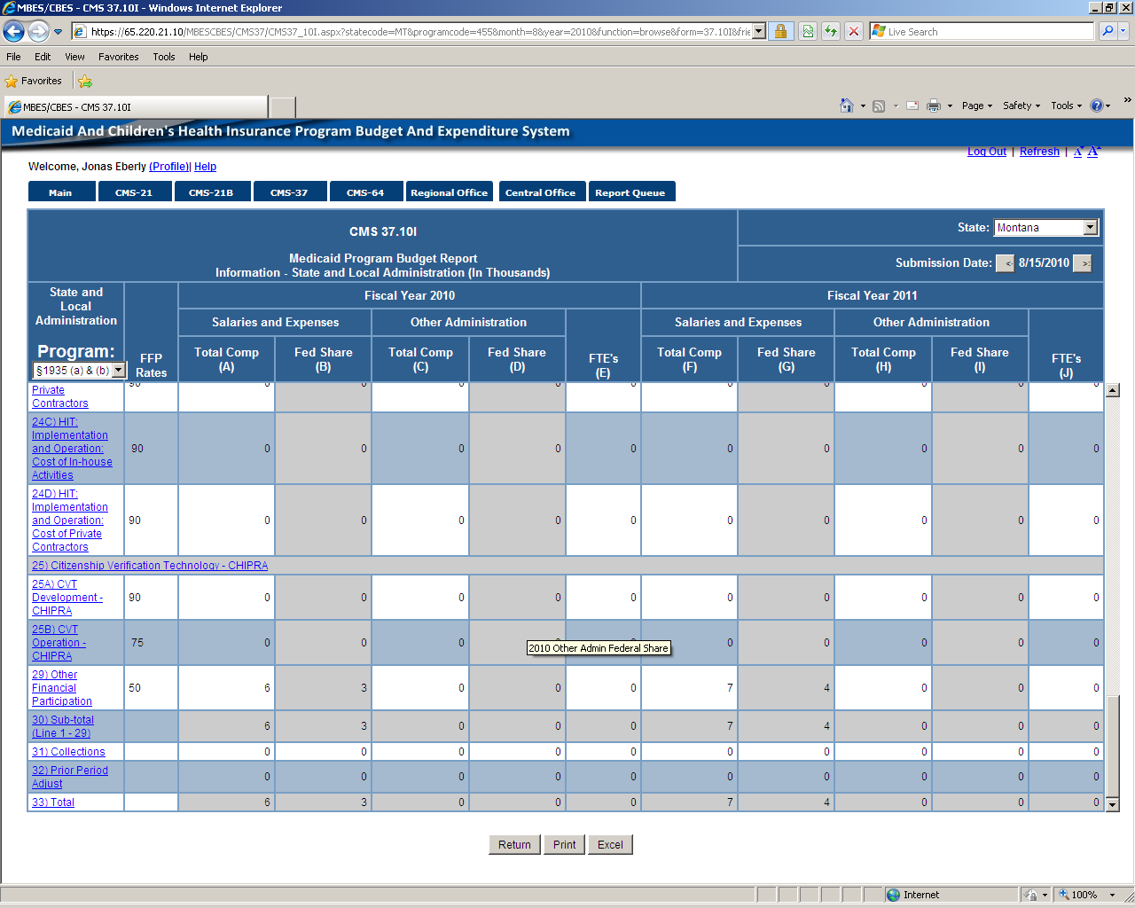

CMS-37.10I End.

Definitions provided for each Line item either in Browse or Edit mode.

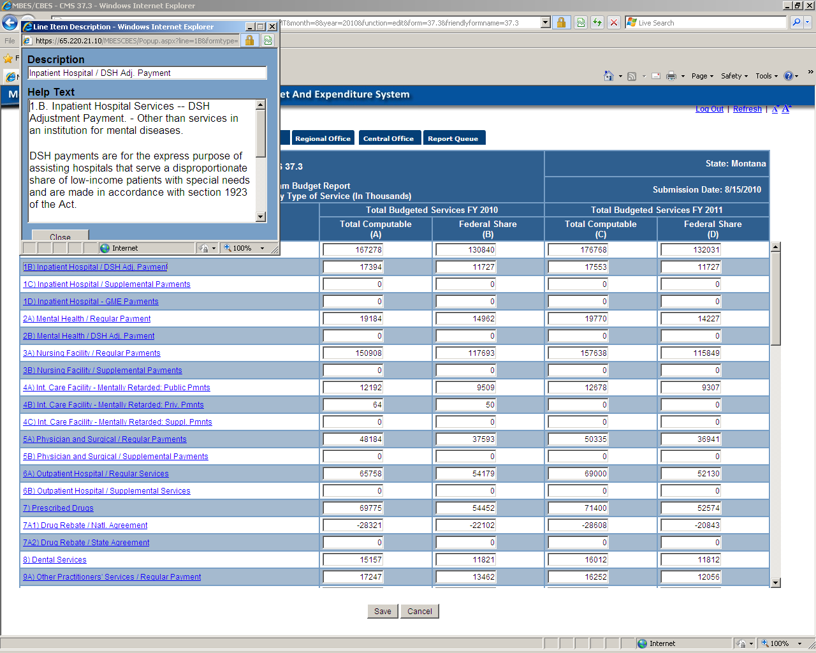

Below the navigation bar, the public has access to Certify, Uncertify, Print, Rates, and Reports. (Only specfied individuals within the State have Certify/Uncertify privileges.

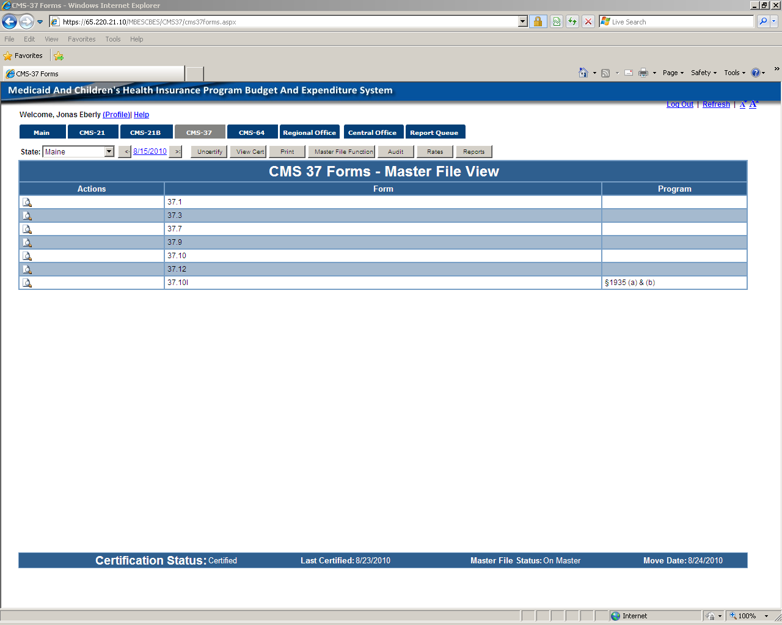

End of certified CMS-37.

Uncertify submission screen.

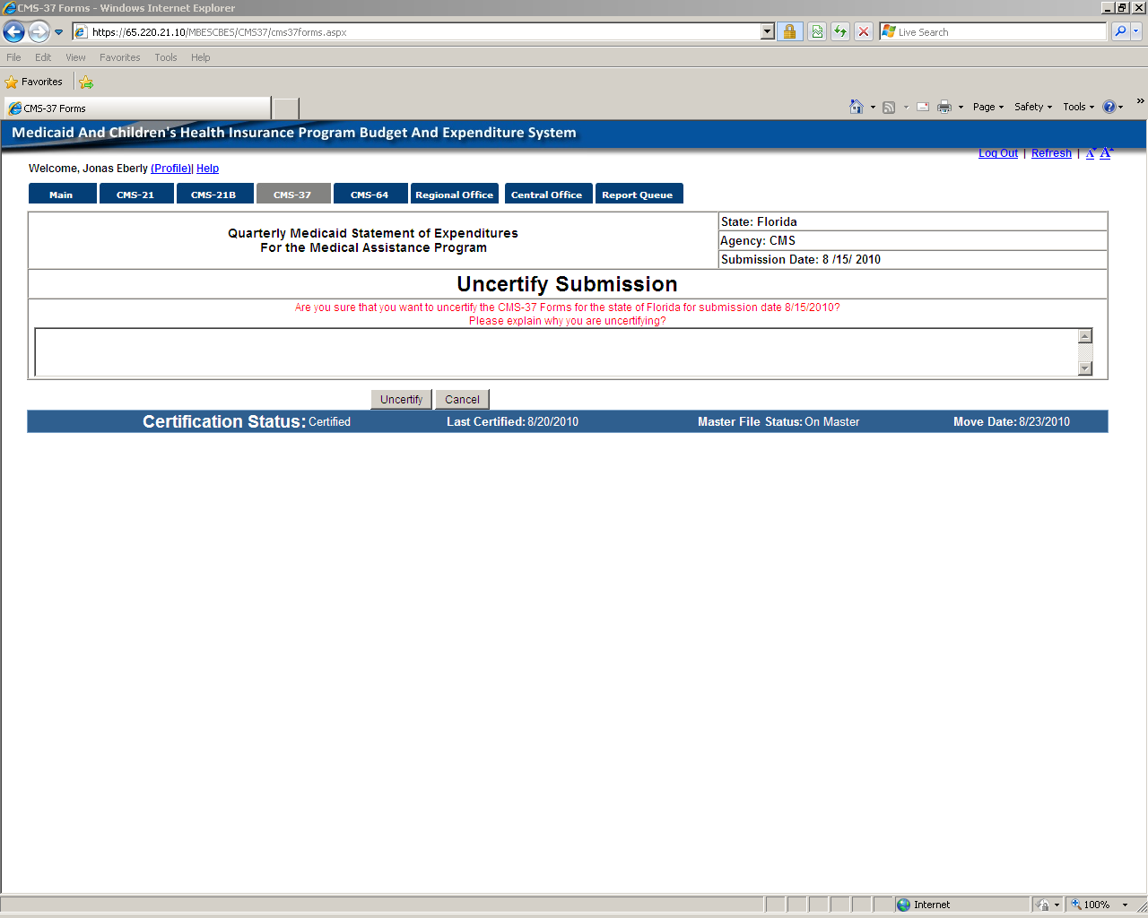

End of uncertify CMS-37 screen.

Printing functions – Option to print blank forms or Entire Series of populated forms.

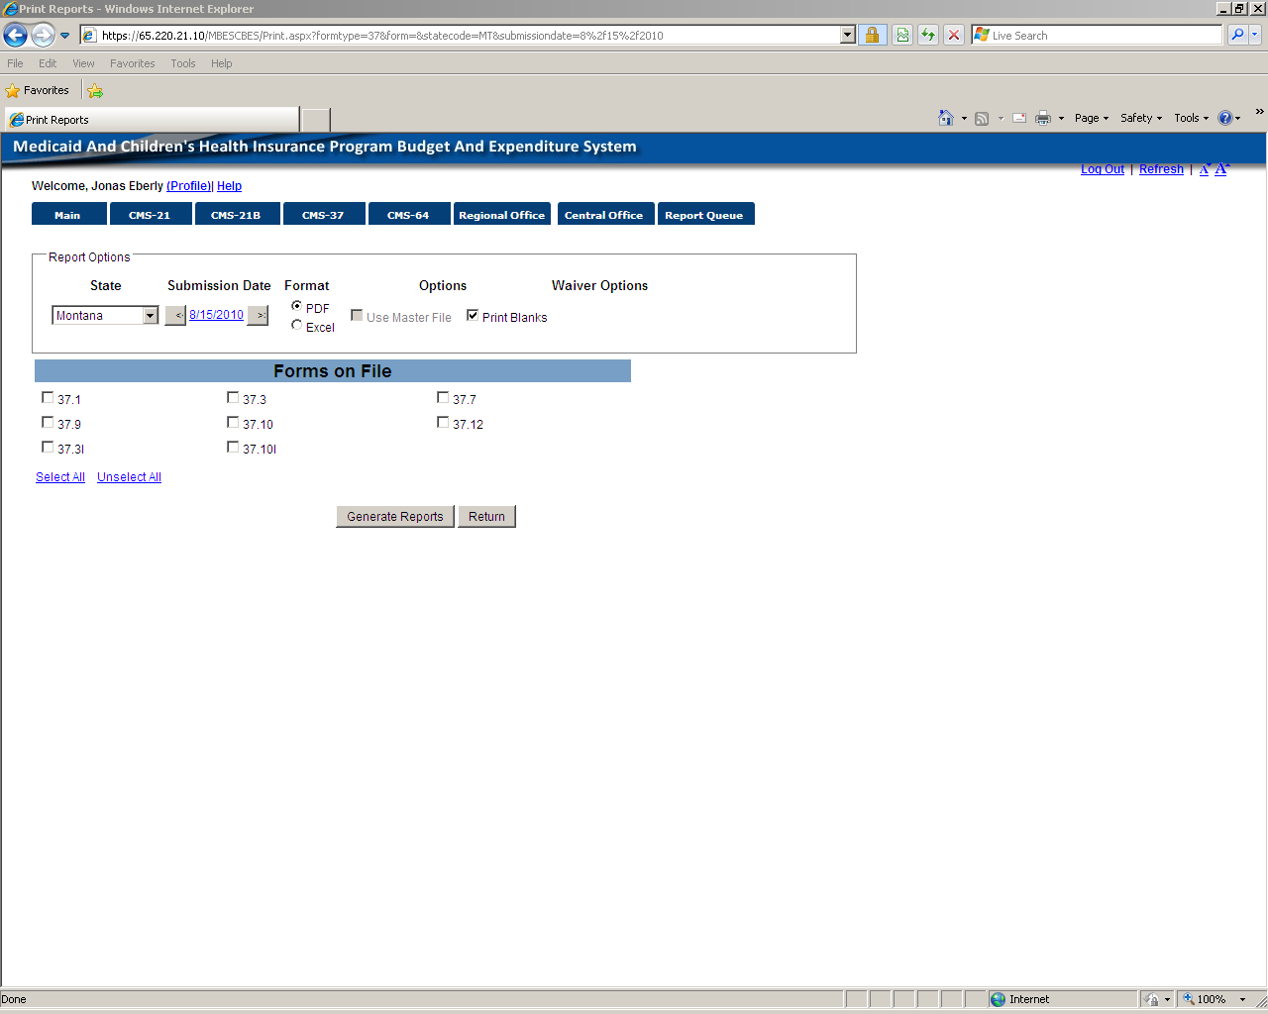

Rates button.

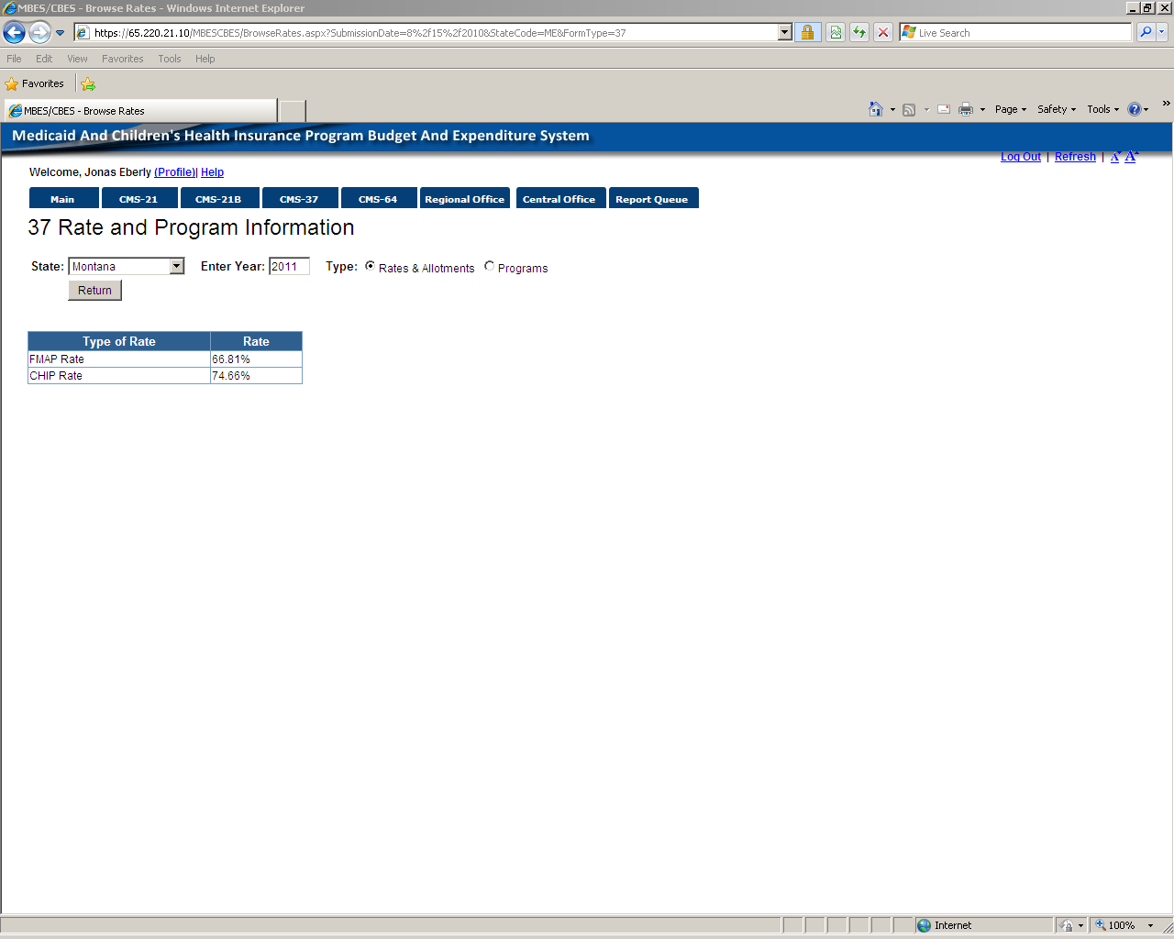

Rates Button continued

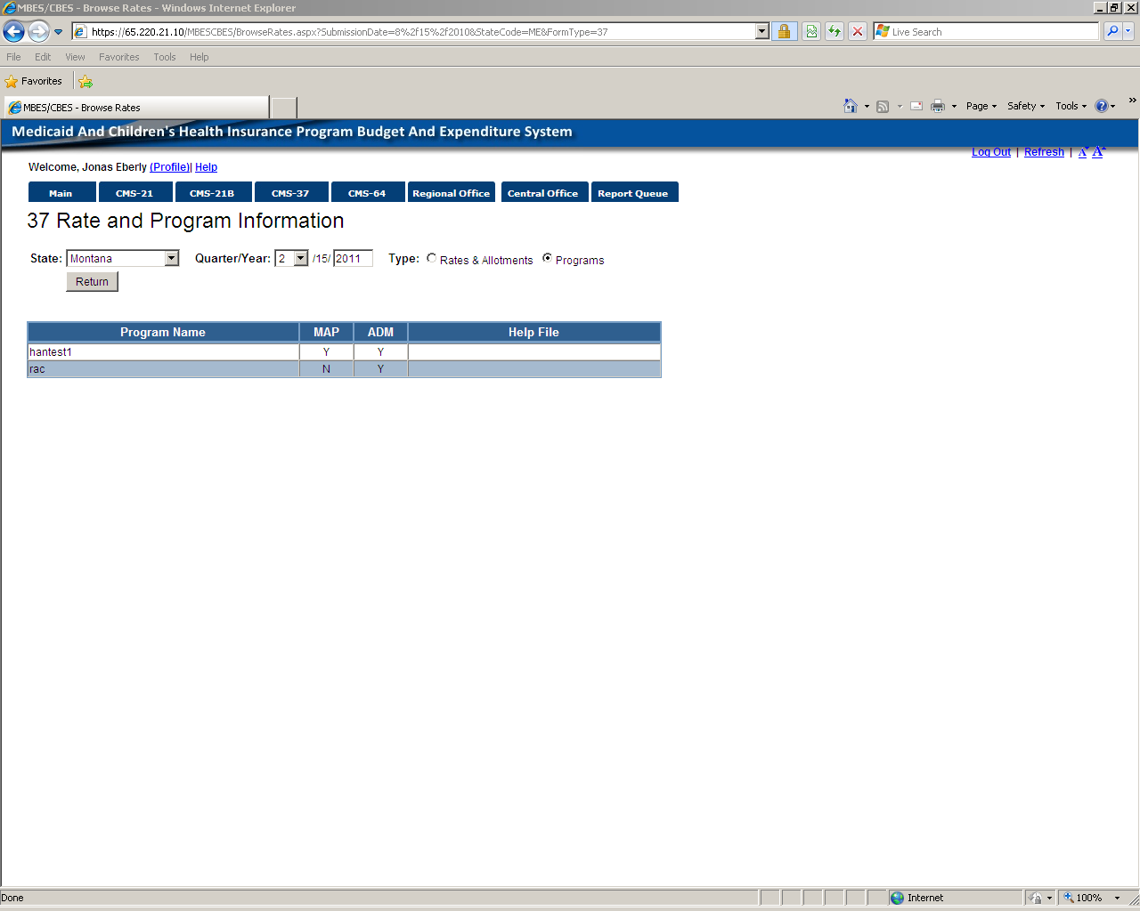

CMS-37 Reports Button

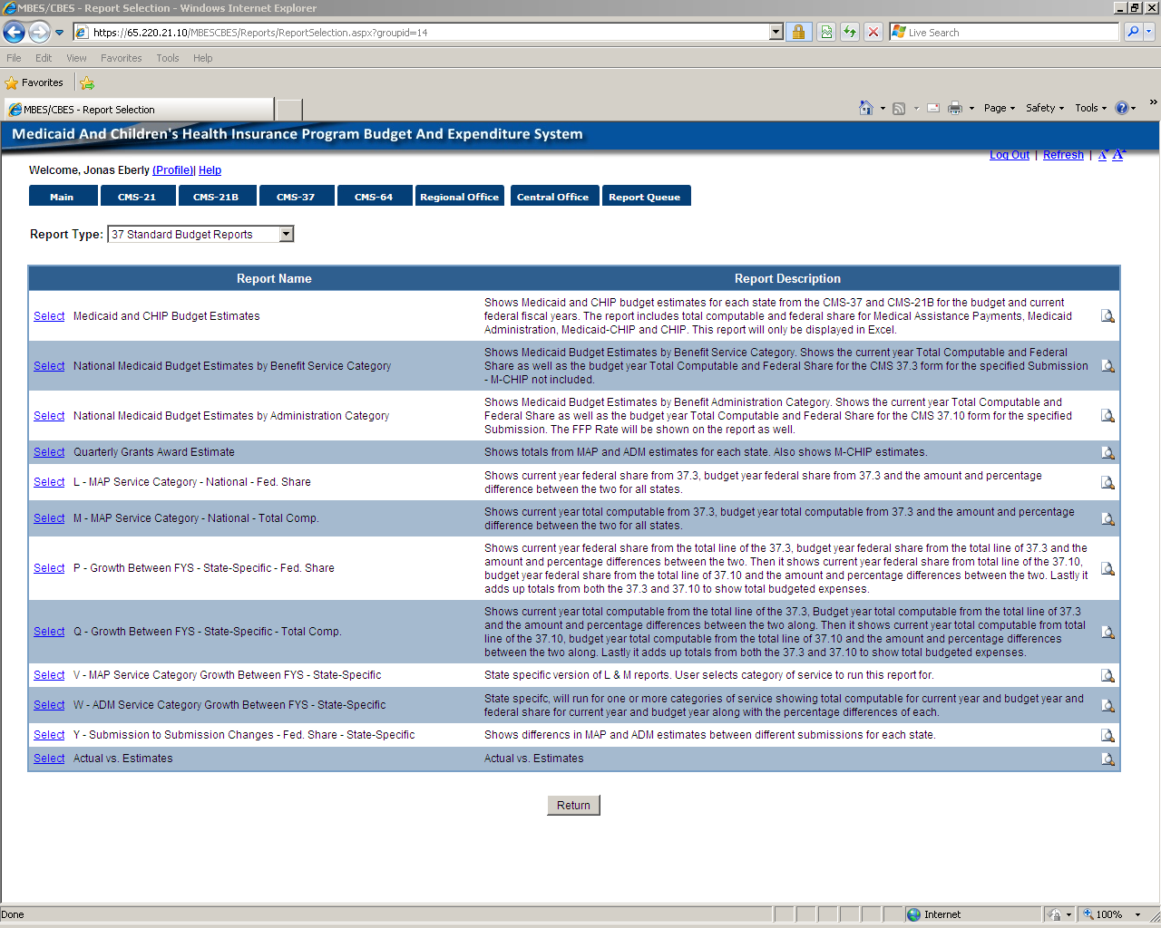

The following figure shows a sample of an error screen that will occur in the event of a system error. To expedite resolution of the error, all errors occurring in the system will now be logged and tracked using the Error Id number presented on the screen:

This is a sample of a Configuration Error screen that is titled, "Server Error in '/MBESCBES' Application." It may appear when the screen is temporarily not available (such as during software maintenance periods or processing conflicts). Included on the screen (from top to bottom) is text for the Description, Parser Error Message, Source Error (Line number identifying the violation appears in red), Source File, and Version Information.