Requirements for BOND-Related Changes to
WIPA/ETO Subsequent to OMB #0960-0629

- Formatting and Numbering of Instructions on the I&R and Assessment Screens

The instructions in the alert text are automatically populated and inform users if they are working with a BOND participant and the participant’s assigned treatment group. Due to unexpected problems with the software, we are not able to make the alert text appear in WIPA/ETO as we originally planned. As a result, we need to reformat the alert text to be displayed with new numbering in the I&R and all three Assessment screens.

An example of the previous I&R screen and our notes from OMB # 09600629 (1/18/11) are below:

Previous Example I&R Screen and Notes from OMB # 09600629 (1/18/11)

Instructions for Treatment Group T1 and automated Treatment group indicator added to the I& R Assessment Screen. The instruction and treatment group indicator will only appear if beneficiary is a BOND participant

Four examples of the required changes are provided below. Two versions of the I&R screens illustrate the changes for the I&R screens for T1-WIC Treatment Group (Example 1) and the Not a BOND Participant option (Example 2). The remaining two versions of the screens illustrate the changes to the baseline assessment for Treatment Group T1-WIC (Example 3) and for the Not a BOND Participant option (Example 4.) The changes to the remaining I&R, baseline, follow-up assessment and summary screens are the same. The changes to the screens are:

- BOND Participant Treatment Status Reformatting. As before, the text of the BOND alert is in the box for Section A. For BOND participants, the treatment group information is now labeled as A-1 – A-4, depending upon the beneficiary’s assigned treatment group. In Example 1 below, treatment group T1-WIC is numbered A-2. A-5 is now the Treatment Group indicator.
- BOND Participant Treatment Status Alert Text. For BOND participants, some of the alert text is changed. BOND requested that we change their alert text and instructions to include only one phone number and eliminate the e-mail address. The text “Please assist the beneficiary to contact BOND Central Operations at 617-520-2880 or BOND Central Ops@bondssa.org to find out where the beneficiary may receive BOND services. “ was removed from some alerts and all of the alert text is now consistent and instructs “Contact the BOND Call Center toll-free at 1-877-7BOND09 (1-877-726-6309) to find out where the beneficiary may receive BOND services” (Example 2).
- BOND Nonparticipants Formatting and Instructions. Previously there was no text indicating the BOND status of a beneficiary who is not participating in BOND; Section A was blank in this case. Due to the limitation of the software, the screen now displays text indicating that the beneficiary is not a BOND participant. This text is not numbered, but now the following sections are renumbered (Example 2). For the assessment screens, the instruction in Section A for BOND nonparticipants is to proceed with standard WIPA services (Example 4). Because the alert field is no longer blank for nonparticipants, instruction is provided to prevent confusion.
- Renumbering Sections and Questions. The following sections, such as Inquiry Information in the I&R screen is now Section B and Topic of Inquiry starts with numbering at B1, and all subsequent sections following sequence. The same is the case for Examples 2-4, and all remaining versions of the screens. The numbering does not affect the collection, storage, or retrieval of the data.

Example 1 : Version of the I&R Assessment Screen for a Beneficiary Assigned to T1-WIC Treatment Group
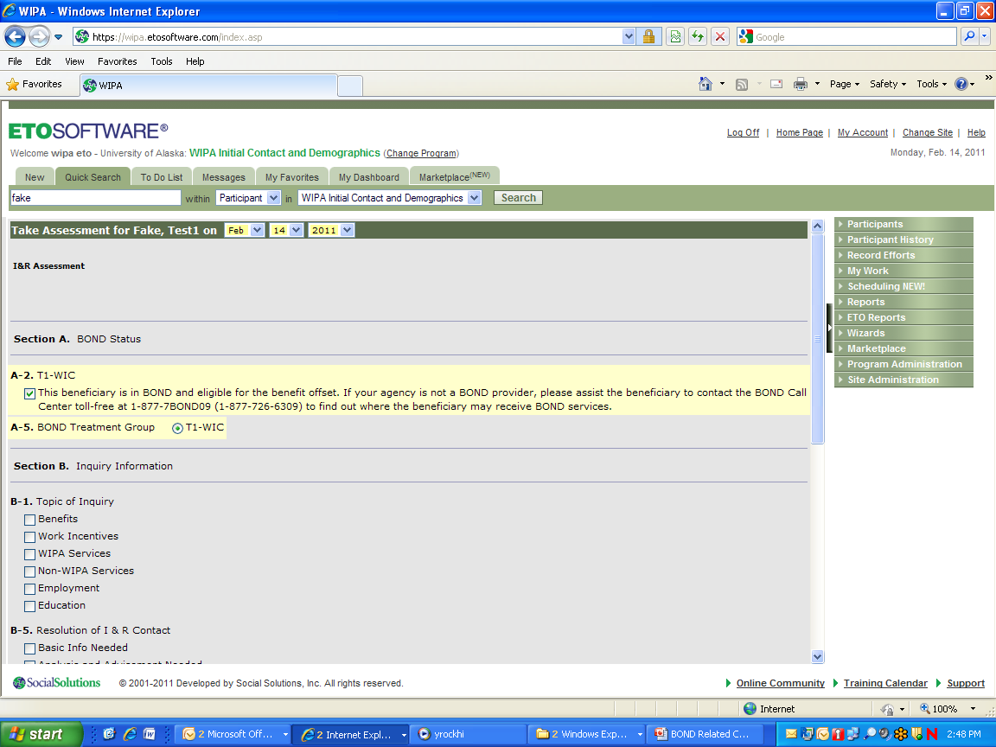

Example 2: Version of the I&R Screen for a Beneficiary Who is Not a BOND Participant.

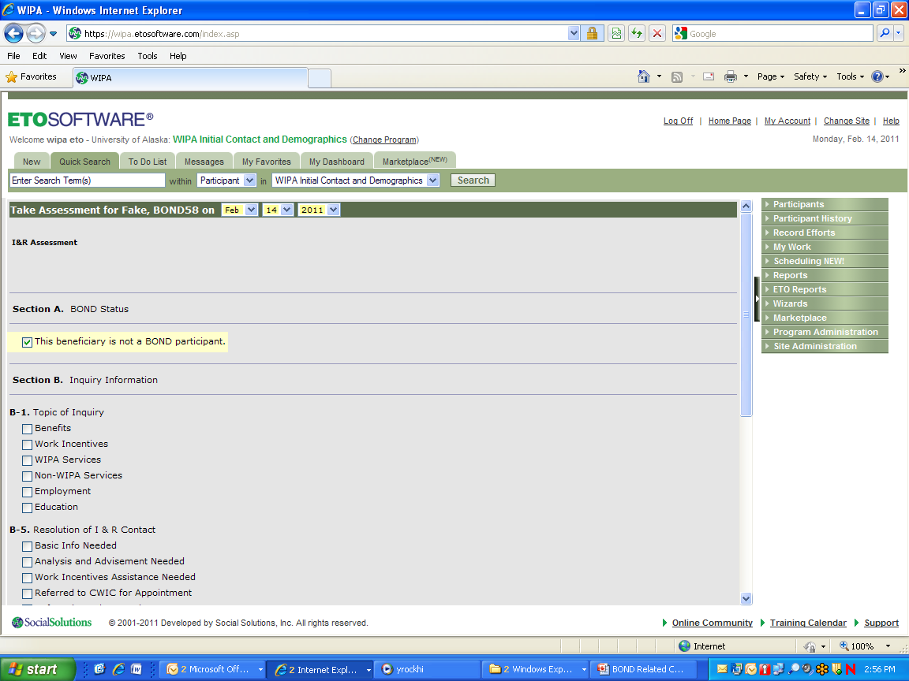

Example 3: Version of the WIPA Baseline Assessment Screen for Beneficiary in T1-WIC

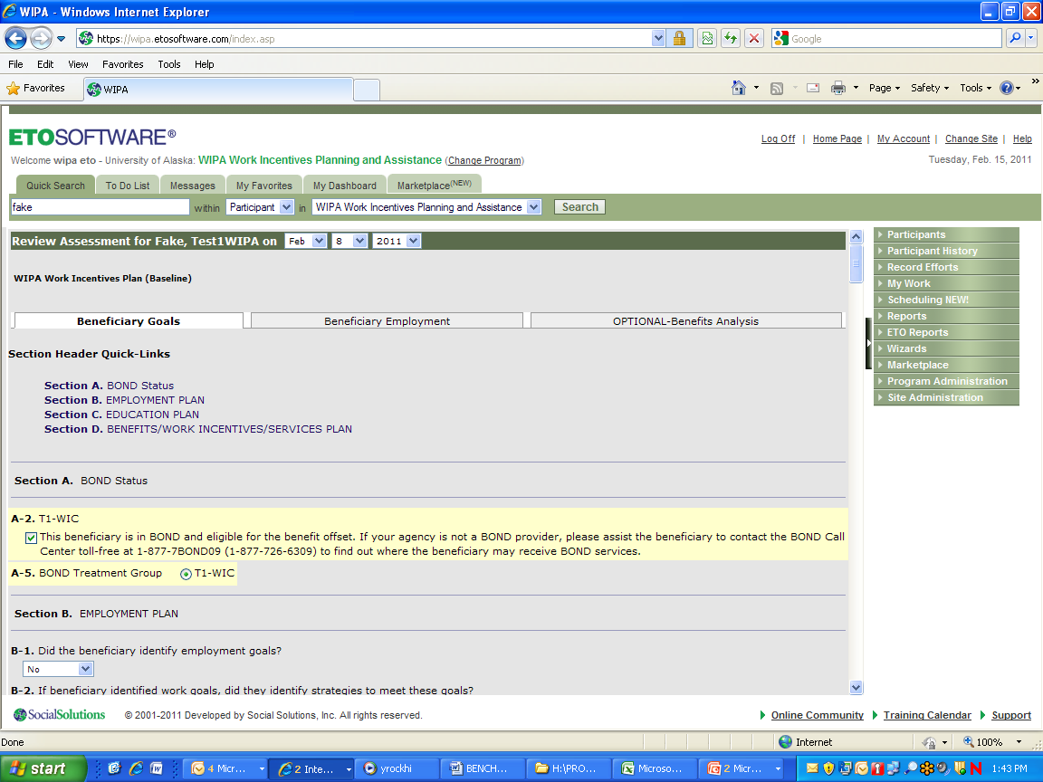

Example 4: Version of the WIPA Baseline Assessment Screen for a Beneficiary Who is Not a BOND Participant

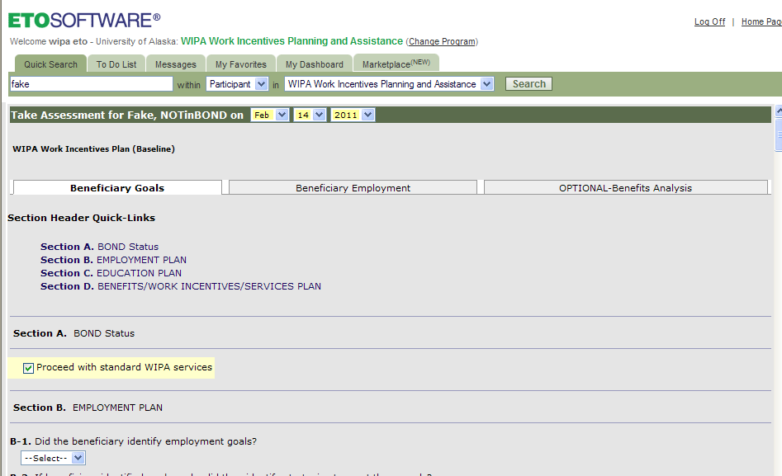

- Consistency of Treatment Group Labels

At the request of BOND, we have relabeled the Treatment Group Variables in WIPA/ETO T1-WIC, T21-WIC and T22-EWIC to be consistent throughout the screens and alerts. For example, previously, the treatment groups were identified as either T1 or T1-WIC . The changes are applied throughout the software. The main change is to the Participant Search Section below, where the treatment groups were previously labeled T22, T1, and T21.

