Requirements for Planned Changes to WIIRC-Related Changes to
WIPA/ETO Subsequent to OMB #0960-0629

Consolidate the Participant Searches
In the current version of ETO, the WIIRC user must perform two separate searches – the first search is performed to determine if the beneficiary is in BOND and the second search is performed separately to determine if the beneficiary has already been enrolled in WIIRC. A series of changes are planned to consolidate the two searches into one search requiring less work for the WIIRC users and reducing errors. The changes will be made over time as the software is able to support.
Change 1 - WIIRC Homepage
“Search for WIIRC or BOND Participants” is modified to include both searches. The name of the link was changed.
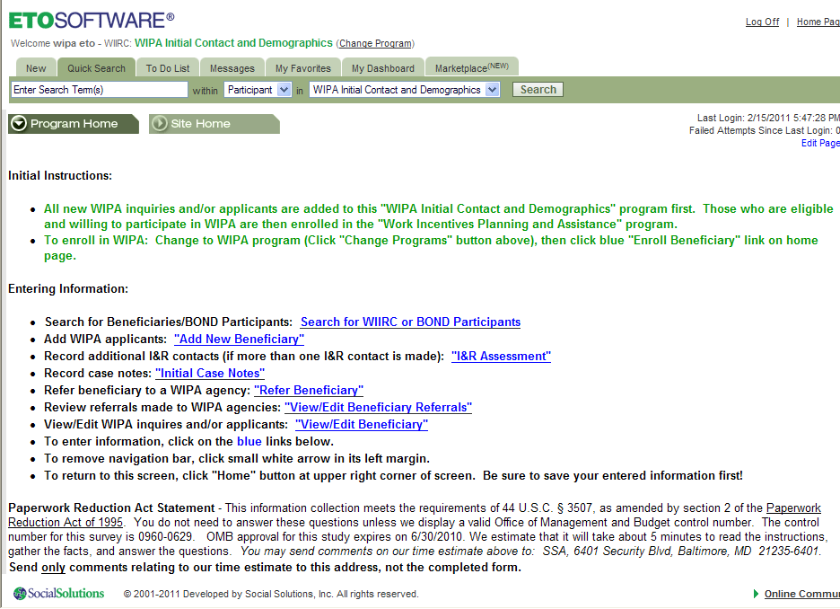

Change 2 - The Demographics Screen. Changed the name of the query to consolidate the two searches. This part of the screen will be eliminated if the software allows.

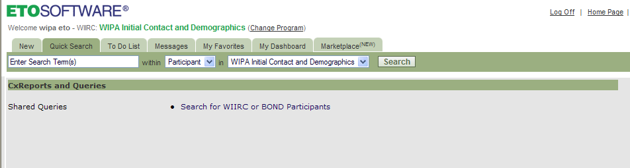

Change 3 - Search Screen. Changed the name of the query and the queries are consolidated.

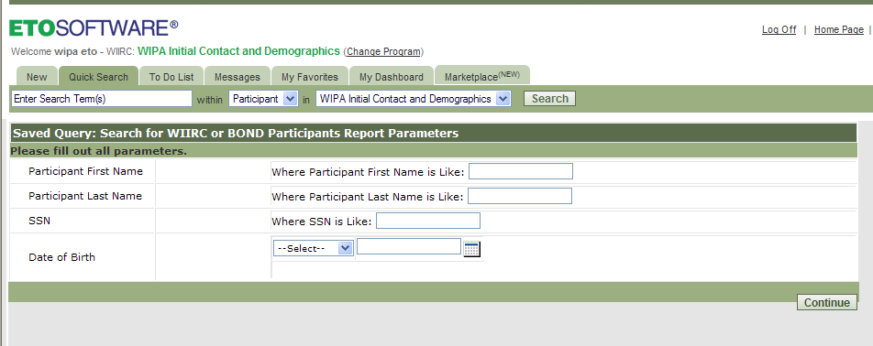

Change 4 - Review Results Screen. Changed the name of the query and the results of both searches are now visible in one output screen. Previously, there were two separate searches and associated search and output screens.
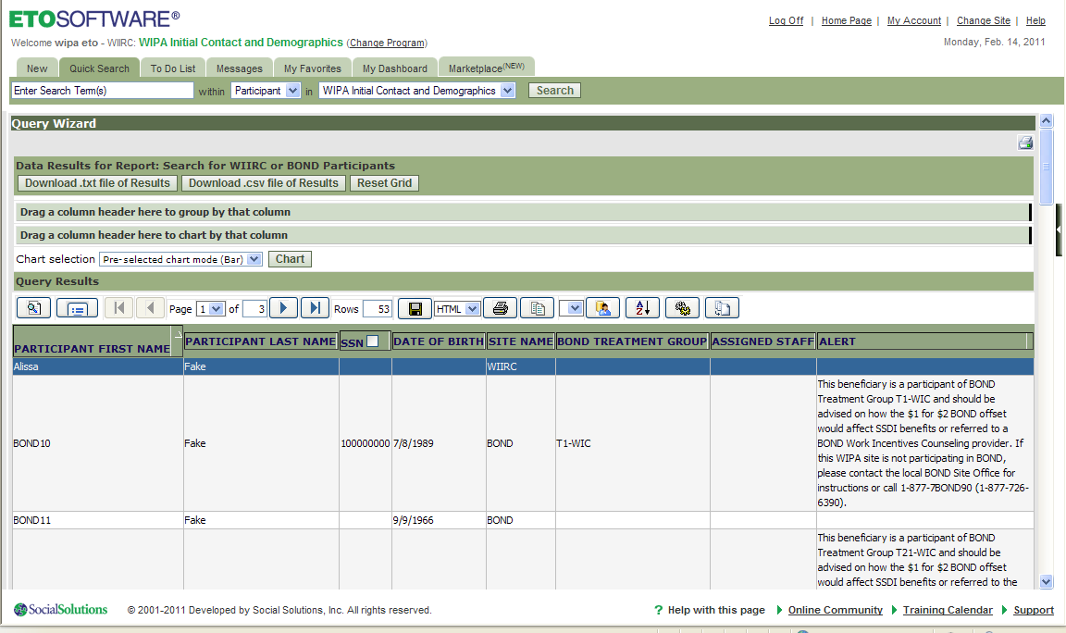
Site Name column “WIIRC” indicates the caller has previously contacted the WIIRC and is already enrolled. Results with “BOND” in the site column indicate that the caller is a BOND participant. If a BOND Participant, the next two columns indicate which treatment group the beneficiary has been assigned to and additional instructions are provided in the Alert column to the immediate right of the Treatment Group column.

