

Pat Quinn, Governor Grace Hong Duffin, Acting Secretary

100 South Grand Avenue, East ! Springfield, Illinois 62762
401 South Clinton Street • Chicago, Illinois 60607

November 24, 2010

Administration for Children and Families, Office of Administration
Office of Information Services
370 L'Enfant Promenade, S.W.
Washington, DC 20447

Attn: ACF Reports Clearance Officer.

Please find attached our comments on the Child Care and Development Fund State Plan Pre-Print dated September 24, 2010. Thank you for the opportunity to review.

We appreciate the direction that the Office of Child Care is heading, and we look forward to working with you to achieve great outcomes for our children.

If you have any questions, please let me know.

Sincerely,
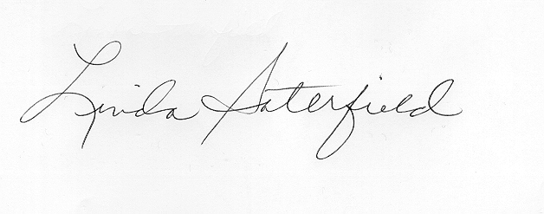
Linda Saterfield, Acting Director
Division of Human Capital Development

