OMB Control # 1024-XXXX Expiration Date:

DRY TORTUGAS NATIONAL PARK FERRY BOAT/SEAPLANE VISITOR QUESTIONNAIRE

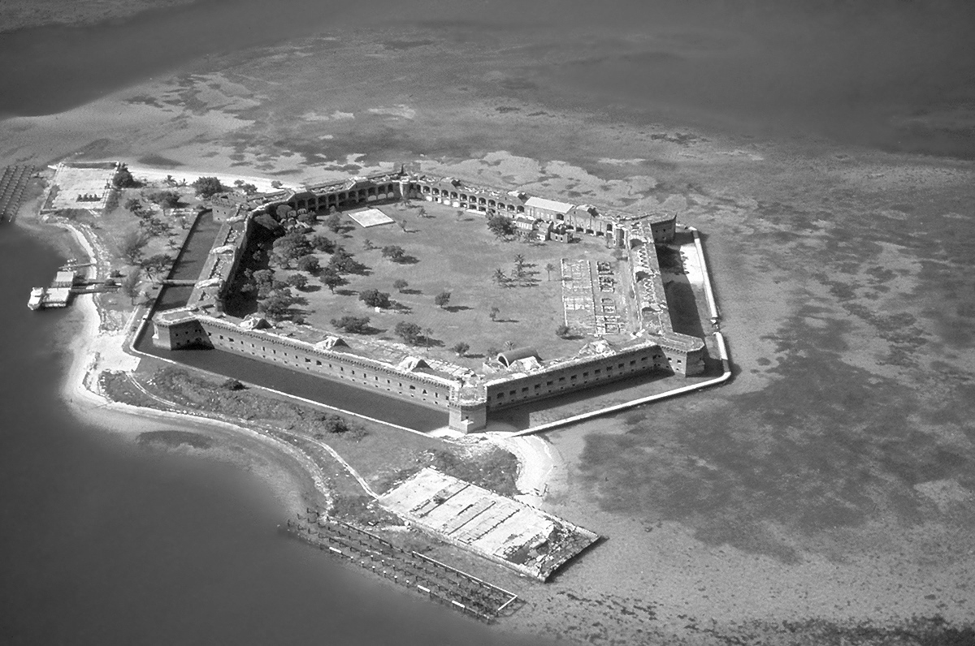

East Carolina University
Human Dimensions of Marine and Coastal Ecosystems
Institute for Coastal Science and Policy
Greenville, NC

Note: The text in the shaded boxes below will not be included in the survey (the visitors will not read this as a part of the survey process). This text is used to annotate the questions in response to Part A question 2 of the PRA Supporting Statement

In the following questions, please tell us about your use history of Dry Tortugas National Park.

[Park Use History] – In this section we would like to understand how people use DRTO and how those use levels have changed over time

1. In which year did you make your first visit to Dry Tortugas National Park?

Year

2. Over the past twelve months, how many visits have you made to Dry Tortugas National Park?

Number of Visits

3. On your most recent visit to Dry Tortugas National Park, how many people, including yourself, were
in your party?

Number of People

4. | Since your first visit to Dry Tortugas National Park, how has your annual visitation rate to Dry
 | Tortugas National Park changed over time? (Please circle one response)

 | 1 | Far fewer visits
 | 2 | Fewer visits
 | 3 | Remained about the same
 | 4 | More visits
 | 5 | Many more visits
 | 6 | This is my first visit to Dry Tortugas National Park
[Activity Information and History] – In this section we would like to understand what activities are important to users of DRTO
and the level of participation in those activities.

5. Below is a list of activities available in Dry Tortugas National Park. Please rank how important
it is for you to participate in the following in Dry Tortugas National Park. If you do not participate in
an activity at all, please select “Not applicable” (n/a).

a. | Recreational fishing ..................................................................................... 1 | 2 | 3 | 4 | 5 | n/a
b. | Snorkeling ........................................................................................................ 1 | 2 | 3 | 4 | 5 | n/a
c. | SCUBA Diving .................................................................................................. 1 | 2 | 3 | 4 | 5 | n/a
d. | Camping ............................................................................................................ 1 | 2 | 3 | 4 | 5 | n/a
e. | Nature/wildlife observation .................................................................... 1 | 2 | 3 | 4 | 5 | n/a
f. | Kayaking ........................................................................................................... 1 | 2 | 3 | 4 | 5 | n/a
g. | Historic tours .................................................................................................. 1 | 2 | 3 | 4 | 5 | n/a
h. | Other (Specify: ) .................................. 1 | 2 | 3 | 4 | 5 | n/a

6. Below is a list of activities available at Dry Tortugas National Park. Please indicate which one of these activities is your primary activity, which of these activities have you participated in on your most recent visit and which of these activities you have participated in during the past twelve months. (Check all that apply)

 | Primary Activity  (Check only one) | Participated in on your MOST RECENT VISIT  (Check all that apply) | Participated in during the PAST 12 MONTHS (Check all that apply)
Recreational fishing
Snorkeling
SCUBA Diving
Camping
Nature/wildlife observation
Kayaking
Historic tours
Other (Specify:____________________________)

7. To what extent do you make use of the following for current information about snorkeling/SCUBA
diving in Dry Tortugas National Park?

a. | Talking with other divers .......................................................................................... 1 | 2 | 3 | 4 | 5
b. | Diving magazines .......................................................................................................... 1 | 2 | 3 | 4 | 5
c. | Government agency publications .......................................................................... 1 | 2 | 3 | 4 | 5
d. | Conservation organization publications ............................................................. 1 | 2 | 3 | 4 | 5
e. | Newspapers..................................................................................................................... 1 | 2 | 3 | 4 | 5
f. | Dive shops/companies ............................................................................................... 1 | 2 | 3 | 4 | 5
g. | Club meetings ................................................................................................................. 1 | 2 | 3 | 4 | 5
h. | Television ......................................................................................................................... 1 | 2 | 3 | 4 | 5
i. | Radio................................................................................................................................... 1 | 2 | 3 | 4 | 5
j. | Online/internet resources ........................................................................................ 1 | 2 | 3 | 4 | 5
k. | Talking with park personnel .................................................................................... 1 | 2 | 3 | 4 | 5
l. | Participating in an interpretive activity led by park personnel ............... 1 | 2 | 3 | 4 | 5
m. | Visiting an information/interpretive center ..................................................... 1 | 2 | 3 | 4 | 5

8. Below is a list of information sources you may have used to gather information about snorkeling/ SCUBA diving in Dry Tortugas National Park. Please tell us how useful each source you used was. If you didn’t use a source, select “Not applicable” (n/a)

a. | Talking with other divers .......................................................................... 1 | 2 | 3 | 4 | 5 | n/a
b. | Diving magazines .......................................................................................... 1 | 2 | 3 | 4 | 5 | n/a
c. | Government agency publications .......................................................... 1 | 2 | 3 | 4 | 5 | n/a
d. | Conservation organization publications ............................................. 1 | 2 | 3 | 4 | 5 | n/a
e. | Newspapers..................................................................................................... 1 | 2 | 3 | 4 | 5 | n/a
f. | Dive shops/companies ............................................................................... 1 | 2 | 3 | 4 | 5 | n/a
g. | Club meetings ................................................................................................. 1 | 2 | 3 | 4 | 5 | n/a
h. | Television ......................................................................................................... 1 | 2 | 3 | 4 | 5 | n/a
i. | Radio................................................................................................................... 1 | 2 | 3 | 4 | 5 | n/a
j. | Online/internet resources ........................................................................ 1 | 2 | 3 | 4 | 5 | n/a
k. | Talking with park personnel .................................................................... 1 | 2 | 3 | 4 | 5 | n/a
l. m. | Participating in an interpretive activity led by park personnel 1  Visiting an information/interpretive center ..................................... 1 | 2  2 | 3  3 | 4  4 | 5  5 | n/a n/a
In the next several questions we would like to know what you think about the
health of Dry Tortugas National Park.

[Perceptions of resource conditions] – In this section we would like to understand knowledge, attitudes and perceptions of environmental conditions within DRTO.

9. Overall, how would you rate the current ecological health of Dry Tortugas National Park?

1 | Very poor
2 | Poor
3 | Fair
4 | Good
5 | Very good

10. Do you feel that the ecological health Dry Tortugas National Park is improving, declining or staying the same?

1 | Declining substantially
2 | Declining somewhat
3 | Staying the same
4 | Improving somewhat
5 | Improving substantially

In the next several questions we would like to know what you think about the condition of cultural and historic resources at Dry Tortugas National Park.

[Perceptions of cultural resources] – In this section we would like to understand knowledge, attitudes and perceptions of the conditions of existing cultural resources within DRTO.

11. During the past 12 months, have you participated in a historical tour or activity at Dry Tortugas
National Park?

1 Yes, If Yes, continue with Question 12, below

2 No, If No, go to Question 17, page 6

12. How important are each of the following items to you on your visits to Dry Tortugas National Park?

b. | Ability to experience a well-maintained historical site ................................ 1 | 2 | 3 | 4 | 5
c. | Opportunity to participate in staff-led historical
 | programing (tours, talks, etc.)............................................................................ 1 | 2 | 3 | 4 | 5
d. | Opportunity to participate in self-guided historical
 | programing (tours, displays, etc.)..................................................................... 1 | 2 | 3 | 4 | 5

13. How satisfied or dissatisfied were you with each of the following items on your most recent trip to Dry
Tortugas National Park?

b. | Ability to experience a well-maintained historical site ................................ 1 | 2 | 3 | 4 | 5
c. | Opportunity to participate in staff-led historical
 | programing (tours, talks, etc.)............................................................................ 1 | 2 | 3 | 4 | 5
d. | Opportunity to participate in self-guided historical
 | programing (tours, displays, etc.)..................................................................... 1 | 2 | 3 | 4 | 5

14. How would you rate the overall quality of historical preservation at Dry Tortugas National Park?

1 Extremely poor quality

2 Poor quality

3 Neither poor or good quality

4 Good quality

5 Extremely good quality

15. Since your first visit to Dry Tortugas National Park, how has the overall quality of historical preservation activities changed over time?

❐ | This is my first visit
1 | Become much worse
2 | Become slightly worse
3 | Remained about the same
4 | Become slightly better
5 | Become much better

16. Currently you pay an entrance fee of $5 to Dry Tortugas National Park. How much more would you be willing to pay if the additional funds went towards.

1 Historical Preservation $ ____________ (if $0 please enter 0)
2 Interpretative services/programs $ ____________ (if $0 please enter 0)

[Perceptions of resource conditions] – in this section we would like to understand knowledge, attitudes and perceptions of environmental conditions and management alternatives within DRTO. Question 17 utilizes social normative theory to examine broader injunctive norms.

In the next several questions we would like to know about your perceptions of Research Natural Areas. For the purpose of this study, a Research Natural Area is an area that is closed to fishing and anchoring.

17. We would like to know about your perceptions of Research Natural Areas (areas closed to fishing and anchoring). Please indicate the extent to which you believe other users of Dry Tortugas National Park would agree or disagree that Research Natural Areas will help to:

a. | Protect living coral ........................................................................................................1 | 2 | 3 | 4 | 5
b. | Protect living seagrass .................................................................................................1 | 2 | 3 | 4 | 5
c. | Increase the number of fish species in the area ...............................................1 | 2 | 3 | 4 | 5
d. | Increase the total number of fish in the area .....................................................1 | 2 | 3 | 4 | 5
e. | Increase the number of large fish in the area ....................................................1 | 2 | 3 | 4 | 5
f. | Decrease conflict among user groups in the area ............................................1 | 2 | 3 | 4 | 5
g. | Restore degraded ecosystems ..................................................................................1 | 2 | 3 | 4 | 5
h. i. | Enhance the SCUBA diving experience.................................................................1  Enhance the recreational fishing experience in  waters surrounding the reserve.........................................................................1 | 2  2 | 3  3 | 4  4 | 5  5
j. | Enhance the level of biological knowledge about such areas .....................1 | 2 | 3 | 4 | 5

18. Below is a list of user groups in Dry Tortugas National Park. Please indicate how you feel each group would be impacted from the creation of a Research Natural Area.

a. | Recreational fishermen .............................................................................................. 1 | 2 | 3 | 4 | 5
b. | Snorkelers ........................................................................................................................ 1 | 2 | 3 | 4 | 5
c. | SCUBA Divers .................................................................................................................. 1 | 2 | 3 | 4 | 5
d. | Power boaters ................................................................................................................ 1 | 2 | 3 | 4 | 5
e. | Sail boaters ...................................................................................................................... 1 | 2 | 3 | 4 | 5
f. | Nature/wildlife observers......................................................................................... 1 | 2 | 3 | 4 | 5
g. | Kayakers............................................................................................................................ 1 | 2 | 3 | 4 | 5
h. | Other (Specify: ).................................................. 1 | 2 | 3 | 4 | 5

The following questions will help us improve our understanding of users of Dry Tortugas National Park.
The information you provide us will remain strictly anonymous. Your name will never be
associated with your answers.

Demographics] – This information is needed to check the representativeness of our sample against the population. Variables such as age, gender and income are included since they are often good predictors of demand and visitation behavior.

19. | What is your age?  Years
20. | Are you:
1 Male
2 Female
21. | What is the ZIP Code of your primary residence?

22. Would you classify yourself as Hispanic or Latino?

1 Yes
2 No

23. Which of the following is the primary language used to communicate in your household?

1 English
2 Spanish
3 Creole
4 Other (Specify: )

24. Which category or categories best describes your race? (Please circle one or more).

1 American Indian or Alaskan Native
2 Asian
3 Black or African American
4 Native Hawaiian or other Pacific Islander
5 White

25. Which of the following categories best describes your annual household income?

1 | Under $5,000 | 9 | $40,000 - $44,999
2 | $5,000 - $9,999 | 10 | $45,000 - $49,999
3 | $10,000 - $14,999 | 11 | $50,000 - $59,999
4 | $15,000 - $19,999 | 12 | $60,000 - $74,999
5 | $20,000 - $24,999 | 13 | $75,000 - $99,999
6 | $25,000 - $29,999 | 14 | $100,000 - $149,999
7 | $30,000 - $34,999 | 15 | $150,000 or more
8 | $35,000 - $39,999

Is there anything else about Dry Tortugas National Park or this questionnaire you would like to share with us?

___________________________________________________________________________________________________________________________________

___________________________________________________________________________________________________________________________________

___________________________________________________________________________________________________________________________________

___________________________________________________________________________________________________________________________________

Your contribution to the effort is greatly appreciated. Please return your completed questionnaire in the postage-paid envelope as soon as possible. Thank you!

Please direct all inquiries to:

David K. Loomis
Human Dimensions of Marine and Coastal Ecosystems
Institute of Coastal Science and Policy
East Carolina University
Greenville, NC 27858-4353

Paperwork Reduction Act Statement: A Federal agency may not conduct of sponsor, and a person is not required to respond to a collection of information unless it displays a valid OMB control number. Public reporting burden for this collection of information is estimated to average 10 minutes per response, including time for reviewing instructions and responding to the questions associated with this collection. The obligation to respond to this collection is completely voluntary. Please send comments regarding the burden estimate or any other aspect of this collection of information, to the National Park Service Chief Information Officer, ADDRESS: Information Collection Clearance Officer, 1201 Eye St. NW, MS 1242, Washington, DC. 20005.

A report containing the results of this study will be available in 2012 at our website: www.ecu.edu/hd

8 Questionnaire No #

