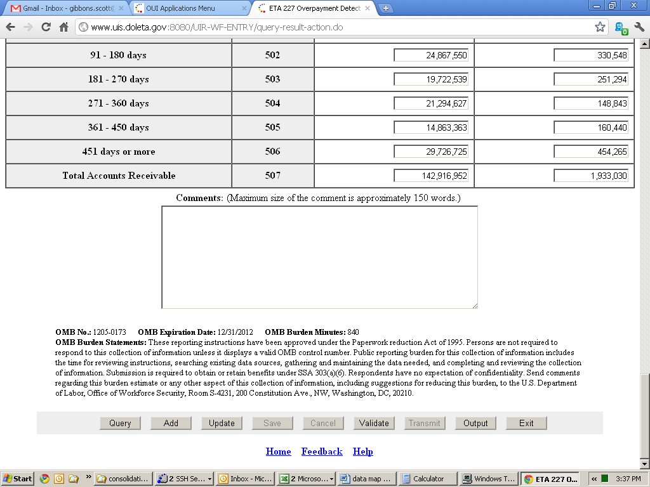

ETA Explanation: Because we use a series of relational databases to store the text of the OMB disclaimer, the burden hours, the collection number and other data which appear on the form the user sees, I cannot at this time provide a single screenshot. We have a database record for the current ETA 9000 and one for the ETA 227. Once OMB approves this change, we will delete the record for the ETA 9000, and subsequently move the 15 hours of burden (900 minutes) and the inventory number they choose (I’m assuming it's going to be 1205-0187 into the consolidated report. We can't do that at the current time as our database system still supports both reprots and we can't make the burden statement for 1205-0187 show up on the facsimile for 1205-0173. We are awaiting OMB approval to begin programming these changes into our system to ensure we are not allocating resources towards a project that would not ultimately be approved.
