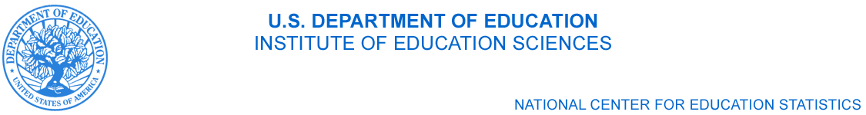

1990 K St, NW, Ste 8130
Washington, DC 20006
(202) 502-7383
ted.socha@ed.gov

April 14, 2011

Lisa M. Maatz
American Association of University Women (AAUW)
1111 Sixteenth St. NW
Washington, DC 20036

Dear Ms Maatz:

Thank you very much for your interest in the 2012 Baccalaureate and Beyond Longitudinal Study (B&B:08/12).

The package you have reviewed describes both the field test and the full scale data collection. The field-test phase of data collection will allow us an opportunity to test data collection procedures and survey items, and conduct experiments designed to increase survey response. With a sample size of 900, any field-test data released would neither be representative of graduates, nor have a large enough sample to provide stable estimates once cross-tabbed. Hence, field-test data will be only used to refine the full scale data collection and will not be released. The 2012 full scale data collection will result in published data sets and statistical reports.

Cross-tabulation of Data
Historically, B&B data have included derived variables for gender, race, gender and race combined, socioeconomic status (parental education, parental income, income), English proficiency (SAT/ACT verbal scores from ETS), mobility, disability, and many more population characteristics. Urbanicity of residence has been reported using the rural-urban commuting area code (RUCA) for current residence (using current zip code). RUCA is based on measures of urbanization, population density, and daily commuting.
In addition to the aforementioned characteristics, the data available for the current cohort of B&B also include measures of English proficiency relative to those of a second known language (if-any).

Data Accessibility
As with previous B&B cohorts, our data are publically available via PowerStats. This user-friendly data tool allows users to create complex tables and run linear and logistic regressions. Results can be downloaded in several formats, including CSV, Excel, and PDF. Since all of the data rest on NCES’ servers, no individual unit data are transmitted over the web or made viewable to the PowerStats users. Thus the respondents’ personally identifiable information (PII) is protected while allowing anyone the ability to create tables and run regressions on the data.

Researchers may also apply for a restricted-use data license through the NCES security office which provides access to individual-level de-identified data and allows users to conduct analyses in SPSS, SAS, Access, and CSV formats.

Thank you again for your interest and please feel free to contact me with any additional comments or questions.

Sincerely,

Ted Socha
Project Officer, B&B

For an exhaustive list, see http://nces.ed.gov/datalab/powerstats/pdf/bb03_subject.pdf.
For more detailed information about RUCA codes visit the Web Site of the US Department of Agriculture's Economic Research Service: http://www.ers.usda.gov/Briefing/Rurality/RuralUrbanCommutingAreas/
Located at http://nces.ed.gov/datalab; Successor of the Data Analysis System (DAS)
For more information, see http://nces.ed.gov/statprog/rudman/.

