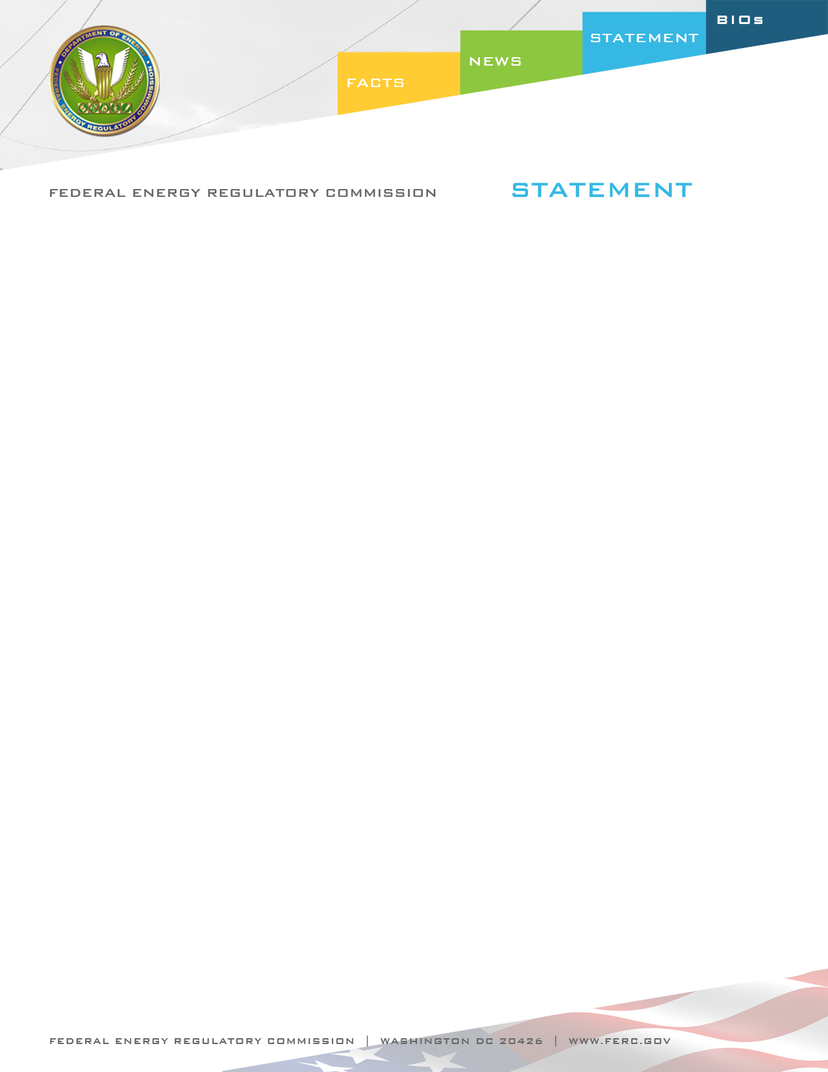

Docket Nos. RM09-18-001, RR09-6-003, RM10-16-000, RM10-10-000,
RM10-15-000, RM09-19-000
Item Nos.: E-4, E-6. E-7, E-8 & E-9

March 17, 2011
Commissioner John R. Norris

Statement of Commissioner John R. Norris on Reliability Orders

A year has passed since March 18, 2010, when the Commission issued a series of reliability orders on pending reliability standards and Commission directives to NERC. In response, industry raised serious concerns about the Commission’s approach to our statutory authority under Federal Power Act (FPA) section 215. To me, that reaction was a wake up call for all of us - FERC, NERC, international regulators, and industry - that we needed to take a moment to pause and consider what we have achieved since passage of the Energy Policy Act of 2005 and the direction in which we want to move forward.

In order to reach that goal, we opened a new dialogue about the reliability of the bulk power system and listened to all points of view as to how we get there from here. Clearly, more work needs to be done, but I feel very positive about the advances that we have made. I believe that the orders on this agenda reflect a more cooperative partnership with NERC and industry. Today’s orders also reflect an effort to ensure we give due weight to NERC’s technical expertise and be mindful when issuing Commission directives. One message I heard during last month’s reliability technical conference was that more Commission directives add to what is already a full plate for NERC, and that NERC should be focused on those activities that have the greatest impact on reliability.

For a moment, I would like to focus on one order on this agenda - the bulk electric system (BES) rehearing order. I think that this order represents a good model for future reliability orders. In the BES Notice of Proposed Rulemaking and Final Rule, the Commission identified a reliability concern as to whether the definition of the bulk electric system encompasses all facilities necessary for operating an interconnected electric transmission network. We then suggested a solution that we thought would address this reliability concern – adopting a 100 kV bright-line threshold with an exemption process. However, we also clearly stated that NERC was free to propose an alternative solution.

I believe this approach – where we (1) clearly identify a core reliability concern requiring resolution, (2) identify a suggested approach to resolve that concern if we have a good idea, and (3) give NERC flexibility to apply its technical expertise to propose an alternative solution to resolve our concern – offers us the best path to resolve reliability issues in a productive manner that appropriately recognizes each of our roles under FPA section 215.

I know that the exemption process has caused a lot of concern, especially for entities in the West. In addition to the exemption process that we have directed NERC to develop, the order clarifies that NERC may establish criteria to identify local distribution facilities and certain categories of radial lines that qualify for exclusion from the definition of the BES and therefore do not need to apply for exemption. Together, I believe our directives in this rulemaking represent a flexible approach that addresses the concerns that commenters raised.

I recognize the importance of this issue to many in industry and will be very cognizant of that when we receive NERC’s proposal for a revised definition, exclusion criteria, and exemption process. When NERC files its proposed solution, we will give due weight to NERC’s technical expertise in evaluating that solution, but we will also fulfill our FPA section 215 responsibilities to ensure that it meets our underlying reliability concern.

