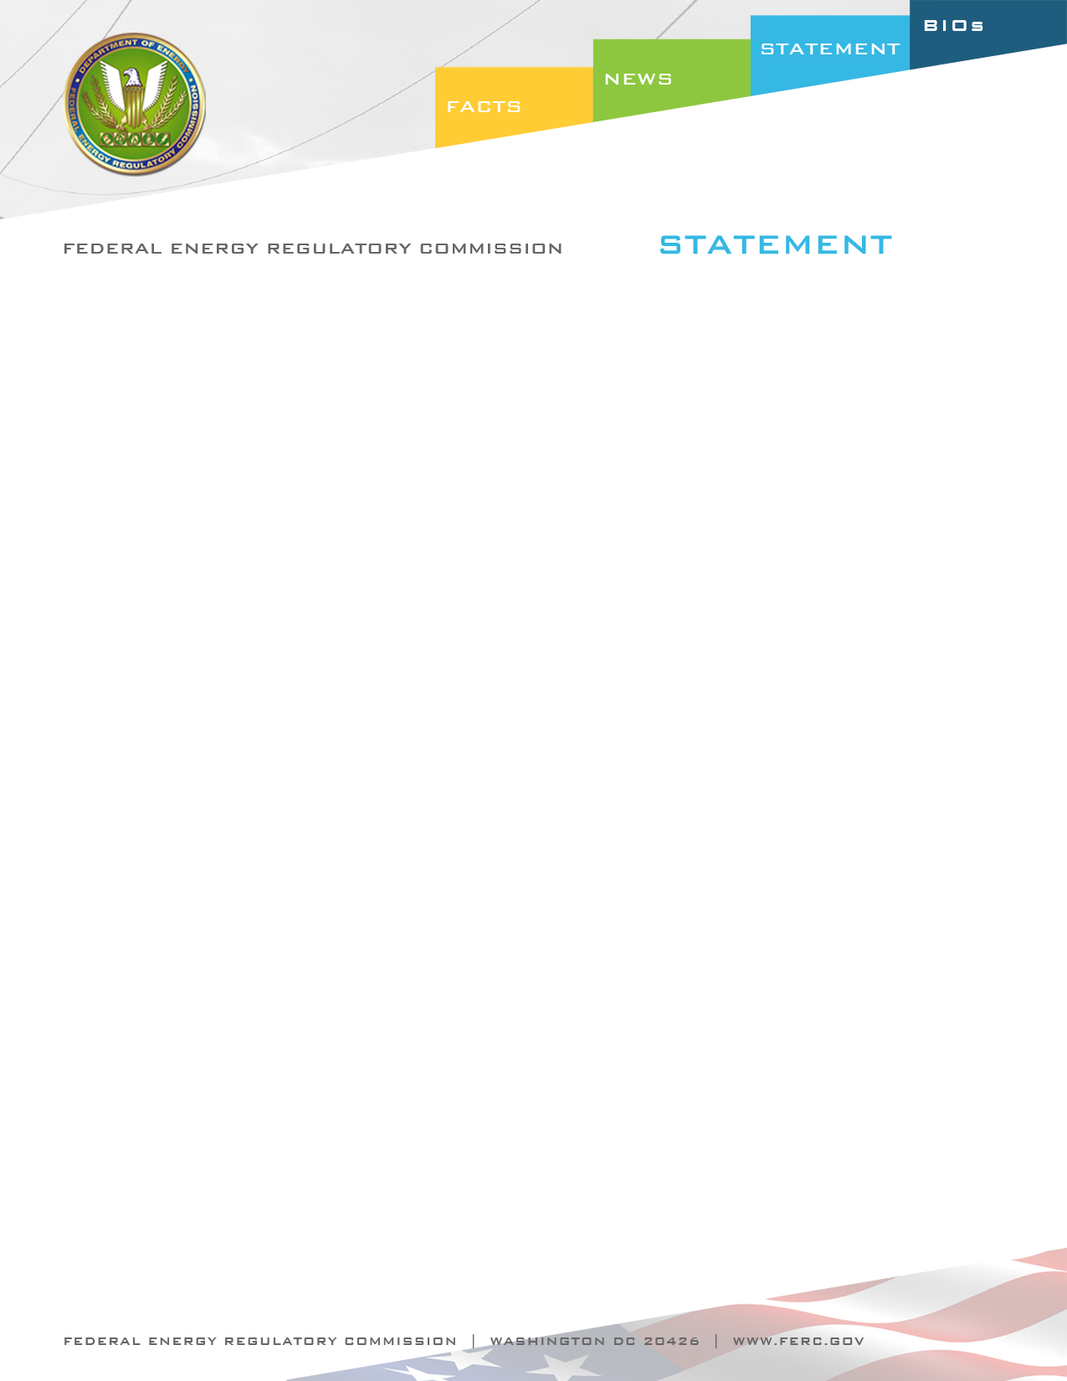

Docket Nos. RM09-18-001, RR09-6-003,
RM10-16-000, RM10-10-000, RM10-15-000, RM09-19-000
Item Nos.: E-4, E-6. E-7, E-8 & E-9

March 17, 2011
Commissioner Marc Spitzer

Statement of Commissioner Marc Spitzer on
Reliability Orders

“As I have previously noted, the Commission, NERC, Regional Entities, and users, owners and operators of the grid are all working toward the same goal – ensuring the reliability of the bulk power system. However, each of us plays a different role in that effort. In the orders issued today, the Commission undertakes its role under section 215 to review standards developed through NERC’s Standard Development Process.

I support the outcomes of the orders we issue today. I believe these orders reflect the ongoing dialogue between us, NERC, Regional Entities and stakeholders about how to work together in accomplishing the goals set forth in section 215.

In working through these orders, the Commission has sought to carefully balance competing interests. These are critical matters for the nation and its consumers and I believe it is paramount that we get these and other reliability issues right. I believe today's orders strike the right balance, but I have an open mind and will examine the records in each docket carefully to ensure that we reach the right and just outcome for NERC, the regions, industry and the public.

I would like to highlight in particular E-10 – the order accepting NERC’s compliance filing to address the potential conflict between NERC’s existing Standards Development Process and its obligation as the ERO to comply with Commission directives under section 215(d)(5). I believe the changes approved today are appropriate to ensure that NERC, as the ERO, has the tools necessary to fulfill its role in the reliability program. I recognize that a great deal of work went into this filing by the stakeholders, NERC staff and NERC board of directors. I greatly appreciate their efforts in this regard, and am pleased to vote to accept the compliance filing.

It was a year ago that the Commission issued a series of orders, which I think it safe to say, caught the industry’s attention. I appreciate, however, how over the past year the FERC, NERC and the industry have used the orders of March 18 to work more cooperatively, rather than retreating into our respective corners, for which NERC and the industry deserve credit. Today’s orders illustrate our ongoing efforts to work together with NERC and the industry on these important issues, and I hope that the cooperation from March 18 continues as we address these issues of great importance to our nation.

I thank the Commission's staff for their hard work on these orders. I support the package of reliability orders.”

