February 1, 2011

«POC_1_Name»
«POC_1_Title»
«FIRM»
«STREET»
«CITY», «STATE» «ZIP»

Greetings «POC_1_Name»,

The Bureau of Industry and Security’s (BIS) Office of Technology Evaluation has partnered with the Department of Defense, Office of the Assistant Secretary of Defense for Networks and Information Integration, to conduct a national security assessment of U.S. information network infrastructure. The goal of the assessment is to quantify replacement cycles for information network equipment; document network maintenance and procurement practices; understand issues affecting network reliability and integrity; and to identify best practices to ensure the operational reliability of critical national information network infrastructure.

Your company has been identified as a provider of information network services in the United States and has been selected to participate in this assessment. To begin, download the Microsoft Excel formatted survey and corresponding instructions at http://www.bis.doc.gov/infonetworksurvey. For internal data collection purposes, a PDF version of the survey can also be downloaded at this website.

The survey document contains corporate- and facility-level sections. A list of specific facilities for which information is to be provided is attached to this letter. If your company finds it easier to have individual facilities submit facility-level survey responses, please notify BIS. If not, BIS will expect one consolidated submission, including distinct facility responses.

Information furnished to BIS is business confidential and will not be published or disclosed, other than in aggregate form. Such information is also protected from disclosure from Freedom of Information Act (FOIA) requests. Also note that your company is required by federal law under 50 U.S.C. App Sec 2155 to complete the survey within 30 days of receipt of this letter.

If you have any questions regarding the survey, e-mail infonetworksurvey@bis.doc.gov, or contact BIS staffers: Mark Crawford at 202-482-8239, Anna Bruse at 202-482-7418, Michael Finucane at 202-482-3892, Meaghan Archer at 202-482-2081, or Erika Maynard at 202-482-5572. Please contact me at 202-482-4060, if you have any questions regarding the overall information network infrastructure assessment.

Thank you for your participation.

Sincerely,

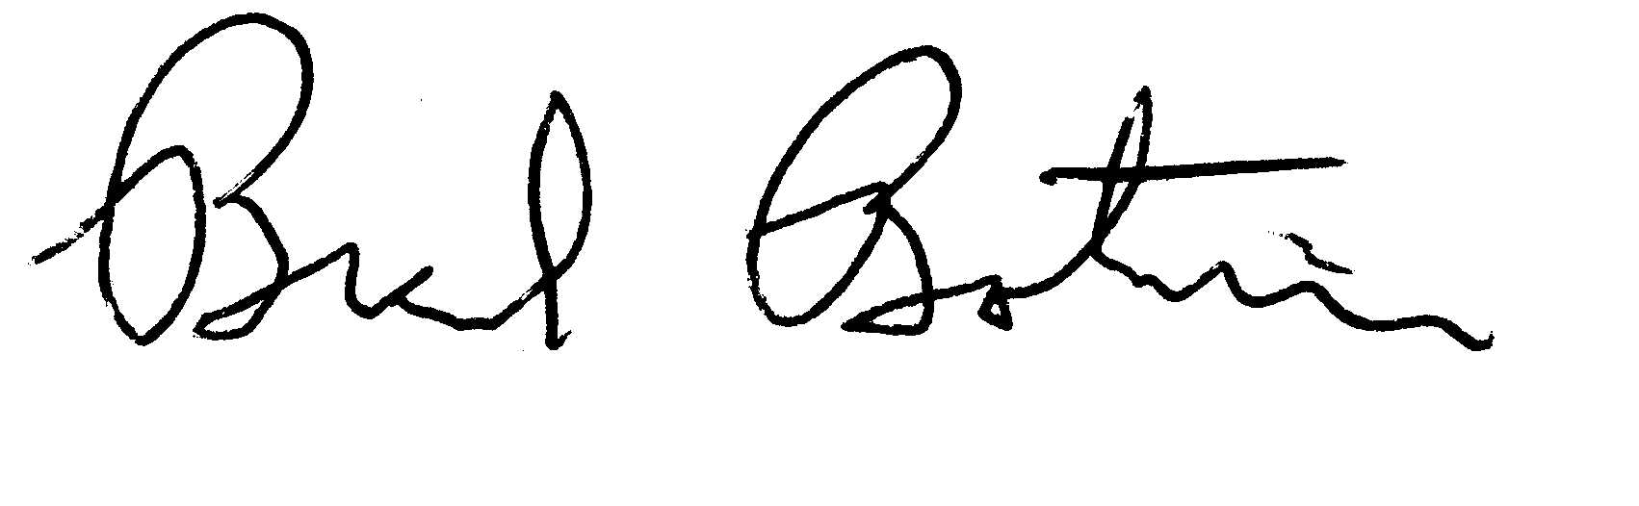
Brad Botwin
Director, Industrial Studies
Office of Technology Evaluation

