Date
POC Name
Title
Company Name
Company Address

Dear POC Name,

The Bureau of Industry and Security’s (BIS) Office of Technology Evaluation, in coordination with the National Geospatial-Intelligence Agency (NGA) and the National Oceanic and Atmospheric Administration (NOAA) is conducting an industrial base assessment of U.S. consumers of commercial electro-optical (EO) satellite imagery. The principal goal of this data collection is to analyze the size and market behavior of the U.S. industry that directly or indirectly utilizes commercial EO satellite imagery.

Your company has been identified as a consumer of and/or provider of an enabling technology/product/service based on U.S. commercial EO satellite imagery. To begin, download the Excel formatted survey and corresponding instructions at:

http://www.bis.doc.gov/eo_survey/index.htm

For internal data collection purposes, a PDF version of the survey can also be downloaded at this website. BIS will only accept Excel survey submissions.

Information furnished to BIS is business confidential and will not be published or disclosed, other than in aggregate form. Such information is also protected from disclosure from Freedom of Information Act (FOIA) requests. Also note that your company is required by federal law under 50 U.S.C. App Sec 2155 to complete the survey within 30 days of receipt of this letter.

If you have any questions regarding the survey, e-mail EOsurvey@bis.doc.gov or contact BIS staffers: Jason Bolton at 202-482-5936, Anna Bruse at 202-482-7418, Erika Maynard at 202-482-5572, Andrea Chamorro at 202-482-7980, or Amanda Patino at 202-482-5415.

Please contact me at 202-482-4060 if you have any questions regarding the overall industrial base assessment.

Thank you for your participation.

Sincerely,

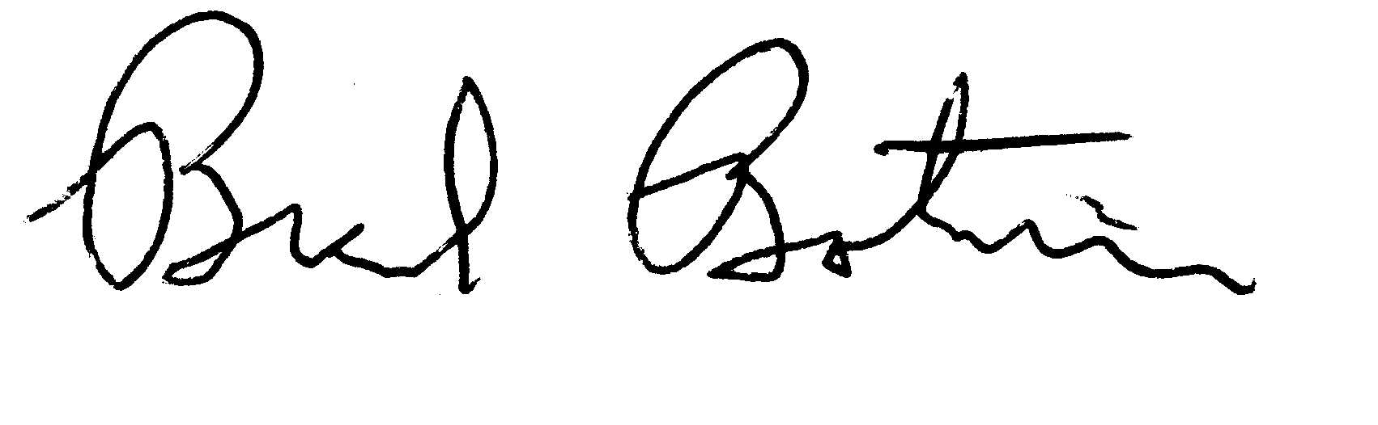
Brad Botwin
Director, Industrial Studies
Office of Technology Evaluation

