Date: February 22, 2011
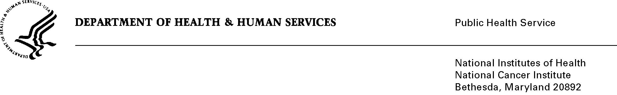

TO: Office of Management and Budget (OMB)

Through: Seleda Perryman, Report Clearance Officer, HHS
Mikia Currie, Program Analyst, Project Clearance Branch, OPERA, NIH
Vivian Horovitch-Kelley, OMB Project Clearance Liaison, OMAA, NCI

FROM: Yikyung Park,Sc.D.
Staff Scientist, Nutritional Epidemiology Branch
Division of Cancer Epidemiology and Genetics
National Cancer Institute/NIH

SUBJECT: Short Follow-Up Questionnaire For the National Institutes of Health (NIH)-AARP Diet and Health Study, OMB No. 0925-0587, Expiry Date: 4/30/2011

This is a request for OMB to approve a 3-year extension for the Short Follow-Up Questionnaire in the prospective cohort study of diet and cancer in the members of the American Association for Retired Persons (AARP), titled, the NIH-AARP Diet and Health Study.

The purpose of the NIH-AARP Diet and Health Study Short Questionnaire is to continue to prospectively investigate the relationship between diet and major cancers in early to late middle-aged men and women in the United States by obtaining information on selected medical conditions, medical procedures, physical status, and lifestyle questions. A secondary objective is to maintain active follow-up with this group on which much data has already been collected beginning in 1995-1996. The NIH-AARP Diet and Health Study received OMB approval in 1995 (OMB# 0925-0423). The Short Questionnaire will enhance the value of the existing database on the cohort, in support of the mission of the Division of Cancer Epidemiology and Genetics at NCI for cancer prevention and treatment.

Following OMB clearance of the AARP Short Questionnaire on April 24, 2008, NCI leadership determined that funding priorities prohibited the immediate full-scale launch of the project. A pilot mailing was conducted to assess the likelihood that participants would be willing to complete the Short Questionnaire as well as the feasibility of its receipt and return via the US Postal Service: in May, July, and August, 2010, the Short Questionnaire was mailed to 1,600 randomly selected participants of the original cohort. The pilot study found a response rate of 63% among participants known to be alive and who received the questionnaire, thus demonstrating that the cohort remains willing to provide information on medical conditions, physical status, diet, and lifestyle, and providing justification for the full-scale implementation of the Short Questionnaire. Because the conduct and analysis of the pilot study used the three-year period granted in the original OMB clearance, a time extension is necessary to conduct the full-scale Short Questionnaire project.

A total of 485,909 live, eligible participants of the original cohort will be asked to complete the Short Questionnaire. The annualized burden for the completion of the questionnaire by all respondents is 32,394 hours.

