Instructions for Tap Water TWF Sample
- Remove contents of the tap water TWF sample kit from the shipping container (Photo 1).  - Call FedEx to schedule a pick up (1-800-463-3399) or bring to the FedEx office as soon as possible. This is prepaid. There will be no charge to you. If FedEX cannot pick up today, place the kit contents in a safe place and put the ice packs in your freezer so you can collect the sample another day. | - On the day of the sampling activities, before collecting the sample, avoid handling, using or taking the following: caffeine, tobacco, antibacterial soaps and hand sanitizers, cleansers, prescription drugs, and over-the-counter medications.  - Affix tap water (TWF) sample ID labels (question 4) and write the date and mark the day of the week on The Tap Water TWF Sample Kit Questionnaire (questions 5 and 6).
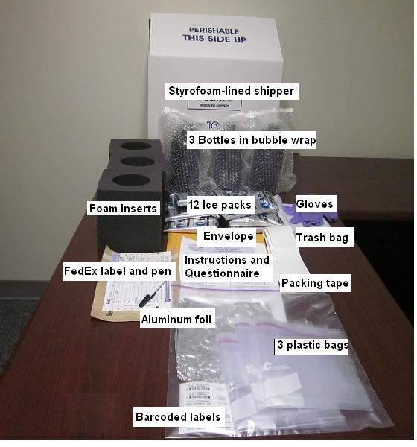
Photo 1. The Tap Water TWF Sample Kit contents.
To be done Monday through Thursday.
The purpose is to send us samples for analysis of your home tap water.

- Go to the kitchen faucet.  - Turn on your water to cold and run at moderate flow for five minutes.  - Put on the provided gloves. Gloves are to protect the tap water TWF sample from soap or oil on your hands.  - Open the aluminum foil and place it on the counter next to your sink.  - Place all bottles included in the tap water TWF collection kit on the aluminum foil (Photo 2). | 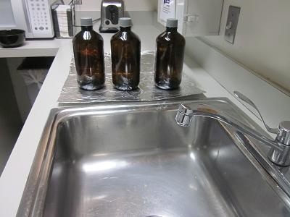  Photo 2. Foil with water pesticide collection bottles
- Reduce the water flow, if needed so that the water will not splash when filling the bottle.  - Hold the first bottle upright and carefully unscrew the lid. Immediately begin filling bottle to the shoulder (Photo 3).  - When handling the bottle do not hold it close to your face  - Do not fill the bottle completely full.  - Do not rinse the bottle.  - Do not pour out the preservative (white powder) inside the bottle. | 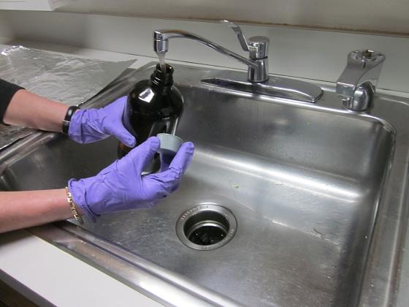  Photo 3. Bottle filling with water
- Fill the bottle with water Replace cap.  - Fill the second and third bottle.  - Label all the bottles with the provided labels (Photo 4).  - Place the bottles in the foam inserts and then into the plastic bags. | 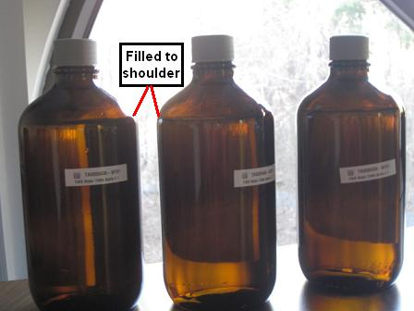  Photo 4. Three bottles filled to the shoulder with water with labels
- Place the samples into the insulated box we provided.  - Remove the ice packs from your freezer. Place the ice packs into the insulated box, surrounding the bottles.  - To keep sample from shifting, fill the extra space with the provided packing material. Put the Styrofoam lid on. | 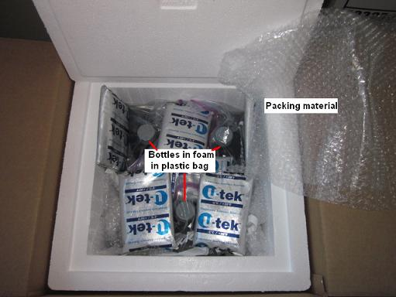  Photo 5. Bottles in foam inserts packed in ice packs.
- Complete rest of the questions for tap water TWF sample questionnaire. Review questionnaire to make sure all questions were answered. Place the questionnaire in the provided envelope.  - Seal the insulated cardboard box (Photo 6).  - Write the date that the tap water TWF sample kit is picked up or dropped off on the prepaid, addressed FedEx label and attach it to the insulated box (Photo 6). | 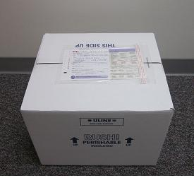  Photo 6. Ensuring label is attached to FedEx box.

Thank you for participating in the National Children’s Study.

Insert local contact information label here.

