Instructions for Tap water TWQ sample
- Remove contents of the tap water TWQ sample kit from the shipping container (Photo 1).  - Call FedEx to schedule a pick up (1-800-463-3399) or bring to the FedEx office as soon as possible. This is prepaid. There will be no charge to you. If FedEX cannot pick up today. Place the kit contents in a safe place and put the ice packs in your freezer so you can collect the sample another day. | - On the day of sample collection, affix the tap water (TWQ) sample ID labels (question 4) and write the date and mark the day of the week on the tap water TWQ sample kit Questionnaire (questions 5 and 6).
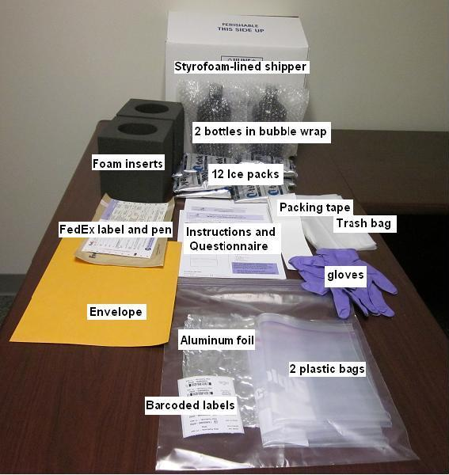
Photo 1. Tap water TWQ sample kit contents.

To be done Monday through Thursday. The purpose is to send us samples for analysis of your home tap water.
- Go to the kitchen faucet.  - Turn on your water to cold and run at moderate flow for five minutes.  - Put on the provided gloves. Gloves are to protect the tap water TWQ sample from soap or oil on your hands.  - Open the aluminum foil with inner side up and place it on the counter next to your sink.  - Place both bottles included in the tap water TWQ sample collection kit on the aluminum foil. | 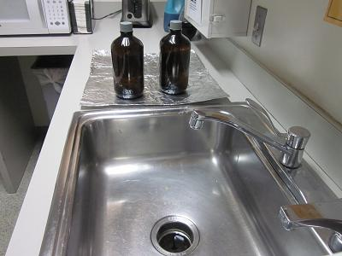  Photo 2. Foil with water pesticide collection bottles
- Reduce the water flow, if needed so that the water will not splash when filling the bottle (Photo 3).  - Hold the first bottle upright and carefully unscrew the lid. Immediately begin filling bottle to the shoulder.  - Do not fill the bottle completely full.  - Do not rinse the bottle.  - Do not pour out the preservative (white powder) inside the bottle. | 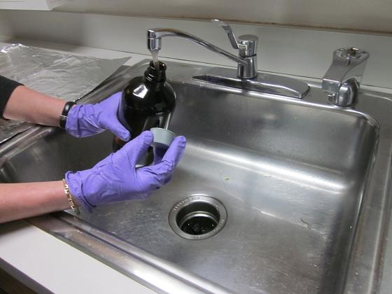  Photo 3. Bottle filling with water
- Fill the bottle with water. Replace cap.  - Fill the second bottle.  - Label both bottles with the provided labels (Photo 4).  - Place the bottles in the foam inserts and then into the plastic bags. Label the bags | 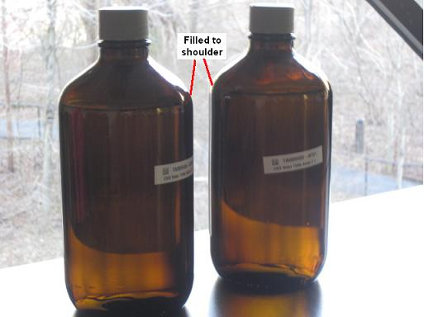  Photo 4. Two bottles filled to the shoulder with water with labels
- Place the samples into the insulated box we provided.  - Remove the ice packs from your freezer.  - Place the ice packs on the bottom of the insulated box, around and top of the bottles. To keep sample and ice packs from shifting, fill the extra space with the provided packing material (Photo 6). Put the Styrofoam lid on. | 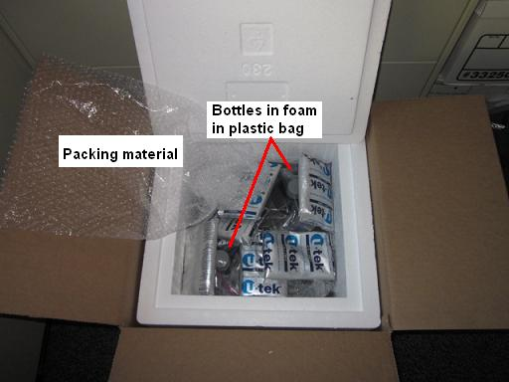  Photo 5. Two bottles filled to the shoulder with water with labels.
- Complete rest of the questions for tap water TWQ sample questionnaire. Review questionnaire to make sure all questions were answered.  - Place the questionnaire inside the FedEx Shipping Box on top of the Styrofoam lid. Seal the insulated cardboard box (Photo 6).  - Write the date that the tap water TWQ sample kit is picked up or dropped off on the prepaid, addressed FedEx label and attach it to the insulated box (Photo 6). | 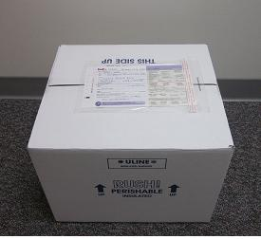  Photo 6. Ensuring label is attached to FedEx box.

Thank you for participating in the National Children’s Study.

Insert local contact information label here.

