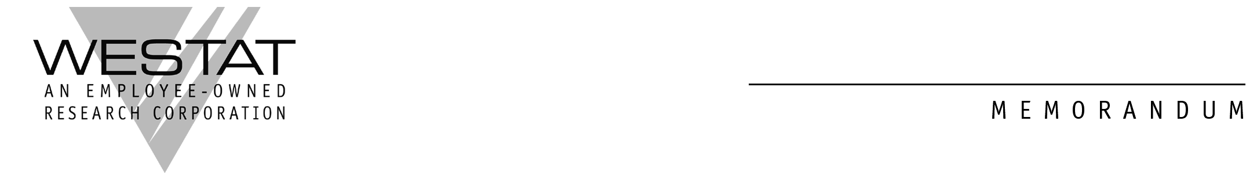

Assurance of Privacy and Informed Consent
for Interview to Test Survey Questions (Adults)

You are being asked to take part in a research study being conducted for the National Cancer Institute (NCI) through the Agency for Healthcare Research and Quality (AHRQ) and its contractor for data collection, Westat. This consent form tells you about the study and what you will be asked to do. Participaton is voluntary – you can choose to take part in the study or not to. If you choose to take part, you will need to sign this form.

Purpose of the research

The goal of this research is to develop a short self-administered questionnaire for adult cancer survivors participating in the Medical Expenditure Panel Survey (MEPS), one of the major research efforts of the U.S. Department of Health and Human Services. The purpose of the questionnaire is to address key issues related to the burden of illness, including the long-term effects.

An important part of developing a survey questionnaire is to first test it with the help of people such as you. It is important that the questions make sense, are easy to answer, and that everyone understands the questions the same way. If you agree to take part in this test, we will ask you to answer the survey questions. Please note that is not the purpose of this test to collect health information about you. The purpose is to test the questions for use in a later survey. Your interview will show us how to improve these questions.

Procedures that we will use

First you will be asked to complete the self-administered questionnaire, Your Experiences with Cancer. Then an interviewer will ask you to explain what you were thinking as you answered the questions. The interviewer will also ask you if there were any words or questions that were confusing and if you understood what was being asked.

The interview will take about an hour and 15 minutes to complete. You will be paid $50.

You may find some of the questions we are testing to be personal or sensitive and you may choose not to answer any question, for any reason. If you do not want to answer a question, just say so, and the interviewer will move on to the next one. You may also stop the interview at any time. If you do stop the interview, you will still receive the full $50. While the interview is in progress, researchers from the Agency for Healthcare Research and Quality (AHRQ), the National Cancer Institute (NCI), Westat, and others who are working with us on this project may listen to the interview.

Recording the interview

We would like to audio record your interview. The recording allows us to more carefully study how well the questions are working. At the bottom of this form, you will be asked to check a box if you are willing to have the interview recorded. Even if you agree, you can still ask to stop the recording at any time, and the interviewer will turn off the machine. If you decide to stop taping, we will ask if we have your consent to keep the portion already recorded.

If you agree to record the interview, we will keep the recording in a locked room or in the safe keeping of a staff person who is working on this project.

Protecting information about you

Materials with personal information such as names and phone numbers will not be connected to the answers you give to the questions we are testing. If you allow recording of the interview, the audiotape will not be labeled with your name or other personal identifying information.

Your name or other personal facts that could identify you will not be used when we discuss, or write about, this study.

The audio recording, consent form, and all study materials that identify you will be destroyed by October 31, 2011.

Benefits and risks

There are no other direct benefits from taking part in this study.

There are no known physical or psychological risks from taking part in this study.

If you have questions about the study, contact Lesly Ger at (301) 294-3977. If you have any questions about your rights as a research subject, contact Sharon Zack at the Westat Institutional Review Board at (301) 610-8828. For counseling services in Montgomery County, call (240) 777-4000.

Please check the boxes next to the statements you agree to:

I freely choose to take part in this research study.

I allow the researchers to record my interview. I also allow NCI staff to play my recording to other people working on this project

Participant signature

Print participant name

Date

