ADVANCE LETTER FOR QRS

Dear (RESPONDENT TO ROUND 5 INTERVIEW):
Thank you for being a part of the Medical Expenditure Panel Survey, conducted for the Agency for Healthcare Research and Quality. Your participation has made a significant contribution to fulfilling the need for complete and accurate information on the use and cost of health care in the United States.
As you may recall, at the end of your last interview the interviewer mentioned that you might be contacted again for a short telephone survey. This survey collects information on health care that is not asked about in the Medical Expenditure Panel Survey. It should take no more than 10 minutes of your time.
To participate in this survey, please call the Westat MEPS toll free survey line at: 800-XXX-XXXX between 9:00 am and midnight, Monday through Friday; 10:00 am and 6:00 pm on Saturday; or 2:00 pm and 9:00 pm on Sunday, Eastern time. A telephone interviewer from Westat will conduct the short interview with you over the phone.
If you have any questions about this study or your participation in it, please call Alex Scott at 1-800-945-MEPS (6377), a toll free number. We thank you for your valuable contribution to this research effort.

Sincerely,
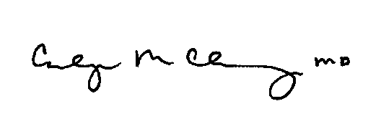  Carolyn Clancy, M.D.  Director  Agency for Healthcare Research and Quality | 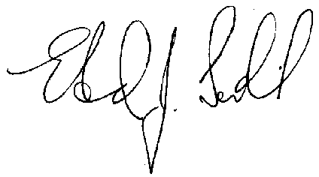  Edward J. Sondik, Ph.D.  Director  National Center for Health Statistics  Centers for Disease Control and Prevention

This survey is authorized under Section 902(a) of the Public Health Service Act [42 U.S.C. 299a]. Personal information is protected by Federal Statutes, Section 934(c) and Section 308(d) of the Public Health Service Act [42 U.S.C. 299c-3(c) and 242m(d)] and will be kept confidential to the extent permitted by law. That law requires that information collected for research conducted or supported by AHRQ that identifies individuals or establishments be used only for the purpose for which it was supplied unless you consent to the use of the information for another purpose.

