FOLLOW UP LETTER FOR QRS

Dear (RESPONDENT TO ROUND 5 INTERVIEW),
Thank you for your participation in the Medical Expenditure Panel Survey (MEPS). Recently we sent you a letter about a short telephone interview that Westat is conducting on behalf of the Agency for Healthcare Research and Quality (AHRQ). The letter indicated that your household has been sampled to participate in an interview that asks questions about health care that were not included in your earlier MEPS interviews. We expect that the interview will take no more than 10 minutes.
Your participation in MEPS has provided AHRQ with much needed information about the health status and health care experiences of the U.S. population. Although participation in MEPS and in this telephone survey is completely voluntary, your role in the survey, and the information you provide, is a valuable public service.
To participate in this short interview, please call the toll free number: 800-XXX-XXXX to speak with a MEPS interviewer who will conduct the interview over the phone. You may call Monday through Friday between 9:00 am and midnight; Saturday between 10:00 am and 6 pm; or Sunday between 2:00 pm and 9:00 pm, Eastern Time.
If you have any questions about this study or your participation in it, please call Alex Scott at 1-800-945-MEPS (6377), a toll free number. Thank you again for your participation in this important research effort.
Sincerely,  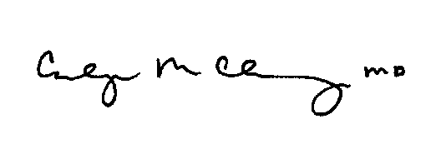  Carolyn Clancy, M.D.  Director  Agency for Healthcare Research and Quality | 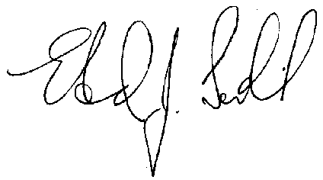  Edward J. Sondik, Ph.D.  Director  National Center for Health Statistics  Centers for Disease Control and Prevention

This survey is authorized under Section 902(a) of the Public Health Service Act [42 U.S.C. 299a]. Personal information is protected by Federal Statutes, Section 934(c) and Section 308(d) of the Public Health Service Act [42 U.S.C. 299c-3(c) and 242m(d)] and will be kept confidential to the extent permitted by law. That law requires that information collected for research conducted or supported by AHRQ that identifies individuals or establishments be used only for the purpose for which it was supplied unless you consent to the use of the information for another purpose.

