Form Approved
OMB No. 0935-0179
Exp. Date 7/31/2014

Agency for Healthcare Research and Quality
Healthcare Providers/ Educators Customer Satisfaction and Needs Assessment
Survey Questionnaire
Version 5

Public reporting burden for this collection of information is estimated to average 10 minutes per response, the estimated time required to complete the survey. An agency may not conduct or sponsor, and a person is not required to respond to, a collection of information unless it displays a currently valid OMB control number. Send comments regarding this burden estimate or any other aspect of this collection of information, including suggestions for reducing this burden, to: AHRQ Reports Clearance Officer Attention: PRA, Paperwork Reduction Project (0935-XXXX) AHRQ, 540 Gaither Road, Room # 5036, Rockville, MD 20850.

Figure 1: Schematic of the Health Educator Customer Satisfaction and Needs Assessment Survey Branch Pattern
SECTION 1:
# | Question | Measurement Scale | Skip Pattern
Agency for Healthcare Research and Quality (AHRQ) Effective Health Care Program Web site
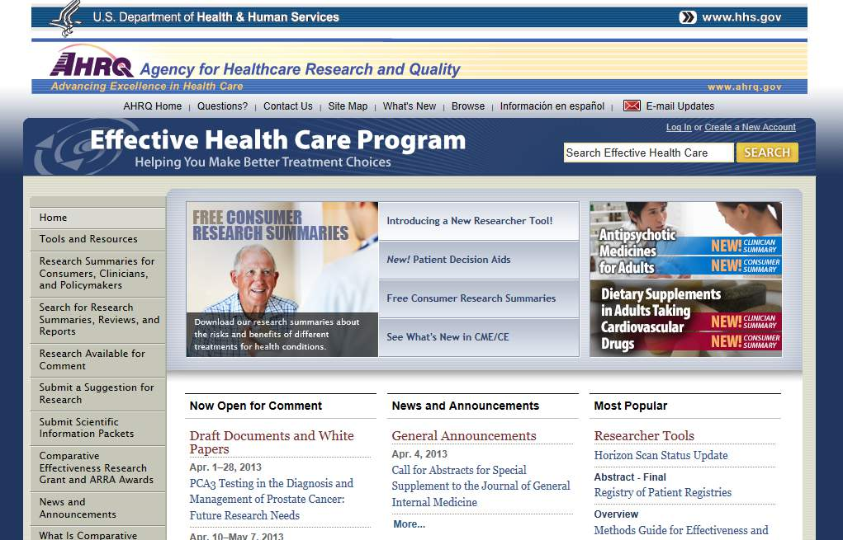

 | How familiar are you with the following:
   | Extremely familiar | Moderately familiar | Somewhat familiar | Not at all familiar
  Agency for Healthcare Research and Quality (AHRQ)
  AHRQ’s Effective Health Care Program
 | How familiar are you with comparative effectiveness research (CER), also sometimes called patient-centered outcomes research (PCOR)? | - Extremely familiar  - Moderately familiar  - Somewhat familiar  - Not at all familiar | Options 1 & 2, go to Q3.  Option 3 & 4, skip to Q4
 | How often do you use the following sources to obtain information about comparative effectiveness research or PCOR? | Please specify any specific sources/organizations you have found useful to you (e.g., journals, government agencies, etc.)____________
   | Daily or almost daily | At least once a week | Two to three times a month | About once a month | A couple of times a year | Never. I don’t use this as a source
  AHRQ Effective Health Care Program Web site
  Federal government agencies (other than AHRQ)
  General Web site searches
  Peer-reviewed published literature
  Private sector organizations
  Professional associations
Section 2 – Respondent Characteristics and Health Educator Screener
 | - Question | Measurement Scale | Skip Pattern
 | What type of health care practitioner are you? Select the option that best characterizes your role. | - Care manager/case manager  - Certified health education specialist (CHES)  - Clinical psychologist  - Clinical social worker  - Community health worker  - Diabetes educator  - Health care navigator/patient navigator  - Nurse  - Nurse practitioner  - Pharmacist  - Physician assistant  - Physician, generalist  - Physician, specialist (Please specify specialty)  - Physical Therapist  - Registered dietician  - Respiratory therapist  - Other  (Please specify specialty or other occupation category)_____________________
 | How many years have you been in your current occupation? | - Less than 2 years  - 3 to 9 years  - 10 to 19 years  - 20 to 25 years  - 26+ years
 | In what kind of setting do you practice the majority of the time? | - Ambulatory/office-based care setting  - Behavioral health care setting  - Community health care setting  - Federally qualified health center/public  - Home care  - Hospital-based setting  - Long term care facility  - Pharmacy setting  - Substance use/abuse treatment center  Other (Please specify)______________________
 | Approximately what percentage of the patients in your practice setting has a chronic disease? (Estimating is fine) | - 0-10%  - 11-25%  - 26-50%  - 51-75%  - >75%  - Do not know
 | Is English your first language | - Yes  - No  If no, what is your first language? ___________________
 | Approximately what percentage of the patients you work with is uninsured, underinsured, or underserved? | - 0-10%  - 11-25%  - 26-50%  - 51-75%  - >75%  - Do not know
 | Do your job responsibilities include educating patients or providing health education to patients or their caregivers? | - Yes – this is my primary job responsibility  - Yes – this is part of my job responsibilities  - No – not part of my job responsibilities | First two options skip to question 11.  For “Not at all,” skip to end of survey.
Section 3 – Screener about type of health education provided by respondent (e.g., helping patients with clinical decisionmaking or just general health promotion, etc.)? Note, this questions attempts to further target individuals who would potentially benefit from AHRQ PCOR/CER information.
 | Question | Measurement Scale | Skip Pattern
 | Do your job responsibilities include helping patients make decisions about their health care or educating patients about their available options for treatment or other interventions (e.g., screening or diagnostic procedures)? | - Yes – this is my primary job responsibility  - Yes – this is part of my job responsibilities  - No – not part of my job responsibilities | First two options skip to question 12.  For option 3 “No” skip to end of survey.
Section 4 – Screener for the type of health educator (e.g., someone involved in diagnosing/treating or other). Used to determine which branch of the survey the respondent will take.
 | - Question | Measurement Scale | Skip Pattern
 | Do your job responsibilities include diagnosing illness, treating illness, writing prescriptions, or making referrals to other health care providers? | - Yes  - No | Yes, go down path 5A  No, go down path 5B
Section 5A/5B Common Path – AHRQ Health Educator Tools and Resources
The Agency for Healthcare Research and Quality’s (AHRQ) is the lead Federal agency charged with improving the quality of health care for all Americans.

AHRQ conducts and synthesizes evidence on the effectiveness and comparative effectiveness of treatments and health care interventions for many health conditions. AHRQ also translates this information into tools and resources for clinicians and patients that can be used when making health care decisions.

AHRQ Tools and Resources for Patients and Clinicians
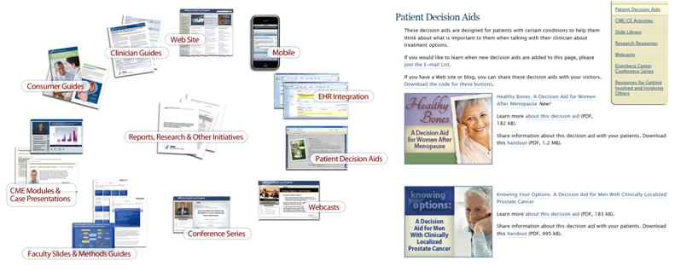
 | Which of the following AHRQ Effective Health Care Tools have your used in the past year? (Select all that apply) |  | - AHRQ Effective Health care Web site  - Clinician summaries  - CME modules  - Consumer summaries  - Faculty slide decks  - Mobile applications from the AHRQ EHC Web site  - Patient decision aids  - Research reviews or syntheses  - Spanish language Consumer summaries  - Viewed or participated in the EHC Web conference series  - Web casts
 | How useful would it be to you, considering the time you have to spend with patients, to have the following tools?
   | Very useful | Somewhat useful | Not very useful | Not at all useful | I don’t use these types of tools
  Clinician summaries on specific topics of interest
  Mobile applications
  Patient summaries (in English) on specific topics of interest
  Patient summaries (in Spanish) on specific topics of interest
  Slide decks on specific topics of interest
  Patient decision aids (in print format) that I can print and share with patients
  Patient decision aids (in electronic format) that I can share with patients in my sessions on an electronic tablet or other handheld device
  Patient decision aids in Spanish
  Video shorts (stand-alone)
  Video shorts (Web based)
  Audio tapes/CDs (stand-alone)
  Audio tapes/CDs (Web based)
 | If you could have any other tools to share with patients, what would they be? |  | Open ended
 | Are there any other languages would you like to have tools translated into? |  | Open ended
 | The following is a list of AHRQ’s priority conditions.  How useful to you would it be to have patient educational information or decisions aids on each of the following topics?
   | Very useful | Somewhat useful | Not very useful | Not at all useful | Not a topic I address
  Breathing Conditions
  Cancer
  Developmental Delays, ADHD, Autism
  Diabetes
  Digestive System Conditions
  Genitourinary Conditions
  Gynecology
  Heart and Blood Vessel Conditions
  Infectious Disease and HIV/AIDs
  Mental Health
  Muscle, Bone, and Joint Conditions
  Nonclinical Topics
  Ophthalmologic Conditions
  Pediatrics
  Pregnancy and Childbirth
  Renal Disease
  Other conditions/topics
  (please specify)__________________
AHRQ – Effective Health Care Program Continuing Education
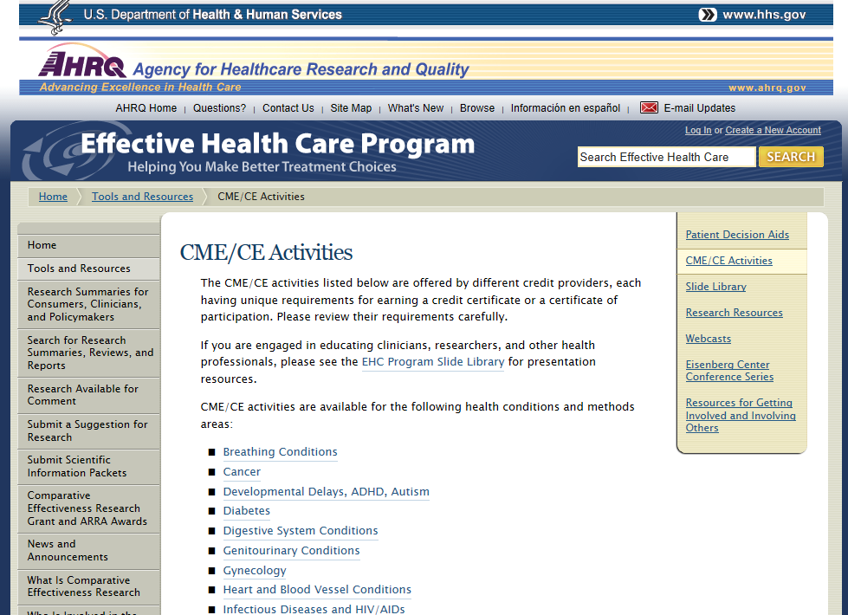
 |  | Would you participate if accredited continuing education modules or workshops were available on how to use AHRQ decision aids and tools? |  | - Definitely  - Probably  - Possibly  - Probably not  - Definitely not
Section 5A – Questions for clinicians who treat or diagnose patients and are involved in education related to helping patients make decisions about the treatment or intervention options
 | - Question | Measurement Scale | Skip Pattern
Shared decisionmaking is a process where both the patient and clinician share information, participate in the decisionmaking process, and agree on the best strategy for treatment.

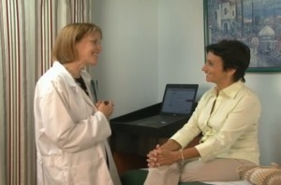


The clinician provides personalized information, tools, and/or decision aids to help the patient understand available treatment options, and encourages the patient to consider his or her personal values in making treatment-related decisions.
 | Using the definition above, how often do you involve your patients in a decisionmaking process regarding their care? |  | - All the time  - Most of the time  - Occasionally  - Rarely  - Never | Options 1-4 proceed to question 20.  Options 5 (Never), proceed to section 7
New Page
 | For each of the following situations, how often do you involve patients in decisionmaking or educational discussions related to their care:
   | All the time | Most of the time | Occasionally | Rarely | Never
  Changing their lifestyle behaviors
  Deciding on their medicines (e.g., blood pressure, cholesterol, depression)
  Whether or not to undergo cancer screening tests (e.g., colon, breast, prostate)
  Having surgery (e.g., back surgery, knee or hip replacements)
  Choosing between various cardiac procedures
  Managing chronic conditions
  Having an MRI or CT Scan
  Other (please specify) _________________________
 | When you engage in shared decisionmaking with patients, how do you typically do it?  Please select all that apply. | - At the point of care, through one-on-one conversations with the patient  - At the point of care with family or other caregivers present  - By phone before their visit  - Directing patients to a Web site that provides patient decision aids online prior to their visit  - Directing patients to a Web site that provides patient decision aids online after their visit  - In a group setting  - Some other way (please specify)__________________
Section 5B – Questions for healthcare professionals who do NOT treat or diagnose patients but are involved in education related to helping patients to understand their treatment or intervention options
# | Question | Measurement Scale | Skip Pattern
 |  | How often do your interactions with patients include education to help them or their caregivers understand the options available for their care?  For example, helping them to understand technical information about their condition, the harms and benefits associated different medicines, or procedures they may be considering. | - Always  - Almost always  - Occasionally  - Almost never  - Never | Options 1-4 proceed to question 20.  Option 5, proceed to section 7
 |  | How often do your decisionmaking or educational discussions with patients/caregivers relate to each of the following situations:  Helping them to….
   | All the time | Most of the time | Occasionally | Rarely | Never
  Change their lifestyle behaviors
  Better understand their medicines (e.g., blood pressure, cholesterol, depression)
  Better understand the harms and benefits of various cancer screening tests (e.g., colon, breast, prostate)
  Better understand the harms and benefits of having surgery (e.g., back surgery, knee or hip replacements)
  Better understand the harms and benefits of various cardiac procedures
  Learn how to manage chronic conditions
  Better understand the harms and benefits of having various imaging procedures (e.g., MRI or CT Scan)
  Other (please specify)
 |  | When you engage in educational discussions with patients, how do you do it?  Please select all that apply. | - Through one-on-one conversations with the patient in my practice setting  - In the clinic during their regular visits, with family or other caregivers present  - In a group setting  - In a community setting  - In the patients home  - By phone before an office visit  - By phone after an office visit  - Directing patients to a Web site that provides patient decision aids online prior to their visit  - Directing patients to a Web site that provides patient decision aids online after their visit  - Some other way (please specify)
Section 5A/5B Common Path – Shared Decision Making/Patient Education Questions
 | Which of the following elements would you say are part of your role in helping patients who are confronted with options regarding their care?  Please select all that are relevant to you. |  | - Assessing factors that might influence the patient’s decisionmaking  - Assessing the patient’s understanding of options and evidence  - Clarifying the patient’s preferred option  - Discussing the patient’s decision support needs and resources  - Determining the patient’s preferred role  - Providing educational resources, including patient decision aids  - Encouraging the patient to select their preferred option  - Coaching patients to discuss their preferences with their clinicians/health care providers  - Screening or planning for barriers to implementation of possible care options
 | How much time per visit are you able to spend with individual patients educating them or discussing options related to medical treatments, procedures, or medicines? |  | - 3 minutes or less  - 4 to 5 minutes  - 6 to 10 minutes  - 11 to 15 minutes  - More than 15 minutes
 | To what extent are you encouraged by your organization to educate patients or to help them better understand their options for treatments or interventions related to their clinical care? |  | - To a great extent  - Neither encouraged nor discouraged  - Not at all
 | How often do the following situations prevent you from fully engaging patients as much as you would like in the decisionmaking process or educating them about health care options?
   | All the time | Most of the time | Occasionally | Rarely | Never
  Not having enough time for detailed discussions with patients
  Patients/caregivers having difficulty understanding the information
  Not having access to trusted sources of information that can be used in this process
  Patients not being interested or confident in participating in this process
  Coming from a different culture
  Not speaking the same language
  Other reasons(Please specify other reasons) __________________________
 | How often do you use the following with patients or caregivers to help them understand their health conditions, or their various treatment or intervention options?
   | All the time | Most of the time | Occasionally | Rarely | Never
  Culturally-appropriate materials
  Interactive Web-based decision aids
  Pamphlets/print decision aids
  Plain language pamphlets/print decision aids
  Low literacy level pamphlets/print decision aids
  Spanish or other language pamphlets/print decision aids
  Videos/DVDs
  Web sites
  Other (please specify)
 | How useful have you found the following types of tools when educating patients or caregivers, or when helping them to make decisions about their care?
   | Very useful | Some-what useful | Not very useful | Not at all useful | Don’t use this type of tool
  Culturally-appropriate materials
  Interactive Web-based decision aids
  Pamphlets/print decision aids
  Plain language pamphlets/print decision aids
  Low literacy level pamphlets/print decision aids
  Spanish or other language pamphlets/print decision aids
  Videos/DVDs
  Web sites
  Other (please specify)
 | How often do you use the following approaches to obtain information about, or gain access to, patient decision aids?
   | All the time | Most of the time | Occasionally | Rarely | Never
  My organization purchases the tools from a commercial vendor
  I access the tools from my own searches of information on the Web and order them
  I receive email alerts from government Agencies or Professional Societies about their availability and share them with my practice staff for their consideration
  Someone else in my organization obtains this information
  Other (please specify)
 | What is your preferred way for learning about available tools and resources that you can share with patients about specific treatments or interventions? |  | - Email alerts from a trusted source  - Text message alerts from a trusted sources on my handheld device  - Searching for information only when I need it  - Through evidence based clinical practice guidelines  - Other (please specify) ________________
Section 5A/B Previous training questions
 | What types of training, if any, have you received regarding patient education or shared decisionmaking? |  | - I took a course while still in school  - I have taken one continuing education (CE) modules that pertained to this topic  - I have taken multiple CE modules that pertain to this topic  - My organization has provided training to relevant staff  - On-the-job training  - I have had no formal training  - Other (please specify) ________________
 | Based on the training you have received for providing patient education or shared decisionmaking, how often would you say that you apply what you learned in practice? |  | - All the time  - Most of the time  - Occasionally  - Rarely  - Never | First three option move to question 18  Later two option move to question 17
 | If you answered rarely or never to the previous question, please explain why. |  | Open ended
 | What about your training did you find valuable in helping you to apply shared decisionmaking approaches in practice? |  | Open ended
 | How valuable would you find each of the following topics in a training course on educating patients about their health care options
   | Very valuable | Some-what valuable | Not very valuable | Not valuable at all
  How to communicate technical information about health care options with patients
  How to discuss harms and benefits of various health care options
  How to address different cultural sensitivities of my patients
  How to convey information to patients with who speak little English
  How to convey information about likely outcomes of different health care options
  How to engage patients to better understand their preferences and values
  Where I can find and access information that would be useful to me in my practice
  Other topics that would be valuable (Please specify)_____________________
 | Are you involved in training other health care professionals about how to communicate or educate patients or their caregivers? |  | - Yes, frequently  - Yes, sometimes  - No, this is not part of my job responsibilities | If yes, go to question 36.  If no, end survey
Section 6: Questions for trainers of other health care professionals or others about shared decisionmaking
 | In your training of other health care professionals related to patient education and/or shared decisionmaking, how important are the following competencies:
   | Very important | Somewhat important | Not very important | Not important at all | Don’t know
  Communicating technical information about health care conditions with patients
  Communicating harms and benefits of various health care options
  Communicating information about likelihoods of outcomes for different health care options
  Cultural sensitivity
  Delivering messages using clear health communication (health literacy/plain language)
  Patient engagement strategies to better understand their preferences and values
  Knowing how to find trusted sources of information
  How to respect patients’ decisions
  Maximizing patients opportunities to make decisions
  How to listen to patients
  Sharing the right information to help patients make more informed decisions
  Other competency (Please specify and rate importance) _____________________
  Other competency (Please specify and rate importance) _____________________
  Other competency (Please specify and rate importance) _____________________
 | In your training of other health care professionals related to patient education and/or shared decisionmaking, how useful have you found the following tools to be:
   | Very useful | Somewhat useful | Not very useful | Not at all useful | Don’t know. I don’t use this type of tool
  Personal stories
  Role-playing scenarios
  Short videos of example scenarios
  Slides
  Worksheets
  Other
  Other (Please specify)_______
SECTION 7: Health care professionals whose job includes patient education/shared decisionmaking, but who do not currently practice it.
# | Questions |  | Measurement Scale | Skip Pattern
 | In your own opinion, how important is shared decisionmaking in medical decisions with patients |  | - Very important  - Somewhat important  - Not very important  - Not important at all
 | You noted that your interactions with patients “never” include education to help them or their caregivers understand the options available for their care.  Which of the following best characterizes the reasons for your response (select all the apply) |  | - My patients/caregivers expect me to provide them with the best recommendation based on my knowledge, experience, and medical training  - My patients/caregivers have difficulty understanding the information  - Not having enough time for detailed discussions with patients  - Not having access to trusted sources of information that can be used in this process  - My patients are not interested or confident in participating in this process  - Most of my patients come from a different culture  - Most of my patients don’t speak English  - I don’t believe that patients are able to make the best choice if given the option  - I worry about legal issues if patients don’t follow my recommendations and then blame me later on if their condition worsens  - I don’t feel comfortable having these kinds of discussions with my patients  - My organization does not encourage or support this type of activity  - I don’t have the training or knowledge about how to do this well.  - I don’t have access to useful patient decision aids that I could use to assist in this process
END SURVEY – Thank you for taking time to complete this survey.

