English iClaim Updated
Screen Package
Version 1.4

April 5, 2011

Table of Contents

1. Pages 4
1.1. ent001_Welcome 4
1.2. ent003_Welcome 5
1.3. ent004_Restart 6
1.4. ini002-r_Applicant Identification 7
1.5. ini003-1_Contact Information 8
1.6. ini003-1_Contact Information_Foreign 9
1.7. ini004-1_Birth and Citizenship 10
1.8. ini004-1_Birth and Citizenship_foreign citizen 11
1.9. ini005-1_01_Medicare Election Information 12
1.10. apn001-r1_Application Number 13
1.11. adi001-1_01_Other SSNs and Names 14
1.12. adi002-1_01_Disability 15
1.13. fam001-1_01_Marriage Information 16
1.14. fam001-1_01_Marriage Information_Yes 17
1.15. fam001-1_01_Marriage Information_No 18
1.16. fam002-1_02_Prior Marriages 19
1.17. fam002-1_02_Prior Marriages_add page_empty table 20
1.18. fam002-1_02_Prior Marriages_add page4 21
1.19. fam002-1_02_Prior Marriages_add_waddl questions 22
1.20. fam002-1_02_Prior Marriages_add page_Yes 23
1.21. fam002-1_02_Prior Marriages_add page_No 24
1.22. fam002-1_02_Prior Marriages_summary page 25
1.23. fam002-1_02_Prior Marriages_summary page_message 26
1.24. fam003-r1_Children 27
1.25. mil001-1_Military Details_initial state 28
1.26. mil001-1_Military Details_tableempty 29
1.27. mil001-1_Military Details_Period1 30
1.28. mil001-1_Military Details_Table9Row_NoWarning 31
1.29. mil001-1_Military Details_Table10Row_Warning 32
1.30. ear001-1-lag_Employer Details 33
1.31. ear001-1-lag_01_tableEmpty 34
1.32. ear001-1-lag_02_EmployerDetailEntry 35
1.33. ear001-1-lag_02_EmployerDetailEntry_Foreign Address 36
1.34. ear001-1-lag_03_table1Row 37
1.35. ear001-1-lag_05_table9Rows 38
1.36. ear002-lag_Self Employment 39
1.37. ear002-lag_workingCollapse_Self Employment 40
1.38. ear003-1-a_Supplemental Information 41
1.39. ear004_Total Earnings 42
ear004-d1-b_Total Earnings 45
1.40. ear005-1-a_Other Pensions/Annuities 46
1.41. wst000-1_Reduced Benefits 47
1.42. wst001-1-b_When to Start Retirement Benefits 48
1.43. wst001-1-e_When to Start Retirement Benefits 49
1.44. wst001-3-c_When to Start Retirement Benefits 50
1.45. wst001-3-d_When to Start Retirement Benefits 51
1.46. wst002-1_Direct Deposit Details 52
1.47. wst002-1_Direct Deposit Details w/Errors 53
1.48. bni001-1_Benefit Information 54
1.49. bni002-3_Health Insurance 55
1.50. rem001_Remarks 56
1.51. ovs001-r1-a_Overall Summary 57
1.52. snd001-r1_Send This Application 63
1.53. snd001-alternate 64
1.54. rec001-r1-a_Evidence and Receipt 65
1.55. wtn001-r1_Next Steps 71

2. Messages 72
2.1. msg005_GoToEstimator 72
2.2. msg010_Check the Information You Entered 73
2.3. msg027_We cannot process your request at this time 74
2.4. msg028_This service is not available at this time 75
2.5. msg045_Hours of Operation 76
2.6. msg051_We cannot Process your request 77
2.7. msg052_We cannot Process your request 78
2.8. msg152_Sign Off 79
2.9. Bank Info Msg - Where can I find this? 80

- Pages
  - ent001_Welcome
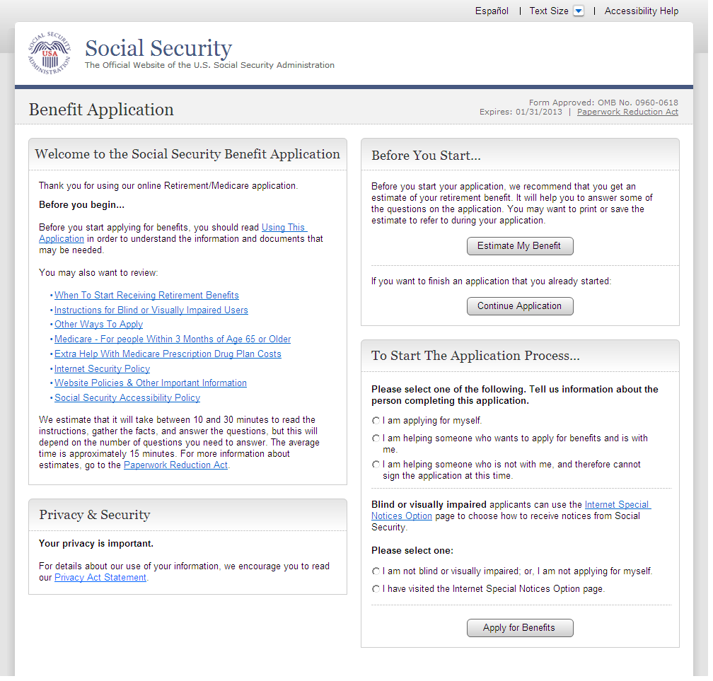
  - ent003_Welcome
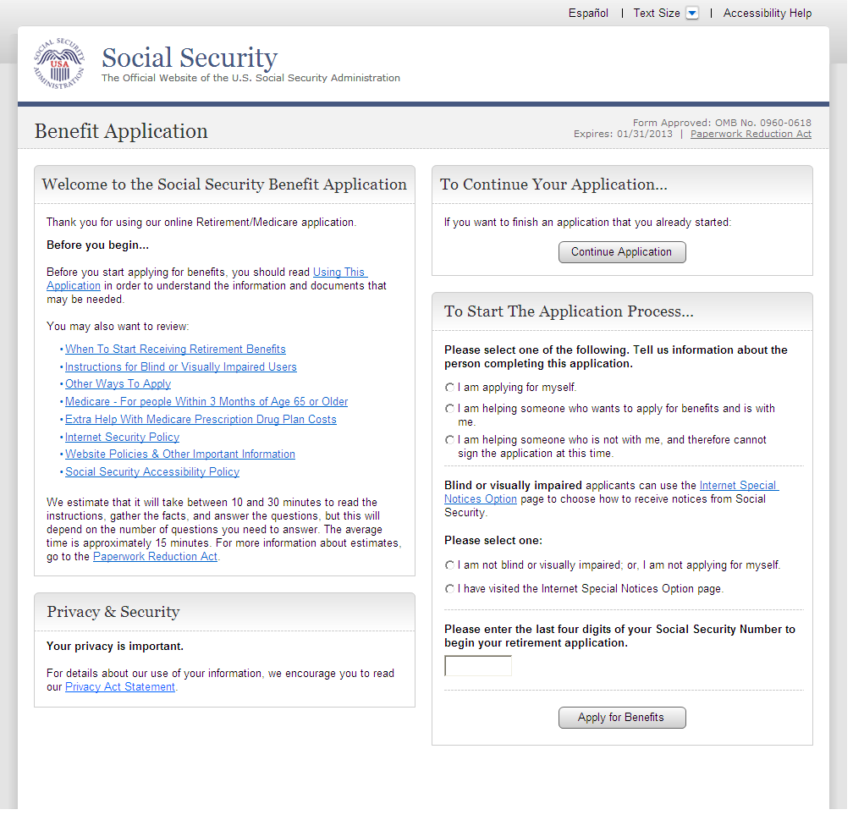
  - ent004_Restart
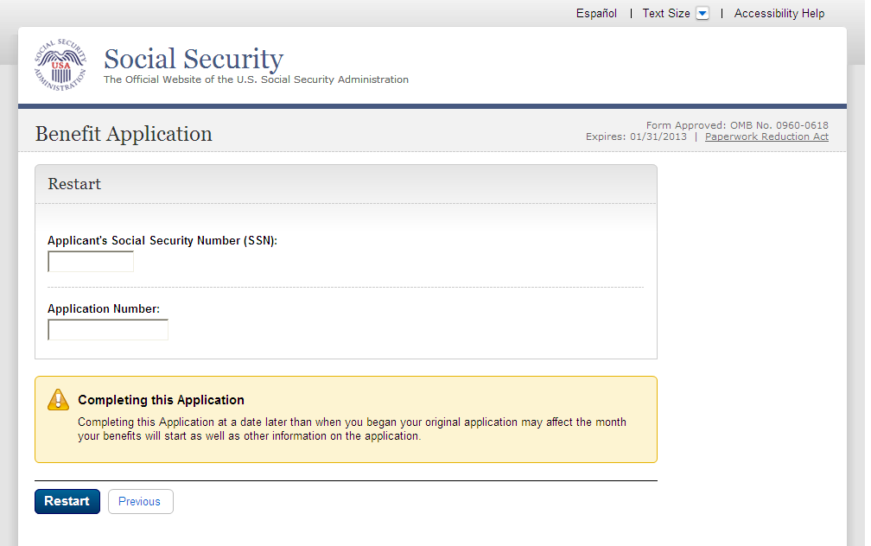
  - ini002-r_Applicant Identification
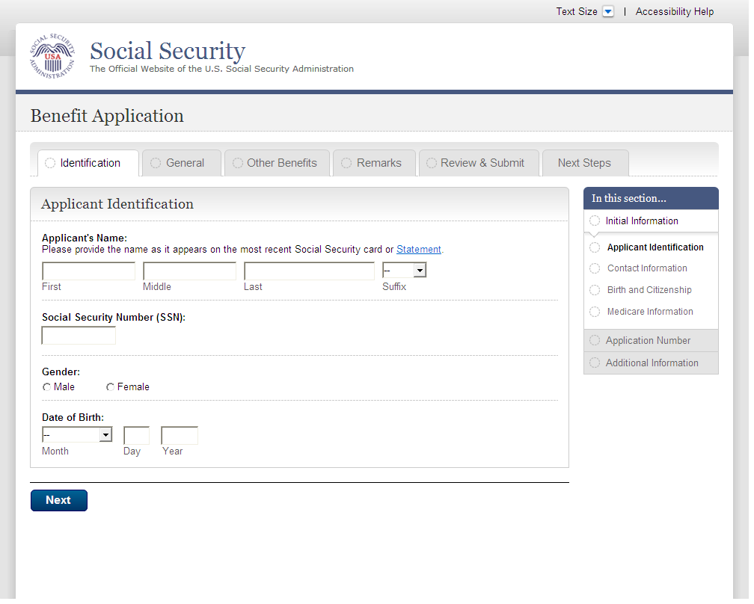
  - ini003-1_Contact Information
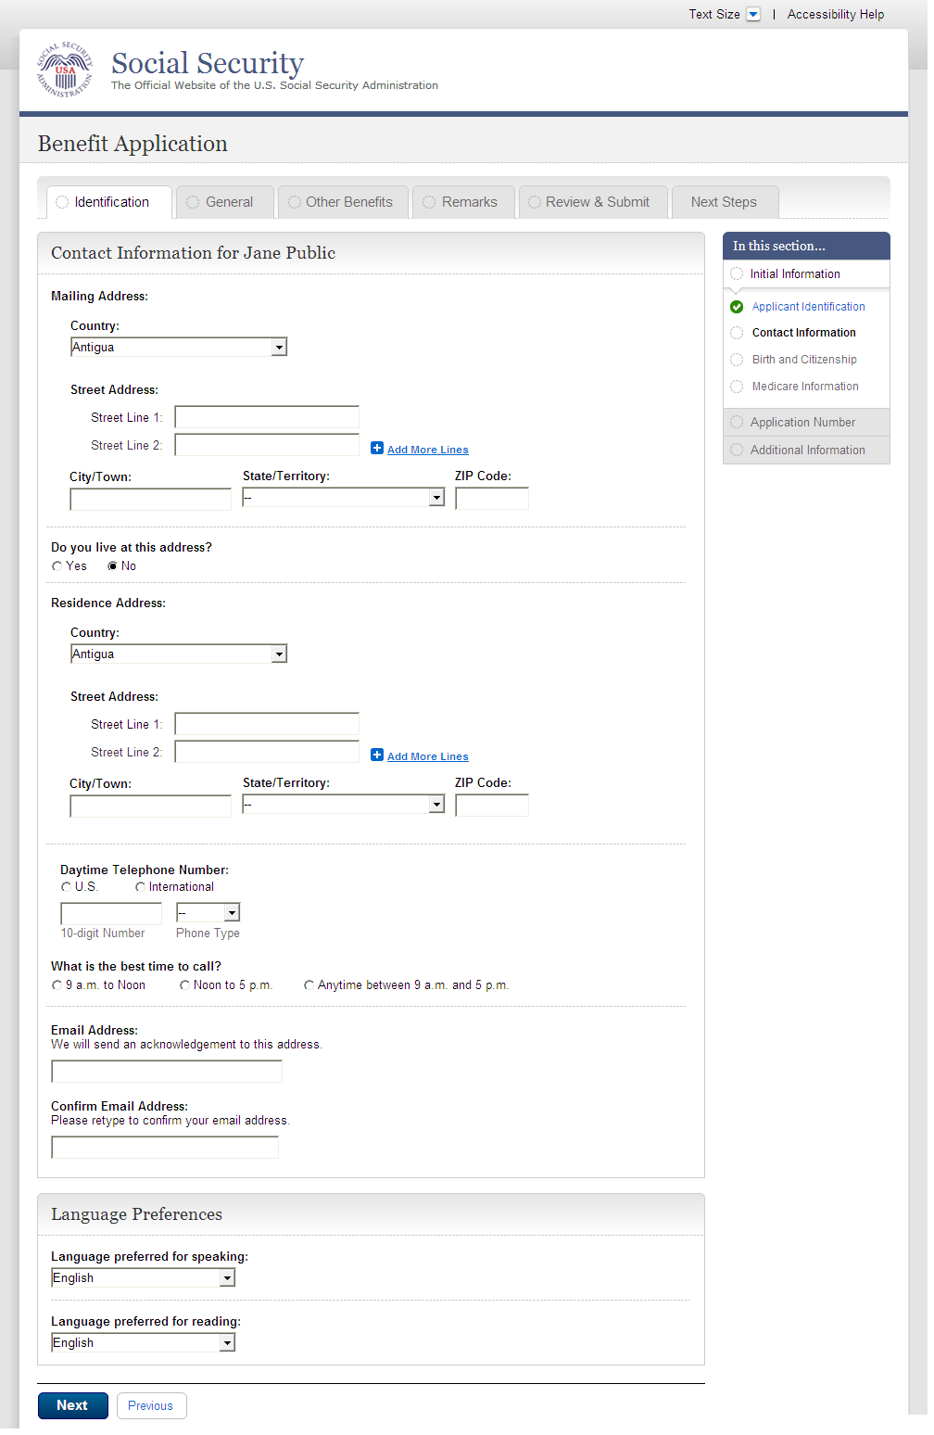
  - ini003-1_Contact Information_Foreign
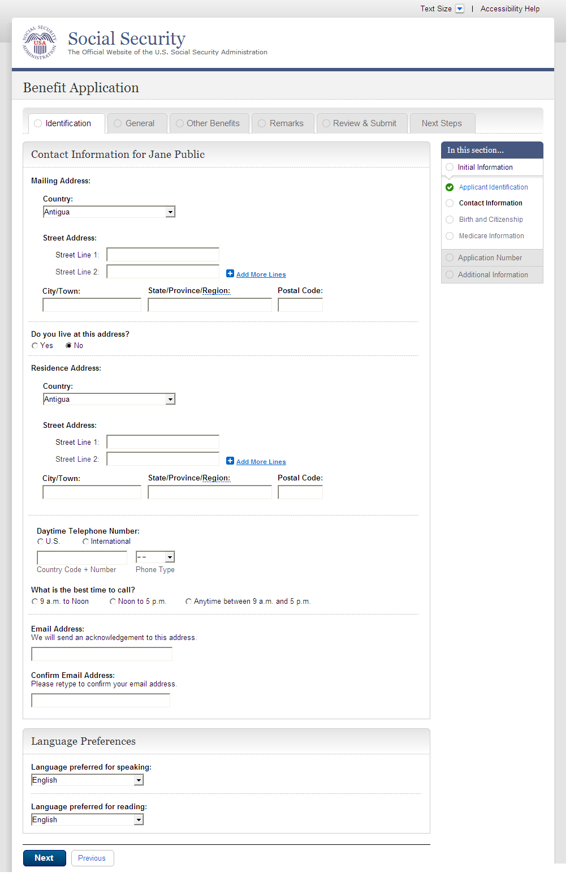
  - ini004-1_Birth and Citizenship
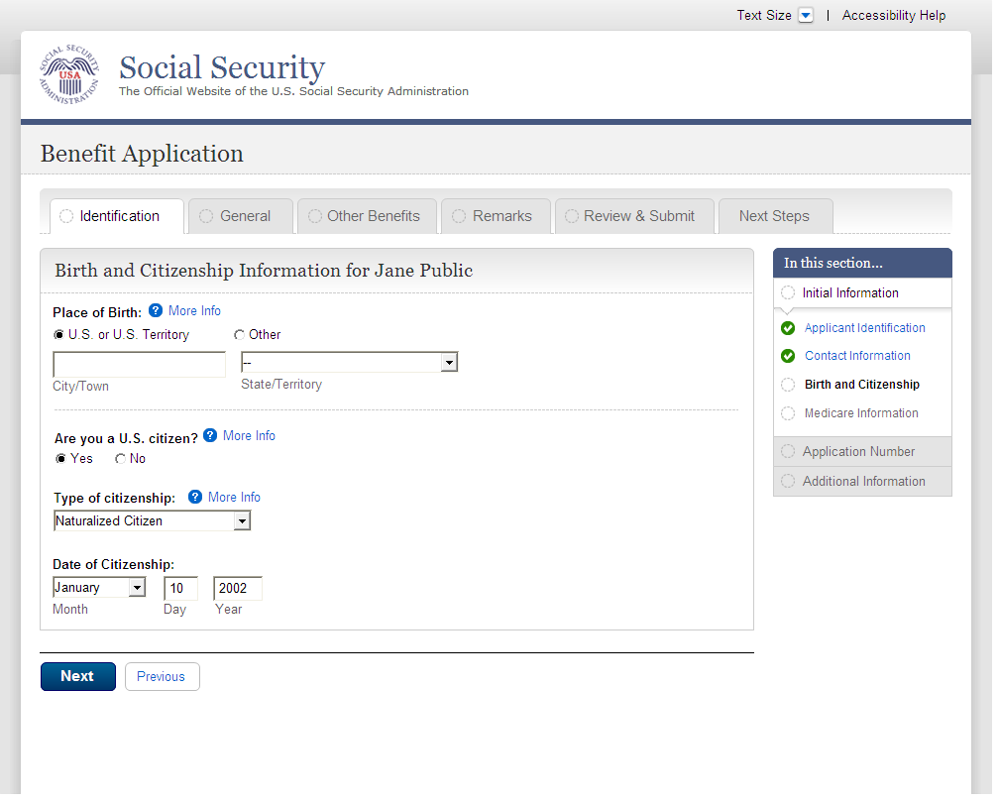
  - ini004-1_Birth and Citizenship_foreign citizen
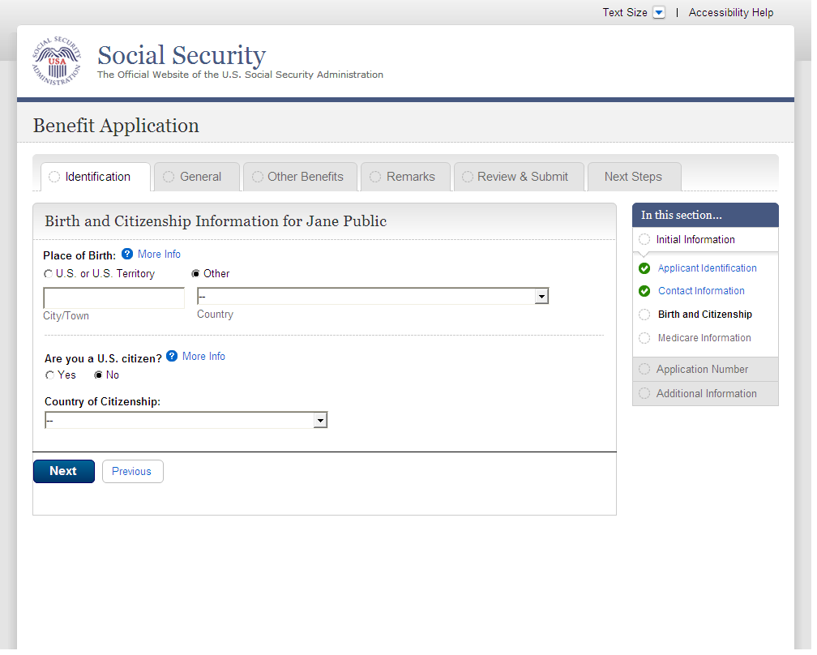
  - ini005-1_01_Medicare Election Information
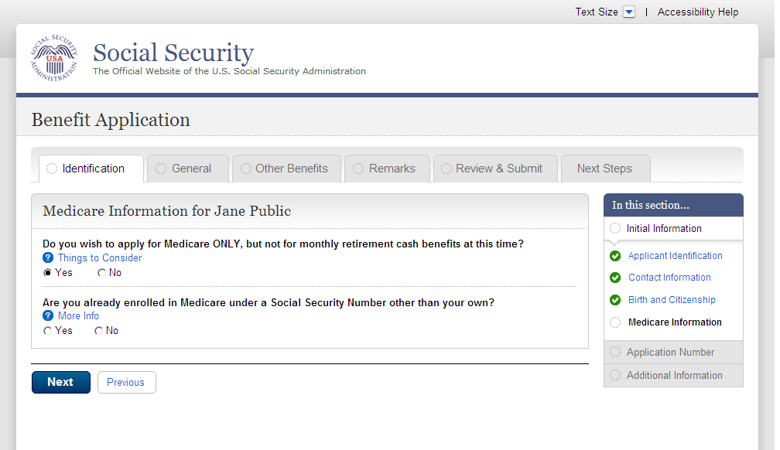
  - apn001-r1_Application Number
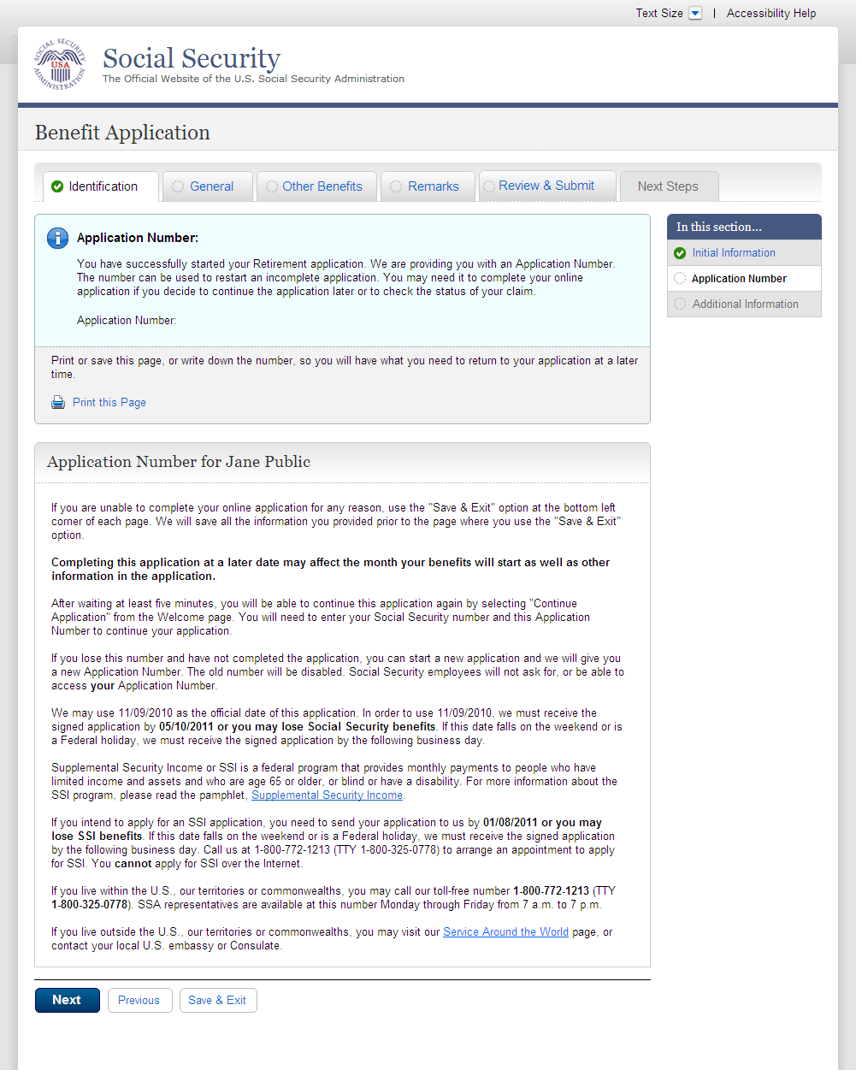
  - adi001-1_01_Other SSNs and Names
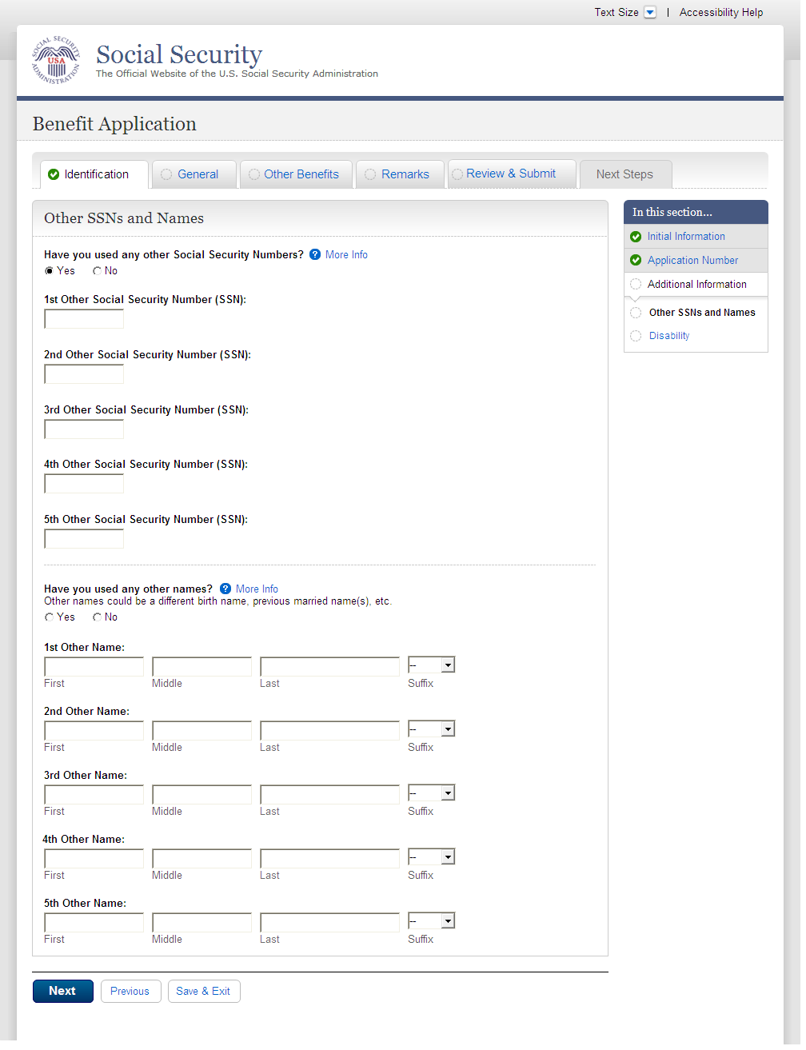
  - adi002-1_01_Disability
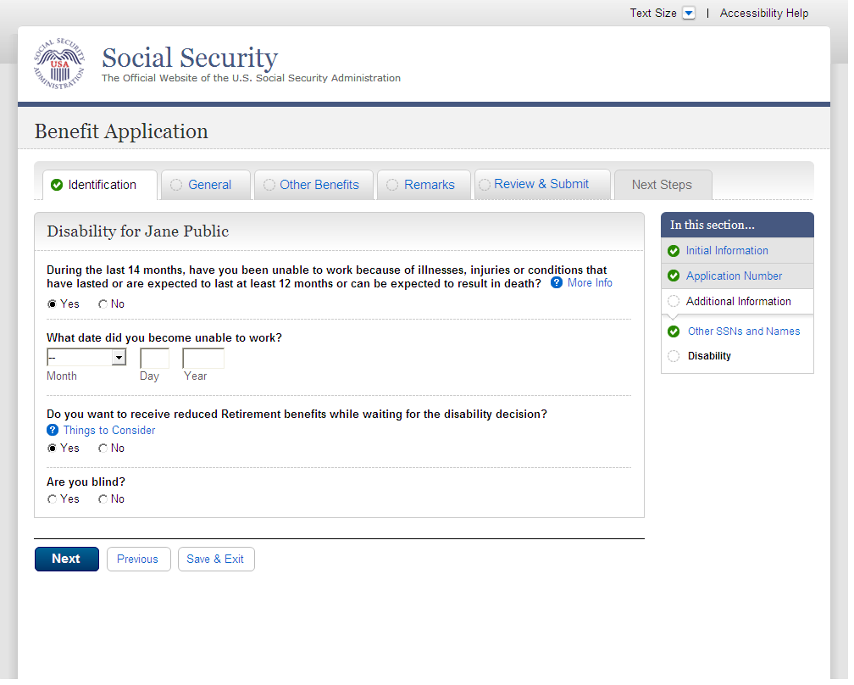
  - fam001-1_01_Marriage Information
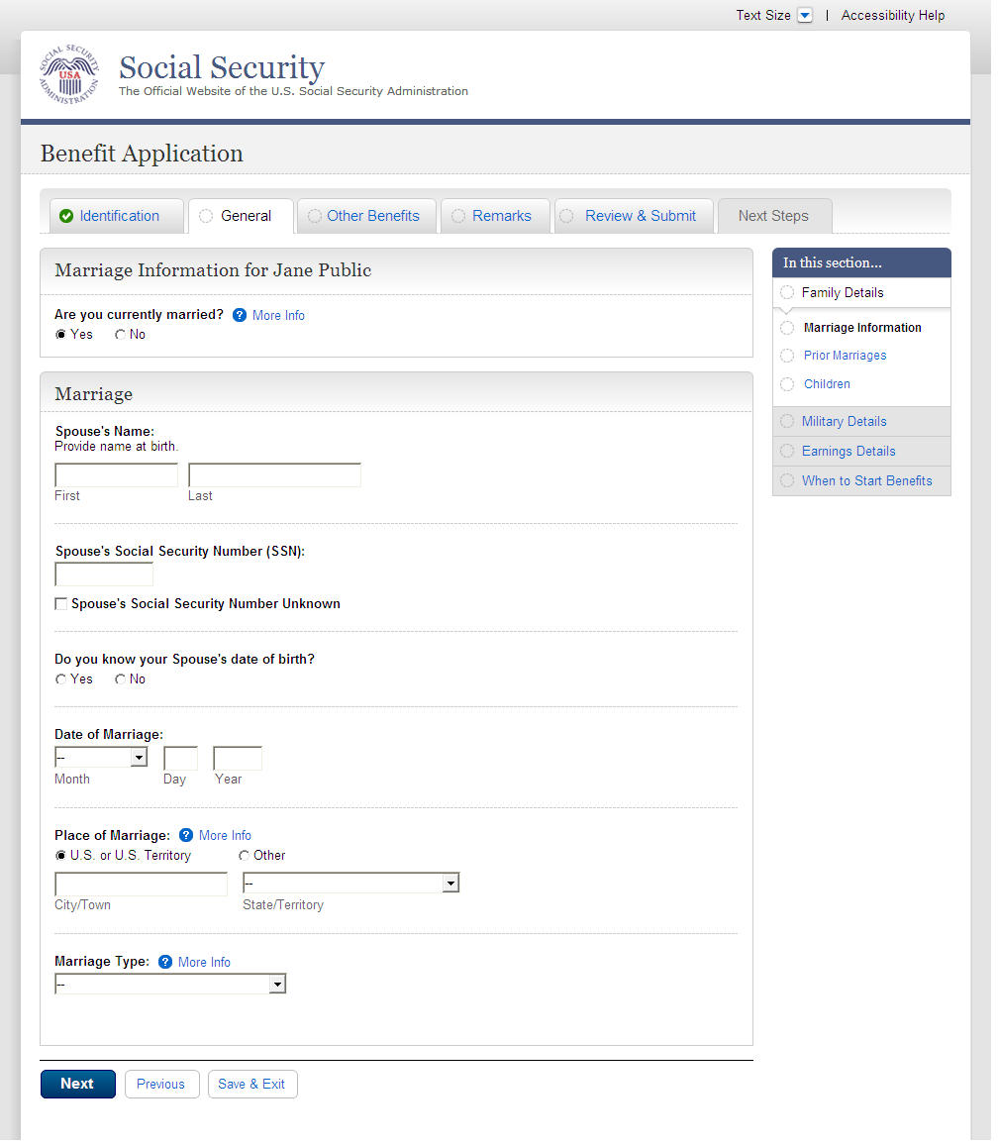
  - fam001-1_01_Marriage Information_Yes
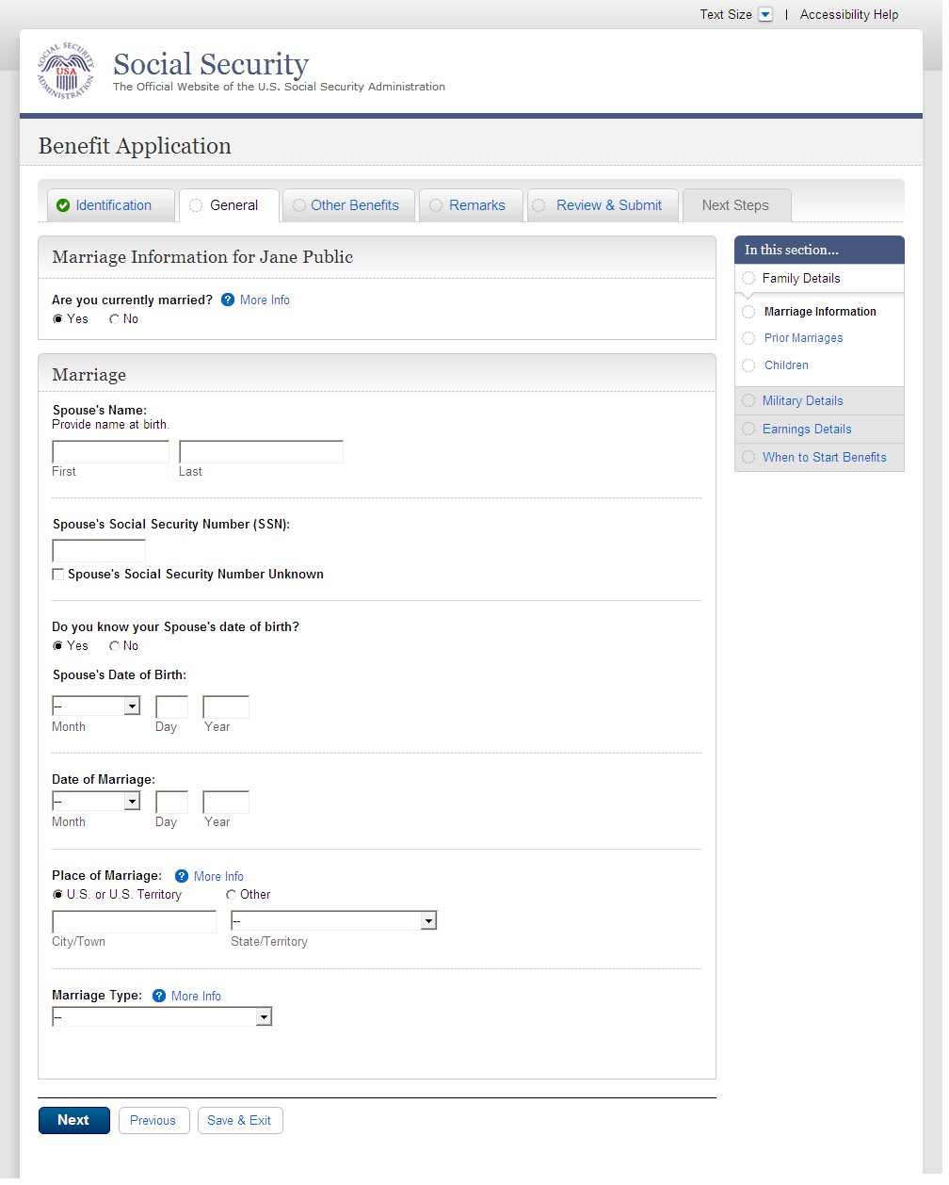
  - fam001-1_01_Marriage Information_No
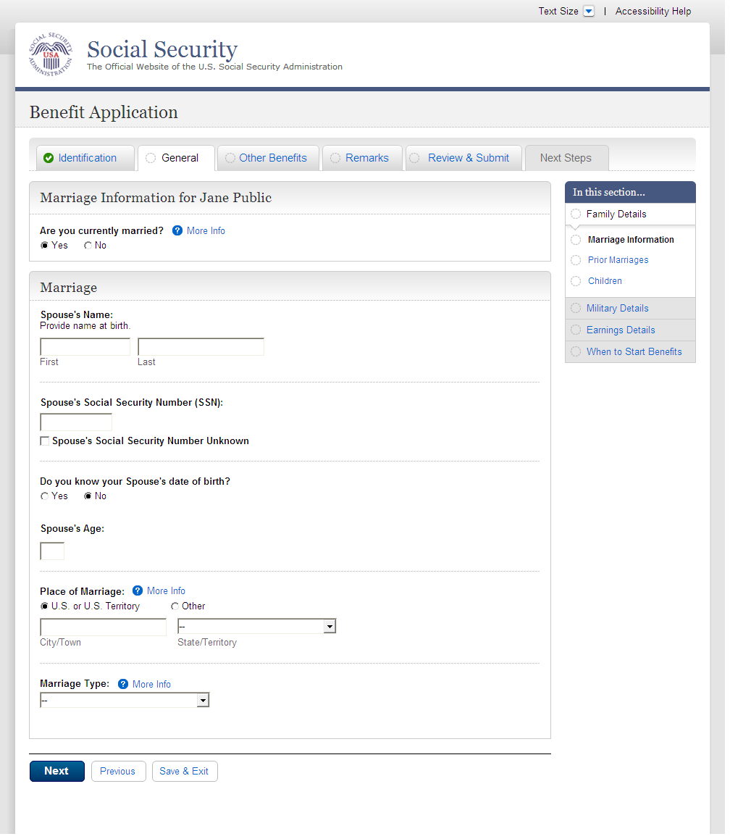
  - fam002-1_02_Prior Marriages
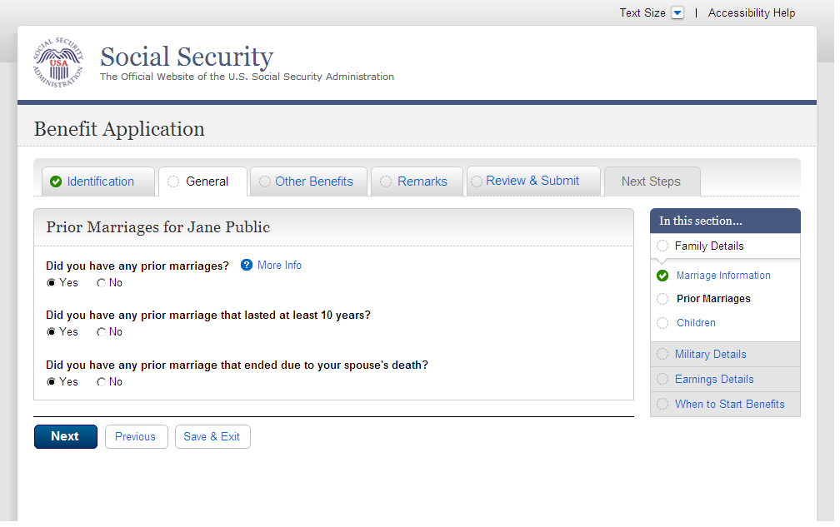
  - fam002-1_02_Prior Marriages_add page_empty table
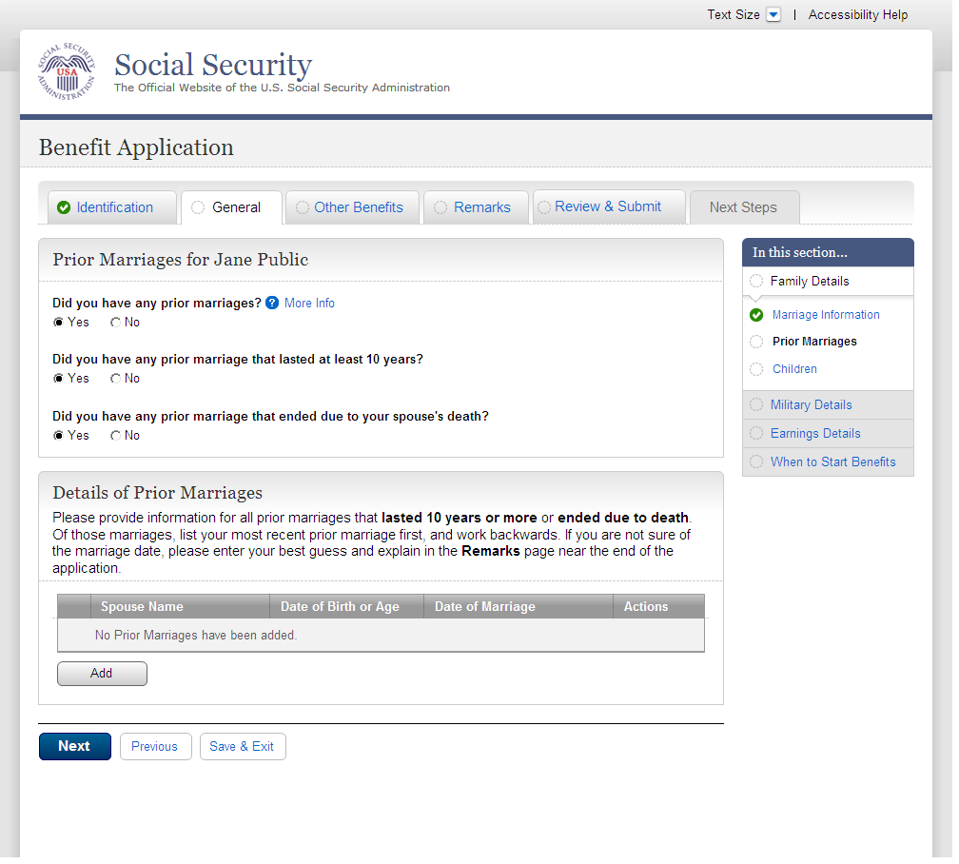
  - fam002-1_02_Prior Marriages_add page4
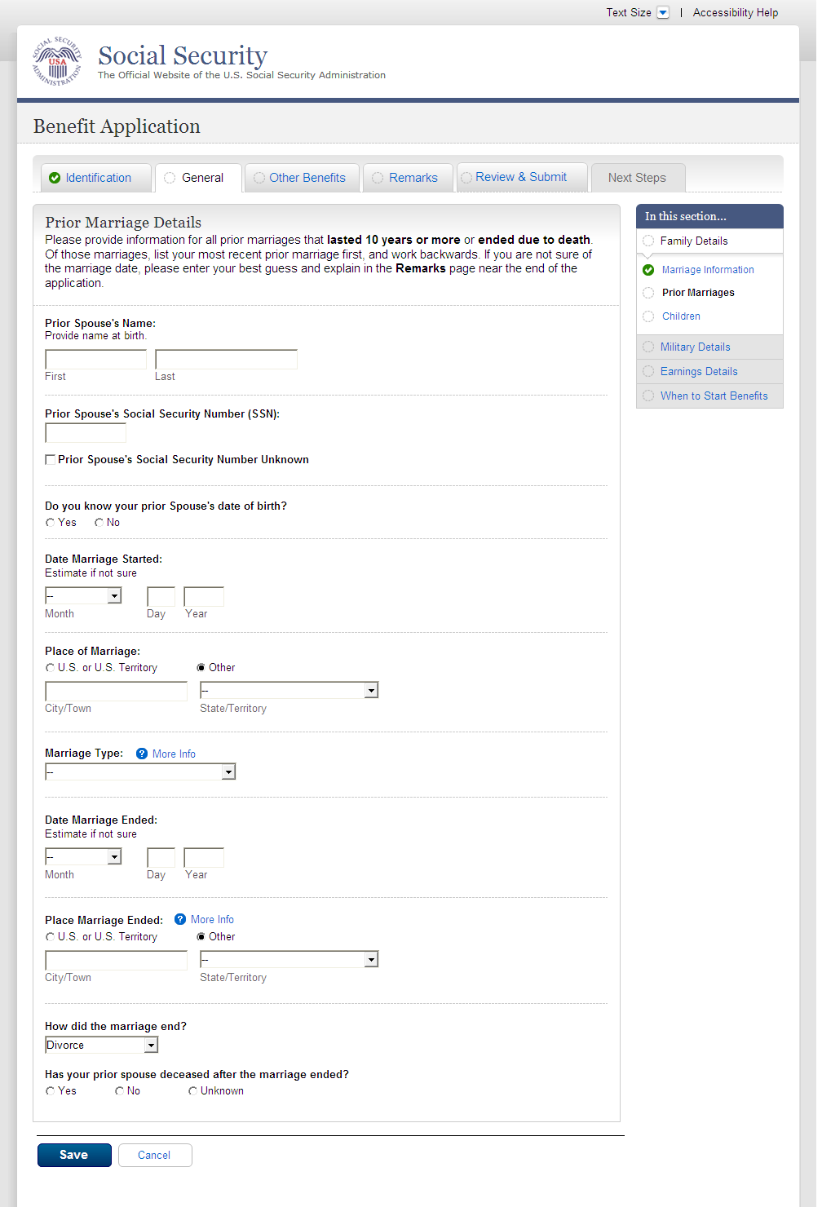
  - fam002-1_02_Prior Marriages_add_waddl questions
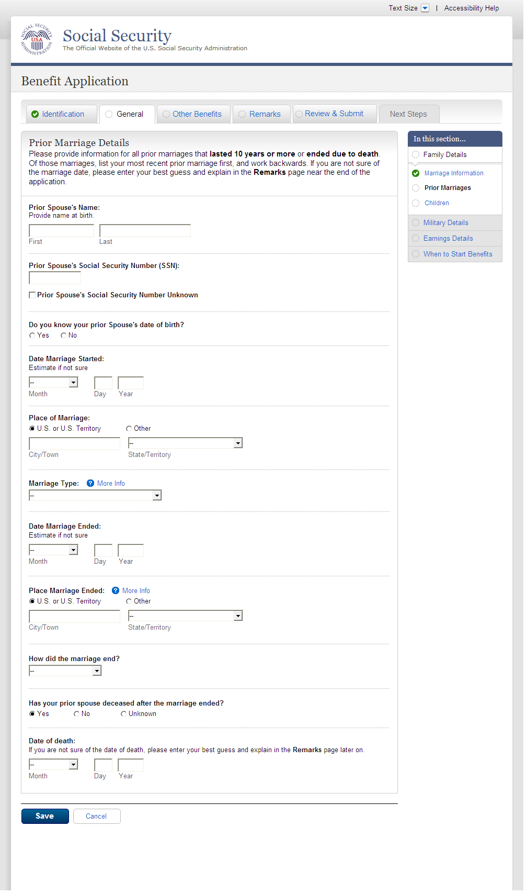
  - fam002-1_02_Prior Marriages_add page_Yes
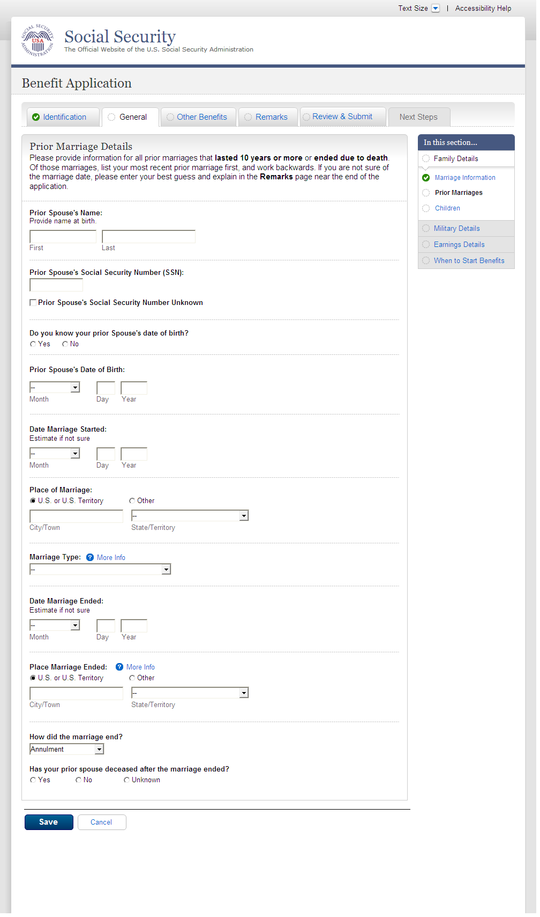
  - fam002-1_02_Prior Marriages_add page_No
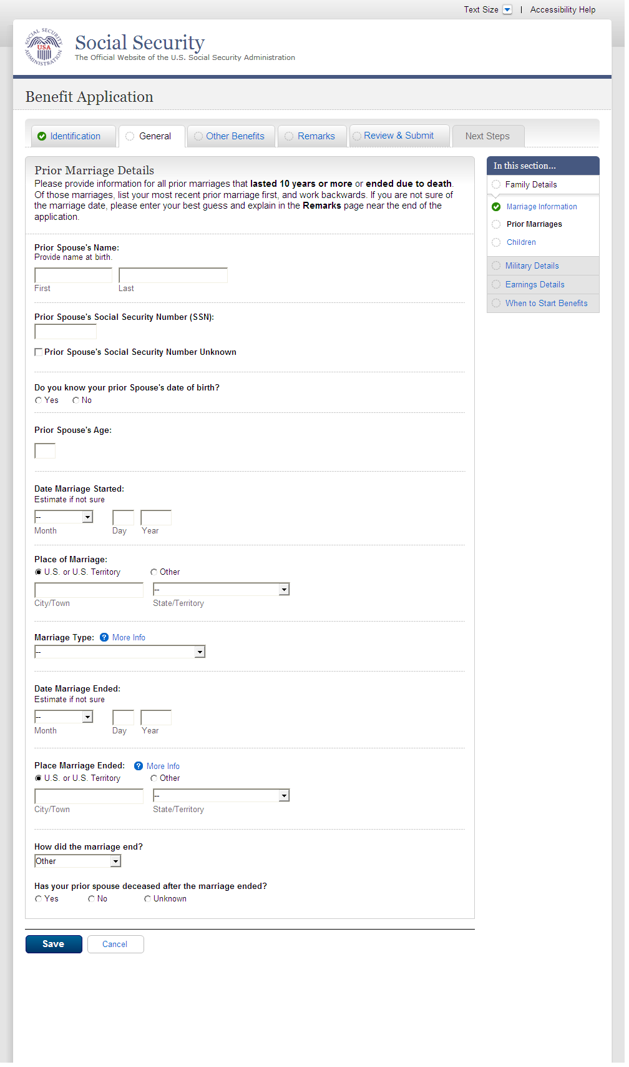
  - fam002-1_02_Prior Marriages_summary page
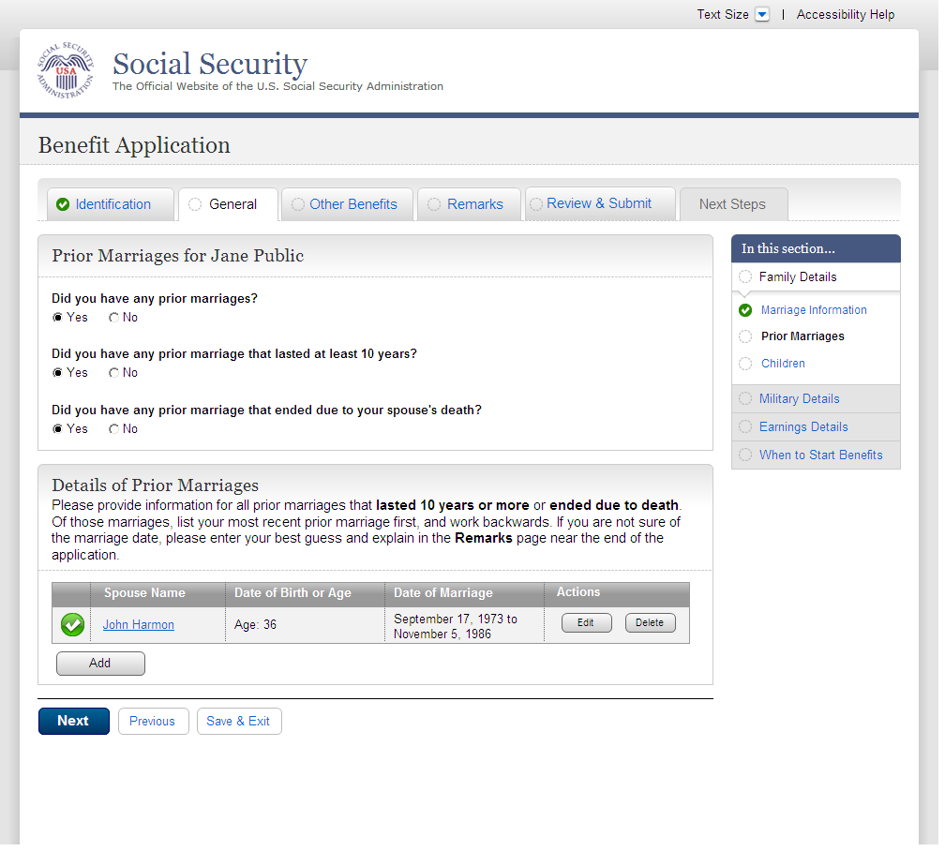
  - fam002-1_02_Prior Marriages_summary page_message
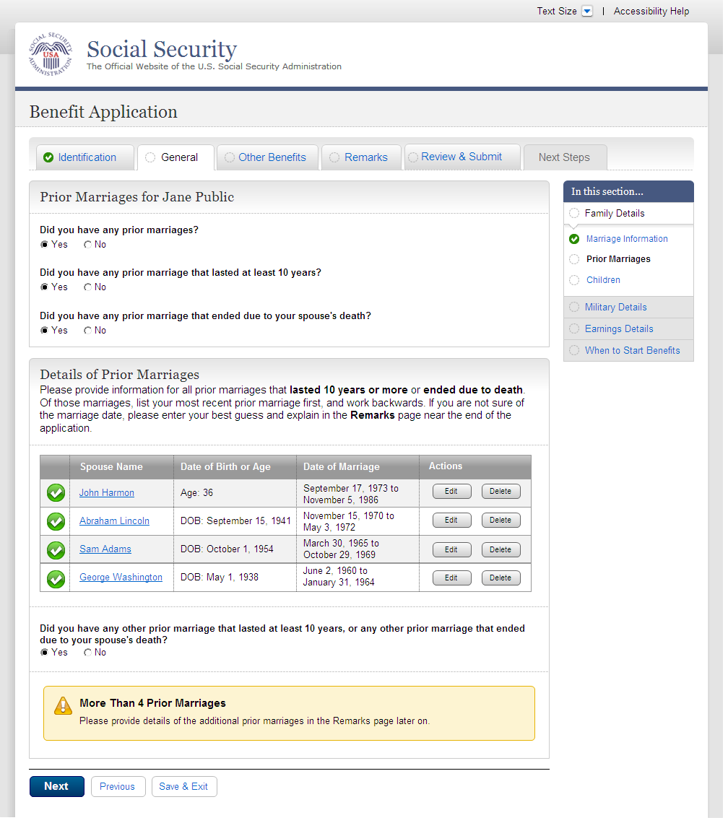
  - fam003-r1_Children
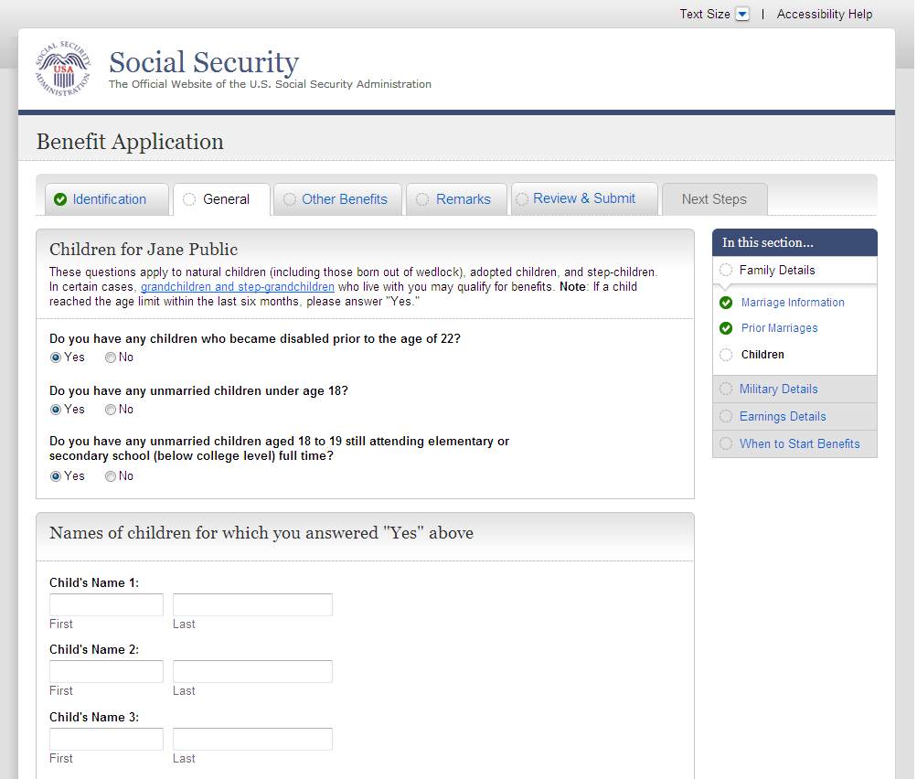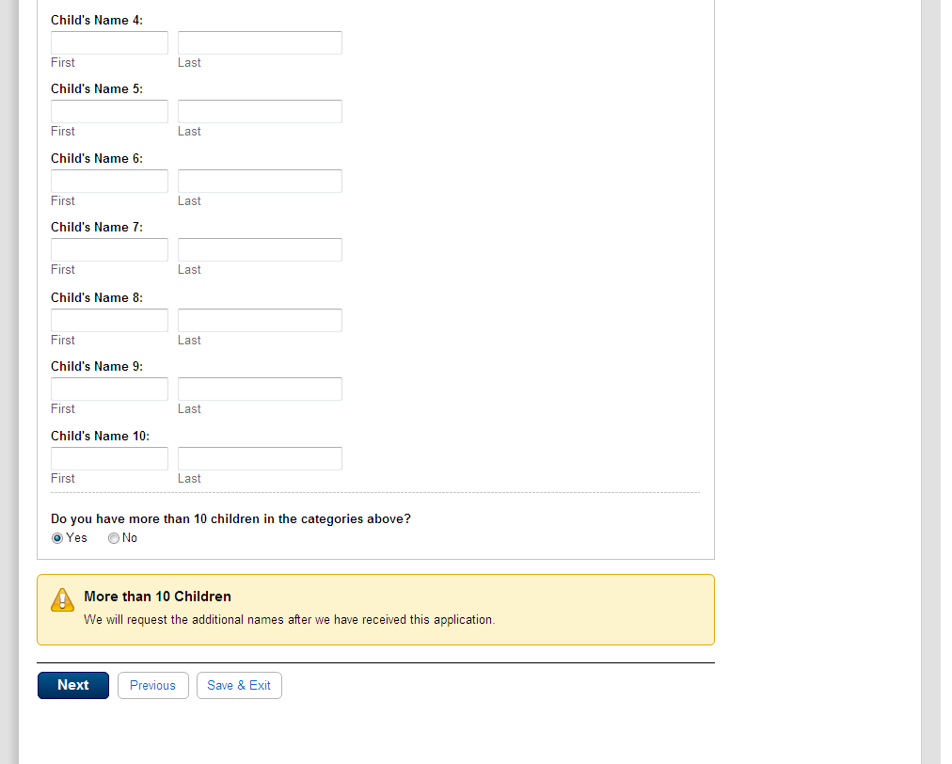
  - mil001-1_Military Details_initial state
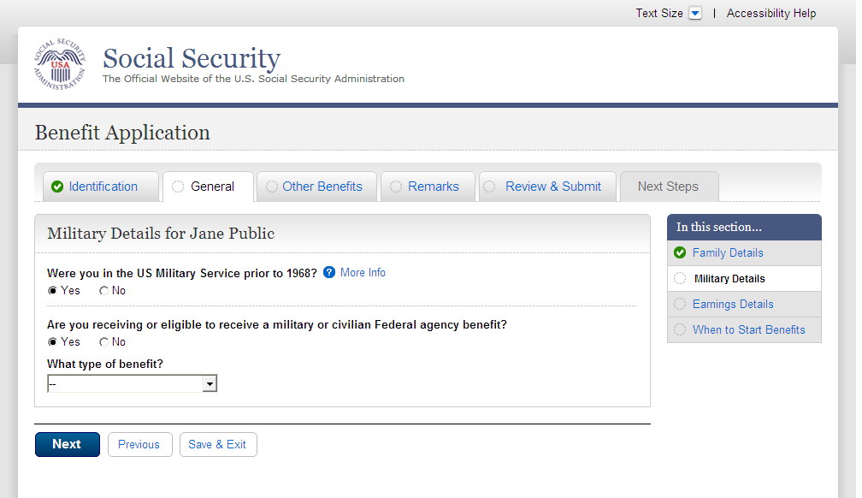
  - mil001-1_Military Details_tableempty
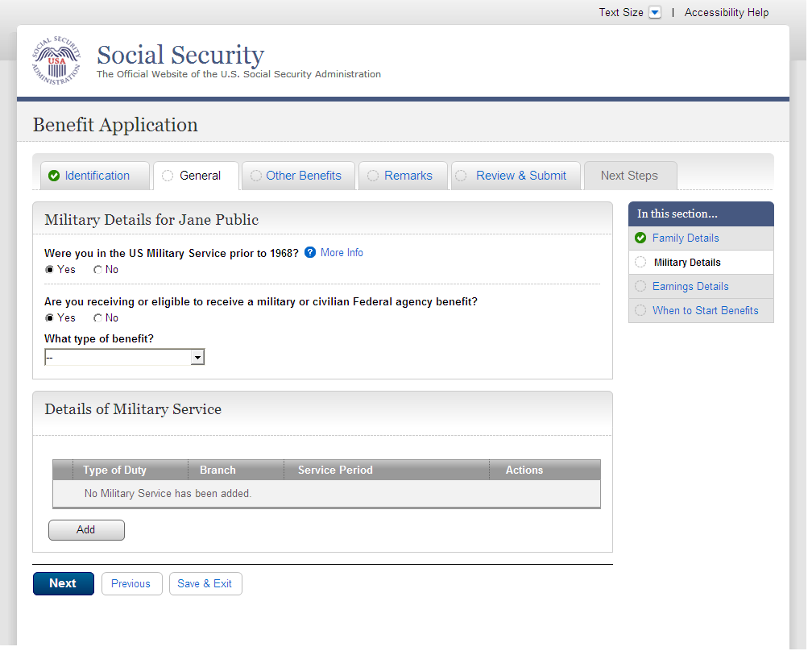
  - mil001-1_Military Details_Period1
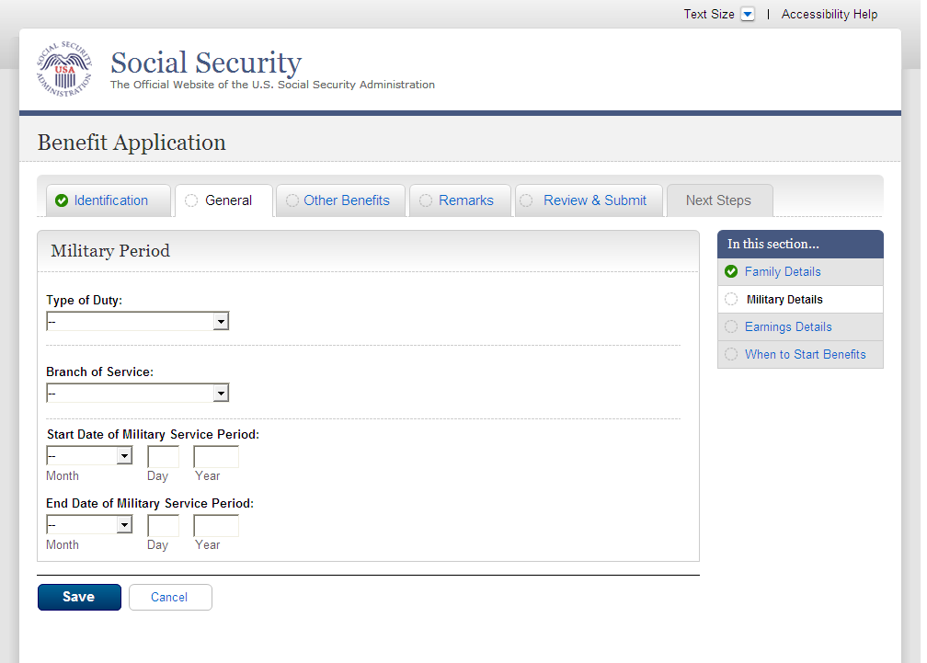
  - mil001-1_Military Details_Table9Row_NoWarning
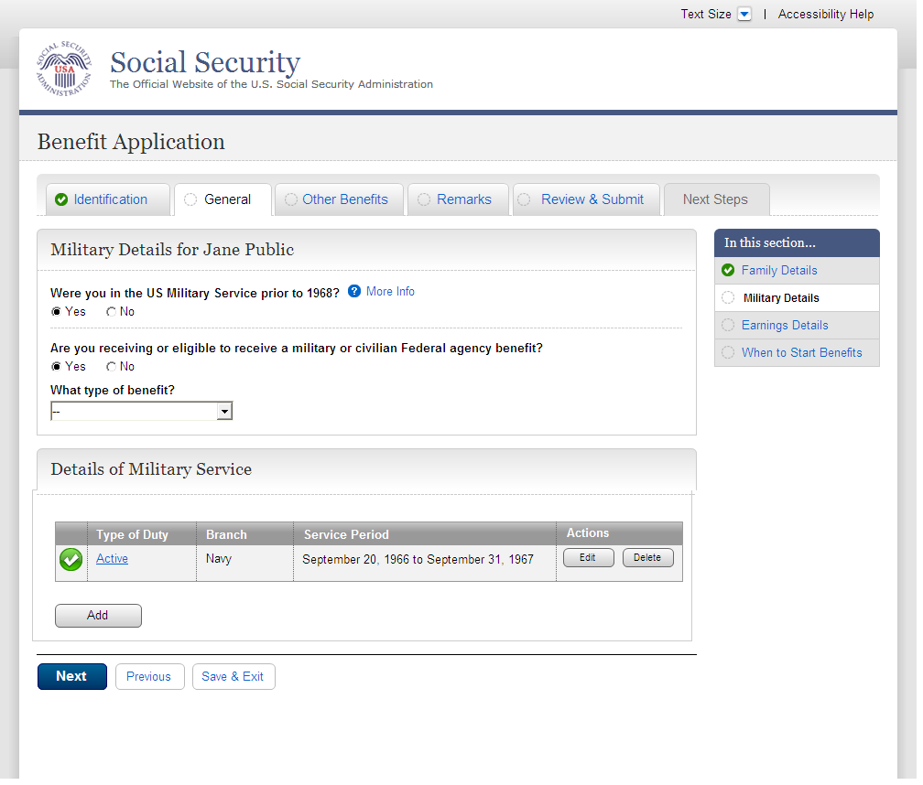
  - mil001-1_Military Details_Table10Row_Warning
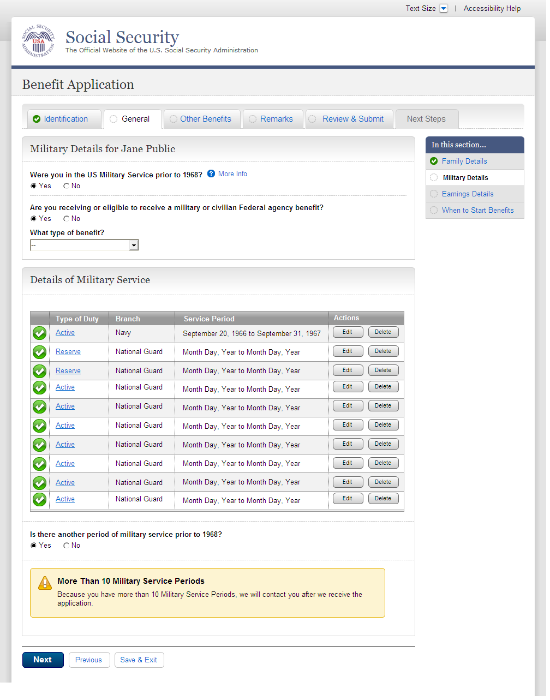
  - ear001-1-lag_Employer Details
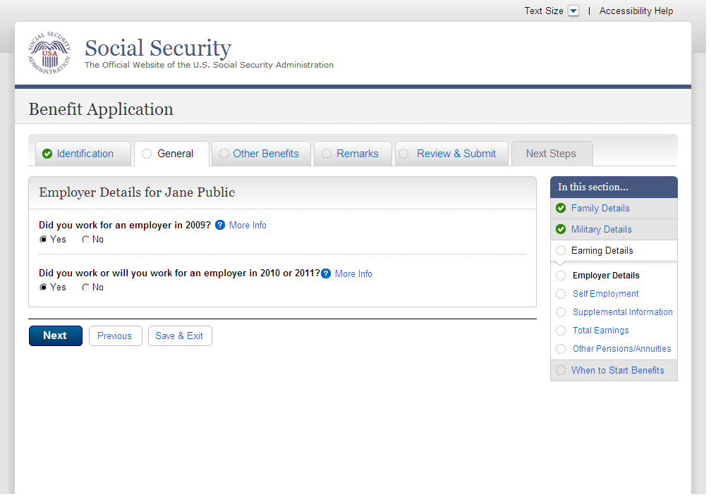
  - ear001-1-lag_01_tableEmpty
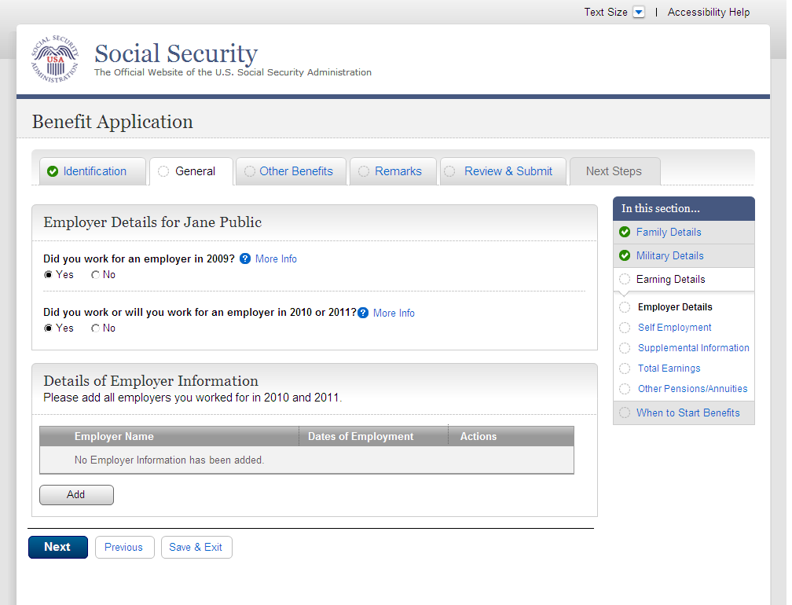
  - ear001-1-lag_02_EmployerDetailEntry
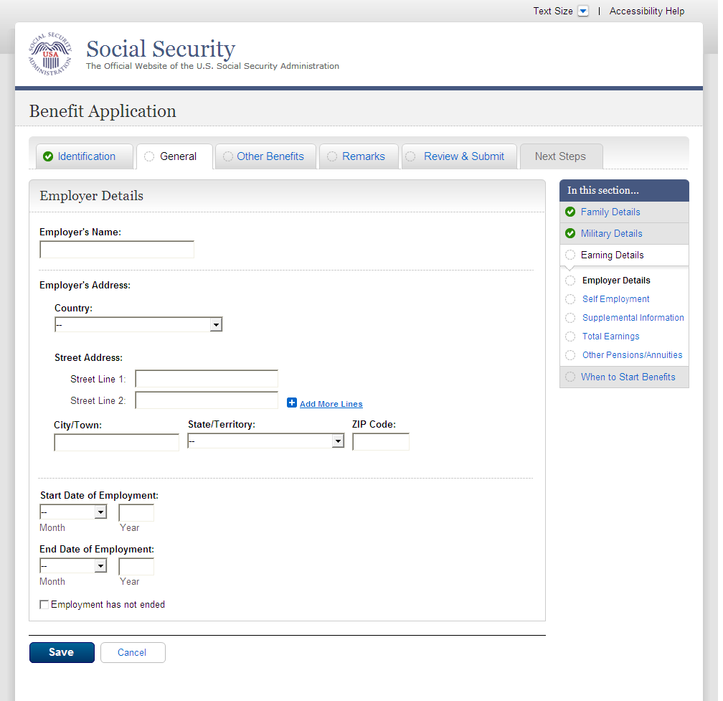
  - ear001-1-lag_02_EmployerDetailEntry_Foreign Address
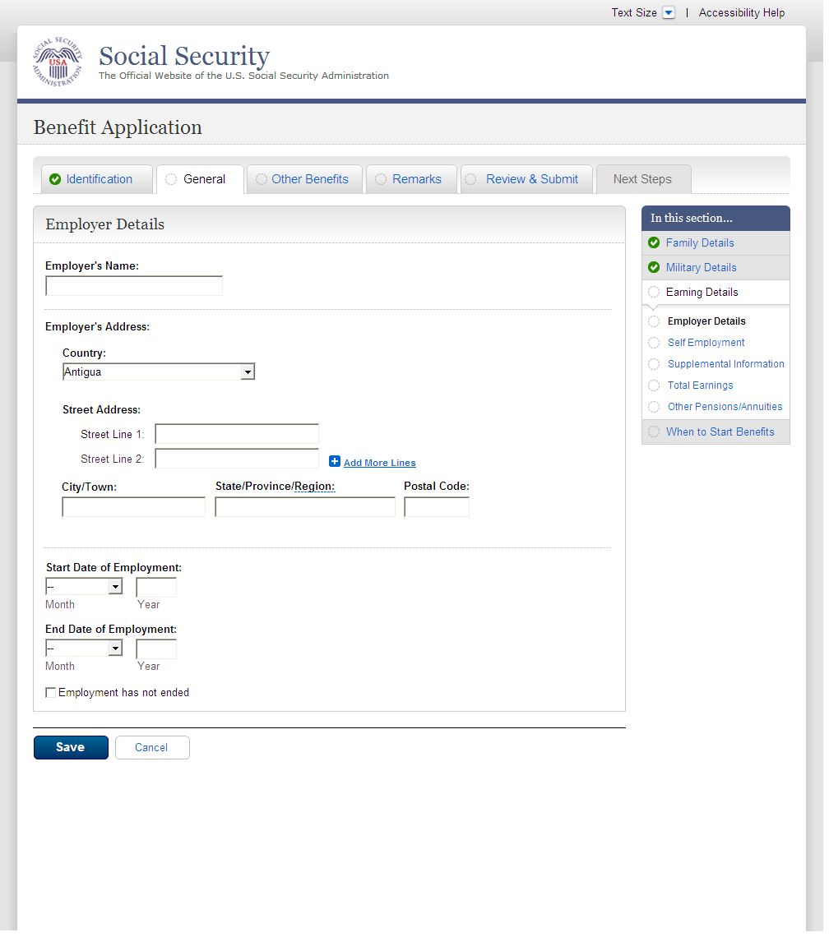
  - ear001-1-lag_03_table1Row
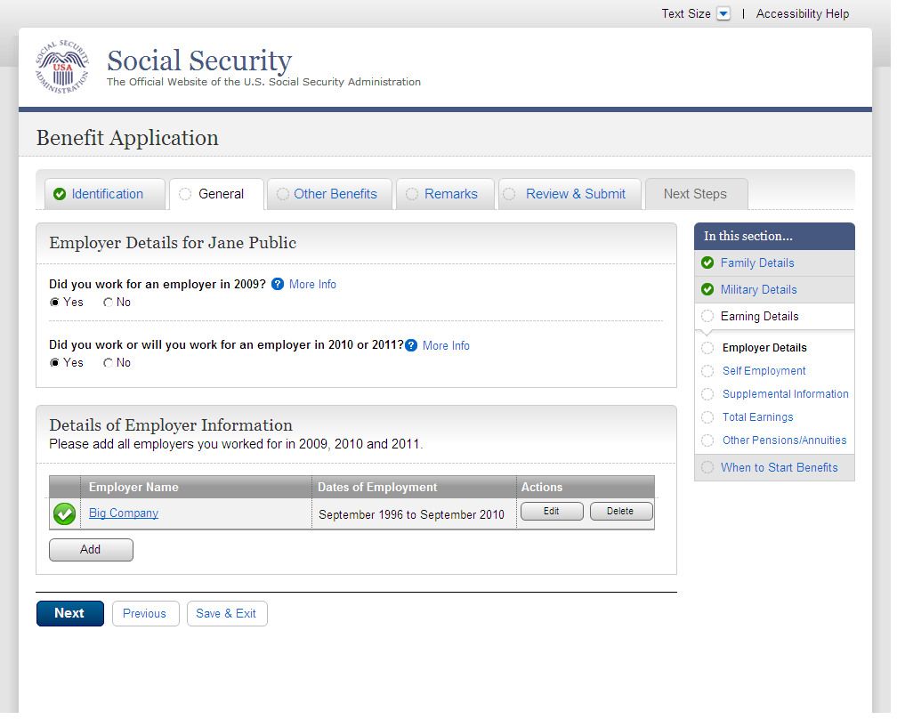
  - ear001-1-lag_05_table9Rows
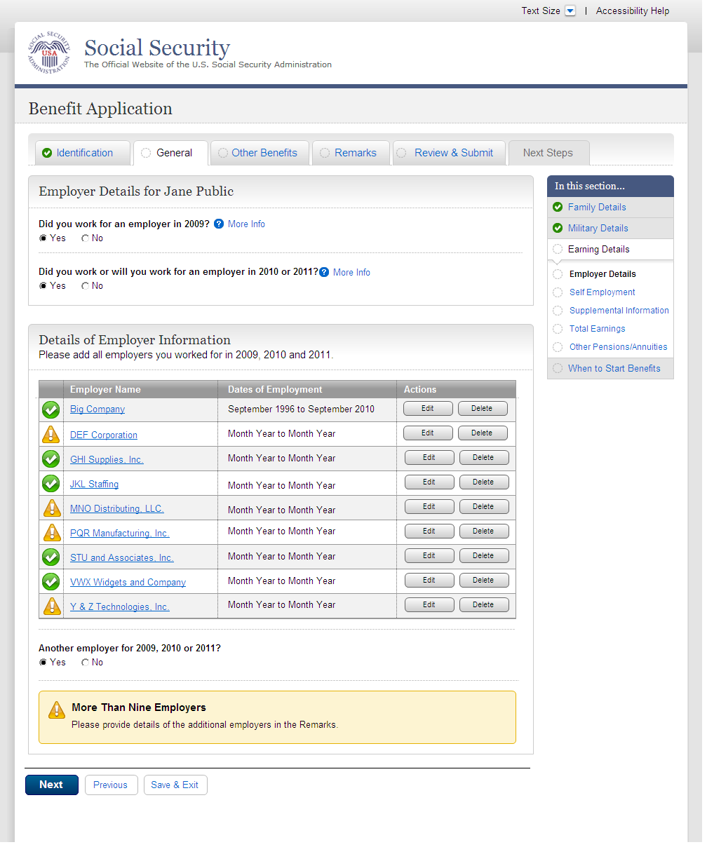
  - ear002-lag_Self Employment
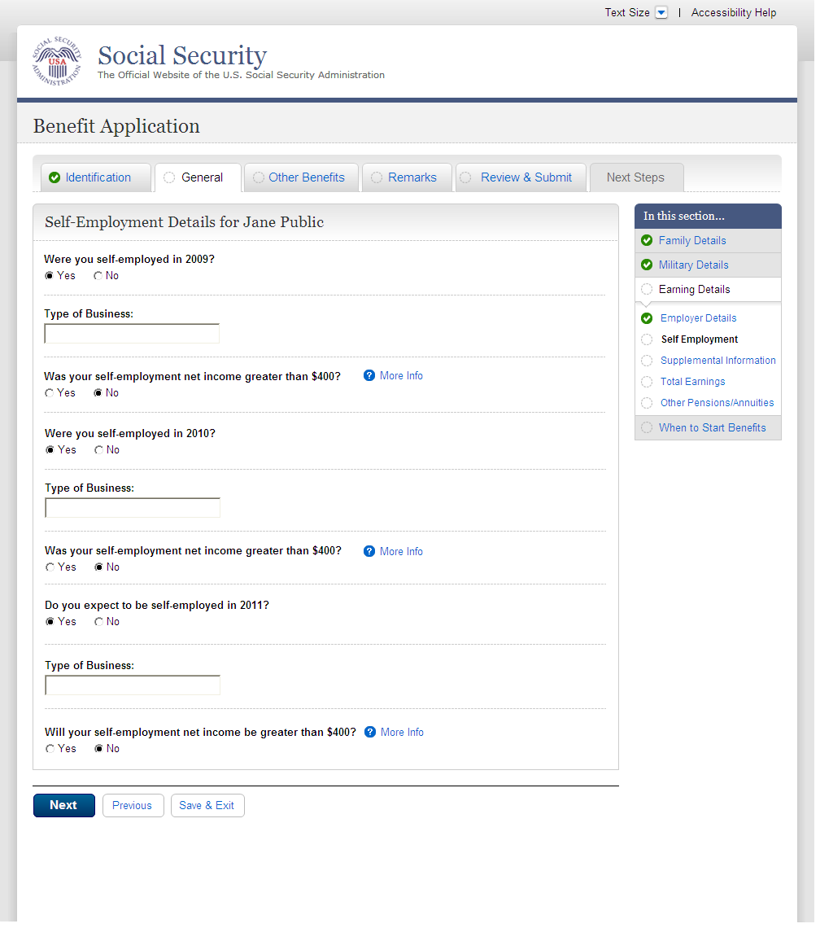
  - ear002-lag_workingCollapse_Self Employment
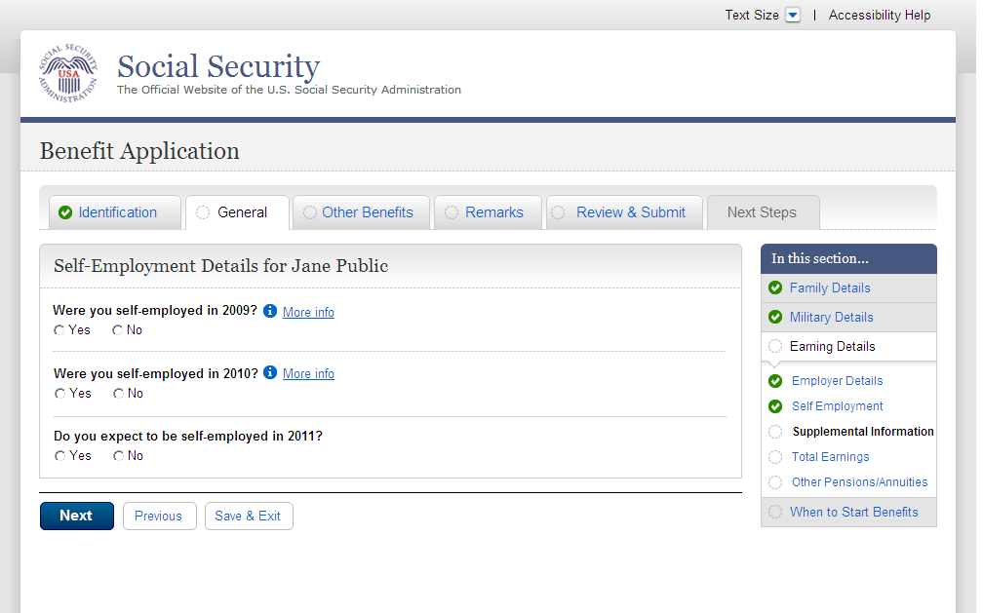
  - ear003-1-a_Supplemental Information
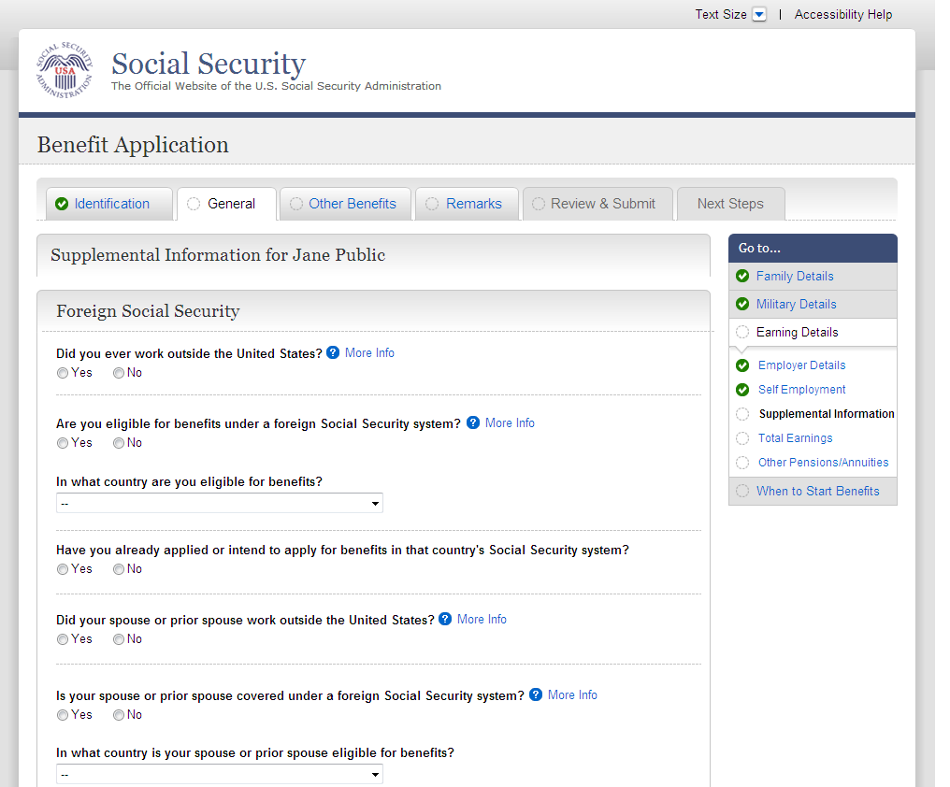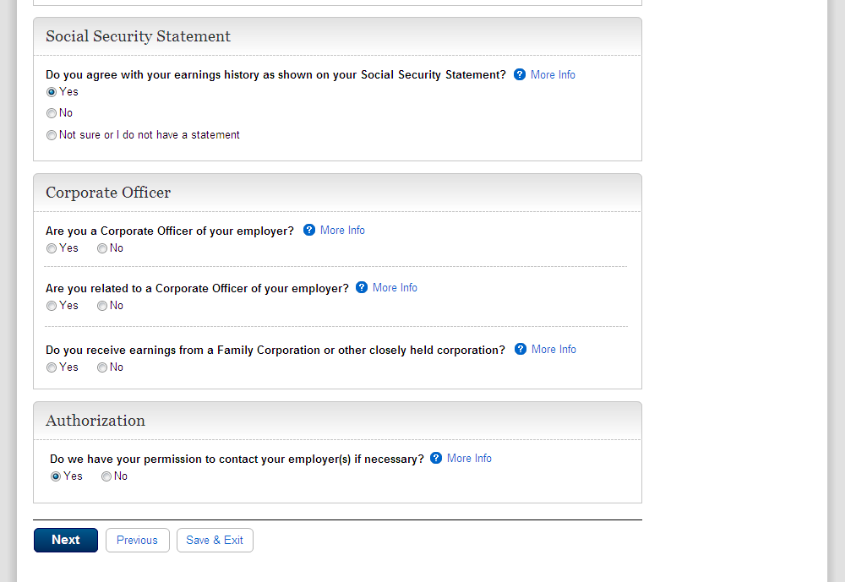
  - ear004_Total Earnings
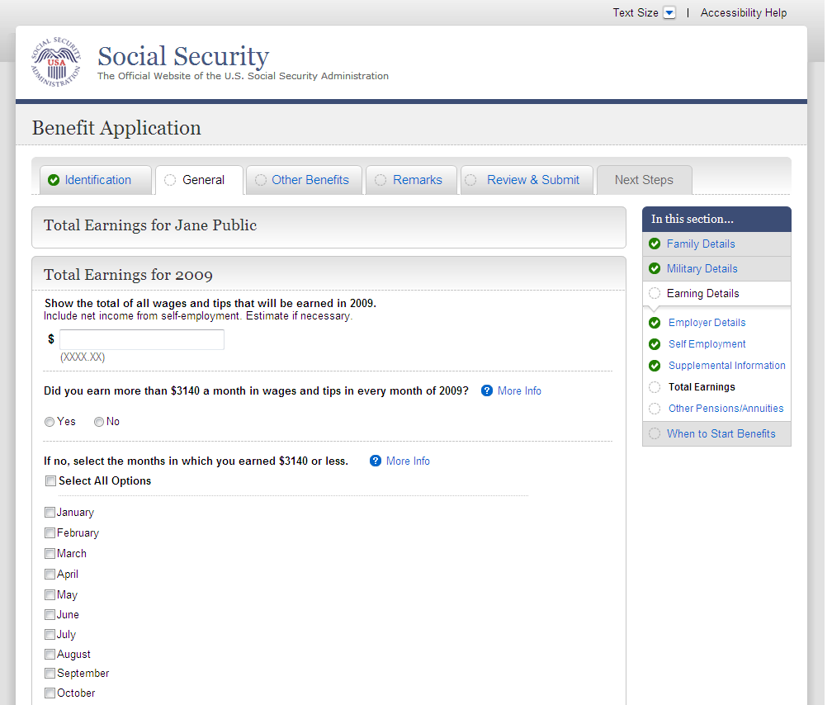
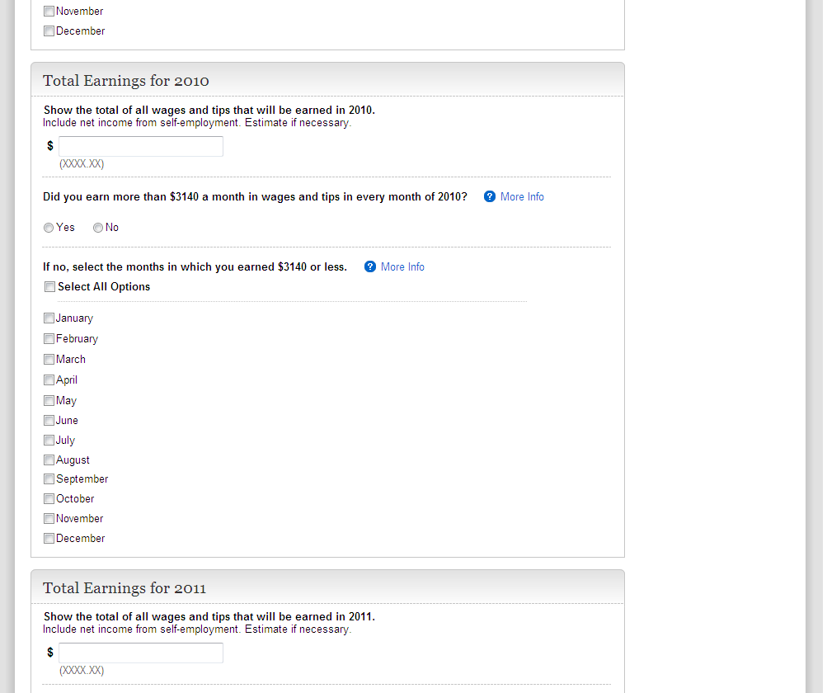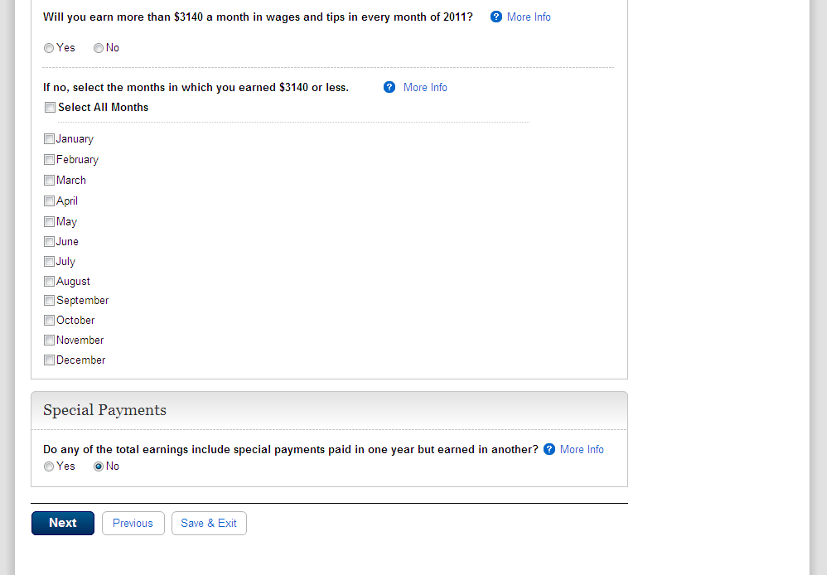

ear004-d1-b_Total Earnings
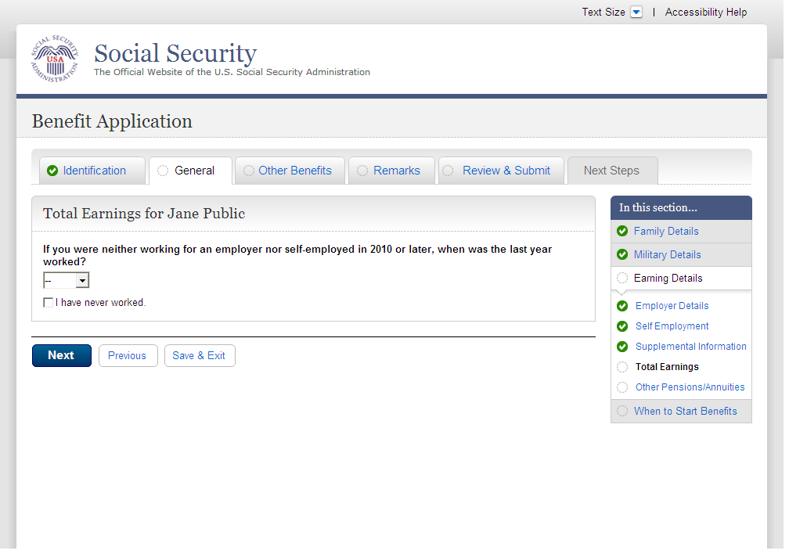
  - ear005-1-a_Other Pensions/Annuities
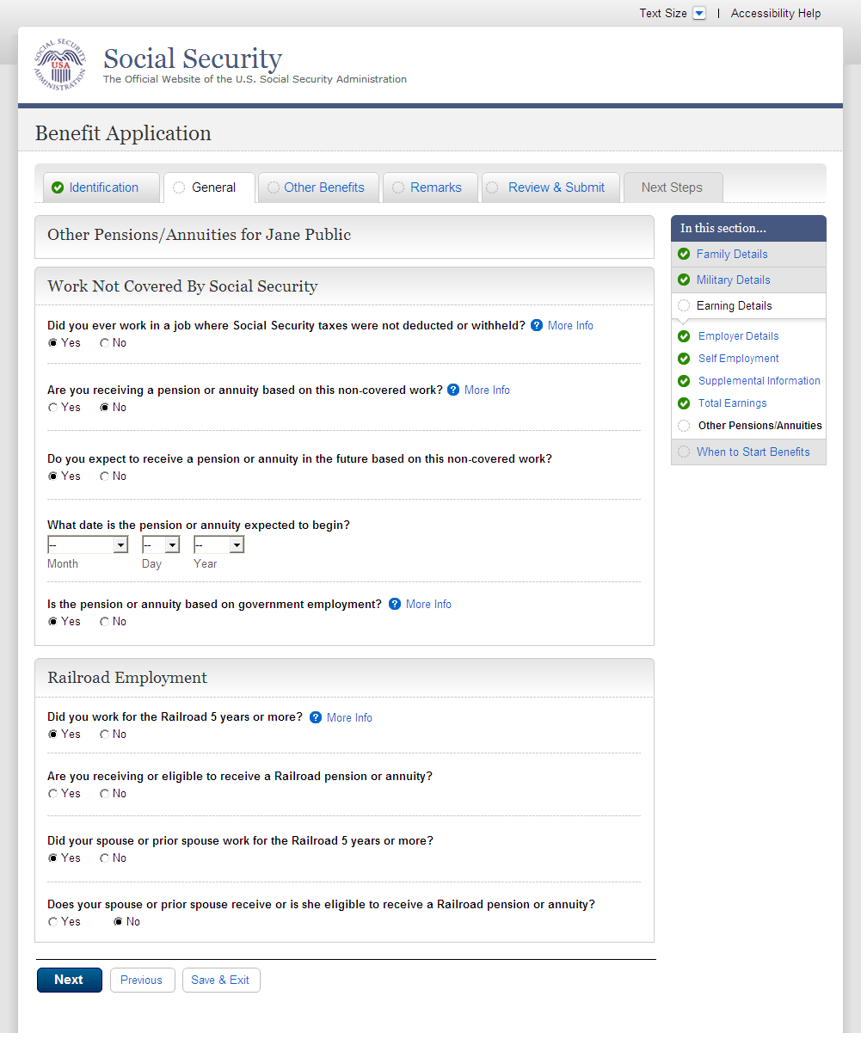
  - wst000-1_Reduced Benefits
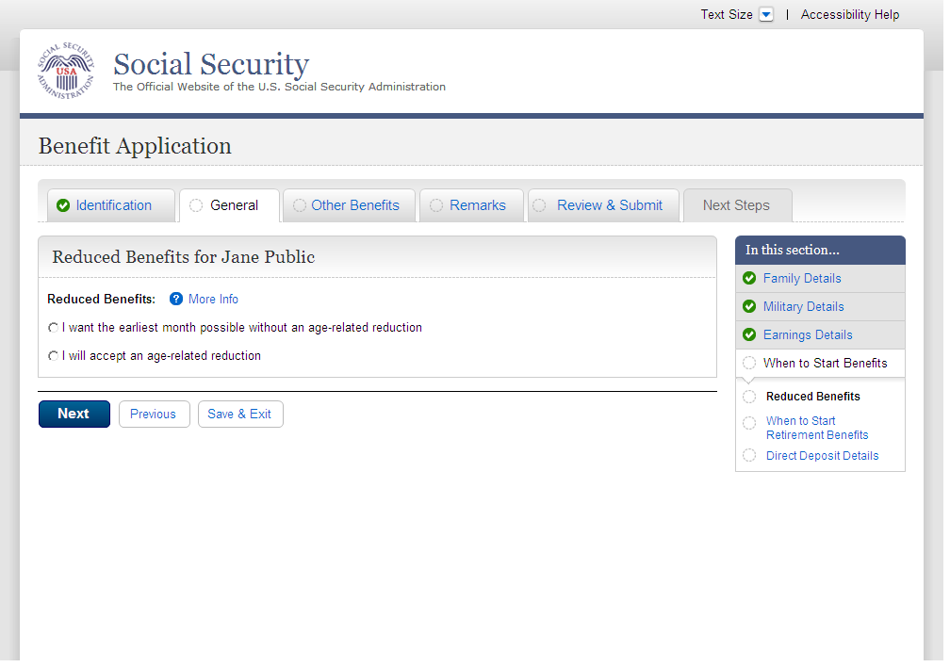
  - wst001-1-b_When to Start Retirement Benefits
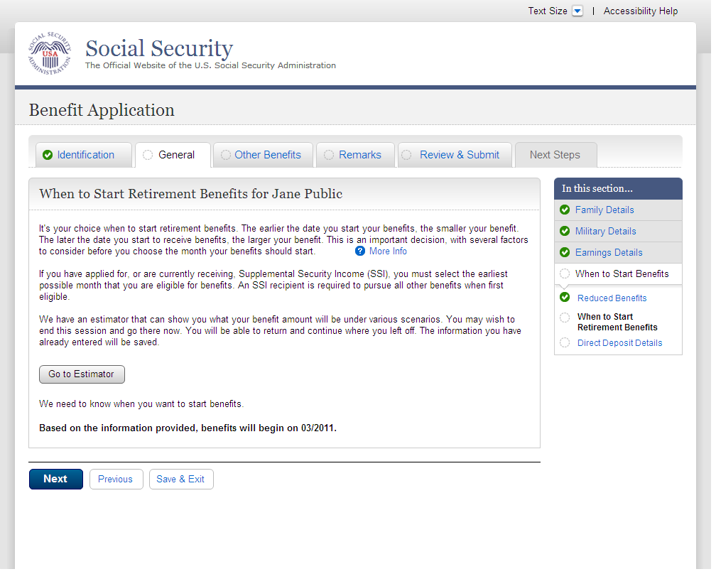
  - wst001-1-e_When to Start Retirement Benefits
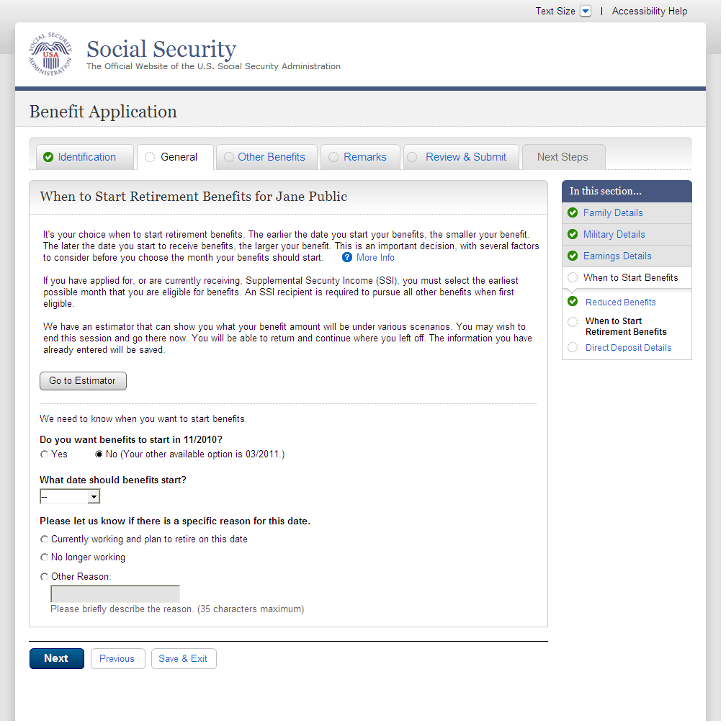
  - wst001-3-c_When to Start Retirement Benefits
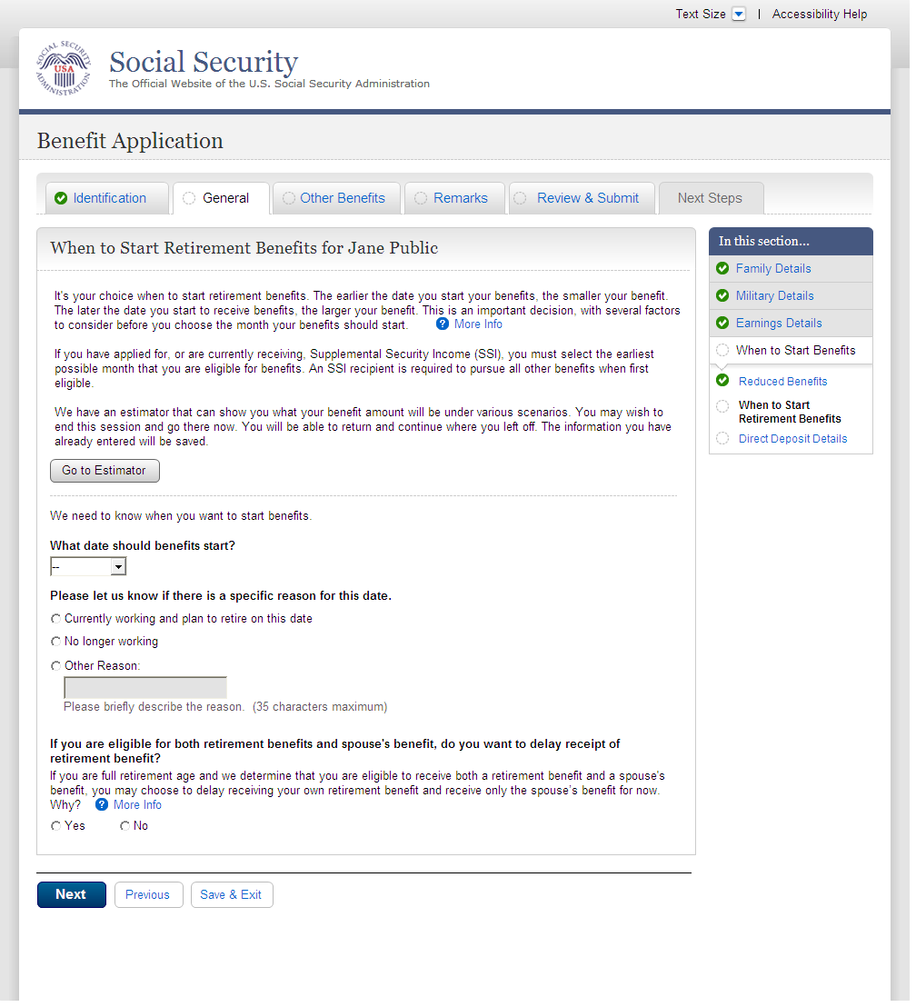
  - wst001-3-d_When to Start Retirement Benefits
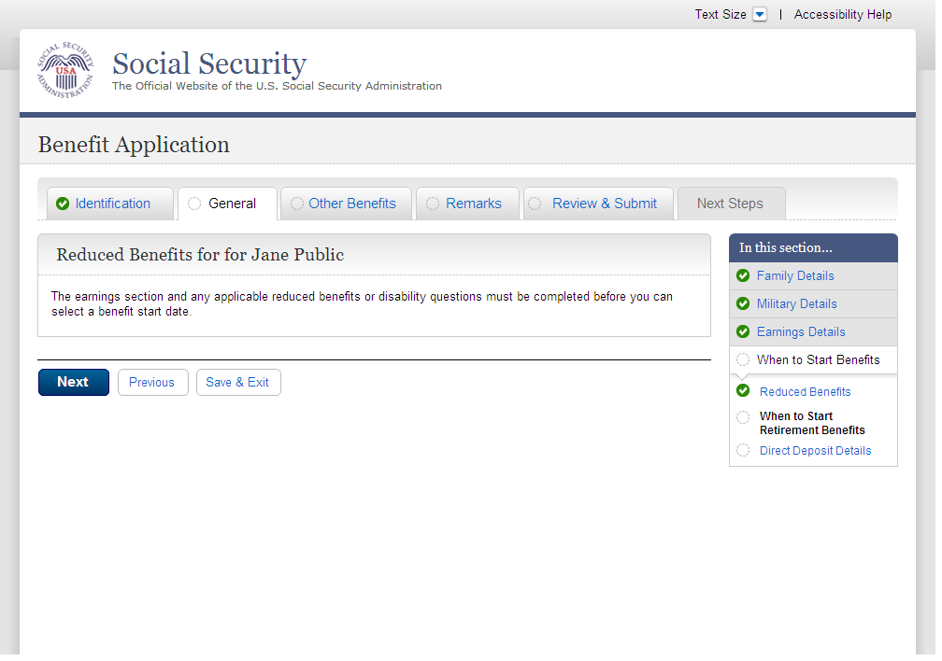
  - wst002-1_Direct Deposit Details
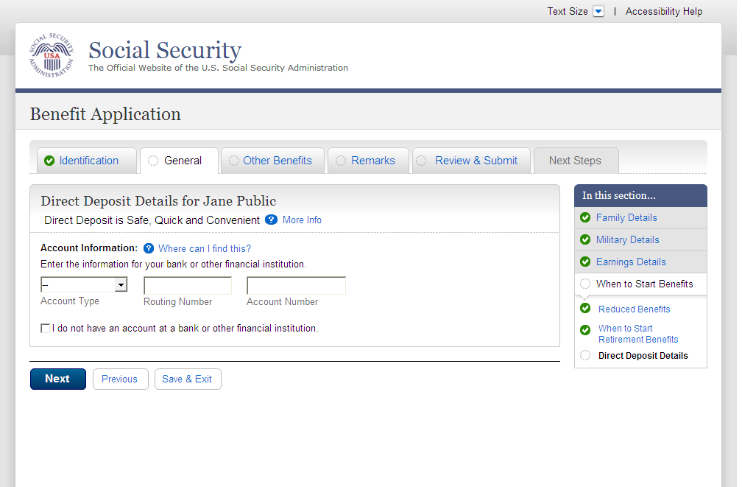

  - bni001-1_Benefit Information
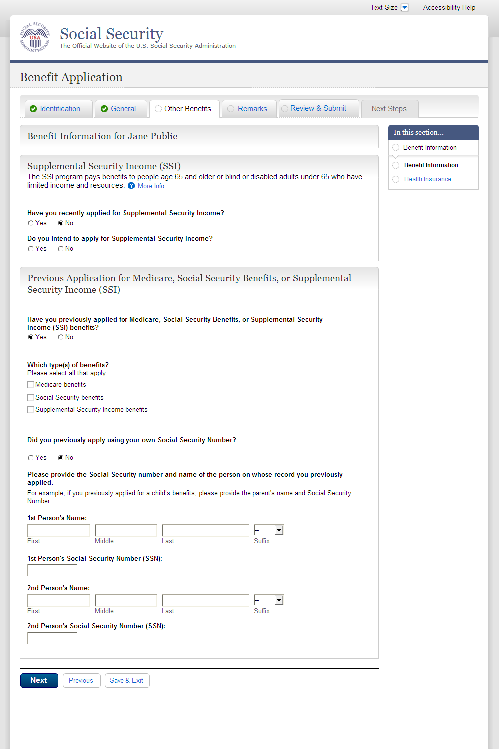
  - bni002-3_Health Insurance
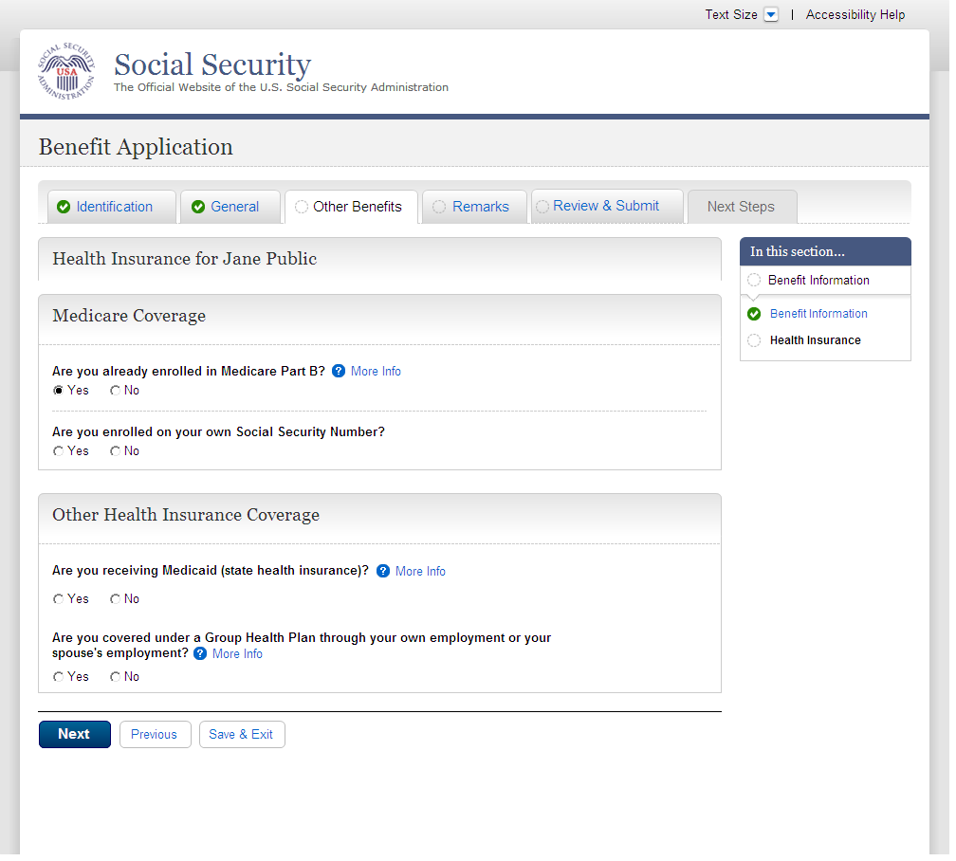
  - rem001_Remarks
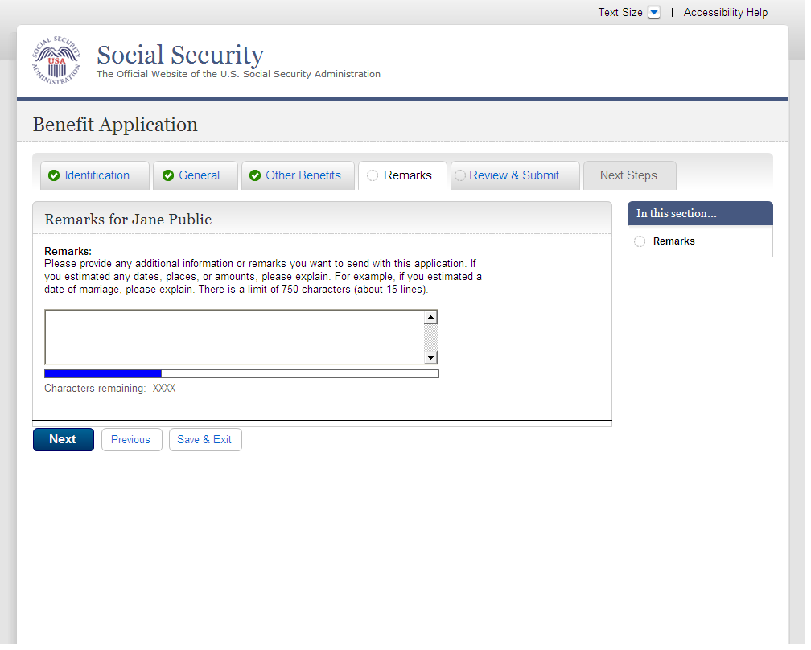
  - ovs001-r1-a_Overall Summary
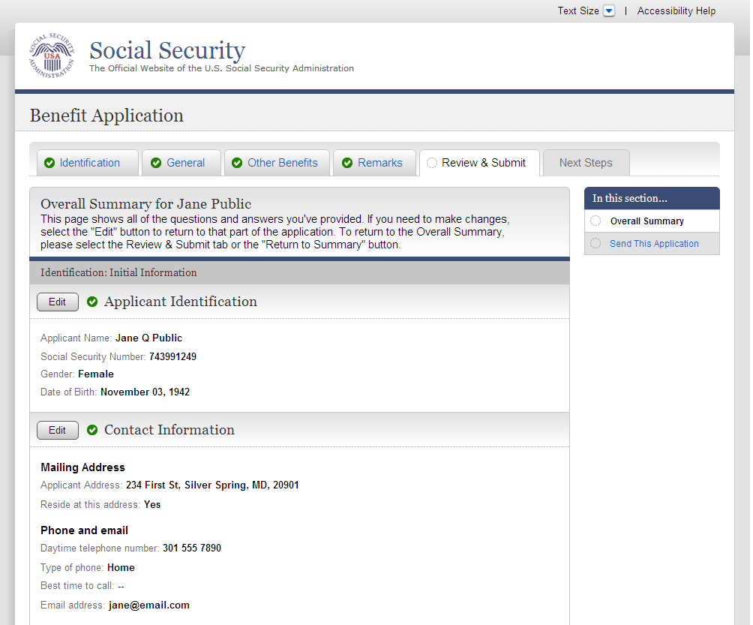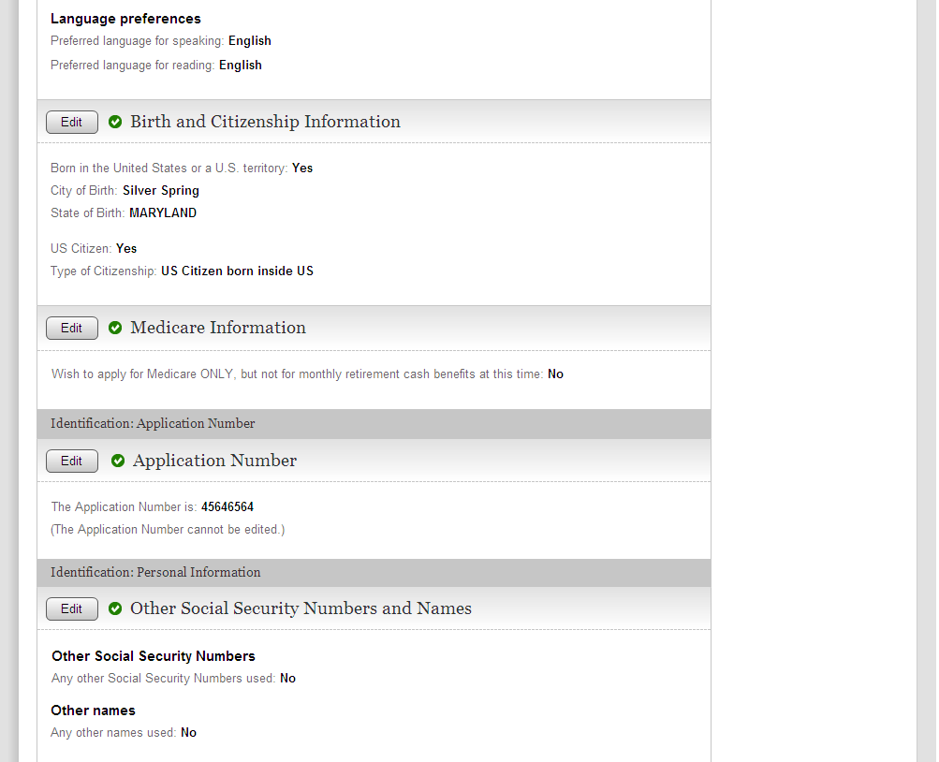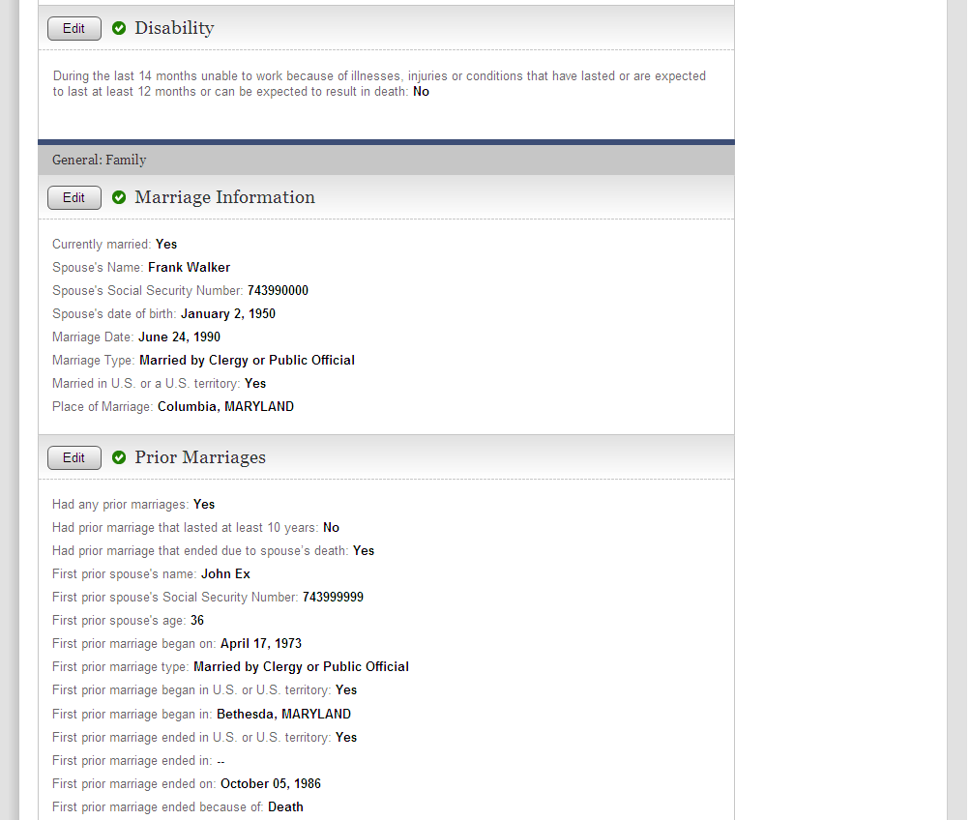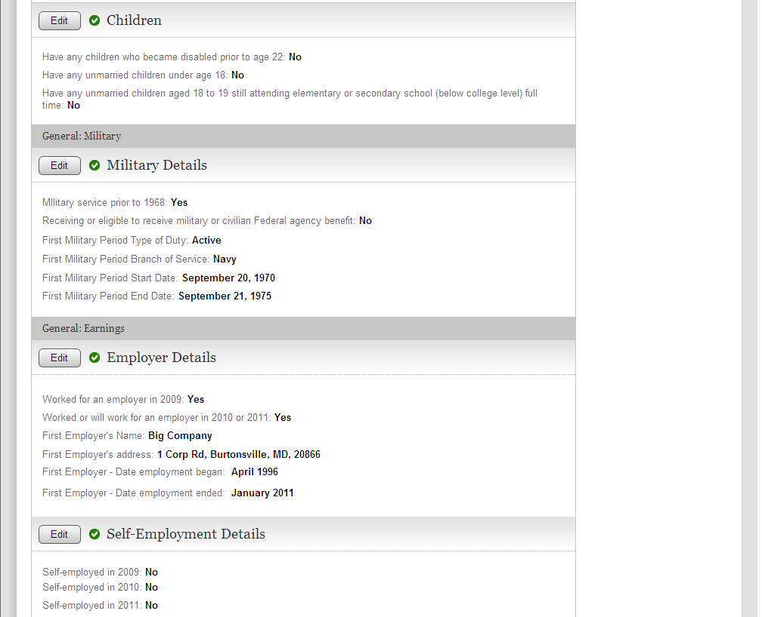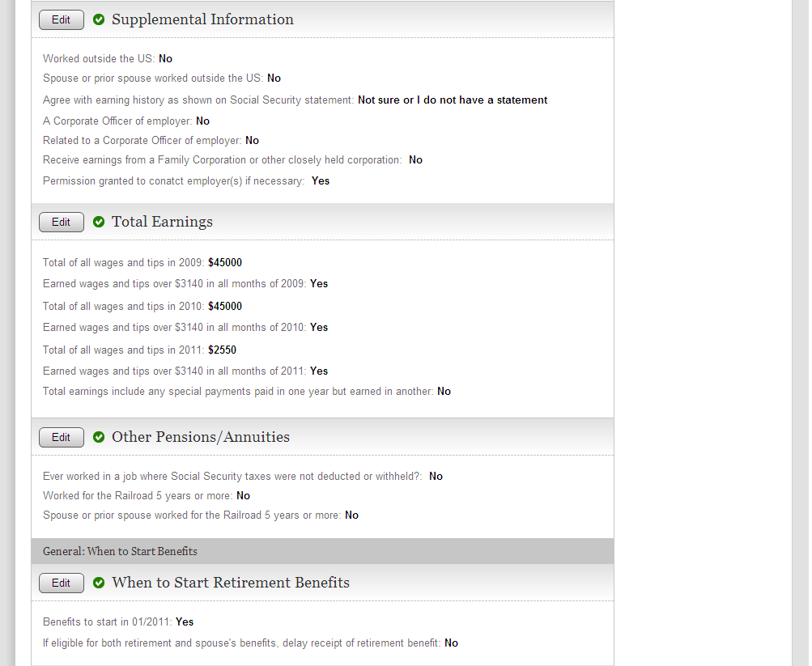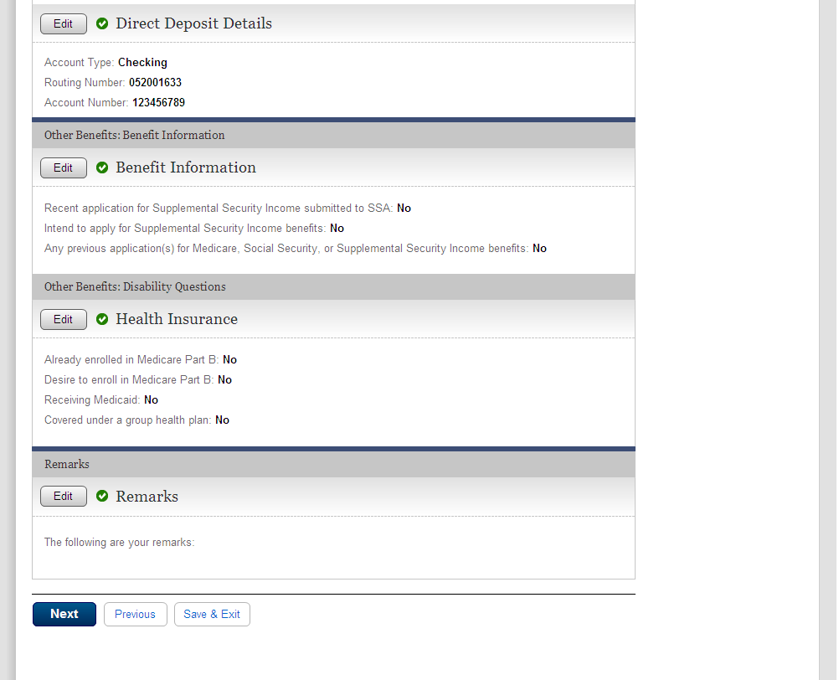

  - snd001-r1_Send This Application
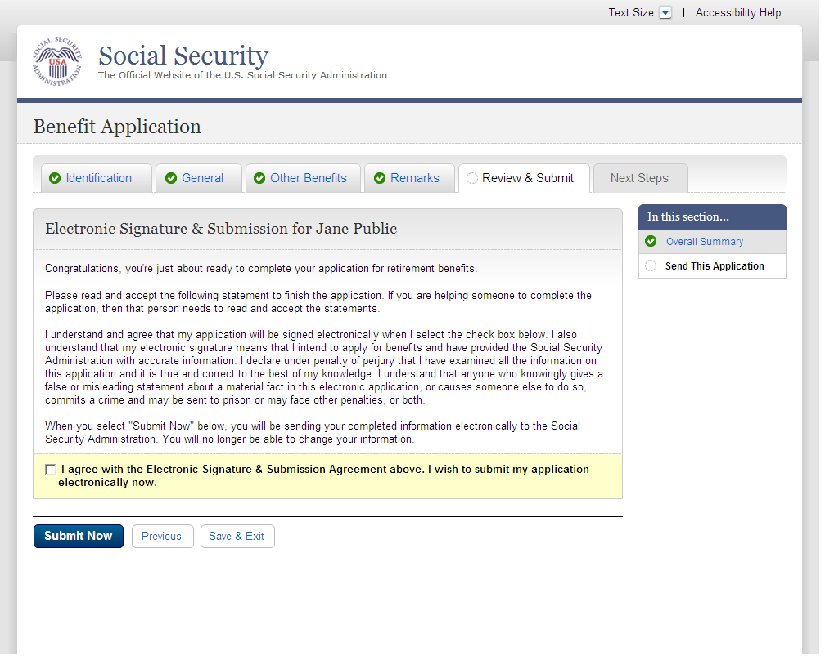
  - rec001-r1-a_Evidence and Receipt
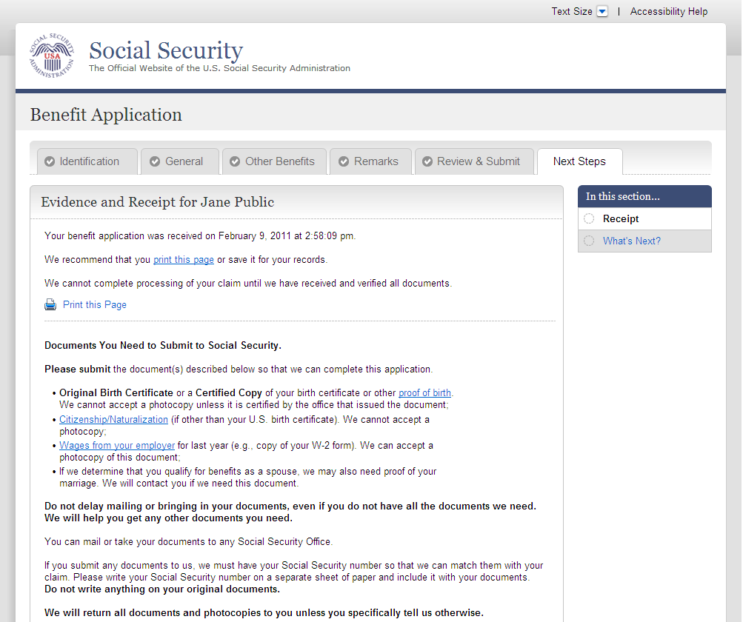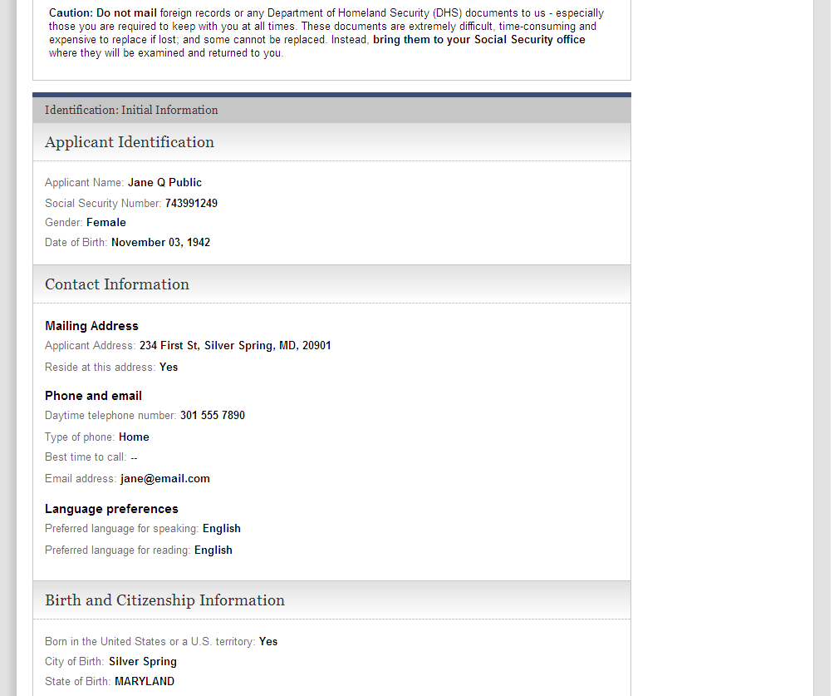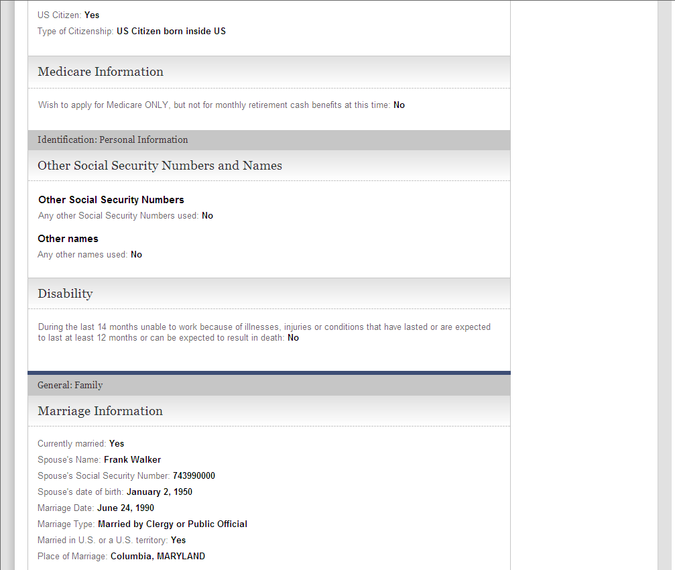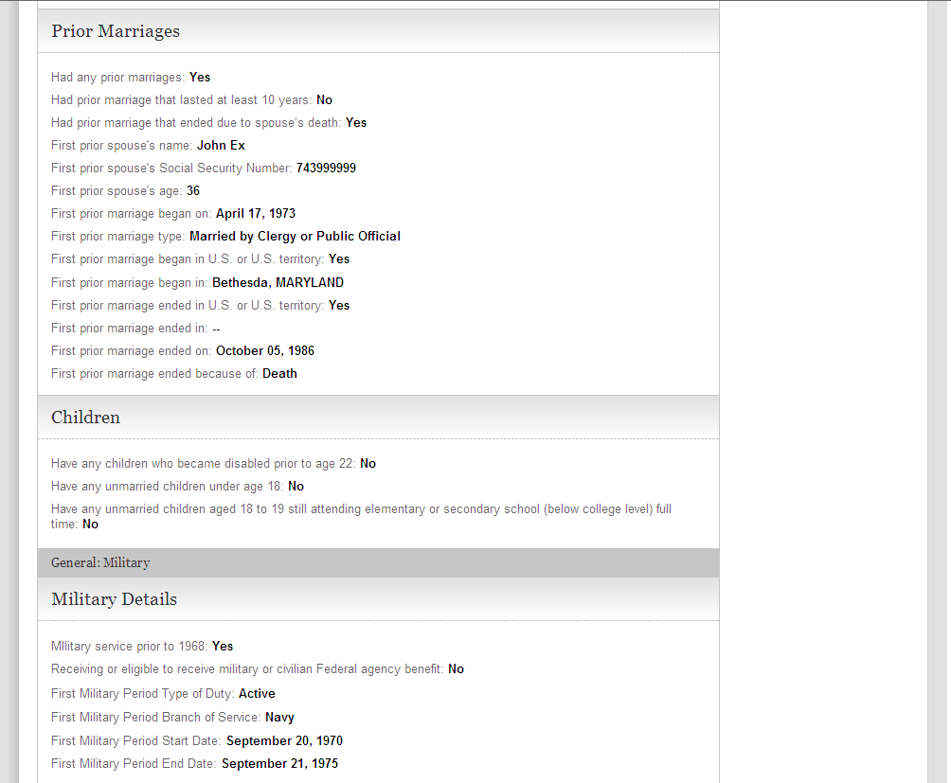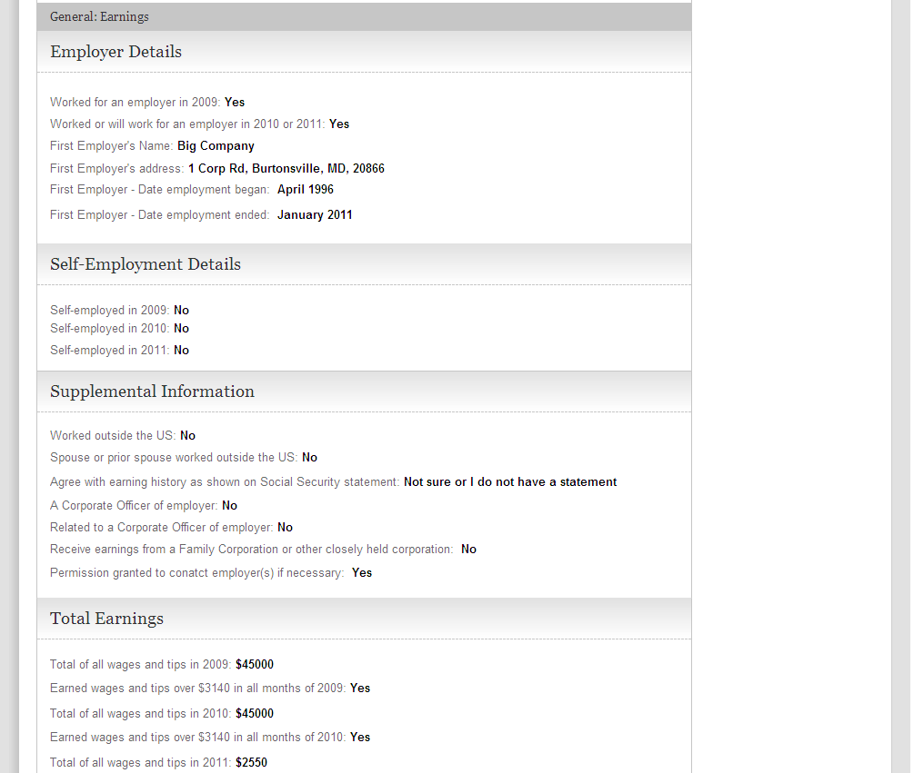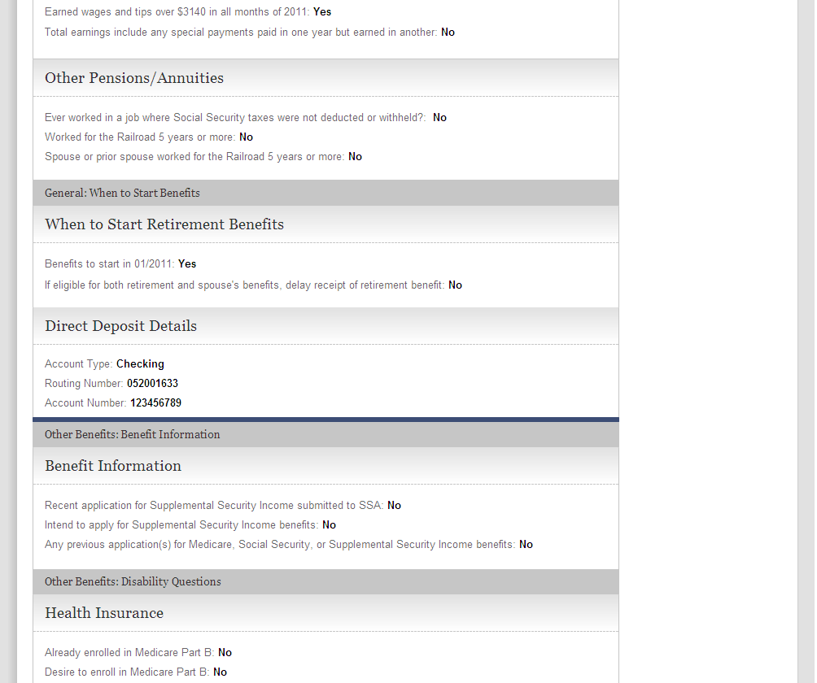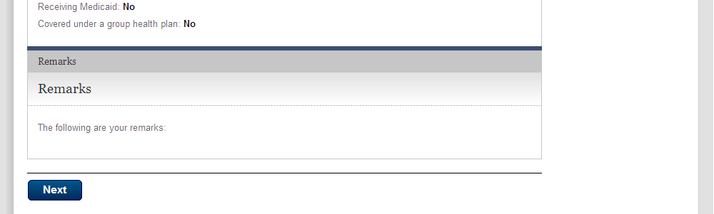

  - wtn001-r1_Next Steps
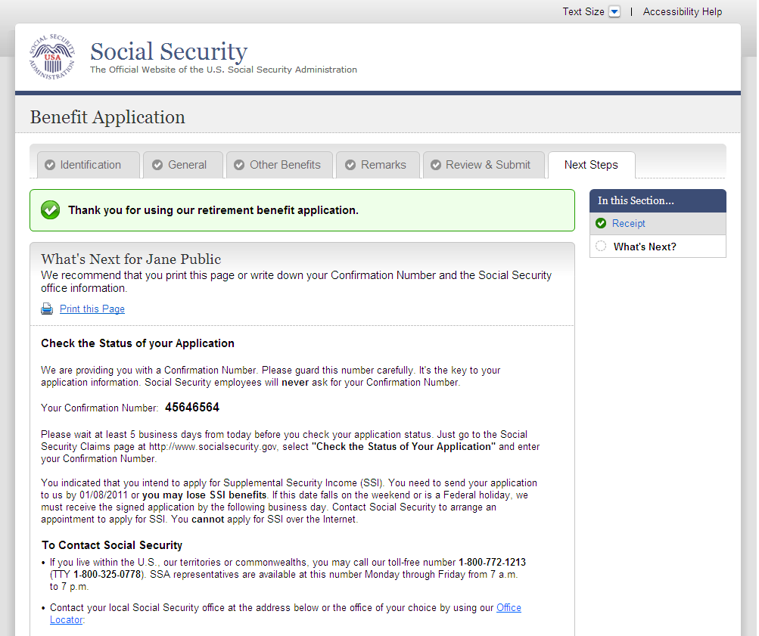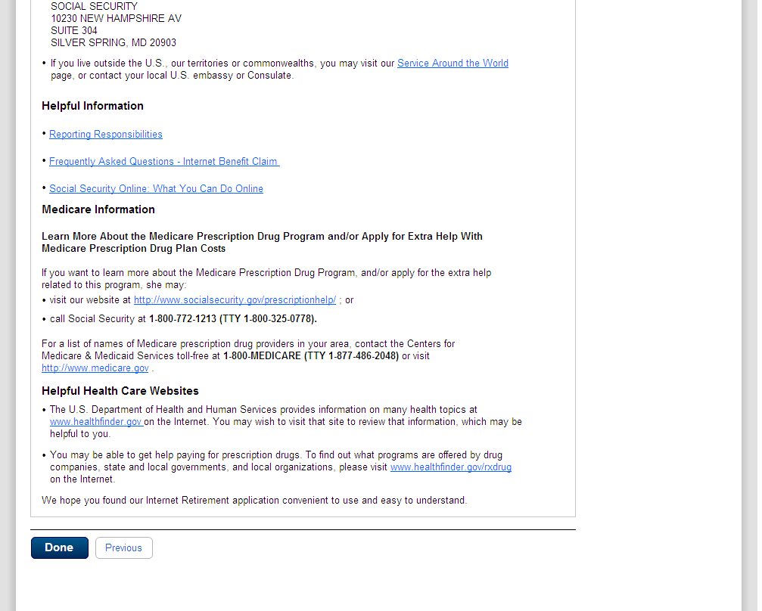

- Messages
  - msg005_GoToEstimator
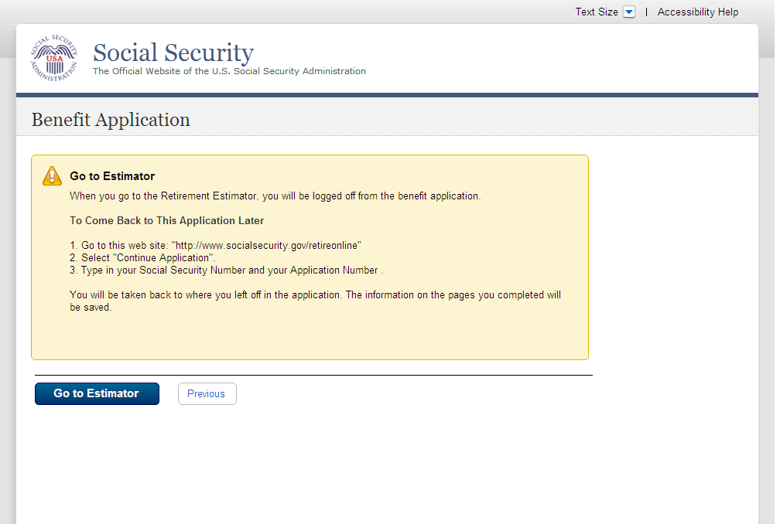
  - msg010_Check the Information You Entered
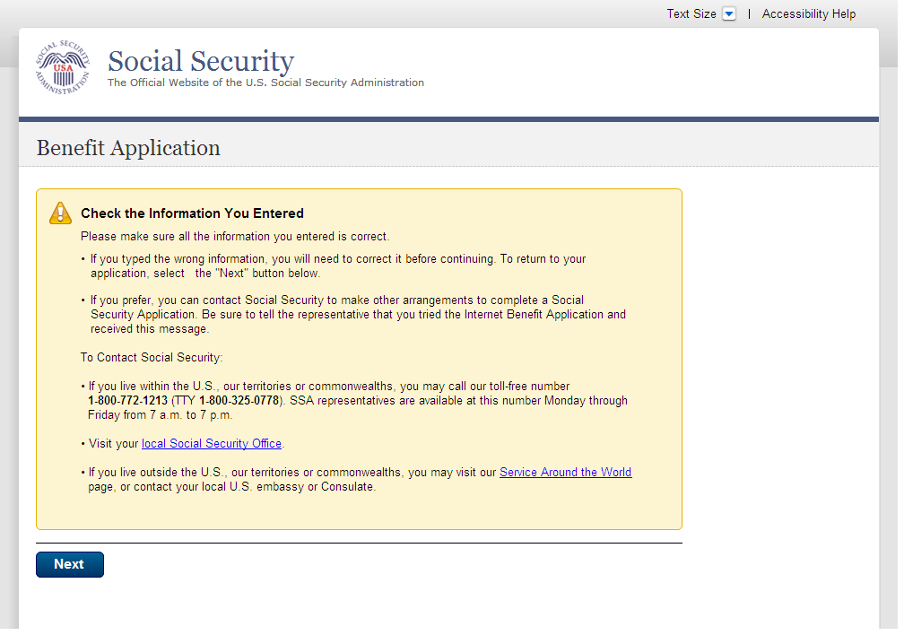
  - msg027_We cannot process your request at this time
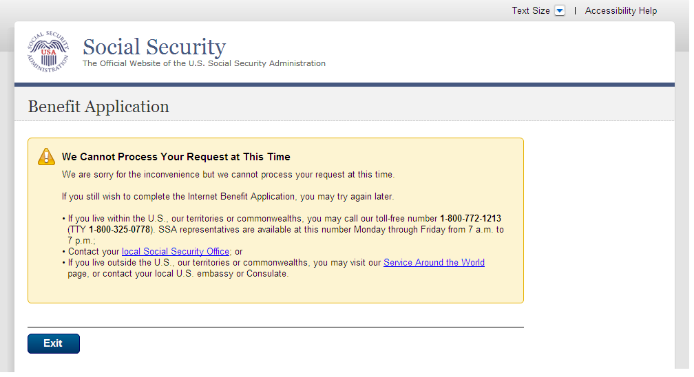
  - msg028_This service is not available at this time
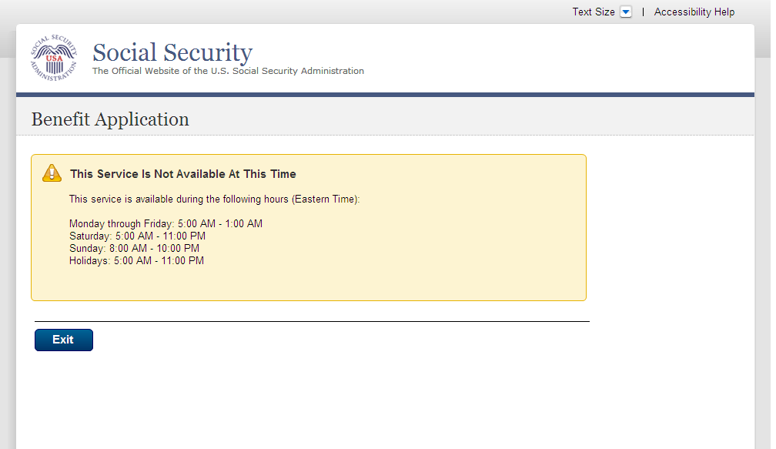
  - msg045_Hours of Operation
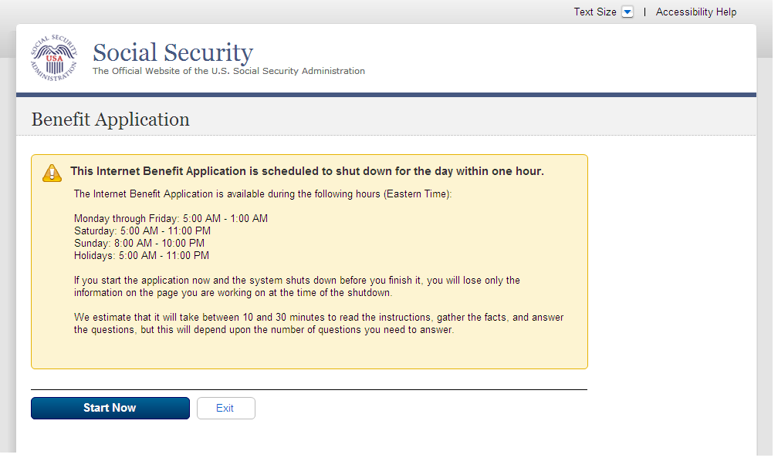
  - msg051_We cannot Process your request
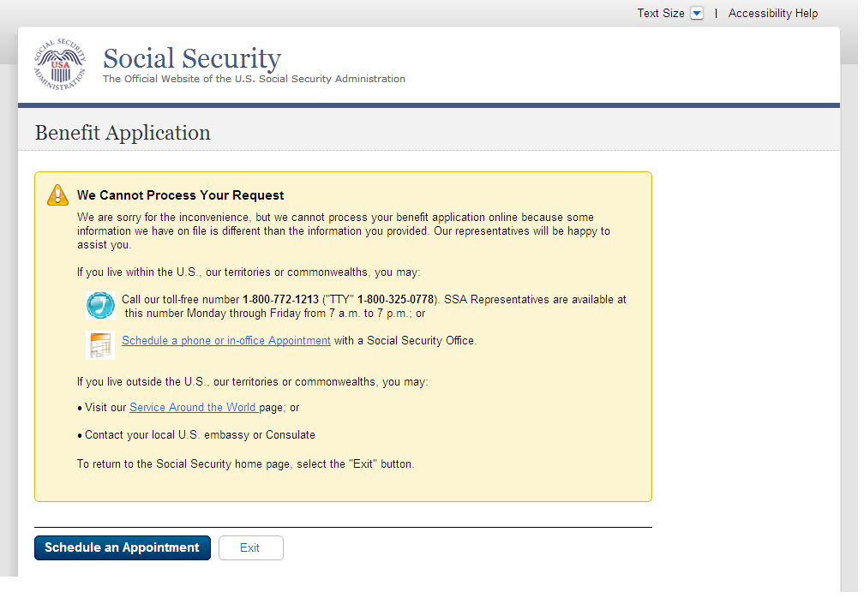
  - msg052_We cannot Process your request
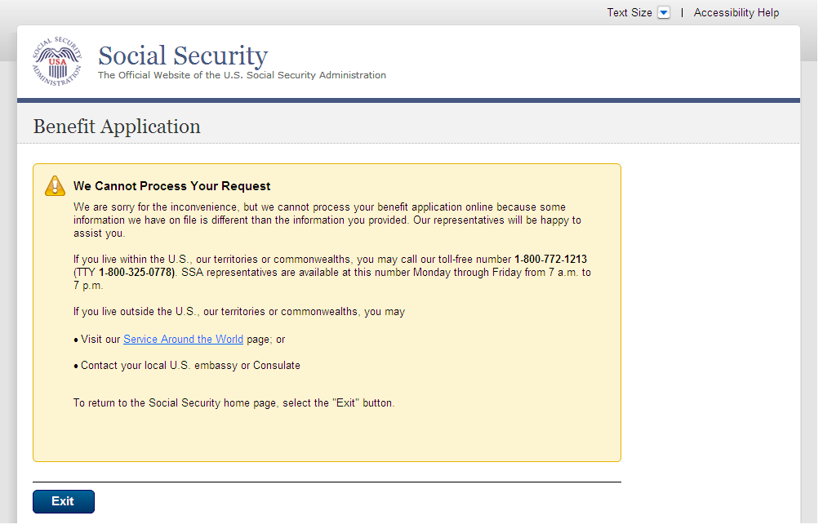
  - msg152_Sign Off
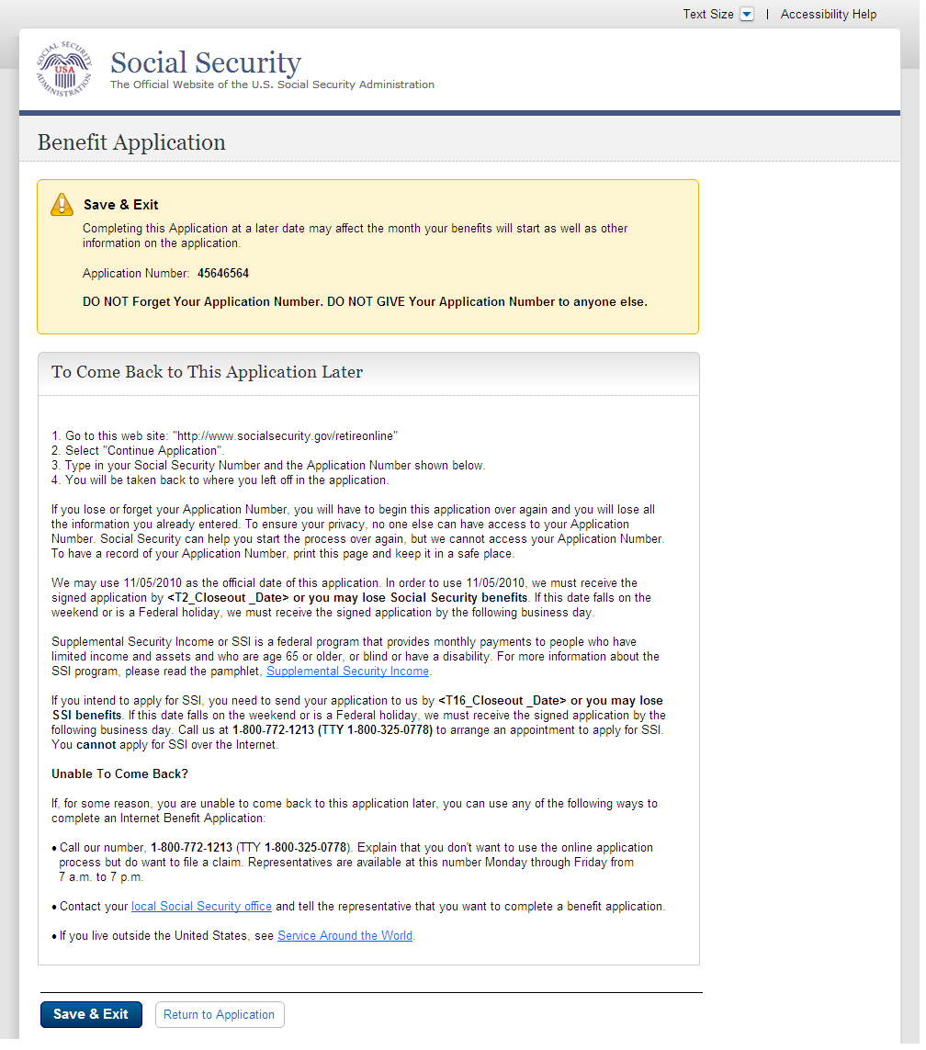
  - Bank Info Msg - Where can I find this?
