English iClaim All Else
Screen Package
Version 1.4



April 6, 2011

Table of Contents
[To update the table of contents, select the message below and press F9]

1. Pages 4
1.1. ent002_Welcome 4
1.2. ini001-r3_Preparers Contact Info 5
1.3. ini001-r3_Preparers Contact Info Foreign 6
1.4. ini001-d3_Preparers Contact Info 7
1.5. ini001-d3_Preparers Contact Info Foreign 8
1.6. ini002-d1_Applicant Identification 9
1.7. ini002-d1_01_Applicant Identification 10
1.8. apn001-d1_Application Number 11
1.9. apn001-m1_Application Number 12
1.10. adi003-1_Disability 13
1.11. fam003-d1_Children 14
1.12. ear005-1-b_Other_Pensions_Annuities 15
1.13. ear005-1-e_Other_Pensions_Annuities 16
1.14. ear005-r1-c_Other_Pensions_Annuities 17
1.15. wst001-1-a_When to Start Retirement Benefits 18
1.16. wst001-1-a_01_When to Start Retirement Benefits 19
1.17. bni002-r1_b_Benefit Information 20
1.18. bni003-1_Benefit Information 21
1.19. bni004-1_Benefit Information 22
1.20. bni005-1_Benefit Information 23
1.21. dsq001-1_Ability To Work 24
1.22. dsq002-1_Disability Payments 25
1.23. dsq003-1_Dependents 26
1.24. dsq004-1_Authorization 28
1.25. rem001-m_Remarks 29
1.26. rem002-r1-cancellation 30
1.27. ovs001-d1-b_Overall Summary 31
1.28. ovs001-r1-e_Overall Summary 35
1.29. ovs001-m1-g_Overall Summary 41
1.30. ovs001-d3-d_Overall Summary 44
1.31. ovs001-r3-c_Overall Summary 49
1.32. ovs001-m3-f_Overall Summary 55
1.33. snd001-d1_Send This Application 57
1.34. snd001-m1_Send This Application 58
1.35. snd001-d3_Send This Application 59
1.36. snd001-m3_Send This Application 60
1.37. snd001-r3_Send This Application 61
1.38. rec001-d1-b_Evidence and Receipt 62
1.39. rec001-r1-e_Evidence and Receipt 67
1.40. rec001-m1-g_Evidence and Receipt 72
1.41. rec001-r3-c_Evidence and Receipt 76
1.42. rec001-d3-d_Evidence and Receipt 81
1.43. rec001-m3-f_Evidence and Receipt 86
1.44. wtn001- d1_What's Next 90
1.45. wtn001- m1_What's Next 92
1.46. wtn001- r3_What's Next 94
1.47. wtn001- d3_What's Next 96
1.48. wtn001- m3_What's Next 98
2. Messages 100
2.1. MSG-Confirm Delete of Table Entry 100
2.2. msg006_YouCannotApplyforMedicareOnly 101
2.3. msg017_SignIn Problem 102
2.4. msg025_Your Time Has Expired 103
2.5. msg029_LimitOnNumberOfRestartsOnPartialApplication 104
2.6. msg030_We Are Processing Your Request 105
2.7. msg047-a_Change Your Answer 106
2.8. msg047-b_Change Your Answer 107
2.9. msg113_Limit on Number of Requests 108
2.10. msg151_Cannot Match Your Zip Code 109

- Pages
  - ent002_Welcome
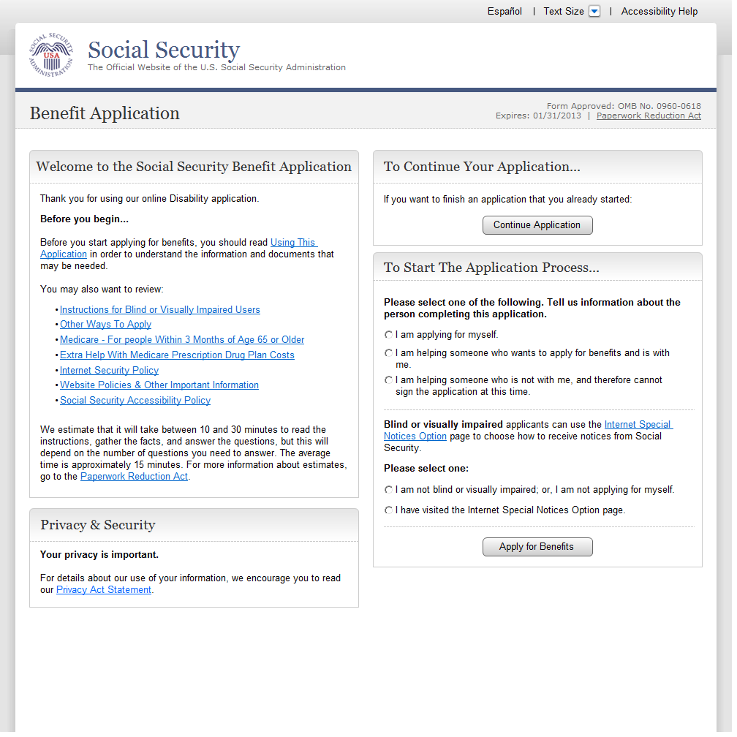
  - ini001-r3_Preparers Contact Info
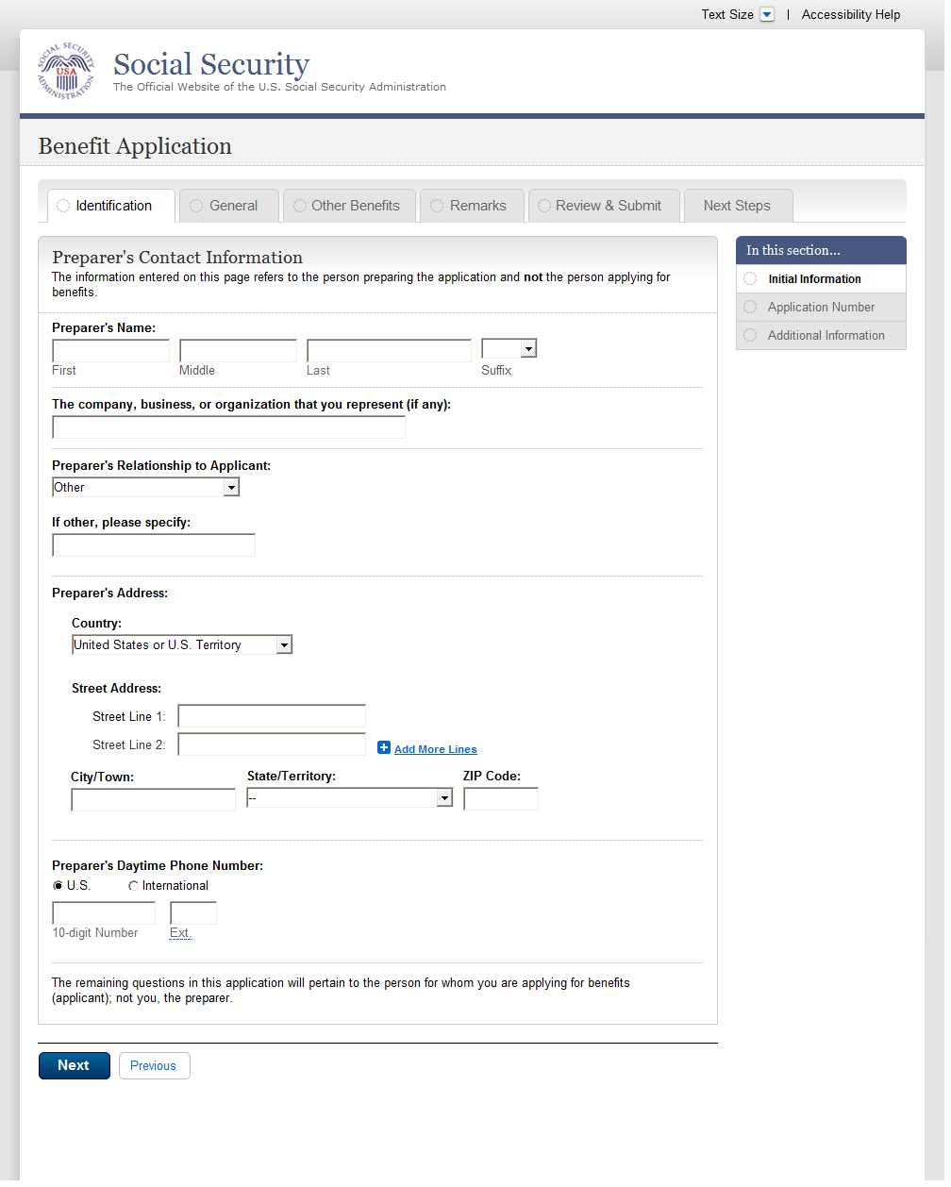
  - ini001-r3_Preparers Contact Info Foreign
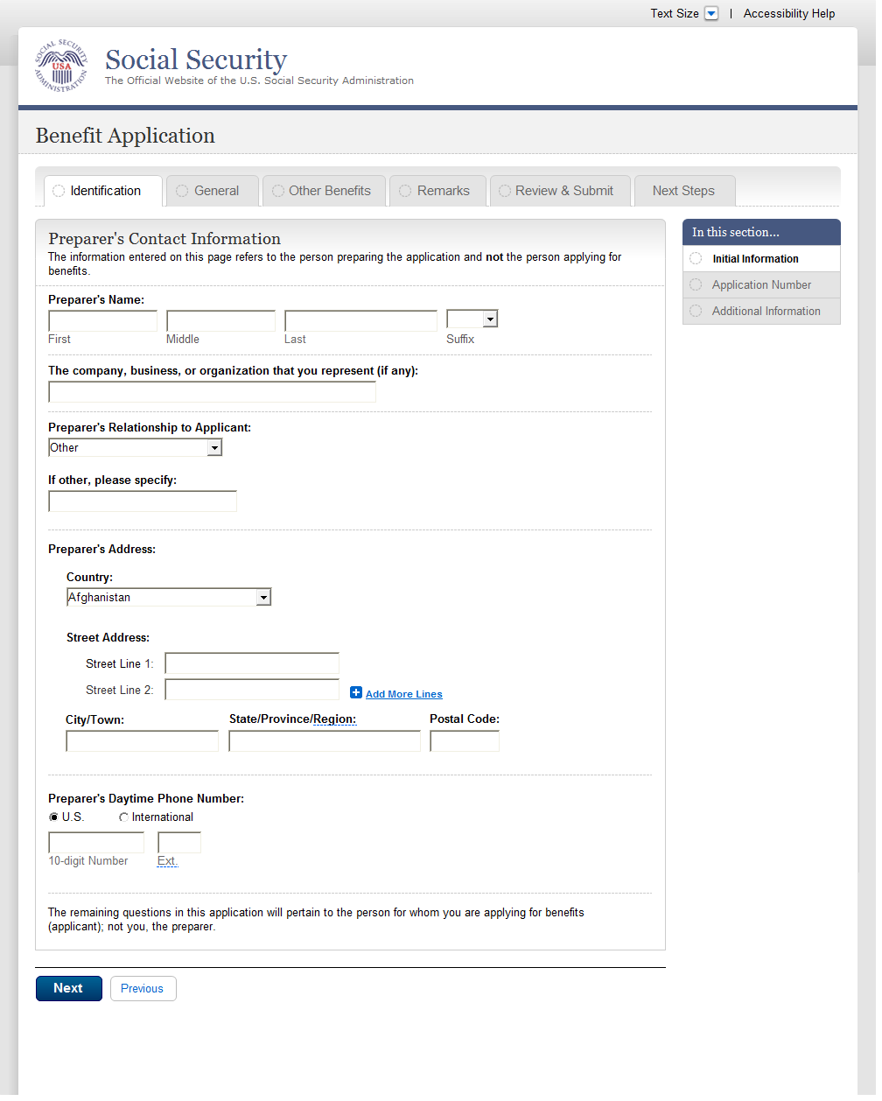
  - ini001-d3_Preparers Contact Info
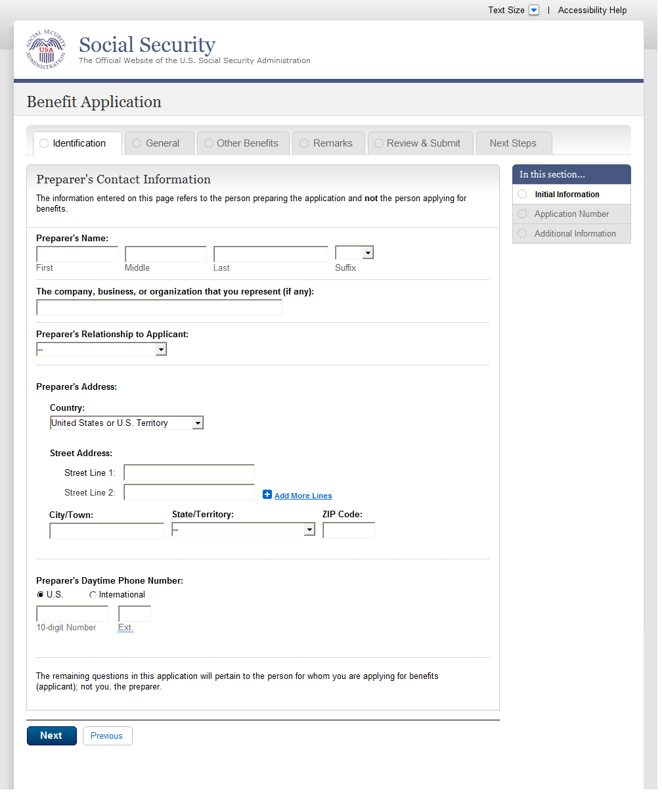
  - ini001-d3_Preparers Contact Info Foreign
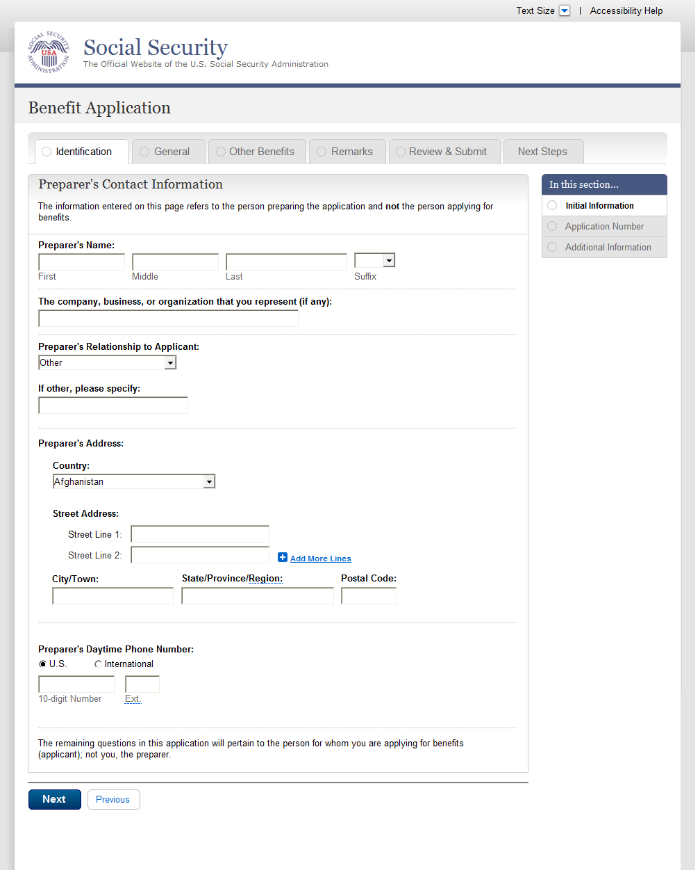
  - ini002-d1_Applicant Identification
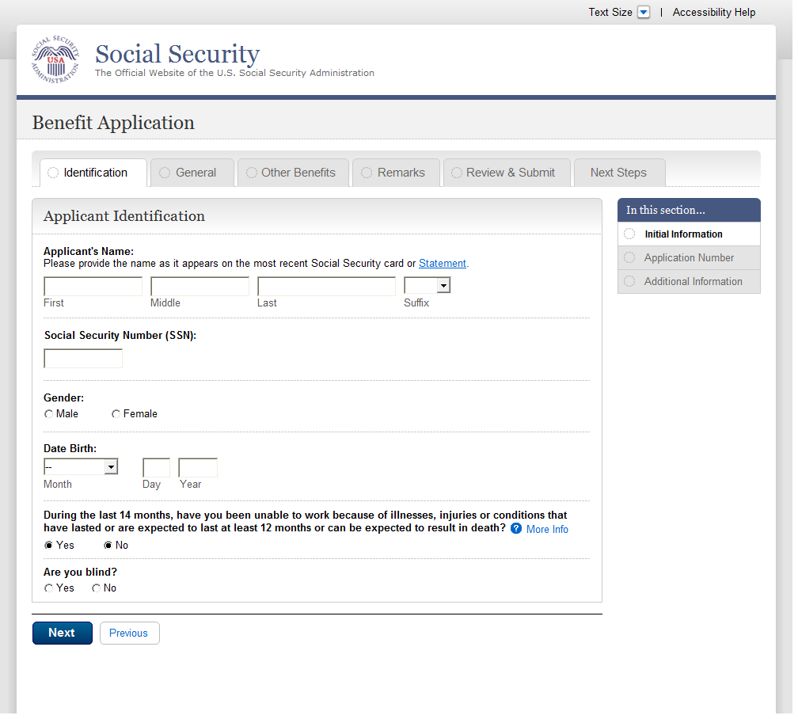
  - ini002-d1_01_Applicant Identification
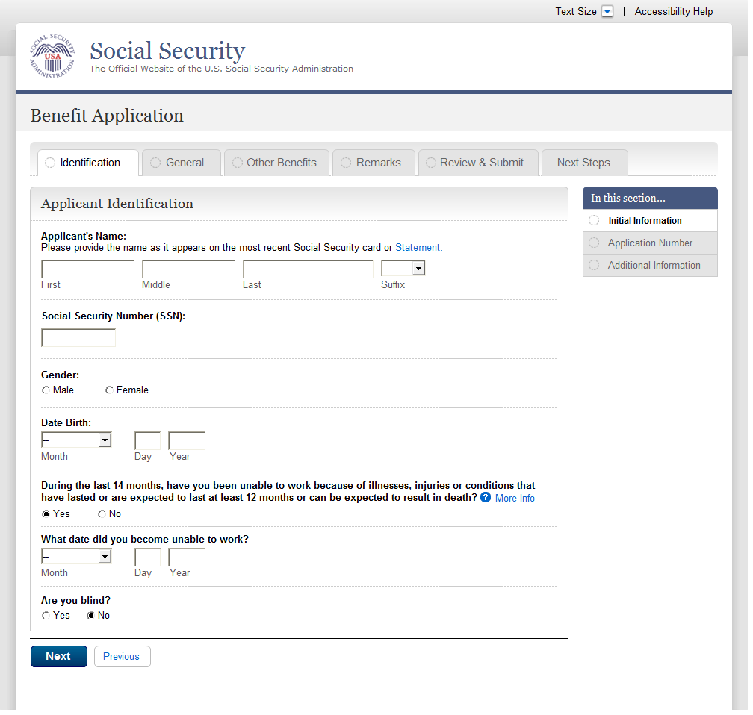
  - apn001-d1_Application Number
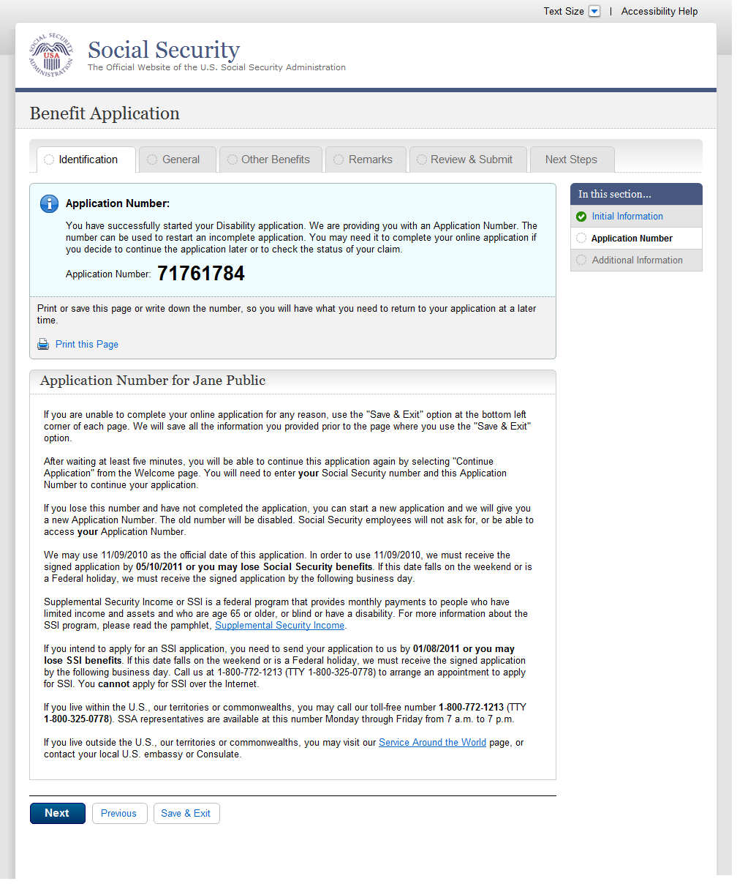
  - apn001-m1_Application Number
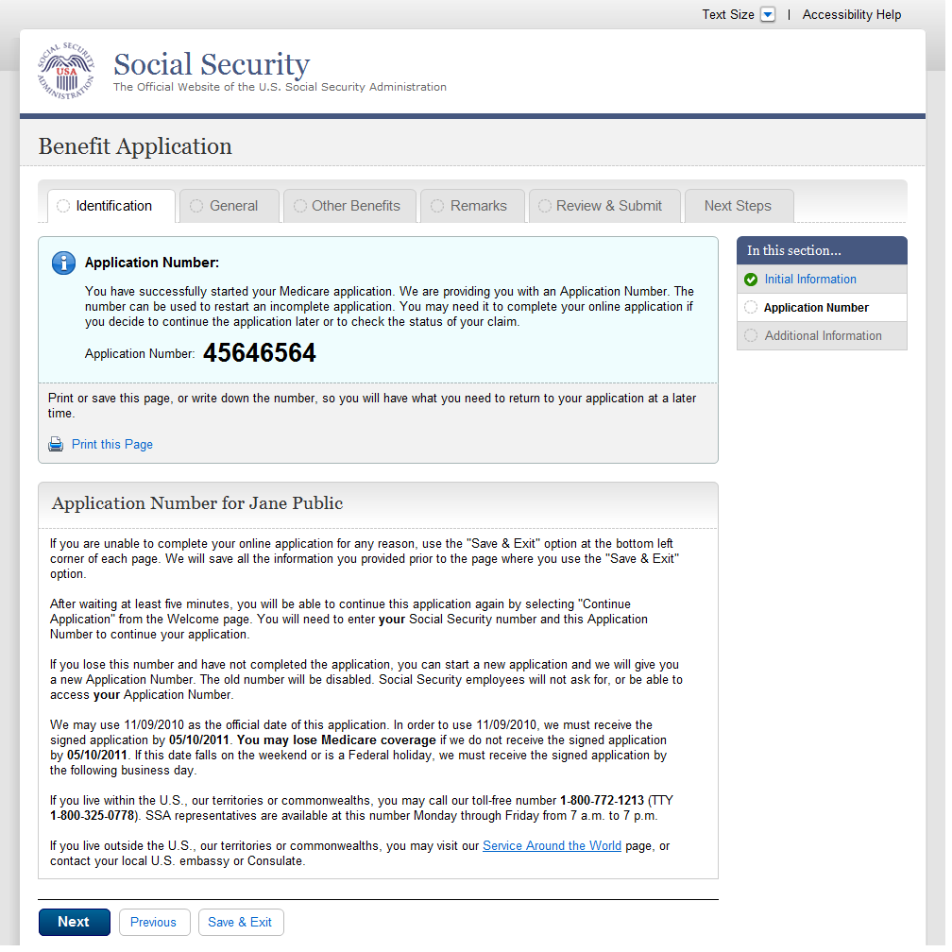
  - adi003-1_Disability
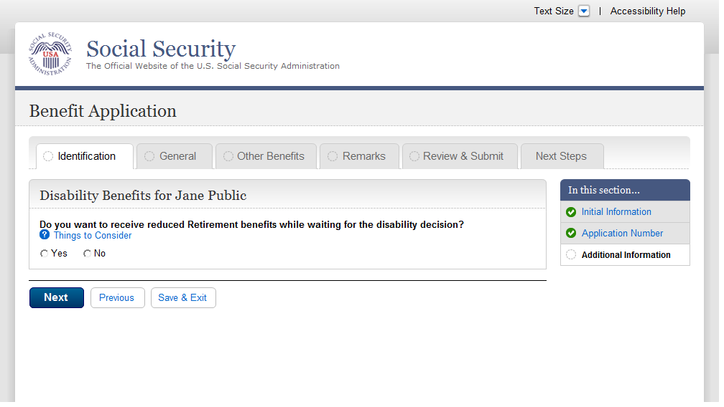
  - fam003-d1_Children
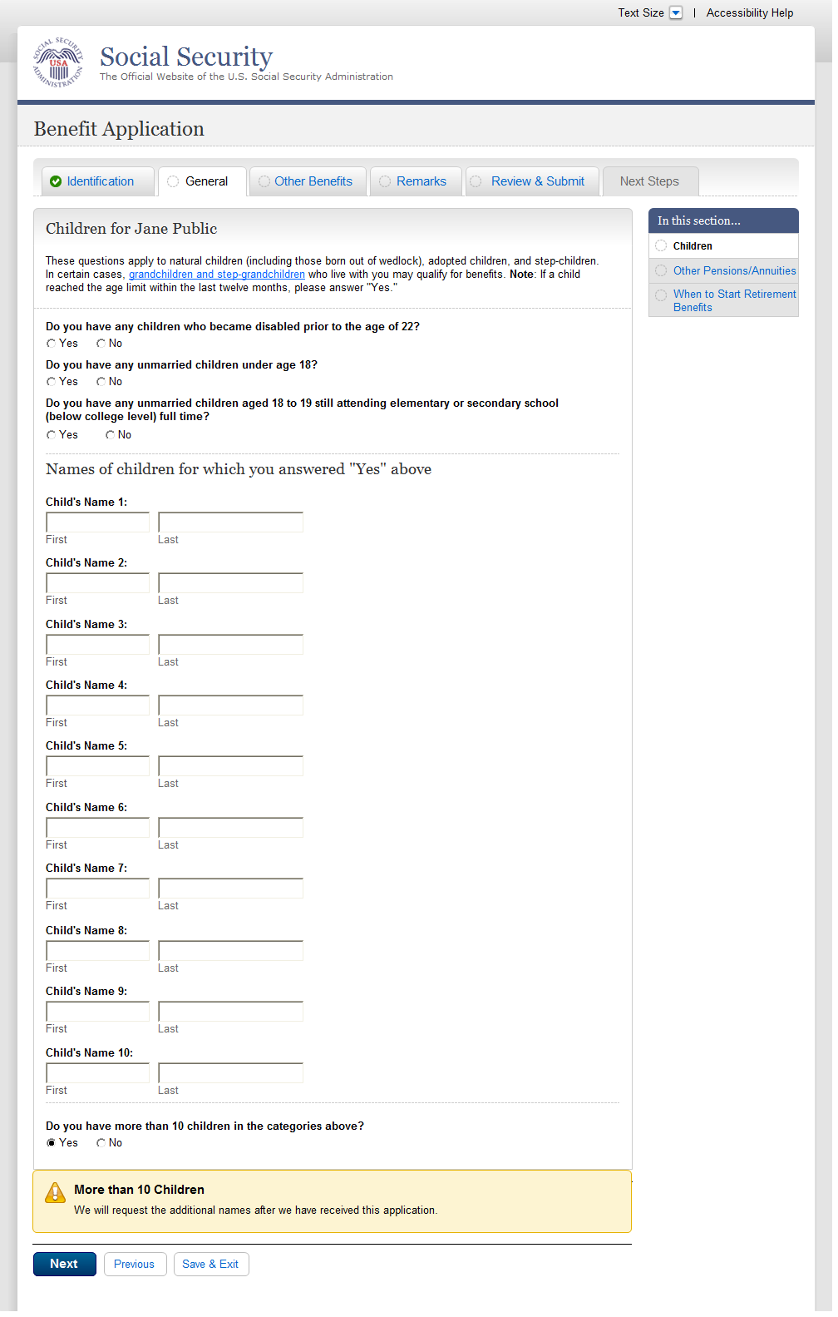
  - ear005-1-b_Other_Pensions_Annuities
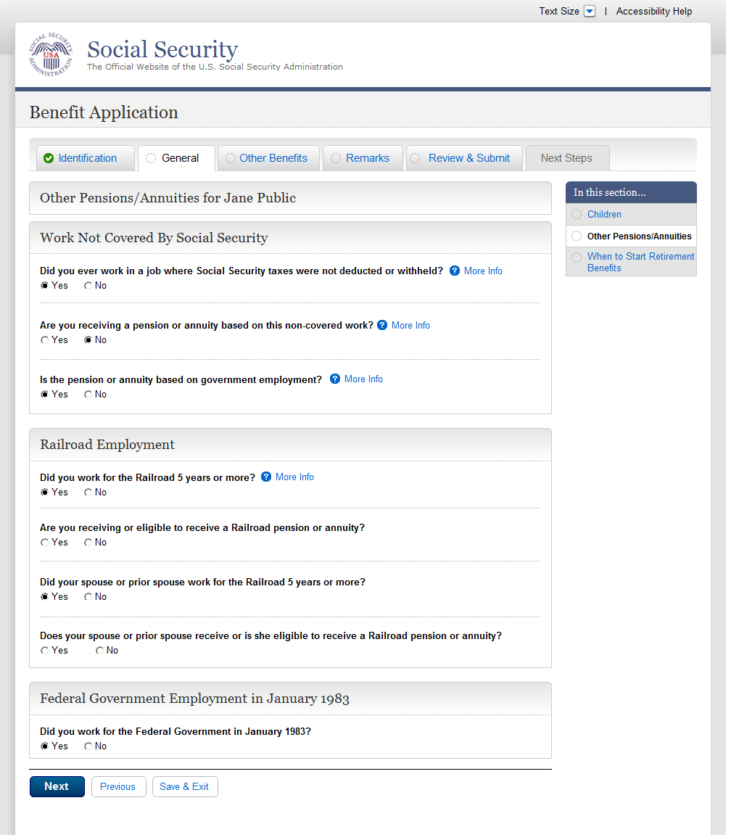
  - ear005-1-e_Other_Pensions_Annuities
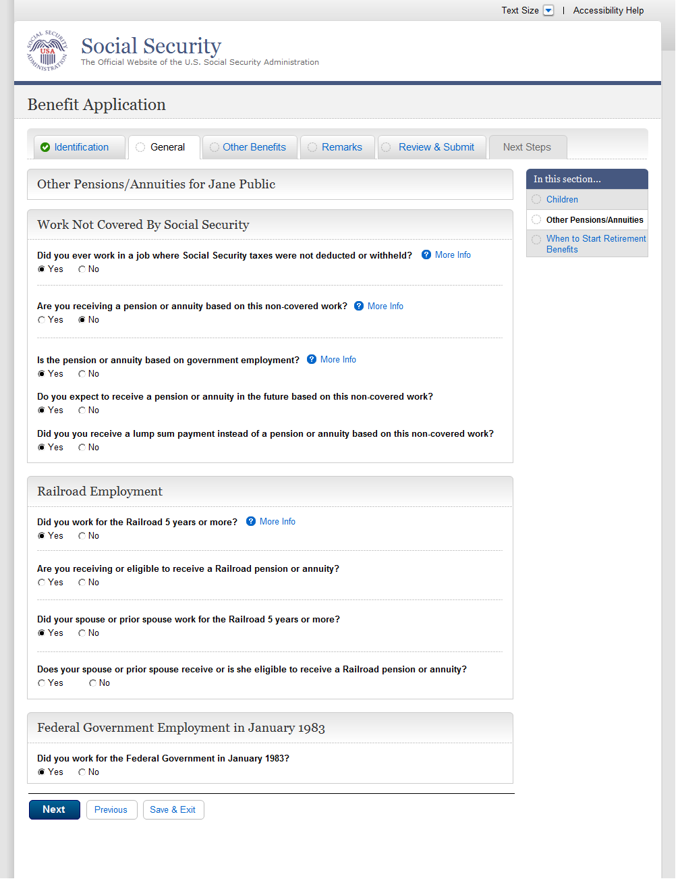
  - ear005-r1-c_Other_Pensions_Annuities
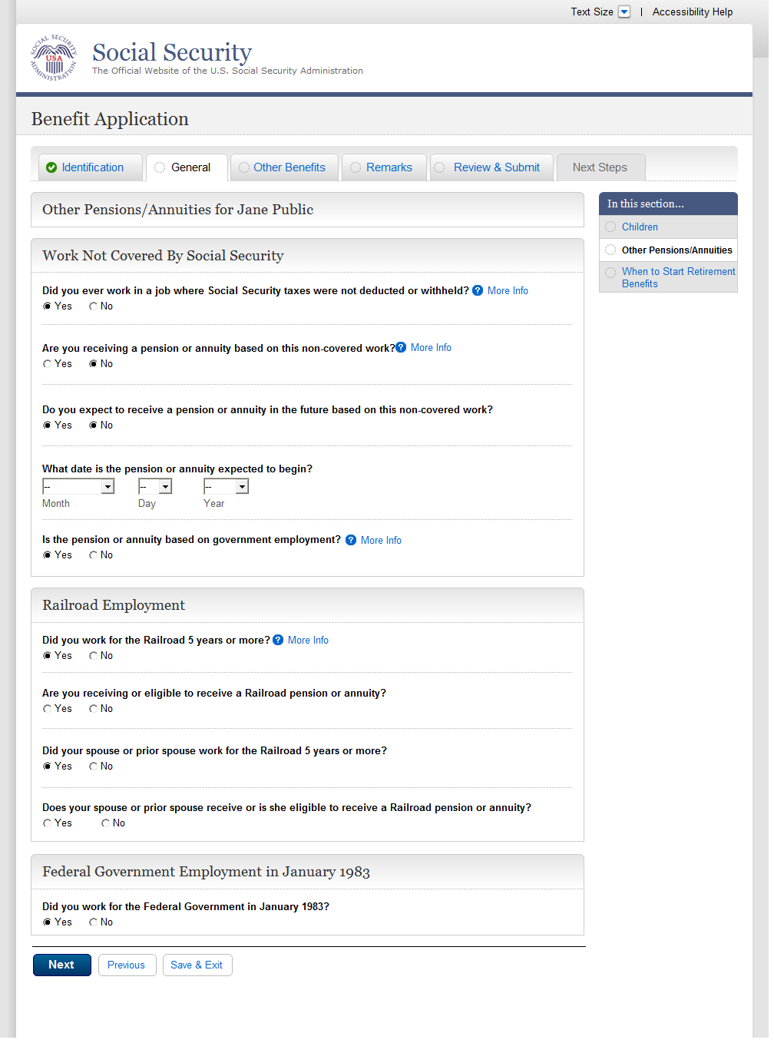
  - wst001-1-a_When to Start Retirement Benefits
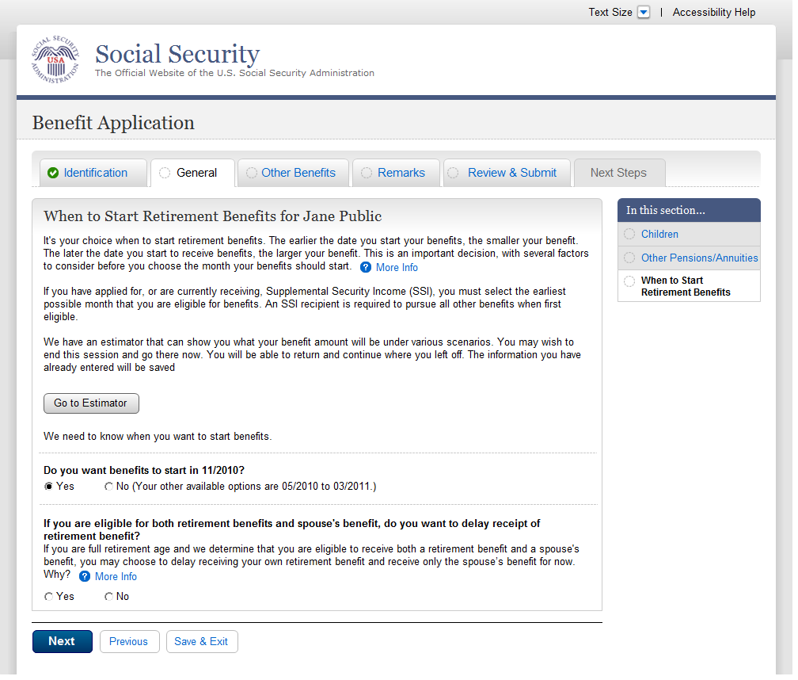
  - wst001-1-a_01_When to Start Retirement Benefits
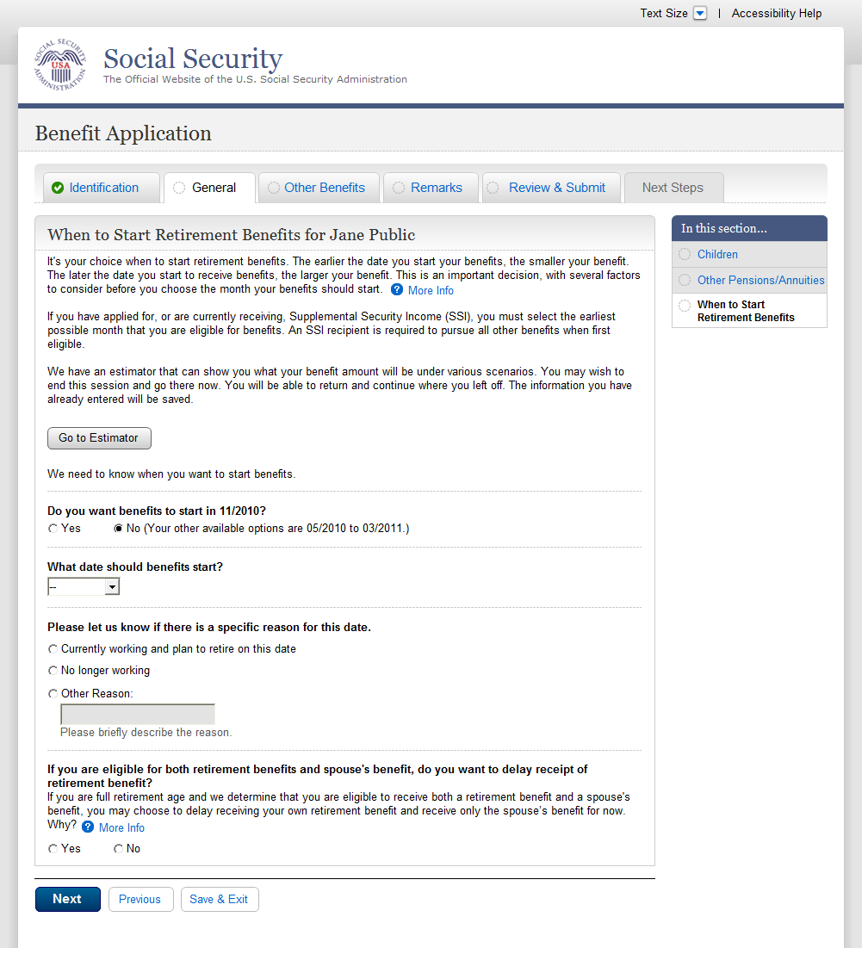
  - bni002-r1_b_Benefit Information
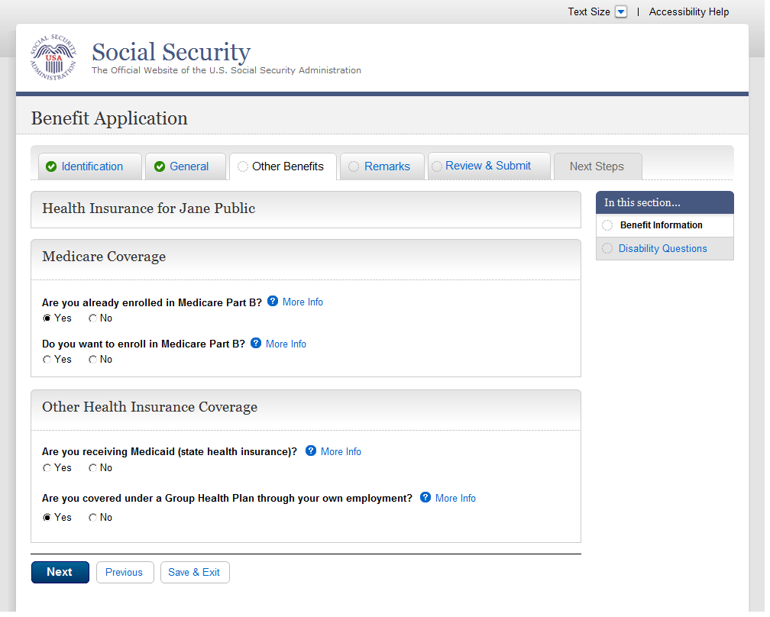
  - bni003-1_Benefit Information
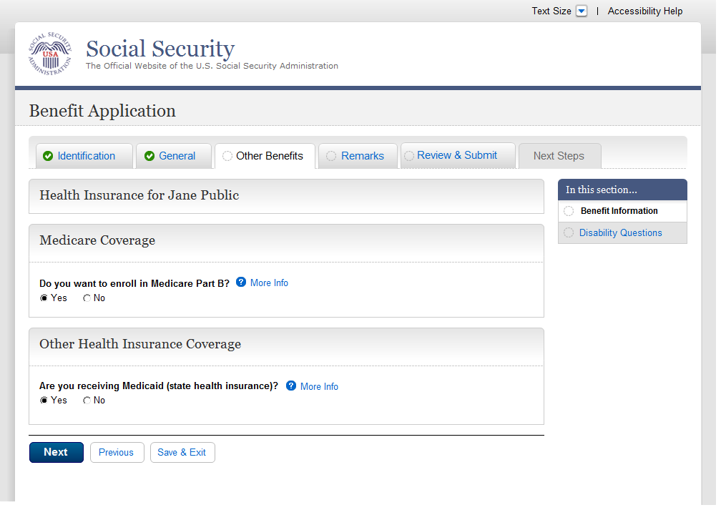
  - bni004-1_Benefit Information
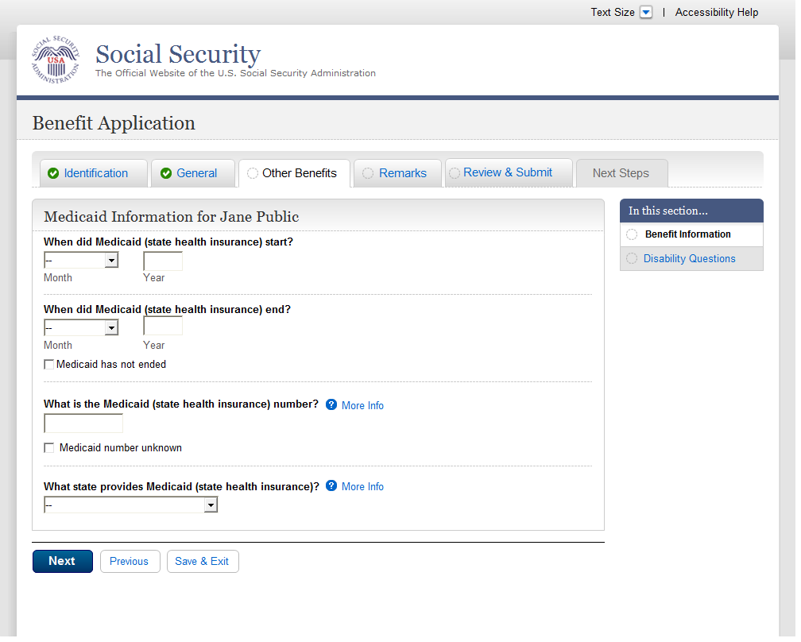
  - bni005-1_Benefit Information
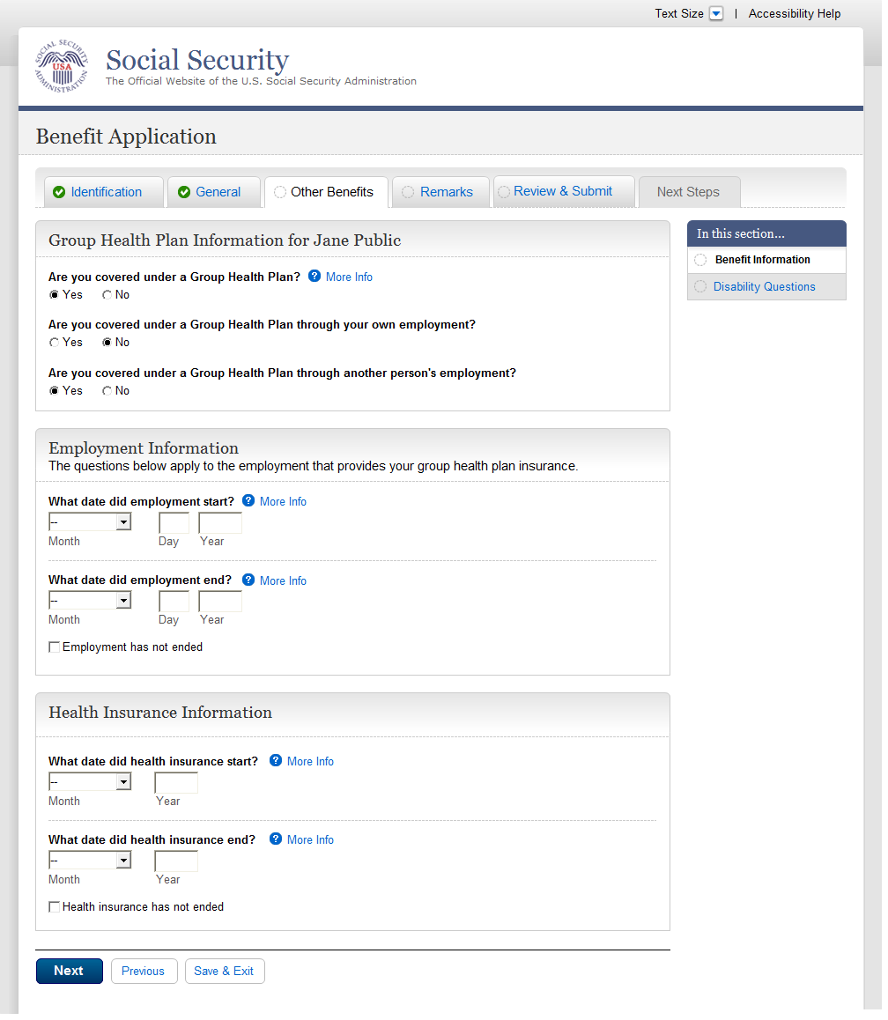
  - dsq001-1_Ability To Work
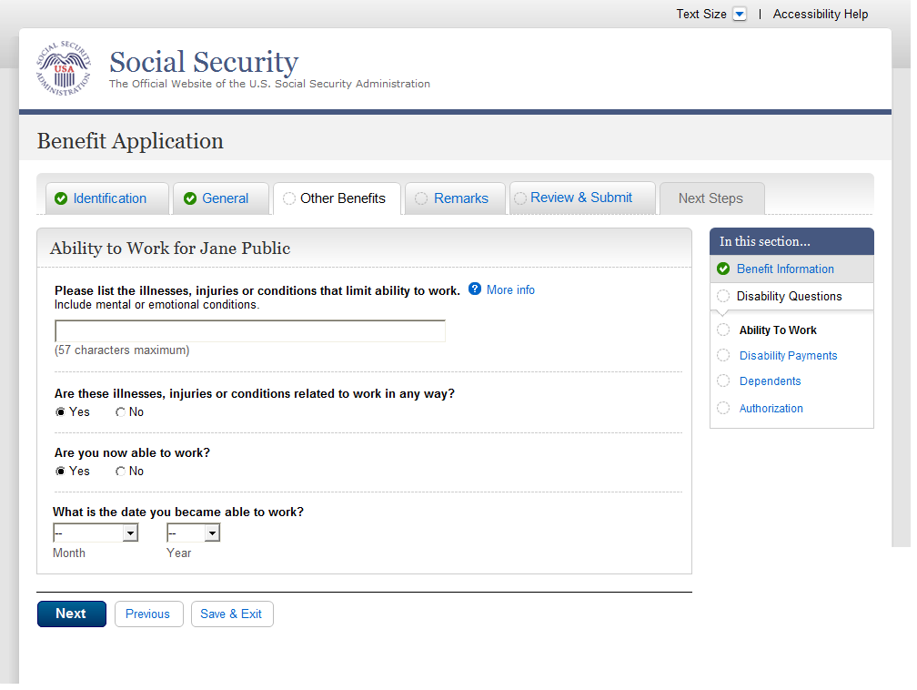
  - dsq002-1_Disability Payments
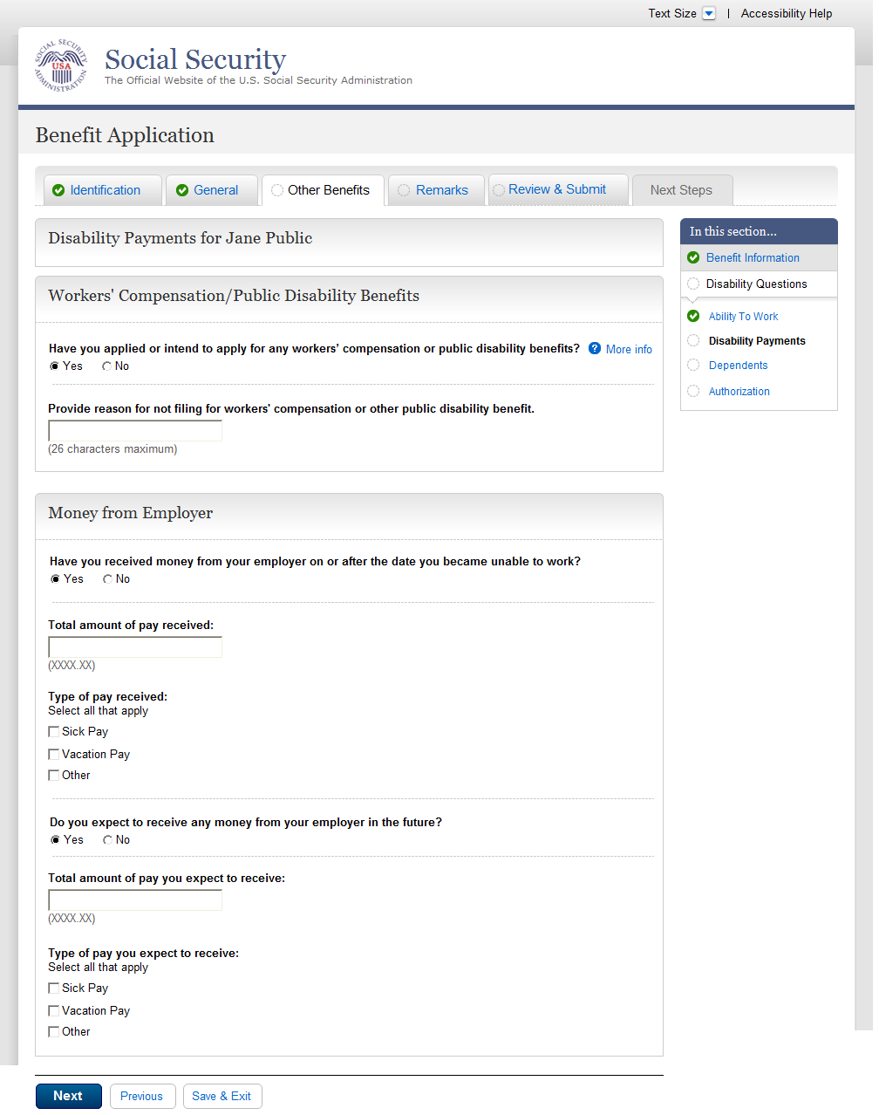
  - dsq003-1_Dependents
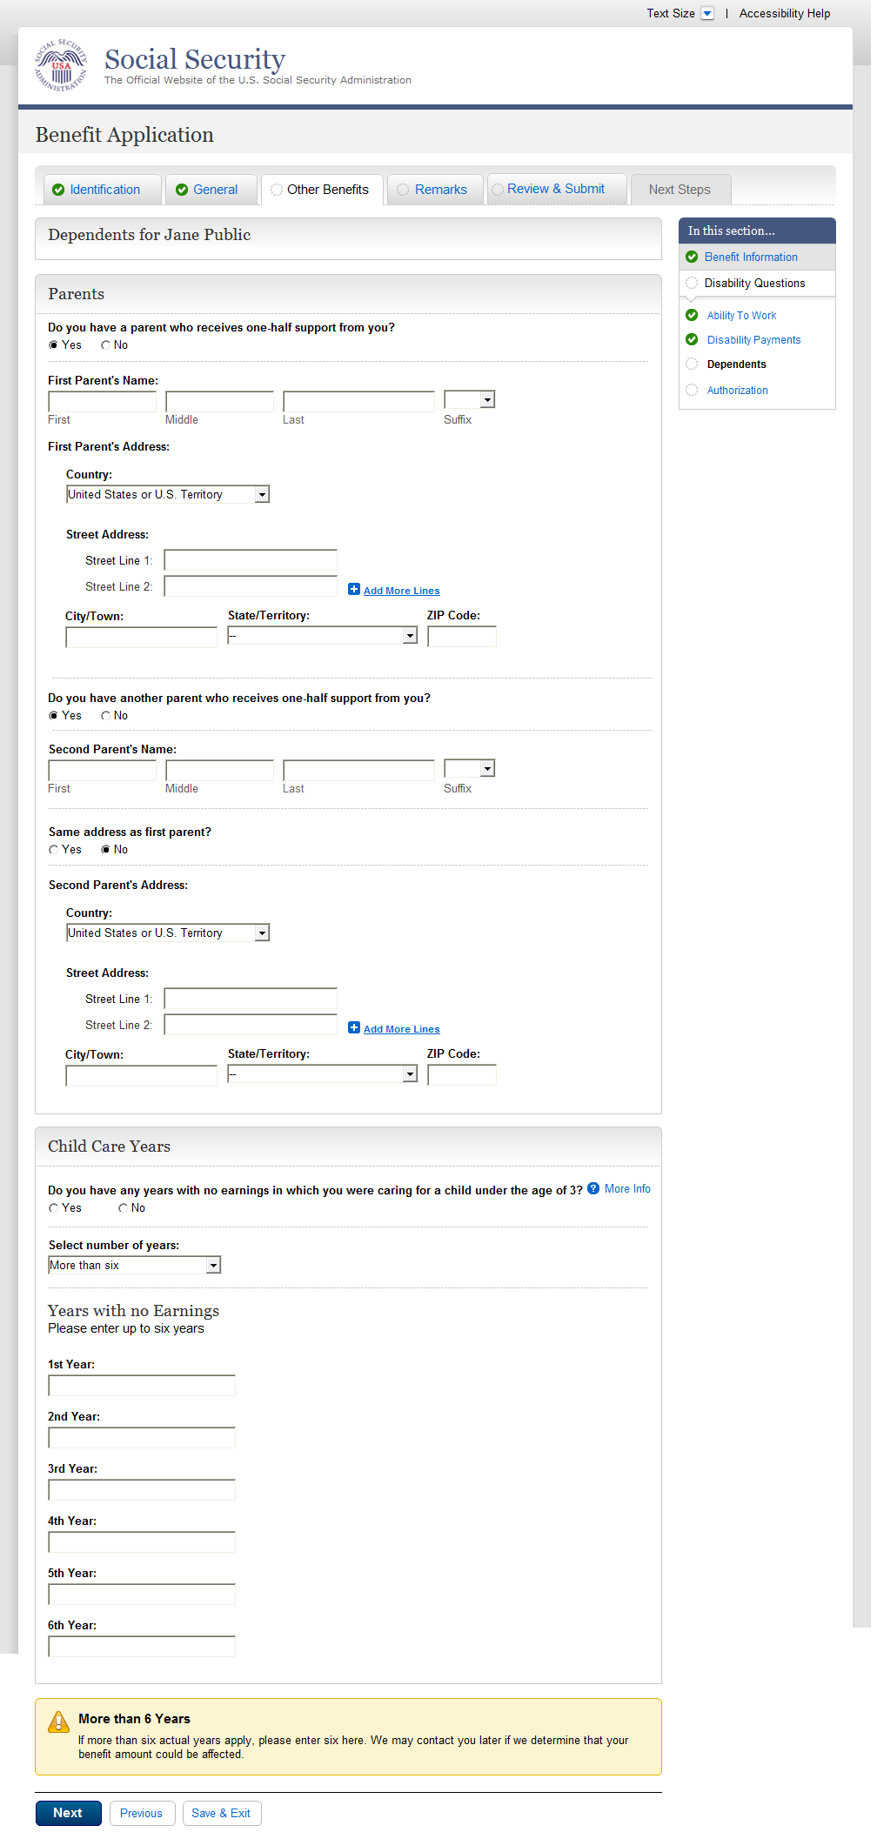
  - dsq004-1_Authorization
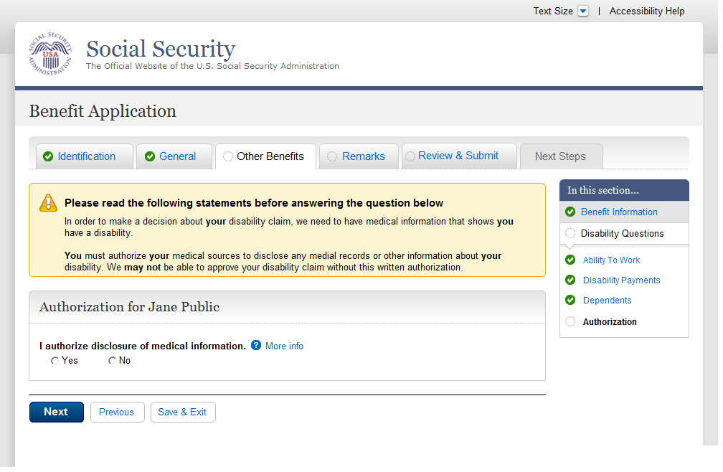
  - rem001-m_Remarks
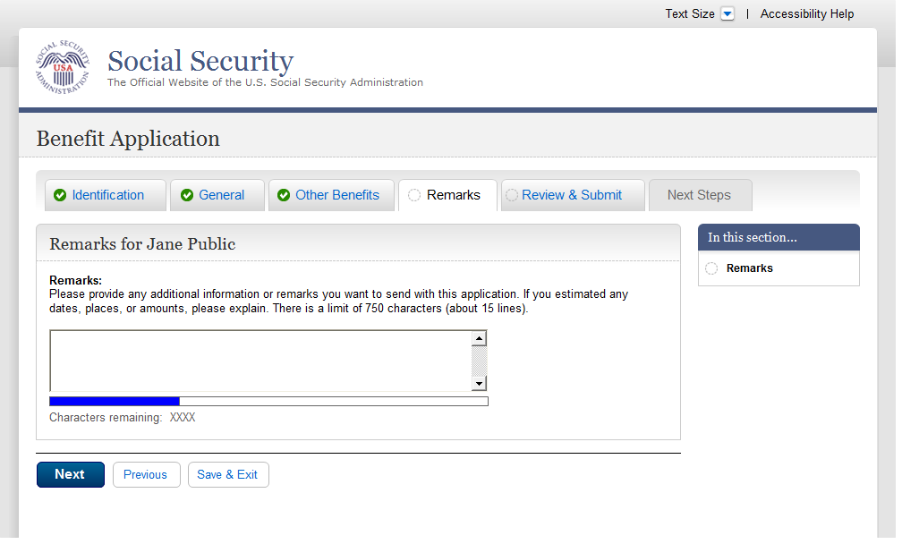
  - rem002-r1-cancellation
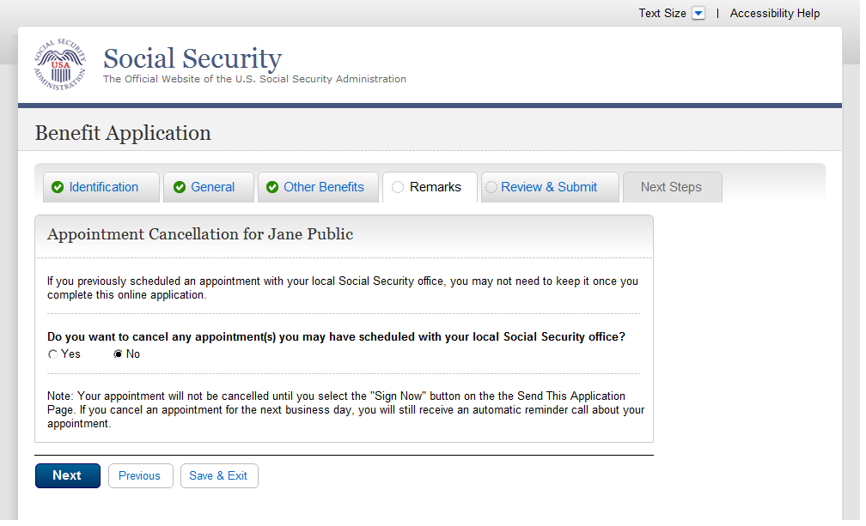
  - ovs001-d1-b_Overall Summary
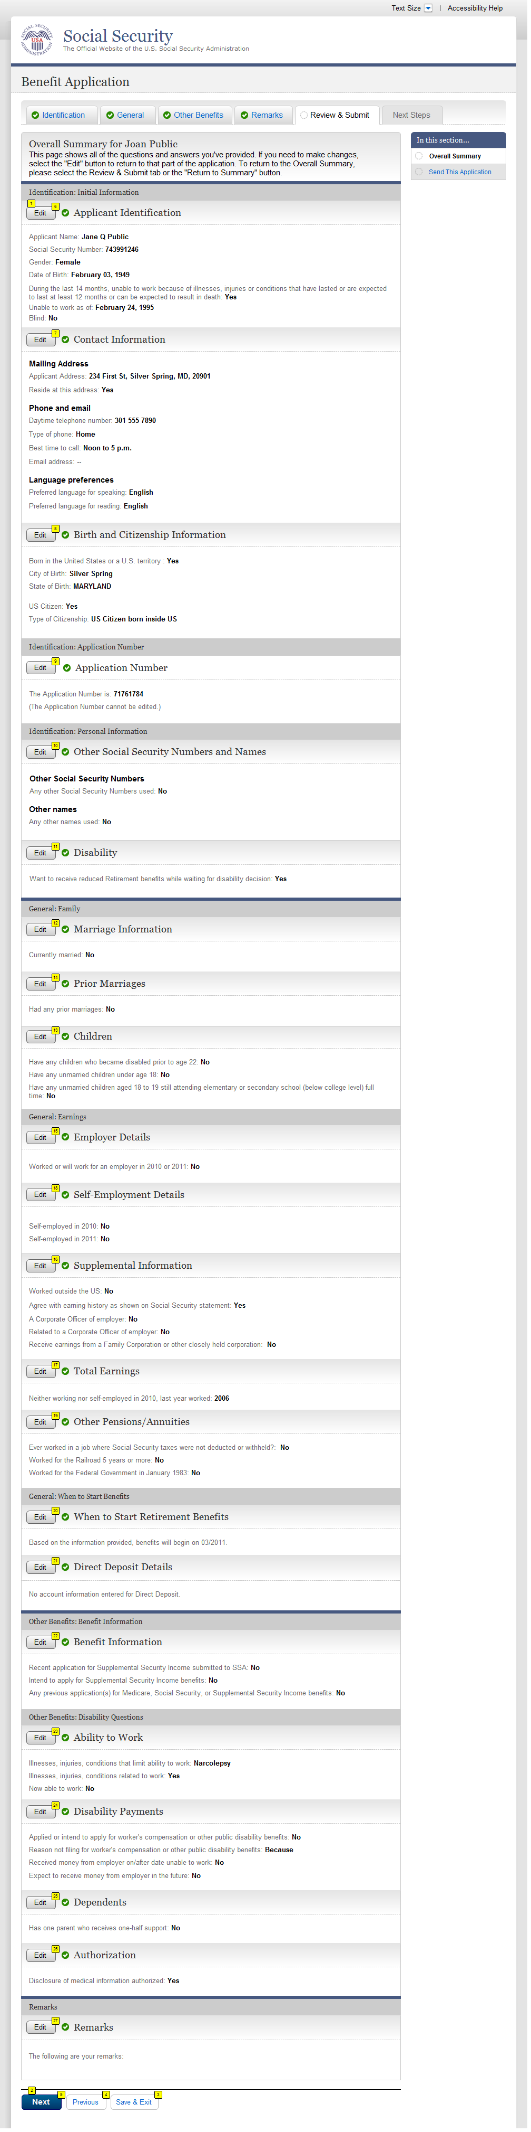
  - ovs001-r1-e_Overall Summary
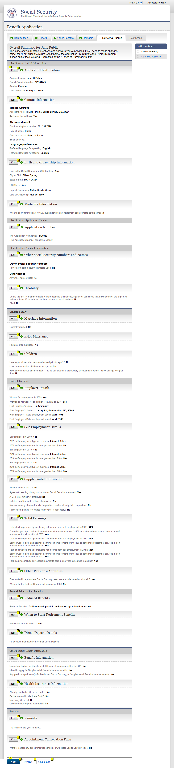
  - ovs001-m1-g_Overall Summary
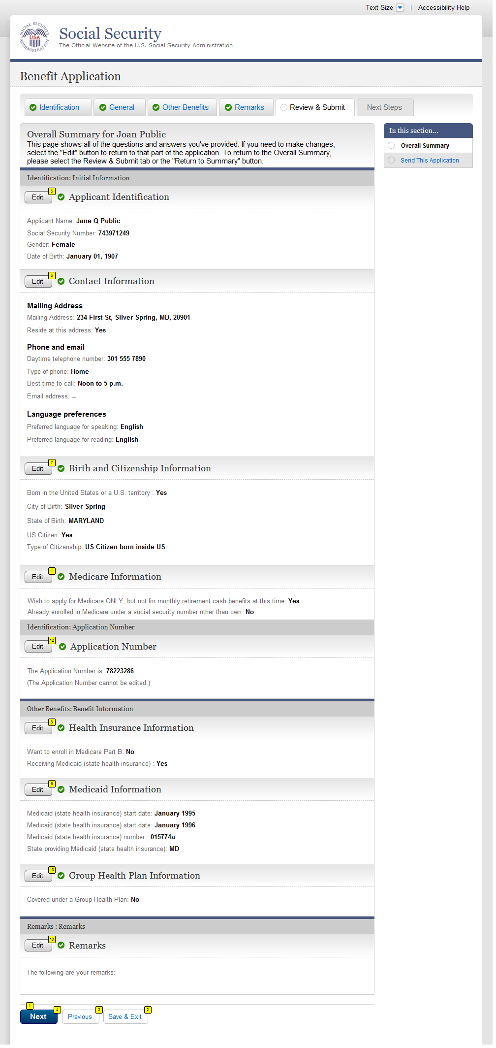
  - ovs001-d3-d_Overall Summary
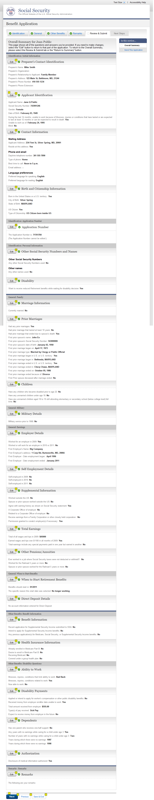

  - ovs001-r3-c_Overall Summary
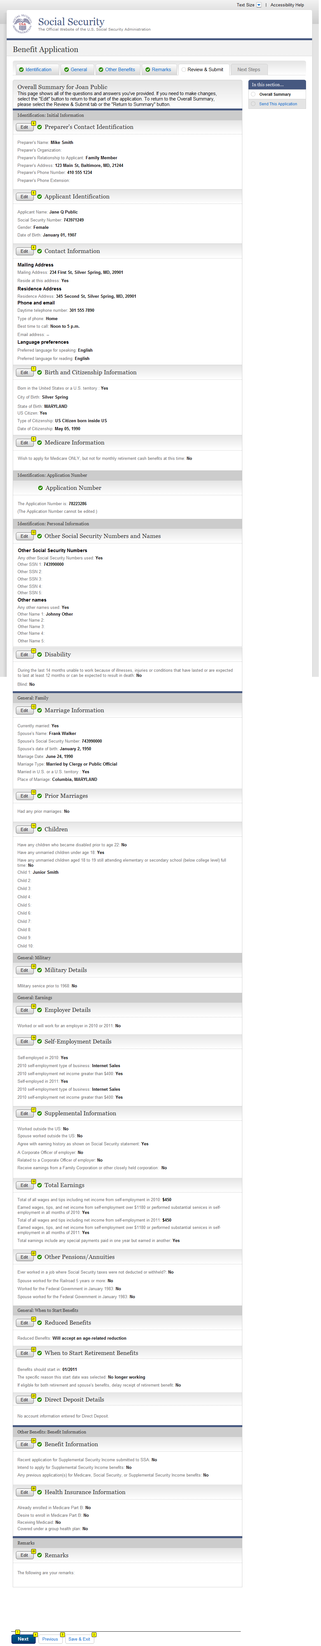
  - ovs001-m3-f_Overall Summary
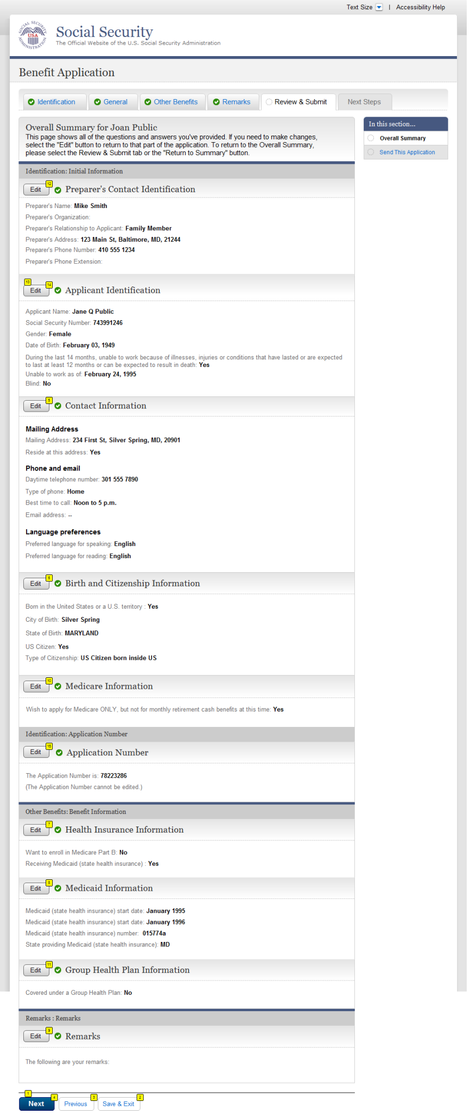
  - snd001-d1_Send This Application
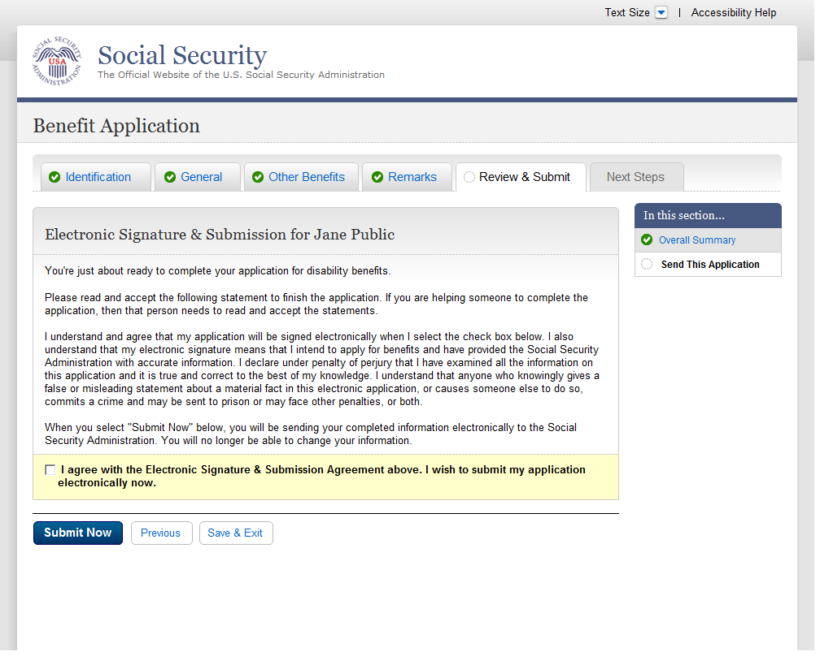
  - snd001-m1_Send This Application
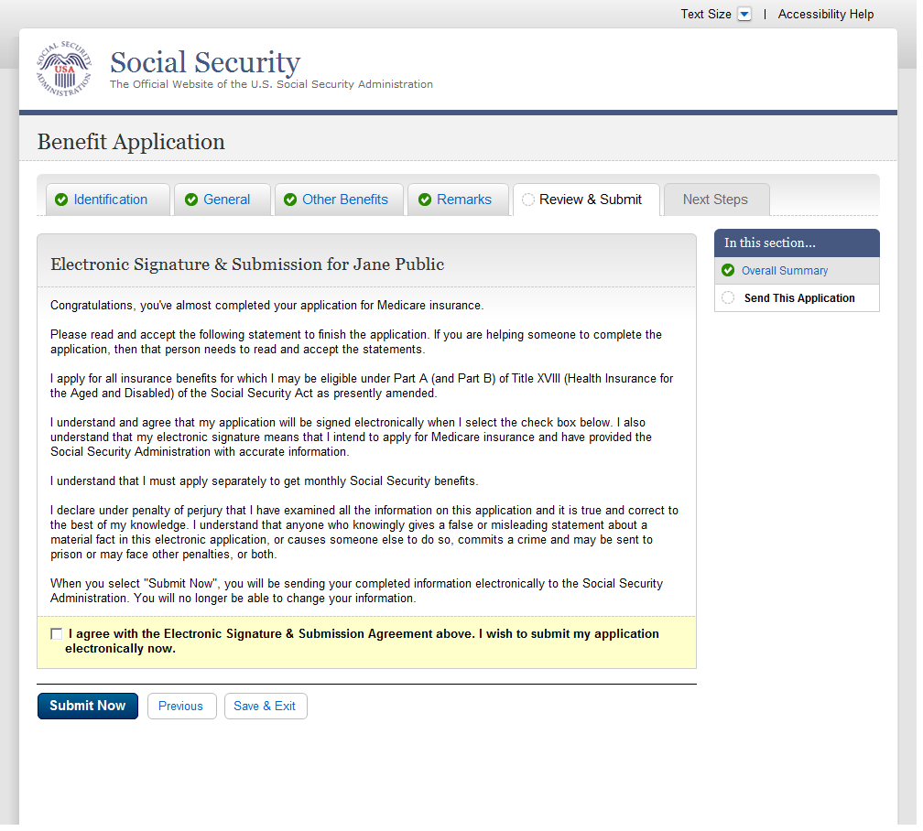
  - snd001-d3_Send This Application
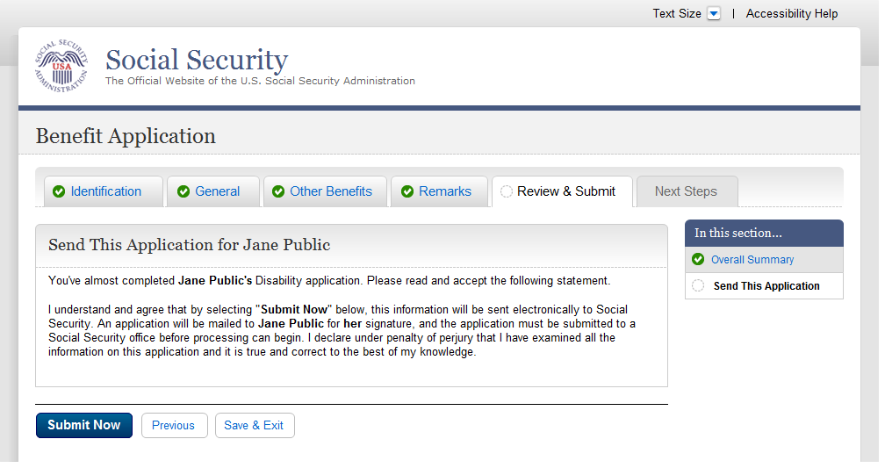
  - snd001-m3_Send This Application
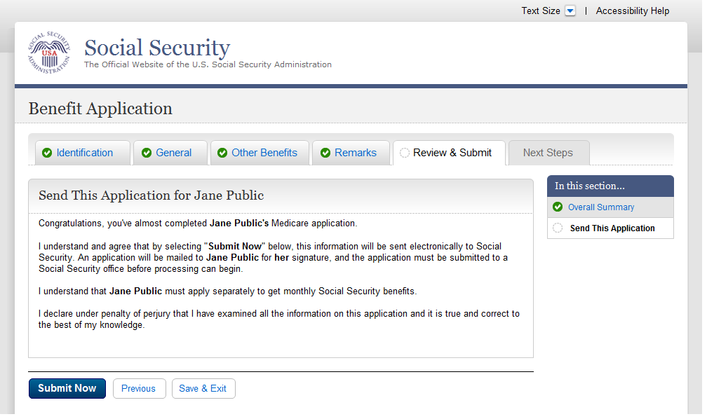
  - snd001-r3_Send This Application
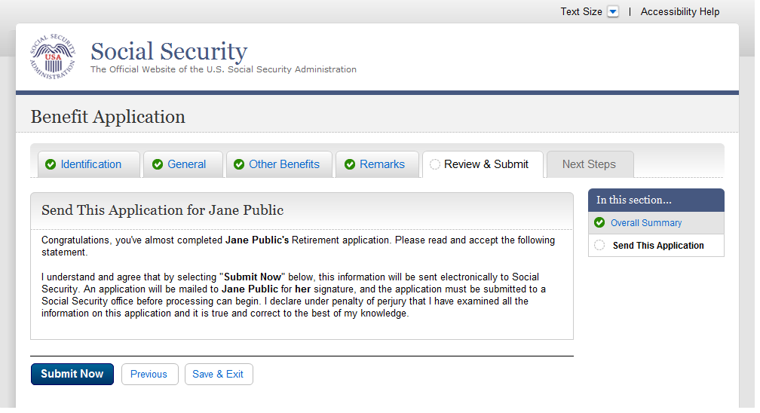
  - rec001-d1-b_Evidence and Receipt
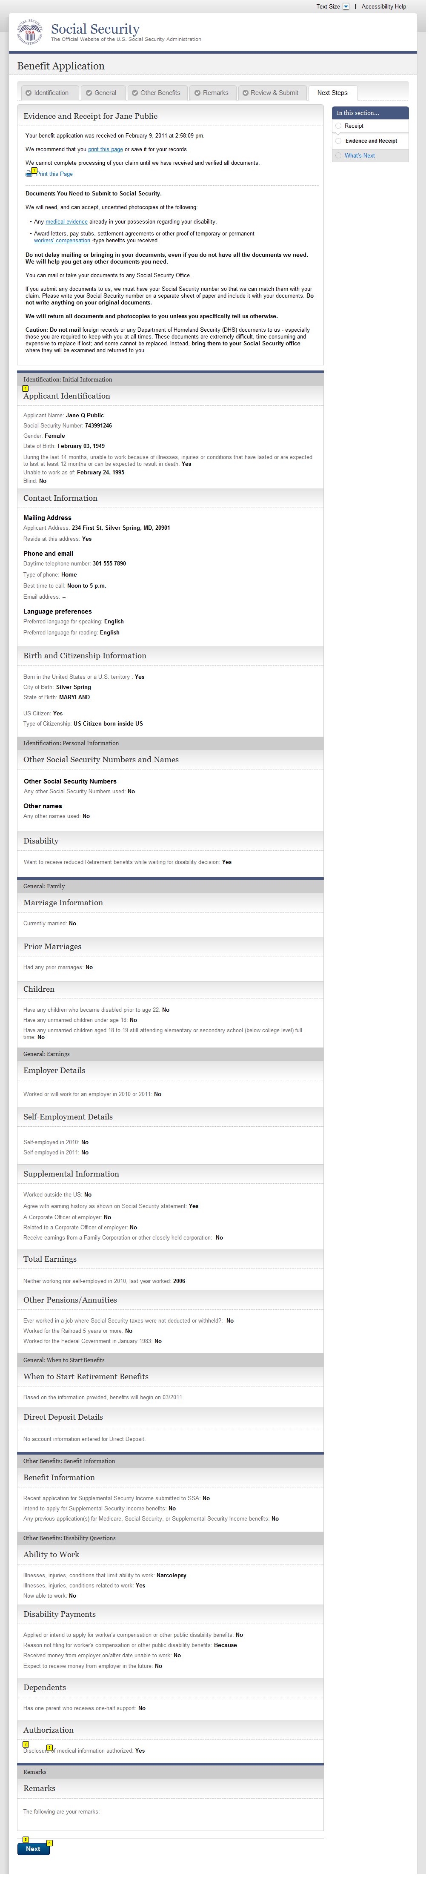
  - rec001-r1-e_Evidence and Receipt
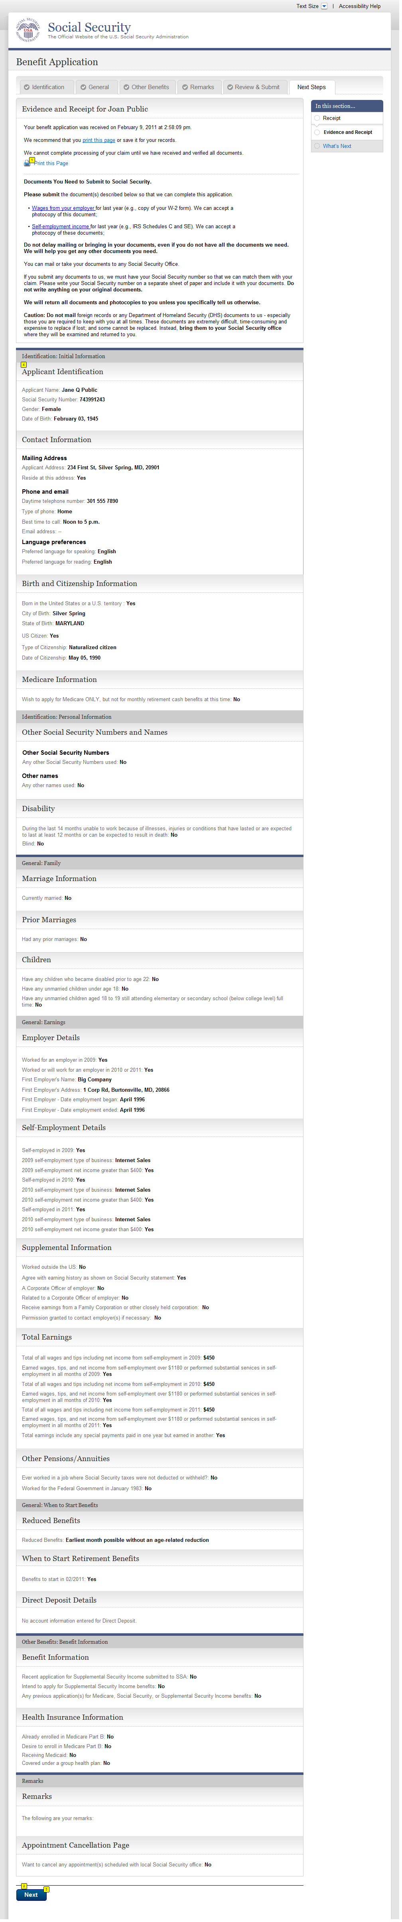
  - rec001-m1-g_Evidence and Receipt
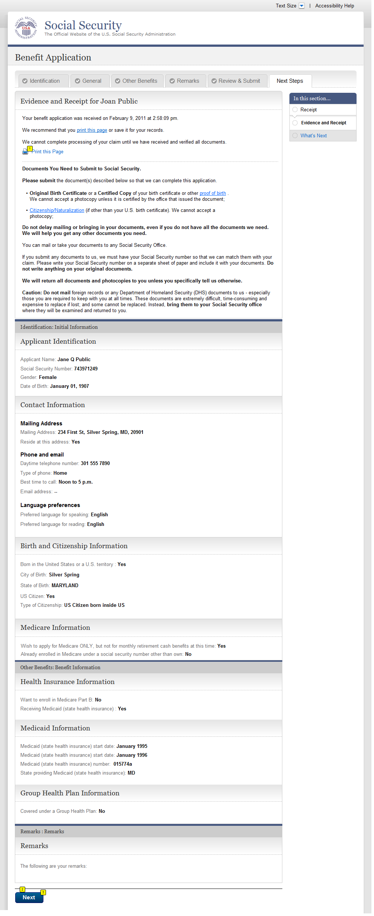
  - rec001-r3-c_Evidence and Receipt
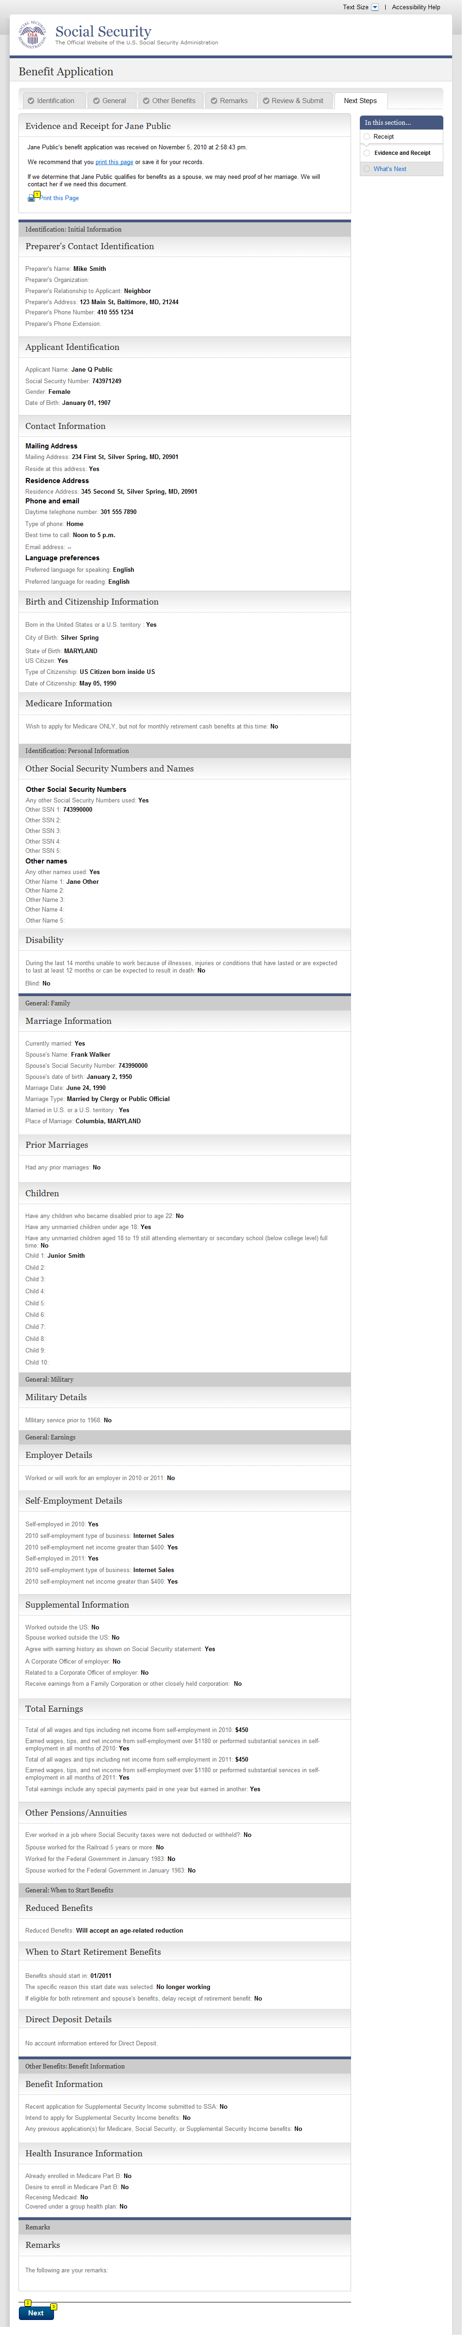
  - rec001-d3-d_Evidence and Receipt
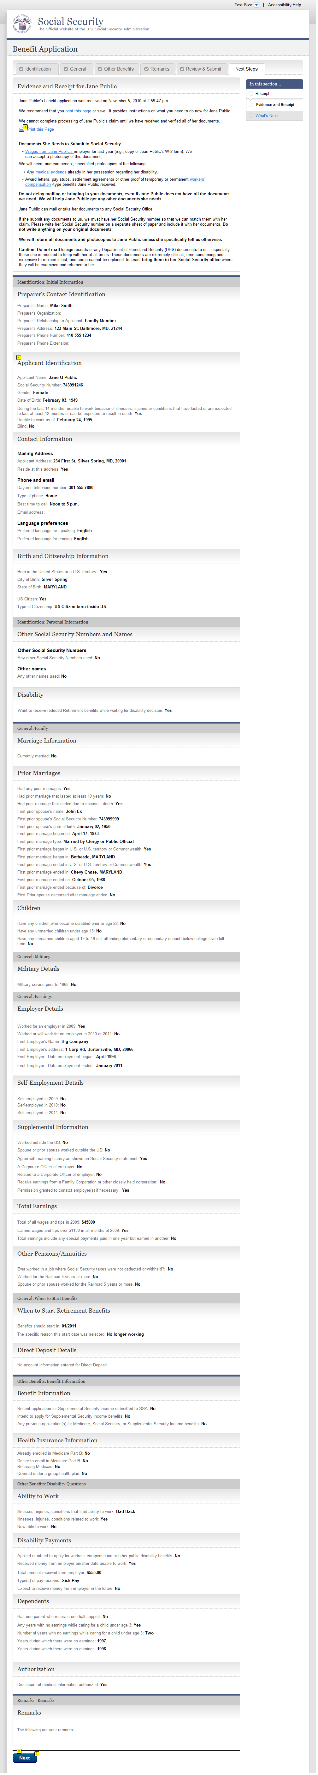
  - rec001-m3-f_Evidence and Receipt
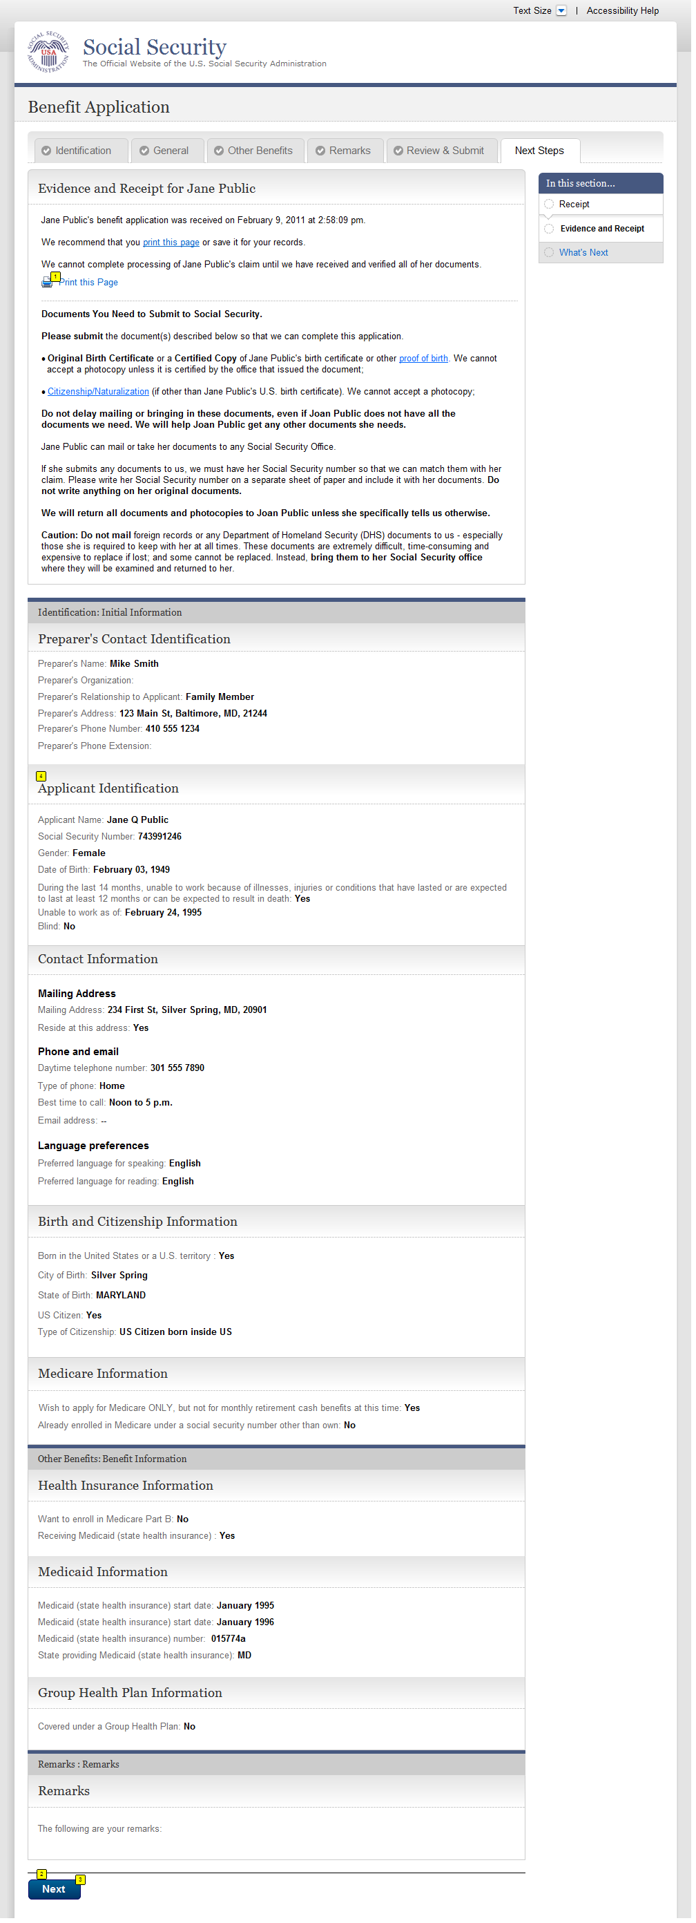
  - wtn001- d1_What's Next
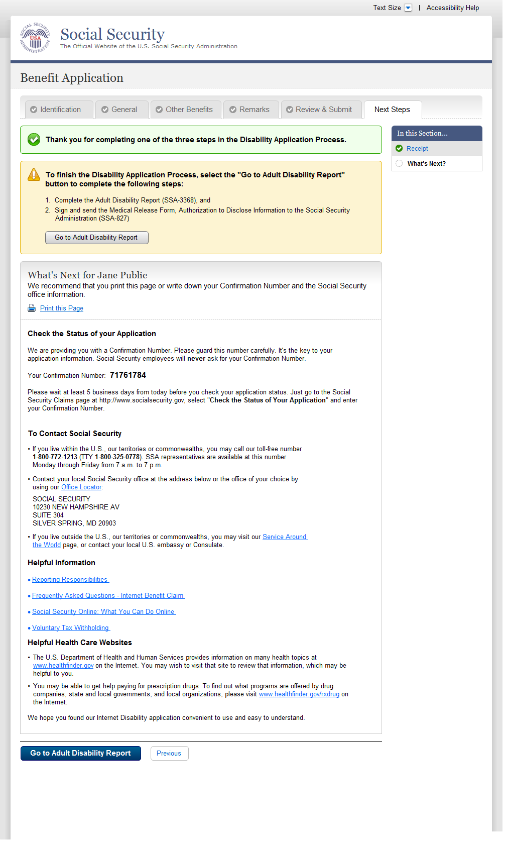
  - wtn001- m1_What's Next
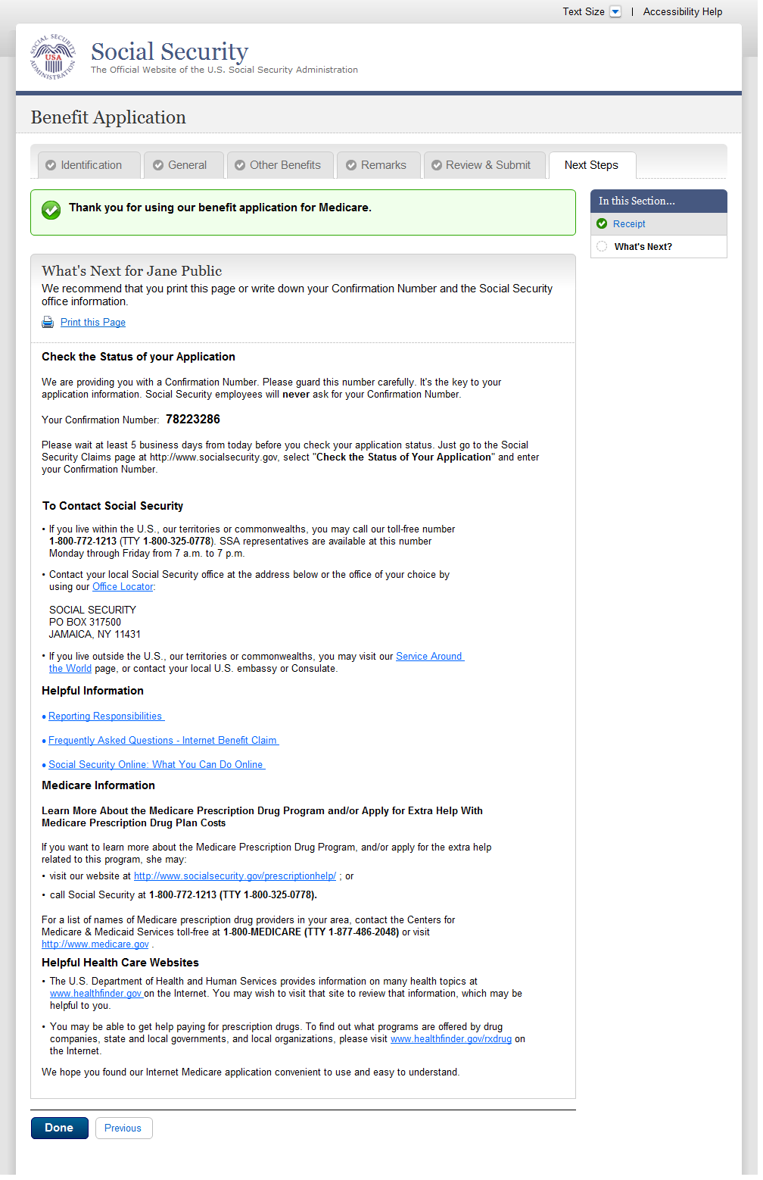
  - wtn001- r3_What's Next
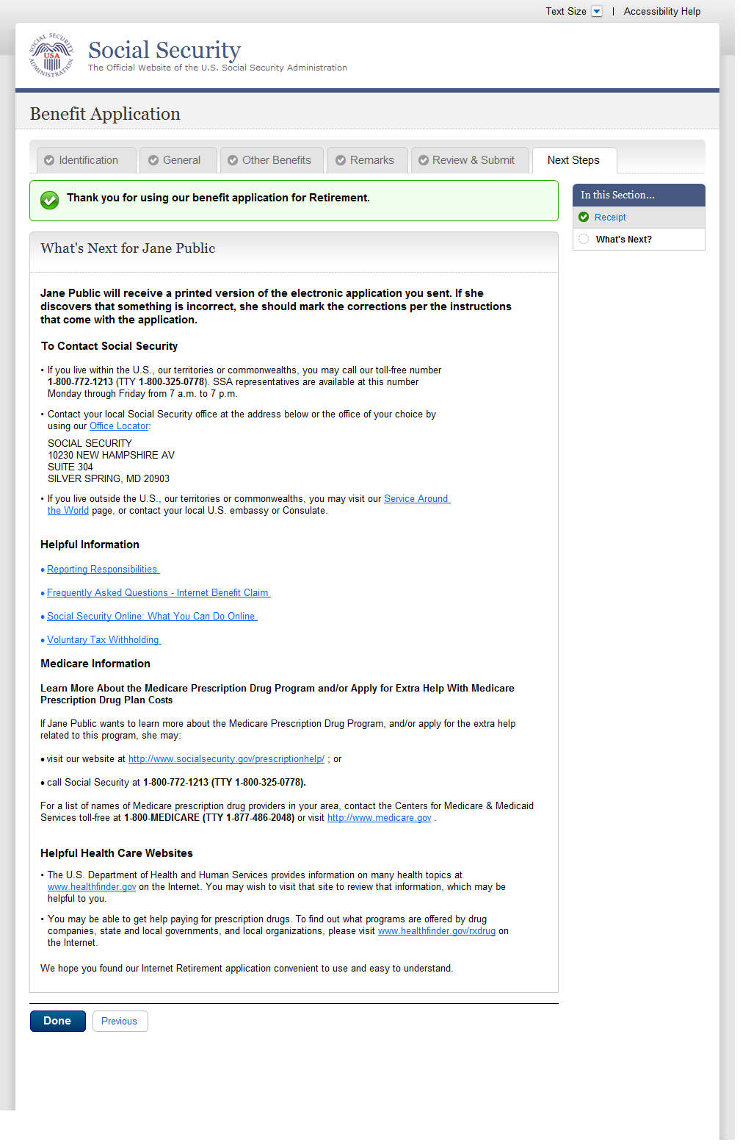
  - wtn001- d3_What's Next
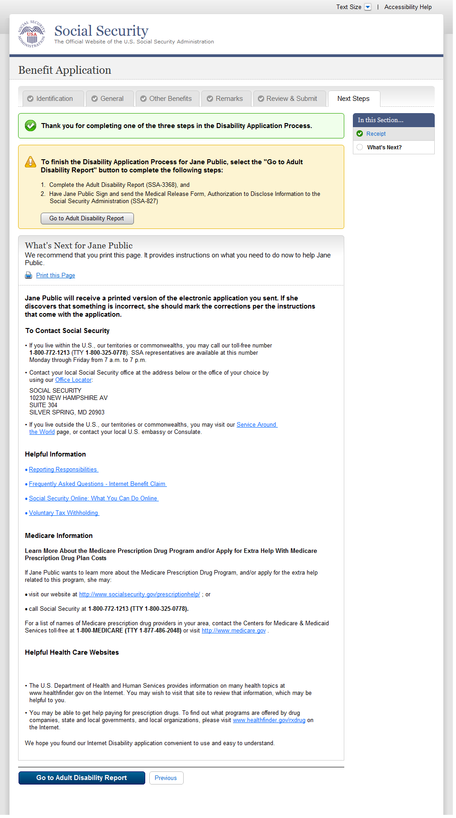
  - wtn001- m3_What's Next
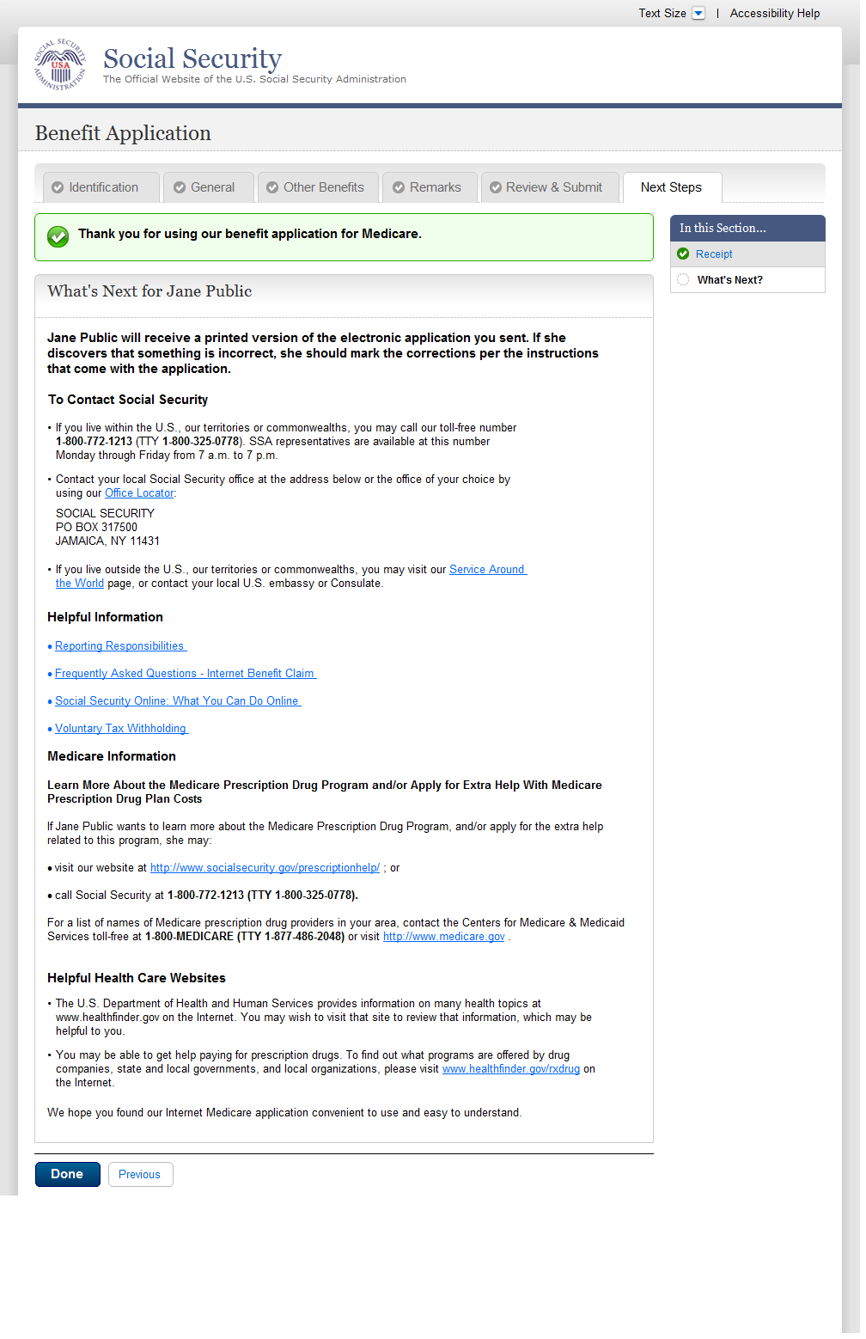
- Messages
  - MSG-Confirm Delete of Table Entry
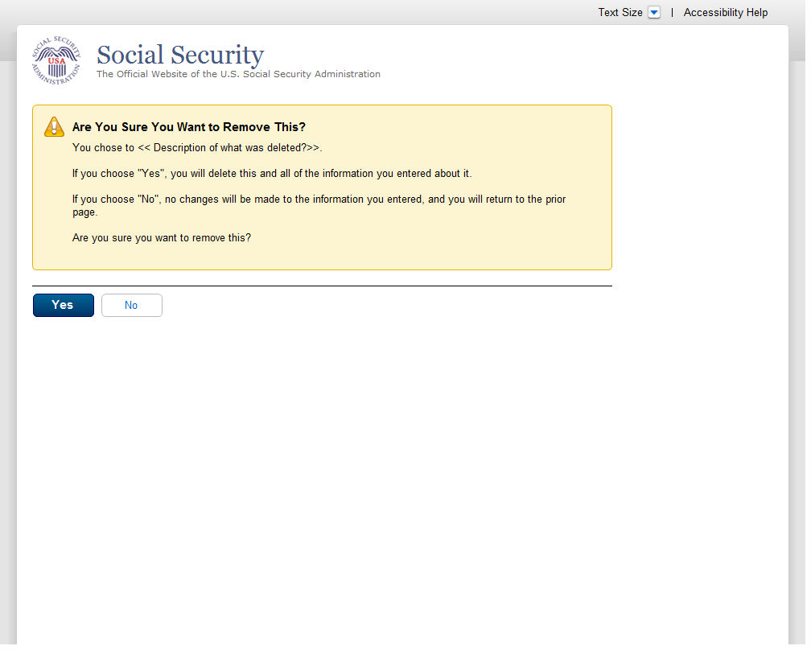
  - msg006_YouCannotApplyforMedicareOnly
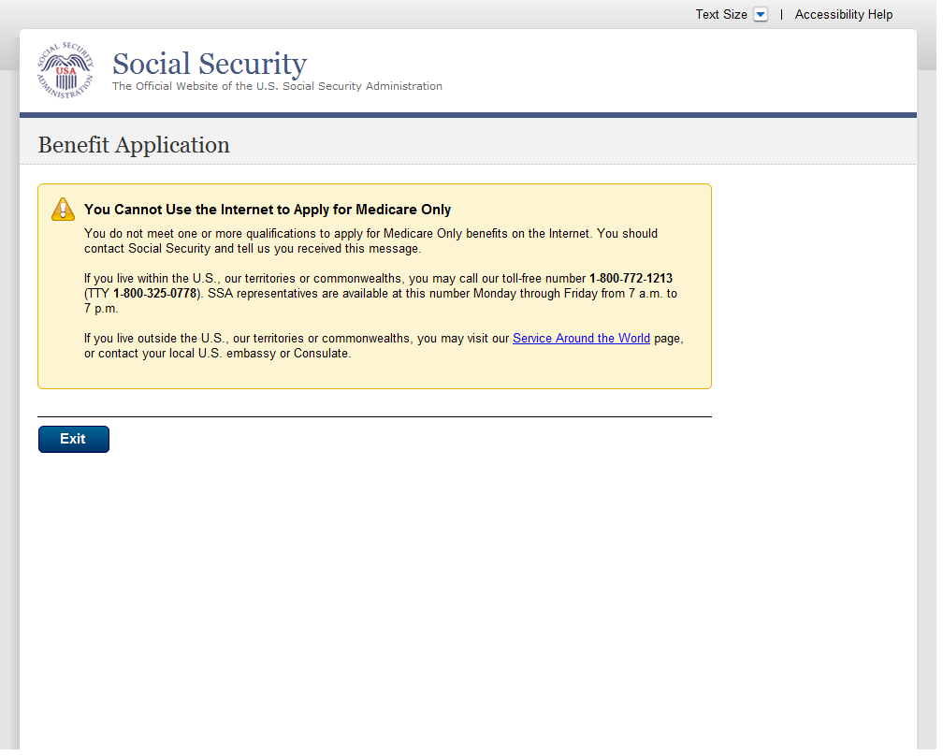
  - msg017_SignIn Problem
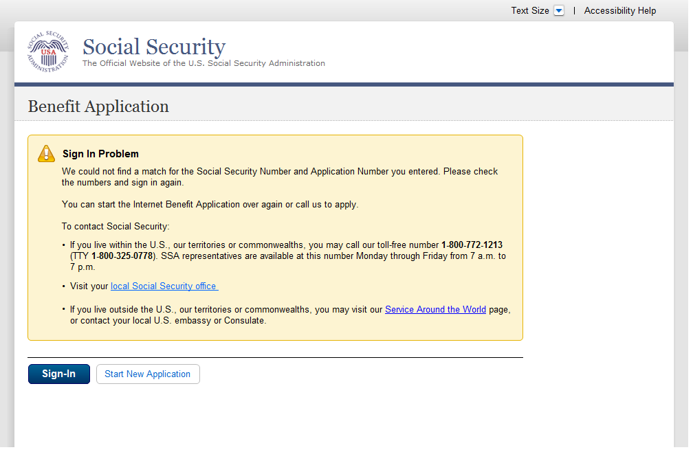
  - msg025_Your Time Has Expired
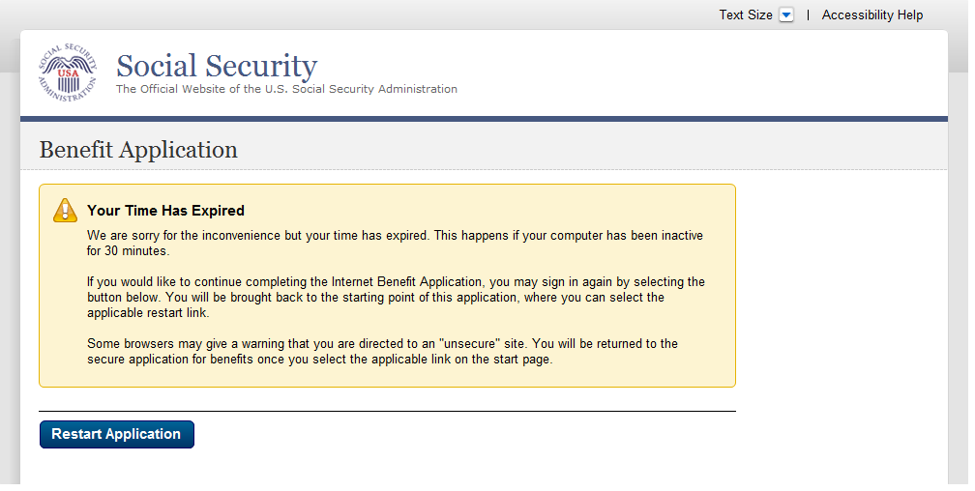
  - msg029_LimitOnNumberOfRestartsOnPartialApplication
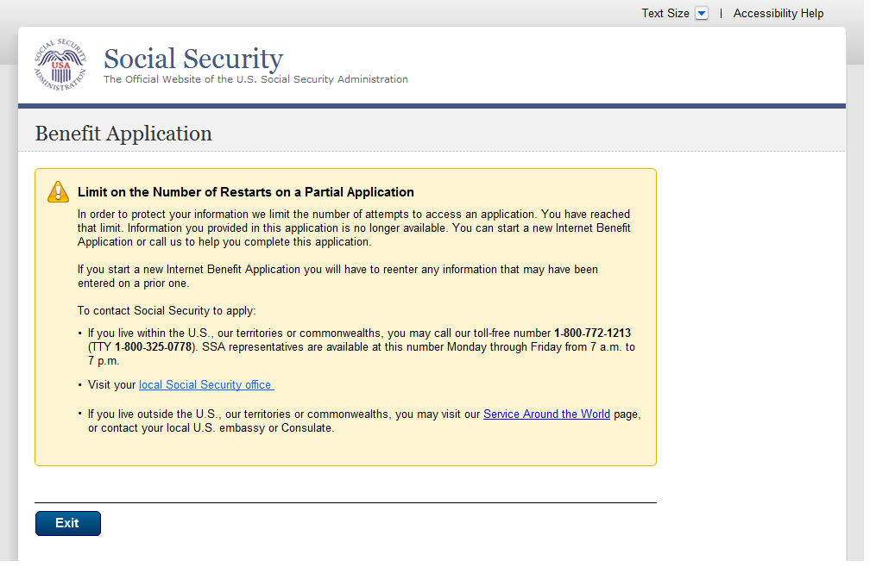
  - msg030_We Are Processing Your Request
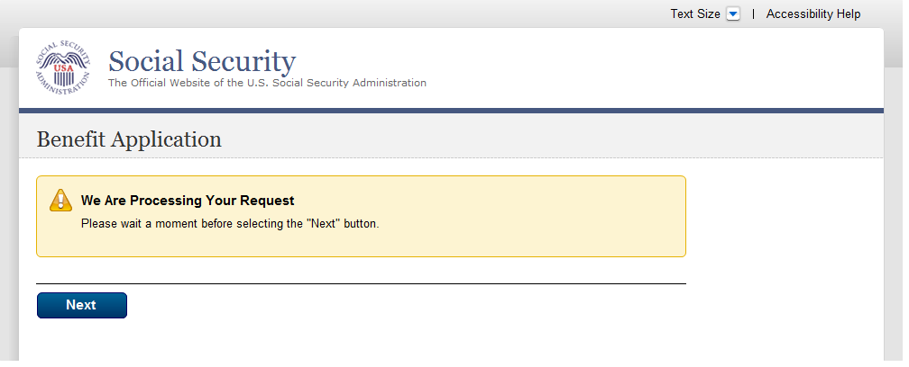
  - msg047-a_Change Your Answer
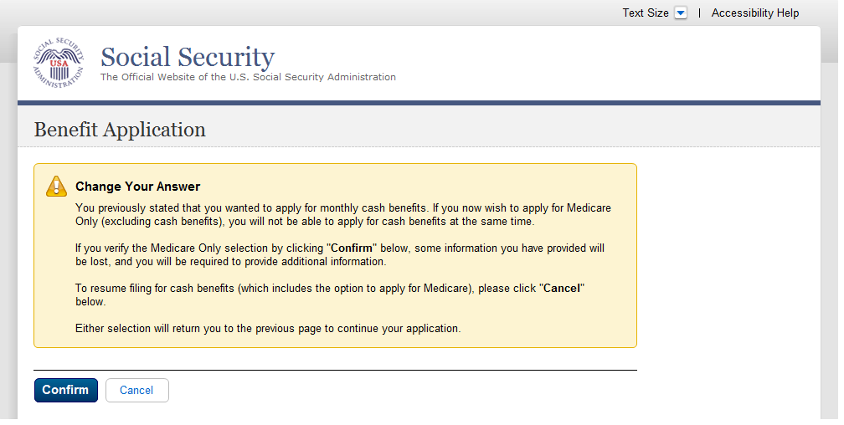
  - msg047-b_Change Your Answer
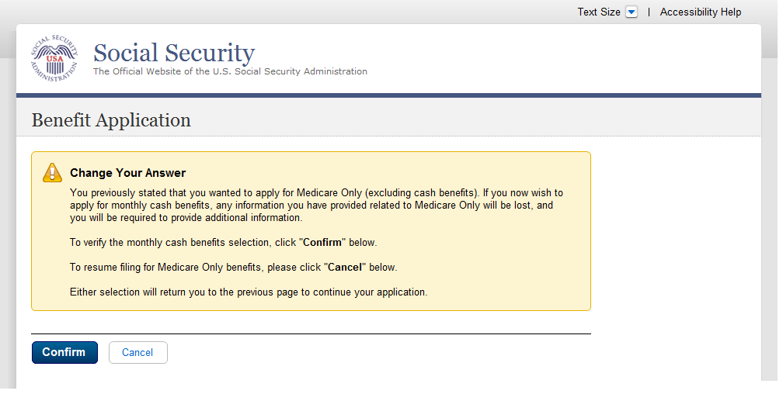
  - msg113_Limit on Number of Requests
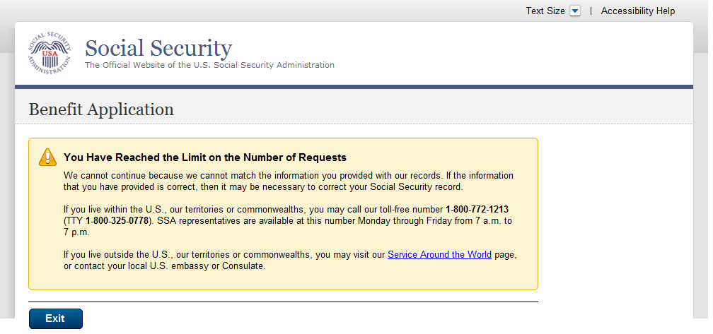
  - msg151_Cannot Match Your Zip Code
