Menu of SSNAP Screens

Main Menu 2
Applicant Info – Select Applicant 3
Numberholder Information 4
Numberholder Address 5
U.S. is Default Selection 5
Foreign Address Selected 5
Military Address Selected 5
U.S. Citizen 12 or Older Interview Questions 6
Additional Information 7
Verify and Sign 8
(Race Ethnicity) – Not a SSNAP screen but will be in the path 9
Privacy Act/Paperwork Reduction Act (to be shared with applicants) ………………………….10

Main Menu
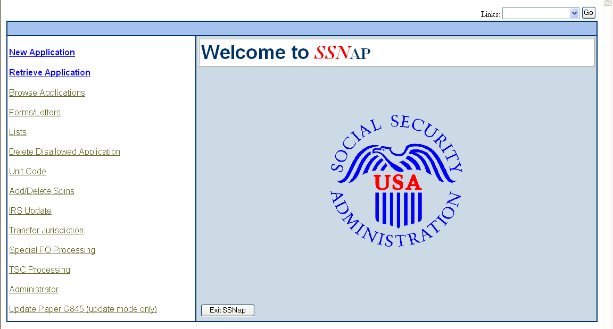

Options in the left menu will depend on the user’s profile.

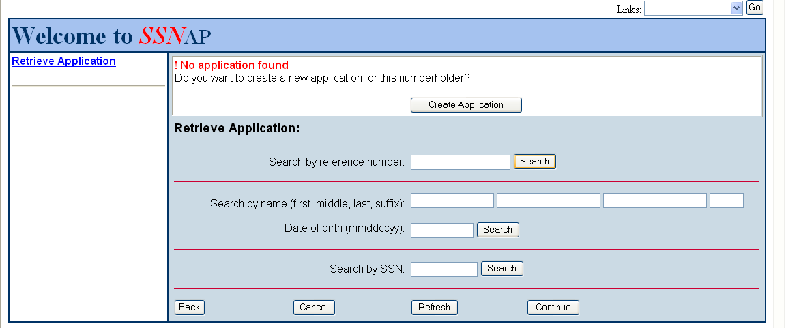
This is an example of selecting Retrieve Application from the Main Menu and entering data for a person who has never applied for a SSN. The user is then given the opportunity to create a new application.
Applicant Info – Select Applicant

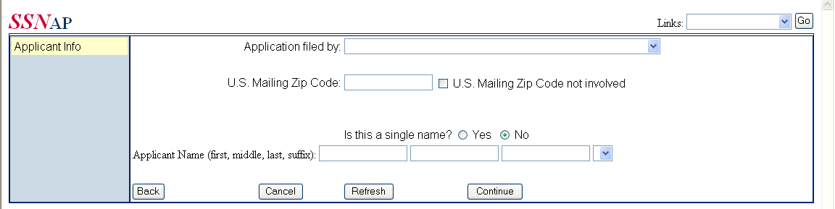
The US Mailing Zip Code is requested to ensure that the applicant is in the proper jurisdiction to best be served. SSA has Card Centers in major cities with their sole function to issue original and replacement SSNs.

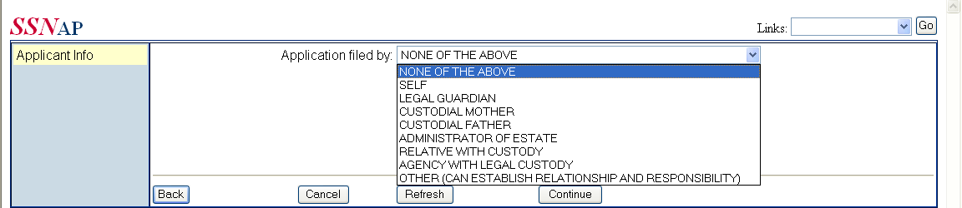

This is the dropdown menu with the possible choices of a proper applicant.

Numberholder Information

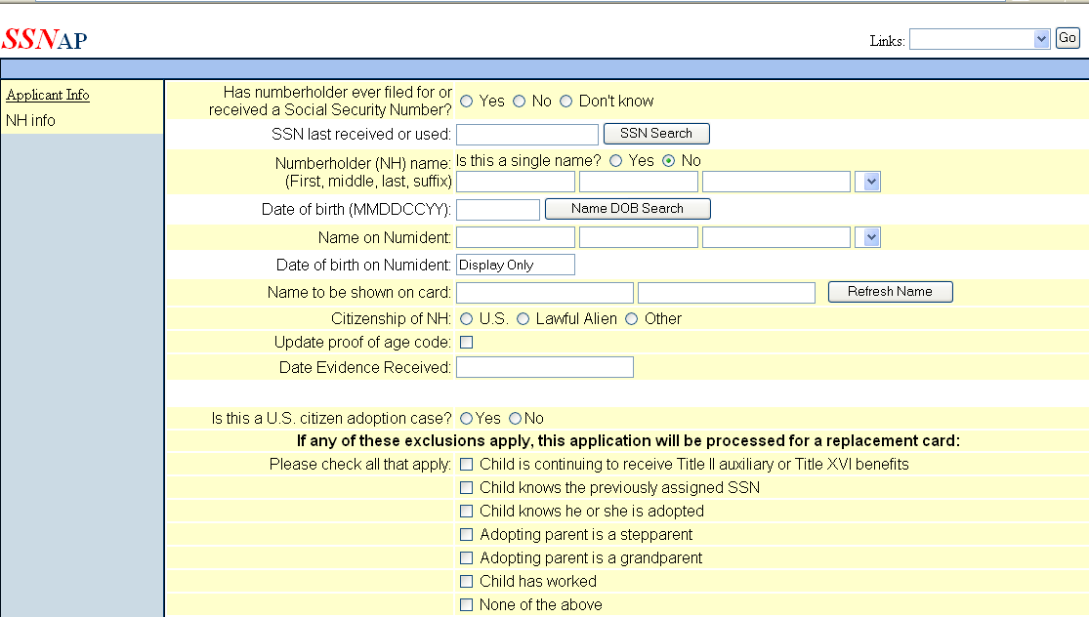
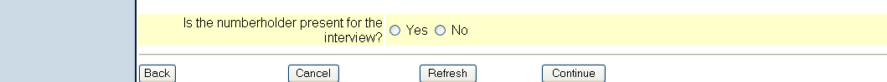

Numberholder Address

U.S. is Default Selection
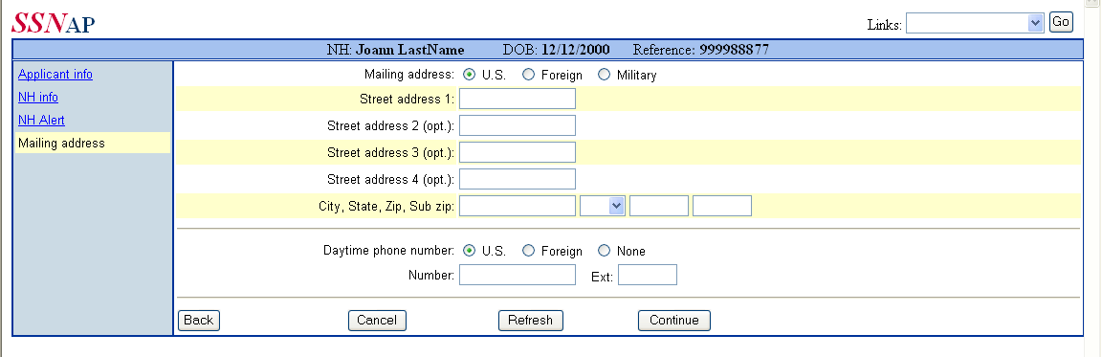

Foreign Address Selected
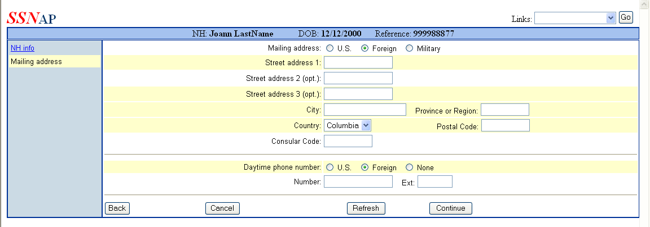

Military Address Selected
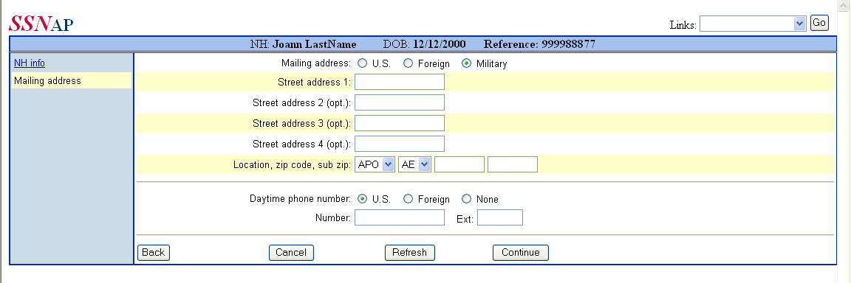
U.S. Citizen 12 or Older Interview Questions

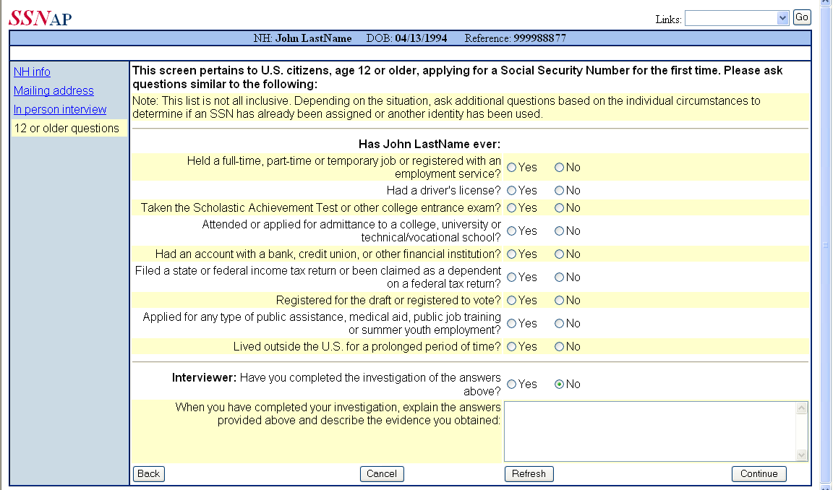

Additional Information

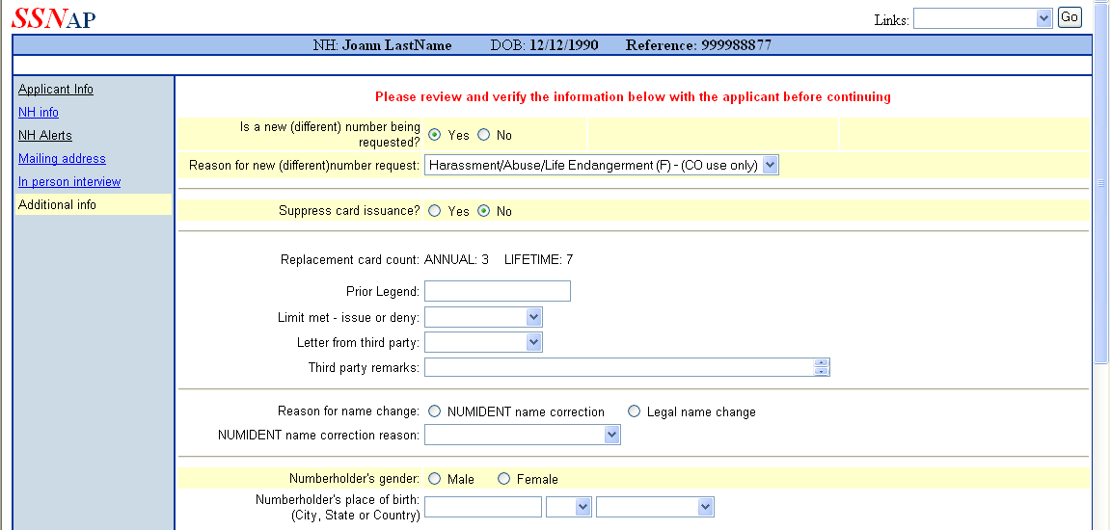
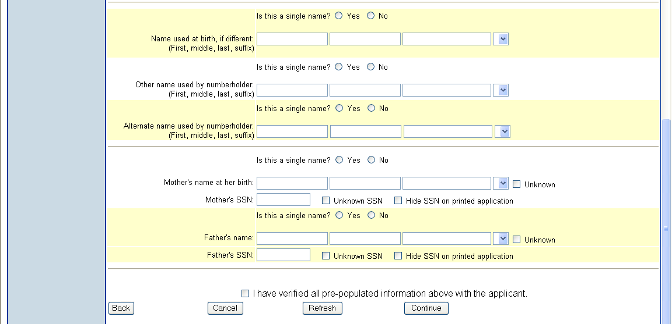

Verify and Sign

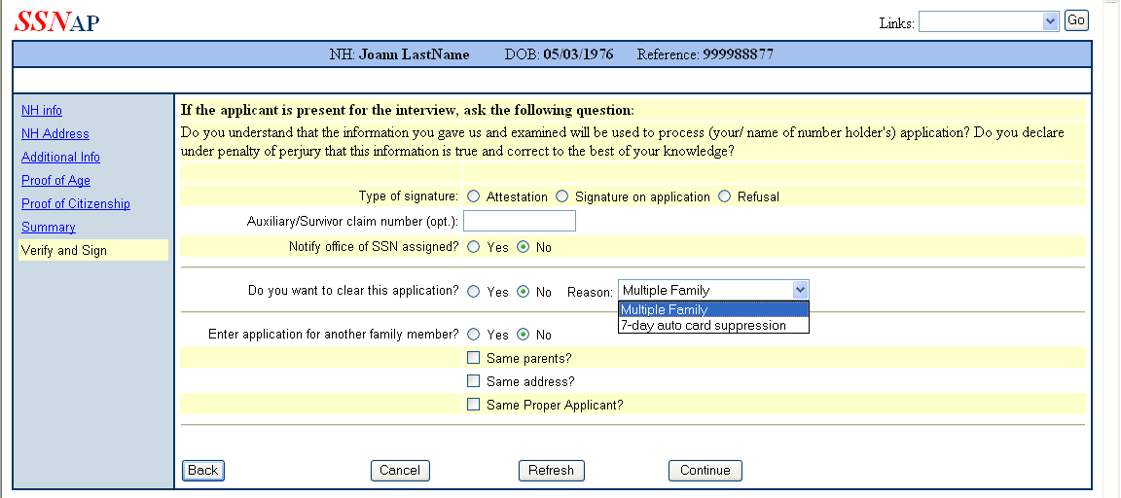

(Race Ethnicity) – Not a SSNAP screen but will be in the path

Additional Information – SSA Employee can Link to/View These Screens (on the next 2 pages) if the Applicant Asks for Information about the Race/Ethnicity Screens

Privacy/Paperwork Reduction Act Statements

Sections 205(c) and 702 of the Social Security Act, as amended, authorize us to collect this information. The information you provide will be used to assign you a Social Security number and issue a Social Security card.

The information you furnish on this form is voluntary. However, failure to provide the requested information may prevent us from issuing you a Social Security number and card.

We rarely use the information you supply for any purpose other than for issuing a Social Security number and card. However, we may use it for the administration and integrity of Social Security programs. We may also disclose information to another person or to another agency in accordance with approved routine uses, which include but are not limited to the following:

- To enable a third party or an agency to assist Social Security in establishing rights to Social Security benefits and/or coverage;

- To comply with Federal laws requiring the release of information from Social Security records (e.g., to the Government Accountability Office and Department of Veterans’ Affairs);

- To make determinations for eligibility in similar health and income maintenance programs at the Federal, state and local level; and

- To facilitate statistical research, audit or investigative activities necessary to assure the integrity of Social Security programs.

We may also use the information you provide in computer matching programs. Matching programs compare our records with records kept by other Federal, state or local government agencies. Information from these matching programs can be used to establish or verify a person’s eligibility for Federally funded or administered benefit programs and for repayment of payments or delinquent debts under these programs.
Complete lists of routine uses for this information are available in System of Records Notice 60-0058 (Master Files of Social Security Number (SSN) Holders and SSN Applications). The Notice, additional information regarding this form, and information regarding our systems and programs, are available on-line at www.ssa.gov or at your local Social Security office.
This information collection meets the requirements of 44 U.S.C. §3507, as amended by Section 2 of the Paperwork Reduction Act of 1995. You do not need to answer these questions unless we display a valid office of Management and Budget control number. We estimate that it will take about 8.5 to 9.5 minutes to read the instructions, gather the facts, and answer the questions. You may send comments on our time estimate to: SSA, 6401 Security Blvd., Baltimore, MD 21235 6401. Send only comments relating to our time estimate to this address, not the completed form.

