Justification for Non-Substantive Change to
Work Incentives Planning and Assistance (WIPA) Projects
OMB No. 0960-0629

Background
In September 2007, the Social Security Administration (SSA) added the Work Incentive Planning and Assistance (WIPA) Program data collection to the Evaluation of the Ticket to Work Program. SSA added the WIPA data collection to provide information for the evaluation of the WIPA Program, and to provide ongoing management information for SSA and WIPA project staff. Subsequent to the most recent OMB clearance approval, we discovered that some of the existing information we planned to use for the evaluation is inadequate. As a result, we request to add one question in the cleared forms to meet the requirements of the evaluation.
Once the data became available from the WIPA data collection in Efforts to Outcomes (ETO) and reached a minimum level of quality, we used it as the foundation of the most recent evaluation of the WIPA program. One of the key findings of the evaluation is a measure of each WIPA’s cost of serving a beneficiary. We adjust the costs, including an adjustment for the additional funding WIPAs receive from other sources. During the last evaluation, we learned that the additional funding information available from grant applications, quarterly reports, and other sources is incomplete and inconsistently reported. For SSA to obtain consistently measured and reported annual information on funding, requires an annual question on the sources of funding in ETO.
Summary of the Non-Substantive Changes
The new “sources of funding” question is:
Below, please indicate the non-SSA sources of funds your organization used to support WIPA operations during the one-year period that ended last March 31st and the percentage of the funds used specifically for WIPA direct services (I&R and benefits counseling) to SSA disability beneficiaries. If the funding period started before or ended after this annual timeframe, please specify the period covered by the funding.
We will make two changes to accommodate the new question in ETO. There is one new option in an existing drop down box to navigate to the new screen with the sources of funding question and there is one new screen for the new question. The illustrations of the screens shots below shows the new screen and the changes outlined in red. We have also provided an example with data entered.
Sources of Funding Question in WIPA/ETO

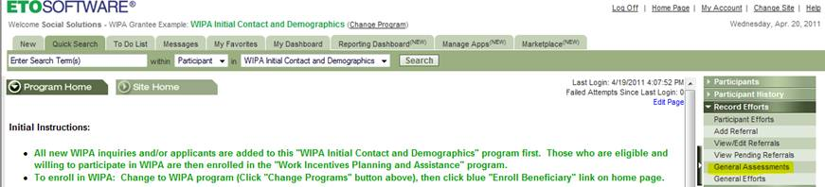

Screen 1 (Change to existing screen): Select the new option “General Assessments”

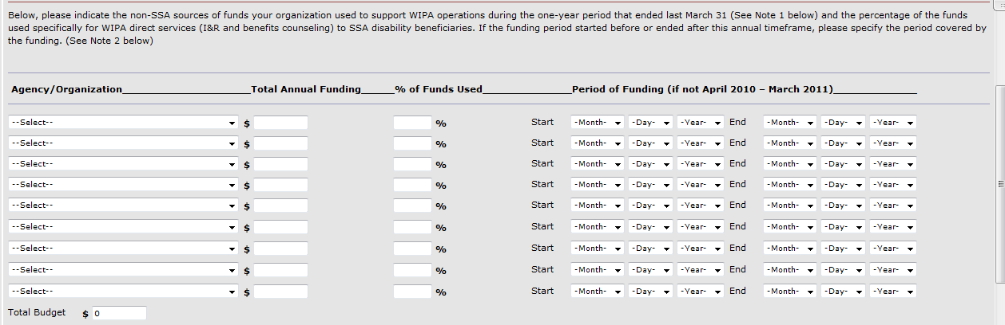
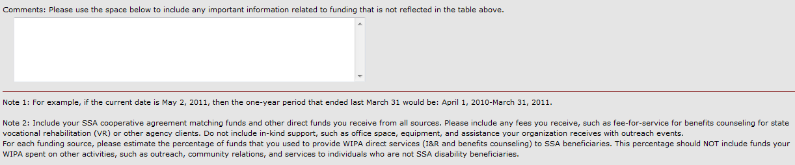

Screen 2 (New): The sources of funding question.

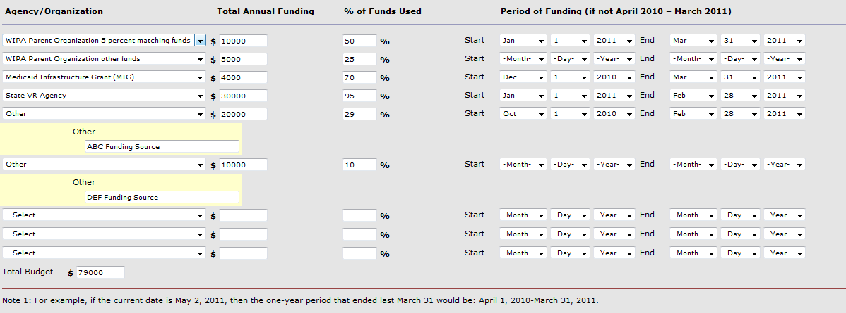
Screen 2 (Example): Example data entered and options selected from drop down boxes

