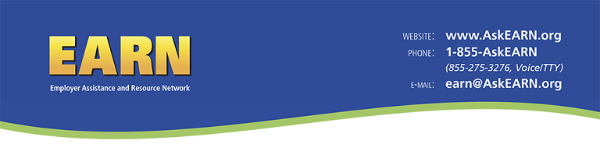

Customer Service Follow-up: Workforce Recruitment Program

Dear ${m://FirstName},

During the last several months, you posted jobs through WRP.jobs, a website designed to assist employers in hiring Workforce Recruitment Program (WRP) job candidates. This survey is designed to gather feedback from you so we can understand the outcomes and impact of the Workforce Recruitment Program. We will also use the data that we gather to help inform improvements to the WRP.

Your answers will be used only for statistical purposes and any reports will summarize findings across the sample and will not associate responses with a specific firm or individual. We will not provide information that identifies you or your organization to anyone outside the study team, except as required by law. This survey is anonymous, please do not place identifiers on this form. We anticipate that your participation in this survey presents no greater risk than everyday use of the Internet. Taking part is completely voluntary and you are free to withdraw at any time. The survey should take less than 5 minutes to complete.

If you have questions, you may contact Sarah von Schrader at sv282@cornell.edu or 607-254-8088

Instructions: Please answer the following questions to the best of your ability.

1. The WRP.jobs website...
 | Strongly Agree | Agree | Neither Agree nor Disagree | Disagree | Strongly Disagree
...was easy to use.
...helped me find qualified candidates.

2. I can identify WRP candidates who apply to positions at my organization, (e.g., through my applicant tracking system, etc.)
- Yes
- No
- Don't Know

3. It is likely that I will…
 | Strongly Agree | Agree | Neither Agree nor Disagree | Disagree | Strongly Disagree
...post jobs to WRP.jobs in the future.
…interview WRP candidates(s) for the position(s) I am trying to fill.
…hire WRP candidate(s) for the position(s) I am trying to fill.

4. Please answer the questions below
 | Strongly Agree | Agree | Neither Agree nor Disagree | Disagree | Strongly Disagree
Working with EARN through the WRP increased my knowledge about recruiting/employing individuals with disabilities.
Recruiting via WRP.jobs is an important part of our strategy for reaching candidates with disabilities.

5. What can we do to improve WRP.jobs?

OMB Information Collection No 1225-0088, Expires 06/30/2014. According to the Paperwork Reduction Act of 1995, no persons are required to respond to a collection of information unless such collection displays a valid OMB control number. Your response is voluntary. Public reporting burden for this collection of information is estimated to average 5 minutes per response, including time for reviewing instructions, searching existing data sources, gathering and maintaining the data needed, and completing and reviewing the collection of information. Send comments about the burden estimated or any other aspect of this collection of information, including suggestions for reducing this burden, to the U.S. Department of Labor, to the attention of the Departmental Clearance Officer, 200 Constitution Avenue NW, Room N1301, Washington, DC 20210. Comments may also be emailed to dol_pra_public@dol.gov. Please do not return the completed form to this address. Submit as specified in this form.

