LOCATING INFORMATION ABOUT PISA

Information about PISA is located on the study website at the National Center for Education Statistics (NCES) and on the Organization for Economic Cooperation and Development (OECD) web site.

PISA on the web at NCES is located at: http://nces.ed.gov/surveys/pisa

The NCES website provides a variety of information about PISA.

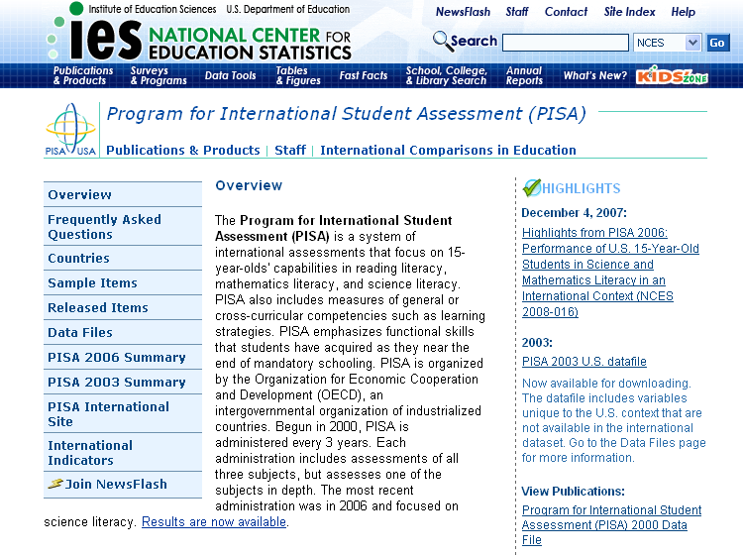
Click on these links to find general information about results and reports from previous rounds, sample items, and a link to the international site at OECD.

Click on the links under Highlights to see the most current data and reporting.

To view sample items from PISA:

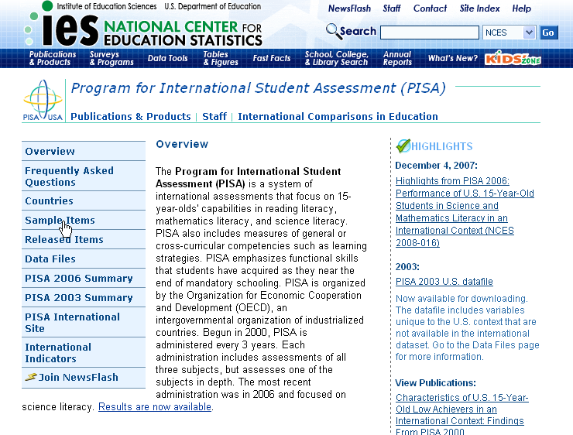
Click on the sample items link.

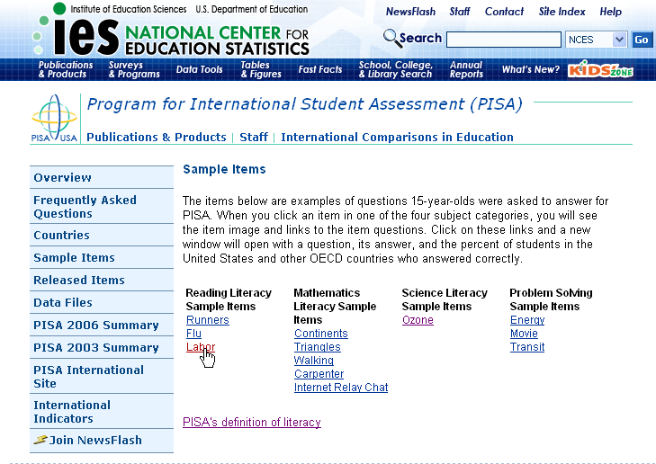
Click the item you wish to view.

The item will load in the lower portion of the window.

Click the question you wish to view and see the scoring guide and results.
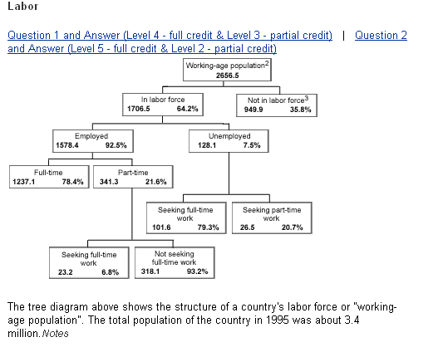

A new window will appear containing the question text, the scoring guide, and the percentage of U.S. students who received full credit along with the OECD average.

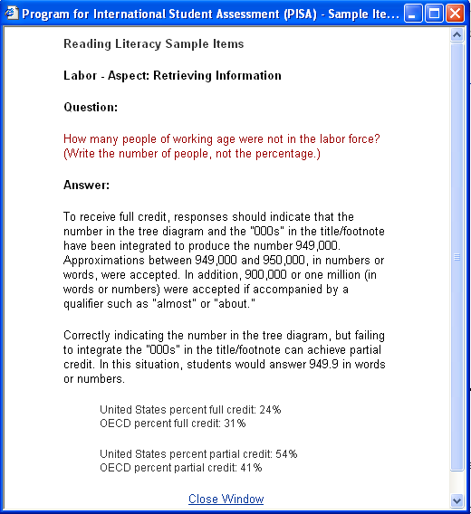

How to access interactive PISA items from the international website

The PISA site at NCES links with the international site at OECD. The OECD site provides the international reports and interactive items and data.

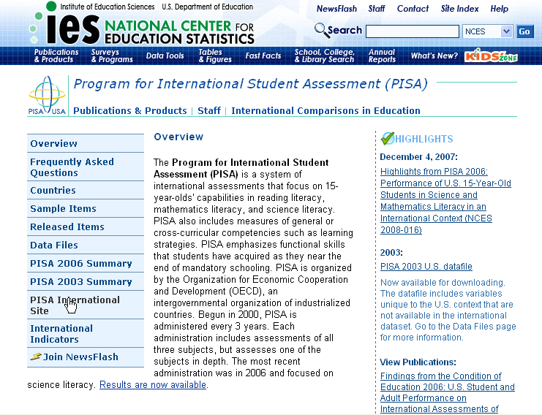
Click on the PISA International Site link.

You will be directed to the link for the PISA site at OECD. Click this link.

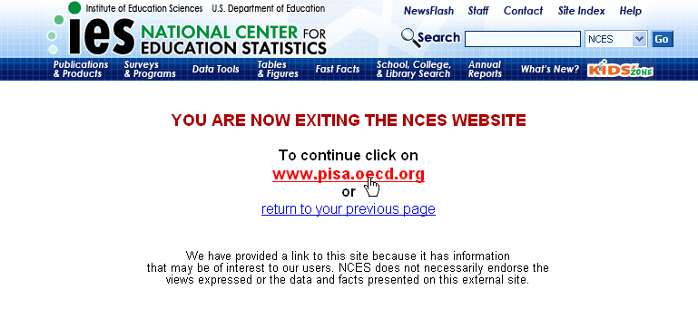
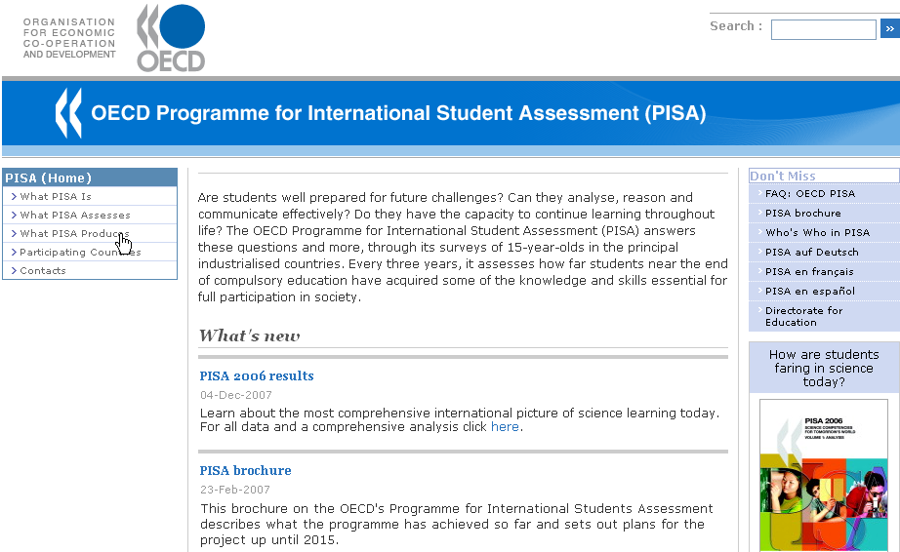
Click on link for What PISA Produces.

Select the PISA year for which you want to view items, and then select Test questions.

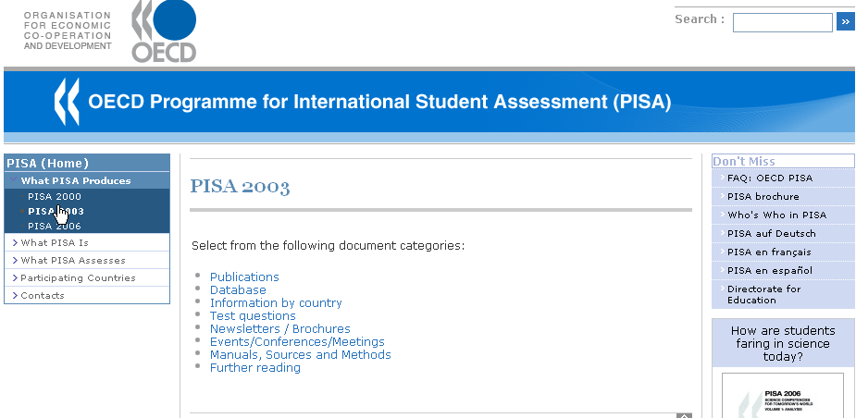
Click on the link for the PISA year you want.
Click on the link for Test questions.
All years have released items available to view in PDF form. Only 2000 and 2003 have interactive items available.

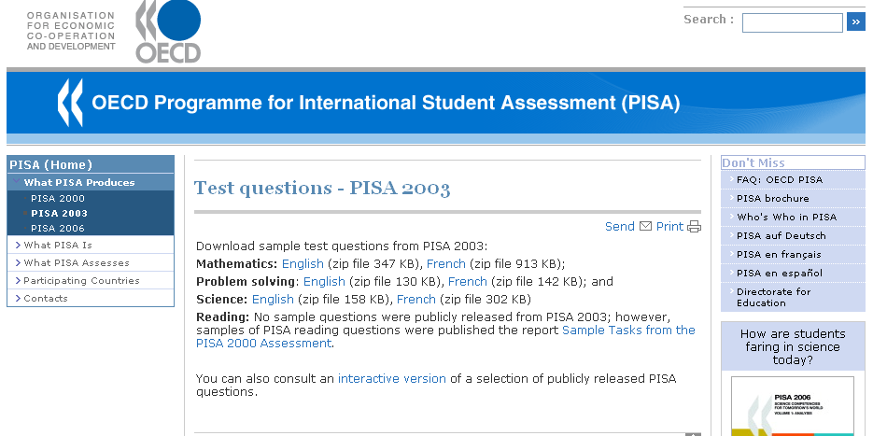
Click on the link for interactive version. A new window will open.

A new window will open containing the interactive PISA questions.

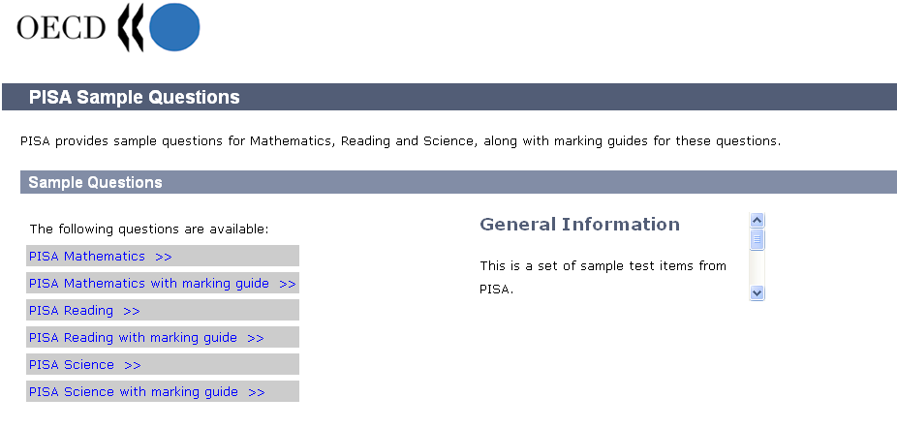

Click on link of the subject area items in which you are interested.

Take some PISA items and see how you do!

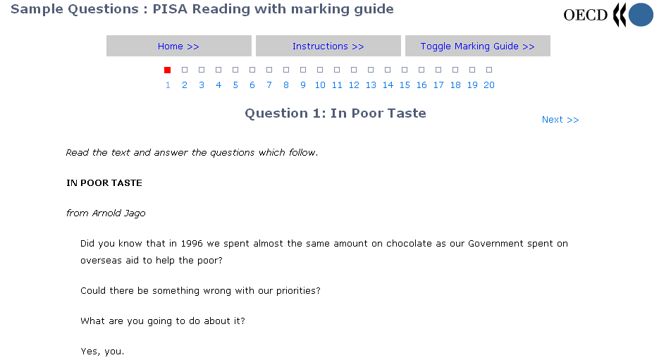
Use the controls to move to different items, view instructions, and move through the marking guide.

How to access PISA reports from the international website

Click on link for What PISA Produces.
Select a publication on the margin
Look under What’s new, or in the margin, for the latest releases.

Click on the link for the PISA year you want.
Click on the link for the Publications.

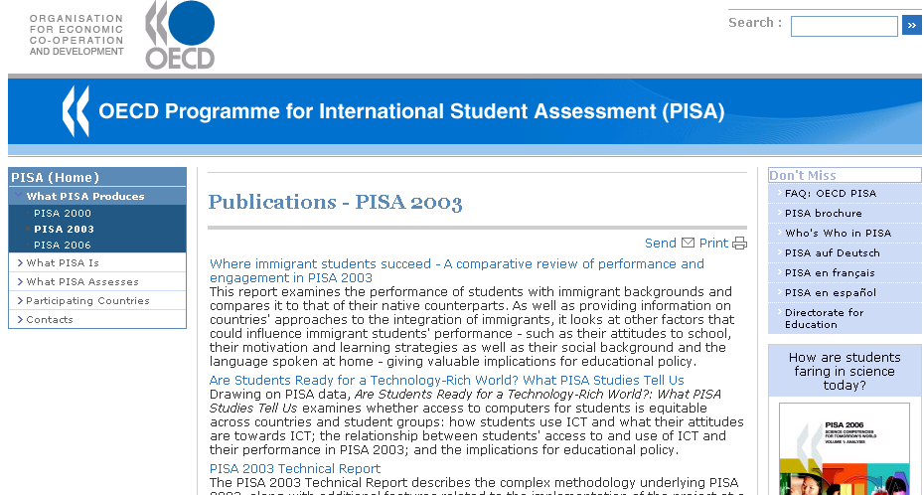
Available publications are listed by title. Access the report by clicking on the title.

Each publication has a page with a brief summary of the report content, table of contents, and ordering information.

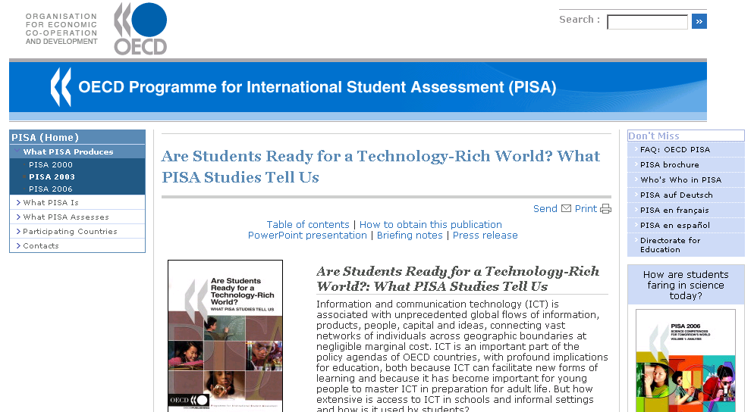

Scroll the page to find out how to obtain the publication and other information.

