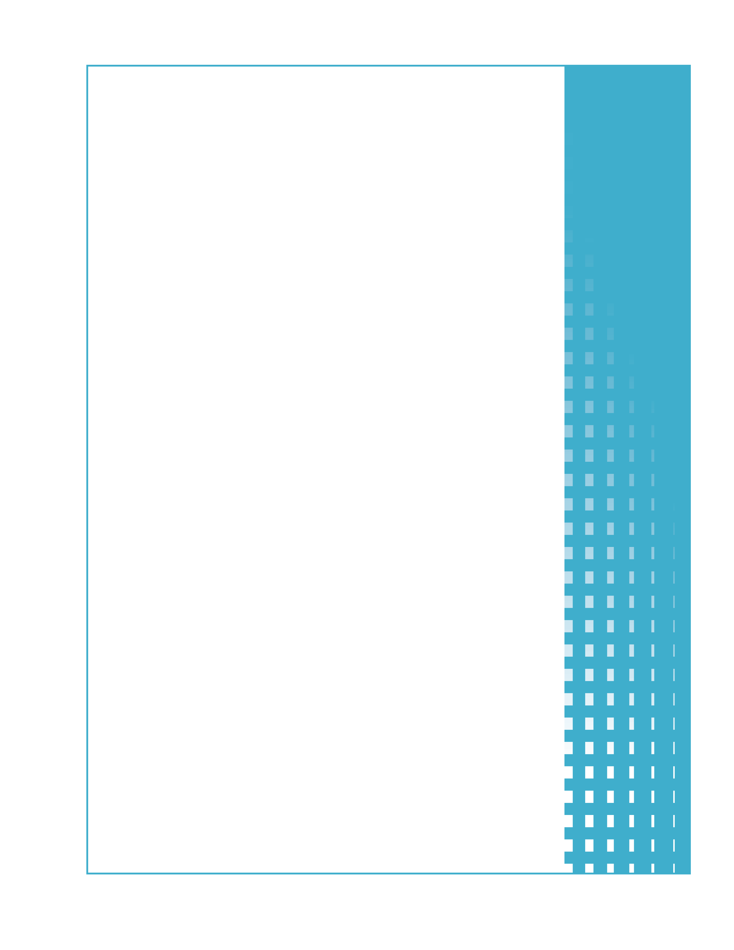

Appendix F6  
  
Round 3  
DTA Staff HIP Interview Guide

DTA Staff HIP Interview Guide

# Round 3: Mature Operations and Feasibility of HIP Expansion

The Massachusetts Department of Transitional Assistance (DTA) is supporting the Healthy Incentives Pilot (HIP) by:

* Dedicating key members of the SNAP and EBT staff to support HIP. These staff will dedicate a percentage of their time to HIP.
* Hiring a full-time team to support HIP.

HIP staff is located at either the central DTA office in Boston or in Hampden County. The purpose of Round 3 interviews with State SNAP, EBT and HIP staff is to document mature HIP operations. The interviews will take place approximately 11 to 12 months after HIP start up.

Key staff and their primary HIP responsibilities include[1]:

|  |  |  |  |
| --- | --- | --- | --- |
| **Position** | **Location** | **Primary Responsibility** | **FTE** |
| Executive Lead (Assistant Commissioner for Policy, Program and External Relations) | DTA Central Office - Boston | Oversight of HIP and HIP staff and ensuring HIP goals and strategic objectives are met | 0.25 |
| Pilot Director | DTA Central Office - Boston | HIP planning, implementation, and oversight | 1.00 |
| Pilot Assistant Director | Hampden County | Supports the Pilot Director providing project management and HIP evaluation support | 1.00 |
| HIP EBT Contractor Liaison | DTA Central Office - Boston | Works with ACS (EBT vendor) providing oversight for EBT system modification and testing and HIP operations | 1.00 |
| HIP EBT Officer (Deputy Director for Financial Program Management) | DTA Central Office - Boston | Communicates with stakeholders concerning EBT program management and procedures. Ensures accurate accounting of HIP benefit issuance. | 0.25 |

Public reporting burden for this collection of information is estimated to average 85 minutes per response, including the time for reviewing instructions, searching existing data sources, gathering and maintaining the data needed, and completing and reviewing the collection of information. An agency may not conduct or sponsor, and a person is not required to respond to, a collection of information unless it displays a currently valid OMB control number. Send comments regarding this burden estimate or any other aspect of this collection of information, including suggestions for reducing this burden, to: U.S. Department of Agriculture, Food and Nutrition Service, Office of Research and Analysis, 3101 Park Center Drive, Room 1014, Alexandria, VA 22302 ATTN: PRA (0584-xxxx). Do not return the completed form to this address.

|  |  |  |  |
| --- | --- | --- | --- |
| **Position** | **Location** | **Primary Responsibility** | **FTE** |
| Data and Management Analyst | DTA Central Office - Boston | Supports HIP data analysis and evaluation | 1.00 |
| HIP Evaluator Liaison (DTA Director of Policy Research) | DTA Central Office - Boston | Ensures HIP data and research standards and priorities are met | 0.25 |
| Federal Grants Analyst | DTA Central Office - Boston | Tracks and reports spending in grant account | 0.25 |
| Trainers | Hampden County | Developing, assessing and implementing structured training and orientation sessions for DTA staff, HIP participants, retailers and community partners | 2.00 |

In addition to staff directly assigned to HIP, Management is also involved in HIP as follows:

**DTA Management**

* SNAP Director
* SNAP Assistant Director
* Deputy Chief of Staff
* Director of Program Assessment
* Budget Director
* Assistant Budget Director

**Hampden County Management Team**

* Regional Director for Western MA

Please Note: The following members of the Hampden County Management Team will be interviewed using the Local Office Interview guides:

* Transitional Assistance Office Director – Springfield State
* Transitional Assistance Office Assistant Director – Springfield State
* Transitional Assistance Office Director – Springfield Liberty
* Transitional Assistance Office Assistant Director – Springfield Liberty
* Transitional Assistance Office Director – Holyoke
* Transitional Assistance Office Assistant Director – Holyoke

Interviews will be scheduled at least two weeks in advance. Interviews are anticipated to take place at DTA facilities.

Interviews will include the questions starting on the following page. Additional, follow-up questions are anticipated, to clarify or expand responses.

**GENERAL INFORMATION**

1. Date and Time of Interview
2. Location of Interview
3. Name(s) of Respondent(s)
4. Have your job description and/or HIP responsibilities changed since the last interview? If no, skip to question 6.
5. New Job Description and/or Responsibilities

**HIP GRANT ACCOUNTING AND REPORTING**

1. Are you involved in accounting or reporting for HIP? If not, please skip to question 7.
   1. If your role or activities have changed since the previous interview, please describe.
   2. In addition to yourself, who else is involved in accounting for and reporting HIP operations resources and costs?
   3. What are the major challenges in tracking and account for funds and how have these challenges been addressed?

**HIP MANAGEMENT AND COORDINATION**

1. Do you have a role in managing or coordinating activities between HIP team members or stakeholders? If no, please skip to question 8.
   1. Has your role or responsibilities in managing and coordinating HIP activities changed since the previous interview? If so, please describe.
   2. Have your interactions with other HIP team members changed since the previous interview? If so, please describe.
   3. Since the previous interview, what issues, if any, have you encountered in managing and coordinating HIP activities and how have these issues been resolved?
   4. Do you have any suggestions to improve HIP management and coordination between team members and/or stakeholders?

**HIP RETAILER RELATIONS**

1. Since the previous interview, have you been involved in HIP retailers or other retailer management and support activities? If not, please skip to question 9.
   1. Have your HIP retailer support activities changed since the previous interview? If yes, please describe.
   2. Have you received any inquiries about HIP from non-participating retailers since HIP the previous interview? Please describe
   3. Have any retailers dropped out of HIP participation since the previous interview? If so why?
   4. What was the biggest challenge in supporting retailers and how were these challenges addressed?
   5. In retrospect, what changes would you make to improve the retailer support process?

**HIP TRAINING**

1. Since the prior interview have you been involved in training activities? If not, skip to question 10.
   1. Were any changes made to training materials or the training approach? If so, please describe.
   2. What led you to make these changes?
   3. What else could be done to improve training materials or processes?
   4. Did you provide any follow-up training or materials to stakeholders? If so, please describe and provide materials if available.

**HIP EVALUATION**

1. Since the previous interview, have you participated in HIP evaluation activities? If no, skip to question 11.
   1. Please describe your role in the HIP evaluation and the activities in which you are involved (data collection, data analysis, other).
   2. Since the previous interview, what issues, if any, have you encountered in the HIP evaluation and how were these issues resolved?
   3. Do you have any suggestions to improve the evaluation?

**HIP RESULTS AND RECOMMENDATIONS**

1. Do you think HIP is achieving the goal of increasing fruit and vegetable consumption?
2. Was the incentive set at an appropriate level?
3. Do you have any suggestions for improving HIP results?
4. What impact, if any, did HIP have on DTA Central Office or Hampden County operations?
5. What was the biggest challenge in implementing and operating HIP and how was that challenge addressed?
6. Please describe any policy changes that were required to implement and operate HIP.

**ISSUES/LESSONS LEARNED**

1. Other than previously discussed, what issues, if any, have you encountered during operations and how were these issues resolved?
2. What lessons learned can be derived from your experiences to date?
3. In retrospect, what could be done to improve HIP operations?
4. Has HIP improved SNAP overall for HIP participants?
5. Do you think HIP should be expanded to other areas of Massachusetts?
6. Do you think HIP should be expanded to other states?
7. What changes would you make before expanding HIP in Massachusetts or other states?

**EXPENDITURES**

1. What additional activities and related costs would you expect to incur if HIP were implemented statewide? (Examples include retailer enablement, expansion of the UPC database, clinic and participant training)
2. Were there activities/costs that you did not anticipate that might impact another state if HIP were deployed nationally?

1. Staffing breakdown based on the Massachusetts DTA HIP Grant Application, March 2010 and Evaluation Meeting November 2, 1010.