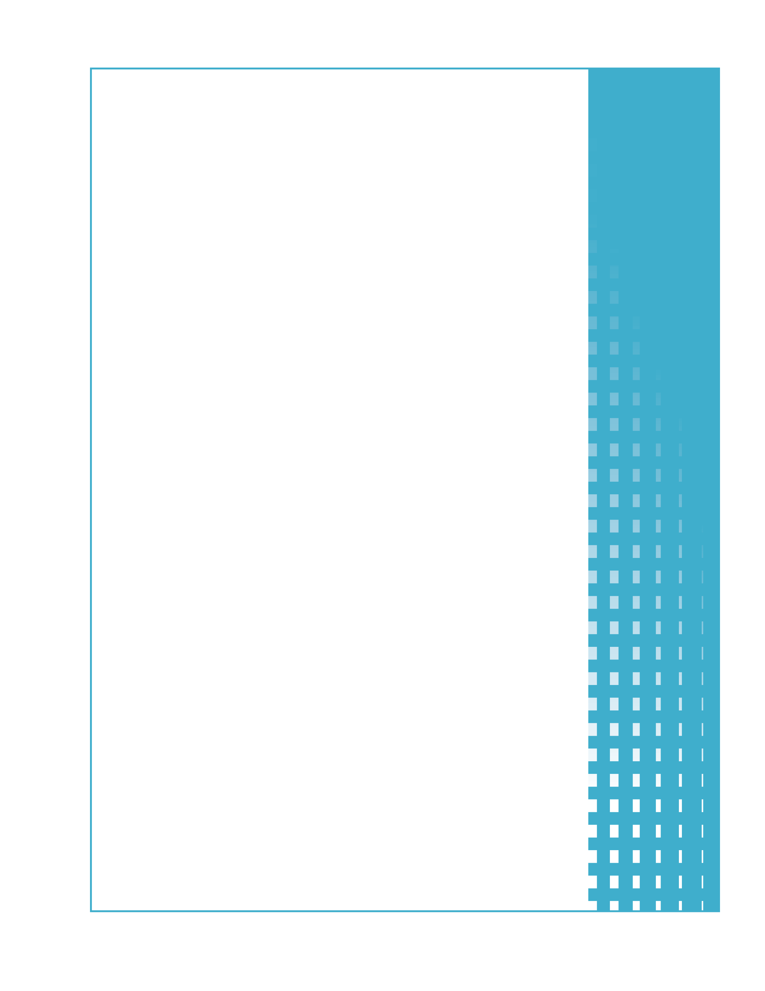

Appendix F7  
  
Round 1  
DTA Technical Team HIP Interview Guide

DTA Technical Team HIP Interview Guide

# Round 1: Implementation

The Massachusetts Department of Transitional Assistance (DTA) is supporting the Healthy Incentives Pilot (HIP) by:

* Dedicating technical staff to support HIP. These staff will dedicate a percentage of their time to HIP.
* Hiring a technical support contractor.

HIP technical staff is located at the central DTA office in Boston. The purpose of Round 1 interviews with HIP technical staff is to document HIP implementation. The interviews will take place approximately six to eight weeks before HIP start up.

Key technical staff and their primary HIP responsibilities include[1]:

|  |  |  |  |
| --- | --- | --- | --- |
| **Position** | **Location** | **Primary Responsibility** | **FTE** |
| EOHHS MIS Systems Analyst | DTA Central Office - Boston | Analyzes user requirements; develops business requirements documentation. | 0.25 |
| EOHHS MIS Application Developer | DTA Central Office - Boston | Designs, codes, and tests applications that support HIP | 0.25 |
| EOHHS MIS QA Tester | DTA Central Office - Boston | Tests applications that support HIP | 0.25 |
| DTA Technology Consultant, Novo Dia Group (NDG) | Contractor  Site – Austin, TX | Provides technical support to the DTA HIP Team | TBD |

Other technical staff not billed to HIP grant that may be interviewed include:

* EOHHS Data Analyst
* EOHHS Business Relationship Managers

Interviews will be scheduled at least two weeks in advance. It is anticipated that interviews will take place at DTA facilities in Boston.

Public reporting burden for this collection of information is estimated to average 85 minutes per response, including the time for reviewing instructions, searching existing data sources, gathering and maintaining the data needed, and completing and reviewing the collection of information. An agency may not conduct or sponsor, and a person is not required to respond to, a collection of information unless it displays a currently valid OMB control number. Send comments regarding this burden estimate or any other aspect of this collection of information, including suggestions for reducing this burden, to: U.S. Department of Agriculture, Food and Nutrition Service, Office of Research and Analysis, 3101 Park Center Drive, Room 1014, Alexandria, VA 22302 ATTN: PRA (0584-xxxx). Do not return the completed form to this address.

Interviews will include the questions starting on the following page. Additional, follow-up questions are anticipated, to clarify or expand responses.

**GENERAL INFORMATION**

1. Date and Time of Interview
2. Location of Interview
3. Name(s) and Title(s) of Respondent(s)
4. Office Location
5. Provide a description of your responsibilities related to HIP.
6. With which other HIP team members do you primarily interact?
7. How and when did you first hear about HIP?

**HIP MANAGEMENT AND COORDINATION**

1. Do you have a role in management or coordinating activities between HIP team members (DTA, ACS, retailers)? If no, please skip to question 9.
   1. Please describe your role in managing or coordinating HIP activities.
   2. With which HIP team members do you primarily interact in coordinating HIP activities and how frequently does this occur?
   3. Do you have any suggestions to improve coordination between team members?

**HIP DESIGN AND DEVELOPMENT**

1. Did/do you participate in the HIP conceptual design or other design sessions? If not, skip to question 10.
   1. Please describe your role in HIP design process.
   2. How many design sessions were held?
   3. Did you participate in all design sessions? If not, how many?
   4. In addition to yourself, who else participated in HIP design sessions?
   5. What was your role in other system design activities (preparing documents etc.)? Who else was involved?
   6. Was formal system design documentation prepared and if not, how were planned changes documented and approved?
   7. If so, please provide a copy of the system design documentation.
   8. What issues, if any, were encountered during system design and how were these issues resolved?
2. Did/do you participate in modifying BEACON 3 (DTA eligibility system) to support HIP? If not, skip to question 11.
   1. What changes to BEACON 3, if any, were required to support HIP and what was your role?
   2. What issues, if any, were encountered during BEACON 3 modifications and how were these issues resolved?
3. Did you participate in testing changes to BEACON 3 or the ACS EBT system? If not, skip to question 12.
   1. Please describe your role in testing BEACON 3 and/or the ACS EBT system.
   2. In addition to yourself, who else participated in testing modifications BEACON 3?
   3. What issues, if any, were encountered during testing and how were these issues resolved?
4. Did you participate in supporting retailers in modifying their integrated electronic cash register systems (IECRS) to support HIP? If yes, describe your role. If no, skip to question 13.
5. Did you participate in testing integrated electronic cash register systems (IECRS)? If yes, describe your role. If no, skip to question 14.
   1. What issues, if any, were encountered during testing and how were these issues resolved?

**HIP IMPLEMENTATION**

1. Did you have HIP implementation responsibilities in addition to design and development? If not, skip to question 17.
   1. Please describe your role in implementing HIP (e.g., IT management, rollout and coordination, retailer recruitment, coordination or oversight, ACS coordination or oversight, HIP evaluation support).
   2. With which individuals/stakeholders do you interact most frequently in implementing HIP?
   3. Which implementation activities are/have been most and least time consuming?
   4. Which implementation activities would you describe as most and least important?
   5. What, if any issues have been encountered during HIP implementation and how were these issues resolved?
2. If your role in implementation is not completed, what activities remain?
3. What changes could have been made to improve the implementation process?

**HIP EVALUATION**

1. Do you have any role in supporting the HIP evaluation? If no, please skip to question 19.
   1. Please describe your role in supporting the evaluation and the evaluation processes in which you are involved (system analysis, data collection, data analysis, reporting, other).
   2. In addition to yourself, who else is supporting the evaluation?
   3. What, if any, evaluation issues have been encountered and how have these issues been resolved?
2. Do you have any suggestions to improve the evaluation?

**ISSUES/LESSONS LEARNED**

1. Other than previously discussed, what issues, if any, have you encountered during implementation and how were these issues resolved?
   1. What impact did they have on HIP implementation?
2. What key lessons have you learned from your experiences to date?

1. Staffing breakdown based on the Massachusetts DTA HIP Grant Application, March 2010 and Evaluation Meeting November 2, 2010.