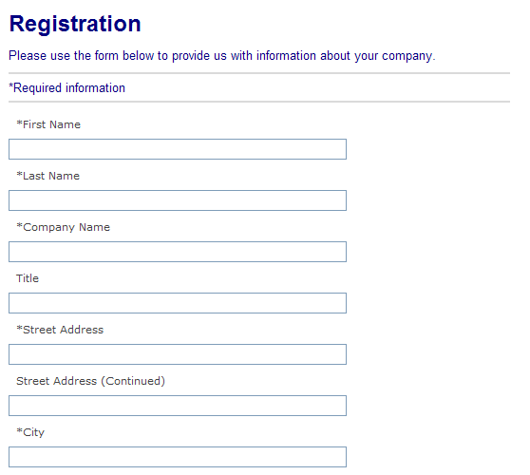
OMB Control No. 0625-0143
Expiration date: xx-xx-2012

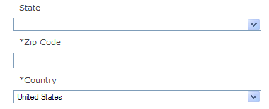
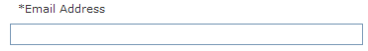
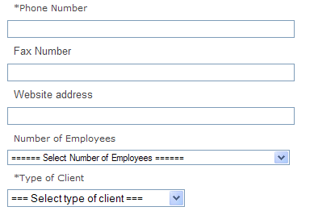
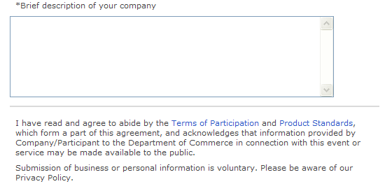

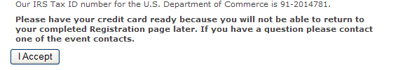
Public reporting for this collection of information is estimated to be 5 minutes per response, including the time for reviewing instructions, and completing and reviewing the collection of information. All responses to this collection of information are voluntary, and will be provided confidentiality to the extent allowed under the Freedom of Information Act (FOIA). Notwithstanding any other provision of law, no person is required to respond to, nor shall any person be subject to a penalty for failure to comply with, a collection of information subject to the requirements of the Paperwork Reduction Act unless that collection of information displays a current valid OMB control number. Send comments regarding the burden estimate or any other aspect of this collection of information, including suggestions for reducing this burden, to the Reports Clearance Officer, International Trade Administration, Department of Commerce, Room 4001, 14th and Constitution Avenue, N.W., Washington, D.C. 20230.

