What You Should Know About Joining
the National Children’s Study
Vanguard Study

Informed Consent Form

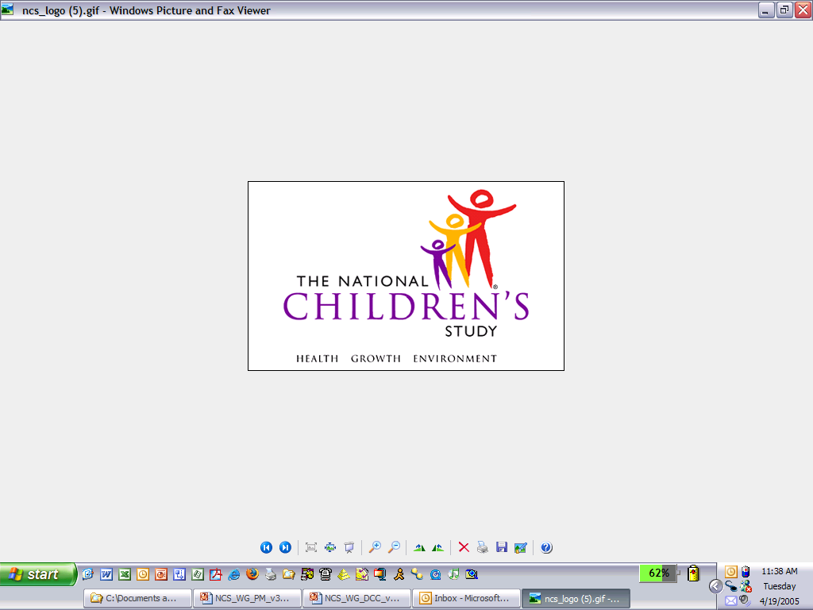

Public reporting burden for this collection of information is estimated to average 40 minutes per response in conjunction with the signature page, including the time for reviewing instructions, searching existing data sources, gathering and maintaining the data needed, and completing and reviewing the collection of information. An agency may not conduct or sponsor, and a person is not required to respond to, a collection of information unless it displays a currently valid OMB control number. Send comments regarding this burden estimate or any other aspect of this collection of information, including suggestions for reducing this burden, to: NIH, Project Clearance Branch, 6705 Rockledge Drive, MSC 7974, Bethesda, MD 20892-7974, ATTN: PRA (0925-0593). Do not return the completed form to this address.

- The mother of your child has joined the National Children’s Study, an important research study to improve the health and well-being of our nation’s children.
- Because fathers play an important part in their children’s lives, we are hoping you will agree to join the Study, too.
- The goal of the Study is to improve the health and well-being of all children.
- With your help, the National Children’s Study will help us learn more about how our physical, social, and family environments affect the health, growth, and development of our children.
- The National Children’s Study has several stages. Different stages of the Study will run at the same time. We are currently in the first stage, called the Vanguard Study. The Vanguard Study will help us decide on the design of the next stage, called the Main Study.
- We hope you will join thousands of fathers from across the United States in helping us to learn information that will help improve our children’s health. Although what we learn in the Vanguard Study may not help you or your family right now, to the things we learn may help people in the future.
- Joining the Vanguard Study is your choice. You can decide to join or not to join. If you do join, you can leave at any time for any reason. You can decide not to answer certain questions or give certain samples.

Sponsors
The National Children’s Study is led by the Eunice Kennedy Shriver National Institute of Child Health and Human Development of the National Institutes of Health (NIH) in collaboration with a consortium of Federal government partners. Study partners include the National Institute of Environmental Health Sciences of the NIH, and the Centers for Disease Control and Prevention, and the Environmental Protection Agency.

What is the goal of the National Children’s Study?
- The goal of the National Children’s Study is to improve the health of all children in the United States.
- The Study will help us learn more about how our community and our physical environment (including air and dust), social environment (our neighborhoods and communities), and family environment:
- Affect how children grow, and
- Help children stay healthy.
- The Study will look at how our genes act together with our surroundings to influence health, growth, and development.
- The National Children’s Study has several stages. The first stage is called the Vanguard Study. The next stage is called the Main Study.
- What we do—the questions we ask and the procedures we use—during the Vanguard Study may be different from what we do in the Main Study.
- The Vanguard Study will help us decide what questions and procedures will work best in the Main Study.
- As we progress through the Vanguard Study, we will use what we learn to help us decide what will work best for the rest of the Vanguard Study. That is why what we do as part of the Vanguard Study will change over time.
- We will use what we learn in the Vanguard Study and in the Main Study to achieve our goal of improving the health of all children.

Why is the National Children’s Study important?
- The National Children’s Study is important because it will help us understand how we can improve our children’s health.
- The National Children’s Study is the largest research study of children’s health and development in the history of the United States.
- With your help, we can learn more about how our physical environment, social environment, and family environment affects children’s health, growth, and development while they are young and when they become adults.
- The Study may also help us better understand why some children develop obesity, diabetes, autism, learning disabilities, or heart disease.

What kind of study is the National Children’s Study?
- The National Children’s Study is an observational study. That means we will follow children from birth to age 21 by:
- Visiting with you at home.
- Asking questions about you and where you live and work.
- Collecting samples from you like blood, urine, and saliva.
- Involving you and your child’s mother in the Study because we know that parents are important to the health of their children.
• As an observational study, we will not:
- Ask you to change what you normally do.
- Ask you to take any medicines or drugs.

How many children will be in the National Children’s Study?
- About 5,000 children will be in the Vanguard Study.
- About 100,000 children from all over the United States will be in all parts of the Study.
- We are also asking mothers and fathers to join the Study.

How long will the National Children’s Study last?
- The National Children’s Study will get information from mothers and fathers before, during, and after pregnancy.
- The Study will follow children until they are 21 years old. Each time that we visit, we will explain what we are doing and ask your permission to do it. We will give you a visit information sheet that describes everything we want to do during the visit.

What is involved in taking part in the National Children’s Study?
- If you join the National Children’s Study, we will visit you at home to get information about you, your health, and where you live.
- Because the Study will change over time, different families may be asked to take part in different Study activities.
- Each time that we visit, we will explain what we are doing and ask your permission to do it. We will give you a visit information sheet that describes everything we want to do during the visit.

How many visits should I expect?
- We plan to visit you once at home during your partner’s pregnancy. We also may ask to visit you at home again.
- Between visits, we will call, e-mail, or send you surveys from time to time to keep in touch and find out about you.

What kinds of information and samples will the National Children’s Study collect?
- The National Children’s Study will visit your home to collect information about you, your health, and your physical, social, and family environment.
- We may take your body measurements like height, weight, and blood pressure.
- We may ask you to answer questions and fill out forms.
- If there are questions you do not want to answer, you can skip them and still be in the Study.
- We may ask for your permission to look at your health information and medical records during the time of the Study.
- If you change your mind after you give us permission, we will stop getting new information from your medical records, but we may keep using the information we have already gotten.
- During some visits, we may ask for your permission to collect samples, like your blood, hair, urine, and saliva.
- Before we ask for any samples, we will explain what type of samples we want, how much we will need, and how we will collect them.
- During some visits, trained National Children’s Study staff will:
      - Use a needle to collect a small amount of blood from a vein in your arm.
      - Cut a small sample of hair from the back of your head.
    - We may also ask you to get some samples by collecting:
      - A small amount of your urine in a cup.
      - A small amount of your saliva 3 times a day for 2 days.
      - Some of your toenail clippings.
  - If there are samples you do not want to give us, you can skip them and still be in the Study.

What about genetic information?
- If you agree, we will get information about your genes. We will get this information from the blood, saliva, and other samples you give us. We will also ask questions about your family medical history.
- Genetic information is collected to help us learn how genes affect our children’s health and how our physical environment and experiences affect the way our genes work.
- Some people worry that research about genetic causes of disease may give information not only about themselves but about family members. There is always some chance that technology could be developed that would make it possible to reveal your identity or that of your family members. We will make every effort to prevent this. We will continue to review and improve the ways we keep your information private.
- Some people are sensitive about genetic information for cultural or religious reasons. If you do not want us to conduct genetic tests, let us know. You can tell us not to collect your genetic information and still be in the Study.
- The Study will not do the genetic testing right away. We will store and test those samples in the future.
- Future genetic testing of samples may sometimes be done together with other approved researchers who receive permission from the Study. We may share your information directly with researchers or we may share it through a secure national research database. The goals of these future studies will be similar to the goals of the National Children’s Study.
- To answer the Study’s research questions, we may also look at your genetic information together with information from other research studies and information sources.

What will the National Children’s Study do with all this information?
- The National Children’s Study may use the information and samples we get from you in several ways.
- We will store your information and samples along with those of other people in the Study indefinitely.
- Researchers may use this information to find out:
- How experiences during early life may affect our children’s health.
- How genes, surroundings, and experiences work together to affect growth, development, and health.
- How conditions that appear later in childhood and adulthood begin in early childhood.
- What we learn early in the Study may lead to more questions about our children’s health. We may use the information we get from you to answer those questions, too.
- In the future, scientists could develop new technologies or products based on the information and samples we collect from you and store for the Study. You will not receive any money that may result from such new technologies or products.
- We may also combine the information we receive from you for this Study with information from other research studies to answer our research questions.
- By agreeing to be in the Study, you are agreeing to allow possible use of your information and samples for future studies on child and maternal health and disease.
- These studies might be done by other approved researchers. The goals of these future studies will be similar to the goals of the National Children’s Study.
- An independent group of doctors, scientists, and community members will make sure that your information and samples will only be used to meet the goals of the National Children’s Study. The Independent Study Monitoring and Oversight Committee, or iSMOC, will make sure that your information and samples will only be used to:
- Help us better understand children’s health and growth.
- Answer questions about why some children are likely to get certain diseases.

How can I find out about the results of the Study?
- We will share what we learn from the Study as a whole. We will keep in touch through newsletters, on our Web site, and in other ways.
- We will share some of the information we learn about you with you when it is available.
- If we know the results from tests we do during a visit, we will share them with you then. For example, we will tell you information about your height, weight, and blood pressure.
- We plan to test most of your samples in the future.
- At this time, we do not know when these tests will be done, which tests will be done, and when information from the tests will be available.
- Most of the tests we will do on the samples will be to help us understand how the physical, social, and family environments, genes, and other factors affect health and disease. These tests will not provide information about your health status.
- A committee of doctors, scientists, and community members (the iSMOC) will advise the Study on which tests may provide information about participants’ health.
- When test results related to your health are available, we may ask you if you want to learn about them.

How will the Study protect my information?
- We will protect your privacy and keep your information safe by:
- Using a number code to label your samples and other information.
- Keeping your number code separate from your name, address, and other personal information. We will look at your information using the number code and not your personal information.
- Keeping your test results and other information in a secure computer database.
- Storing samples and other information in a secure place. We will limit and keep track of access to your samples to make sure they are safe.
- Researchers who want to use your information must:
- Get certified by the National Children’s Study and the Federal government.
- Get permission to use your information. A group of doctors, scientists, and community members (the iSMOC) will make sure that your information and samples will only be used to meet the goals of the Study. The goals are to better understand child health and growth and to learn about why some children are more likely to get diseases.
- Sign an affidavit of nondisclosure. This means promising to use your information only for research. They must also agree not to share your information with anyone who has not made this same promise.
- Protect your information by reporting it only as part of a group.
- We will track researchers to make sure they are keeping your information safe.
- We will regularly review all of the ways we keep your information and samples safe to keep improving how we protect your privacy.
- The U.S. Department of Health and Human Services (HHS) gave the National Children’s Study a legal document, called a Certificate of Confidentiality. This means the Study cannot be forced by a court order or subpoena to give out information that might identify you in any court.

When might the Study have to give out my information?
- If we learn that you or someone else is harming you, your child, or others around you, we may be required by law to report this to the police or a social services agency in your community.
- If you give someone or an organization written permission to see the information you gave the Study, we cannot use the Certificate of Confidentiality to protect your information from that person or organization.

What are the possible benefits of being in the National Children’s Study?
- Taking part in the National Children’s Study may not help you or your family right now. But the Study may help us learn things about health that could benefit all of us—including your children and grandchildren—in the years to come.
- If you need medical or social services, we will give you names and contact information for people and agencies that can try to help. But the Study cannot and will not pay for your health care or mental health services.

What are the possible risks or burdens to me and to my community from being in the National Children’s Study?
- The immediate risks from the Study are the same as those in routine health care.
- Some of the questions we ask and some of the ways we get samples may be uncomfortable. If you are uncomfortable, you can skip any part of the Study. You are in charge.
- Giving a blood sample may cause a small amount of pain. People sometimes feel brief pain when blood is taken, and there is a very small risk of infection, bruising, bleeding, or fainting.
- A visit to your home will probably take 2 to 3 hours. We will schedule these visits at a convenient time, but they may interrupt your daily routine. You can change the date or time of any scheduled visit at any time.
- We may learn information about adoption or the biological parents of your child. We will not give out any information about parentage to you or any other members of your family.
- Although we are taking many steps to protect your information, there is always a chance that your information or identity could be disclosed. We will continue to review and improve the ways we keep your information private. To protect your information, we will keep your name and address separate from our information files.
- We will get information about your health, your community, and your race and ethnicity. We will make files with this information available to approved researchers. In addition to the risks to individuals, the risks of providing information about racial or community groups are unknown. There is a possibility that specific Study findings will be associated with particular racial and ethnic groups.

Will I be paid for being in the National Children’s Study?
- We will give you about $25 to $100 in cash or gift certificates to thank you each time you participate in a Study visit.
- From time to time, we may also give you small gifts like a tote bag, picture frame, or other small items to thank you for being in the Study.

What if I want to leave the National Children’s Study?
- You can leave the Study at any time. You also can leave the Study for a short time and come back.
- If you leave the Study, we will not ask for any new information, but we will keep using the information and samples you have already given us.
- If you want us to destroy or return of any of your unused samples, you can ask us to do so and we will.
- Leaving the Study will not affect your access to health care or any other benefits you may be receiving, like those from Social Security, Medicaid, WIC, or the Supplemental Nutrition Assistance Program.

What if I move?
- We hope you will tell us if you are planning to move so you can still be part of the Study in your new home.
- If you move and forget to tell us, we will try to get in touch with you. We will use the information you have given us about family members and friends, as well as publicly available information.
- If we get in touch with you, we will ask if you want to continue to be part of the Study.

Will it cost me anything to be in the National Children’s Study?
- No. There is no cost to you for being in the National Children’s Study.
- The Study will pay for all tests and procedures done as part of the Study. Any future tests done on your samples will also be paid for by the Study.

Does the National Children’s Study pay for health care for my family or me?
- The Study cannot and will not pay for health care or mental health services for you or your family. If you need medical or social services, we will give you names and contact information for people and agencies that can try to help.
- The information we collect is for research purposes only. Being part of the Study does not take the place of your usual doctor or clinic visits.

If I join the National Children’s Study, will I have to join other studies?
- If you join the National Children’s Study, you do not have to join any other studies. We may invite you to be in other studies connected with the National Children’s Study.
- If you are invited to be in other studies, you can always say no.

Will the media be interested in my participation in the National Children’s Study?
- The National Children’s Study will not tell the media anything about the identities of Study participants.
- Because of the importance of the Study reporters may go to communities where the Study is being done. They may ask participants if they want to talk about their experiences with the Study.
- If you are contacted by reporters, you can decide if you want to talk to them. If you do talk to a reporter, they can write about anything you tell them. What you say will be public information. The organization that the reporter works for will have control over any information and material you give them.
- If you talk with the media about your or your child’s experience with the Study, your role and your child’s role as Study participants will be public knowledge. When this information becomes public, it will be harder for the Study to protect the privacy of your information and information about other participants from your community.

Who can I contact if I have questions about the National Children’s Study?
- If you have questions now, you can ask the Study representative who gave you this informed consent form.
- If you have any other questions about your rights as a Study participant, now or in the future, you can contact the people listed on the page that we will ask you to sign.

Important things to remember about joining the National Children’s Study
- After reading this informed consent form, we hope you will decide to join the National Children’s Study.
- We will ask you to sign a page that says you have decided to join the Study.
- If you join the Study now, you can quit at any time.
- You decide what questions to answer. You can also decide what samples to give. If you decide not to answer some questions or give some samples, you still can be in the Study.
- Before you decide, you may want to talk with your family, friends, or doctor about joining the Study.

Thank you for taking the time to learn about the National Children’s Study.
National Children’s Study: Vanguard Study
Informed Consent for Fathers Study Participation
- I have received the informed consent form, “What You Should Know about Joining the National Children’s Study Vanguard Study,” which explains the nature and purpose of the Study.
- I understand that I can leave the Study at any time and for any reason and then rejoin later.
- I understand that if there is a question I do not want to answer, a sample that I do not want to provide, or a part of the Study I do not want to do, I can skip it and still be in the Study.
- I understand that my biological samples will be stored in a secure facility and that the Study will protect access to my samples.
- I understand that these samples may be used for a variety of tests in the future, including genetic tests.
- I understand that I will not routinely get results back from tests done on the samples I give to the Study.
- I have asked and received answers to all my questions about the Study. I understand that I can ask more questions at any time.

 | Yes | No
I give my permission for the Study to collect biological samples from me.
I give my permission for the Study to use my biological samples to obtain my genetic information.

I choose to join the National Children’s Study.
Participant
Printed Legal Name of Participant: ___________________________________________________________
Signature of Participant: ___________________________________________ Date: _____/_____/_______
(mm/dd /yyyy)
Date of Birth: _______/________/_______ (mm/dd/yyyy)

Parent/Legal Guardian (if participant is a non-emancipated minor)
I have received the informed consent form, “What You Should Know About Joining the National Children’s Study Vanguard Study,” which explains the nature and purpose of the National Children’s Study. I give my permission for _______________________ to take part in the Study if he agrees to be part of it.
(Printed Name of Child)
Printed Legal Name of Parent/Legal Guardian: _________________________________________________
Signature of Parent/Legal Guardian: ____________________________ Date: _______/________/_______
(mm/dd/yyyy)

Witness (if required)
I observed the interviewer explain “What You Should Know about Joining the National Children’s Study Vanguard Study” to the participant and he signed or marked this form.
_______________________________________________ _______/________/_______
Signature of Witness (mm/dd/yyyy)
Printed Name of Person Obtaining Consent: ___________________________________
Signature of Person Obtaining Consent: __________________________ Date: _____/_____/_____
If you have questions about this study, you may call the local numbers listed on the label below.
For Office Use Only Study Participant (Adult or Emancipated Minor Only) Parent/Legal Guardian (If Participant is Minor) Both

SO keep top copy
Give participant bottom copy

