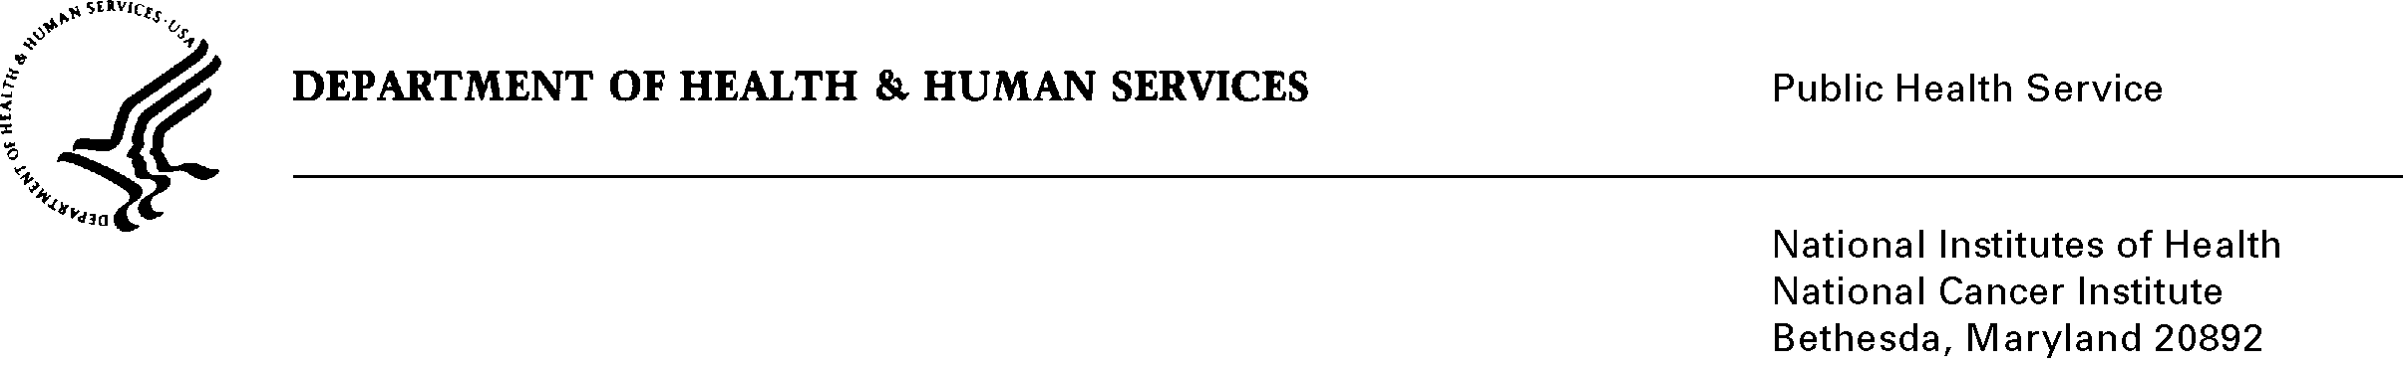
Date: January 17, 2010

TO: Office of Management and Budget (OMB)

Through: Seleda Perryman, Report Clearance Officer, HHS
Mikia Currie, Program Analyst, OPERA, NIH
Vivian Horovitch-Kelley, OMB Project Clearance Liaison, NCI

FROM: John Speakman, NCI CBIIT Chief Program Officer
National Cancer Institute/NIH

SUBJECT: cancer Biomedical Informatics Grid® (caBIG®) Support Service Provider (SSP) Program (NCI)

This is a request for OMB to approve this Existing Collection in Use Without an OMB number, titled, “cancer Biomedical Informatics Grid® (caBIG®) Support Service Provider (SSP) Program (NCI).” This information collection has been in effect since April 2008 and was put on hold in January, 2011 until OMB approval is issued.

The NCI Center for Biomedical Informatics and Information Technology (CBIIT) launched the enterprise phase of the caBIG® initiative with an emphasis on widespread institutional adoption of the program and tools. This emphasis on adoption has generated an expanding community with diverse needs for support, which are met largely through the resources available through the caBIG® Enterprise Support Network (ESN), including the caBIG® Support Service Provider (SSP) Program.

The caBIG® SSPs provide caBIG® end-users with the freedom to match what caBIG® has to offer to their unique organizational goals and needs, so having this customized support option available is critically important to advancing the goals of the caBIG® program. caBIG® SSP applicants are evaluated against well-defined criteria published in the SSP Program Announcement and must successfully demonstrate that they have the technical capabilities, staffing and scalability, geographic coverage (when applicable), and the domain expertise in biomedicine to effectively serve caBIG® users.

The information submitted by SSP applicants enables NCI to determine whether such applicants are qualified to enter into trademark license negotiations with NCI to use the caBIG® trademarks in connection with their services and become designated as caBIG® SSPs. Thus, the collection of information from SSP applicants is critical to both ensuring that the goals and objectives of the caBIG® program will be maintained and furthered by the organizations designated as SSPs and facilitating NCI’s ability to exercise appropriate stewardship of the caBIG® trademarks. Approximately 15 vendors are estimated to respond to this information collection annually. The annualized burden for the completion of the questionnaire by all respondents is 360 hours.

