0960-0696
i1020
Revised screen shots
Table of Contents

1. Pages 11
1.1. Welcome 12
1.1.1. User Interface 12
1.2. Welcome 13
1.2.1. User Interface 13
1.3. Should You Use This Application? 14
1.3.1. User Interface 14
1.4. Welcome Back 15
1.4.1. User Interface 15
1.5. Save & Exit 16
1.5.1. User Interface 16
1.6. You Are Not Eligible For The Extra Help 17
1.6.1. User Interface 17
1.7. Go Ahead 18
1.7.1. User Interface 18
1.8. Preparing To Find Out If You Qualify 19
1.8.1. User Interface 19
1.9. Preparing To Use This Application 20
1.9.1. User Interface 20
1.10. (Apply Now) 21
1.11. About You and Your Spouse 22
1.11.1. User Interface 22
1.12. About You and Your Spouse - With 23
1.12.1. User Interface 23
1.13. About You 24
1.13.1. User Interface 24
1.14. About the Person Completing 25
1.14.1. User Interface 25
1.15. About the Person Completing 26
1.15.1. User Interface 26
1.16. Reentry Number Issued Normal Process 27
1.16.1. User Interface 27
1.17. About You And Your Spouse's Living Situation - Married 28
1.17.1. User Interface 28
1.18. About Your Living Situation - Single 29
1.18.1. User Interface 29
1.19. Wages And Earnings - Married 30
1.19.1. User Interface 30
1.20. Wages And Earnings - Married 31
1.20.1. User Interface 31
1.21. Wages And Earnings - Single (WITHOUT) 32
1.21.1. User Interface 32
1.22. Wages And Earnings - Single (WITH) 33
1.22.1. User Interface 33
1.23. Income Other Than Wages And Earnings - Married 34
1.23.1. User Interface 34
1.24. Income Other Than Wages And Earnings - Single 35
1.24.1. User Interface 35
1.25. Resources - Married 36
1.25.1. User Interface 36
1.26. Resources - Single 37
1.26.1. User Interface 37
1.27. Tool: Add Up Your Accounts 38
1.27.1. User Interface 38
1.28. Tool: Add Up Your Investments 39
1.28.1. User Interface 39
1.29. Tool: Add Up Your Other Pensions And Annuities 40
1.29.1. User Interface 40
1.30. Tool: Add Up Your Types Of Income 41
1.30.1. User Interface 41
1.31. (Find Out if You Qualify) 42
1.32. Find Out If You And Your Spouse Qualify (Married) Part 1 (WITHOUT) 43
1.32.1. User Interface 43
1.33. Find Out If You And Your Spouse Qualify (Married) Part 1 (WITH) 44
1.33.1. User Interface 44
1.34. Find Out If You Qualify (Single) Part 1 45
1.34.1. User Interface 45
1.35. Find Out If You Qualify (Married) Part 3 (WITH) 46
1.35.1. User Interface 46
1.36. Find Out If You Qualify (Single) Part 3 (WITHOUT) 47
1.36.1. User Interface 47
1.37. Find Out if You Qualify (Single) Part 3 (WITH) 48
1.37.1. User Interface 48
1.38. Find Out If You Qualify (Married) Part 2 49
1.38.1. User Interface 49
1.39. Find Out If You Qualify (Single) Part 2 50
1.39.1. User Interface 50
1.40. Find Out If You Qualify (You Should Apply) 51
1.40.1. User Interface 51
1.41. Find Out If You Qualify (You Probably Do Not Qualify) 52
1.41.1. User Interface 52
1.42. Review and Send 53
1.43. Review Your Information 54
1.43.1. User Interface 54
1.44. Review Your Information 55
1.44.1. User Interface 55
1.45. Ready to Submit 56
1.45.1. User Interface 56
1.46. Ready to Submit 57
1.46.1. User Interface 57
1.47. Ready to Submit 58
1.47.1. User Interface 58
1.48. Ready to Submit 59
1.48.1. User Interface 59
1.49. Ready to Submit 60
1.49.1. User Interface 60
1.50. Ready to Submit 61
1.50.1. User Interface 61
1.51. Successful Submission - Print Or Save Your Receipt 62
1.51.1. User Interface 62
1.52. Unsuccessful Submission 63
1.52.1. User Interface 63
1.53. Next Steps 64
1.53.1. User Interface 64
1.54. Missing Information (Fix Errors) 65
1.54.1. User Interface 65
1.55. Successful Submission - Print Or Save Yoour Receipt (print) 66
1.55.1. User Interface 66
1.56. Unsuccessful Submission 67
1.56.1. User Interface 67
1.57. Message Pages 68
1.58. Authentication - Medicare Part D Database Not Eligible Or SSI Recipient 69
1.58.1. User Interface 69
1.59. Check The Social Security Number You Entered 70
1.59.1. User Interface 70
1.60. How The Online Application Works 71
1.60.1. User Interface 71
1.61. Privacy Act Statement 72
1.61.1. User Interface 72
1.62. Internet Security Policy 73
1.62.1. User Interface 73
1.63. Limit Number Of Restarts 74
1.63.1. User Interface 74
1.64. Limit Number Of Starts For A New Application 75
1.64.1. User Interface 75
1.65. Limit On The Number Of Tries To Start An Application 76
1.65.1. User Interface 76
1.66. Name Check Mismatch 77
1.66.1. User Interface 77
1.67. Not Eligible For The Prescription Drug Plan 78
1.67.1. User Interface 78
1.68. Off Hours Message 79
1.68.1. User Interface 79
1.69. Other Ways To Apply 80
1.69.1. User Interface 80
1.70. Paperwork Reduction Act Statement 81
1.70.1. User Interface 81
1.71. Print/Save/View Guide 82
1.71.1. User Interface 82
1.72. Processing Alert 83
1.72.1. User Interface 83
1.73. Sign-In Problem 84
1.73.1. User Interface 84
1.74. Special Instructions For Blind Users 85
1.74.1. User Interface 85
1.75. System Failure 86
1.75.1. User Interface 86
1.76. There Is A Pending Application For This Social Security Number 87
1.76.1. User Interface 87
1.77. Warning System Shutdown 88
1.77.1. User Interface 88
1.78. We Cannot Process Your Request 89
1.78.1. User Interface 89
1.79. What You Will Need 90
1.79.1. User Interface 90
1.80. You Do Not Live In One Of The 50 States Or DC 91
1.80.1. User Interface 91
1.81. You Have Already Sent Us An Application 92
1.81.1. User Interface 92
1.82. Your Session Has Expired 93
1.82.1. User Interface 93
1.83. Help Pages 94
1.84. Main Help Pages 95
1.84.1. User Interface 95
1.85. Help: Are you assisting someone (other than your spouse who lives with you) with this application? 96
1.85.1. User Interface 96
1.86. Help: Did you (or your spouse, if married and living together) get an application in the mail from us? 97
1.86.1. User Interface 97
1.87. Help: Do you (or your spouse, if married and living together) have Medicare? 98
1.87.1. User Interface 98
1.88. Help: Are you (or your spouse, if married and living together) 64 years and 9 months old or older? 99
1.88.1. User Interface 99
1.89. Help: Have you (or your spouse, if married and living together) received: 100
1.89.1. User Interface 100
1.90. Help: In which state do you (or your spouse, if married and living together) live? 101
1.90.1. User Interface 101
1.91. Help: What is your marital status? 102
1.91.1. User Interface 102
1.92. Help: Do you have combined savings, investments, and real estate worth more than: 103
1.92.1. User Interface 103
1.93. Help: Have you worked in 2010 or 2011? 104
1.93.1. User Interface 104
1.94. Help: Has your spouse worked in 2010 or 2011? 105
1.94.1. User Interface 105
1.95. Help: Have you worked this calendar year? 106
1.95.1. User Interface 106
1.96. Help: Has your spouse worked this calendar year? 107
1.96.1. User Interface 107
1.97. Help: Are you UNDER age 65? 108
1.97.1. User Interface 108
1.98. Help: Is your spouse UNDER age 65? 109
1.98.1. User Interface 109
1.99. Help: Not counting your spouse, how many other relatives live in your household? 110
1.99.1. User Interface 110
1.100. Help: How many relatives live in your household and receive at least one-half of their financial support from you? 111
1.100.1. User Interface 111
1.101. Help: Do you have to pay for things related to a disability or blindness that enable you to work? 112
1.101.1. User Interface 112
1.102. Help: Does your spouse have to pay for things that enable him or her to work? 113
1.102.1. User Interface 113
1.103. Help: Do you expect to earn wages this calendar year? 114
1.103.1. User Interface 114
1.104. Help: Does your spouse expect to earn wages this calendar year? 115
1.104.1. User Interface 115
1.105. Help: What do you expect your net earnings from self-employment to be this calendar year? 116
1.105.1. User Interface 116
1.106. Help: What does your spouse expect the net earnings from self-employment to be this calendar year? 117
1.106.1. User Interface 117
1.107. Help: Have you stopped working in 2010 or 2011, or plan to stop working in 2011 or 2012? 118
1.107.1. User Interface 118
1.108. Help: Has you your spouse stopped working in 2010 or 2011, or plan to stop working in 2011 or 2012? 119
1.108.1. User Interface 119
1.109. Help: Do you receive Social Security benefits? 120
1.109.1. User Interface 120
1.110. Help: Does your spouse receive Social Security benefits? 121
1.110.1. User Interface 121
1.111. Help: Do you receive Railroad Retirement benefits? 122
1.111.1. User Interface 122
1.112. Help: Does your spouse receive Railroad Retirement benefits? 123
1.112.1. User Interface 123
1.113. Help: Do you receive Veterans benefits? 124
1.113.1. User Interface 124
1.114. Help: Does your spouse receive Veterans benefits? 125
1.114.1. User Interface 125
1.115. Help: Do you receive income from other pensions or annuities? 126
1.115.1. User Interface 126
1.116. Help: Does your spouse receive income from other pensions or annuities? 127
1.116.1. User Interface 127
1.117. Help: Do you receive other income not listed above, including alimony, net rental income, workers' compensation, etc.? 128
1.117.1. User Interface 128
1.118. Help: Does your spouse receive other income not listed above, including alimony, net rental income, workers' compensation, etc.? 129
1.118.1. User Interface 129
1.119. Help: Your Name 130
1.119.1. User Interface 130
1.120. Help: Your Social Security Number 131
1.120.1. User Interface 131
1.121. Help: What is your date of birth? 132
1.121.1. User Interface 132
1.122. Help: Spouse's Name 133
1.122.1. User Interface 133
1.123. Help: Spouse's Social Security Number 134
1.123.1. User Interface 134
1.124. Help: What is your spouse's date of birth? 135
1.124.1. User Interface 135
1.125. Help: Your Mailing Address 136
1.125.1. User Interface 136
1.126. Help: Your Phone Number 137
1.126.1. User Interface 137
1.127. Help: If your spouse has Medicare (or expects to have it in the next three months), does he or she also wish to apply? 138
1.127.1. User Interface 138
1.128. Help: Do you have combined savings, investments, and real estate worth more than $25,260? 139
1.128.1. User Interface 139
1.129. Help: OPTIONAL: (contact person) 140
1.129.1. User Interface 140
1.130. Help: Contact's Phone Number 141
1.130.1. User Interface 141
1.131. Help: Do you have combined savings, investments, and real estate worth more than $12,640? 142
1.131.1. User Interface 142
1.132. Help: Relationship to Applicant 143
1.132.1. User Interface 143
1.133. Help: Form Completer's Phone Number 144
1.133.1. User Interface 144
1.134. Help: Form Completer's Address 145
1.134.1. User Interface 145
1.135. Help: Primary Applicant's Name 146
1.135.1. User Interface 146
1.136. Help: Primary Applicant's Social Security Number 147
1.136.1. User Interface 147
1.137. Help: What is the primary applicant's date of birth? 148
1.137.1. User Interface 148
1.138. Help: Has the primary applicant worked in 2010 or 2011? 149
1.138.1. User Interface 149
1.139. Help: If the spouse has Medicare (or expects to have it in the next three months), does he or she also wish to apply? 150
1.139.1. User Interface 150
1.140. Help: Do the applicants have combined savings, investments, and real estate worth more than $25,260? 151
1.140.1. User Interface 151
1.141. Help: Spouse's Name 152
1.141.1. User Interface 152
1.142. Help: Spouse's Security Number 153
1.142.1. User Interface 153
1.143. Help: What is the spouse's date of birth? 154
1.143.1. User Interface 154
1.144. Help: Has the applicant's spouse worked in 2010 or 2011? 155
1.144.1. User Interface 155
1.145. Help: Mailing Address 156
1.145.1. User Interface 156
1.146. Help: Phone Number 157
1.146.1. User Interface 157
1.147. Help: Applicant's Name 158
1.147.1. User Interface 158
1.148. Help: Applicant's Social Security Number 159
1.148.1. User Interface 159
1.149. Help: What is the applicant's date of birth? 160
1.149.1. User Interface 160
1.150. Help: Has the applicant worked in 2010 or 2011? 161
1.150.1. User Interface 161
1.151. Help: Does the applicant have combined savings, investments, and real estate worth more than $12,640? 162
1.151.1. User Interface 162
1.152. Help: Have these wages or self-employment earnings decreased in the last two years? 163
1.152.1. User Interface 163
1.153. Help: Have these wages or self-employment earnings decreased in the last two years? 164
1.153.1. User Interface 164
1.154. Help: Has any of the income from these sources decreased in the last two years? 165
1.154.1. User Interface 165
1.155. Help: Has any of the income from these sources decreased in the last two years? 166
1.155.1. User Interface 166
1.156. Help: Do you or your spouse have bank accounts (checkings, savings and certificates of deposit)? 167
1.156.1. User Interface 167
1.157. Help: Do you or your spouse have stocks, bonds, savings bonds, mutual funds, Individual Retirement Accounts or other similar investments? 168
1.157.1. User Interface 168
1.158. Help: Do you or your spouse have any other cash at home or anywhere else? 169
1.158.1. User Interface 169
1.159. Help: Do you have bank accounts (checkings, savings and certificates of deposit)? 170
1.159.1. User Interface 170
1.160. Help: Do you have stocks, bonds, savings bonds, mutual funds, Individual Retirement Accounts or other similar investments? 171
1.160.1. User Interface 171
1.161. Help: Do you have any other cash at home or anywhere else? 172
1.161.1. User Interface 172
1.162. Help: Will some money from any of the sources listed above be used to pay for your funeral or burial expenses? 173
1.162.1. User Interface 173
1.163. Help: Will some money from any of the sources listed above be used to pay for your spouse's funeral or burial expenses? 174
1.163.1. User Interface 174
1.164. Help: Other than your home and the property on which it is located, do you or your spouse own any real estate? 175
1.164.1. User Interface 175
1.165. Help: Other than your home and the property on which it is located, do you own any real estate? 176
1.165.1. User Interface 176
1.166. Help: Ready to submit 177
1.166.1. User Interface 177

- Pages
  - Explanation of Changes
The following changes described below apply to the overall application and not to individual screens.
Header and Banner Change
- The Social Security Administration Emblem and Title now display at the top of every page.
- The Extra Help With Medicare Prescription Drug Plan Costs banner has changed from a red and blue color scheme to a gray and blue color scheme.

Page Navigation
- ‘Next’ and ‘Previous’ buttons have replaced the ‘Previous’ and ‘Continue’ buttons.
- The buttons have also moved from the right hand margin to the left hand margin.
- The primary action, which is ‘Next’ in most cases, is presented first with the secondary action, ‘Previous’ following beside it.
- The “Sign Out (Finish this Later)” button has changed to ‘Save & Exit’ and is located at the bottom of the screen

Progress Bar
- The Progress Bar now contains numbered indicators, as opposed to plain unnumbered bullets.

Support Panel
- Each data collection screen within the application now contains a Support Panel along the right-hand side. This Support Panel will include the #800 information as well as the agency’s hours of Operation.
- The ‘Need Help?’ link is now contained within this Support Panel.

Text Size & Accessibility Help
- The option to increase the text size is now available in the upper right hand corner of each screen.
- An ‘Accessibility Help’ link is also now available in the upper right hand corner of each screen.

Progressive Disclosure
A new feature of the application will effectively condense the application when a question regarding income or wages is answered ‘No’. For instance, if the question “Do you expect to earn wages this calendar year?” is answered ‘No’, the user will not see the text and data collection field related to the amount of their expected wages.

Question and Answer Layout
The radio button options and associated text fields are now positioned below the question. Previously, these fields were located to the right of the question.

Phone Number Fields
Phone Number fields are now one input field as opposed to three smaller input fields.

Address Line Fields
All Address Line fields have been renamed as ‘Street Line’ fields. The number of available address fields has been reduced from 3 to 2, with the option to expand the number of fields to 4 if necessary. The ‘Apt No.’ field has been removed.

Name Fields
All Name Fields now have the ‘First’, ‘M.I.’, ‘Last’ and ‘Suffix’ field identifiers below the actual field. These indicators were previously under the field title (i.e. Spouse’s Name, Primary Applicant’s Name, etc)

SSN Fields
SSN fields did not previously accept dashes or hyphens. The ‘(Do NOT include dashes or hyphens.)’ reminder has been removed since the field now accepts these values.

Help Screens
All help screens now begin with ‘Help:’ with the appropriate topic following the colon. Each Help screen also contains a ‘Close’ box now as opposed to the text ‘Close this window to return to the application.’
Message Screens
On each Message screen that contains a ‘Close’ box, the text ‘Close this window to return to the application.’ was replaced with ‘Close’.

  - Welcome
    - User Interface
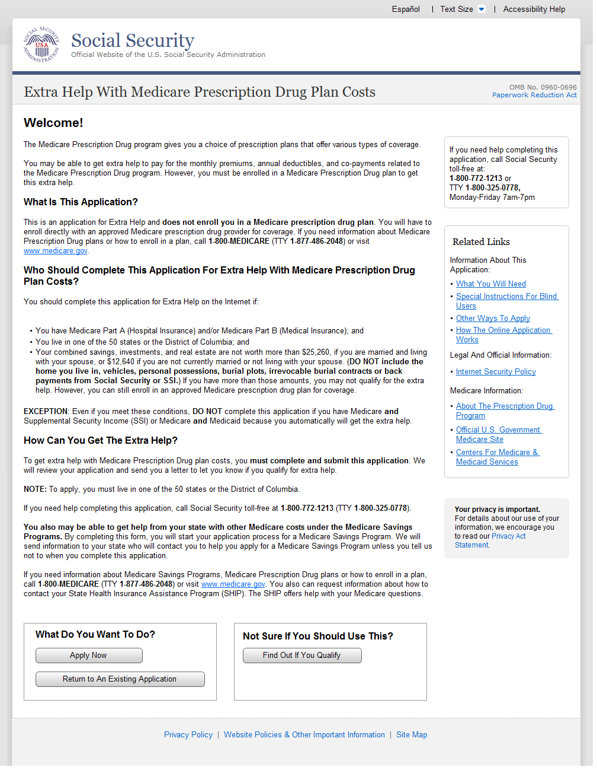
E

D
C
B
A
  - Welcome
- The Welcome Page now displays in a single column view as opposed to a two-column view.
- The ‘What Do You Want To Do?’ box now contains only ‘Apply Now’ and ‘Return to An Existing Application’ options. The ‘Find Out If You Qualify’ option has been separated.
- The Support Panel on the ‘Welcome’ page now contains the ‘Related Links’ section and the Privacy Act Statement hyperlink.
- The Privacy Policy, Website Policy & Other Important Information and Site Map links formerly included in the Related Links section are now located at the bottom of the page.
- The Welcome Page now allows the user to switch to Spanish. If selected, all the pages after this one will be presented in Spanish.

    - User Interface
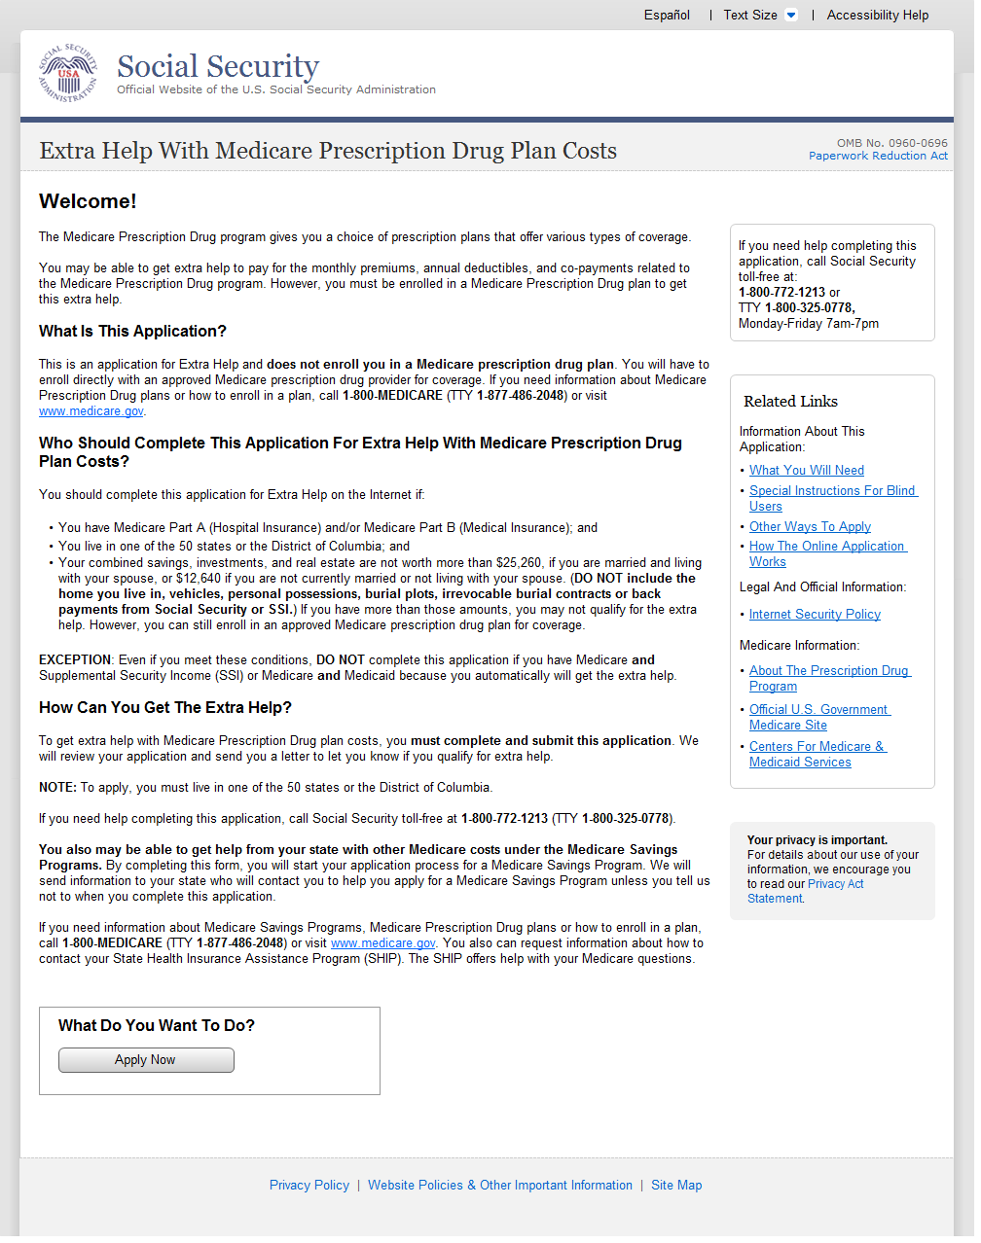
C
B
A
  - Should You Use This Application?
- The Welcome Page now displays in a single column view as opposed to a two-column view.
- The Support Panel on the ‘Welcome’ page now contains the ‘Related Links’ section and the Privacy Act Statement hyperlink.
- The Privacy Policy, Website Policy & Other Important Information and Site Map links formerly included in the Related Links section are now located at the bottom of the page.

    - User Interface
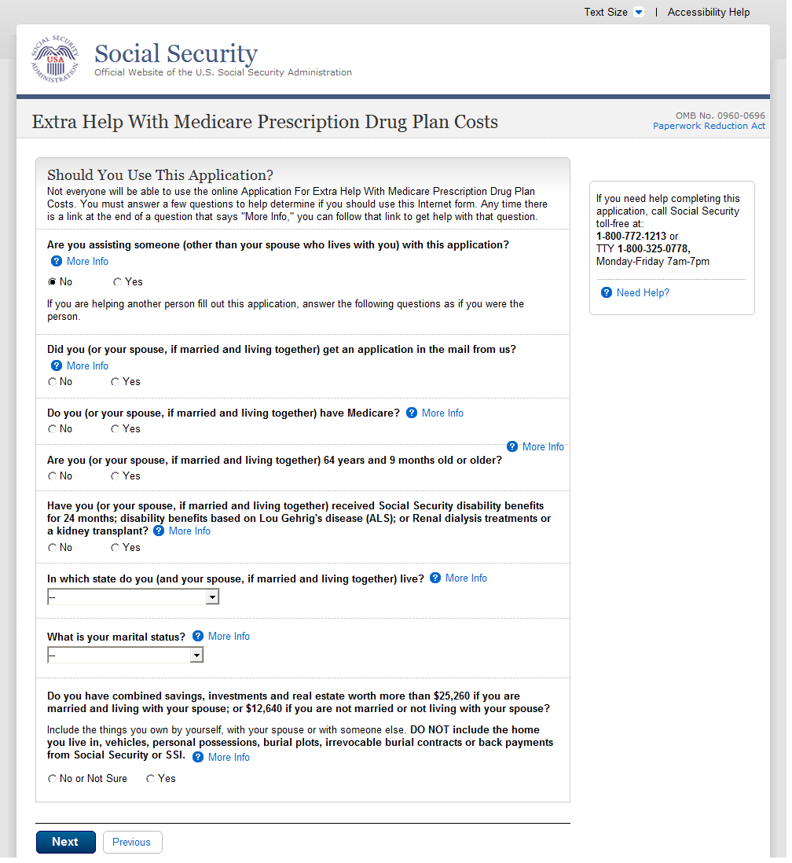
A
B
B
  - Welcome Back
- Bullets moved between the question and sentence to make the question easier to understand.
- Bullets removed from within questions for formatting purposes.

    - User Interface
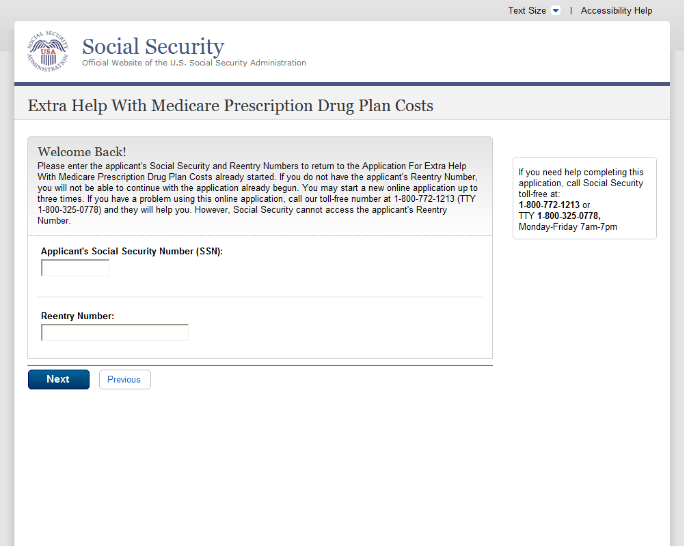
A
  - Save & Exit
- Added ‘(SSN)’ after ‘Social Security Number’
    - User Interface
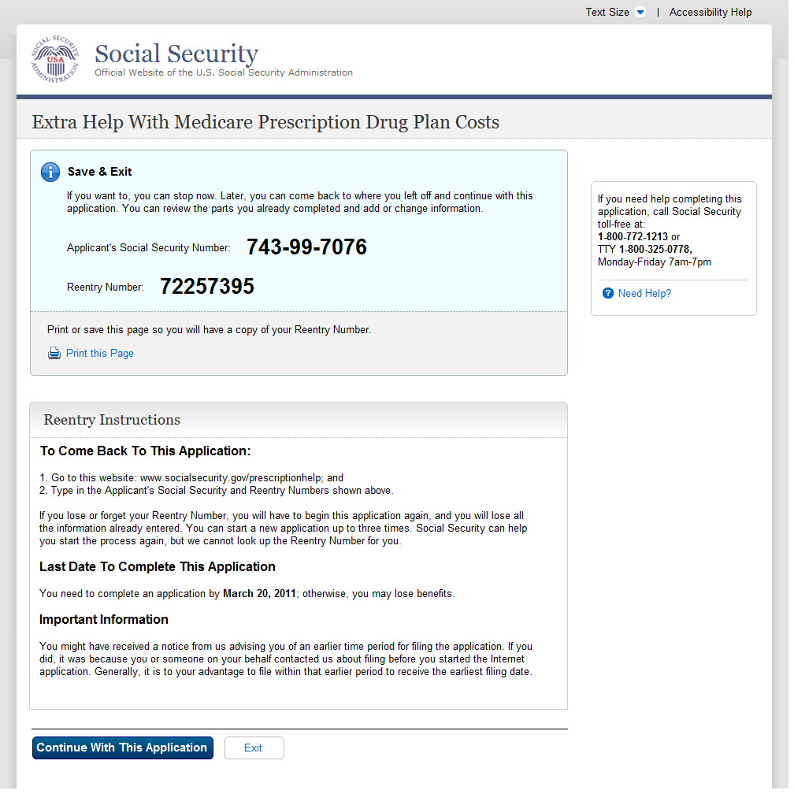
C
B
A
  - You Are Not Eligible For The Extra Help
- ‘i’ icon added to indicate important information. Background color set to light blue to draw attention to information. Section now titled ‘Save & Exit’ instead of ‘Sign Out’.
- Added a ‘Print this Page’ link instead of directing user to the ‘Print Button’ at the top of their browser.
- The ‘To Come Back To This Application’, ‘Last Date To Complete This Application’ and Important Information’ are now housed under a new section titled ‘Reentry Instructions’

    - User Interface
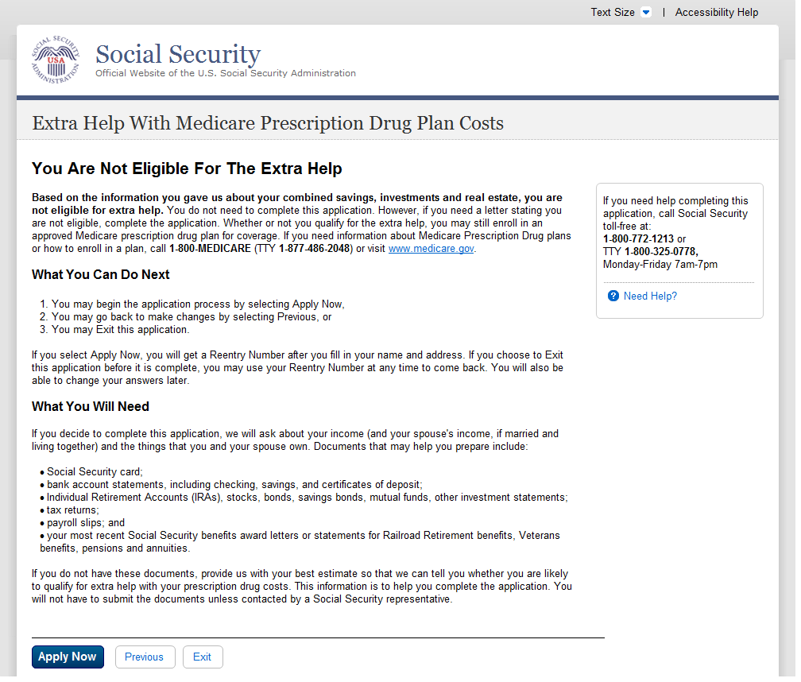
  - Go Ahead
    - User Interface
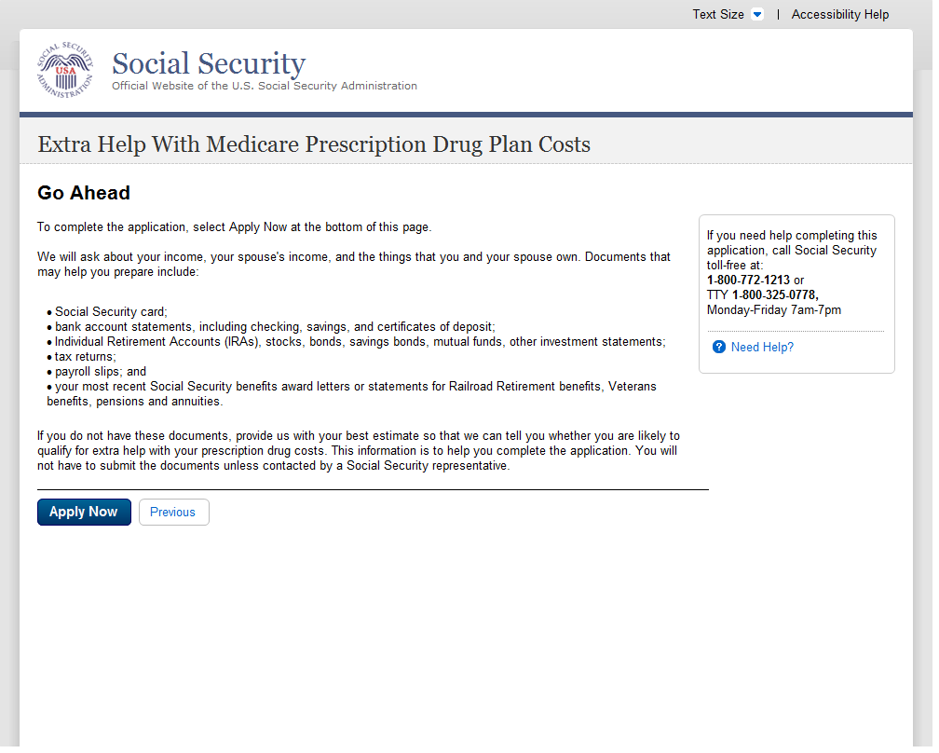
  - Preparing To Find Out If You Qualify
    - User Interface
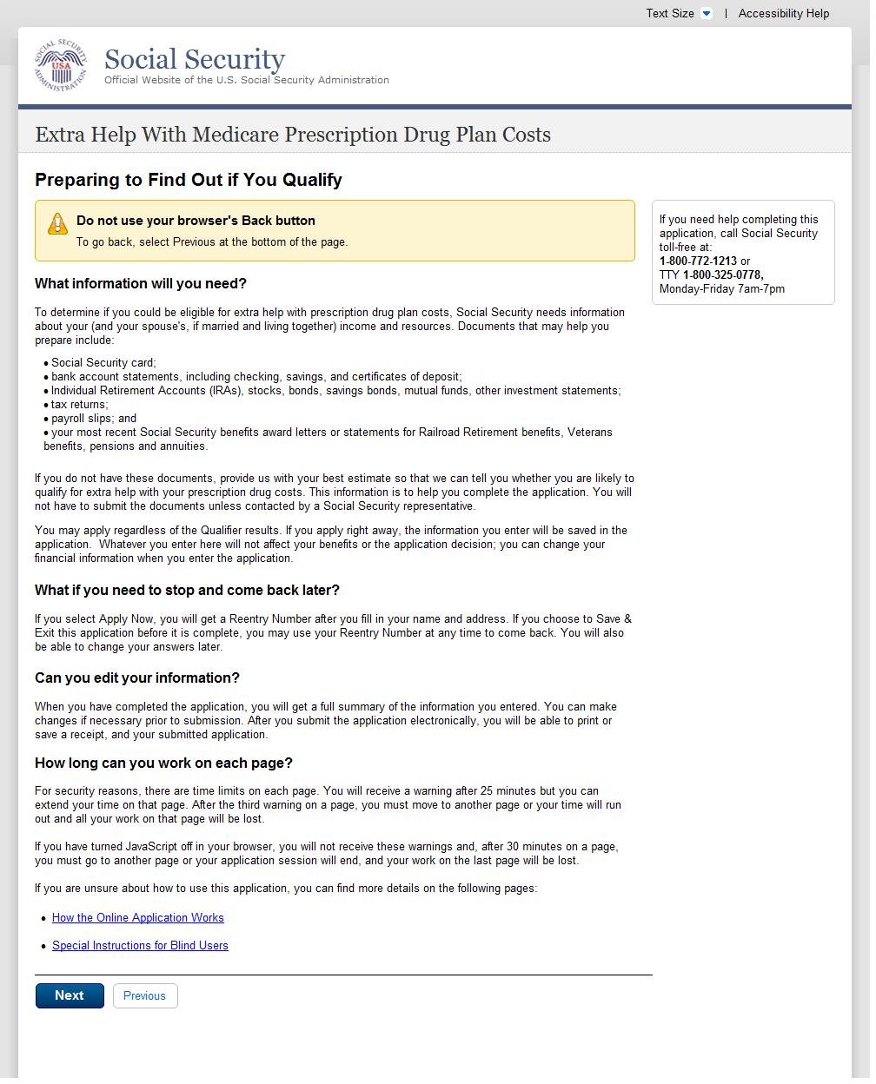
A
  - Preparing To Use This Application
A. Area highlighted with background color.
    - User Interface
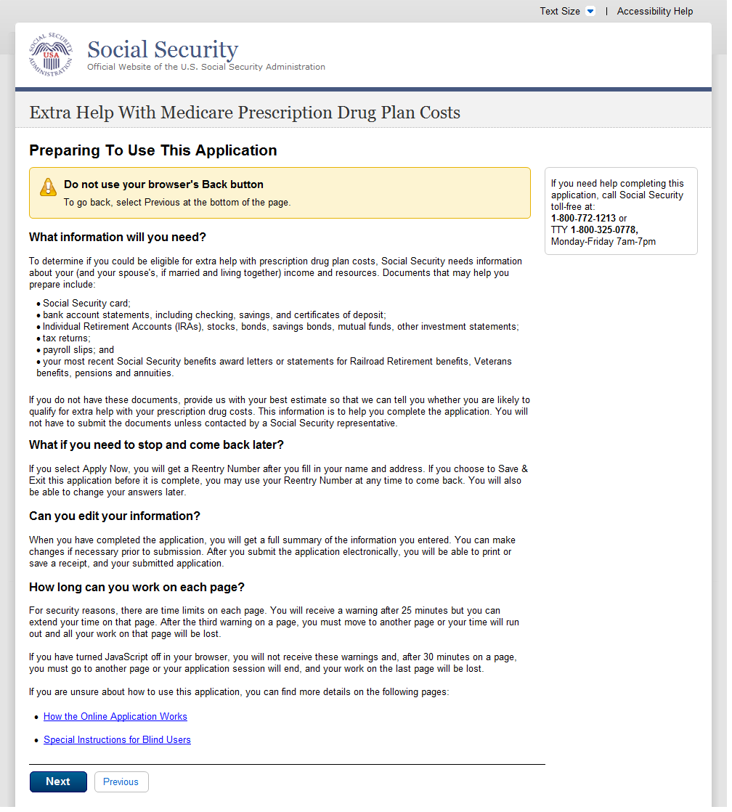
A
A. Area highlighted with background color.

(Apply Now)
  - About You and Your Spouse
    - User Interface
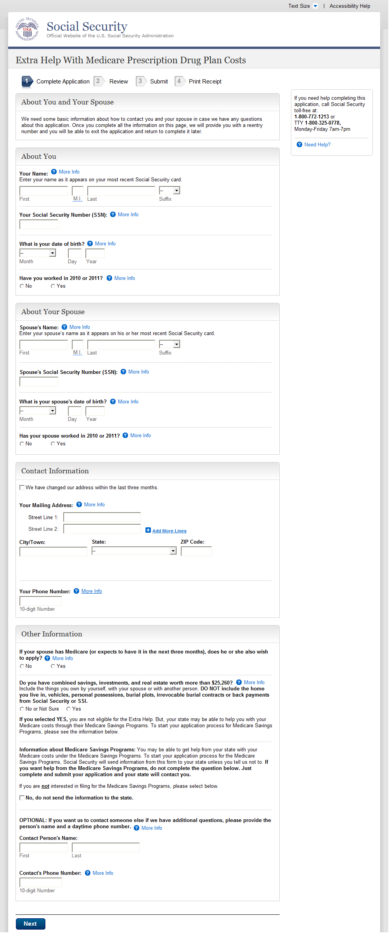
  - About You and Your Spouse - With
    - User Interface
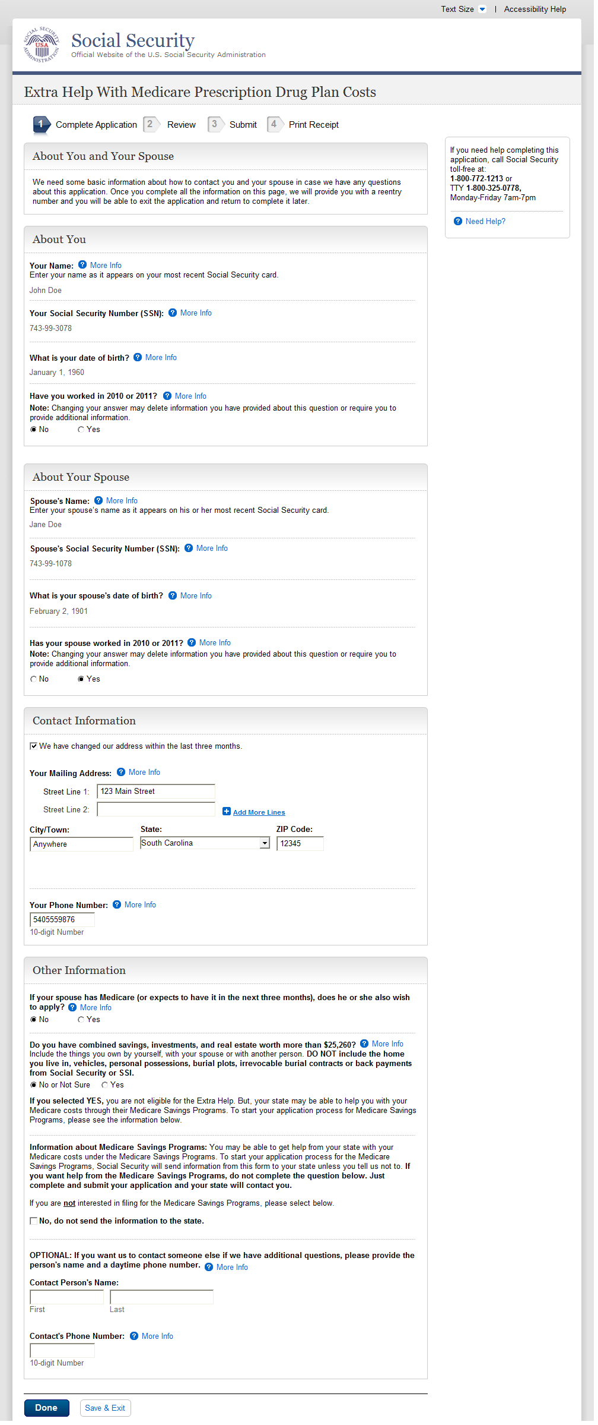
A
A
  - About You
- The ‘Change This Answer’ button has been removed. Users can now change this answer, if necessary, by selecting the appropriate radio button. The ‘Note: Changing your answer…’ language was added to alert the user of the effects.

    - User Interface
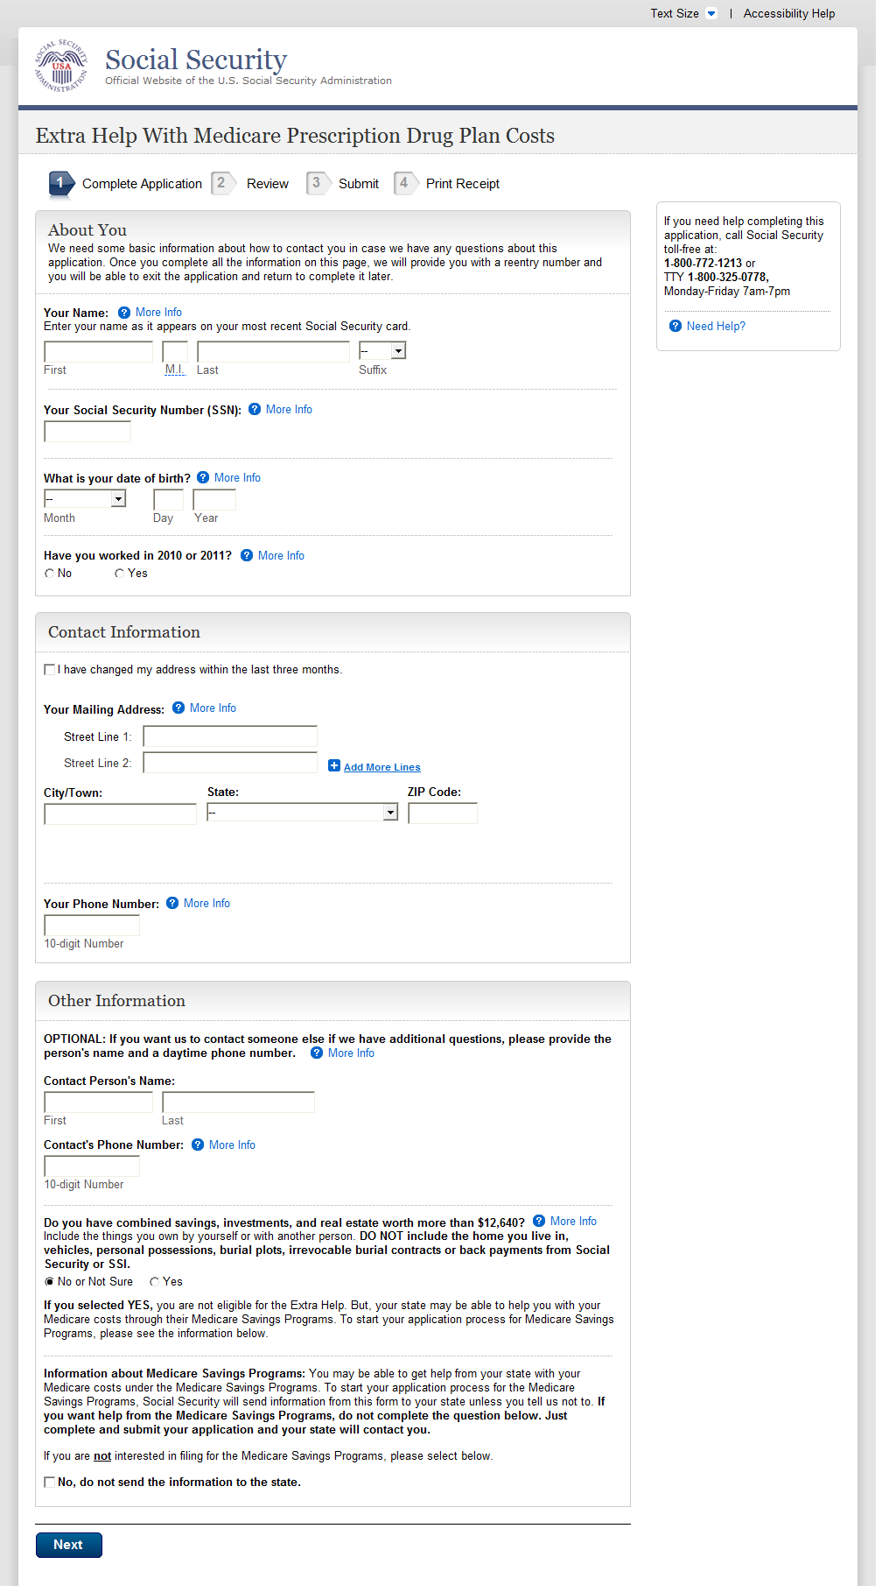
  - About the Person Completing
Changes covered on Page 11.
    - User Interface
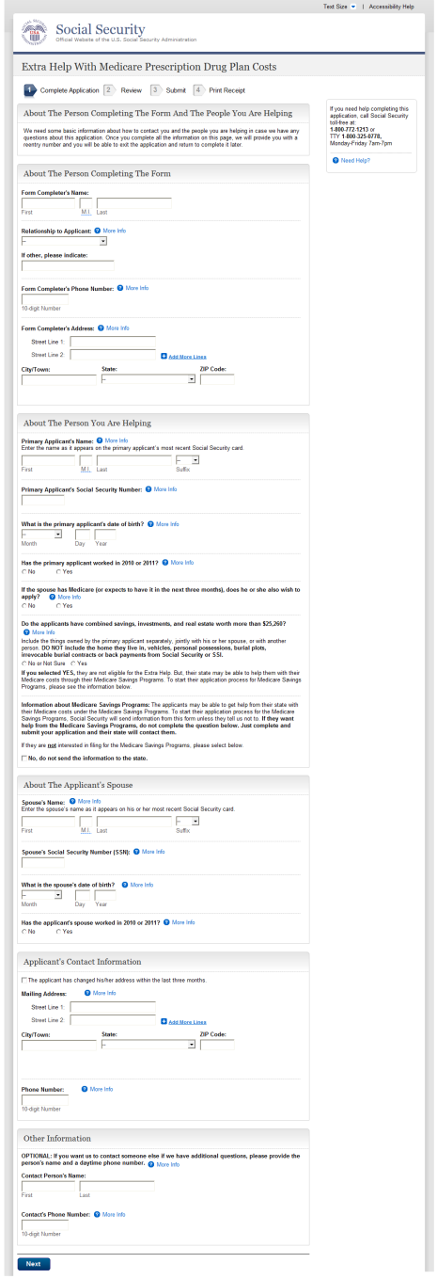
Changes covered on Page 11.

  - About the Person Completing
    - User Interface
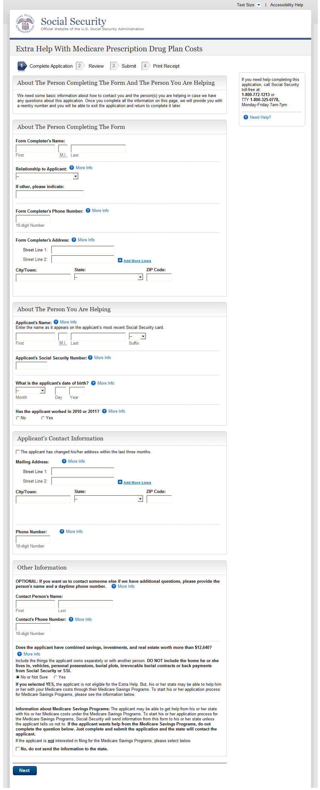
Changes covered on Page 11.
Reentry Number Issued Normal Process
    - User Interface
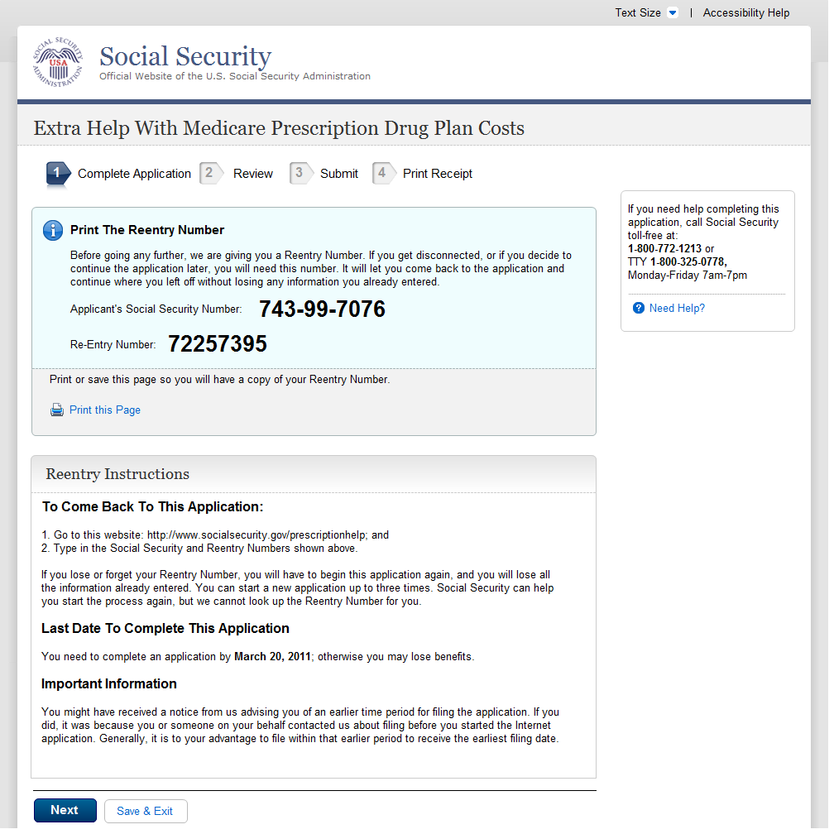
  - About You And Your Spouse's Living Situation - Married
    - User Interface
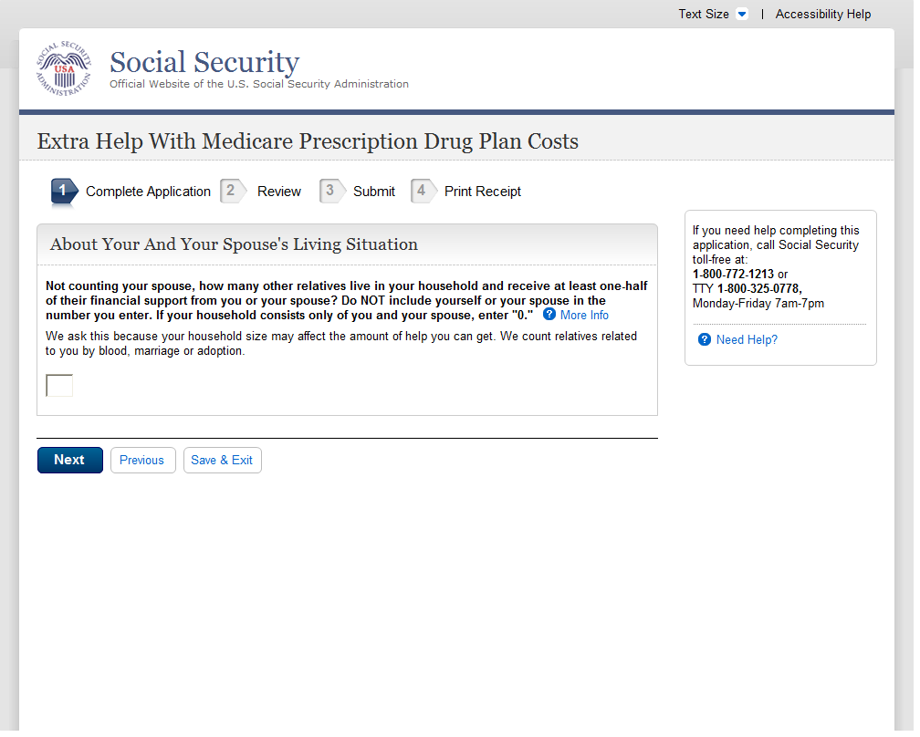
  - About Your Living Situation - Single
Changes covered on Page 11.
    - User Interface
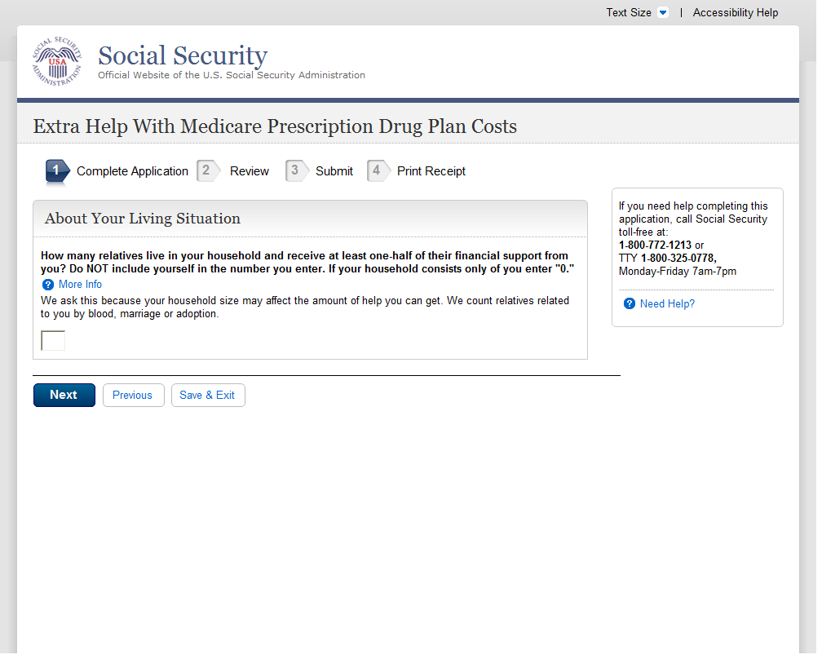
  - Wages And Earnings - Married
    - User Interface
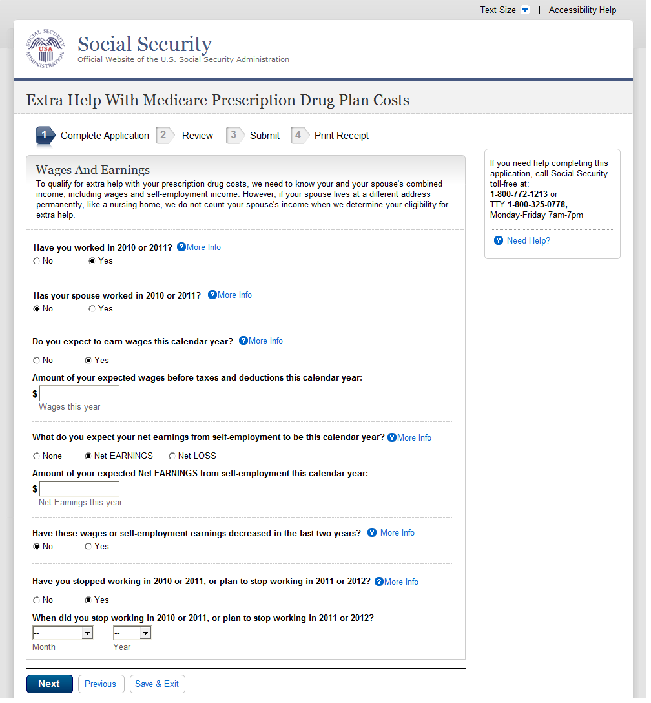
D
C
B
A
  - Wages And Earnings - Married
- The ‘Change This Answer’ button has been removed. Users can now change this answer by selecting the appropriate radio button. The ‘Note: Changing your answer…’ language was added to alert the user of the effects.
- Regardless of whether the spouse indicated work in 2010/2011, the application now asks the applicant and spouse wage and earnings question separately. Since the spouse did not indicate work on the above example, there is no field available for their wages and earnings. The current application asks ‘What do you or your spouse expect to earn in wages before taxes and deductions this calendar year?’
- Similar to [B] above, the language referencing the spouse is removed from the question. Since the spouse did not indicate work on the above example, there is no field available for their wages and earnings. The question used to read ‘What do you or your spouse expect your net earnings from self-employment to be this calendar year?’
- Similar to [B] and [C] above, the language referencing the spouse is removed from the question. Since the spouse did not indicate work on the above example, there is no field available for their wages and earnings. The question used to read ‘Have you or your spouse stopped working in 2010 or 2011, or plan to stop working in 2011 or 2012?’

    - User Interface
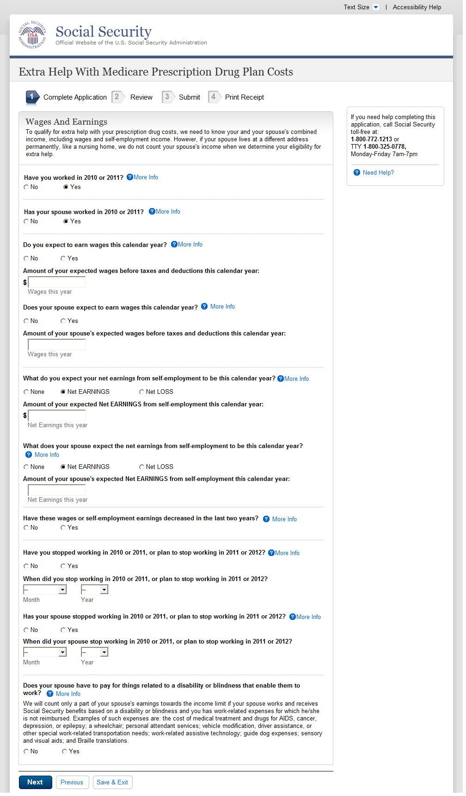
A
B
C
D
  - Wages And Earnings - Single (WITHOUT)
- The ‘Change This Answer’ button has been removed.
- Here the question ‘What do you or your spouse expect to earn in wages before taxes and deductions this calendar year?’ is broken into two questions. The ‘What’ has been removed from the question as only an affirmative answer will reveal the ‘Amount of your expected wages’ language and input field.
- Here the question ‘What do you or your spouse expect your net earnings from self-employment to be this calendar year?’ is broken into two questions. The ‘What’ has been removed from the question as only an affirmative answer will reveal the ‘Amount of your expected Net Earnings’ language and input field.
- Here the question ‘Have you or your spouse stopped working in 2010 or 2011, or plan to stop working in 2011 or 2012?’ is broken into two questions. An affirmative answer will reveal a follow-up question to capture the month and year. This is a new question and reads ‘When did you stop working in 2010 or 2011, or plan to stop working in 2011 or 2012?’

    - User Interface
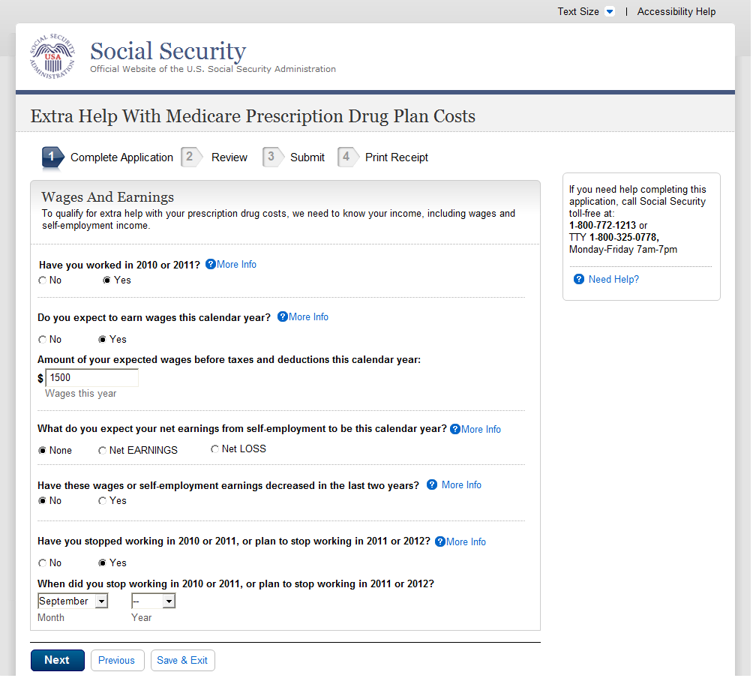
A
B
C
D
  - Wages And Earnings - Single (WITH)
- The ‘Change This Answer’ button has been removed.
- The ‘What’ has been removed from the question as only an affirmative answer will reveal the ‘Amount of your expected wages’ language and input field.
- The ‘What’ has been removed from the question as only an affirmative answer will reveal the ‘Amount of your expected Net Earnings’ language and input field.
- An affirmative answer to ‘Have you stopped working in 2010 or 2011, or plan to stop working in 2011 or 2012?’ will reveal a follow-up question to capture the month and year. This is a new question and reads ‘When did you stop working in 2010 or 2011, or plan to stop working in 2011 or 2012?’

    - User Interface
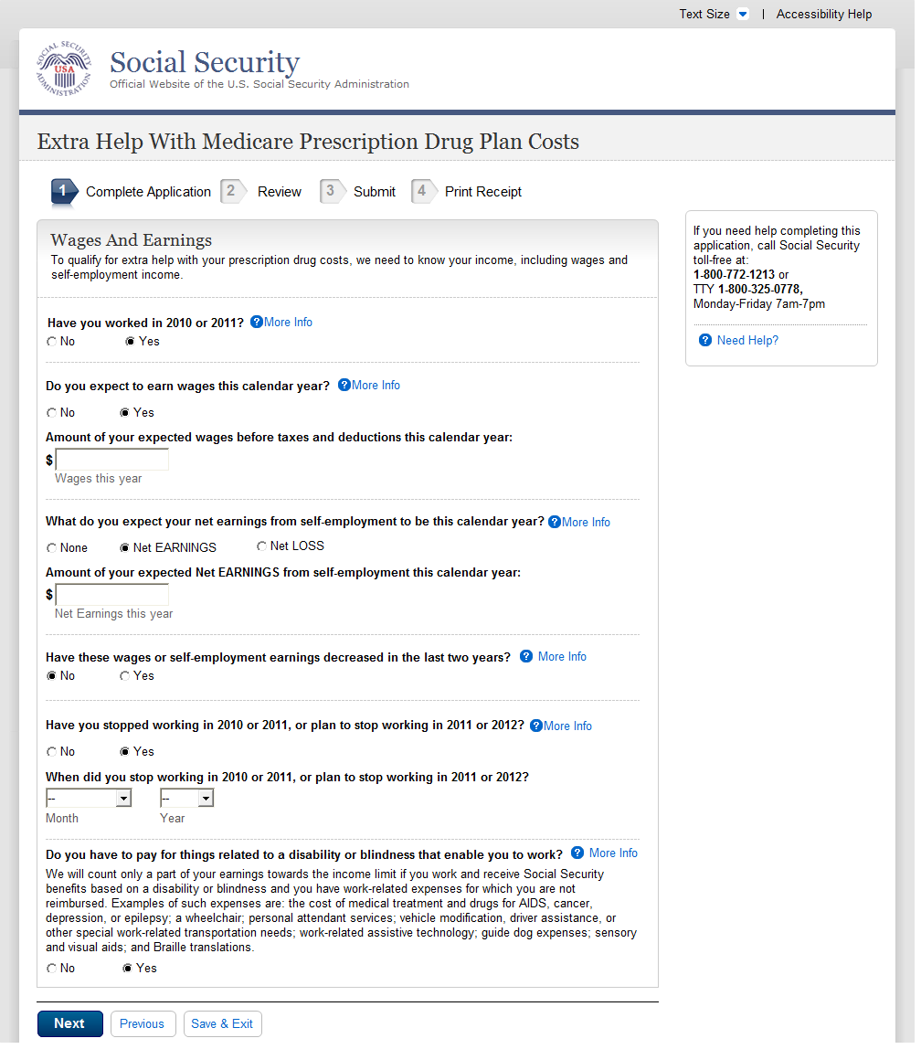
A
B
C
D
  - Income Other Than Wages And Earnings - Married
- The ‘Change This Answer’ button has been removed.
- The ‘What’ has been removed from the question as only an affirmative answer will reveal the ‘Amount of your expected wages’ language and input field.
- The ‘What’ has been removed from the question as only an affirmative answer will reveal the ‘Amount of your expected Net Earnings’ language and input field.
- An affirmative answer to ‘Have you stopped working in 2010 or 2011, or plan to stop working in 2011 or 2012?’ will reveal a follow-up question to capture the month and year. This is a new question and reads ‘When did you stop working in 2010 or 2011, or plan to stop working in 2011 or 2012?’

    - User Interface
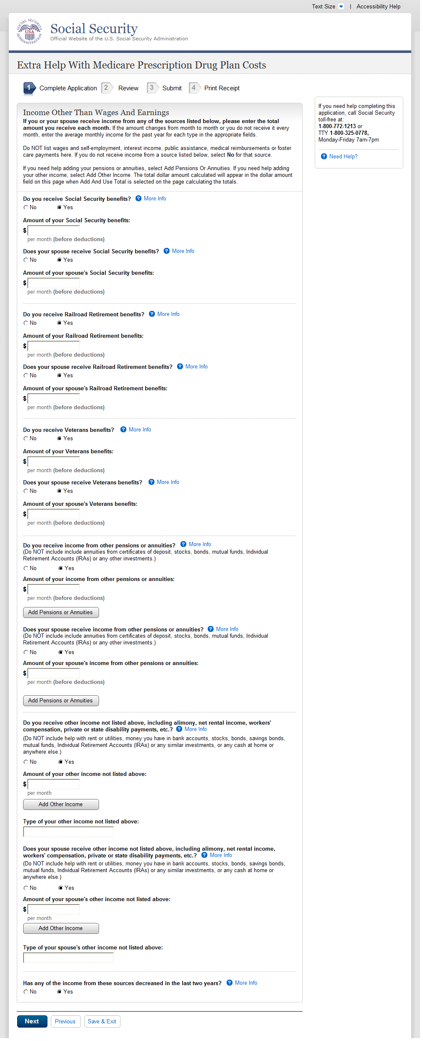
Similar to pages above, these questions are no longer phrased to include both the applicant and spouse together. Both the applicant and spouse must answer individual questions regarding SSA, RRB, VA and other pension and annuity questions. If the answer is ‘yes’, a follow-up question will be revealed to collect the amount.

  - Income Other Than Wages And Earnings - Single
    - User Interface
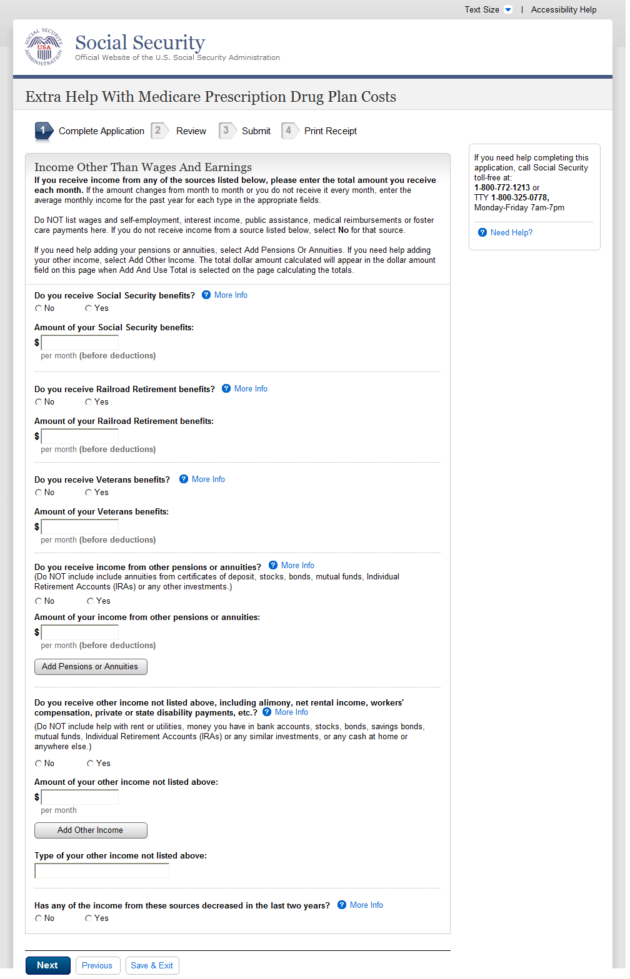
  - Resources - Married
    - User Interface
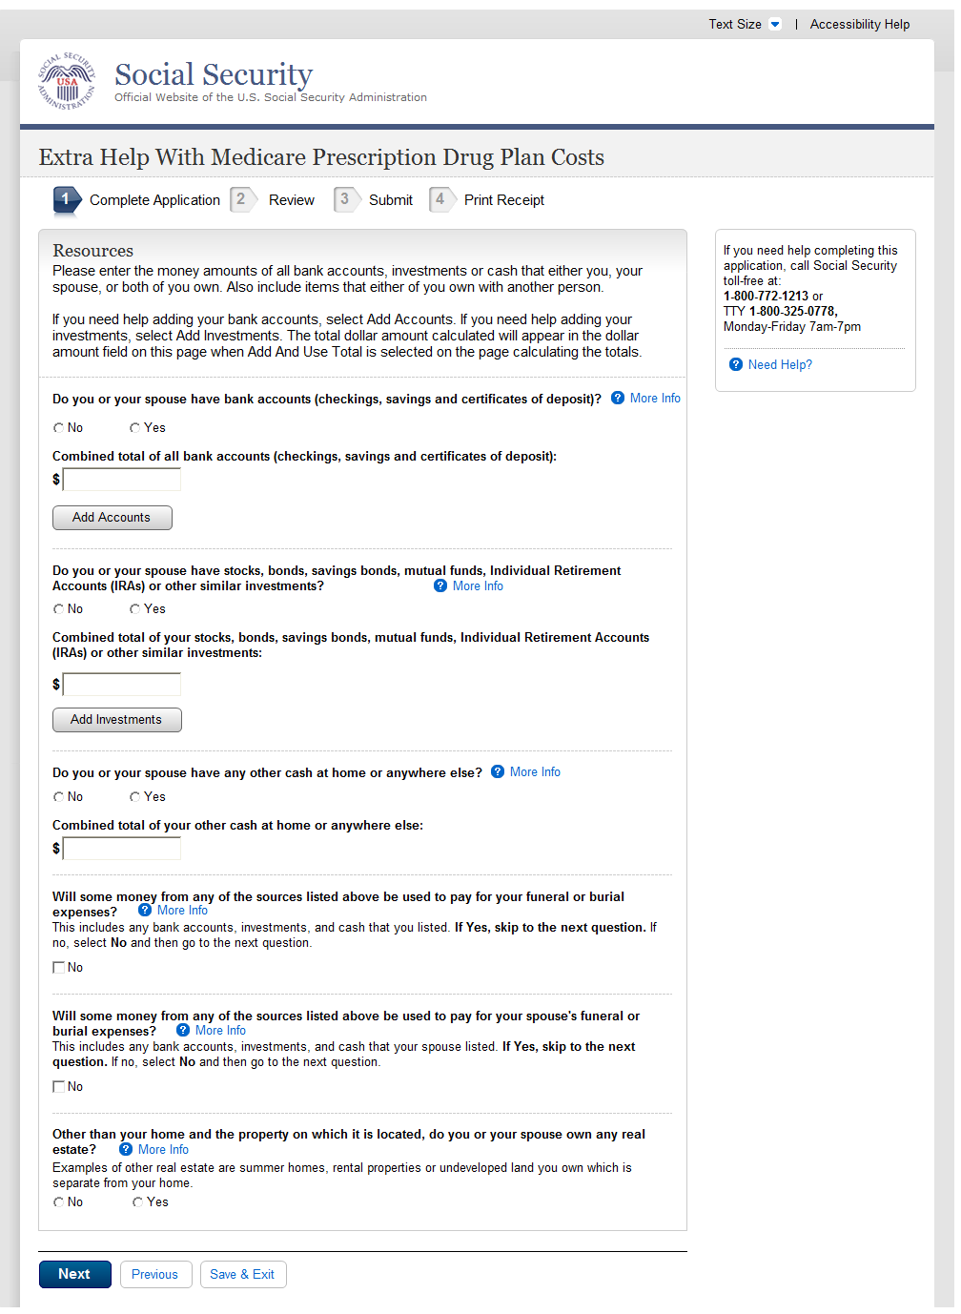
A
  - Resources - Single
- The first three questions were originally under an umbrella statement:
‘Do you or your spouse have any of the following resources? If Yes, enter the combined total for those items.
Combined total of all bank accounts (checking, savings and certificates of deposit)
Combined total of all stocks, bonds, savings bonds, mutual funds, Individual Retirement Accounts or other similar investments
Any other Cash at home or anywhere else’
These questions were separated to improve clarity.
    - User Interface
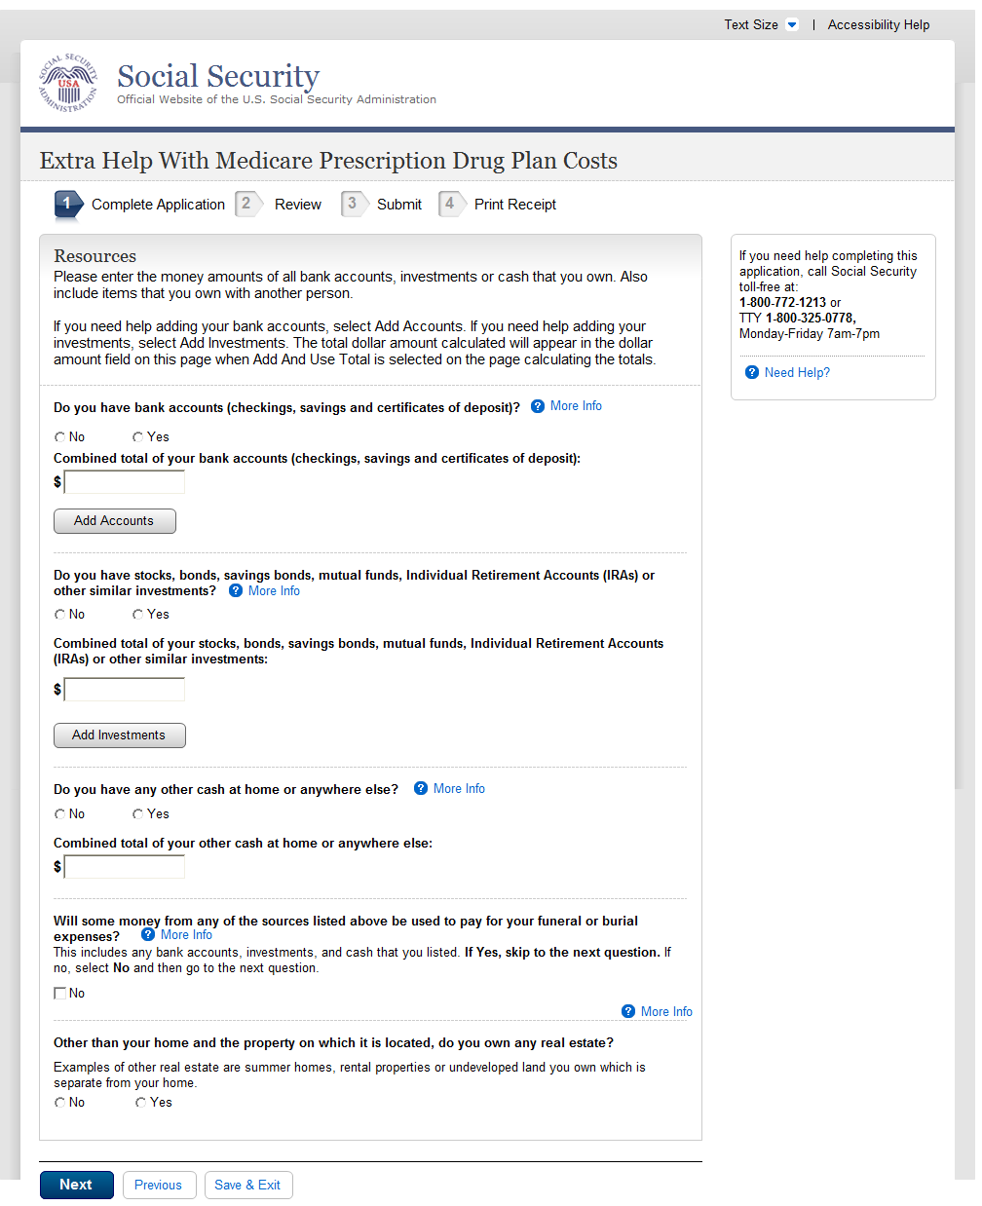
A
  - Tool: Add Up Your Accounts
- The first three questions were originally under an umbrella statement:
‘Do you or your spouse have any of the following resources? If Yes, enter the combined total for those items.
Combined total of all bank accounts (checking, savings and certificates of deposit)
Combined total of all stocks, bonds, savings bonds, mutual funds, Individual Retirement Accounts or other similar investments
Any other Cash at home or anywhere else’
These questions were separated to improve clarity.
    - User Interface
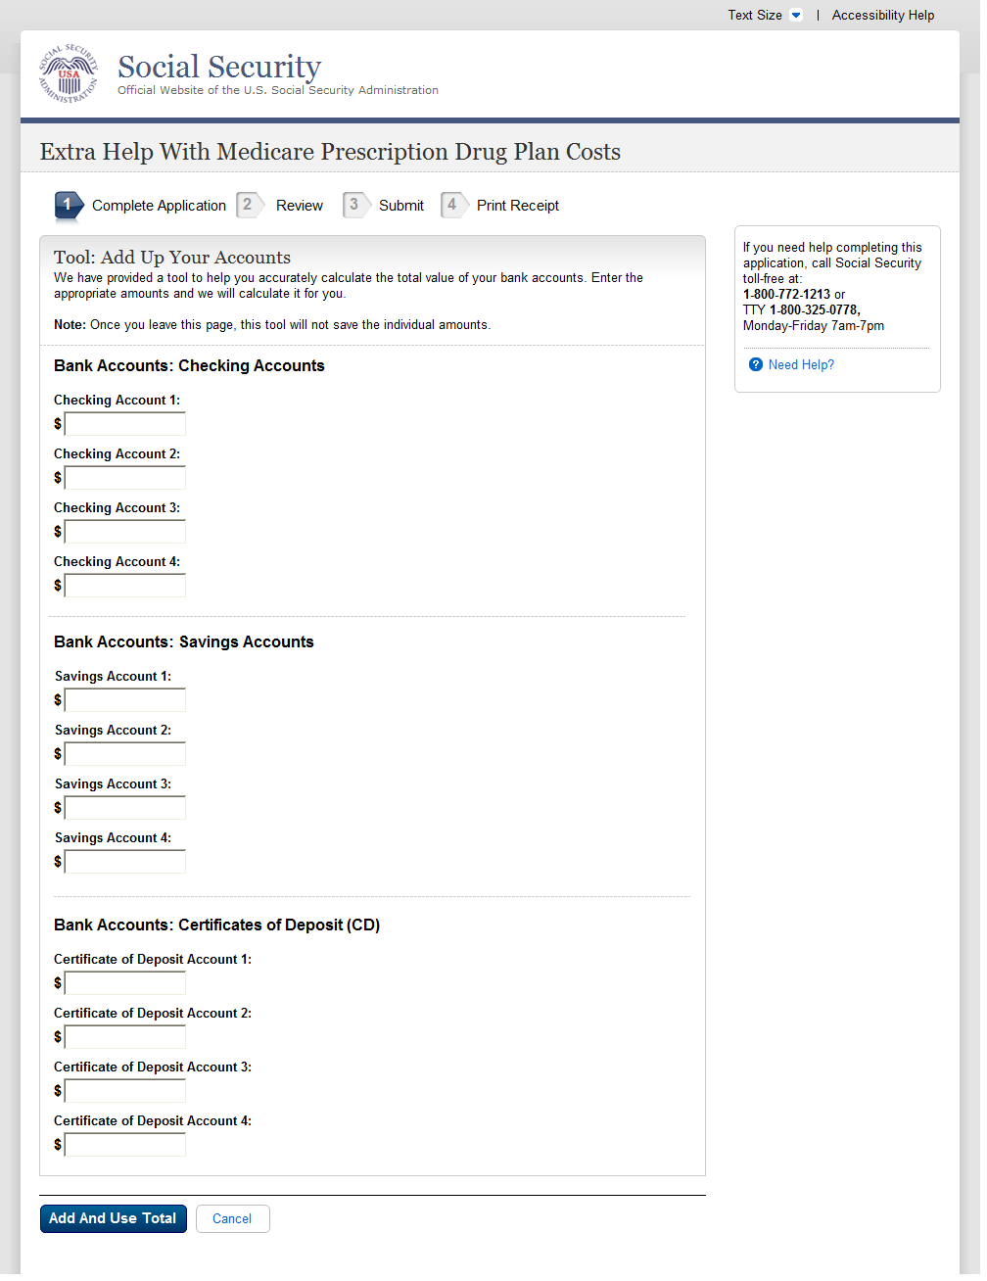
  - Tool: Add Up Your Investments
    - User Interface
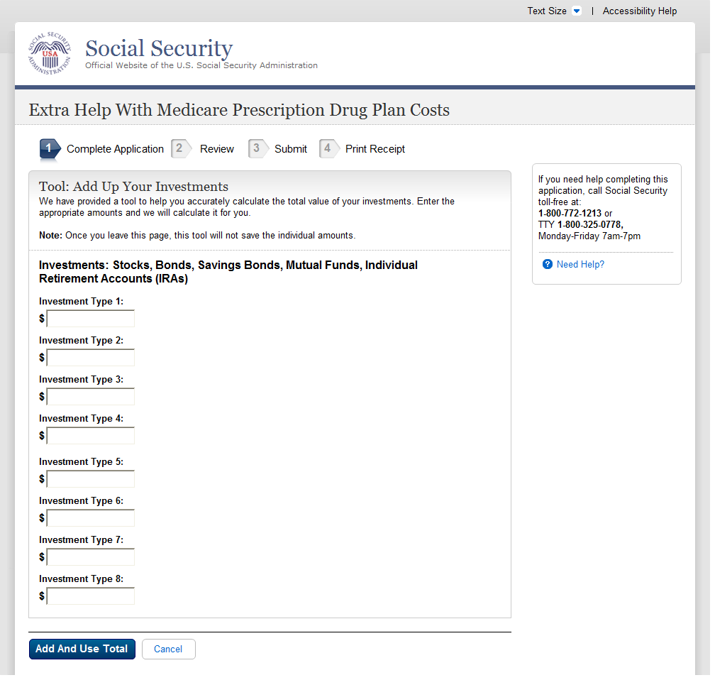
  - Tool: Add Up Your Other Pensions And Annuities
    - User Interface
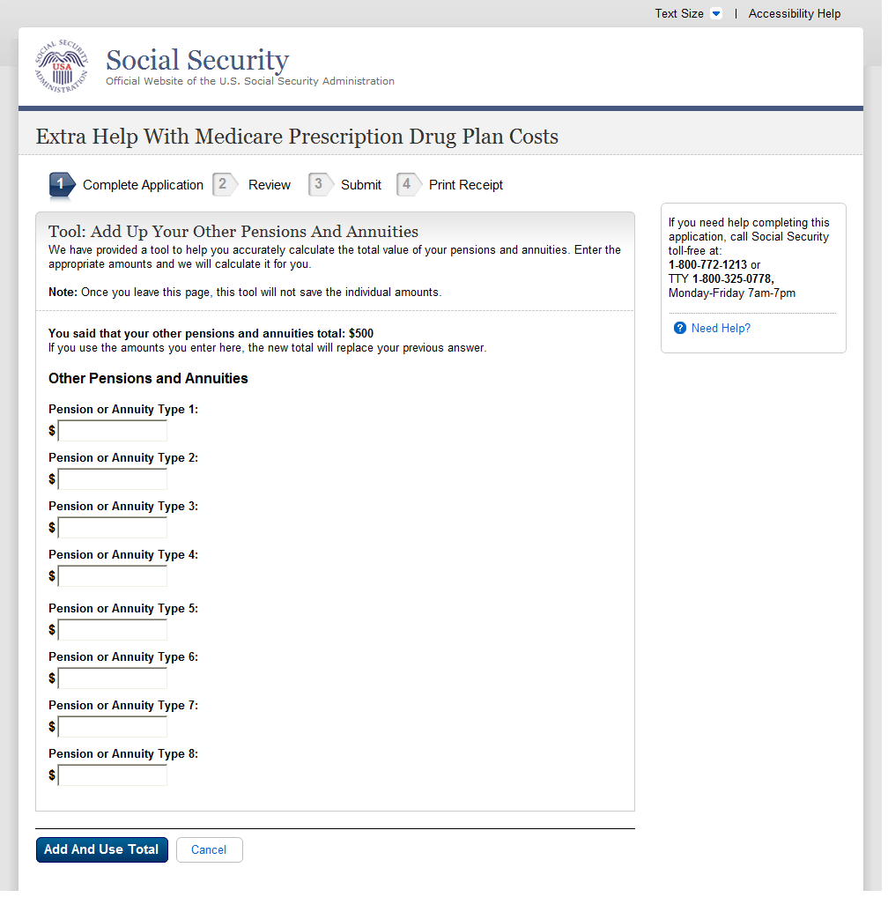
  - Tool: Add Up Your Types Of Income
    - User Interface
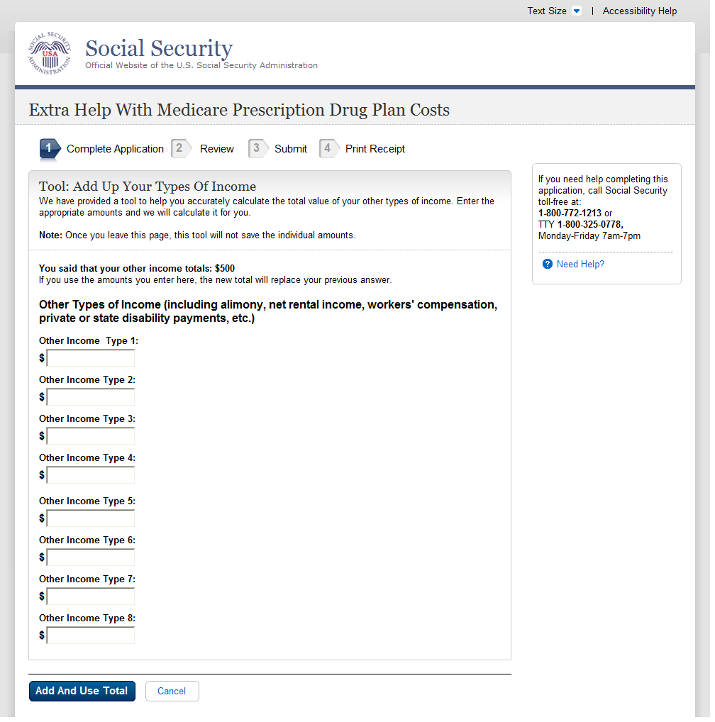
  - (Find Out if You Qualify)
  - Find Out If You And Your Spouse Qualify (Married) Part 1 (WITHOUT)
    - User Interface
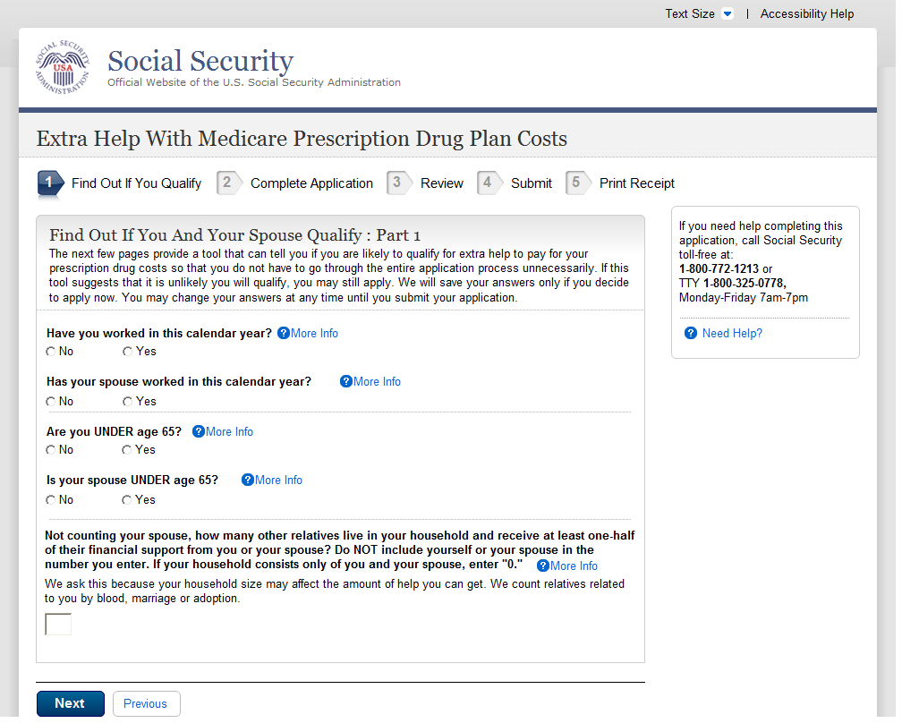
A
  - Find Out If You And Your Spouse Qualify (Married) Part 1 (WITH)
A. These questions were previously worded as ‘Have you or your spouse worked in this calendar year?’ and ‘Are you or your spouse UNDER age 65?’. The questions have been separated.
    - User Interface
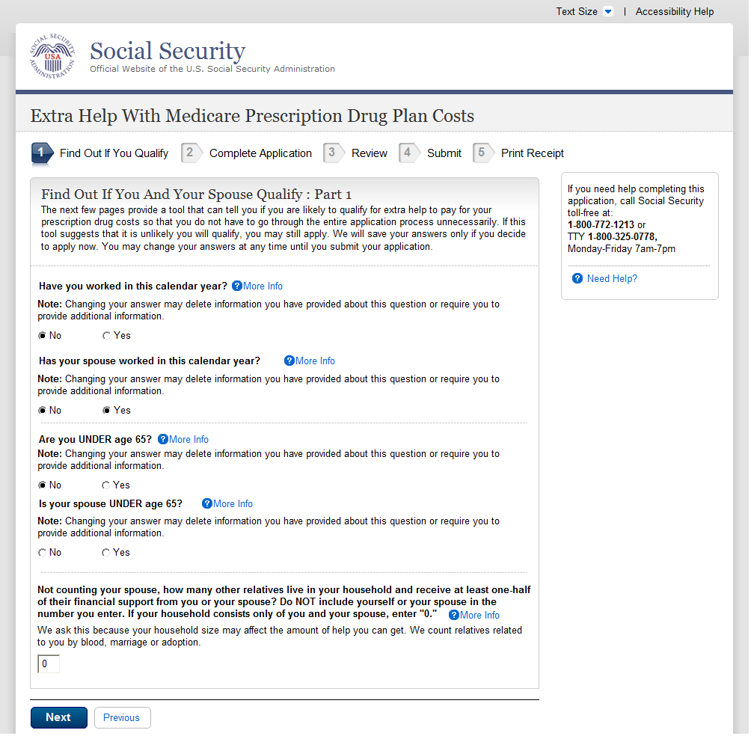
- The ‘Change This Answer’ button has been removed. Users can now change this answer, if necessary, by selecting the appropriate radio button. The ‘Note: Changing your answer…’ language was added to alert the user of the effects.
A
A
  - Find Out If You Qualify (Single) Part 1
    - User Interface
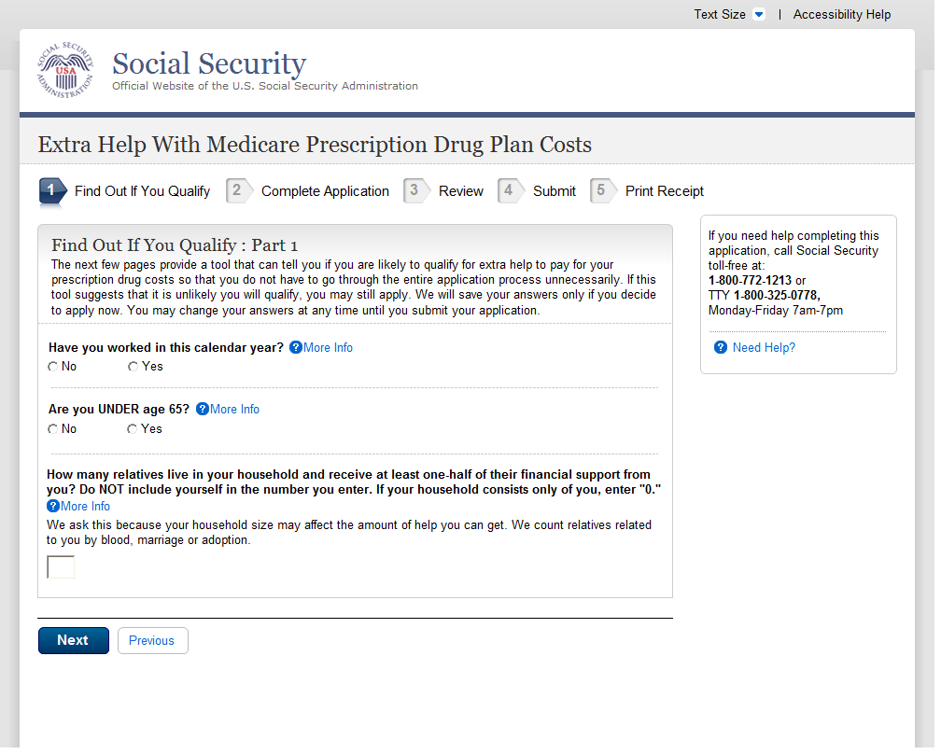
  - Find Out If You Qualify (Married) Part 3 (WITH)
    - User Interface
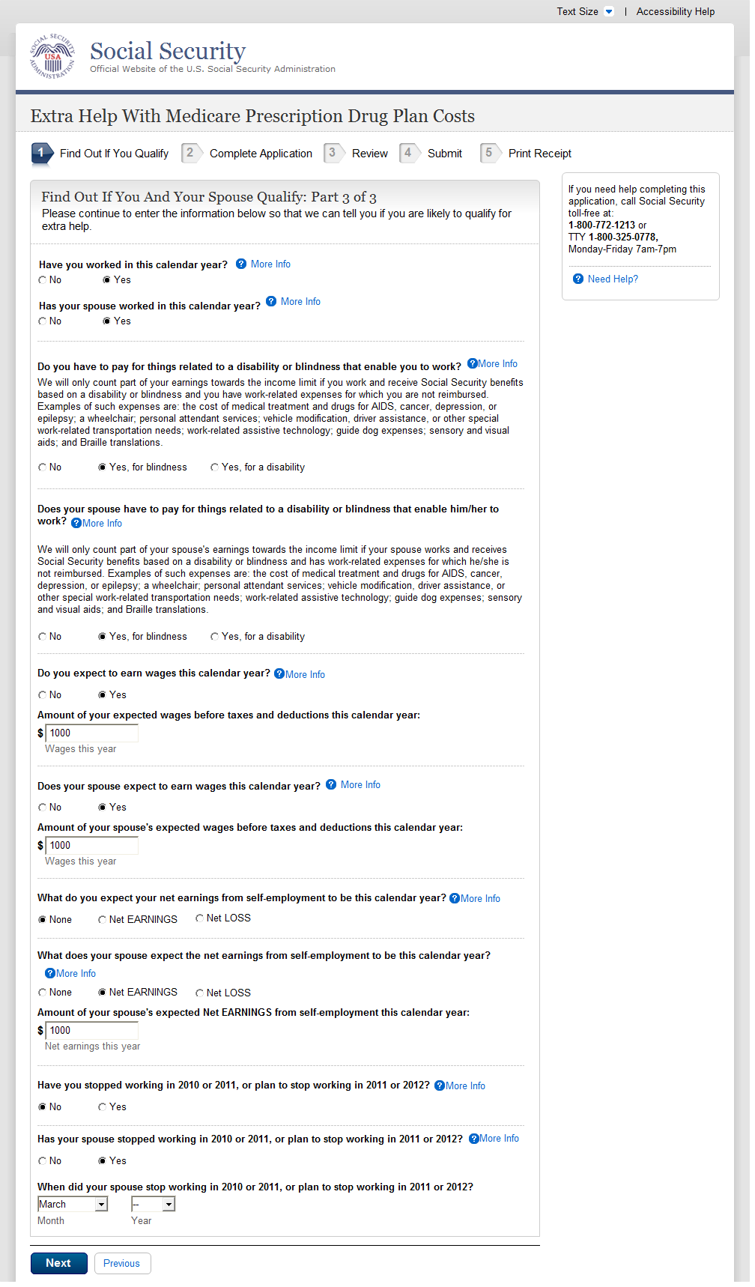

  - Find Out If You Qualify (Single) Part 3 (WITHOUT)
B
B
B
B
A
- The ‘Change This Answer’ button has been removed. Users can now change this answer, if necessary, by selecting the appropriate radio button.
- These questions previously applied to both applicant and spouse. The questions have been separated so that each member of the couple has their own question/answer.
    - User Interface
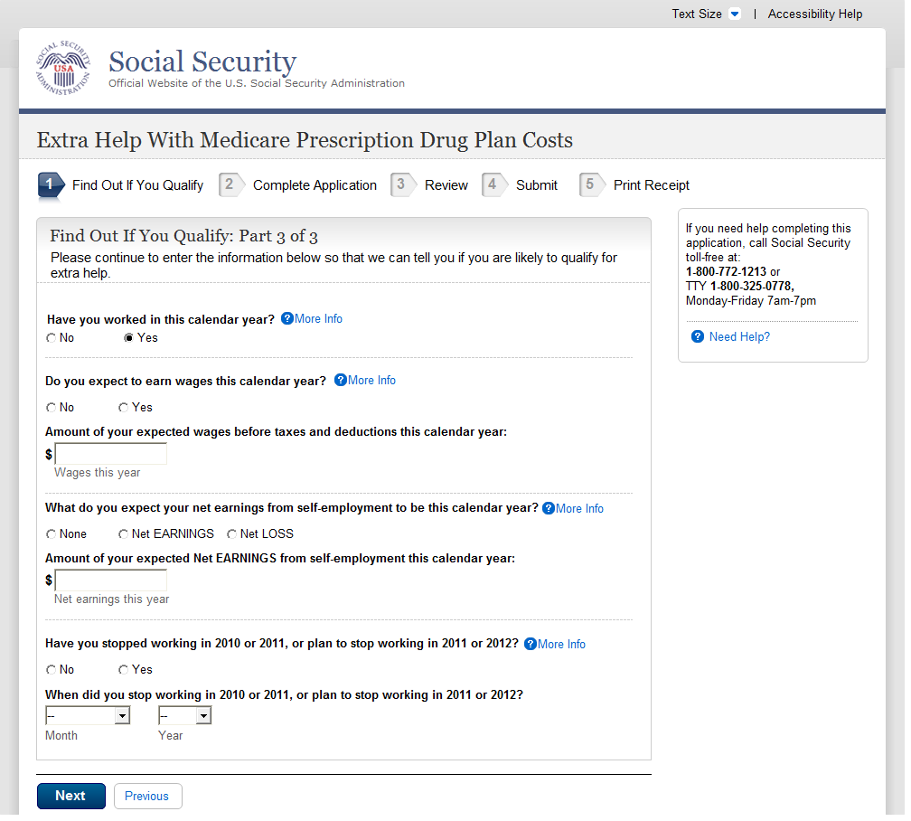
B
A
  - Find Out if You Qualify (Single) Part 3 (WITH)
- The ‘Change This Answer’ button has been removed. Users can now change this answer, if necessary, by selecting the appropriate radio button.
- This question has been re-worded. It previously read: ‘What do you expect your net earnings from self-employment to be this calendar year?’ The ‘Amount of your expected wages before taxes and deductions this calendar year:’ and text box are now only displayed with an affirmative answer.

    - User Interface
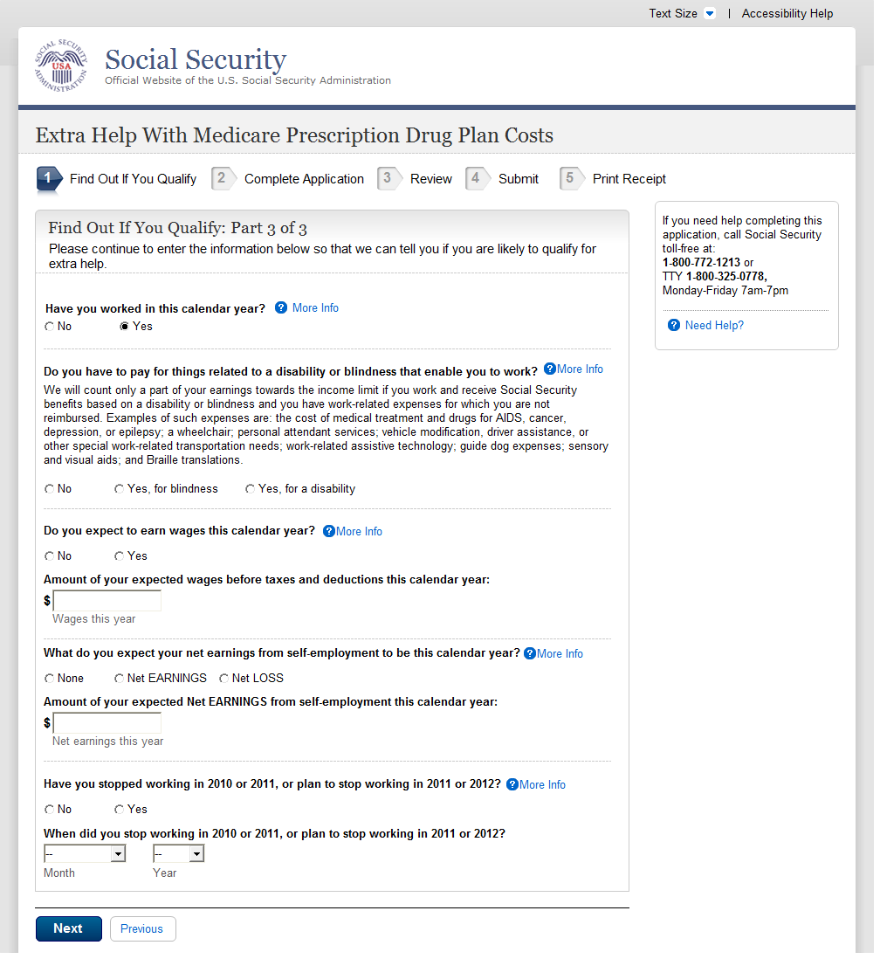
A
B
  - Find Out If You Qualify (Married) Part 2
- The ‘Change This Answer’ button has been removed. Users can now change this answer, if necessary, by selecting the appropriate radio button.
- This question has been re-worded. It previously read: ‘What do you expect your net earnings from self-employment to be this calendar year?’ The ‘Amount of your expected wages before taxes and deductions this calendar year:’ and text box are now only displayed with an affirmative answer.

    - User Interface
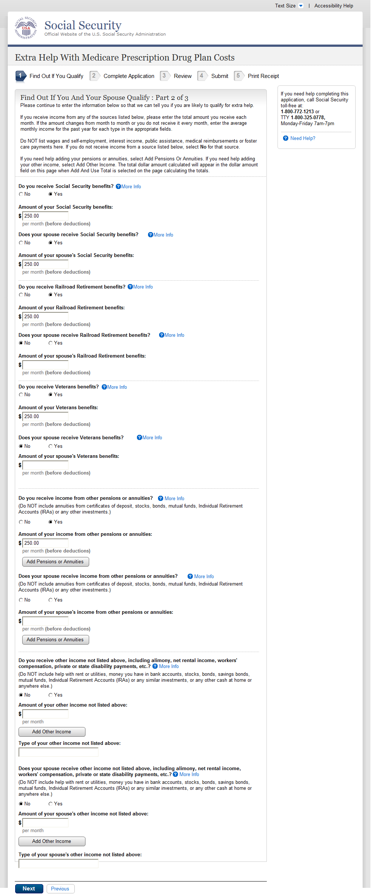
Similar to pages above, these questions are no longer phrased to include both the applicant and spouse together. Both the applicant and spouse must answer individual questions regarding SSA, RRB, VA and other pension and annuity questions. If the answer is ‘yes’, a follow-up question will be revealed to collect the amount.
  - Find Out If You Qualify (Single) Part 2
    - User Interface
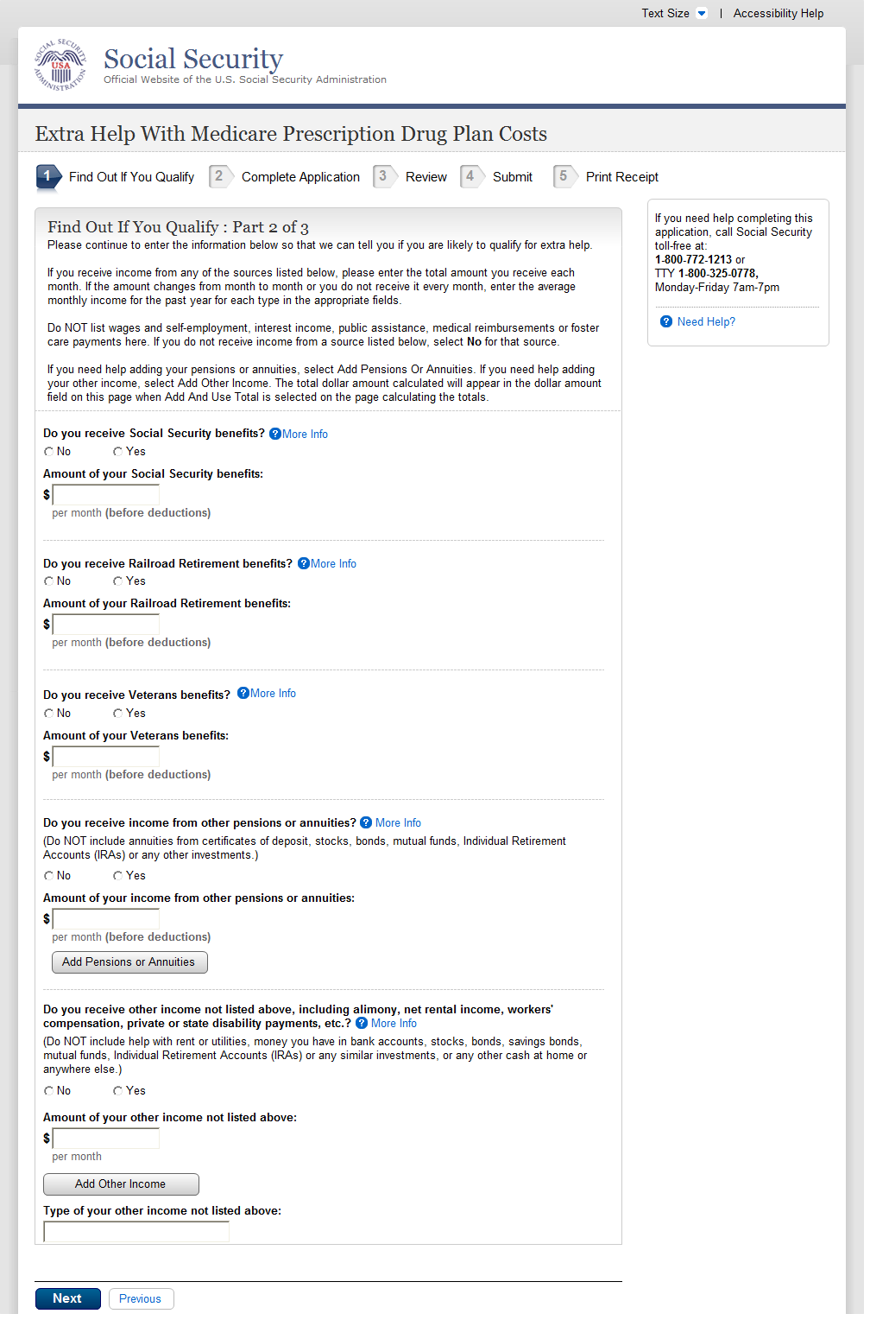
The ‘Amount of…’ and associated text boxes are only present with an affirmative answer.
  - Find Out If You Qualify (You Should Apply)
    - User Interface
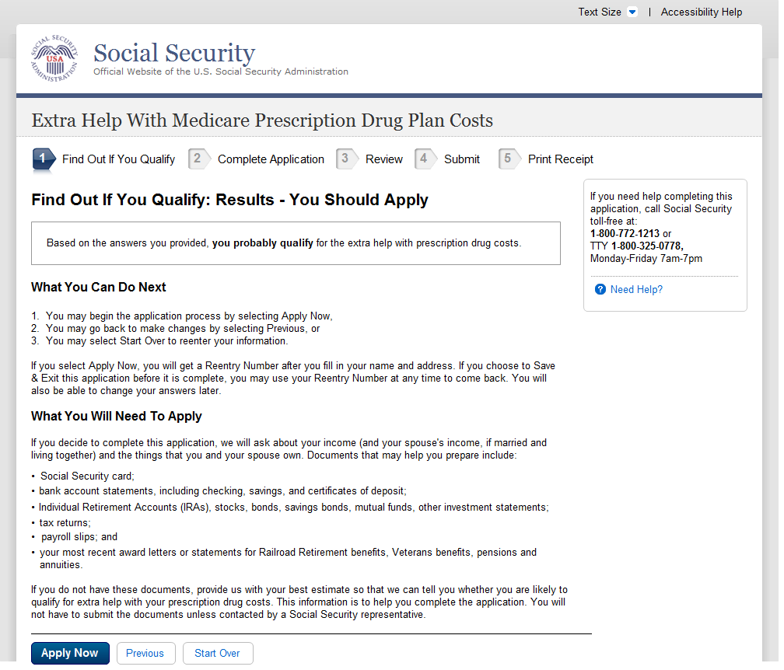
  - Find Out If You Qualify (You Probably Do Not Qualify)
    - User Interface
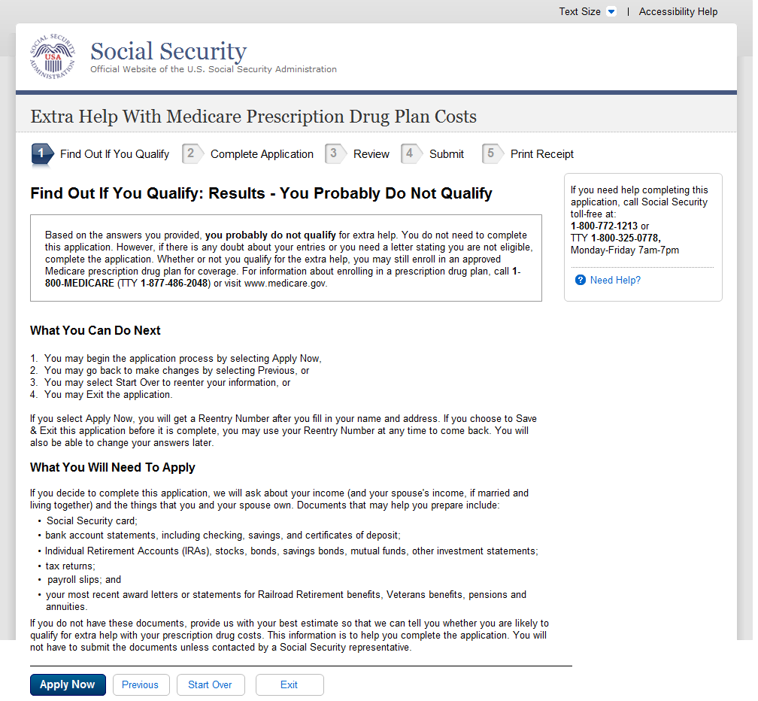
  - Review and Send
  - Review Your Information
    - User Interface
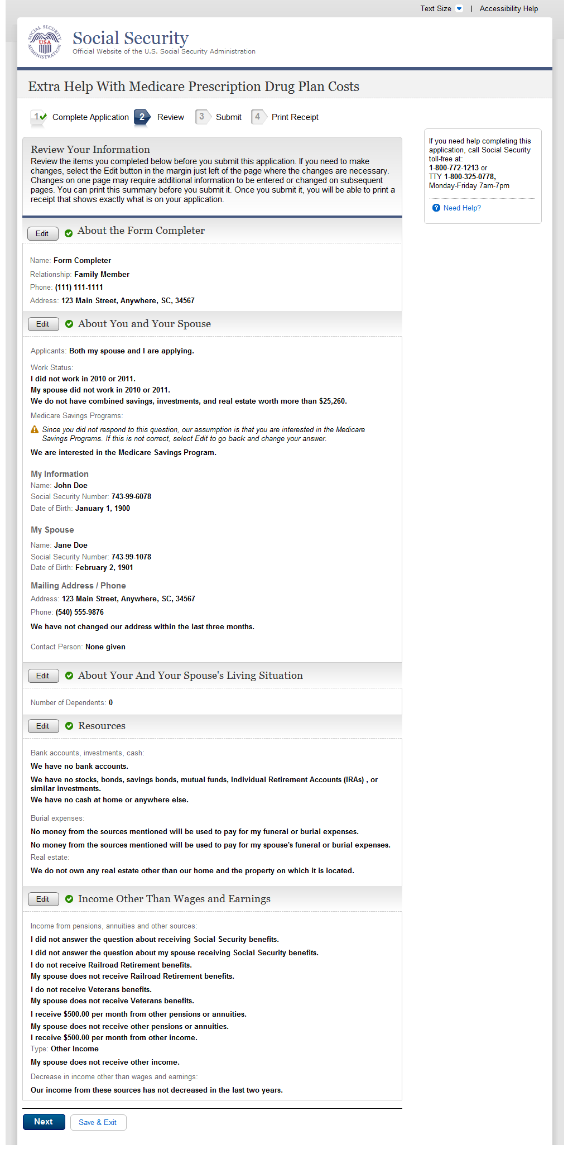
  - Review Your Information
    - User Interface
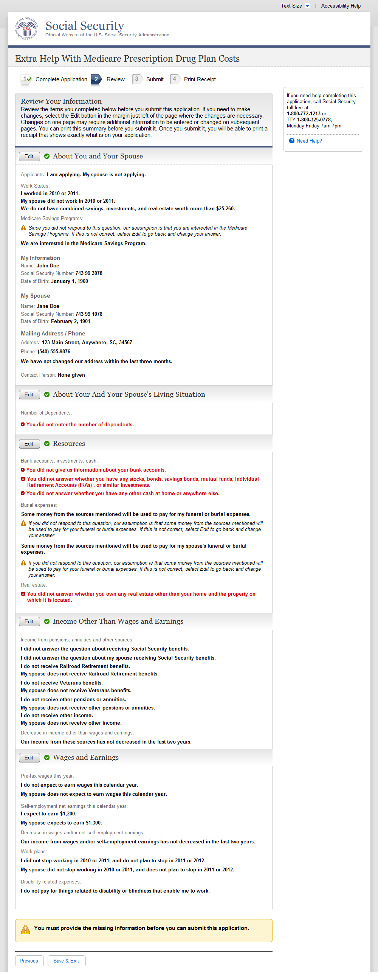
A
  - Ready to Submit
- This alert is now highlighted using a shaded box and exclamation point icon.
    - User Interface
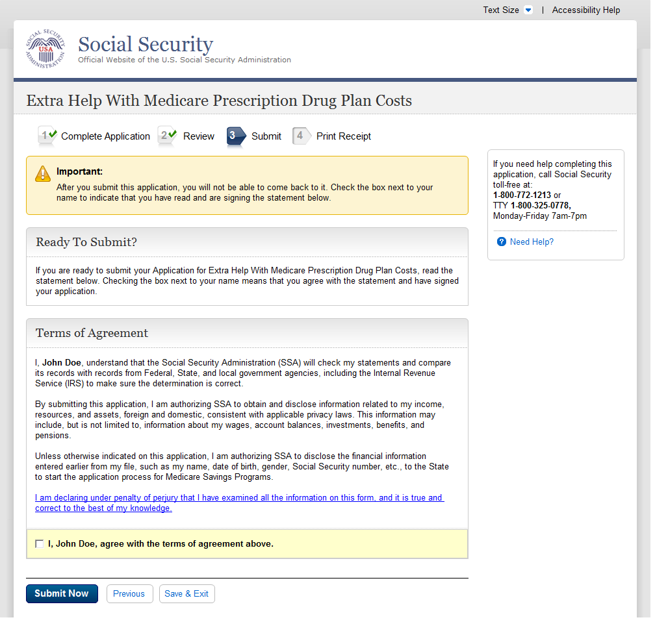
- The ‘Important’ note has been moved from just above the check box to the very top of the page.
- The attestation section is now titled ‘Terms of Agreement’
- The language following the check box previously read “I, John Doe, read and agree with the above.”
C
A
B
  - Ready to Submit
    - User Interface
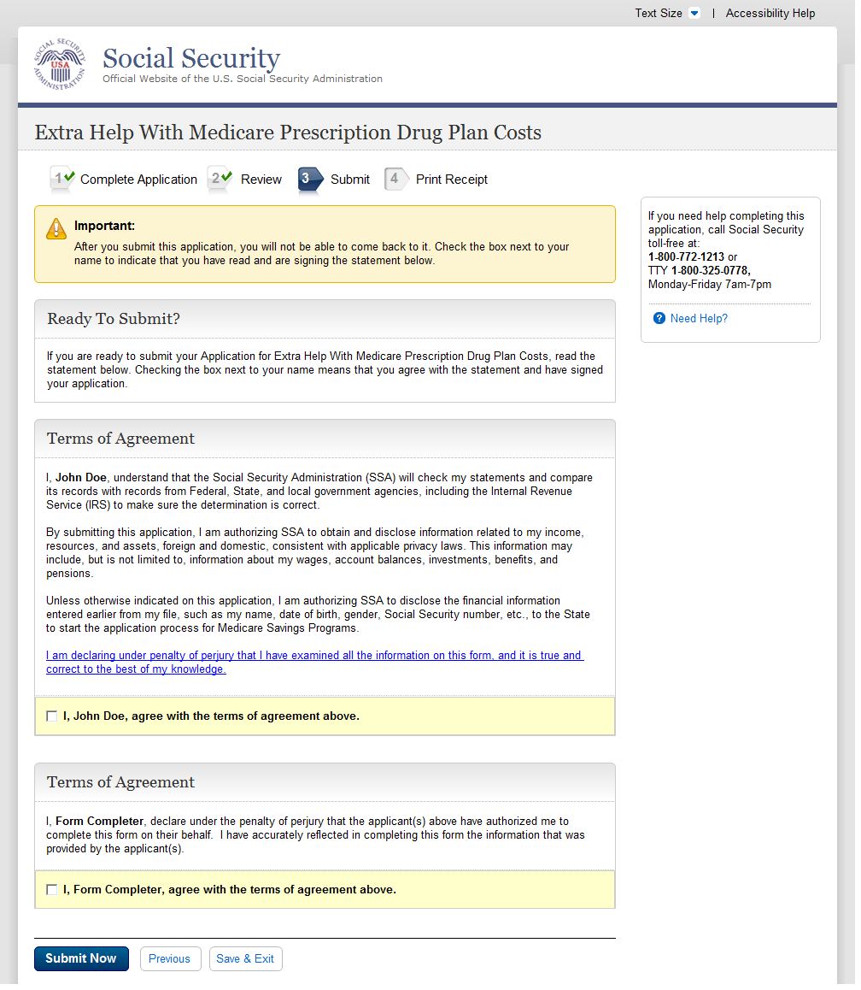
C
B
A
  - Ready to Submit
- The ‘Important’ note has been moved from just above the check box to the very top of the page.
- The attestation section is now titled ‘Terms of Agreement’. The language following the check box has changed from ‘I, John Doe, read and agree with the above.’ To ‘I, John Doe agree with the terms of agreement above.’
- Third Party Form Completers no longer attest that the information is true and correct to the best of their knowledge. Applicant attestation statements and electronic ‘signatures’ are now included when a third party form completer is completing the application. Third Party Form Completers also no longer authorize the disclosure of information on the applicant’s behalf. Third Party Form Completers now declare that the applicant(s) have authorized them to complete an application on their behalf and that the information reflected in the application was provided to them by the applicant(s).
    - User Interface
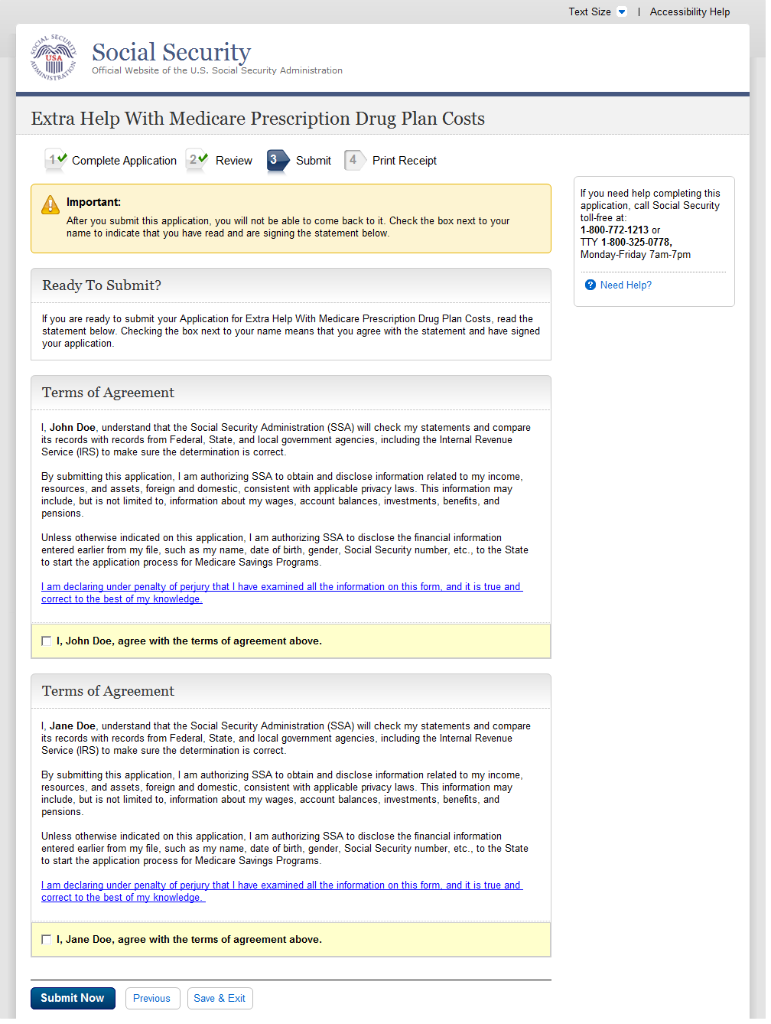
A
B
B
  - Ready to Submit
- The ‘Important’ note has been moved from just above the check box to the very top of the page.
- The attestation section is now titled ‘Terms of Agreement’. The language following the check box has changed from ‘I, Jane Doe, read and agree with the above.’

    - User Interface
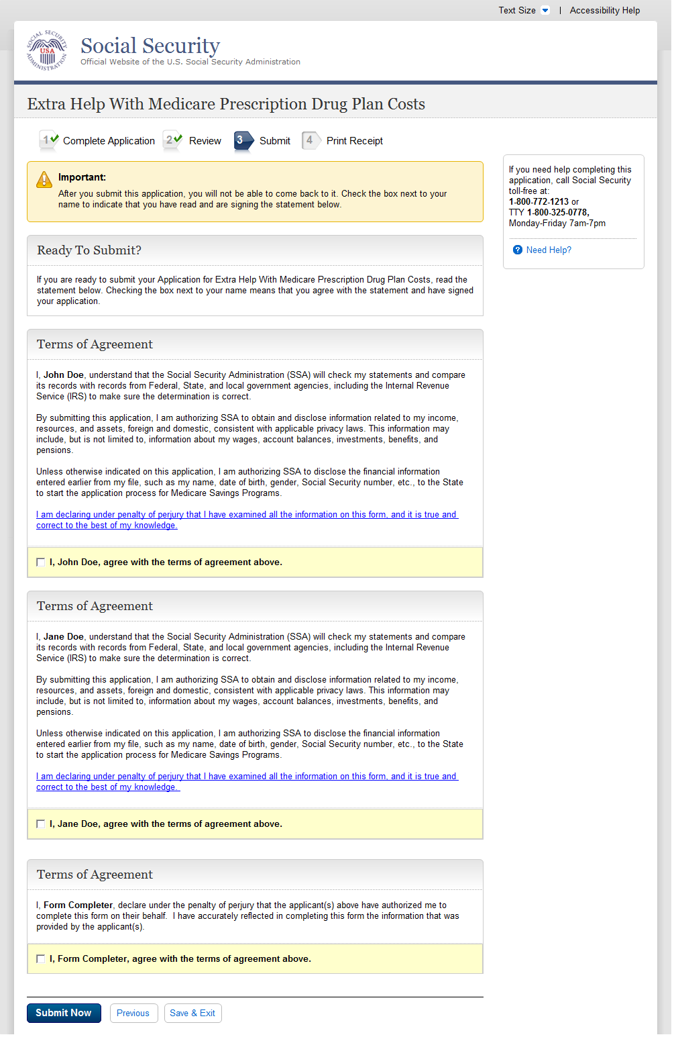
A
B
C
  - Ready to Submit
- The ‘Important’ note has been moved from just above the check box to the very top of the page.
- The attestation section is now titled ‘Terms of Agreement’. The language following the check box has changed from ‘I, John Doe, read and agree with the above.’
- Third Party Form Completers no longer attest that the information is true and correct to the best of their knowledge. Applicant attestation statements and electronic ‘signatures’ are now included when a third party form completer is completing the application. Third Party Form Completers also no longer authorize the disclosure of information on the applicant’s behalf. Third Party Form Completers now declare that the applicant(s) have authorized them to complete an application on their behalf and that the information reflected in the application was provided to them by the applicant(s).
    - User Interface
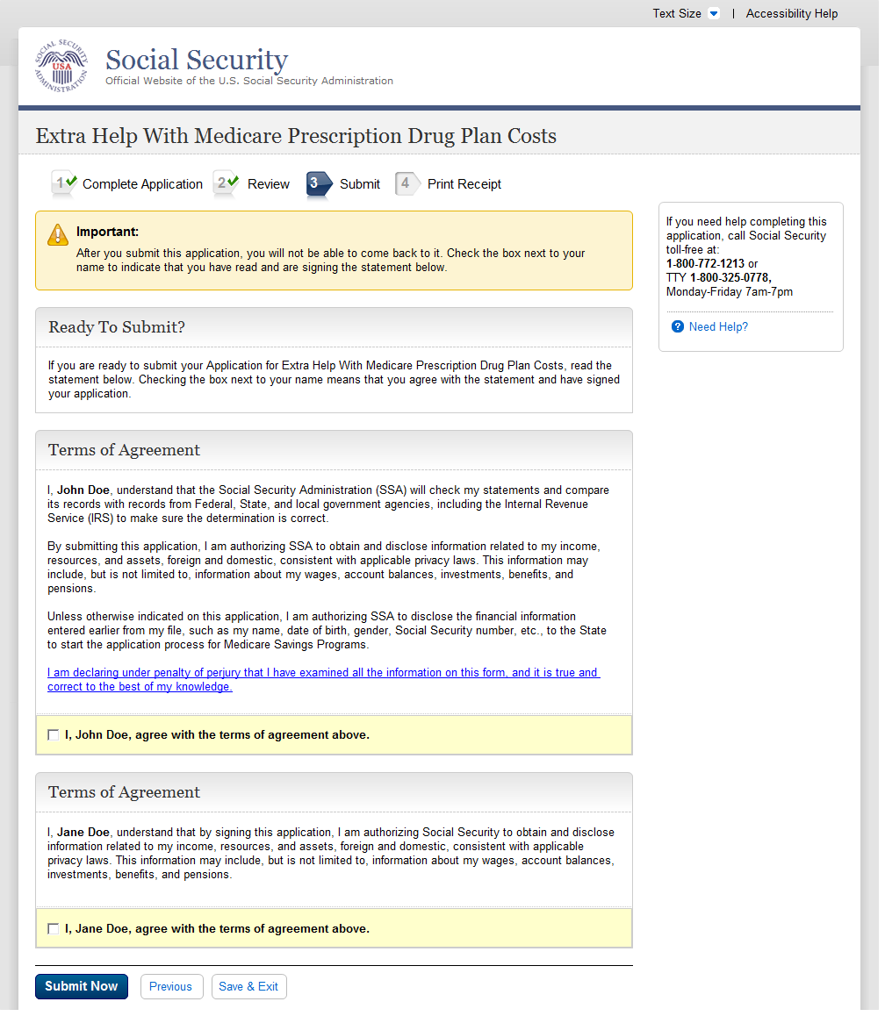
B
A
  - Ready to Submit
- The ‘Important’ note has been moved from just above the check box to the very top of the page.
- The attestation section is now titled ‘Terms of Agreement’. The language following the check box has changed from ‘I, John Doe, read and agree with the above.’ to ‘I, John Doe, agree with the terms of agreement above.’

    - User Interface
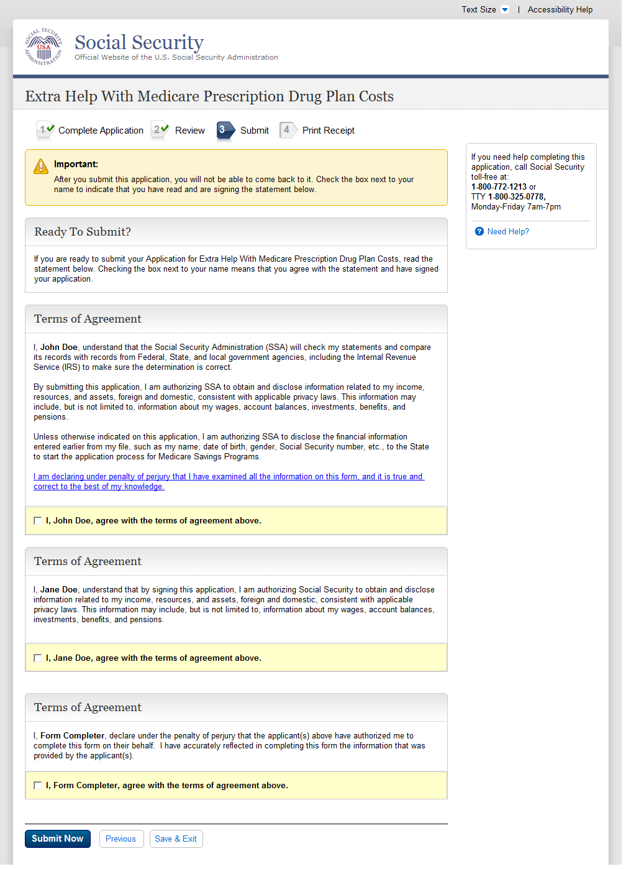
A
B
C
  - Successful Submission - Print Or Save Your Receipt
- The ‘Important’ note has been moved from just above the check box to the very top of the page.
- The attestation section is now titled ‘Terms of Agreement’. The language following the check box has changed from ‘I, John Doe, read and agree with the above.’
- Third Party Form Completers no longer attest that the information is true and correct to the best of their knowledge. Applicant attestation statements and electronic ‘signatures’ are now included when a third party form completer is completing the application. Third Party Form Completers also no longer authorize the disclosure of information on the applicant’s behalf. Third Party Form Completers now declare that the applicant(s) have authorized them to complete an application on their behalf and that the information reflected in the application was provided to them by the applicant(s).
    - User Interface
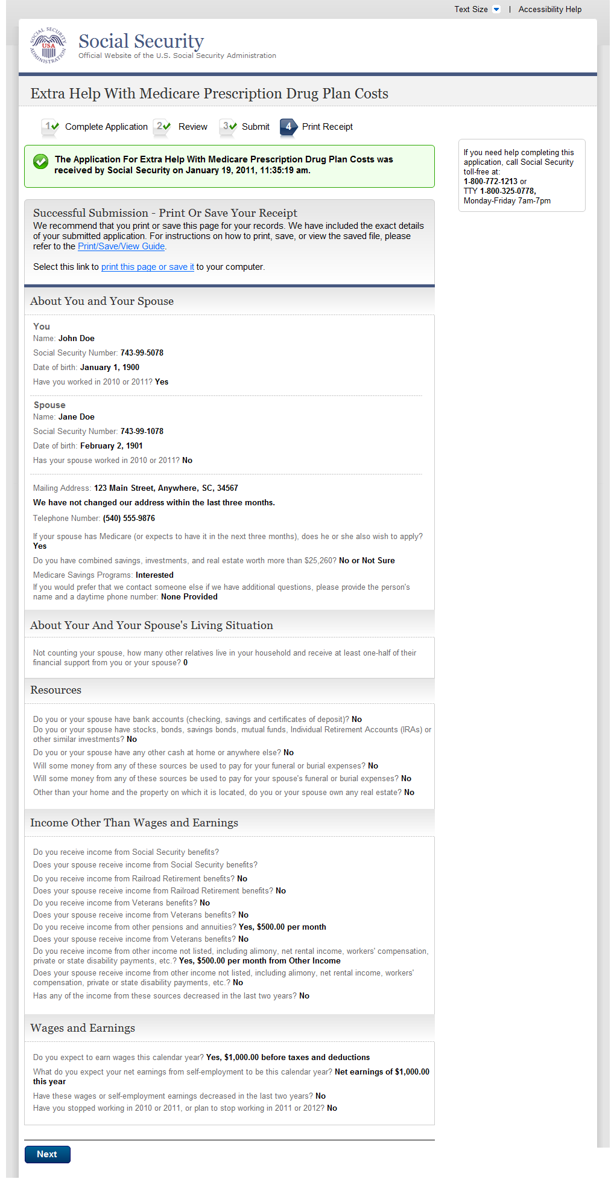
This section houses the same information, however, the layout has been changed to a single column view.
  - Unsuccessful Submission
    - User Interface
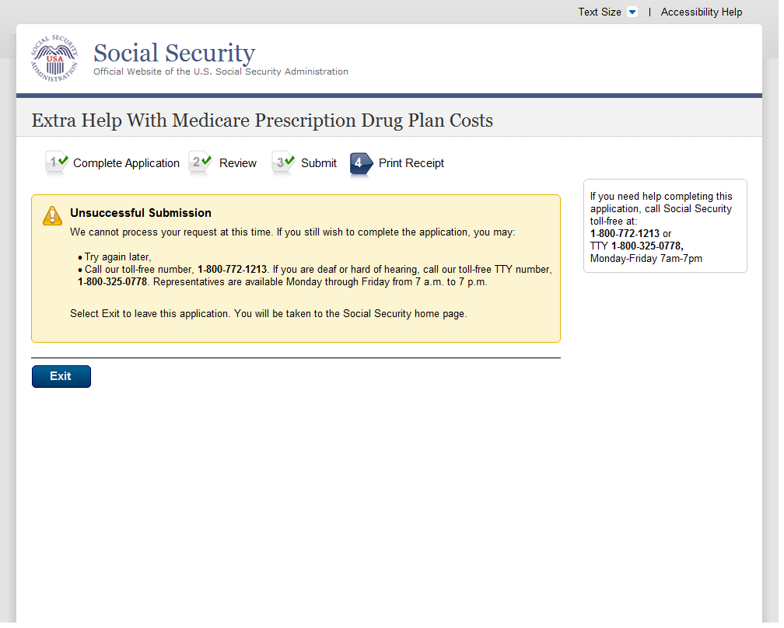
- This field is highlighted with a shaded box.
A
  - Next Steps
    - User Interface
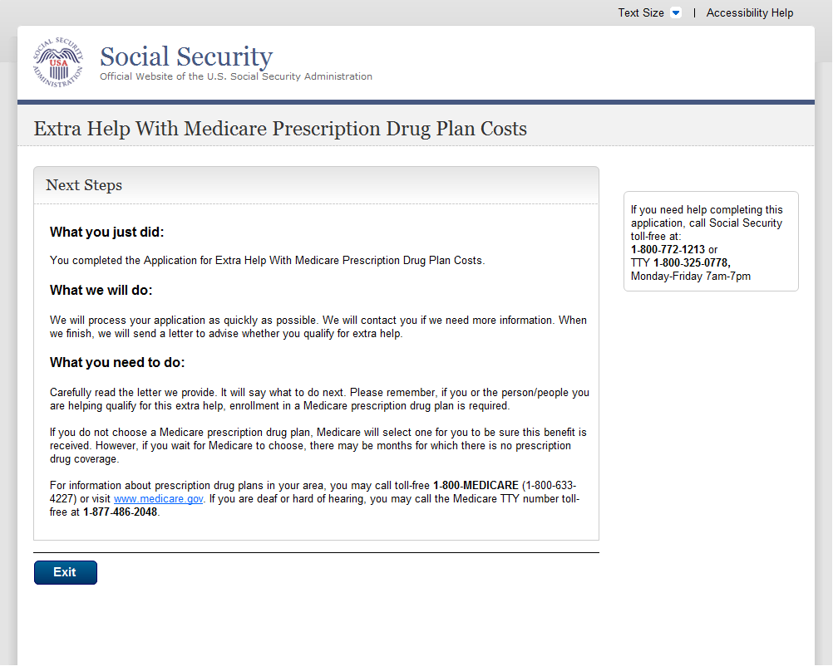
  - Missing Information (Fix Errors)
    - User Interface
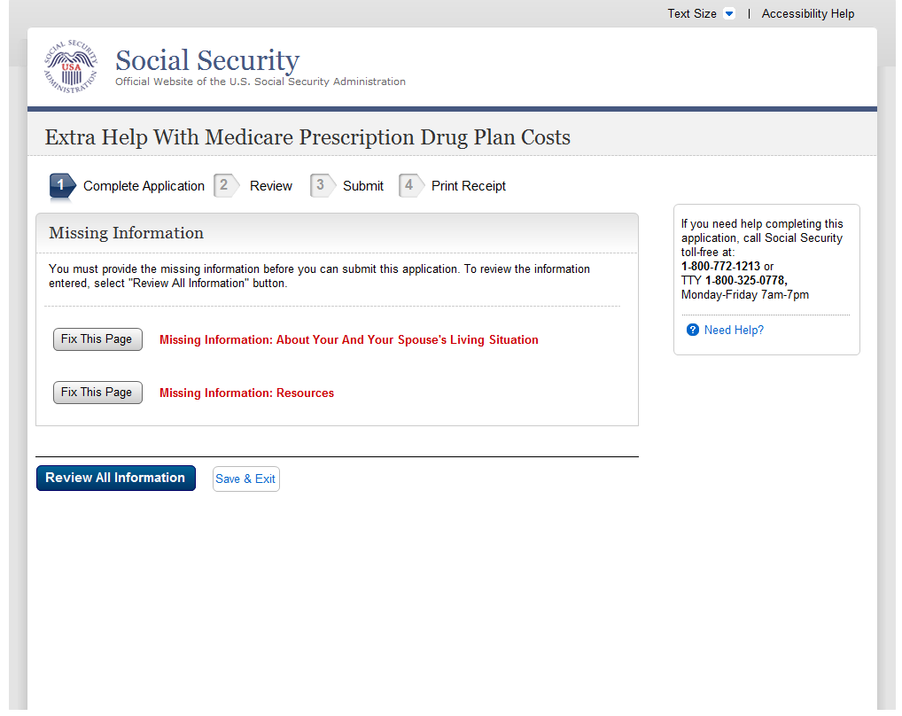
  - Successful Submission - Print Or Save Yoour Receipt (print)
    - User Interface
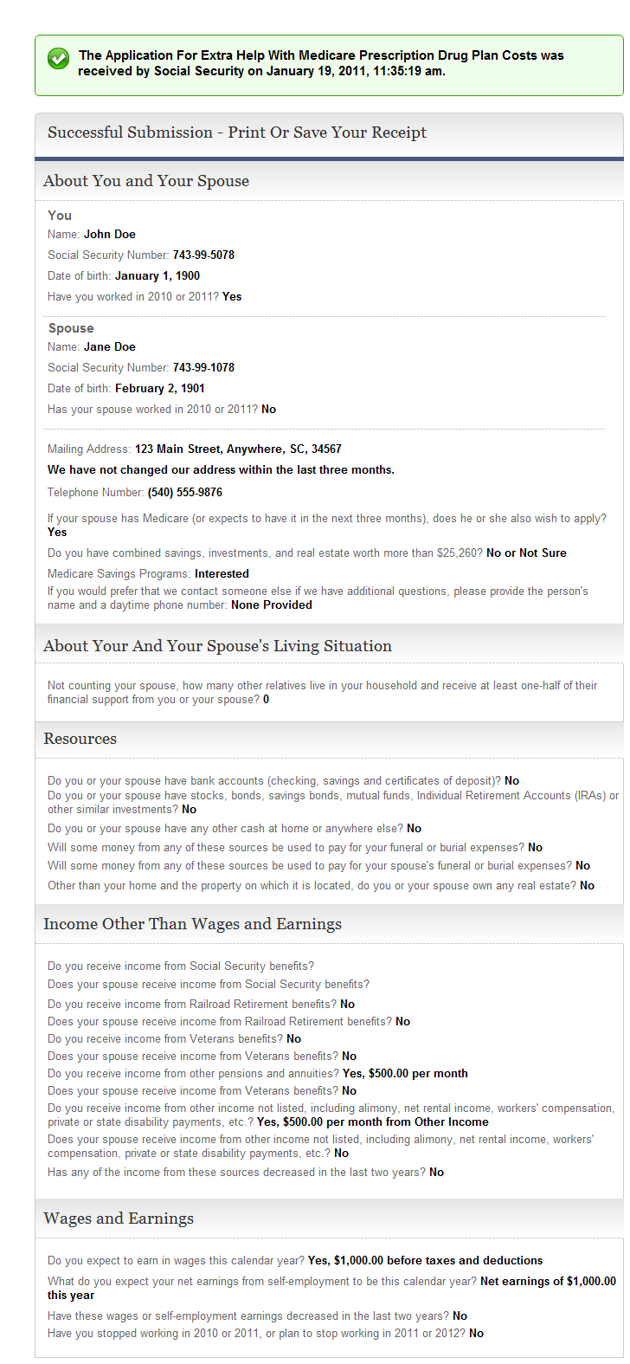
This section houses the same information, however, the layout has been changed to a single column view.
  - Unsuccessful Submission
    - User Interface
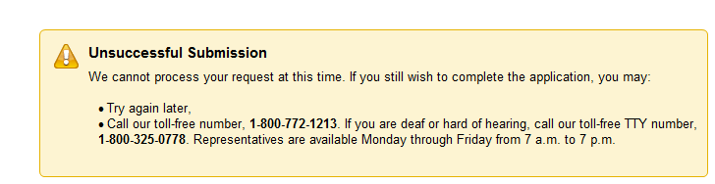
A
  - Message Pages
- This information is not highlighted using a shaded box.
“Please Confirm” message pages have been removed as they are no longer required with the navigational changes.

Authentication - Medicare Part D Database Not Eligible Or SSI Recipient
    - User Interface
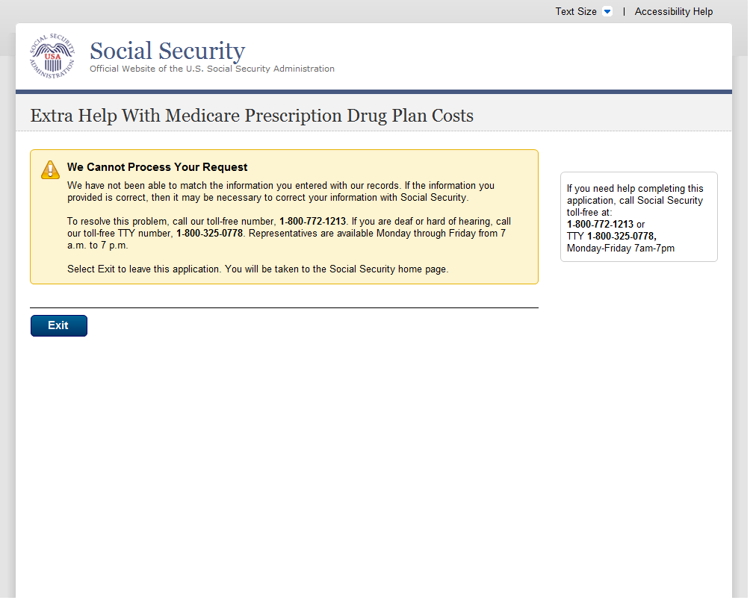
  - Check The Social Security Number You Entered
    - User Interface
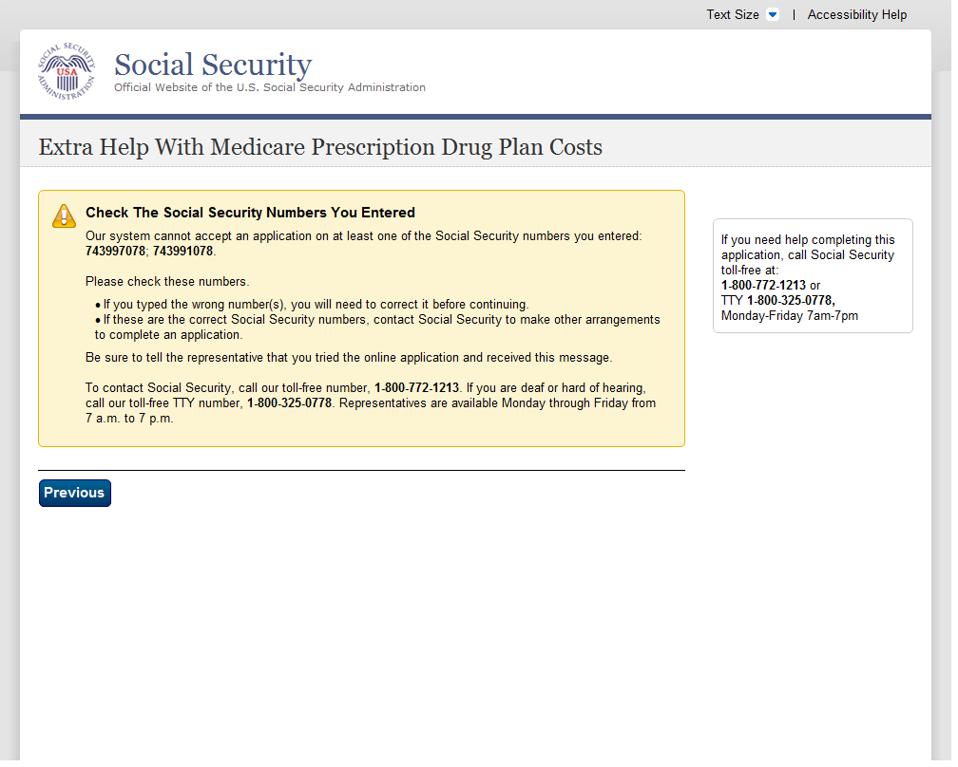
  - How The Online Application Works
    - User Interface
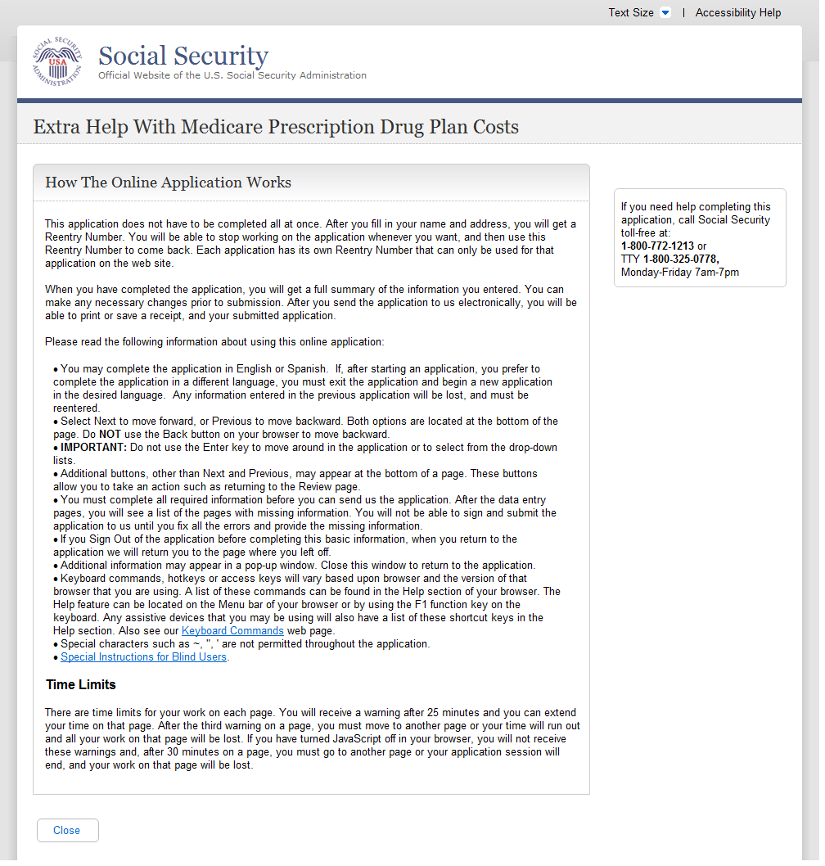
A
A
  - Privacy Act Statement
- Added new language to accommodate new Spanish language option.
    - User Interface
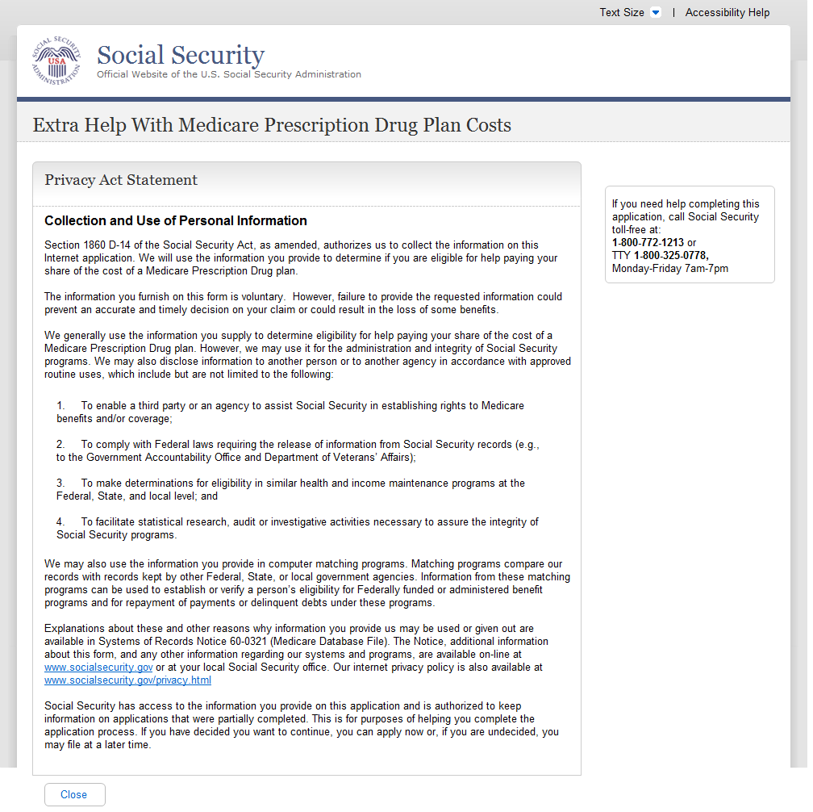
  - Internet Security Policy
This is a new message page. In the current application, the privacy act statement is on the welcome page. In the new application, on the welcome page, there is a link to the privacy act statement. When the user clicks on the link, it takes the user to this page.
    - User Interface
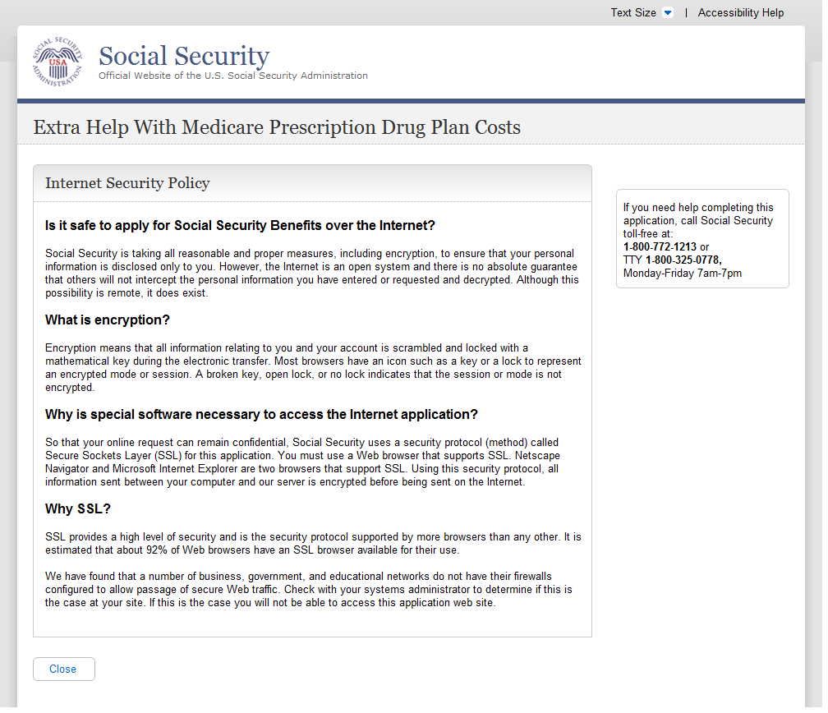

Limit Number Of Restarts
    - User Interface
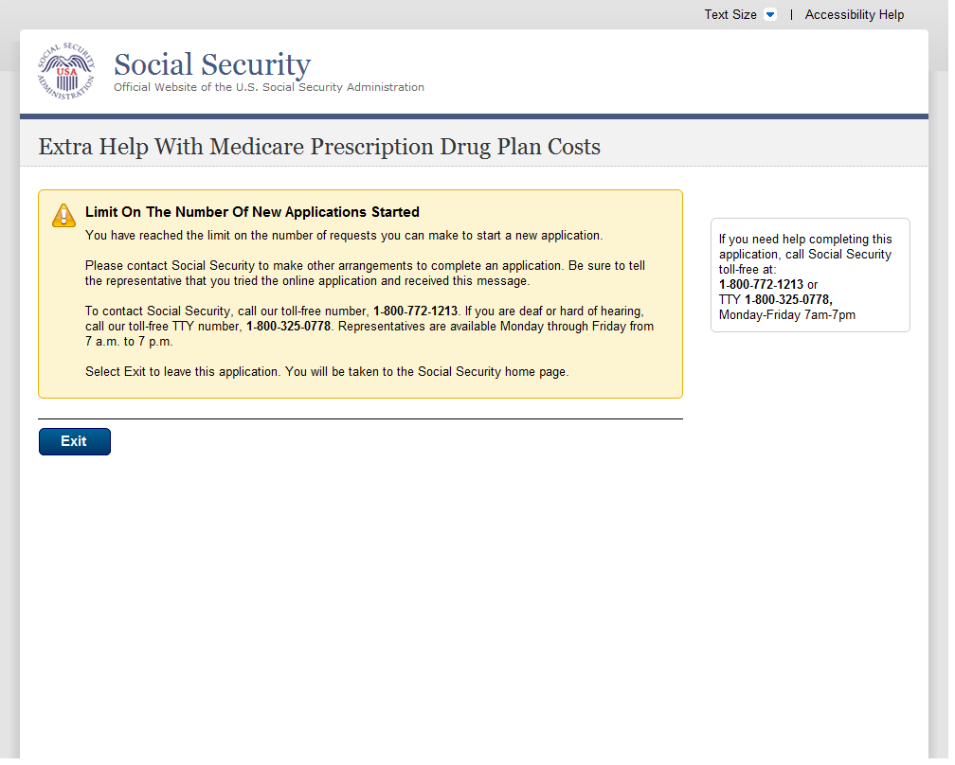
  - Limit Number Of Starts For A New Application
    - User Interface
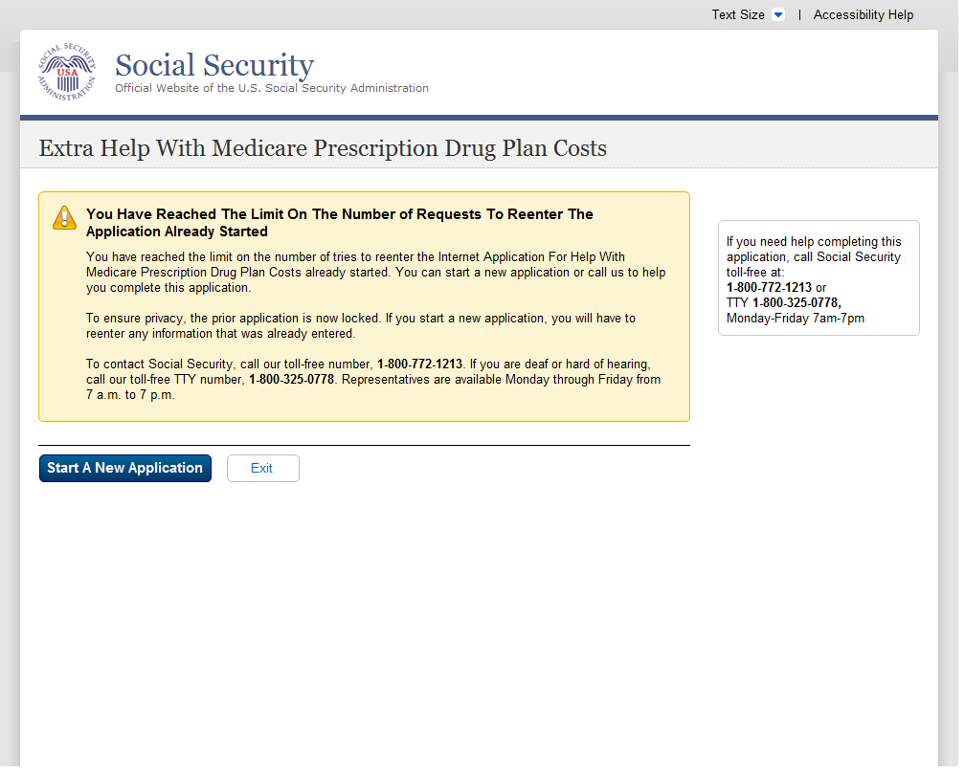
  - Limit On The Number Of Tries To Start An Application
    - User Interface
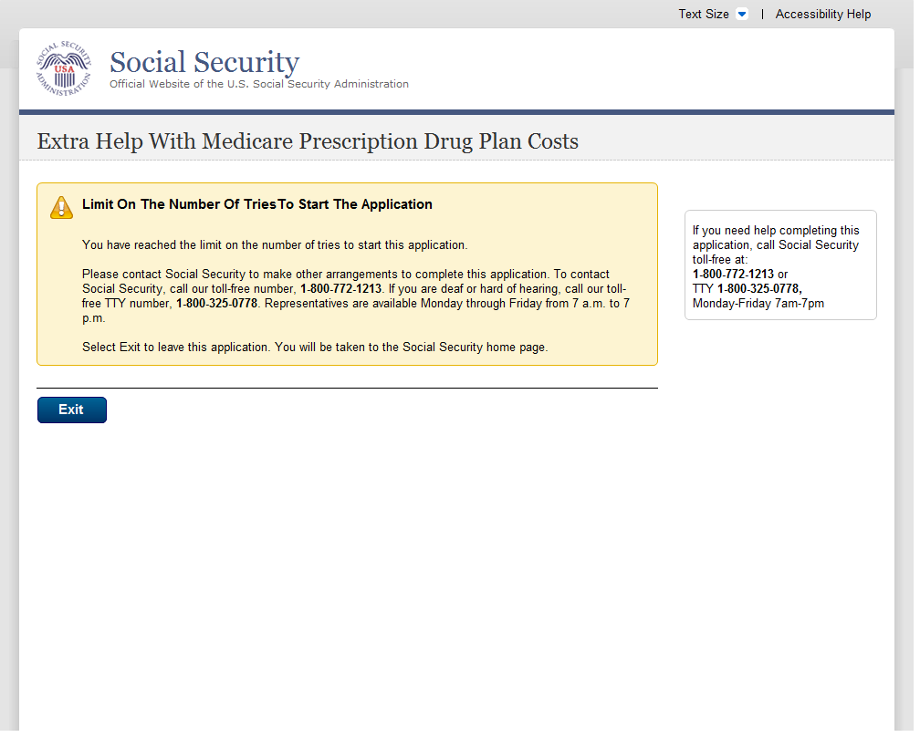
  - Name Check Mismatch
    - User Interface
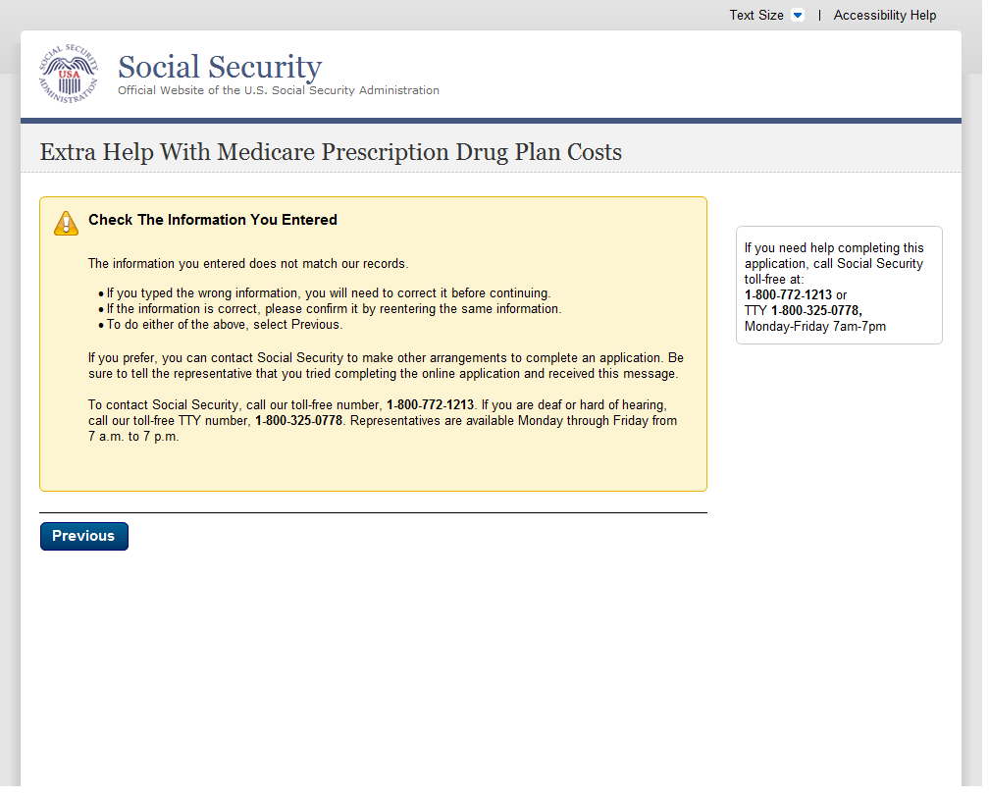
  - Not Eligible For The Prescription Drug Plan
    - User Interface
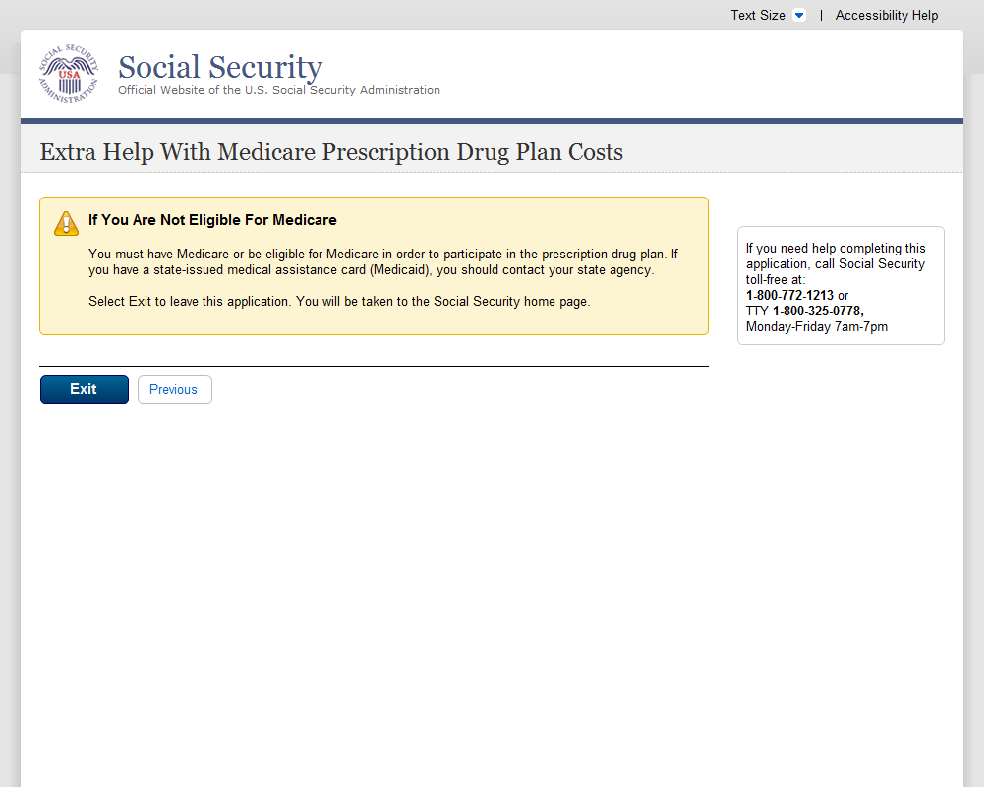
  - Off Hours Message
    - User Interface
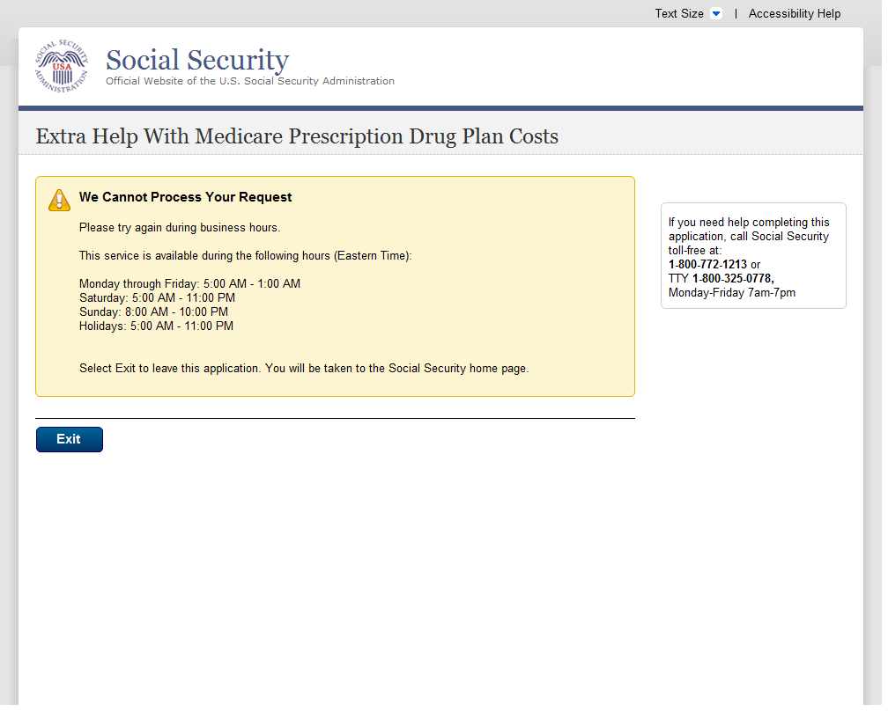
  - Other Ways To Apply
    - User Interface
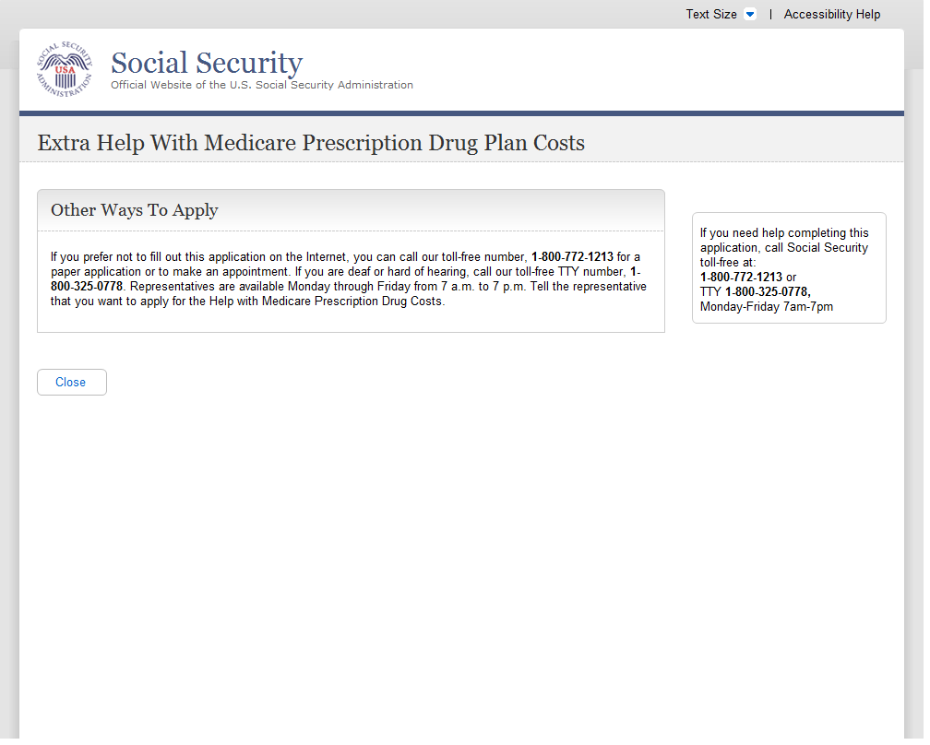
  - Paperwork Reduction Act Statement
    - User Interface
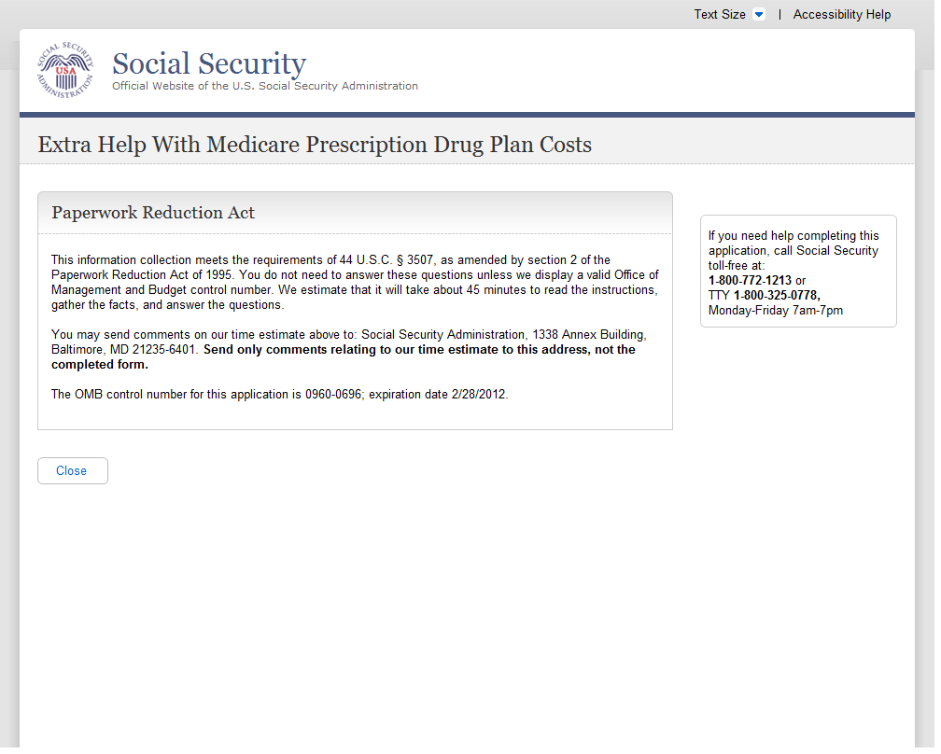
  - Print/Save/View Guide
    - User Interface
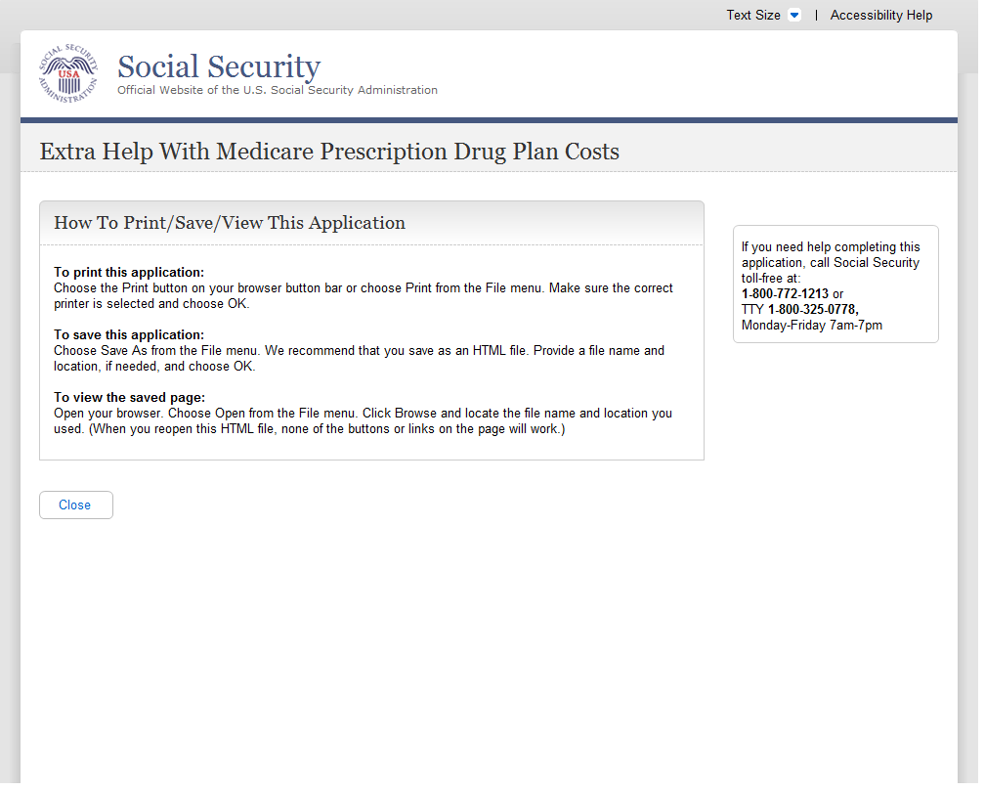
  - Processing Alert
    - User Interface
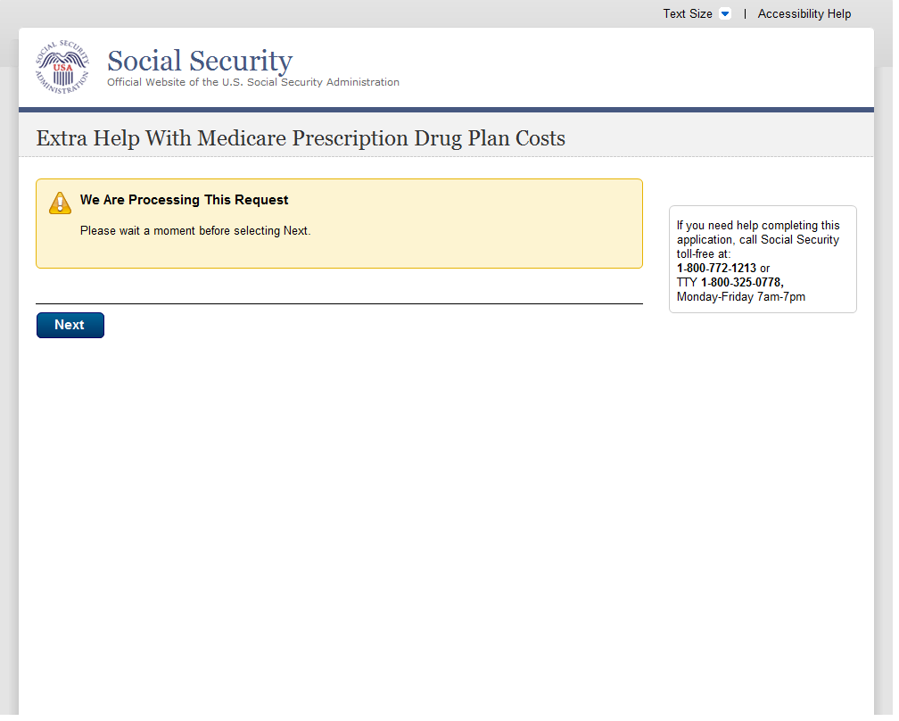
A
  - Sign-In Problem
- Changed text from “Continue” to “Next” due to navigational changes.
    - User Interface
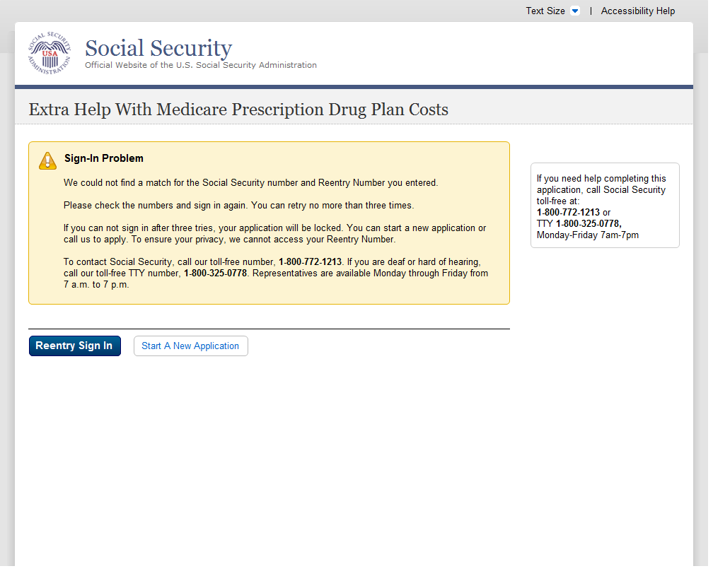
  - Special Instructions For Blind Users
    - User Interface
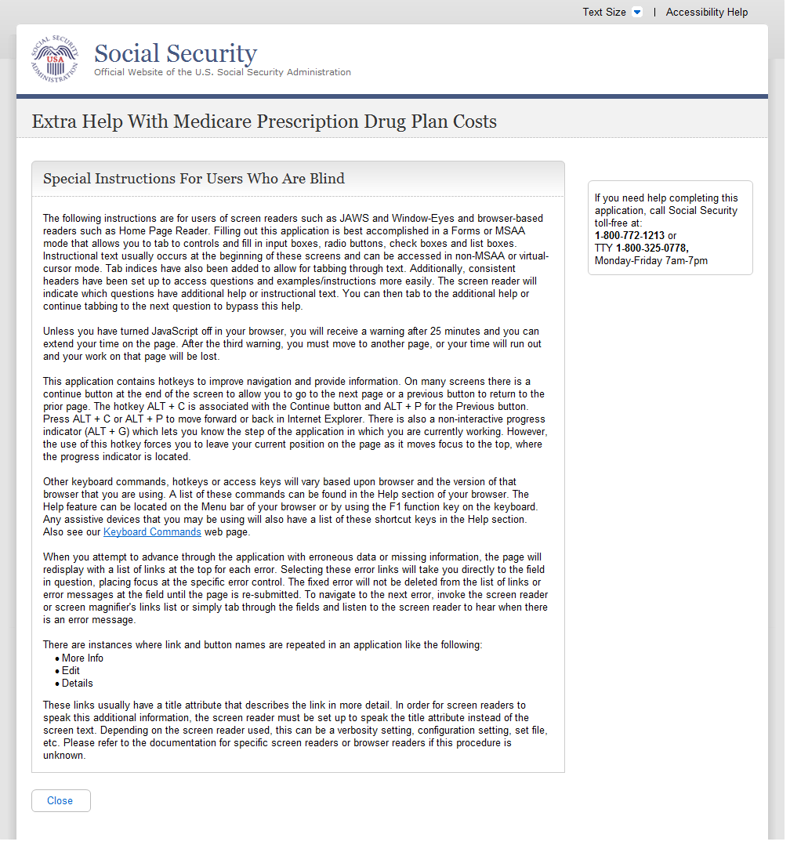
  - System Failure
    - User Interface
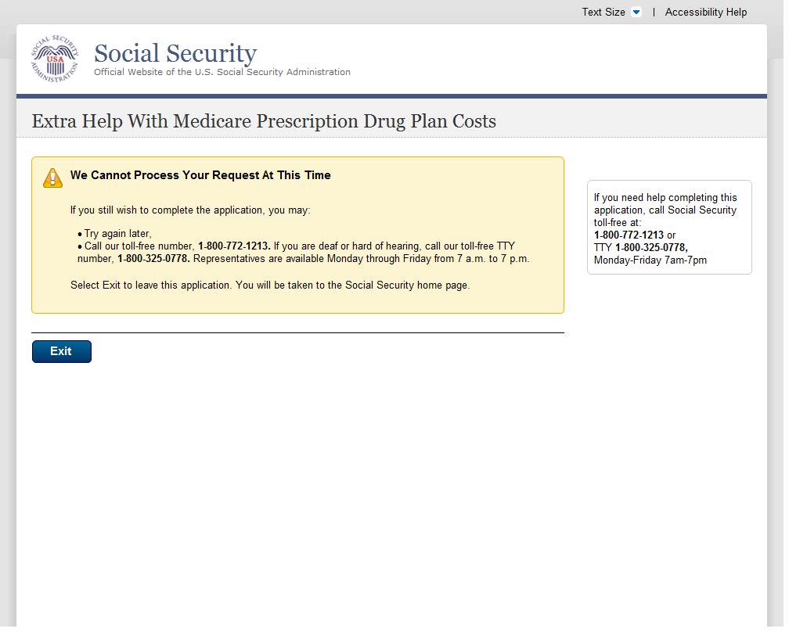
  - There Is A Pending Application For This Social Security Number
    - User Interface
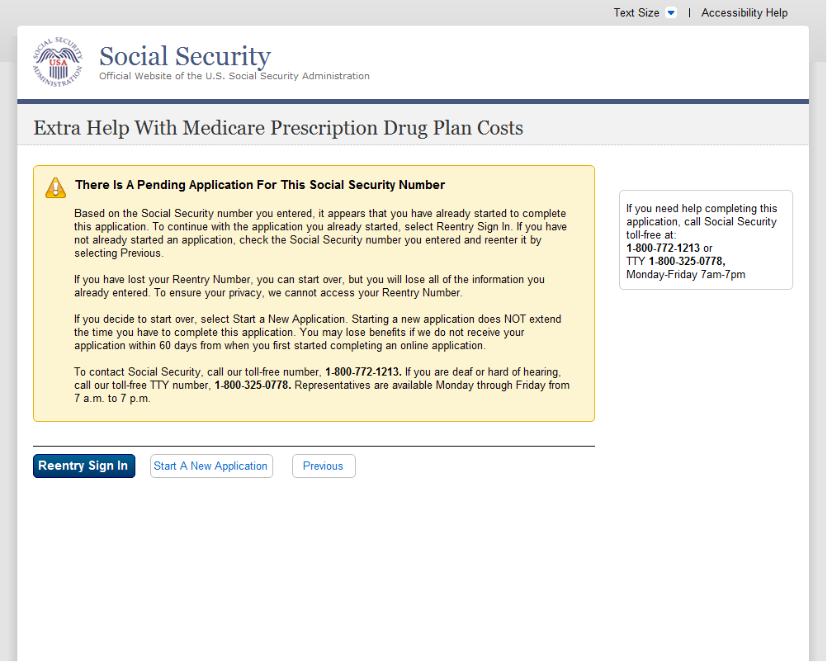
  - Warning System Shutdown
    - User Interface
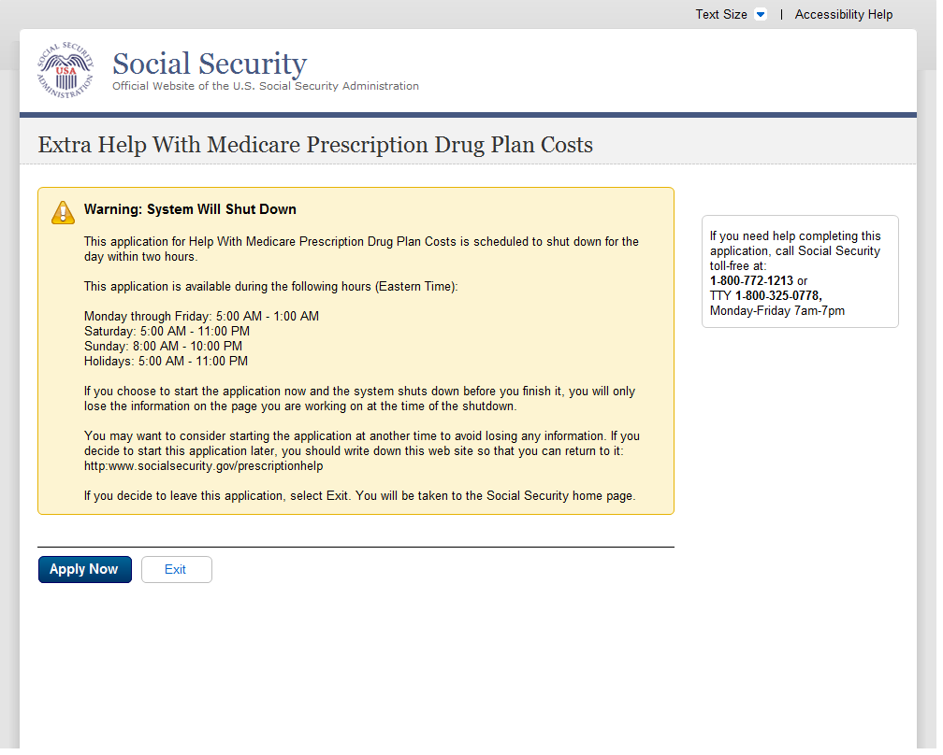
  - We Cannot Process Your Request
    - User Interface
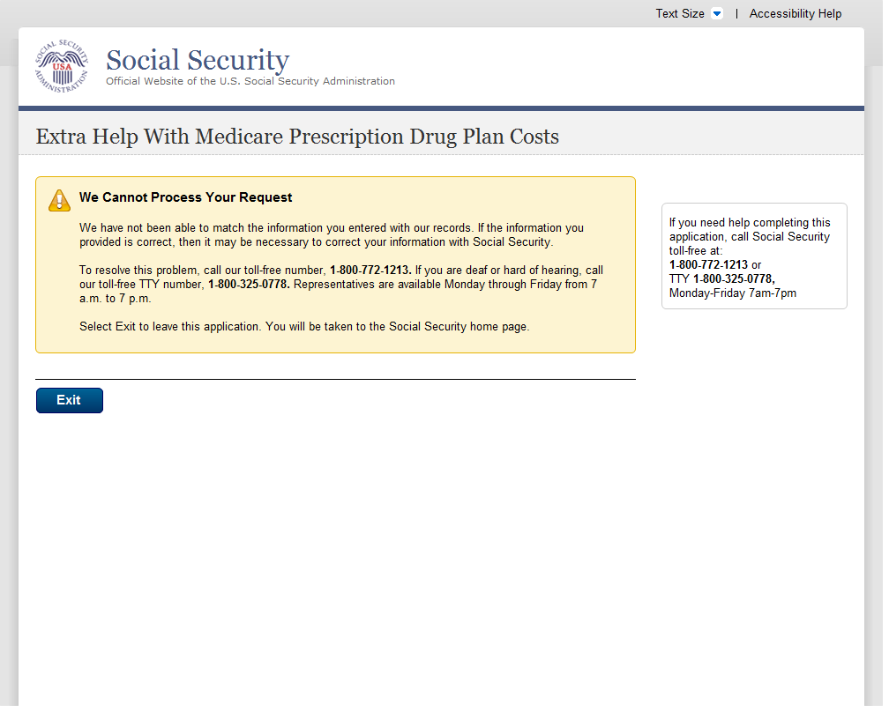
  - What You Will Need
    - User Interface
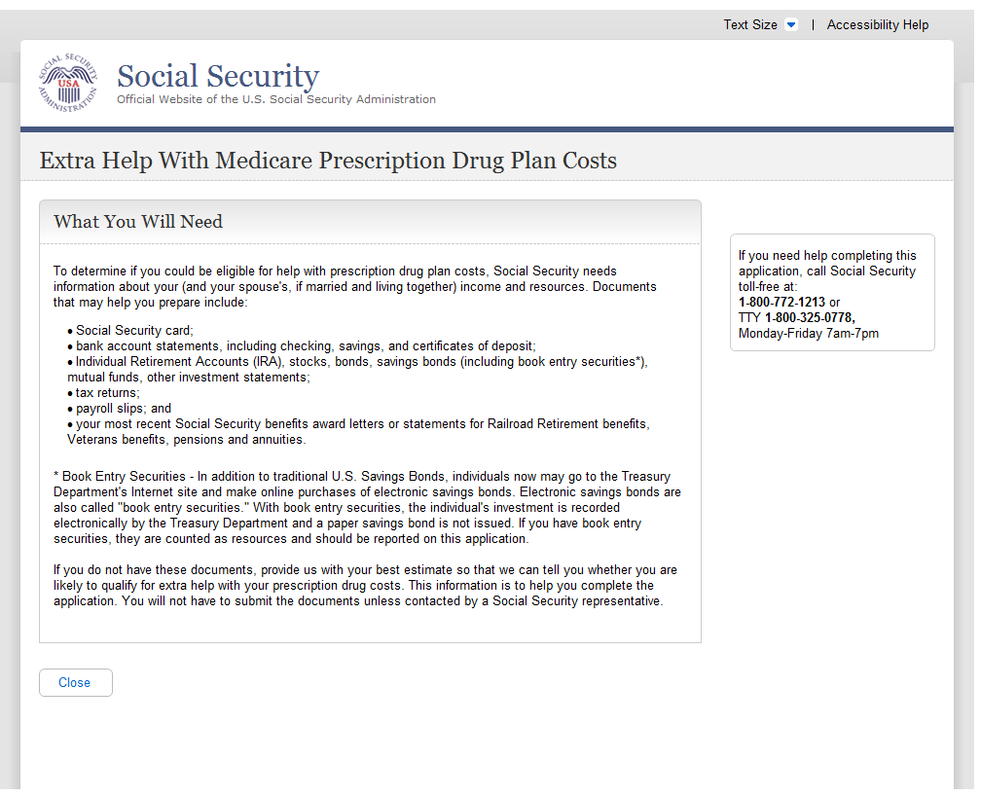
  - You Do Not Live In One Of The 50 States Or DC
    - User Interface
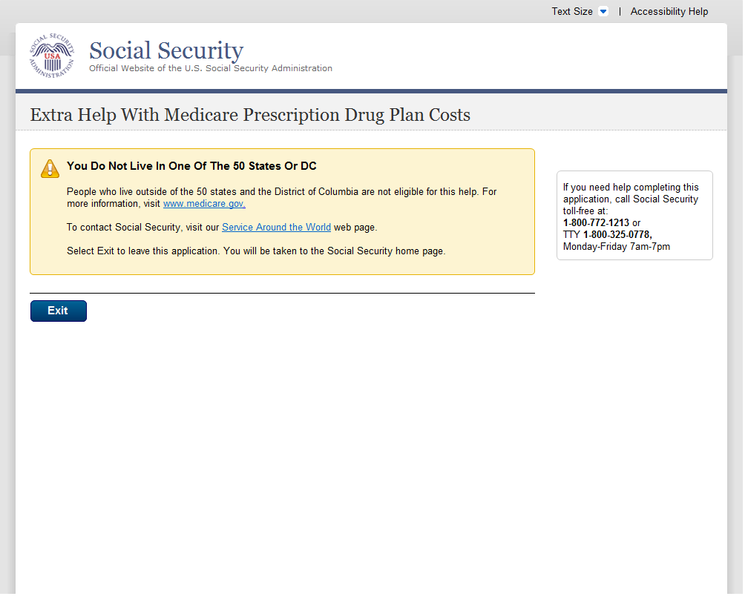
  - You Have Already Sent Us An Application
    - User Interface
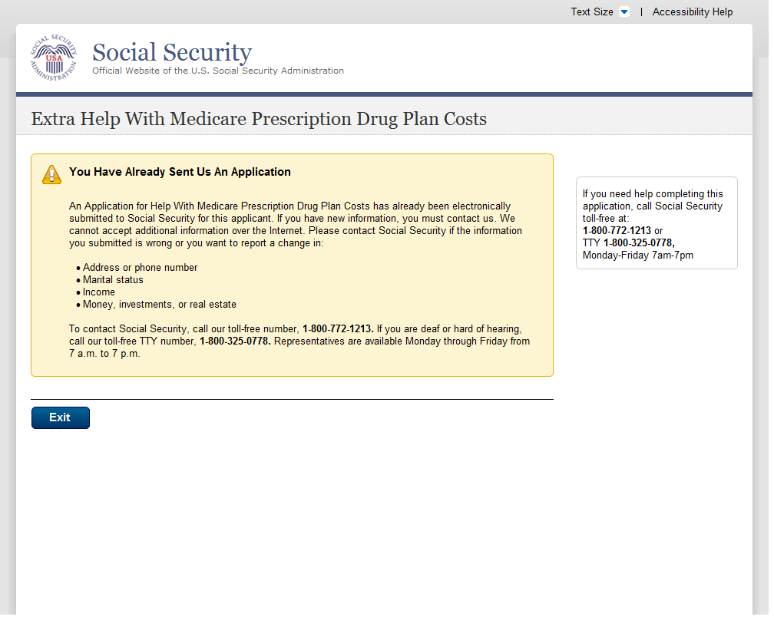
  - Your Session Has Expired
    - User Interface
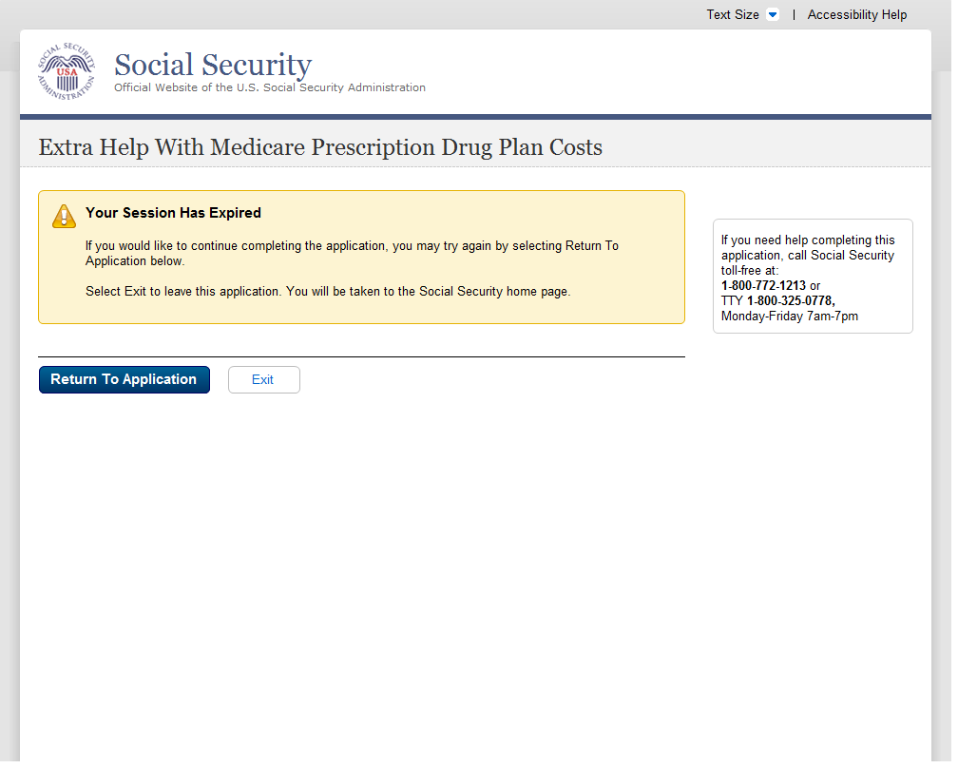
  - Help Pages
  - Main Help Pages
    - User Interface
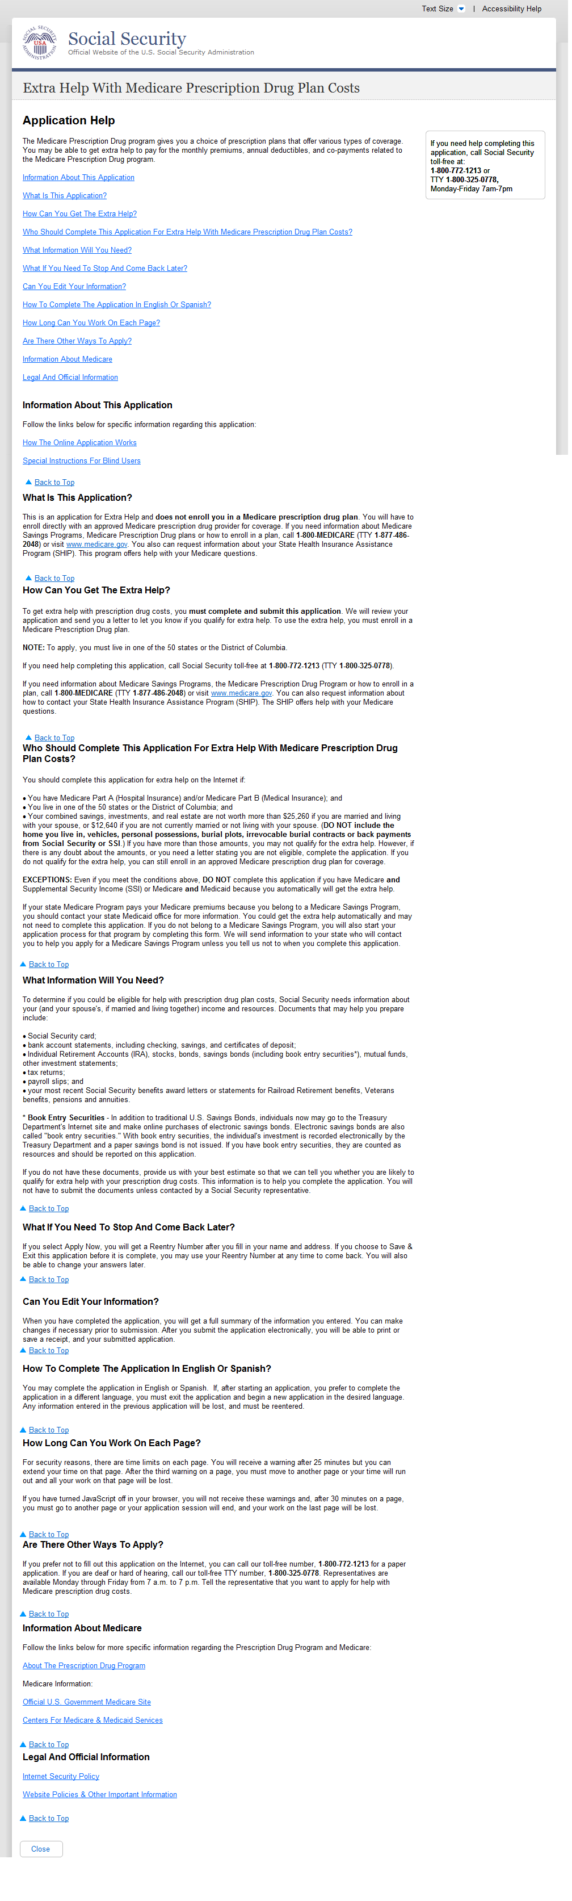
B
A
C
A
  - Help: Are you assisting someone (other than your spouse who lives with you) with this application?
- If you choose to Sign Out of changed to If you choose to Save & Exit
- New Section Added to explain to the user that the application could be completed in English or Spanish. This section also explains to the user how to change languages if he/she has already started an application.
- Removed language Close this window to return to the application. Replace with a left justified button that states Close.
    - User Interface

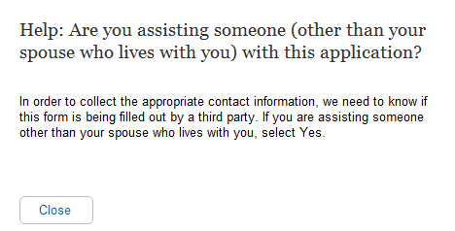
  - Help: Did you (or your spouse, if married and living together) get an application in the mail from us?
    - User Interface
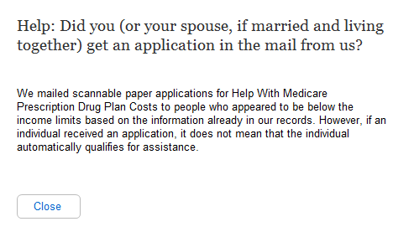
  - Help: Do you (or your spouse, if married and living together) have Medicare?
    - User Interface
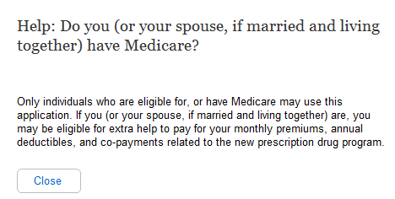
  - Help: Are you (or your spouse, if married and living together) 64 years and 9 months old or older?
    - User Interface
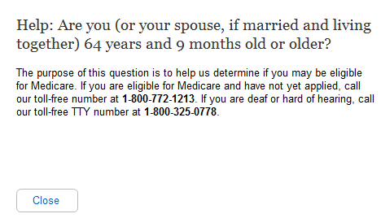
  - Help: Have you (or your spouse, if married and living together) received:
    - User Interface
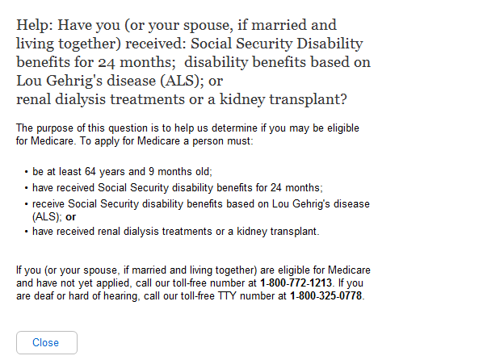
A
  - Help: In which state do you (or your spouse, if married and living together) live?
- Bullets have been removed from the help question. The types of benefits are in list form, instead of in bullet form.
    - User Interface
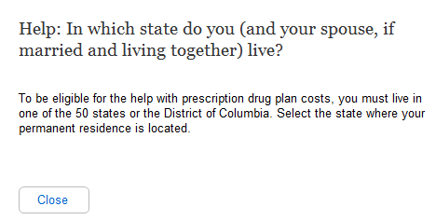
  - Help: What is your marital status?
    - User Interface
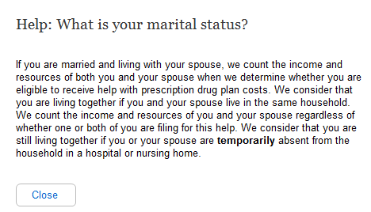
  - Help: Do you have combined savings, investments, and real estate worth more than:
    - User Interface
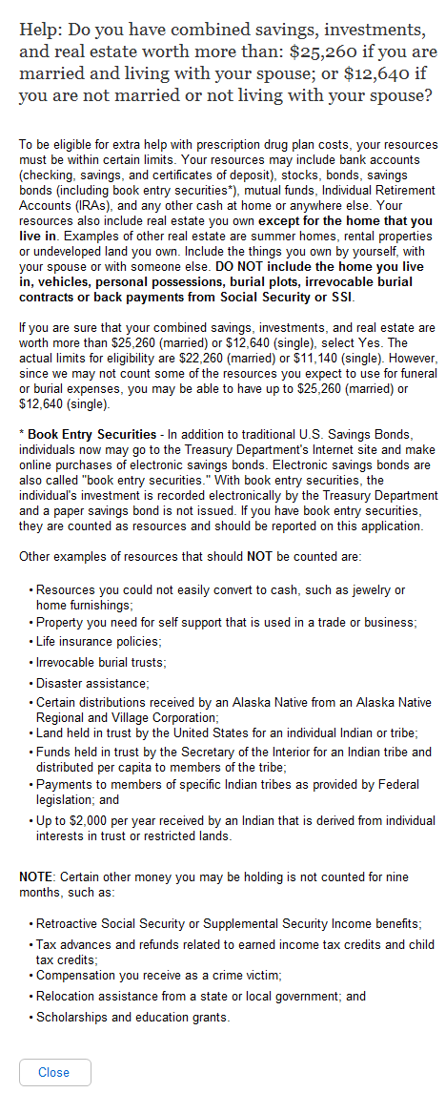
  - Help: Have you worked in 2010 or 2011?
    - User Interface
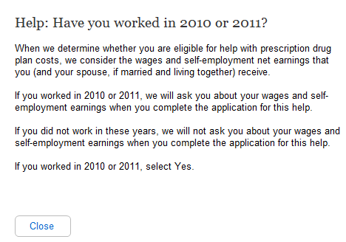
B
A
  - Help: Has your spouse worked in 2010 or 2011?
- Removed “(or your spouse, if married and living together)” after the first two words in the sentence “If you”.
- Sentence changed from “If neither you nor your spouse worked in these years, we will not ask you about your wages and self-employment earnings when you complete the application for this help.” to “If you did not work in these years, we will not ask you about your wages and self-employment earnings when you complete the application for this help.”

    - User Interface
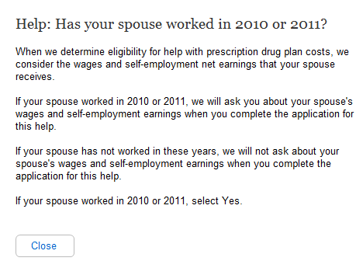
  - Help: Have you worked this calendar year?
New Help Screen. The help in the current application is one help page for many application questions. For the new application, there are individual help screens for each question. In the new application, we separated the applicant and spouse questions, so all the spousal questions are new and therefore all the spousal help pages are new.
    - User Interface
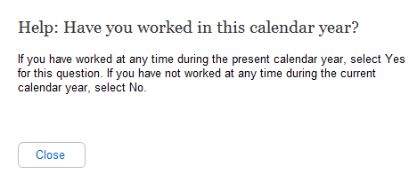
  - Help: Has your spouse worked this calendar year?
    - User Interface
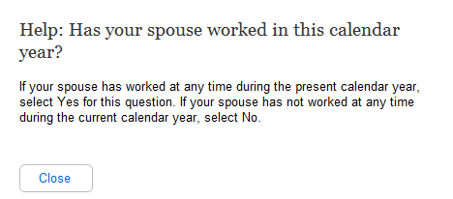
  - Help: Are you UNDER age 65?
    - User Interface
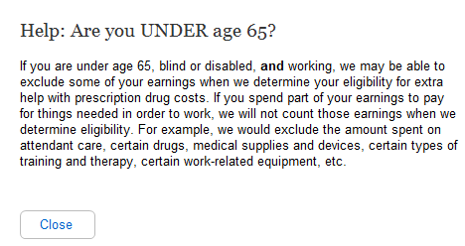
  - Help: Is your spouse UNDER age 65?
    - User Interface
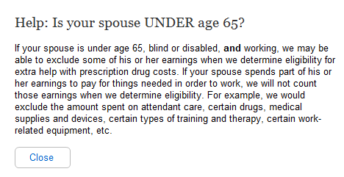
  - Help: Not counting your spouse, how many other relatives live in your household?
    - User Interface
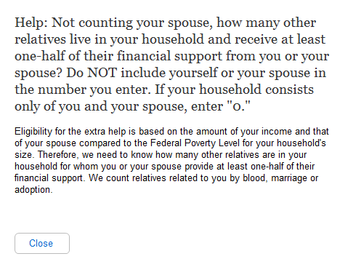
  - Help: How many relatives live in your household and receive at least one-half of their financial support from you?
    - User Interface
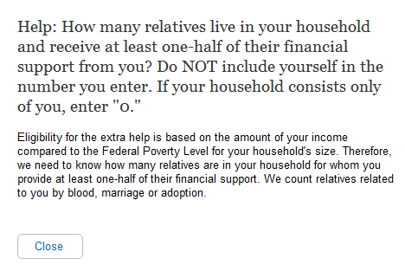
  - Help: Do you have to pay for things related to a disability or blindness that enable you to work?
    - User Interface
A
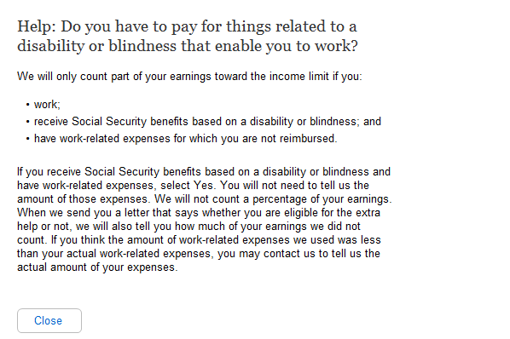
  - Help: Does your spouse have to pay for things that enable him or her to work?

Sentence changed from “Do you or your spouse have to pay for things related to a disability or blindness that enable you to work?” to “Do you have to pay for things related to a disability or blindness that enable you to work?”

    - User Interface
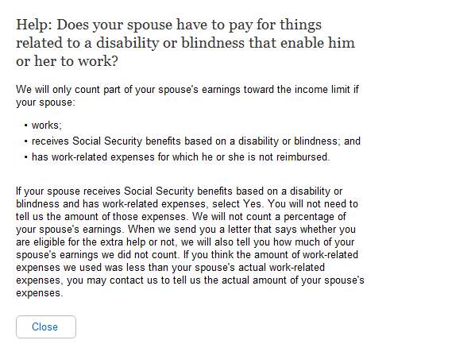
New Help Screen. The help in the current application is one help page for many application questions. For the new application, there are individual help screens for each question. In the new application, we separated the applicant and spouse questions, so all the spousal questions are new and therefore all the spousal help pages are new.

  - Help: Do you expect to earn wages this calendar year?
    - User Interface
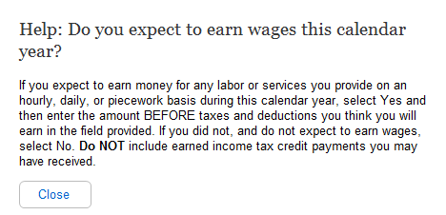
B

A
- Changed Title from “What do you or your spouse expect to earn in wages before taxes and deductibles this calendar year?“ to “Help: Do you expect to earn wages this calendar year?”
- First four words of the first sentence changed from “If you or your spouse” to “If you”.

  - Help: Does your spouse expect to earn wages this calendar year?
    - User Interface
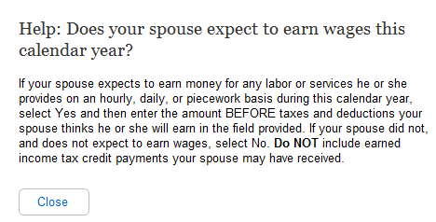
  - Help: What do you expect your net earnings from self-employment to be this calendar year?
New Help Screen. The help in the current application is one help page for many application questions. For the new application, there are individual help screens for each question. In the new application, we separated the applicant and spouse questions, so all the spousal questions are new and therefore all the spousal help pages are new.

    - User Interface
A
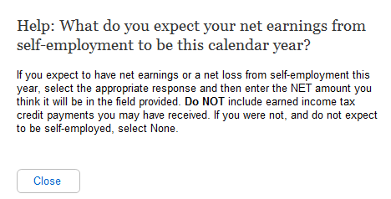
B

  - Help: What does your spouse expect the net earnings from self-employment to be this calendar year?

Changed Title from “What do you or your spouse expect your net earnings from self-employment to be this calendar year?“ to “Help: What do you expect your net earnings from self-employment to be this calendar year?”
- First four words of the first sentence changed from “If you or your spouse” to “If you”.

    - User Interface
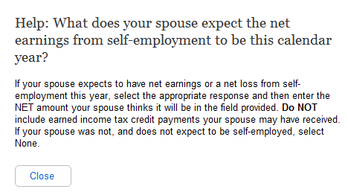
  - Help: Have you stopped working in 2010 or 2011, or plan to stop working in 2011 or 2012?
New Help Screen. The help in the current application is one help page for many application questions. For the new application, there are individual help screens for each question. In the new application, we separated the applicant and spouse questions, so all the spousal questions are new and therefore all the spousal help pages are new.

    - User Interface
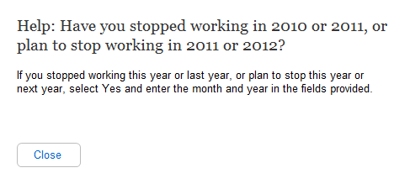
B

A

Question changed from “Have you or your spouse stopped working in 2010 or 2011, or plan to stop working in 2011 or 2012?” to “Help: Have you stopped working in 2010 or 2011, or plan to stop working in 2011 or 2012?”
- First four words of the first sentence changed from “If you or your spouse” to “If you”.

Help: Has you your spouse stopped working in 2010 or 2011, or plan to stop working in 2011 or 2012?
    - User Interface
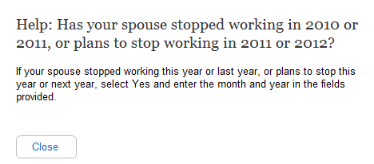
  - Help: Do you receive Social Security benefits?
New Help Screen. The help in the current application is one help page for many application questions. For the new application, there are individual help screens for each question. In the new application, we separated the applicant and spouse questions, so all the spousal questions are new and therefore all the spousal help pages are new.

    - User Interface
A
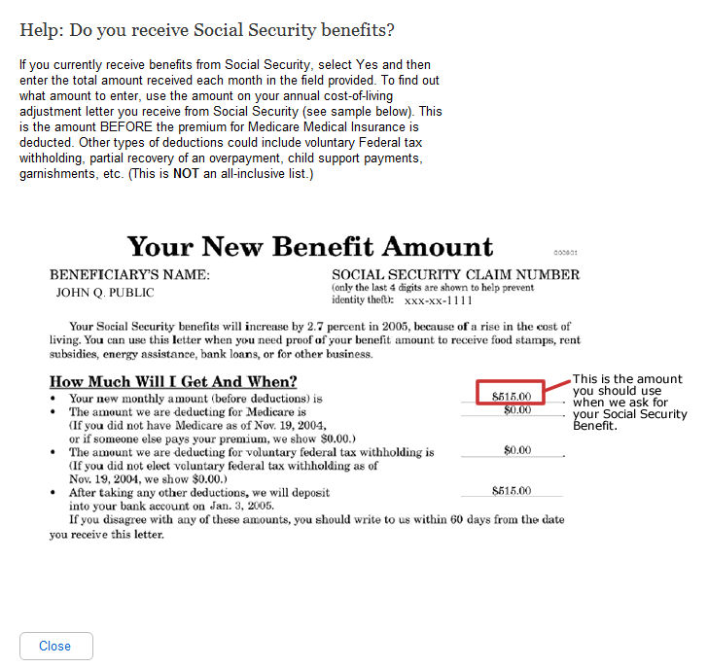
B

  - Help: Does your spouse receive Social Security benefits?
- Question changed from “Do you or your spouse receive Social Security Benefits?” to “Help: Do you receive Social Security benefits?”
- The first words of the first sentence have been changed from “If you or your spouse” to “If you”.
    - User Interface
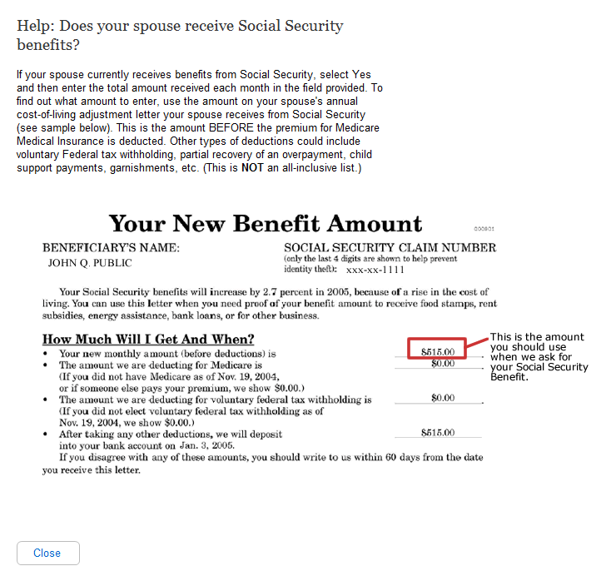
  - Help: Do you receive Railroad Retirement benefits?
New Help Screen. The help in the current application is one help page for many application questions. For the new application, there are individual help screens for each question. In the new application, we separated the applicant and spouse questions, so all the spousal questions are new and therefore all the spousal help pages are new.

    - User Interface
A
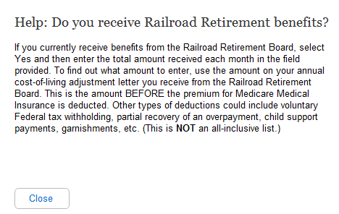
B

  - Help: Does your spouse receive Railroad Retirement benefits?
- Question changed from “Do you or your spouse receive Railroad Retirement Benefits?” to “Help: Do you receive Railroad Retirement Benefits?”
- First words of first sentence changed from “If you or your spouse” to “If you”
    - User Interface
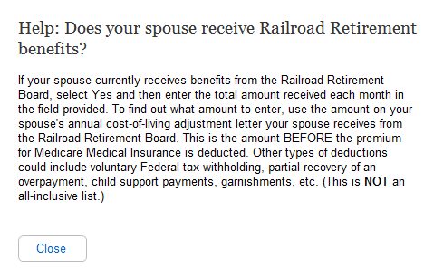
  - Help: Do you receive Veterans benefits?
New Help Screen. The help in the current application is one help page for many application questions. For the new application, there are individual help screens for each question. In the new application, we separated the applicant and spouse questions, so all the spousal questions are new and therefore all the spousal help pages are new.

    - User Interface
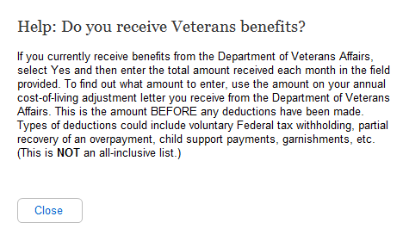
B

A
- Question changed from “Do you or your spouse receive Veterans Benefits?” to “Help: Do you receive Veterans Benefits?”
- First words of first sentence changed from “If you or your spouse” to “If you”

  - Help: Does your spouse receive Veterans benefits?
    - User Interface
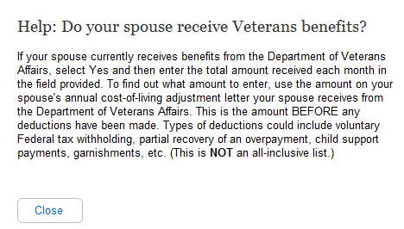
  - Help: Do you receive income from other pensions or annuities?
New Help Screen. The help in the current application is one help page for many application questions. For the new application, there are individual help screens for each question. In the new application, we separated the applicant and spouse questions, so all the spousal questions are new and therefore all the spousal help pages are new.

    - User Interface
A
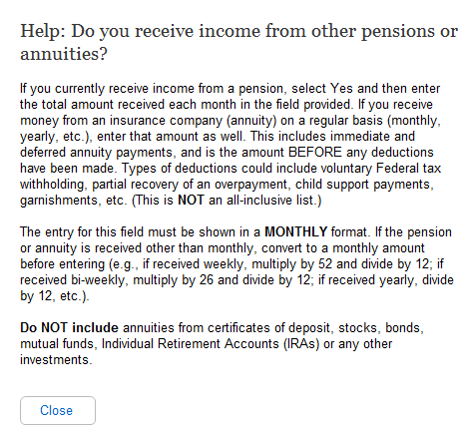

C

B

  - Help: Does your spouse receive income from other pensions or annuities?
- Question changed from “Do you or your spouse receive income from other pensions or annuities?” to “Help: Do you receive income from other pensions or annuities?”
- First two sentences changed from “If you or your spouse currently receive income from a pension, enter the total amount received each month in this field. If you receive money from an insurance company (annuity) on a regular basis (monthly, yearly, etc.), enter that amount in this field as well.” to “If you currently receive income from a pension, select Yes and then enter the total amount received each month in the field provided. If you receive money from an insurance company (annuity) on a regular basis (monthly, yearly, etc.), enter that amount as well.”
- Included the words Individual Retirement Accounts (IRAs).

    - User Interface
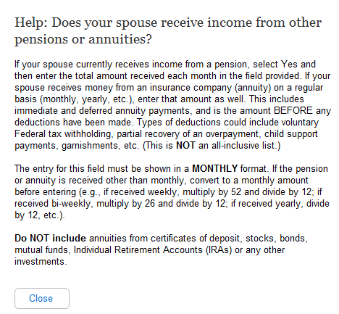
  - Help: Do you receive other income not listed above, including alimony, net rental income, workers' compensation, etc.?
New Help Screen. The help in the current application is one help page for many application questions. For the new application, there are individual help screens for each question. In the new application, we separated the applicant and spouse questions, so all the spousal questions are new and therefore all the spousal help pages are new.

    - User Interface
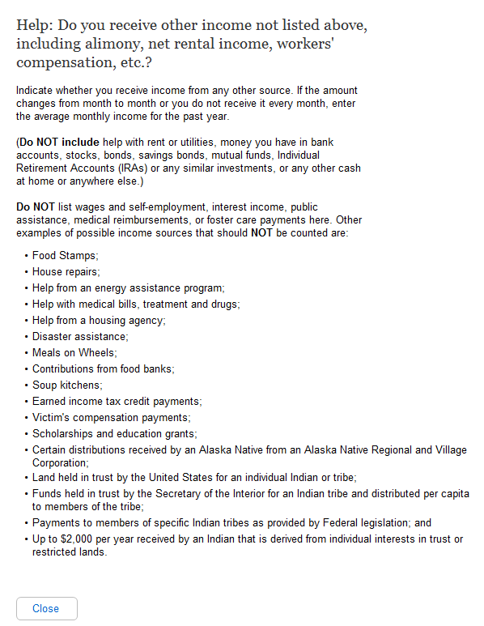
B

A

Question changed from “Do you or your spouse receive other income not listed above, including alimony, net rental income, workers' compensation, private or state disability payments, etc.?” to “Help: Do you receive other income not listed above, including alimony, net rental income, workers' compensation, etc.?”
- First words of first sentence changed from “Indicate whether you or your spouse” to “Indicate whether you”

  - Help: Does your spouse receive other income not listed above, including alimony, net rental income, workers' compensation, etc.?
    - User Interface
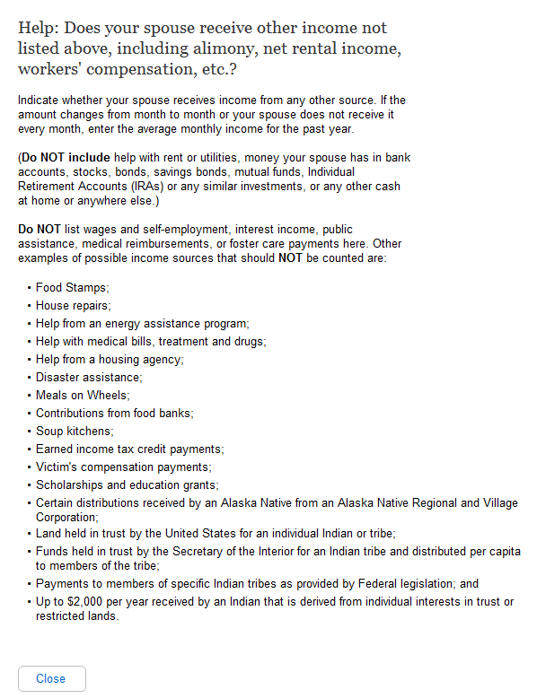
  - Help: Your Name
New Help Screen. The help in the current application is one help page for many application questions. For the new application, there are individual help screens for each question. In the new application, we separated the applicant and spouse questions, so all the spousal questions are new and therefore all the spousal help pages are new.

    - User Interface
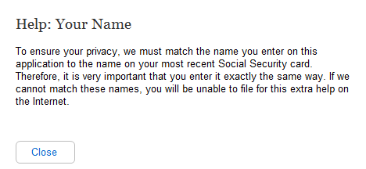
  - Help: Your Social Security Number
    - User Interface
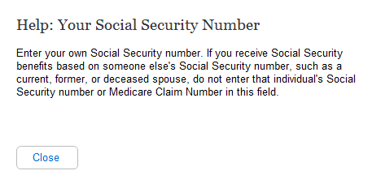
  - Help: What is your date of birth?
    - User Interface
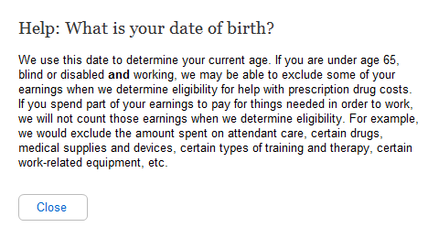
  - Help: Spouse's Name
    - User Interface
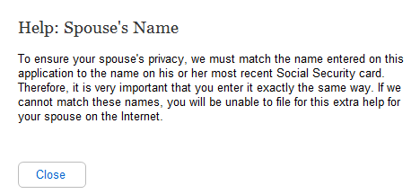
  - Help: Spouse's Social Security Number
    - User Interface
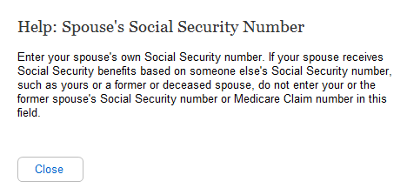
  - Help: What is your spouse's date of birth?
    - User Interface
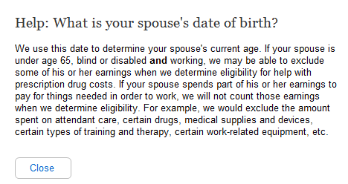
  - Help: Your Mailing Address
    - User Interface
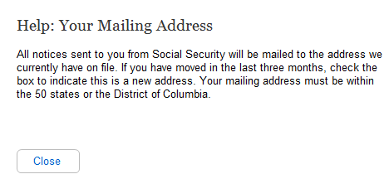
  - Help: Your Phone Number
    - User Interface
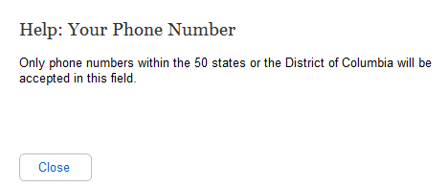
  - Help: If your spouse has Medicare (or expects to have it in the next three months), does he or she also wish to apply?
    - User Interface
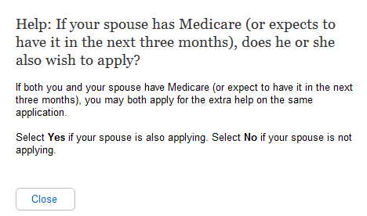
  - Help: Do you have combined savings, investments, and real estate worth more than $25,260?
    - User Interface
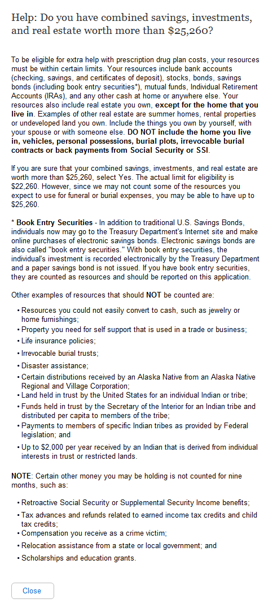
  - Help: OPTIONAL: (contact person)
    - User Interface
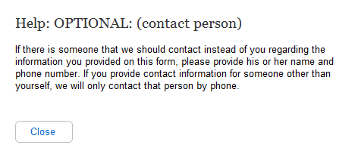
  - Help: Contact's Phone Number
    - User Interface
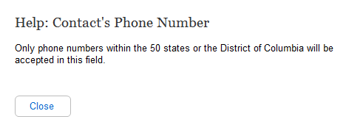
  - Help: Do you have combined savings, investments, and real estate worth more than $12,640?
    - User Interface
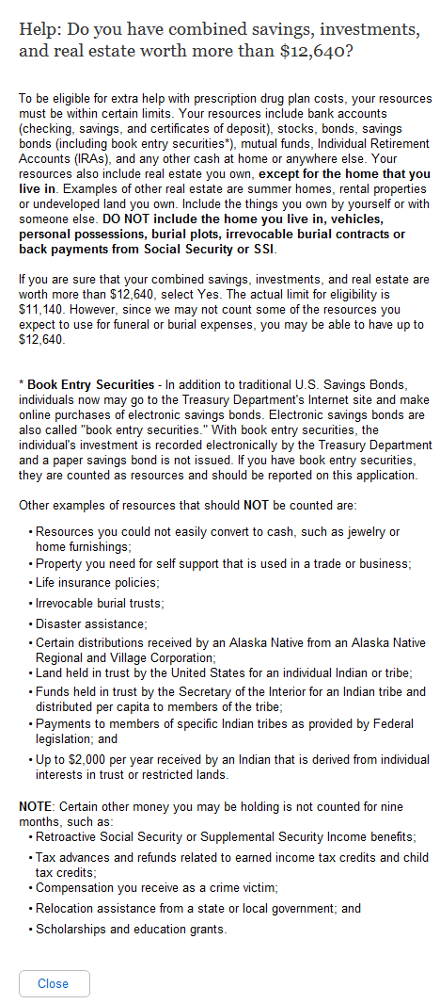
  - Help: Relationship to Applicant
    - User Interface
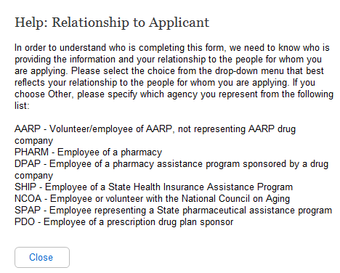
  - Help: Form Completer's Phone Number
    - User Interface
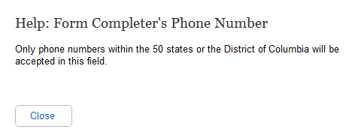
  - Help: Form Completer's Address
    - User Interface
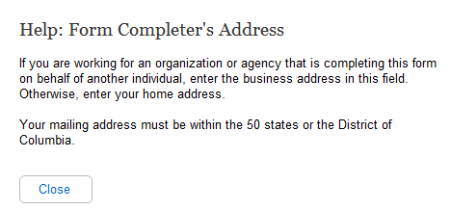
  - Help: Primary Applicant's Name
    - User Interface
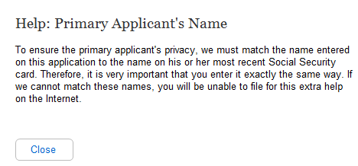
  - Help: Primary Applicant's Social Security Number
    - User Interface
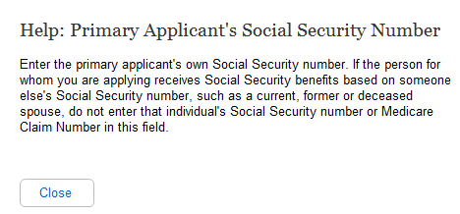
  - Help: What is the primary applicant's date of birth?
    - User Interface
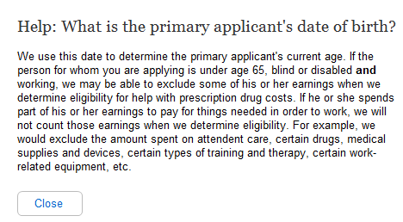
  - Help: Has the primary applicant worked in 2010 or 2011?
    - User Interface
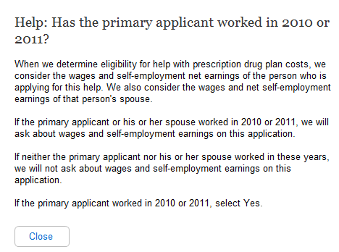
  - Help: If the spouse has Medicare (or expects to have it in the next three months), does he or she also wish to apply?
    - User Interface
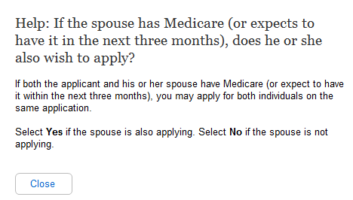
  - Help: Do the applicants have combined savings, investments, and real estate worth more than $25,260?
    - User Interface
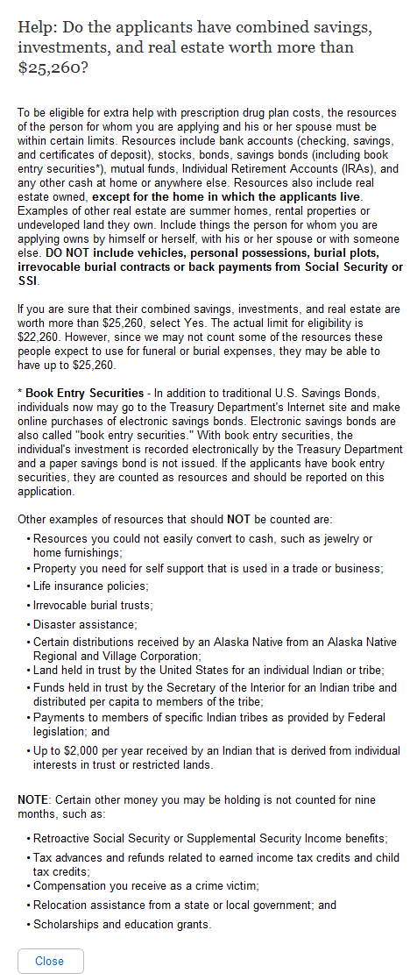
  - Help: Spouse's Name
    - User Interface
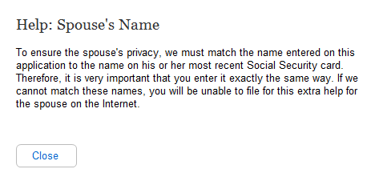
  - Help: Spouse's Security Number
    - User Interface
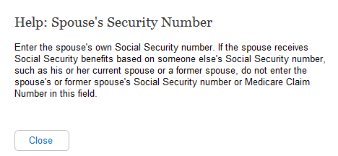
  - Help: What is the spouse's date of birth?
    - User Interface
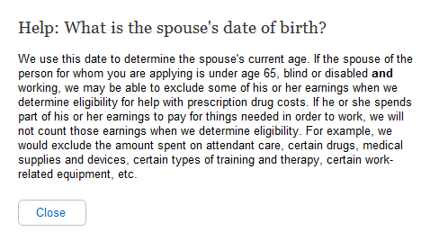
  - Help: Has the applicant's spouse worked in 2010 or 2011?
    - User Interface
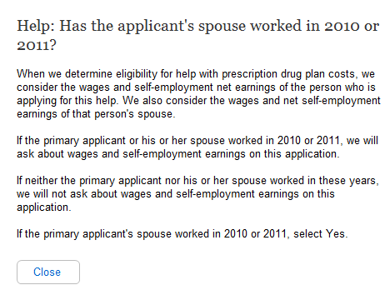
  - Help: Mailing Address
    - User Interface
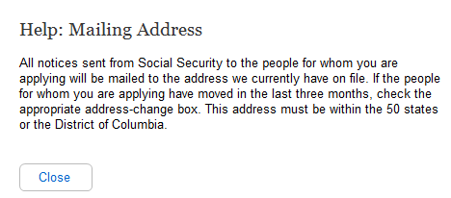
  - Help: Phone Number
    - User Interface
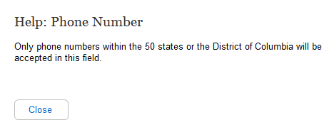
  - Help: Applicant's Name
    - User Interface
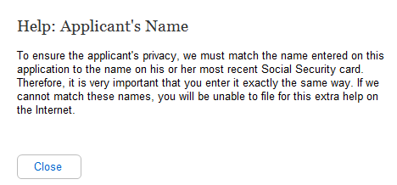
  - Help: Applicant's Social Security Number
    - User Interface
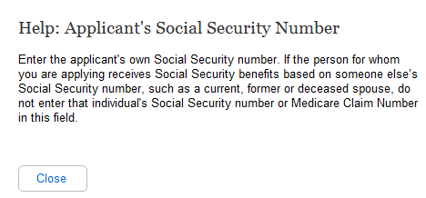
  - Help: What is the applicant's date of birth?
    - User Interface
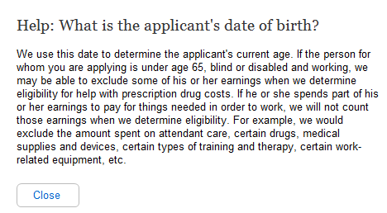
  - Help: Has the applicant worked in 2010 or 2011?
    - User Interface
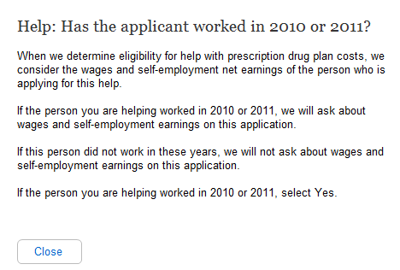
  - Help: Does the applicant have combined savings, investments, and real estate worth more than $12,640?
    - User Interface
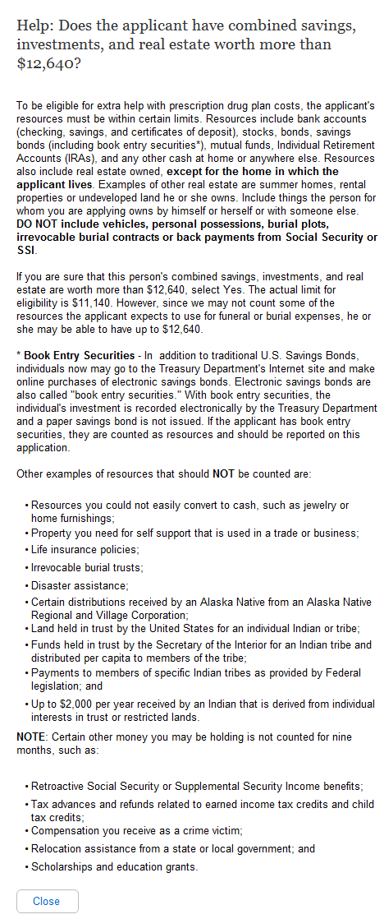
  - Help: Have these wages or self-employment earnings decreased in the last two years?
    - User Interface
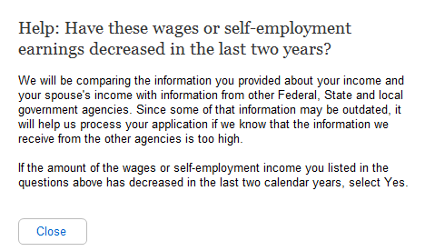
  - Help: Have these wages or self-employment earnings decreased in the last two years?
    - User Interface
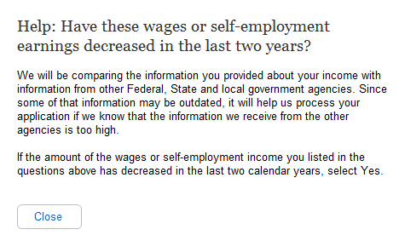
  - Help: Has any of the income from these sources decreased in the last two years?
    - User Interface
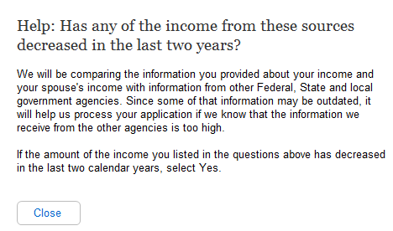
  - Help: Has any of the income from these sources decreased in the last two years?
    - User Interface
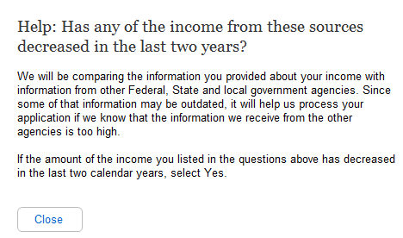
  - Help: Do you or your spouse have bank accounts (checkings, savings and certificates of deposit)?
    - User Interface
A
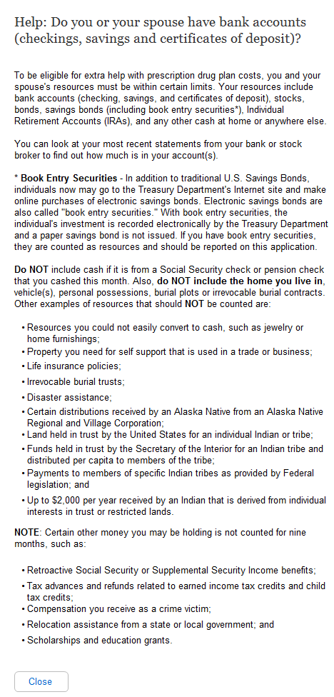
  - Help: Do you or your spouse have stocks, bonds, savings bonds, mutual funds, Individual Retirement Accounts or other similar investments?

Changed from “Do you or your spouse have any of the following resources? If Yes, enter the combined total for those items.
Combined total of all bank accounts (checking, savings and certificates of deposit)
Combined total of all stocks, bonds, savings bonds, mutual funds, Individual Retirement Accounts or other similar investments
Any other cash at home or anywhere else” to “Help: Do you or your spouse have bank accounts (checking, savings and certificates of deposit)?”

    - User Interface
A
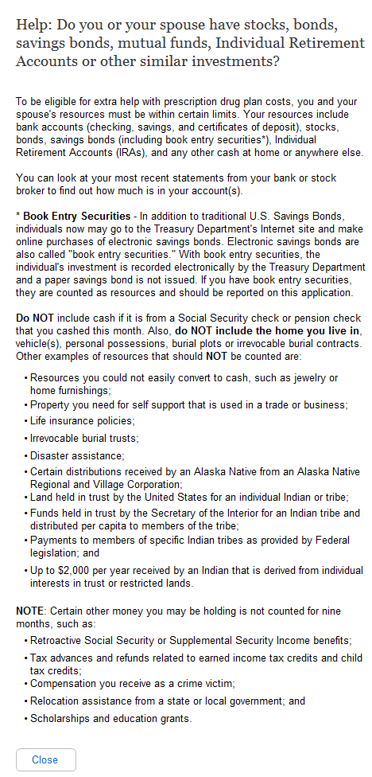

Changed from “Do you or your spouse have any of the following resources? If Yes, enter the combined total for those items.
Combined total of all bank accounts (checking, savings and certificates of deposit)
Combined total of all stocks, bonds, savings bonds, mutual funds, Individual Retirement Accounts or other similar investments
Any other cash at home or anywhere else” to “Help: Do you or your spouse have stocks, bonds, savings bonds, mutual funds, Individual Retirement Accounts or other similar investments?”

  - Help: Do you or your spouse have any other cash at home or anywhere else?
    - User Interface
A
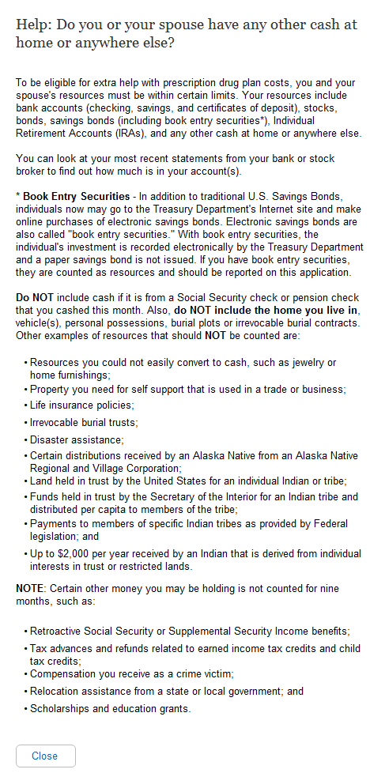
  - Help: Do you have bank accounts (checkings, savings and certificates of deposit)?

Changed from “Do you or your spouse have any of the following resources? If Yes, enter the combined total for those items.
Combined total of all bank accounts (checking, savings and certificates of deposit)
Combined total of all stocks, bonds, savings bonds, mutual funds, Individual Retirement Accounts or other similar investments
Any other cash at home or anywhere else” to “Help: Do you or your spouse have any other cash at home or anywhere else?”

    - User Interface
A
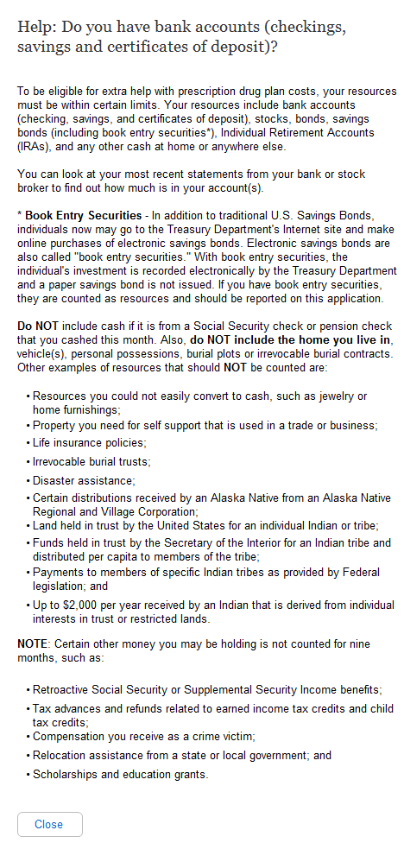
  - Help: Do you have stocks, bonds, savings bonds, mutual funds, Individual Retirement Accounts or other similar investments?

Changed from “Do you or your spouse have any of the following resources? If Yes, enter the combined total for those items.
Combined total of all bank accounts (checking, savings and certificates of deposit)
Combined total of all stocks, bonds, savings bonds, mutual funds, Individual Retirement Accounts or other similar investments
Any other cash at home or anywhere else” to “Help: Do you have bank accounts (checking, savings and certificates of deposit)?”

    - User Interface
A
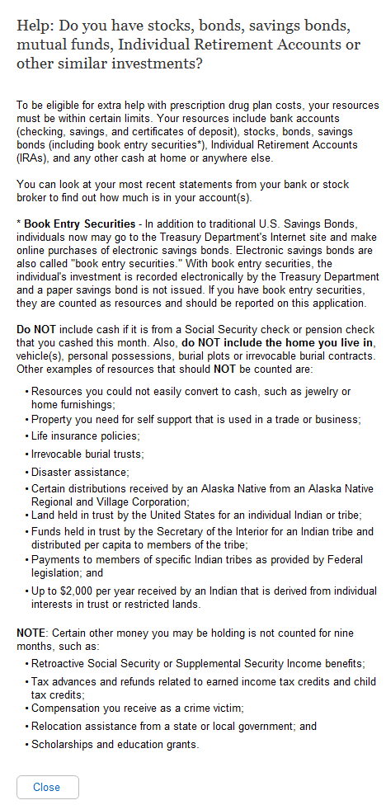
  - Help: Do you have any other cash at home or anywhere else?

Changed from “Do you or your spouse have any of the following resources? If Yes, enter the combined total for those items.
Combined total of all bank accounts (checking, savings and certificates of deposit)
Combined total of all stocks, bonds, savings bonds, mutual funds, Individual Retirement Accounts or other similar investments
Any other cash at home or anywhere else” to “Help: Do you have stocks, bonds, savings bonds, mutual funds, Individual Retirement Accounts or other similar investments?”

    - User Interface
A
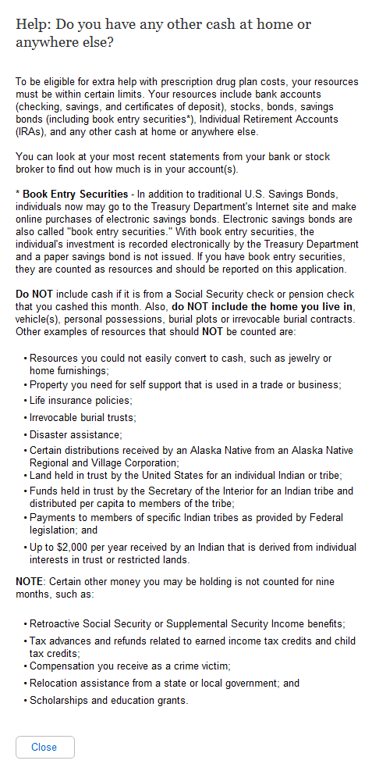
  - Help: Will some money from any of the sources listed above be used to pay for your funeral or burial expenses?

Changed from “Do you or your spouse have any of the following resources? If Yes, enter the combined total for those items.
Combined total of all bank accounts (checking, savings and certificates of deposit)
Combined total of all stocks, bonds, savings bonds, mutual funds, Individual Retirement Accounts or other similar investments
Any other cash at home or anywhere else” to “Help: Do you have any other cash at home or anywhere else?”

    - User Interface
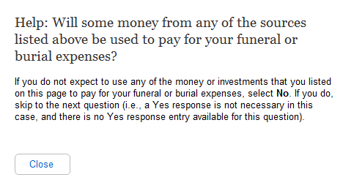
  - Help: Will some money from any of the sources listed above be used to pay for your spouse's funeral or burial expenses?
    - User Interface
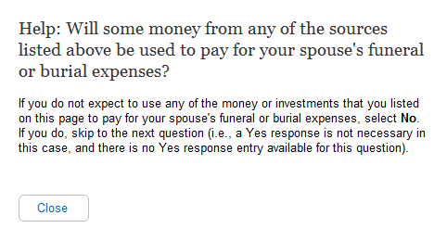
  - Help: Other than your home and the property on which it is located, do you or your spouse own any real estate?
    - User Interface
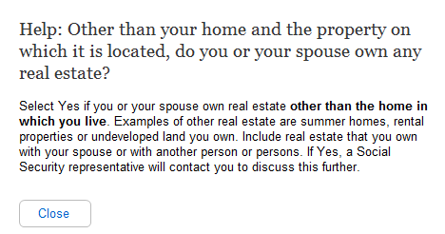
  - Help: Other than your home and the property on which it is located, do you own any real estate?
    - User Interface
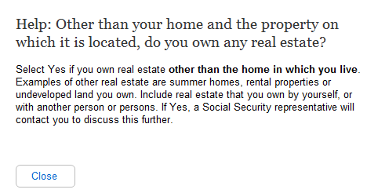
  - Help: Ready to submit
    - User Interface
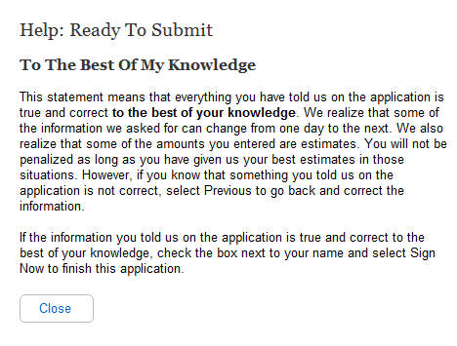
A

- “Submit Now” changed to “Sign Now”

