English iClaim Updated
Screen Package
Version 1.6

Social Security Administration

May 20, 2011

Table of Contents

1. Pages 4
1.1. Changes to Document 4
1.2. ent001_Welcome 5
1.3. ent003_Welcome 6
1.4. ent004_Restart 7
1.5. ini002-r_Applicant Identification 8
1.6. ini003-1_Contact Information 9
1.7. ini003-1_Contact Information_Foreign 10
1.8. ini004-1_Birth and Citizenship 11
1.9. ini004-1_Birth and Citizenship_foreign citizen 12
1.10. ini005-1_01_Medicare Election Information 13
1.11. apn001-r1_Application Number 14
1.12. adi001-1_01_Other SSNs and Names 15
1.13. adi002-1_01_Disability 16
1.14. fam001-1_01_Marriage Information 17
1.15. fam001-1_01_Marriage Information_Yes 18
1.16. fam001-1_01_Marriage Information_No 19
1.17. fam002-1_02_Prior Marriages 20
1.18. fam002-1_02_Prior Marriages_add page_empty table 21
1.19. fam002-1_02_Prior Marriages_add page4 22
1.20. fam002-1_02_Prior Marriages_add_waddl questions 23
1.21. fam002-1_02_Prior Marriages_add page_Yes 24
1.22. fam002-1_02_Prior Marriages_add page_No 25
1.23. fam002-1_02_Prior Marriages_summary page 26
1.24. fam002-1_02_Prior Marriages_summary page_message 27
1.25. fam003-r1_Children 28
1.26. mil001-1_Military Details_initial state 29
1.27. mil001-1_Military Details_tableempty 30
1.28. mil001-1_Military Details_Period1 31
1.29. mil001-1_Military Details_Table9Row_NoWarning 32
1.30. mil001-1_Military Details_Table10Row_Warning 33
1.31. ear001-1-lag_Employer Details 34
1.32. ear001-1-lag_01_tableEmpty 35
1.33. ear001-1-lag_02_EmployerDetailEntry 36
1.34. ear001-1-lag_02_EmployerDetailEntry_Foreign Address 37
1.35. ear001-1-lag_03_table1Row 38
1.36. ear001-1-lag_05_table9Rows 39
1.37. ear002-lag_Self Employment 40
1.38. ear002-lag_workingCollapse_Self Employment 41
1.39. ear003-1-a_Supplemental Information 42
1.40. ear004_Total Earnings 43
ear004-d1-b_Total Earnings 45
1.41. ear005-1-a_Other Pensions/Annuities 46
1.42. wst000-1_Reduced Benefits 47
1.43. wst001-1-b_When to Start Retirement Benefits 48
1.44. wst001-1-e_When to Start Retirement Benefits 49
1.45. wst001-3-c_When to Start Retirement Benefits 50
1.46. wst001-3-d_When to Start Retirement Benefits 51
1.47. wst002-1_Direct Deposit Details 52
1.49. bni001-1_Benefit Information 53
1.50. bni002-3_Health Insurance 54
1.51. rem001_Remarks 55
1.52. ovs001-r1-a_Overall Summary 56
1.53. snd001-r1_Send This Application 63
1.54. rec001-r1-a_Evidence and Receipt 64
1.55. wtn001-r1_Next Steps 70
1.56. wtn001-r1_Next Steps-Expanded 71
2. Messages 73
2.1. msg005_GoToEstimator 73
2.2. msg010_Check the Information You Entered 74
2.3. msg027_We cannot process your request at this time 75
2.4. msg028_This service is not available at this time 76
2.5. msg045_Hours of Operation 77
2.6. msg051_We cannot Process your request 78
2.7. msg052_We cannot Process your request 79
2.8. msg152_Sign Off 80
2.9. Bank Info Msg - Where can I find this? 81

- Pages
  - Changes to Document
5/16/2011:
- Based on Based on the PAS Forum information gathering session the following changes have been made to the Welcome and What’s Next pages
  - ENT001 and ENT003 – language and page layout changes
    - Moved the Retirement Estimator to the left side of the page under the “Applying for benefits” section to reduce confusion where applicants perceive the “Estimate My Benefits” to be the starting point of the application
    - Changed the button label from “Continue Application” to “Return to a Saved Application”
    - Myself link goes to: http://www.socialsecurity.gov/info/isba/retirement/firstpartyrib.htm
    - Someone else link goes to: http://www.socialsecurity.gov/info/isba/retirement/thirdpartytype.htm
    - Modified the links in the “You may also want to review” section

    - Page template change
      - Language removed: Form Approved
      - Expiration date removed
      - Footer added with links
  - ENT003 – Reflects the secure connection that has been previously established and allows the applicant to “Sign Out” of the secure session, if desired
  - WTN001 – language placement changes. Helpful Information, Medicare Information, and Hepful Health Care Websites will be displayed “collapsed” by default. The Contact Information will be displayed “expanded” by default.

- Message pages update
  - MSG005 and MSG152 to reflect the new button label on the Welcome page.

- Prior Marriage, Military and Employment table pages –
  - Updated FAM002, MIL001, and EAR001 pages. Each column in a table should have a label. Updated the tables to include the label – Status – in the first column.
5/20/11
- Updated the ENT001 and ENT003 screens with the correct Privacy Act Statement
  - ent001_Welcome
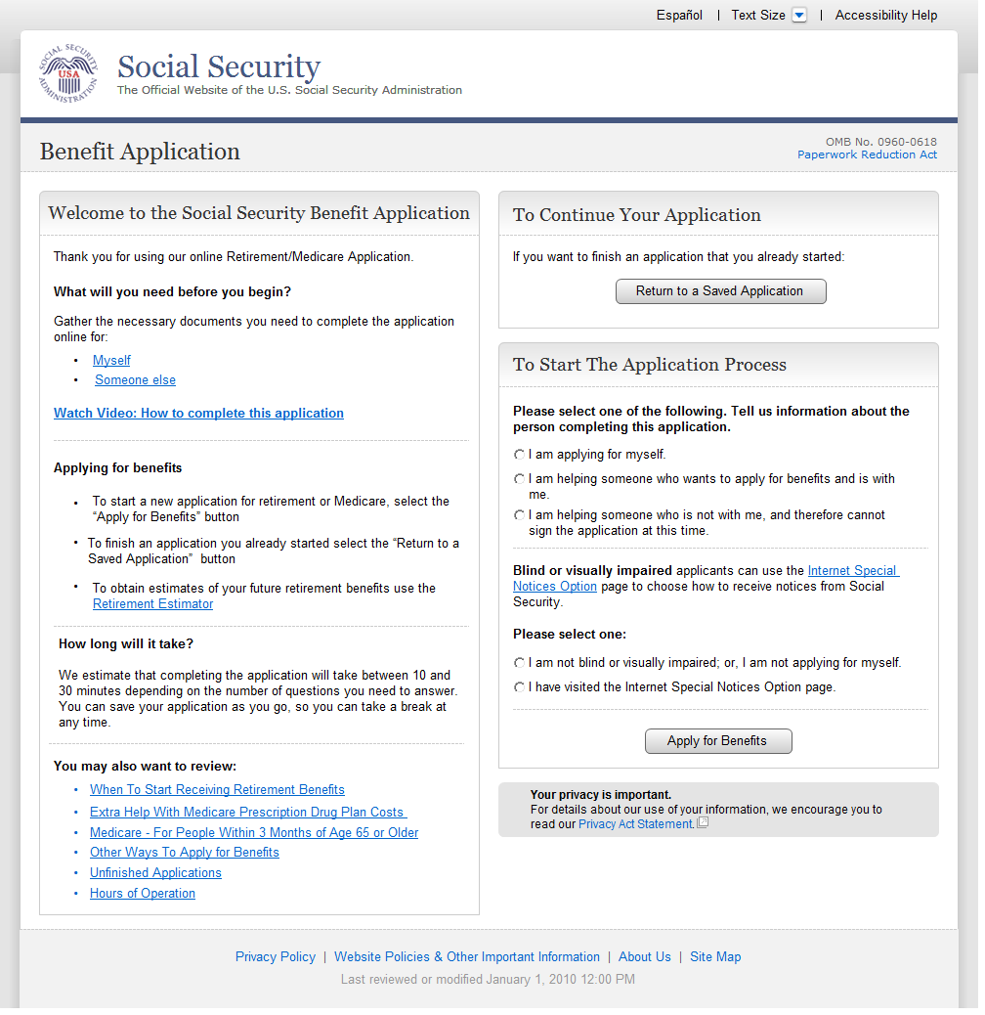
  - ent003_Welcome
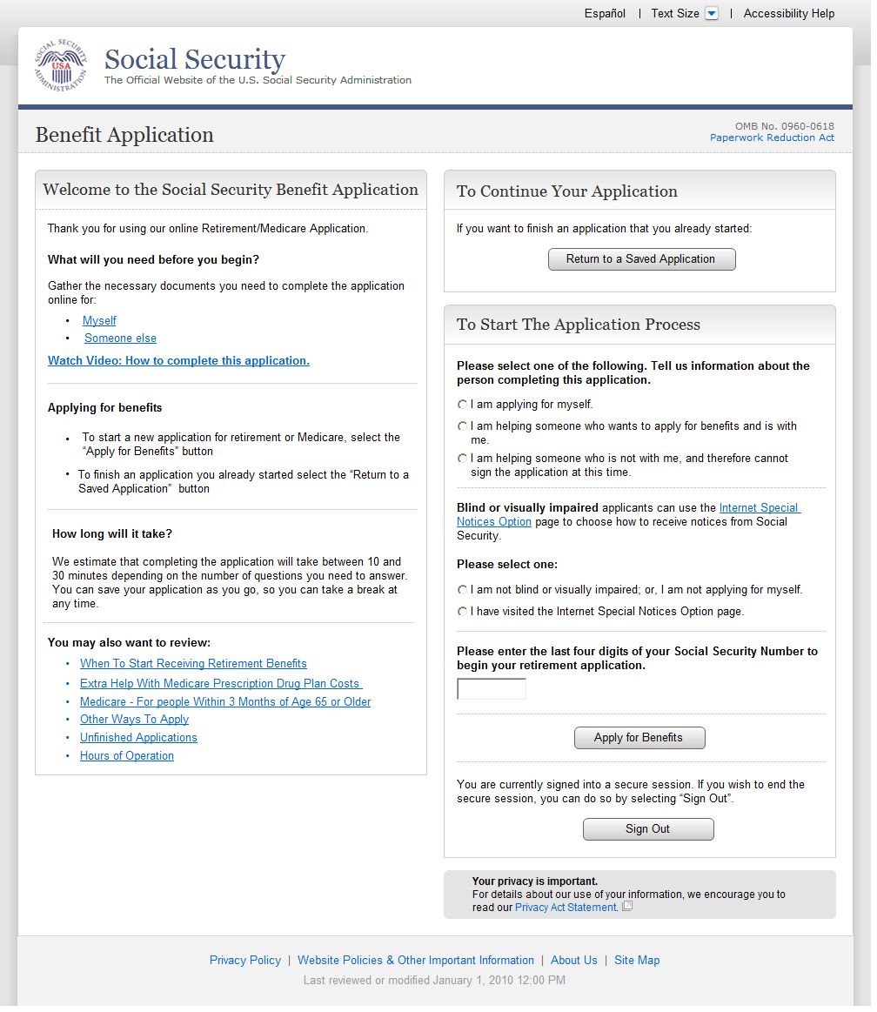
  - ent004_Restart
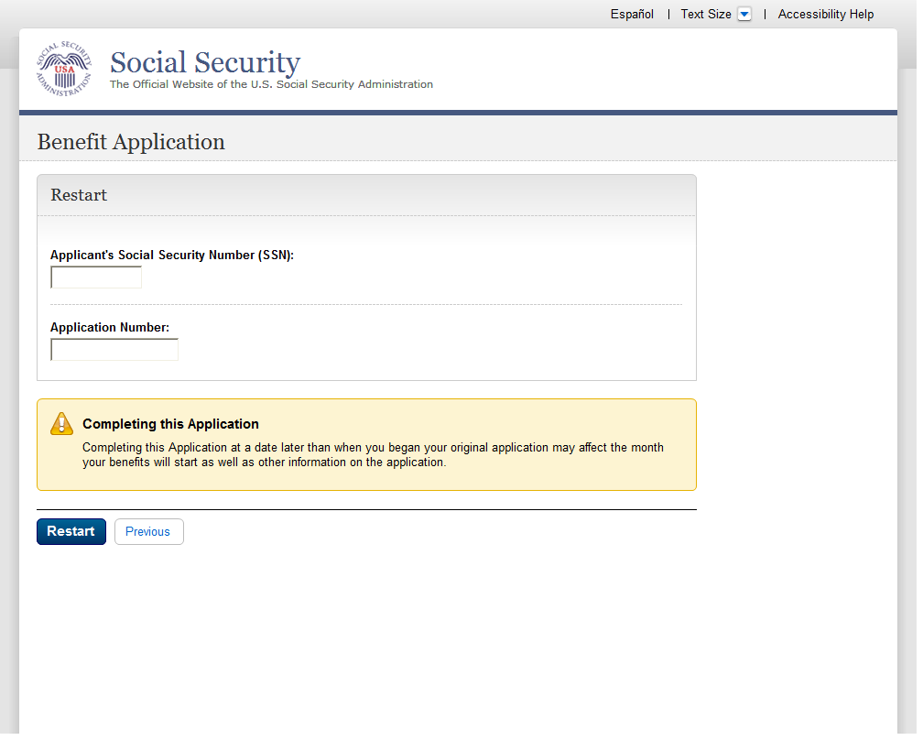
  - ini002-r_Applicant Identification
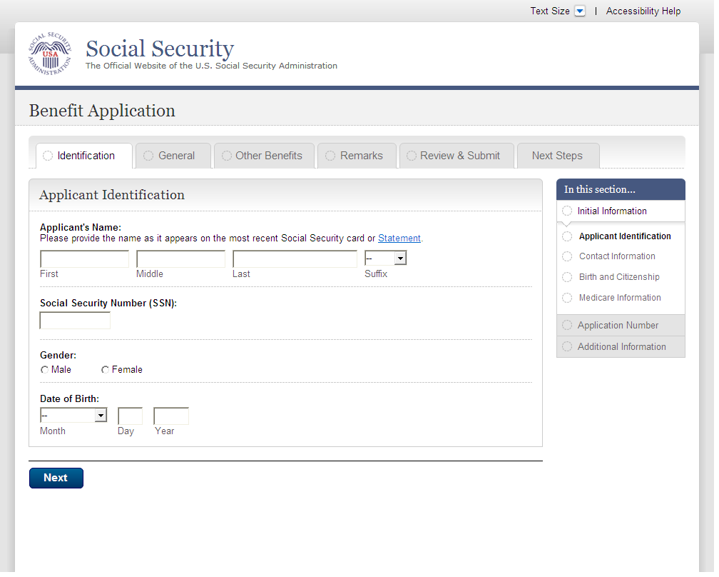
  - ini003-1_Contact Information
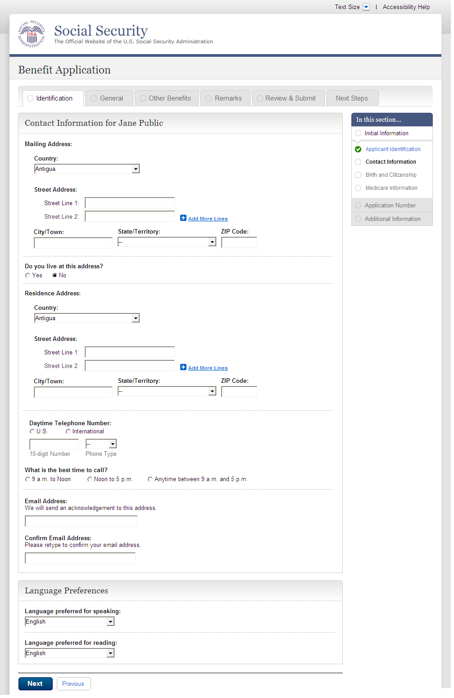
  - ini003-1_Contact Information_Foreign
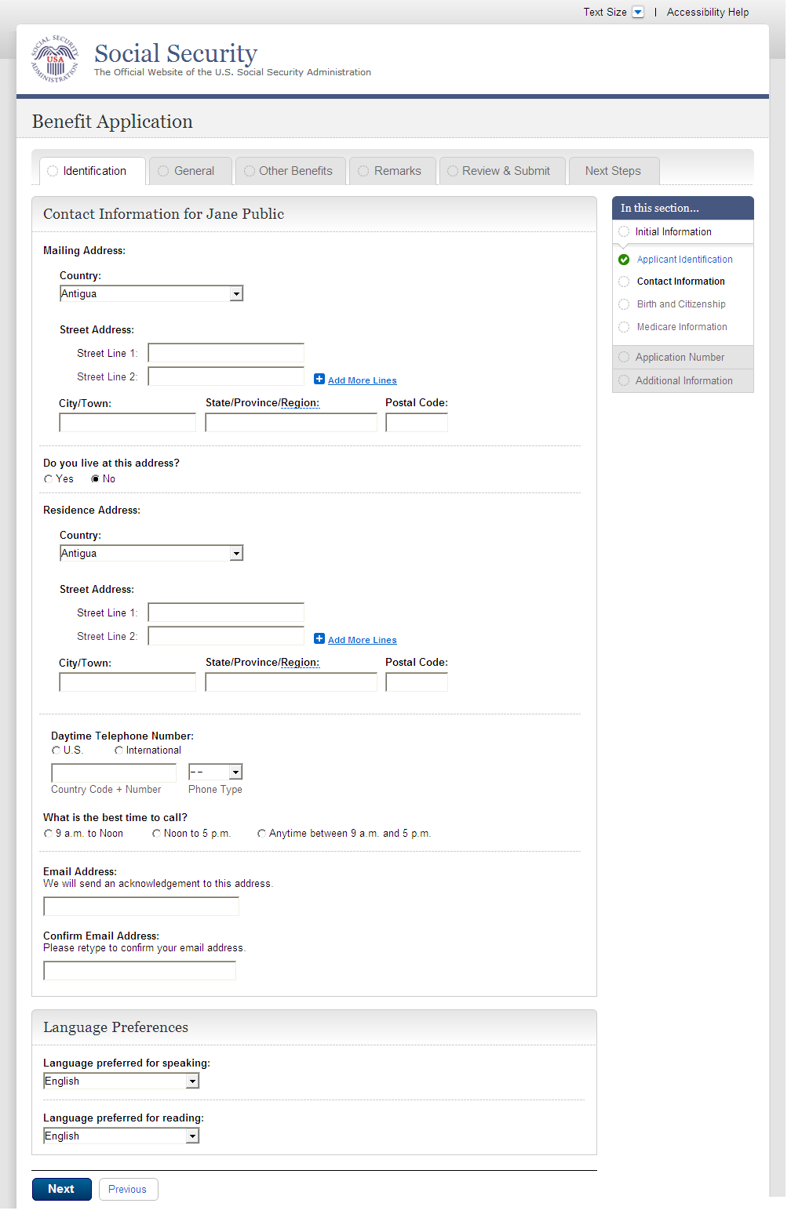
  - ini004-1_Birth and Citizenship
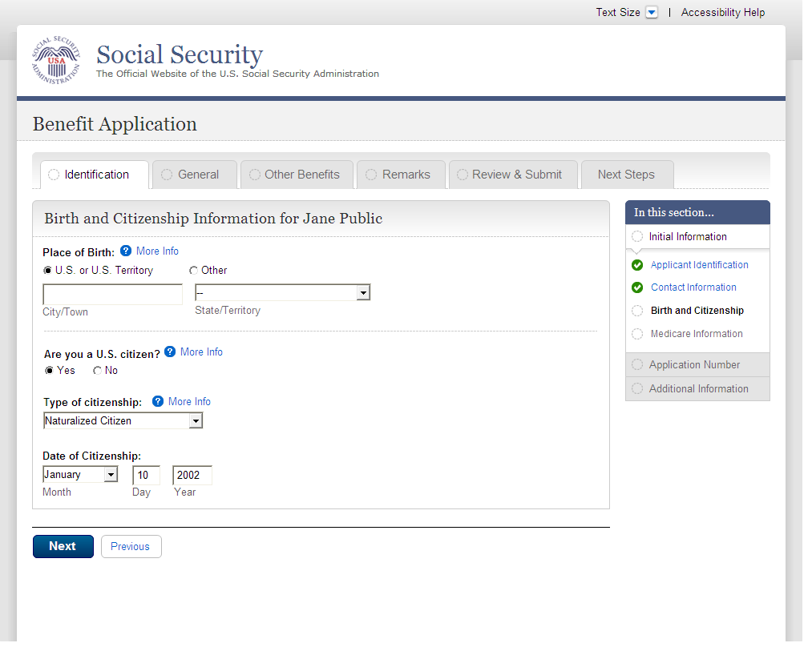
  - ini004-1_Birth and Citizenship_foreign citizen
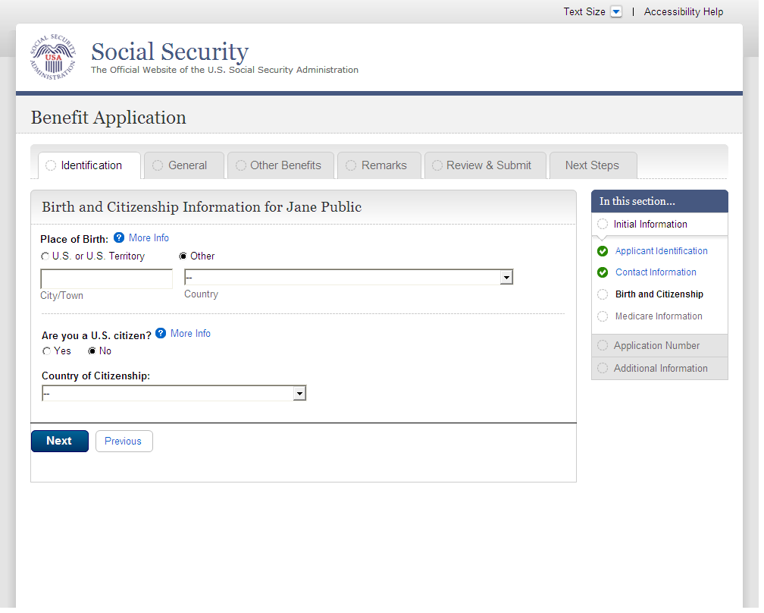
  - ini005-1_01_Medicare Election Information
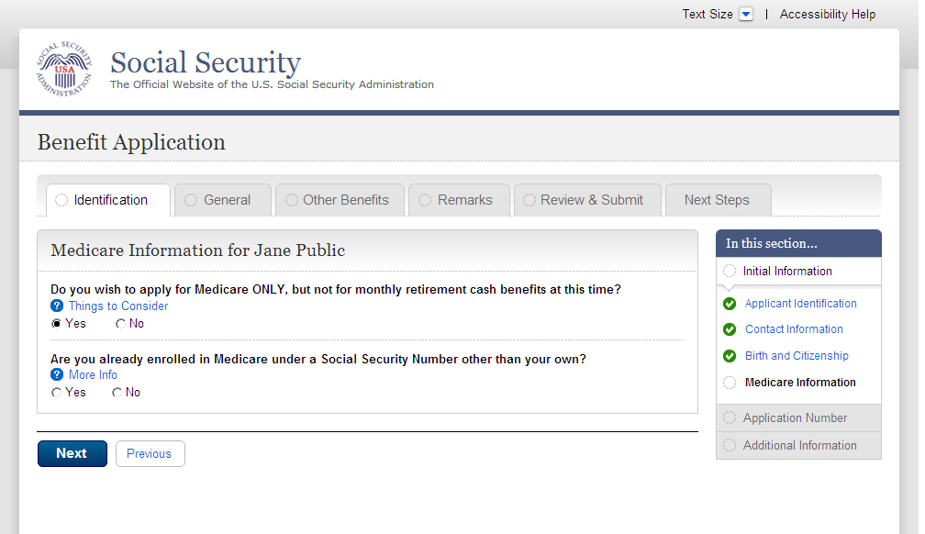
  - apn001-r1_Application Number
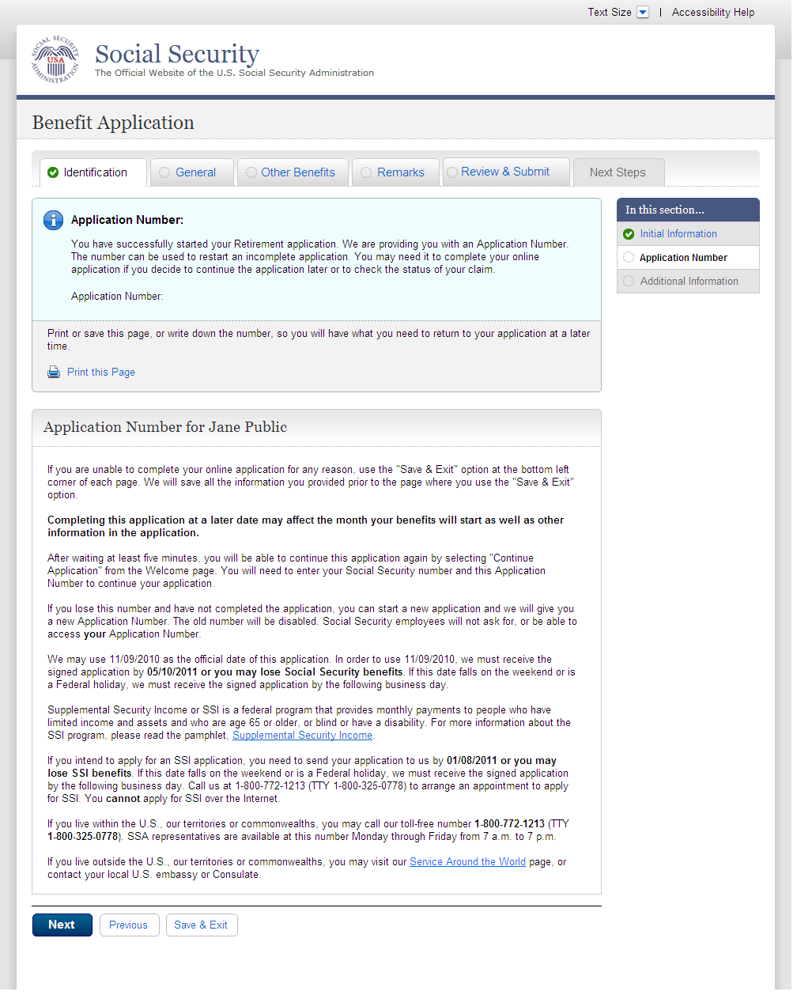
  - adi001-1_01_Other SSNs and Names
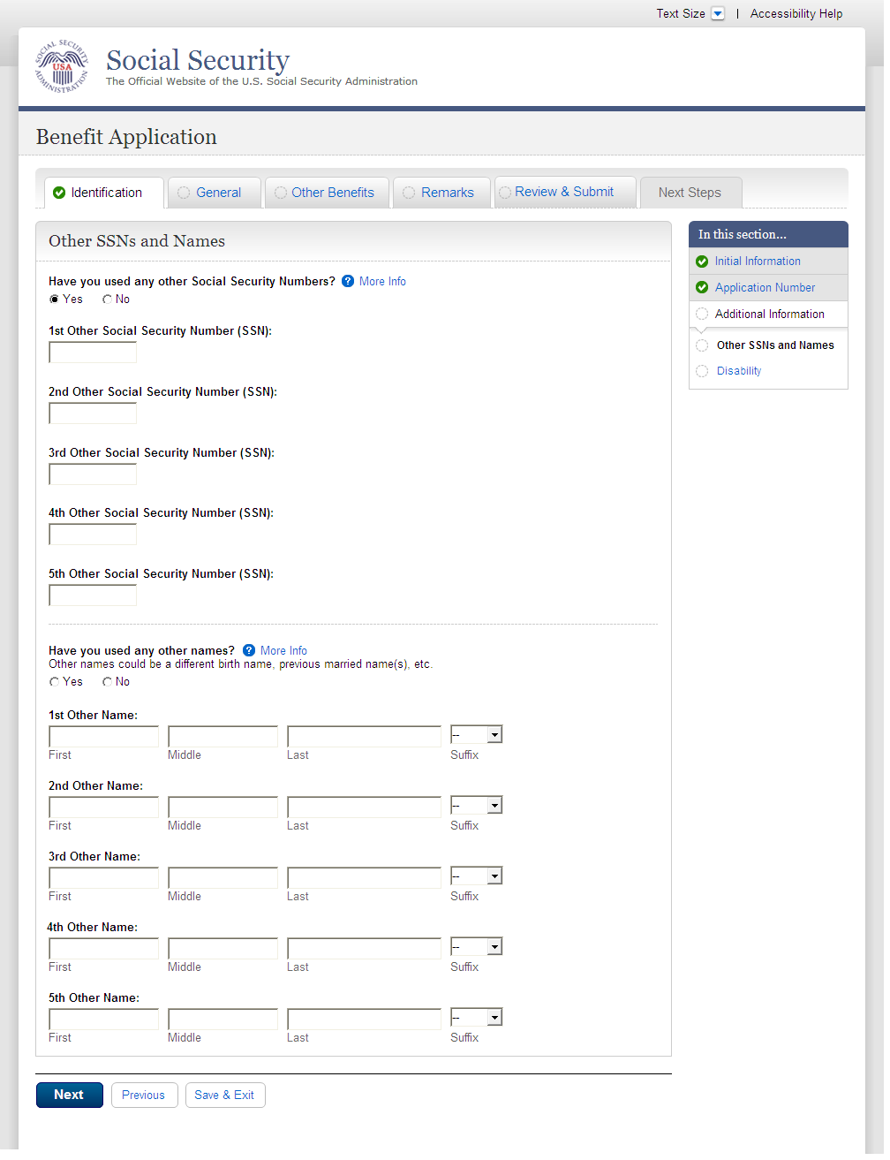
  - adi002-1_01_Disability
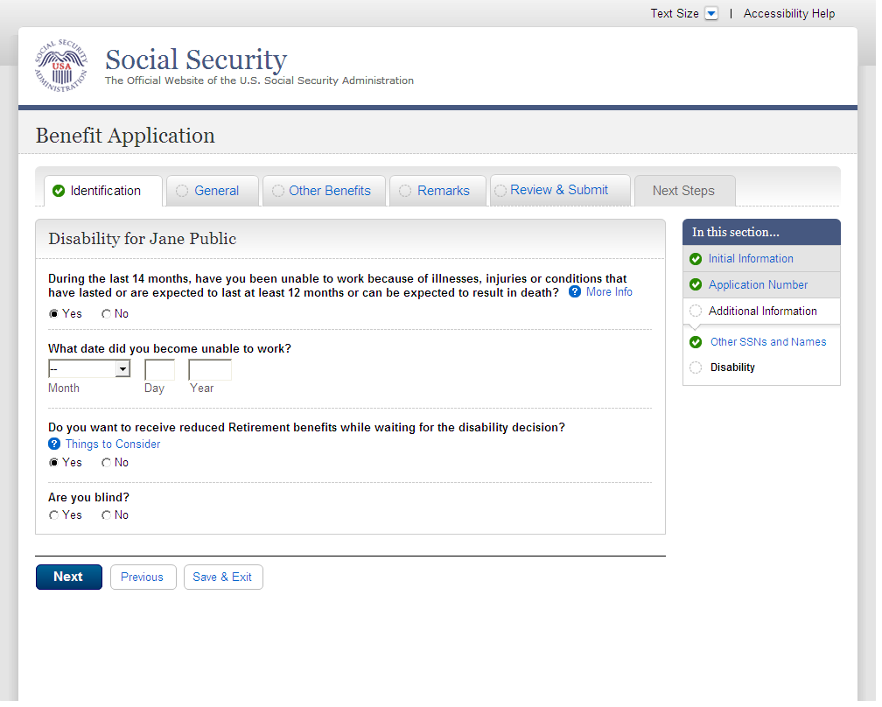
  - fam001-1_01_Marriage Information
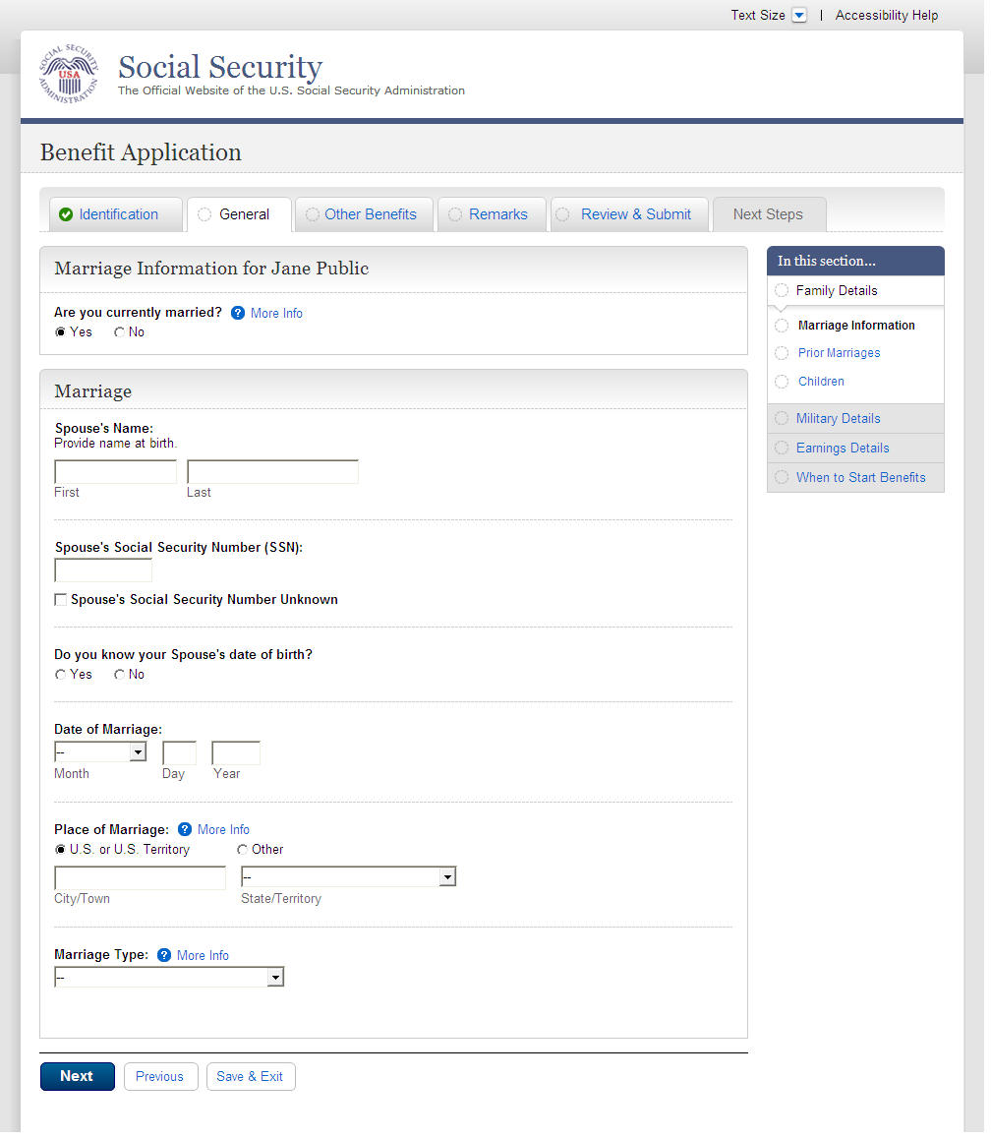
  - fam001-1_01_Marriage Information_Yes
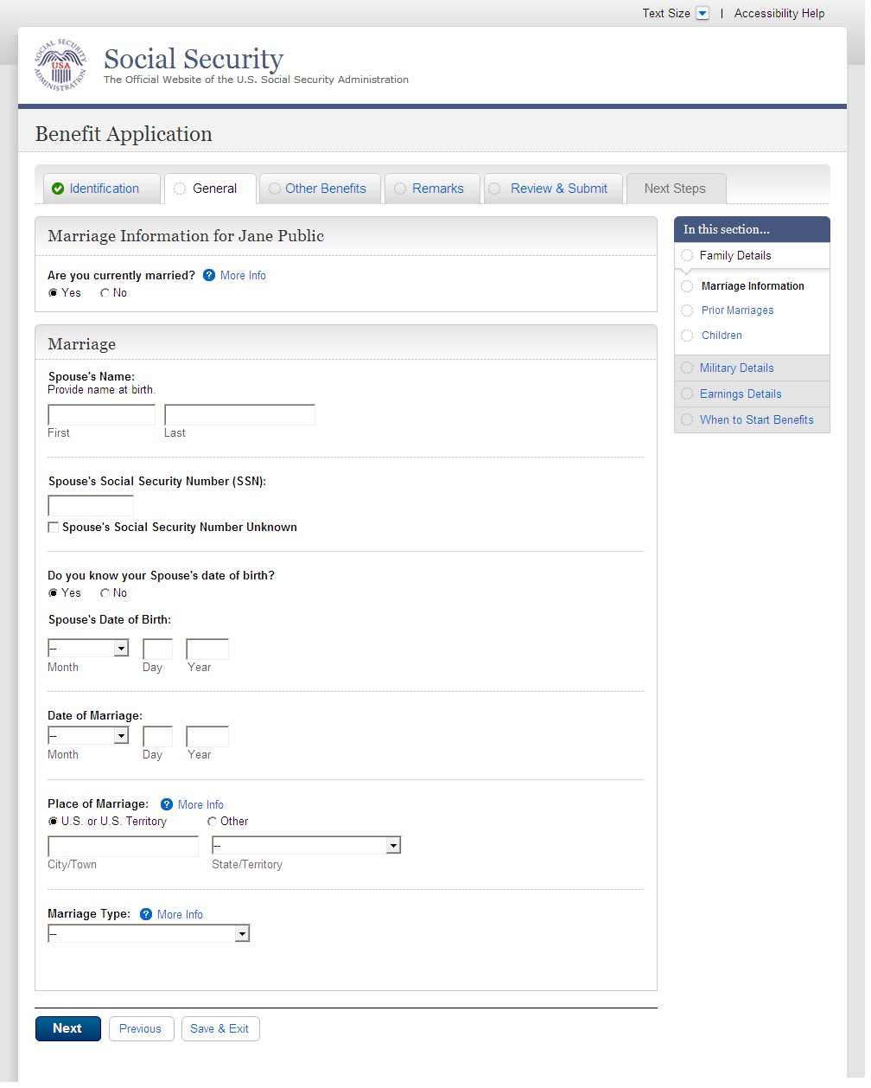
  - fam001-1_01_Marriage Information_No
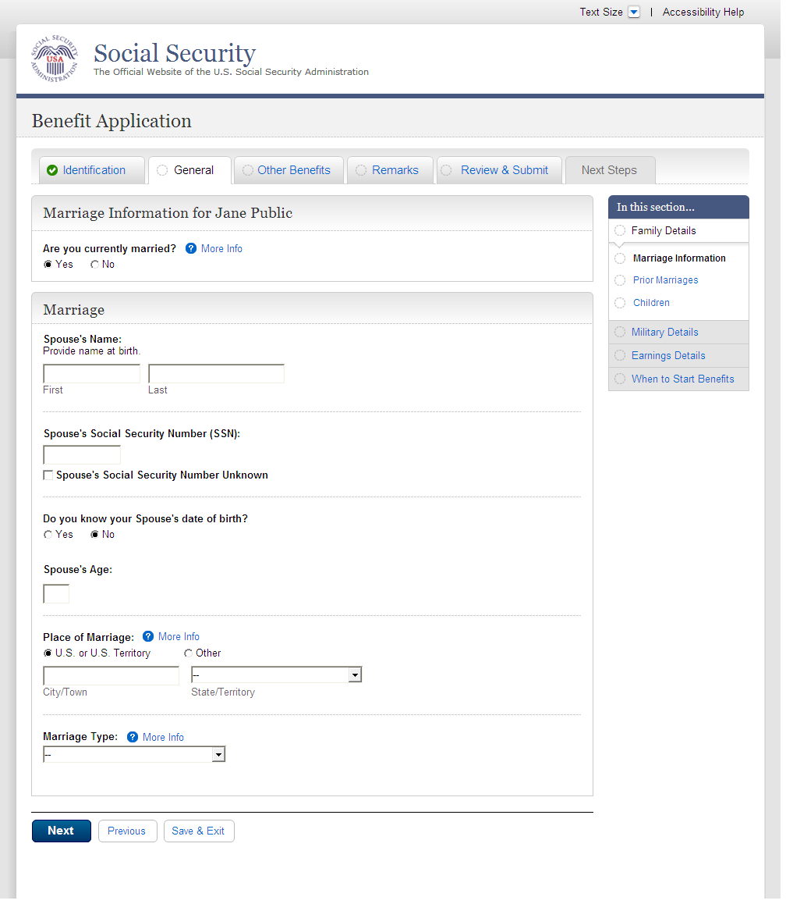
  - fam002-1_02_Prior Marriages
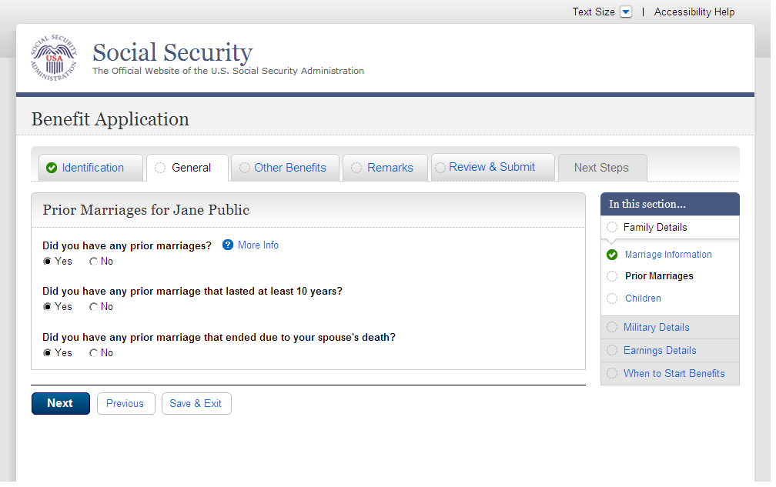
  - fam002-1_02_Prior Marriages_add page_empty table
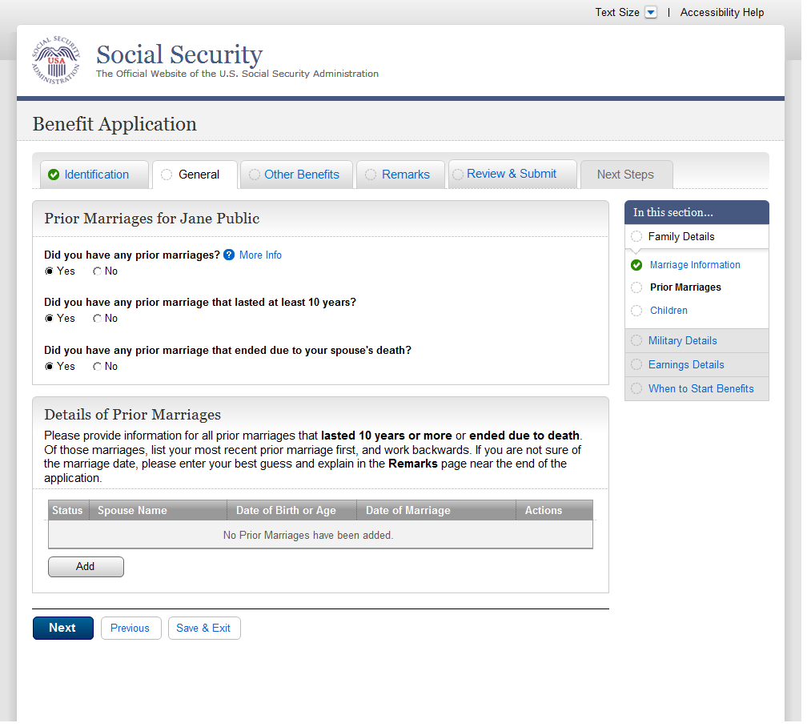
  - fam002-1_02_Prior Marriages_add page4
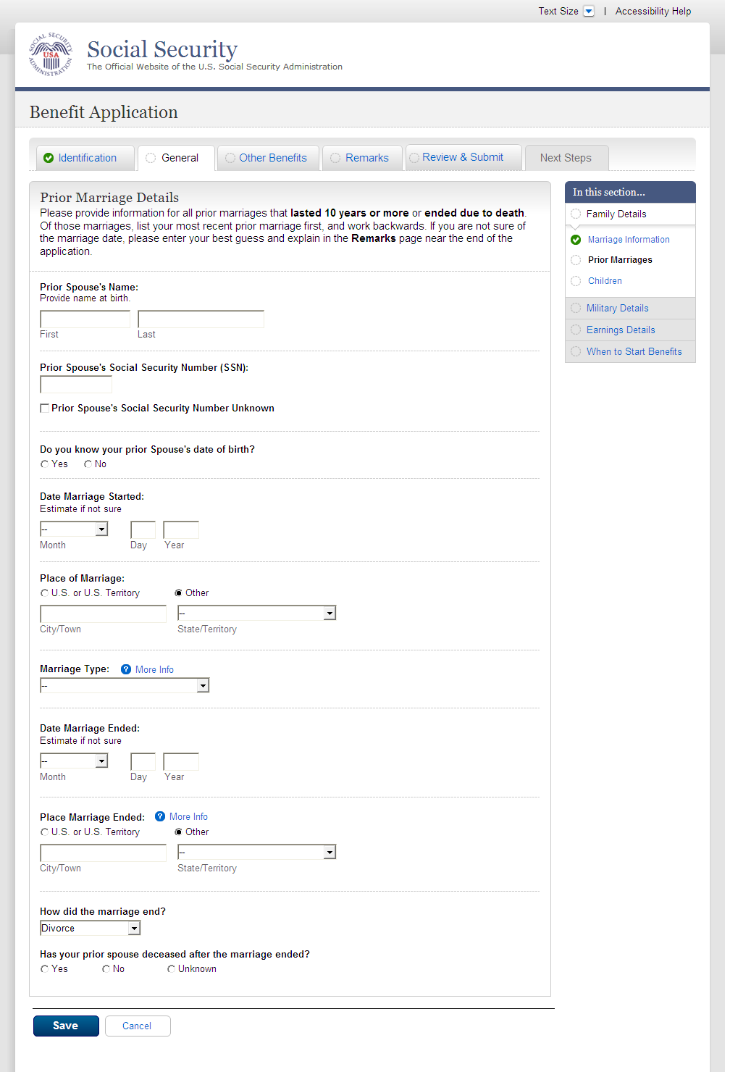
  - fam002-1_02_Prior Marriages_add_waddl questions
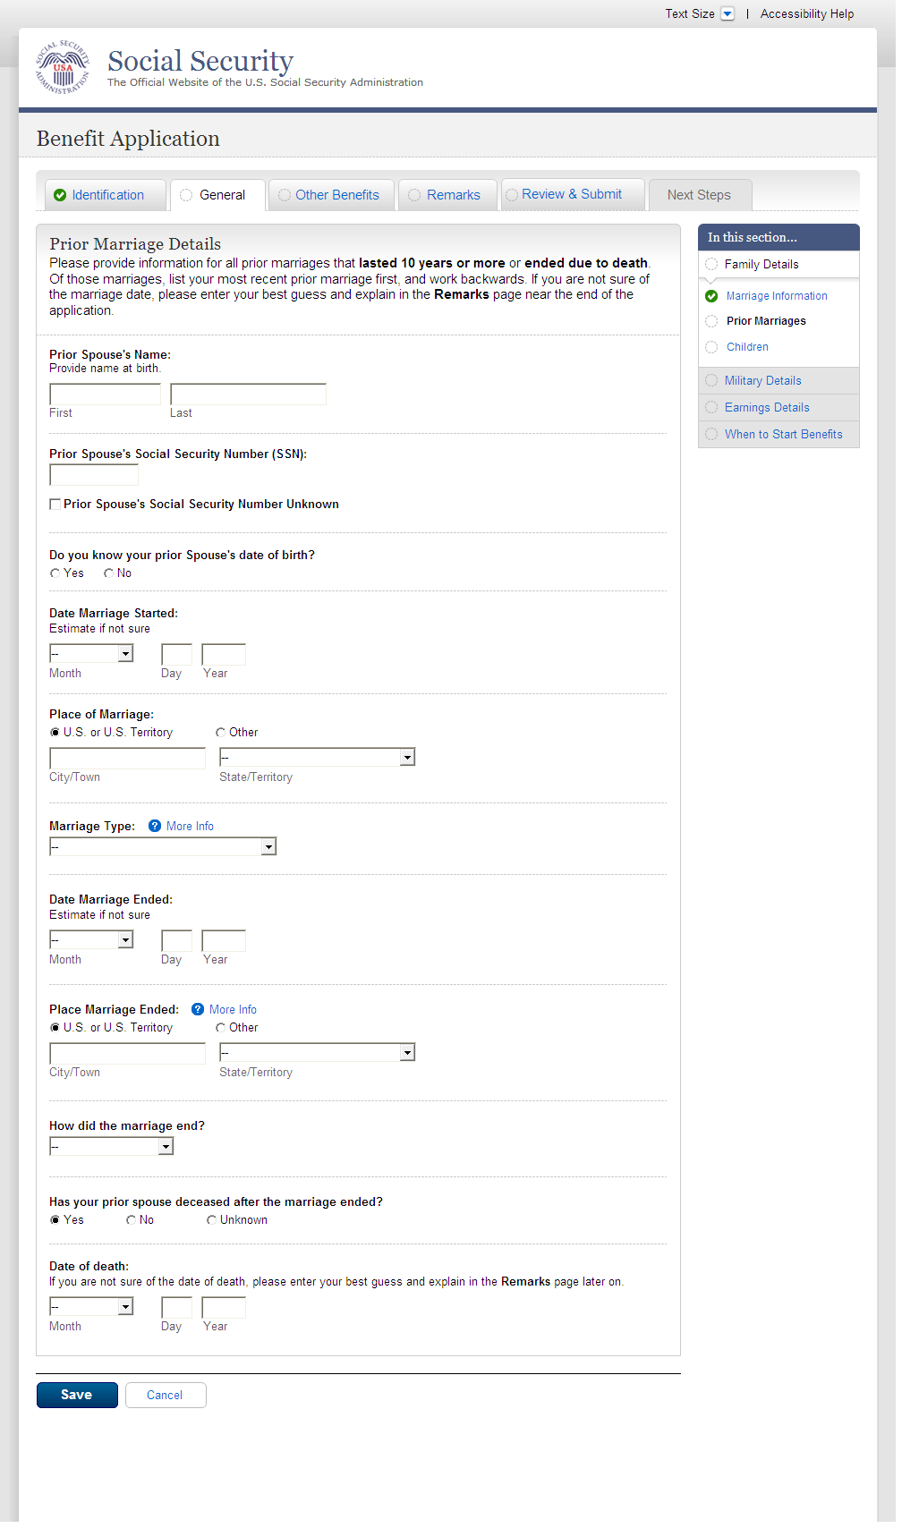
  - fam002-1_02_Prior Marriages_add page_Yes
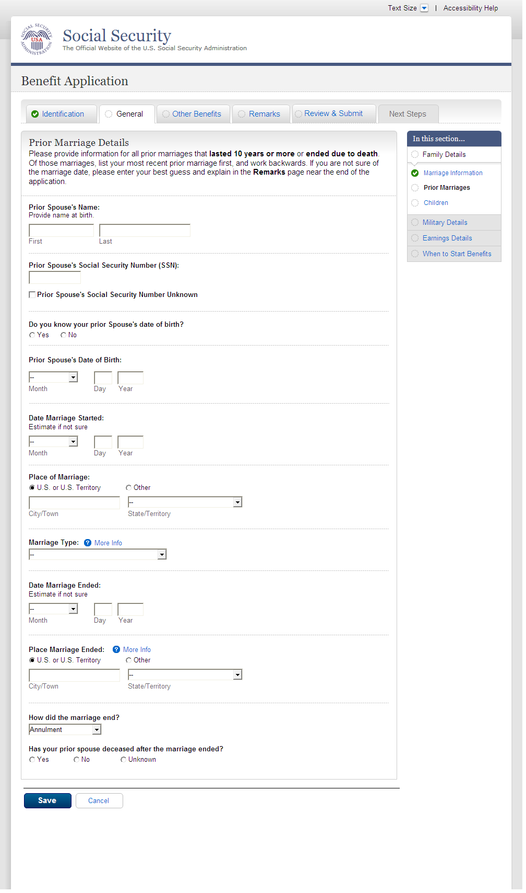
  - fam002-1_02_Prior Marriages_add page_No
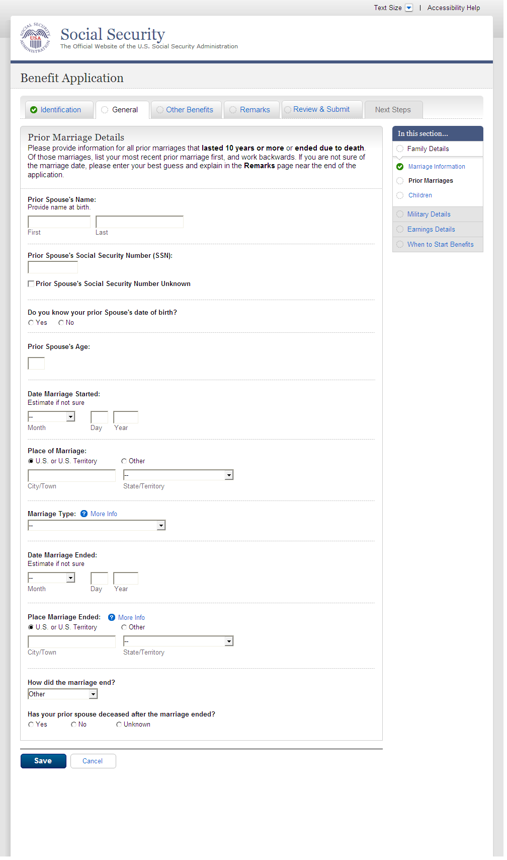
  - fam002-1_02_Prior Marriages_summary page
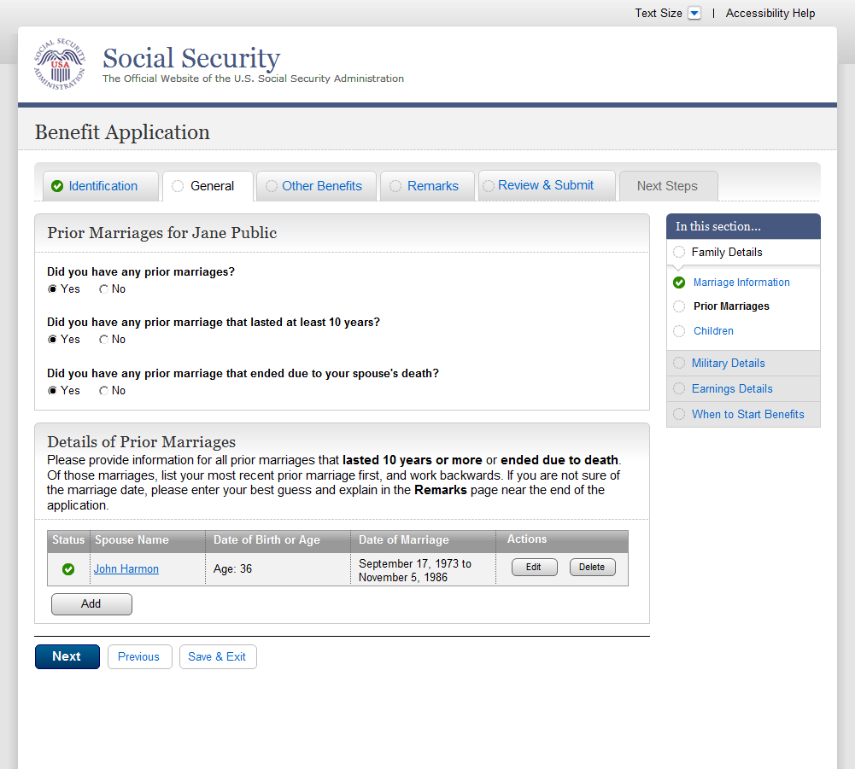
  - fam002-1_02_Prior Marriages_summary page_message
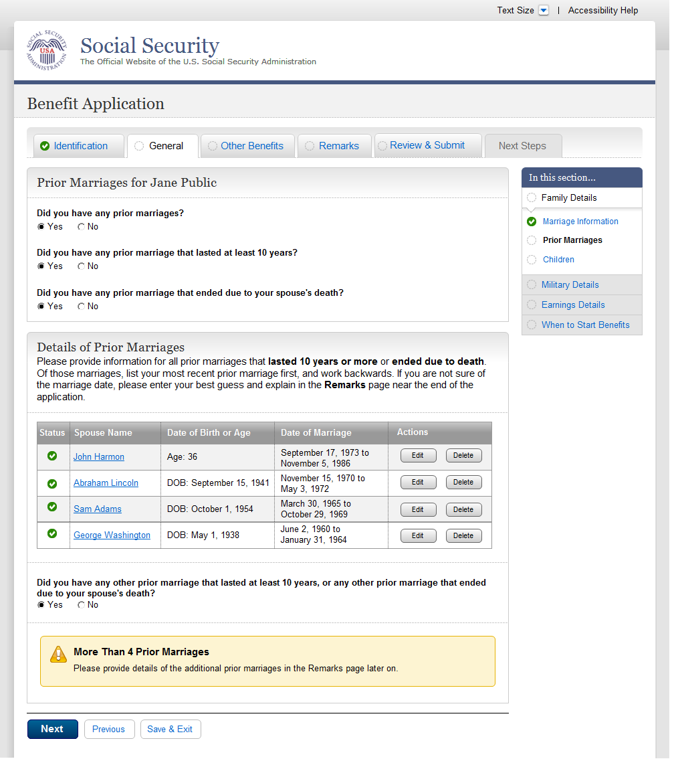
  - fam003-r1_Children
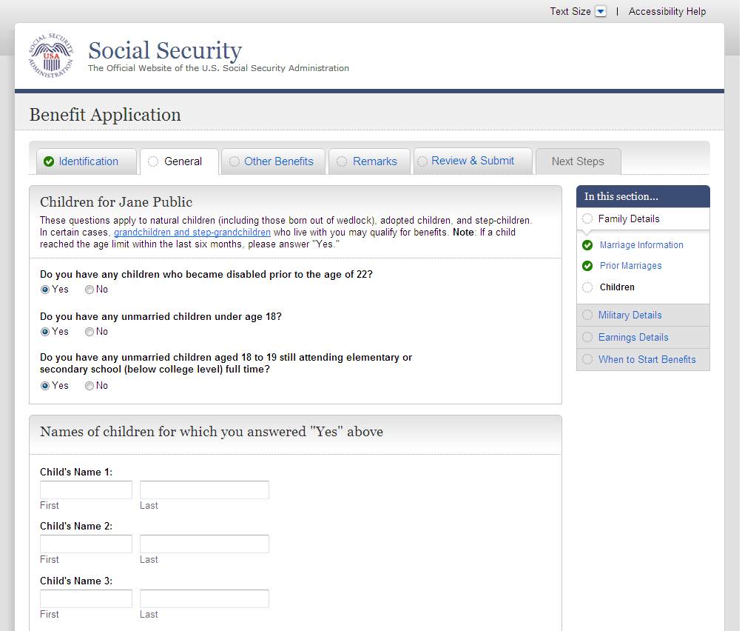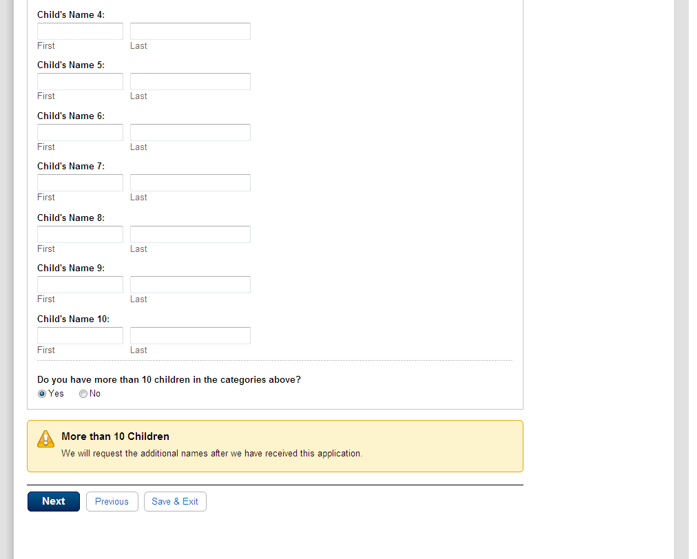
  - mil001-1_Military Details_initial state
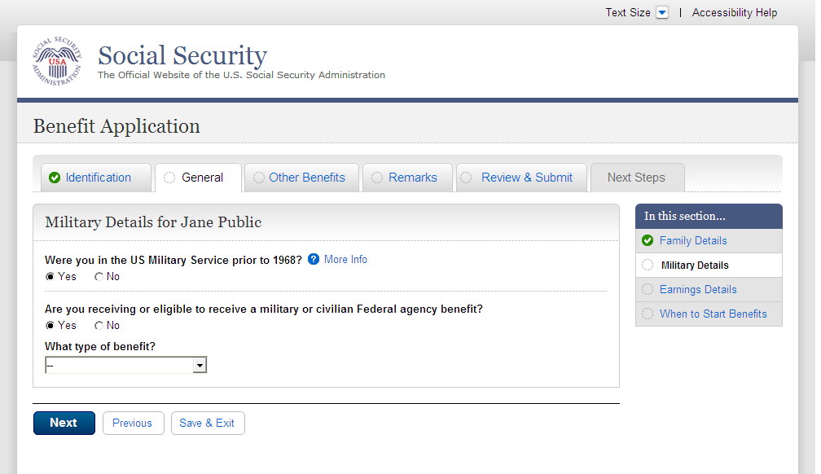
  - mil001-1_Military Details_tableempty
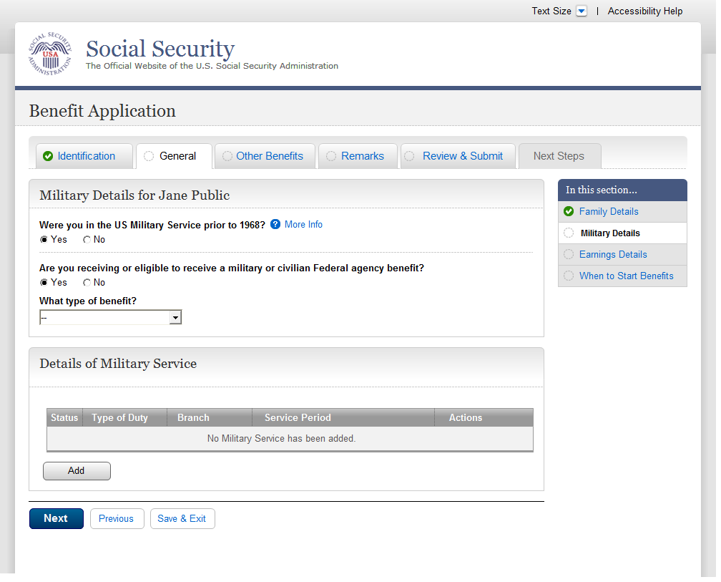
  - mil001-1_Military Details_Period1
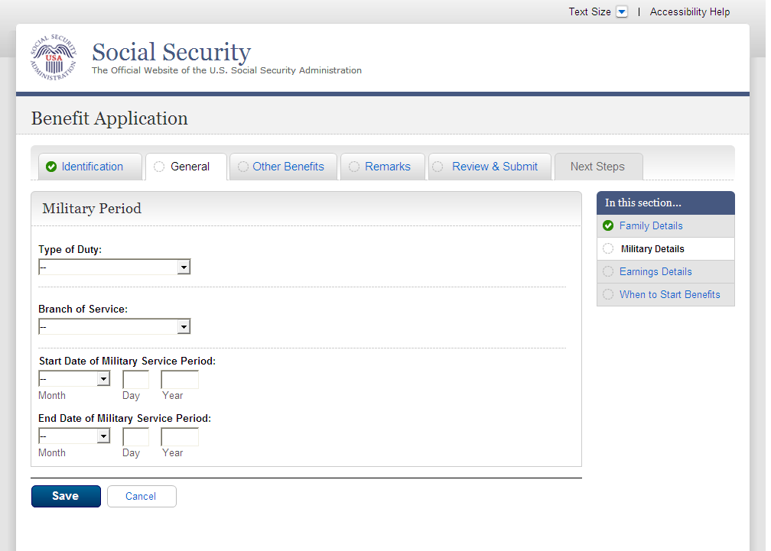
  - mil001-1_Military Details_Table9Row_NoWarning
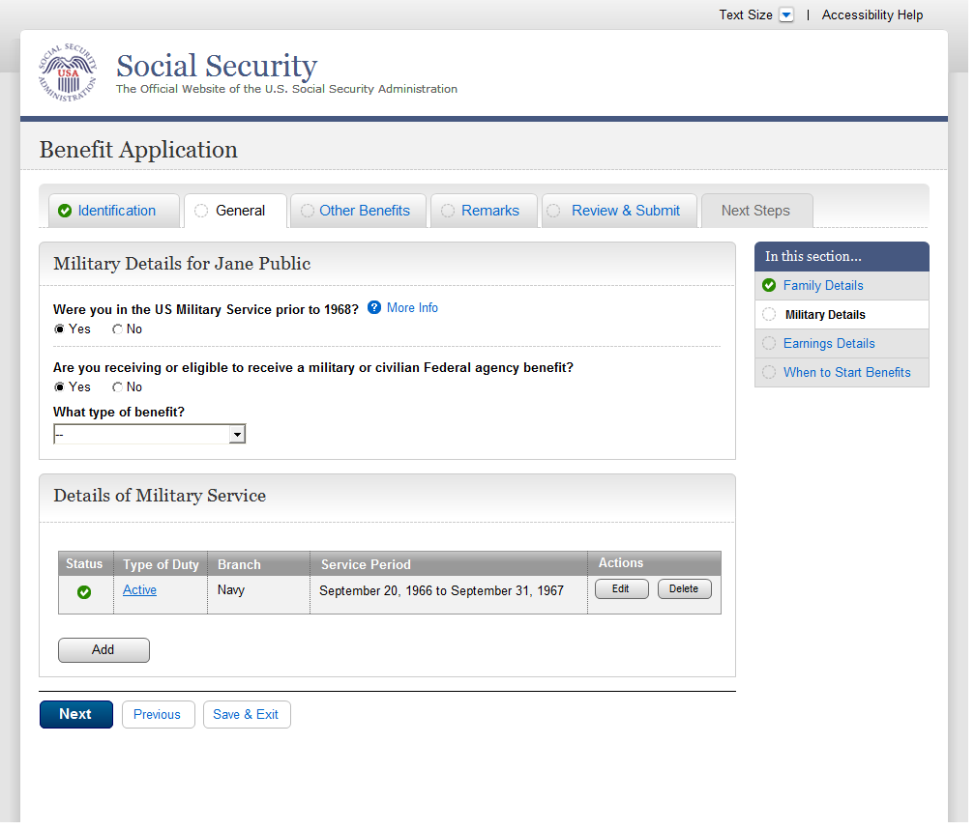
  - mil001-1_Military Details_Table10Row_Warning
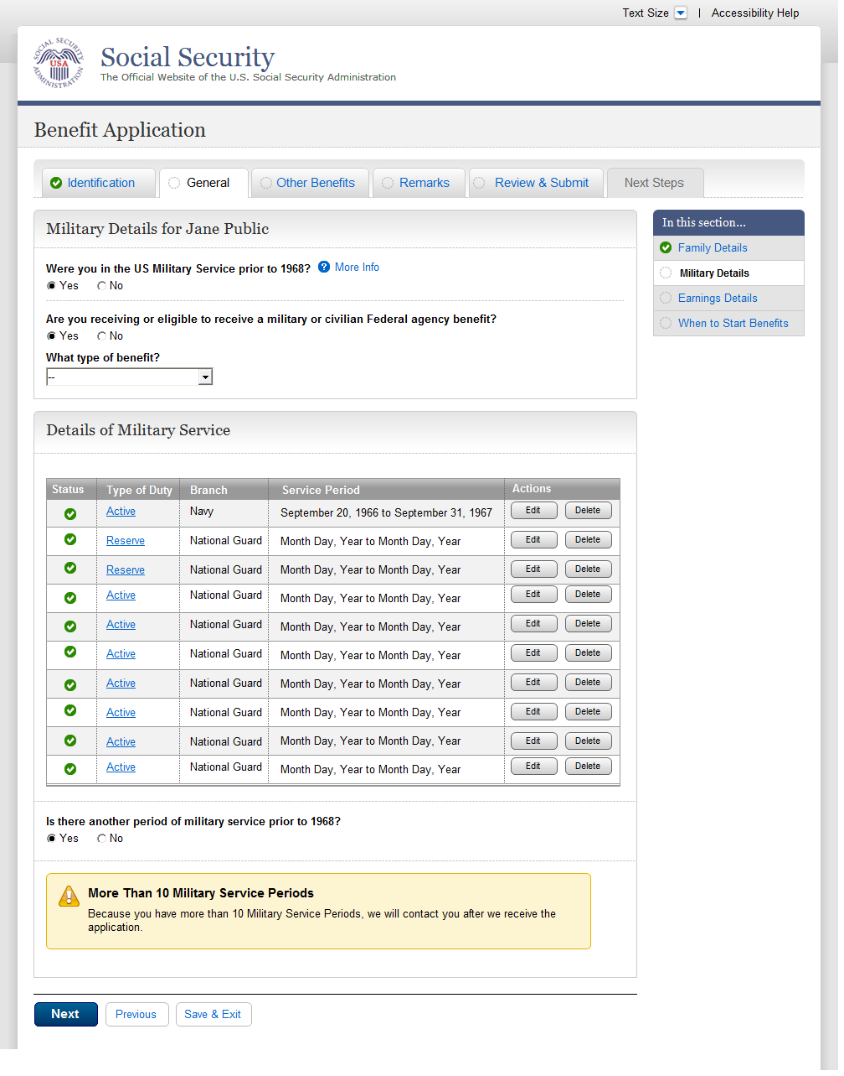
  - ear001-1-lag_Employer Details
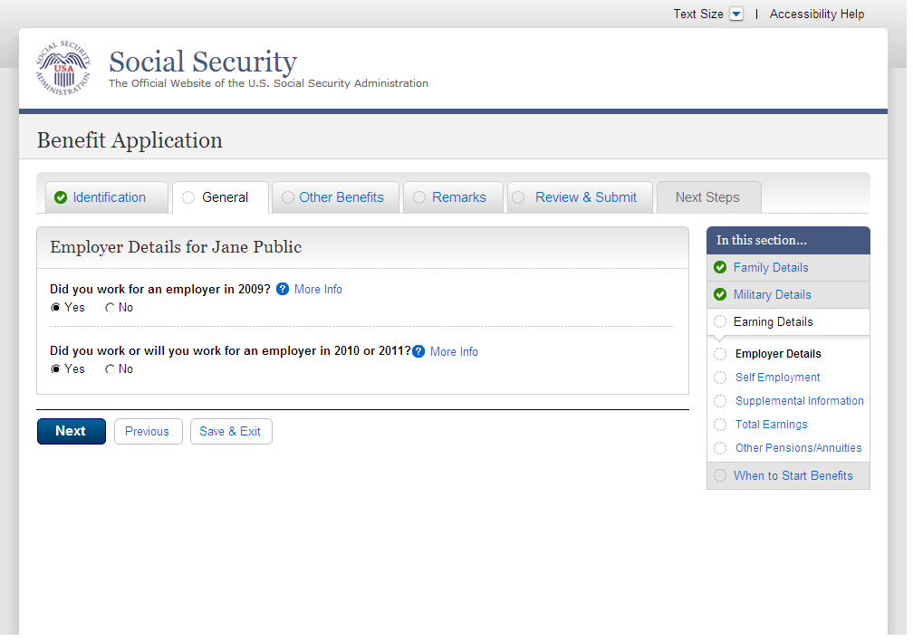
  - ear001-1-lag_01_tableEmpty
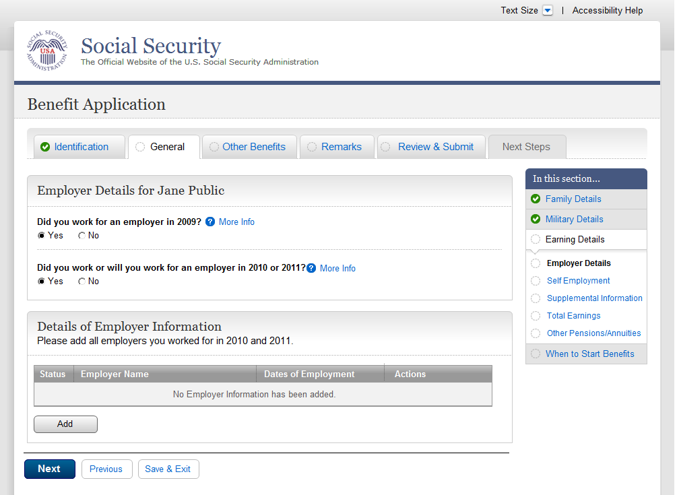
  - ear001-1-lag_02_EmployerDetailEntry
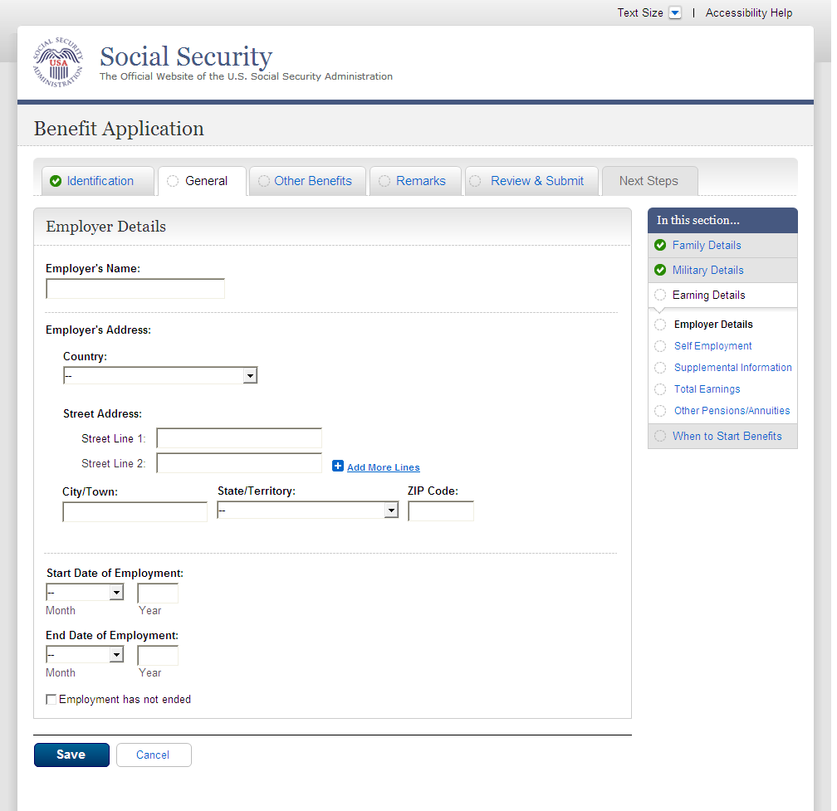
  - ear001-1-lag_02_EmployerDetailEntry_Foreign Address
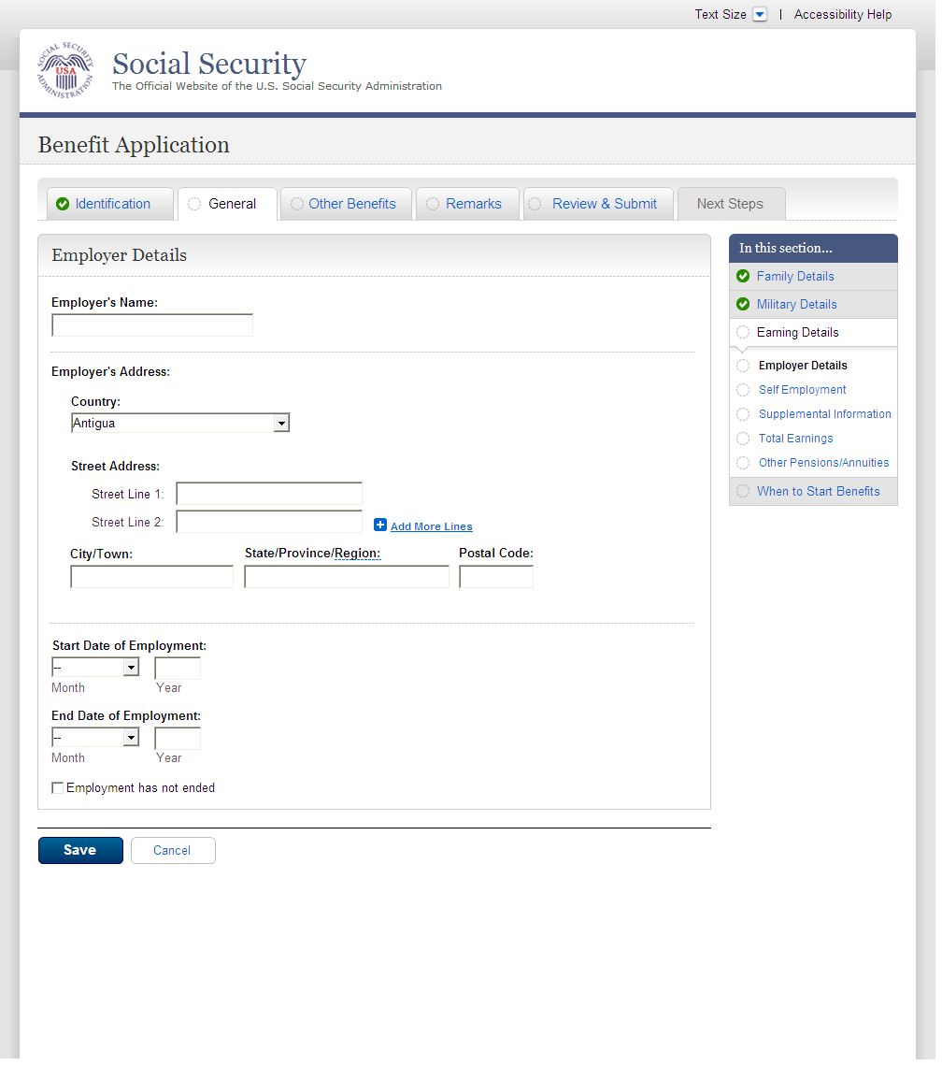
  - ear001-1-lag_03_table1Row
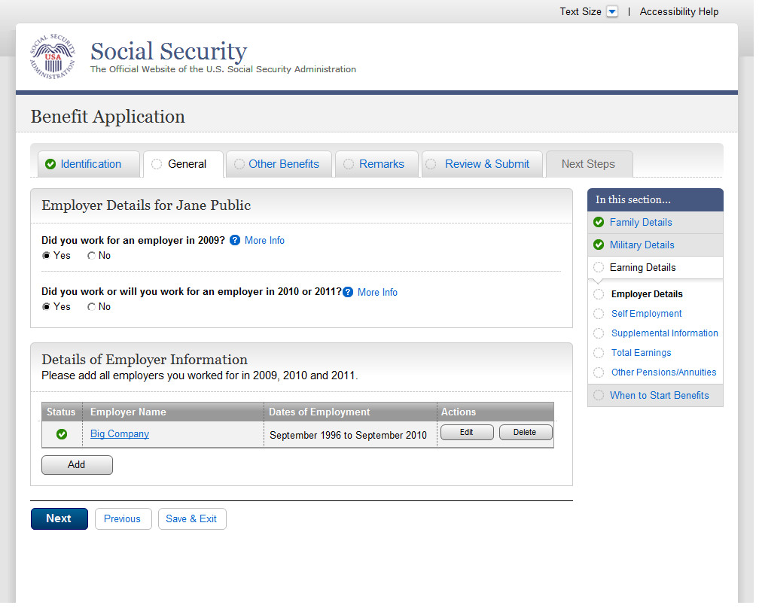
  - ear001-1-lag_05_table9Rows
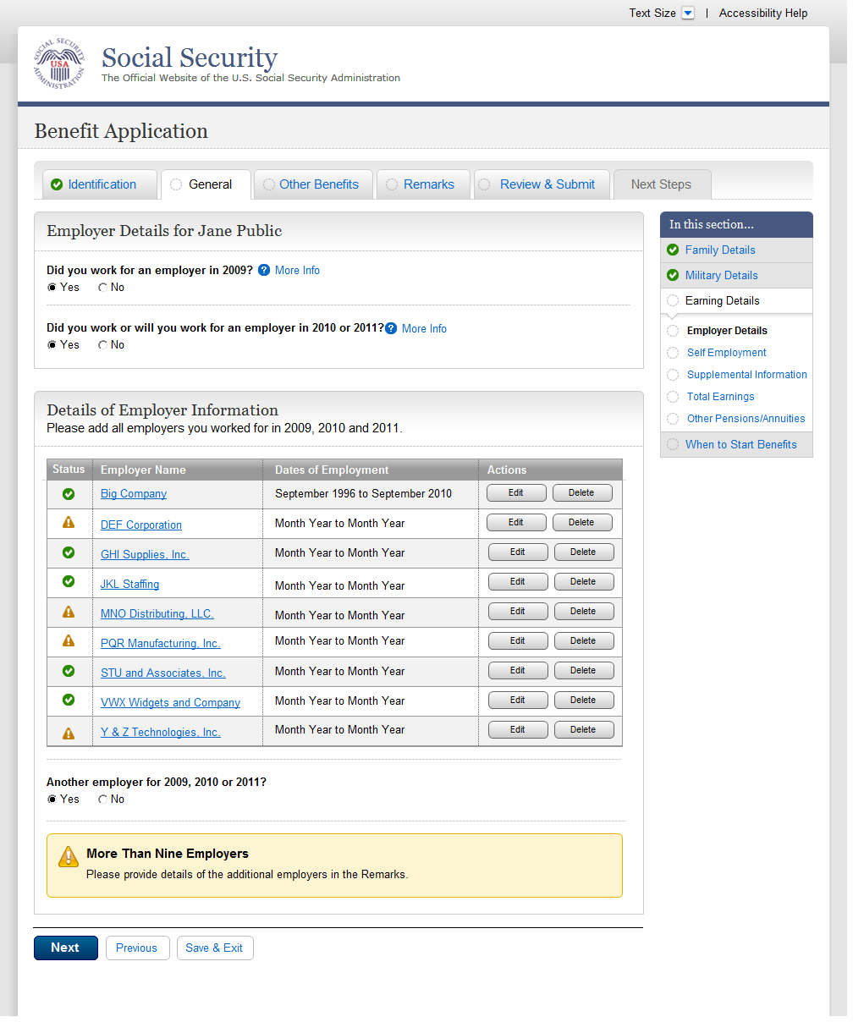
  - ear002-lag_Self Employment
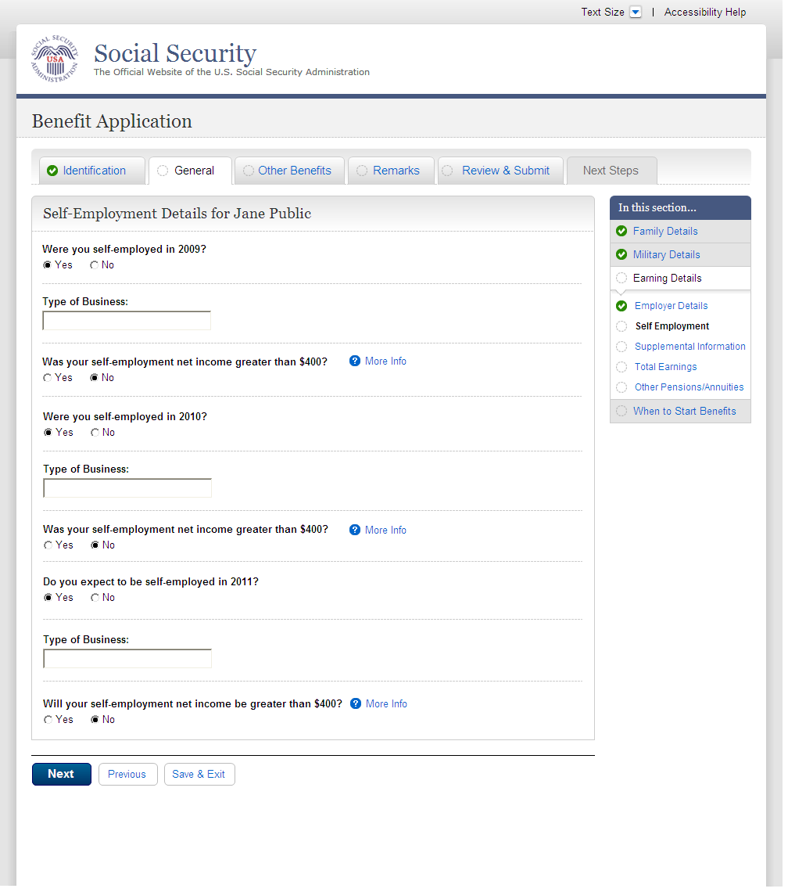
  - ear002-lag_workingCollapse_Self Employment
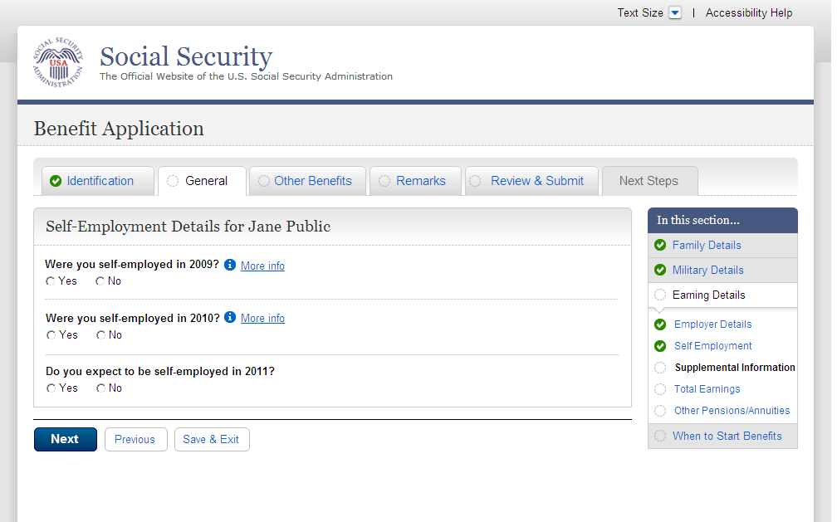
  - ear003-1-a_Supplemental Information
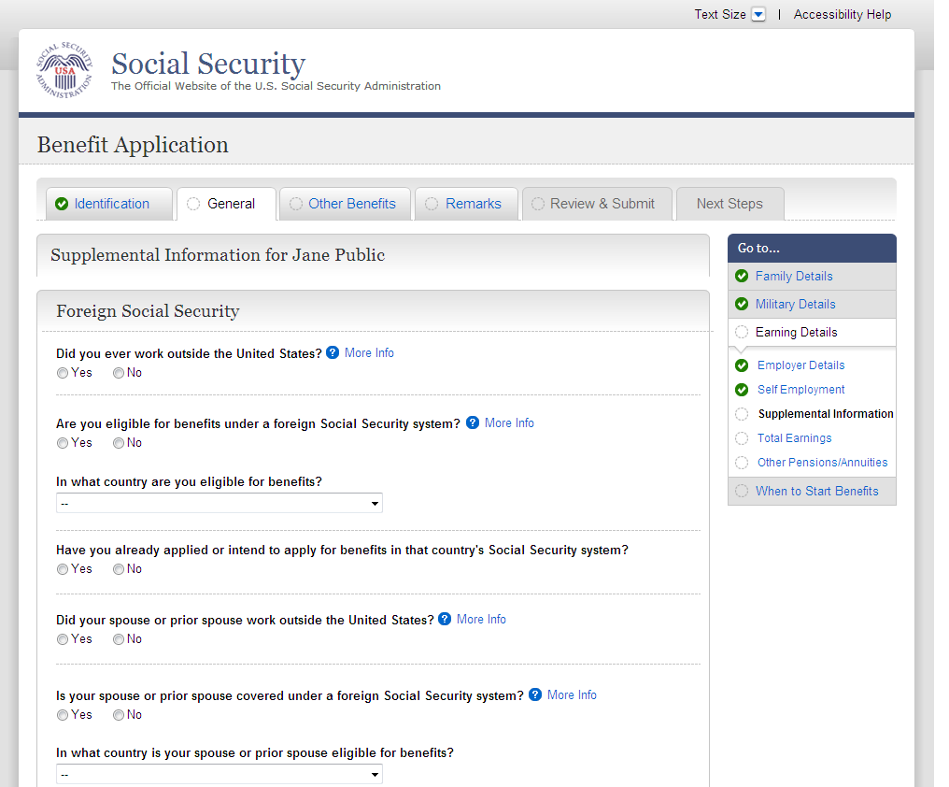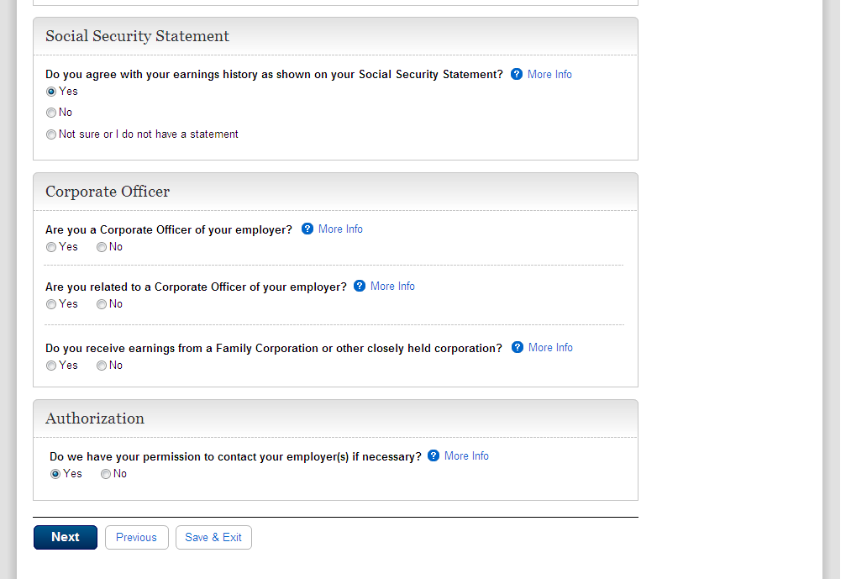
  - ear004_Total Earnings
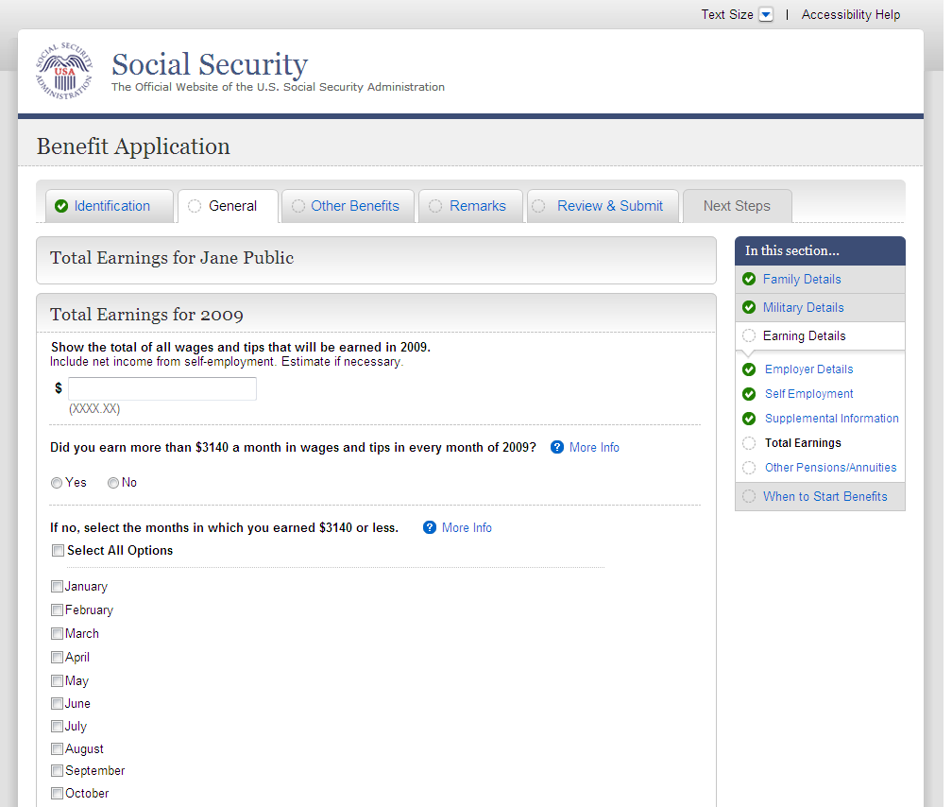
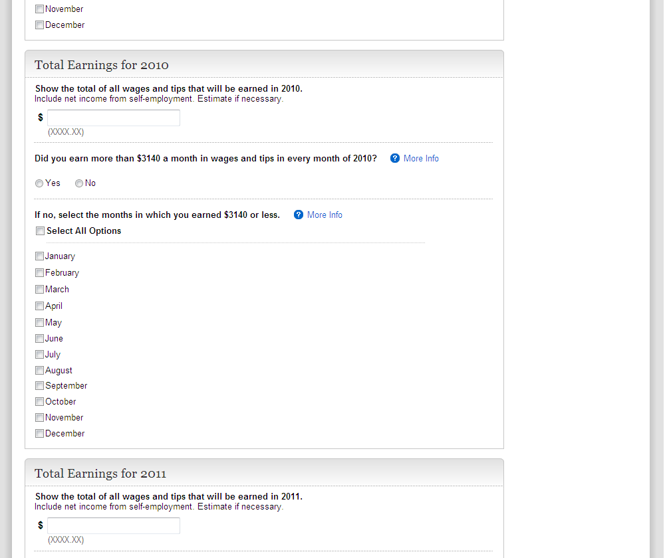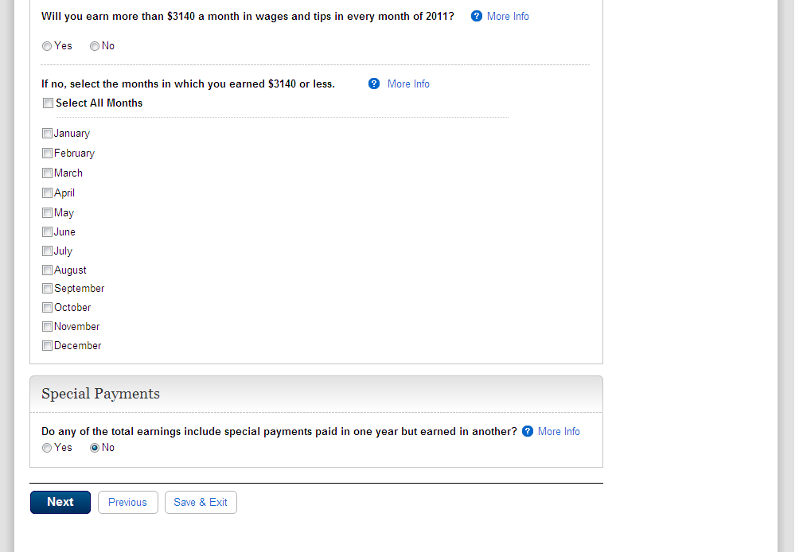

ear004-d1-b_Total Earnings
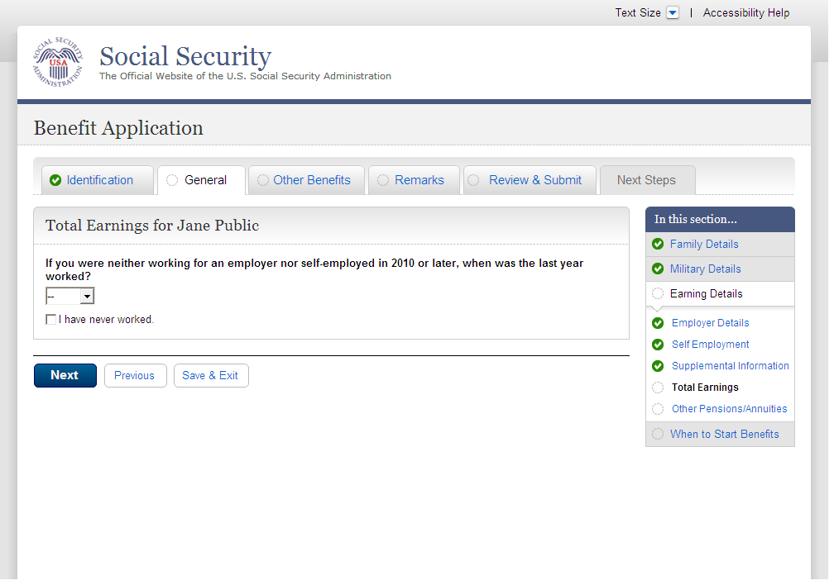
  - ear005-1-a_Other Pensions/Annuities
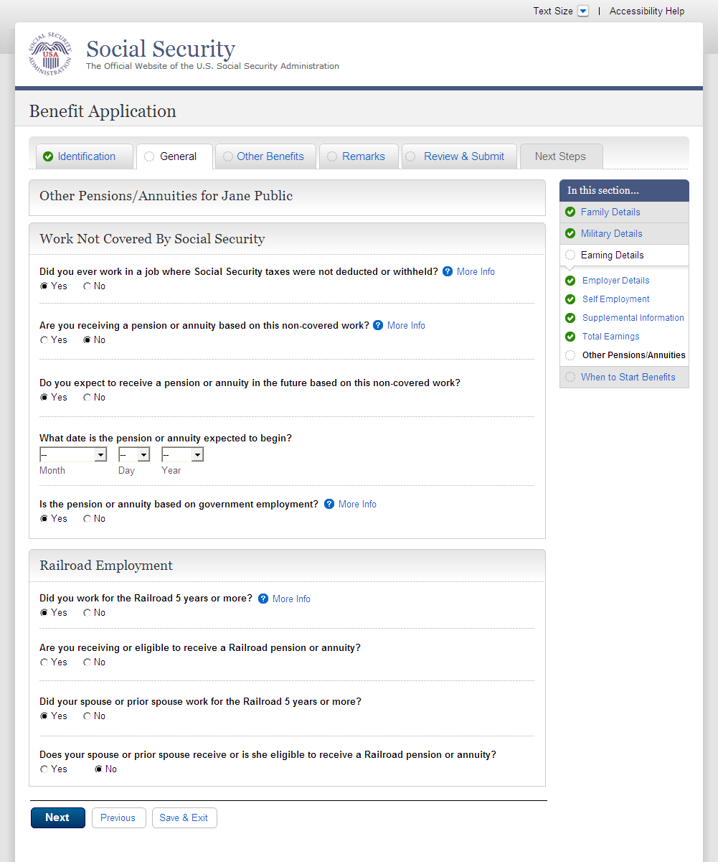
  - wst000-1_Reduced Benefits
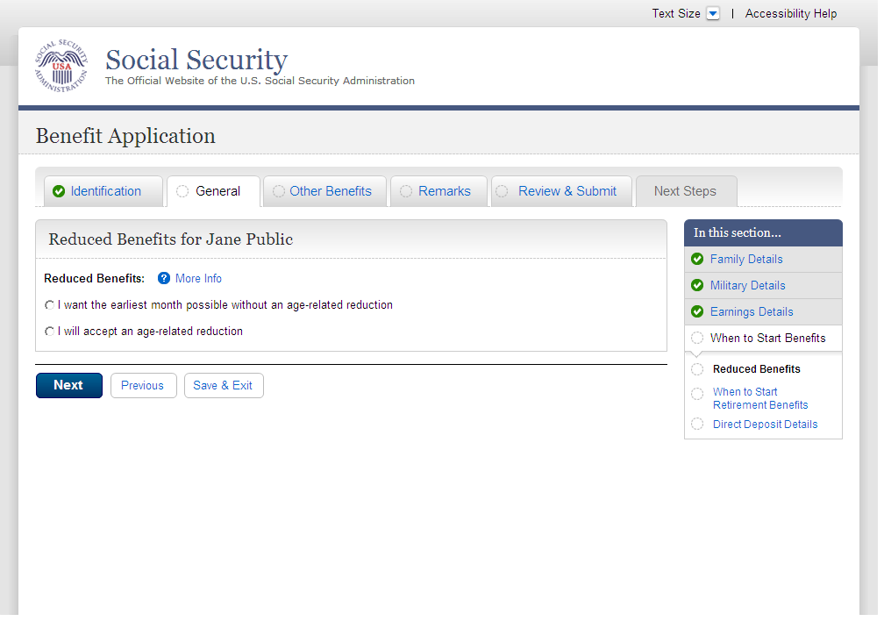
  - wst001-1-b_When to Start Retirement Benefits
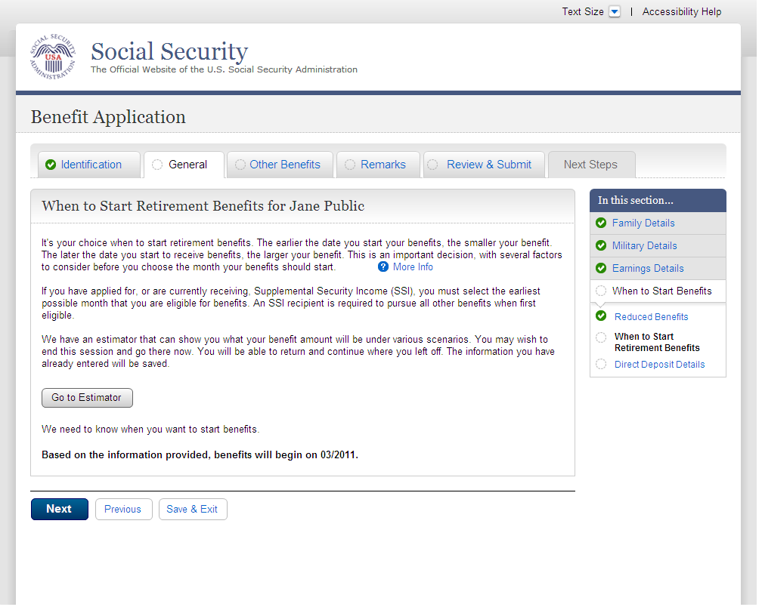
  - wst001-1-e_When to Start Retirement Benefits
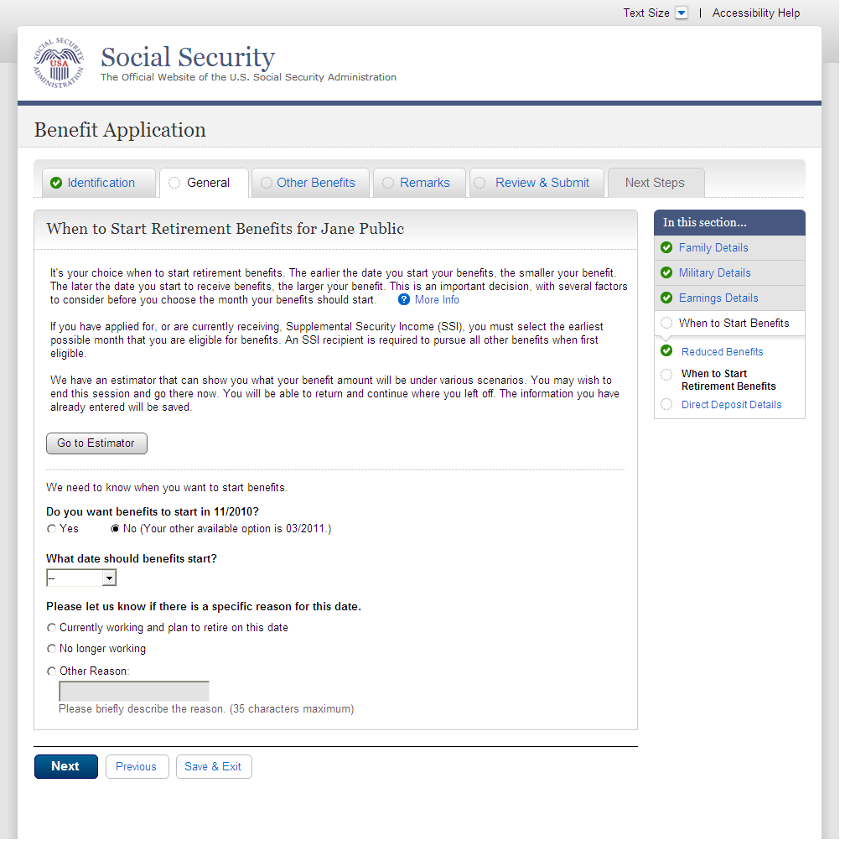
  - wst001-3-c_When to Start Retirement Benefits
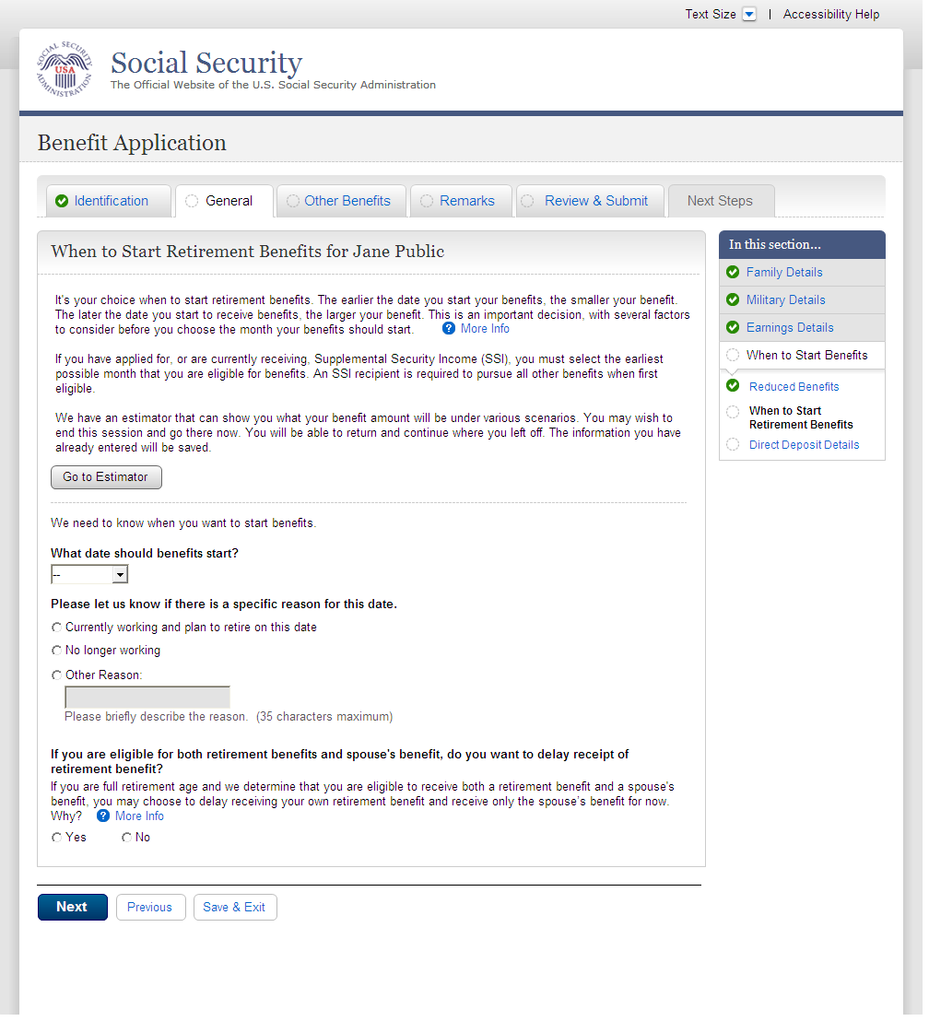
  - wst001-3-d_When to Start Retirement Benefits
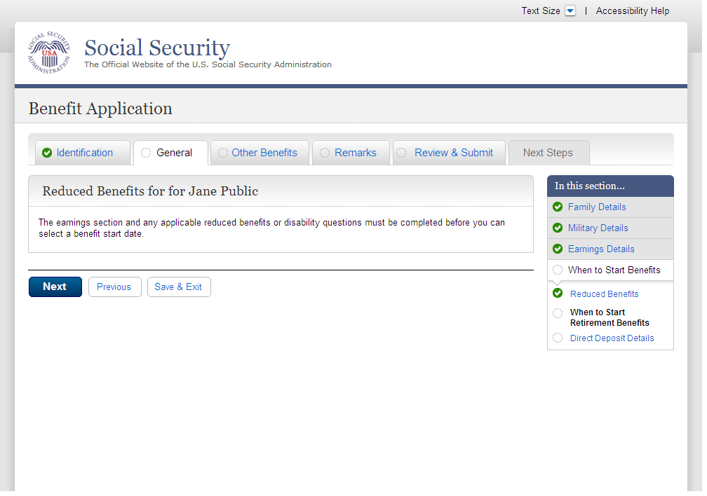
  - wst002-1_Direct Deposit Details
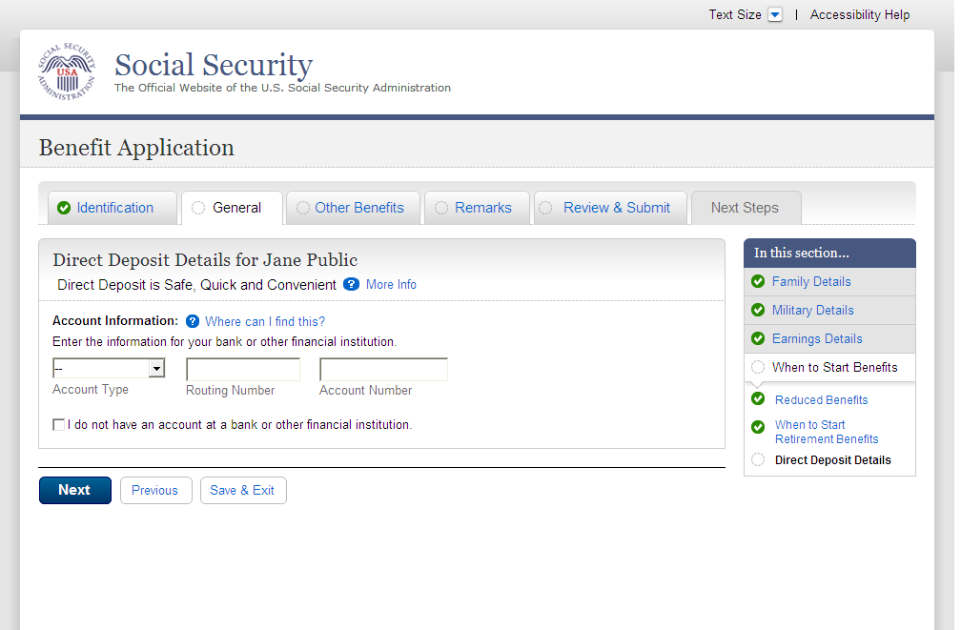

  - bni001-1_Benefit Information
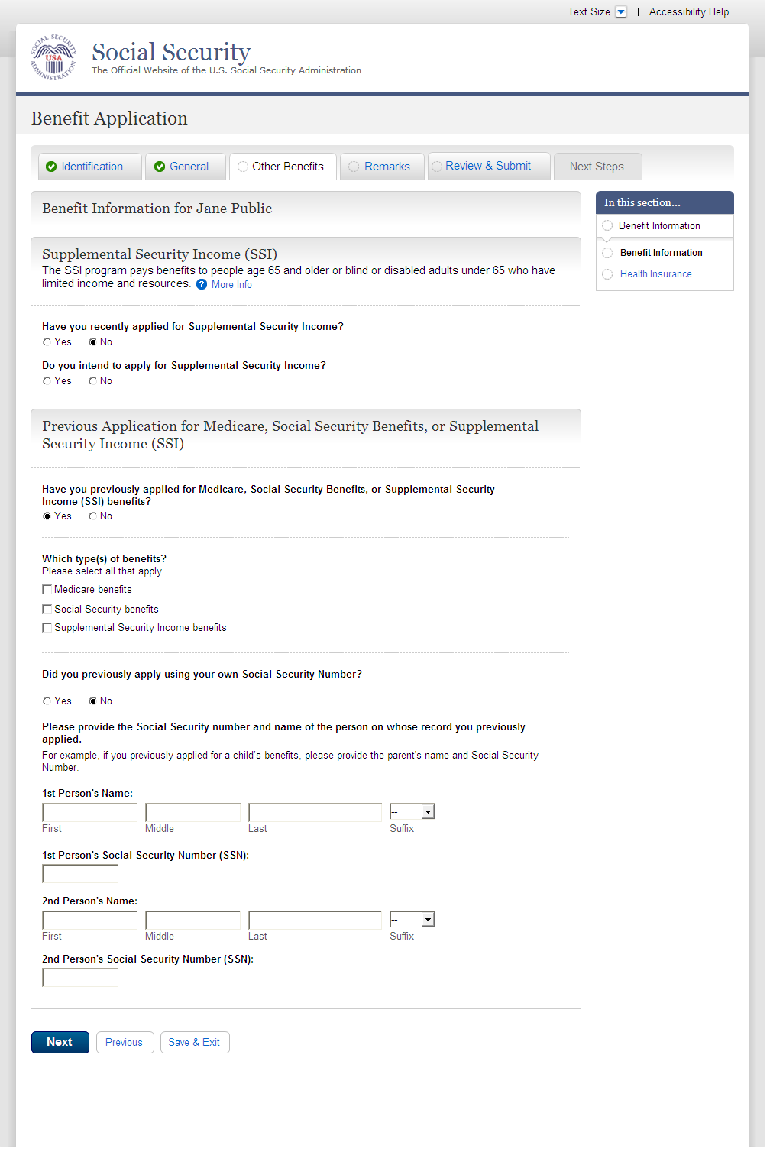
  - bni002-3_Health Insurance
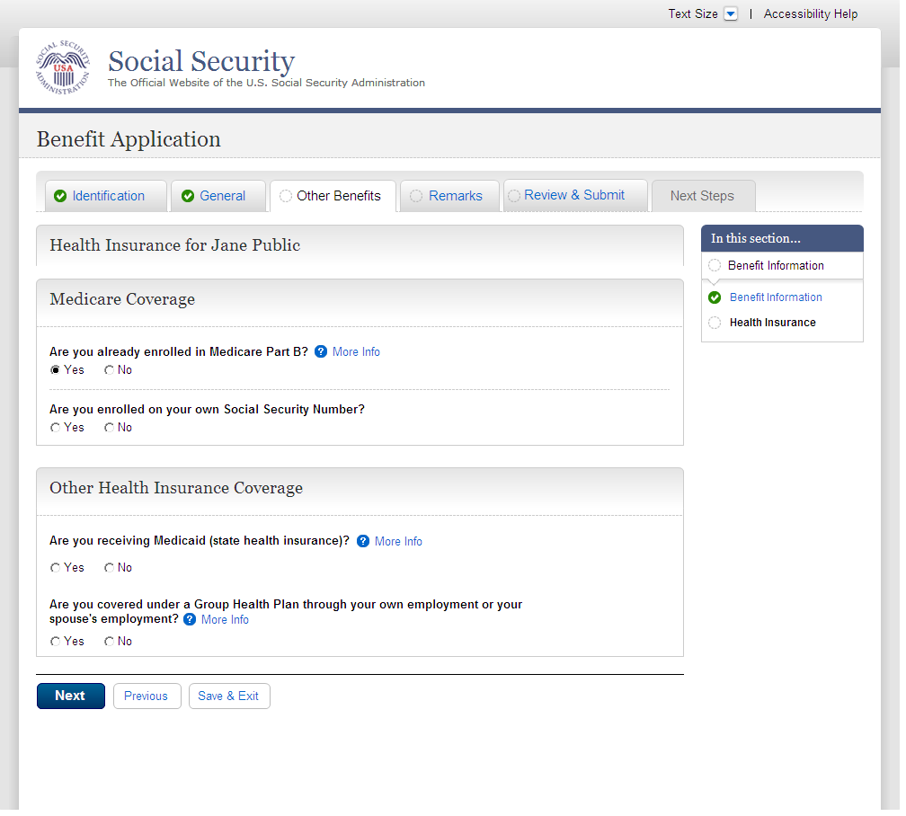
  - rem001_Remarks
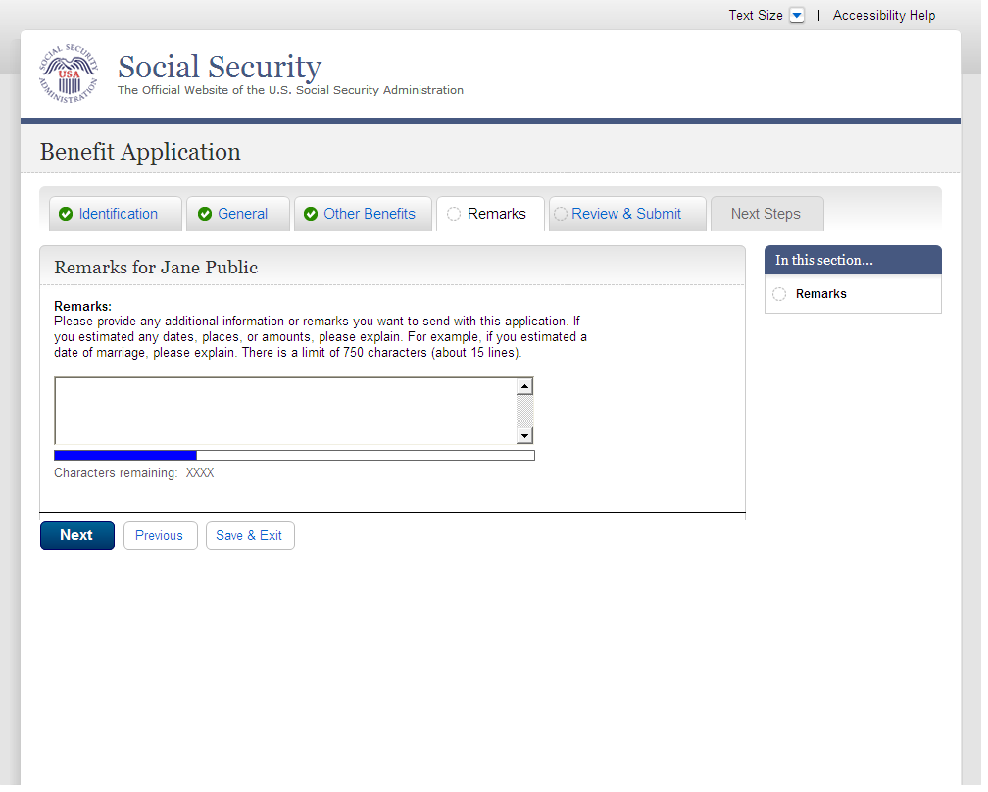
  - ovs001-r1-a_Overall Summary
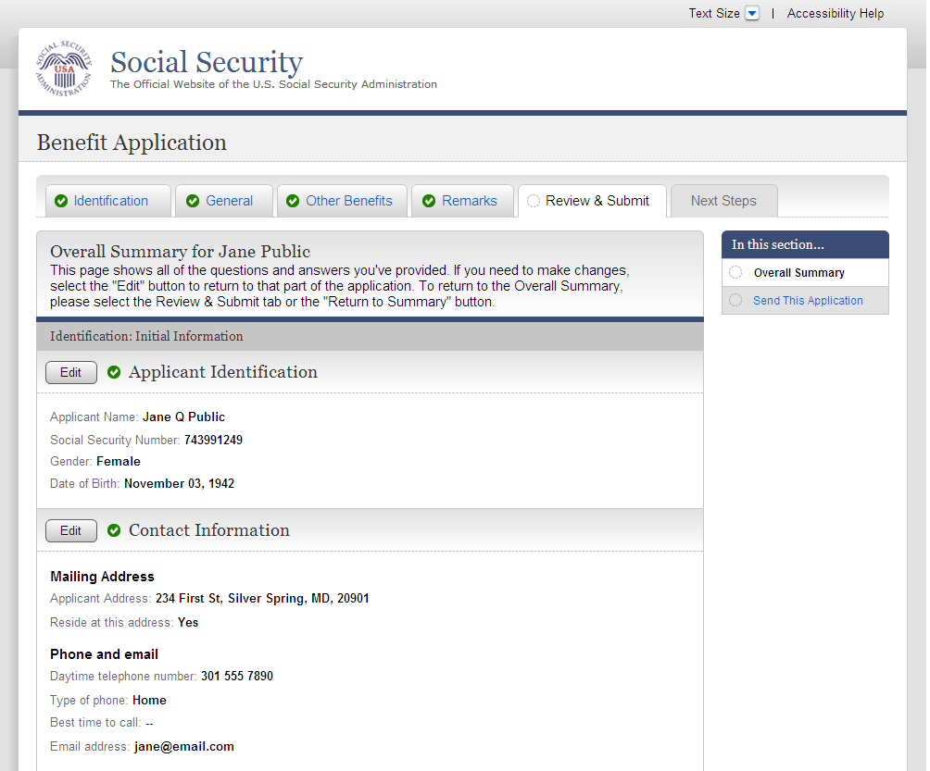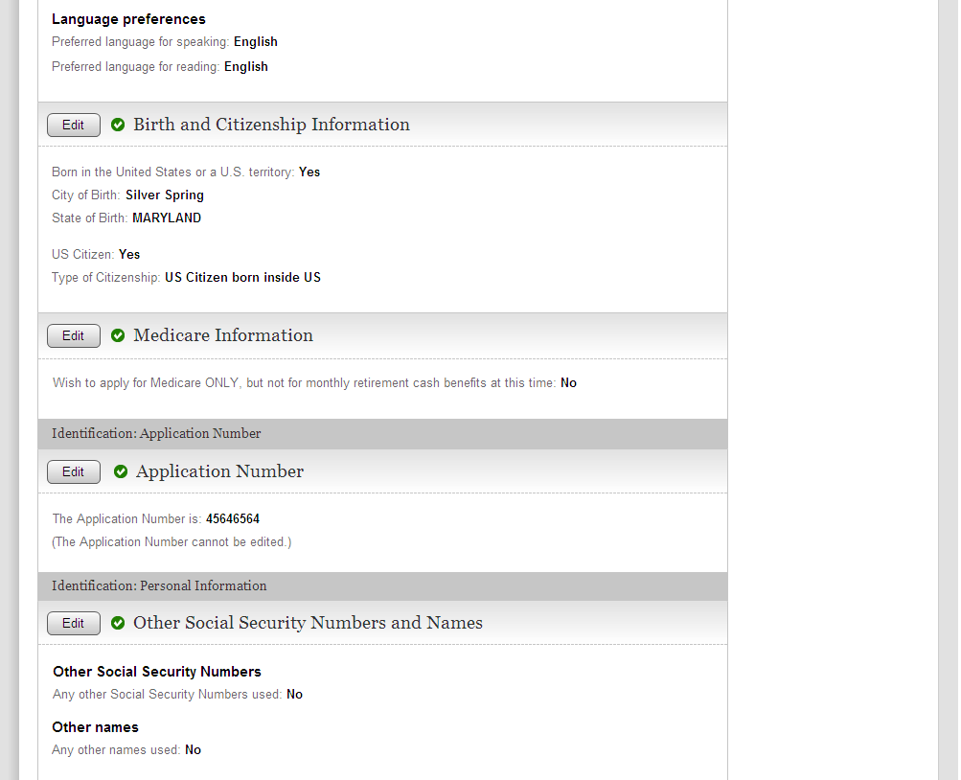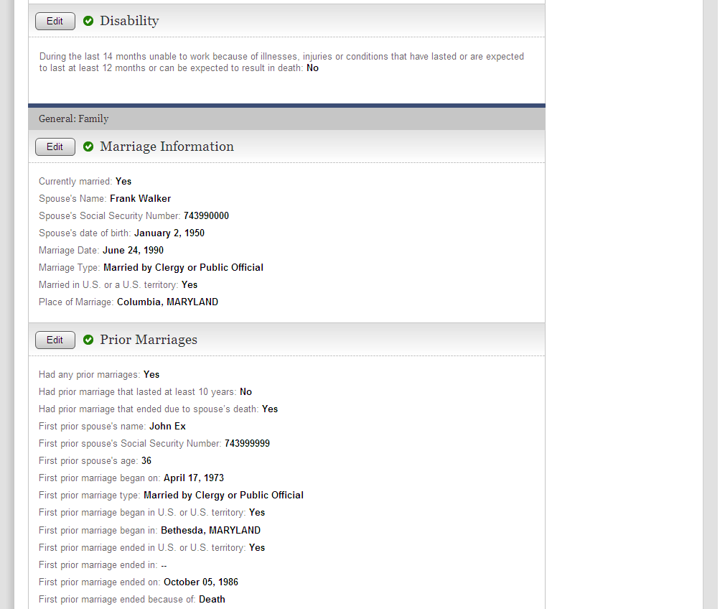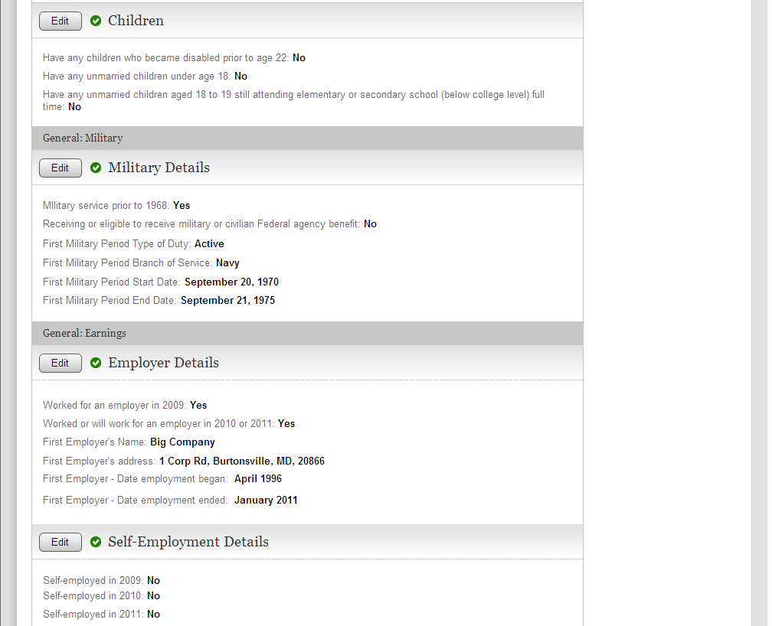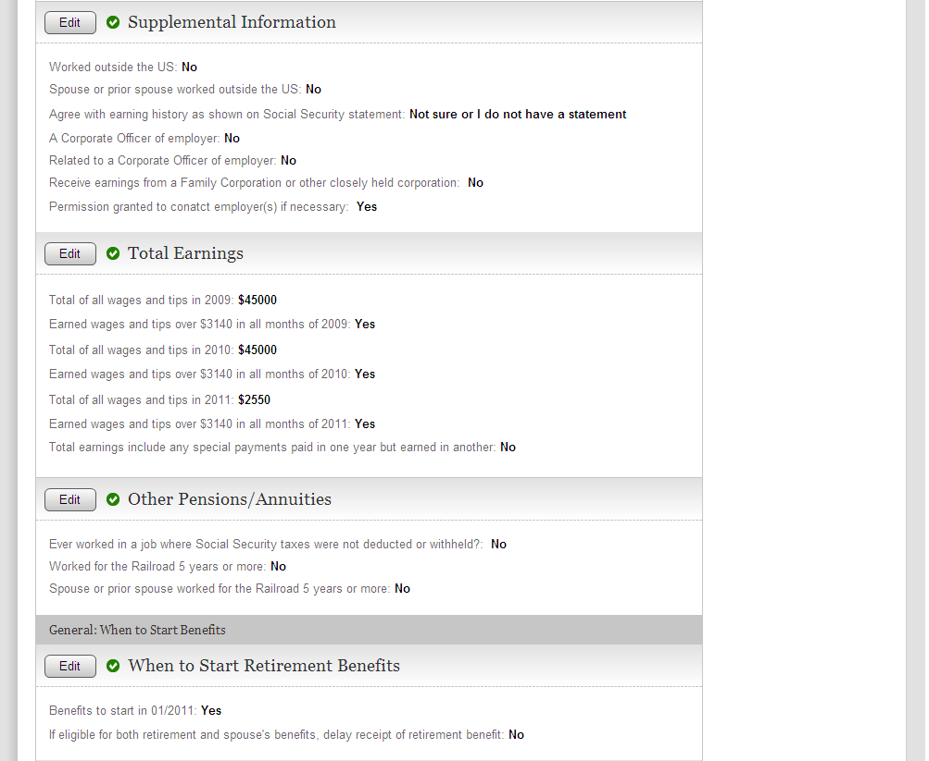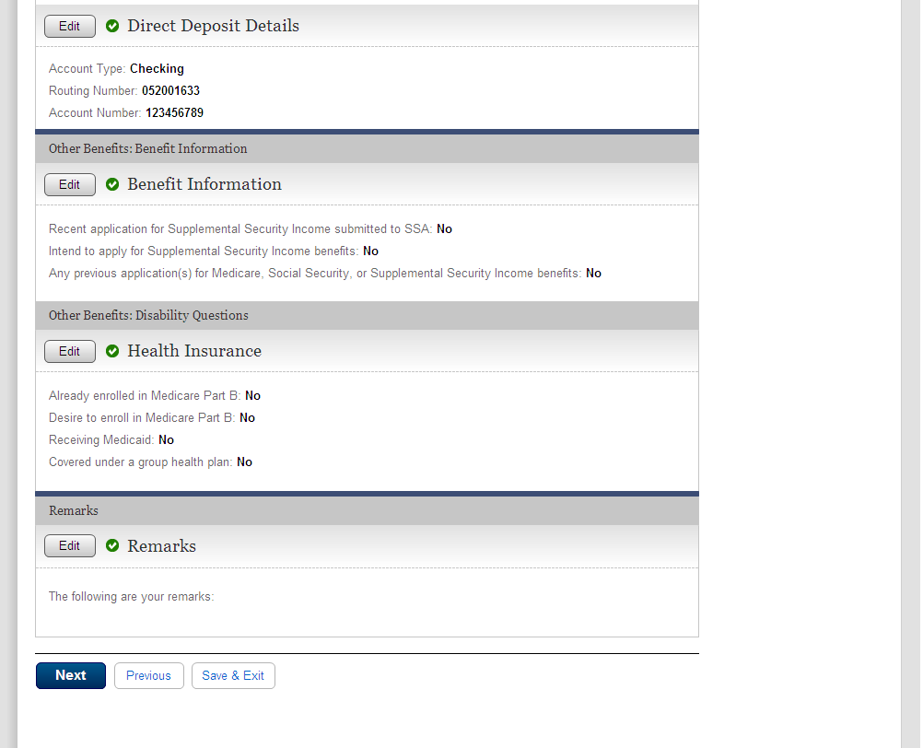

  - snd001-r1_Send This Application
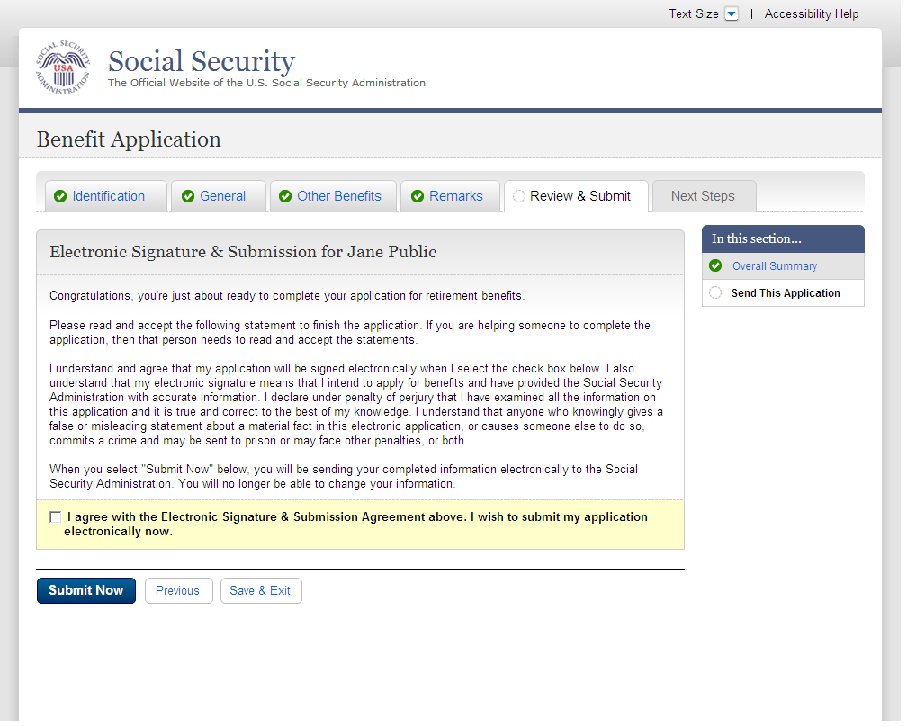
  - rec001-r1-a_Evidence and Receipt
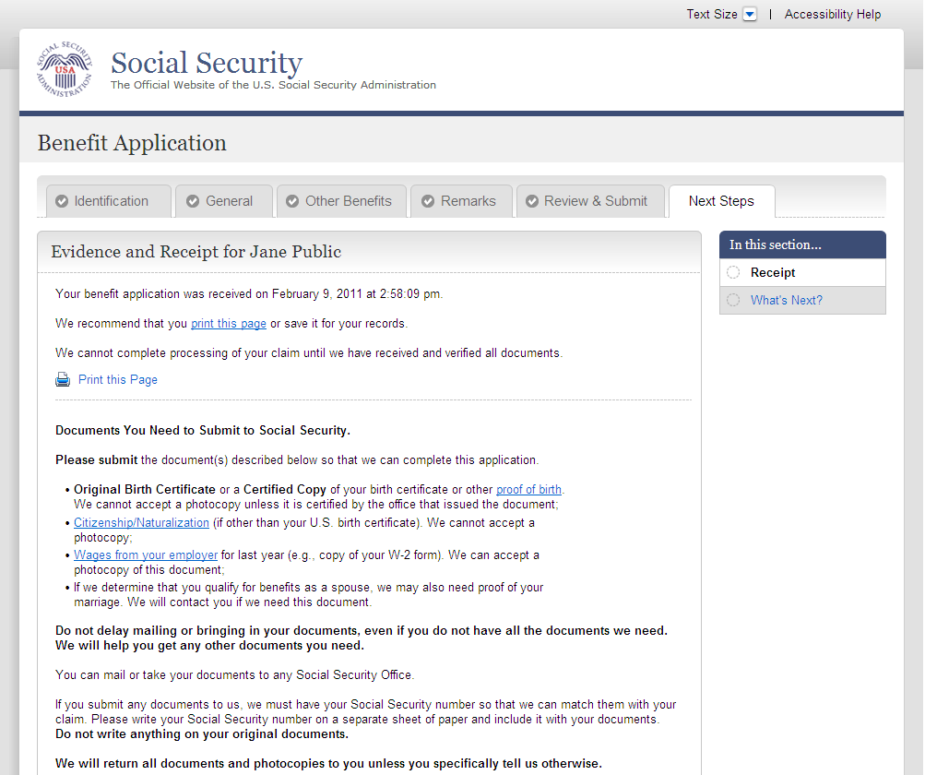
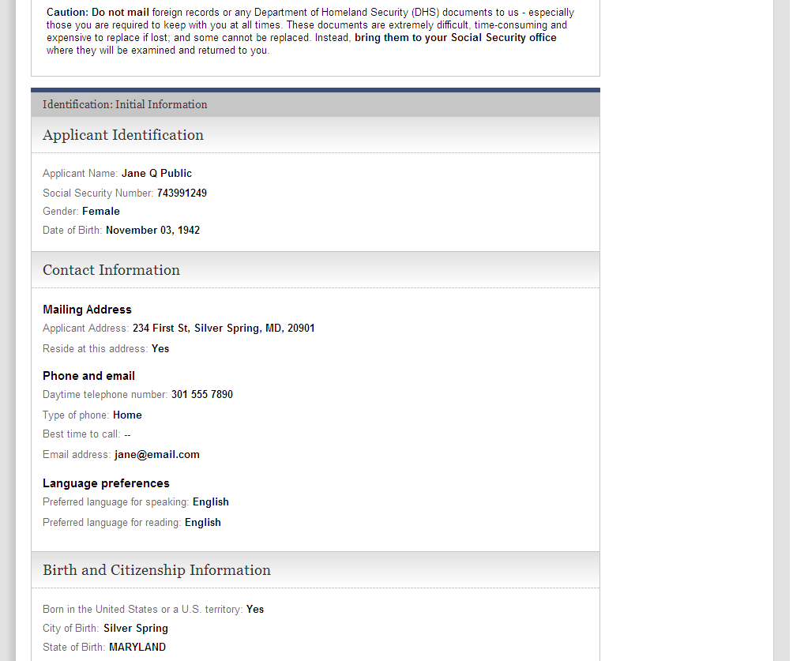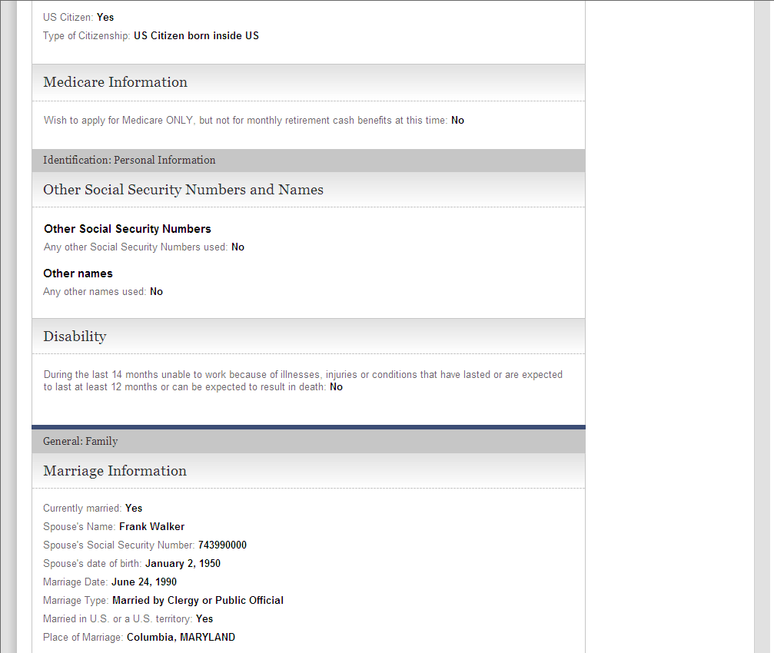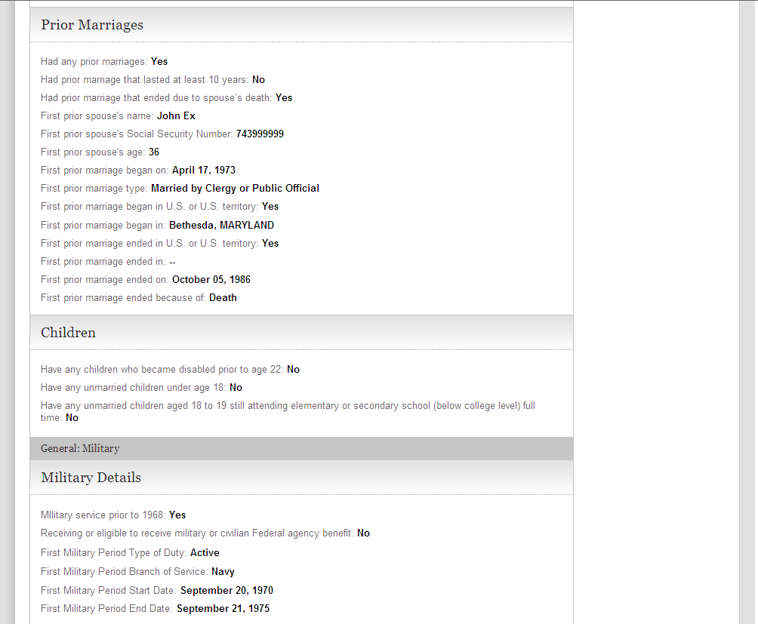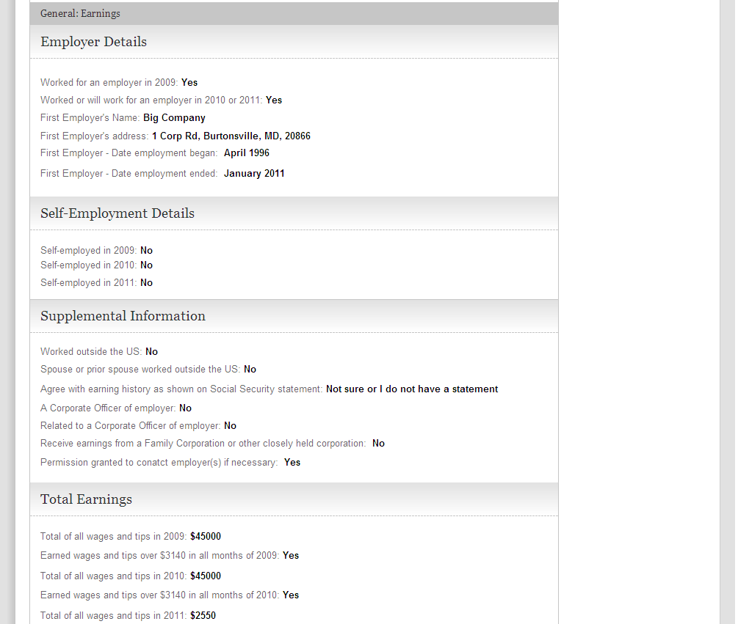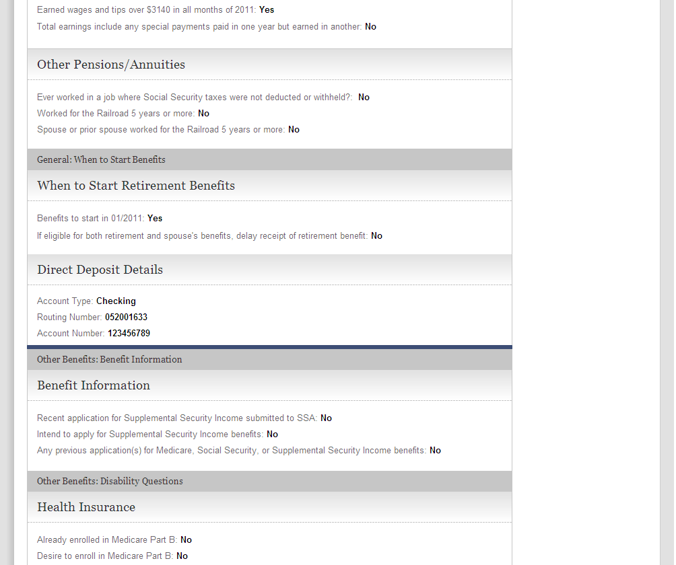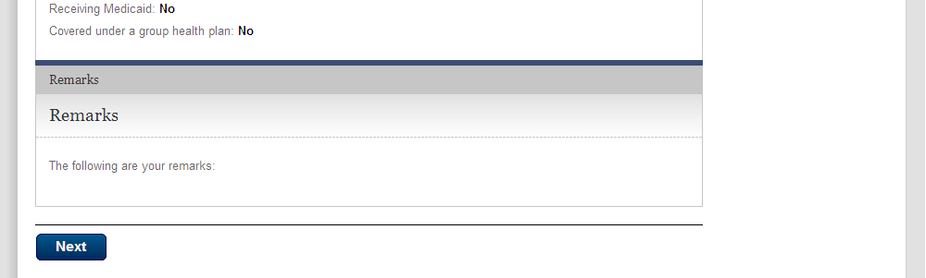

  - wtn001-r1_Next Steps
Default view, Contact Information will display expanded and the other remaining sections will display collapsed.

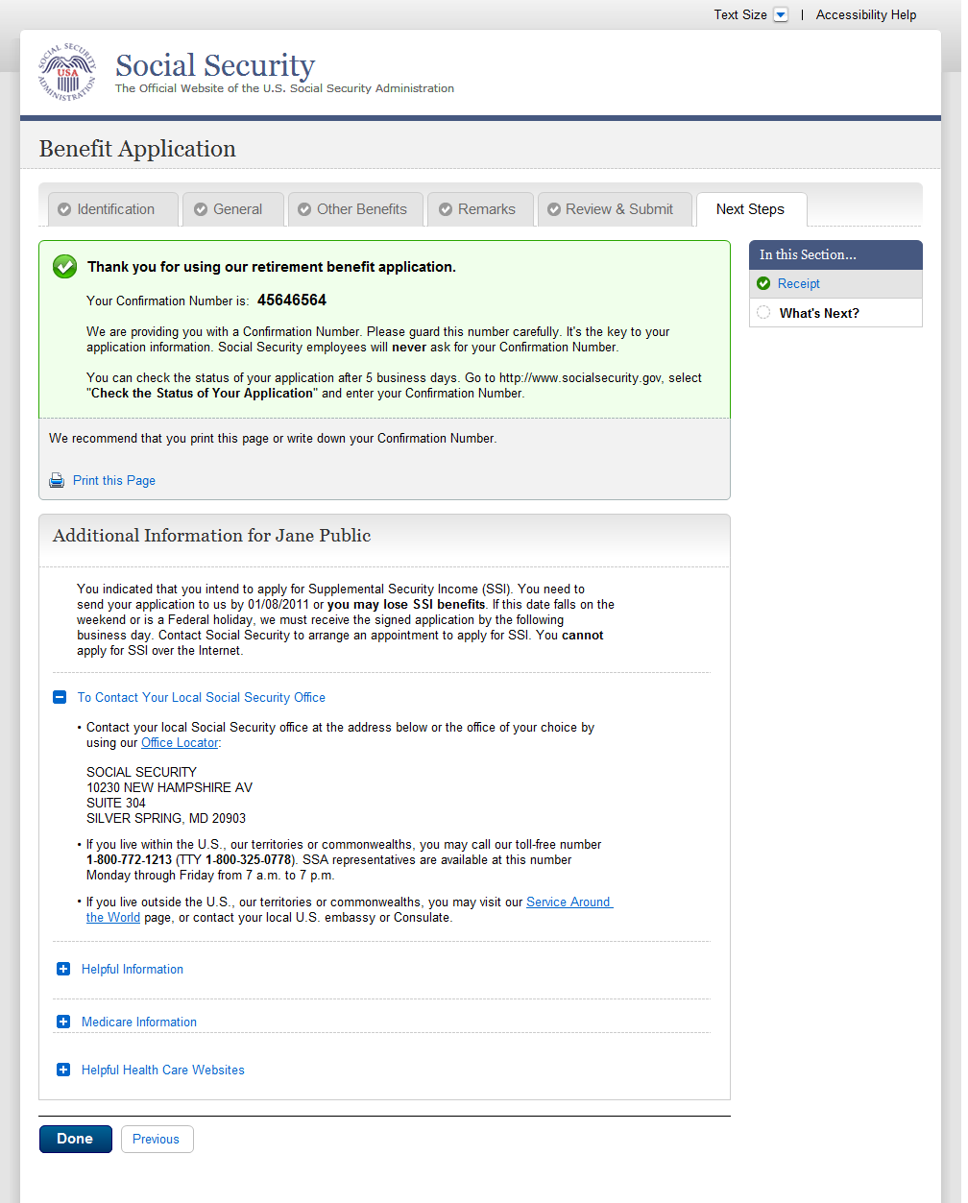

  - wtn001-r1_Next Steps-Expanded
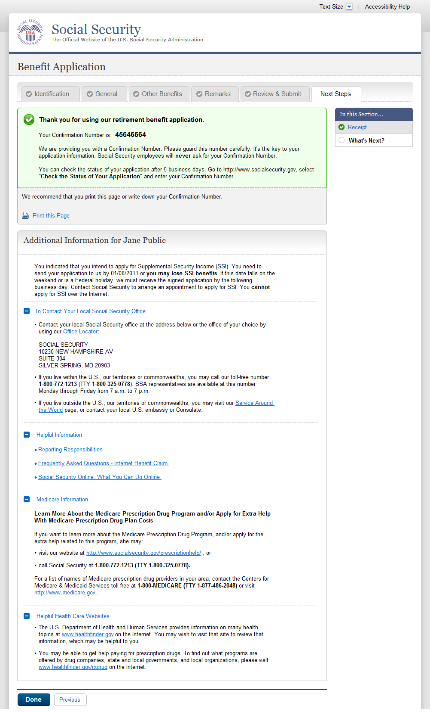

- Messages
  - msg005_GoToEstimator
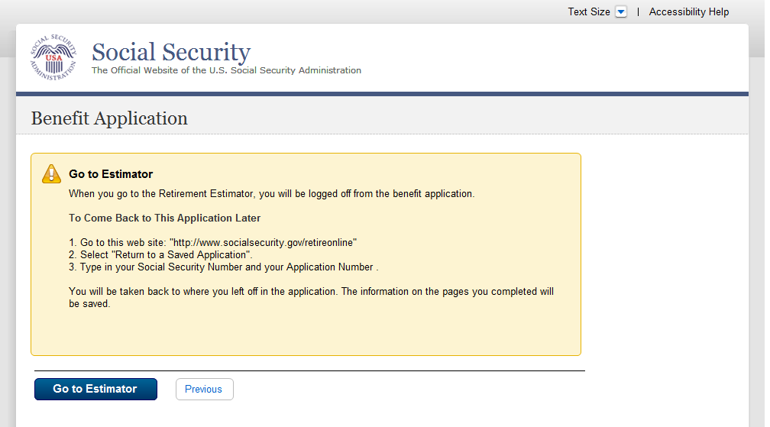
  - msg010_Check the Information You Entered
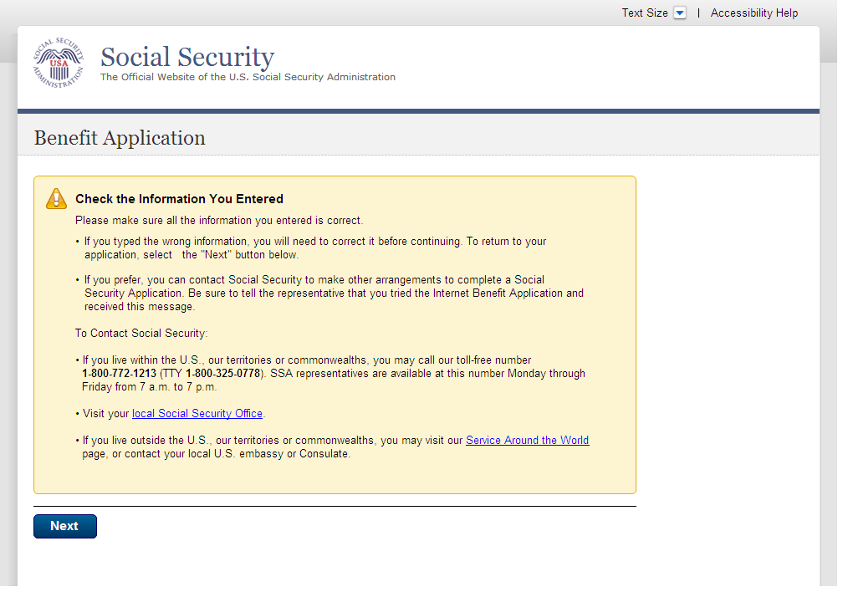
  - msg027_We cannot process your request at this time
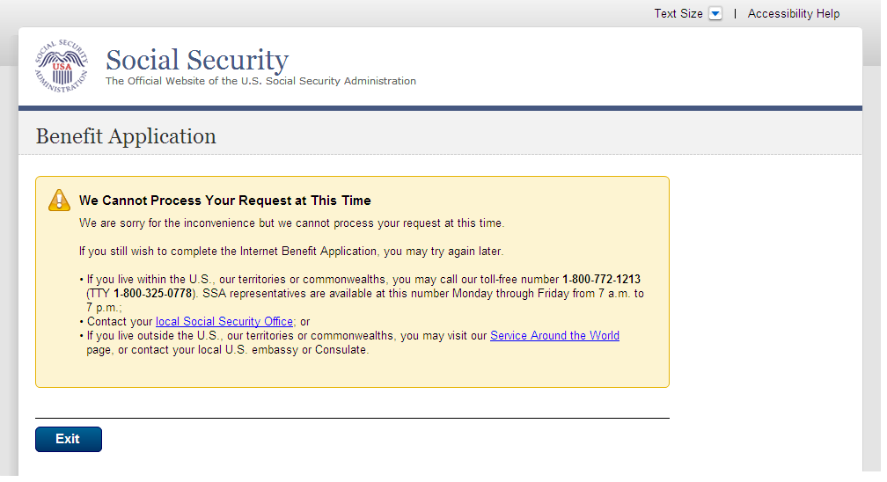
  - msg028_This service is not available at this time
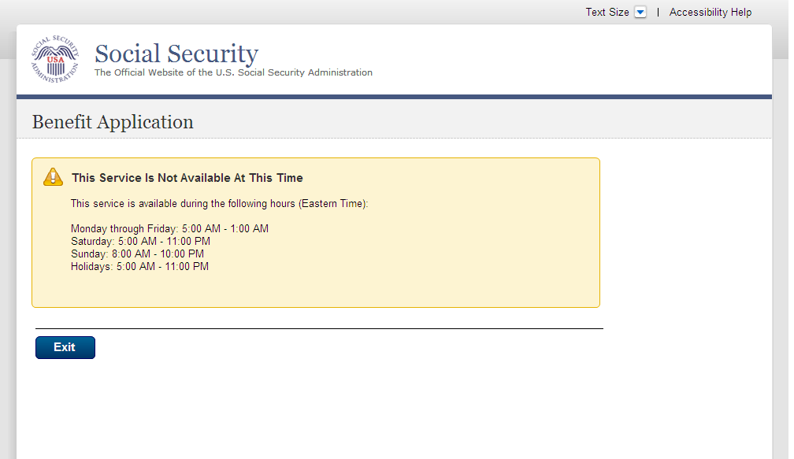
  - msg045_Hours of Operation
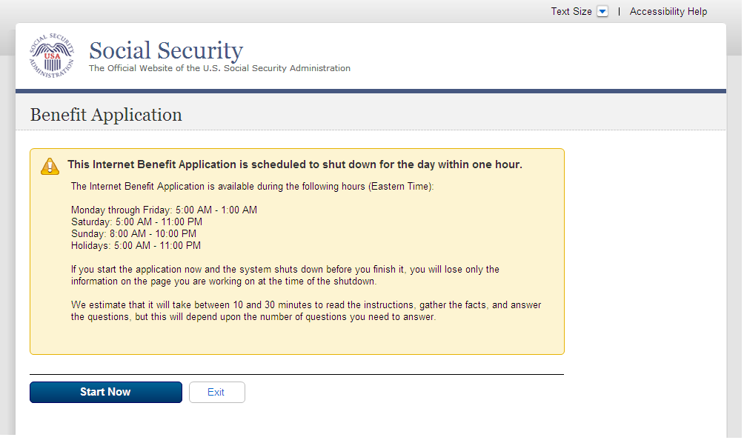
  - msg051_We cannot Process your request
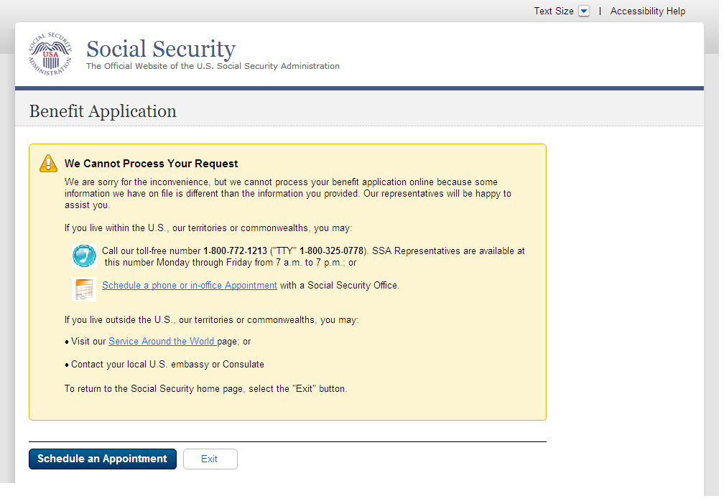
  - msg052_We cannot Process your request
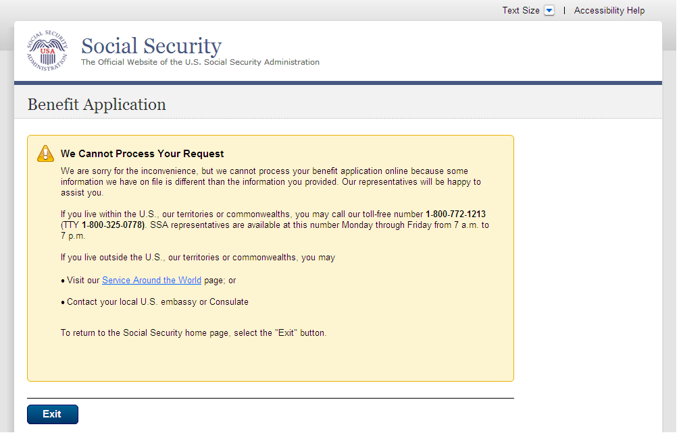
  - msg152_Sign Off
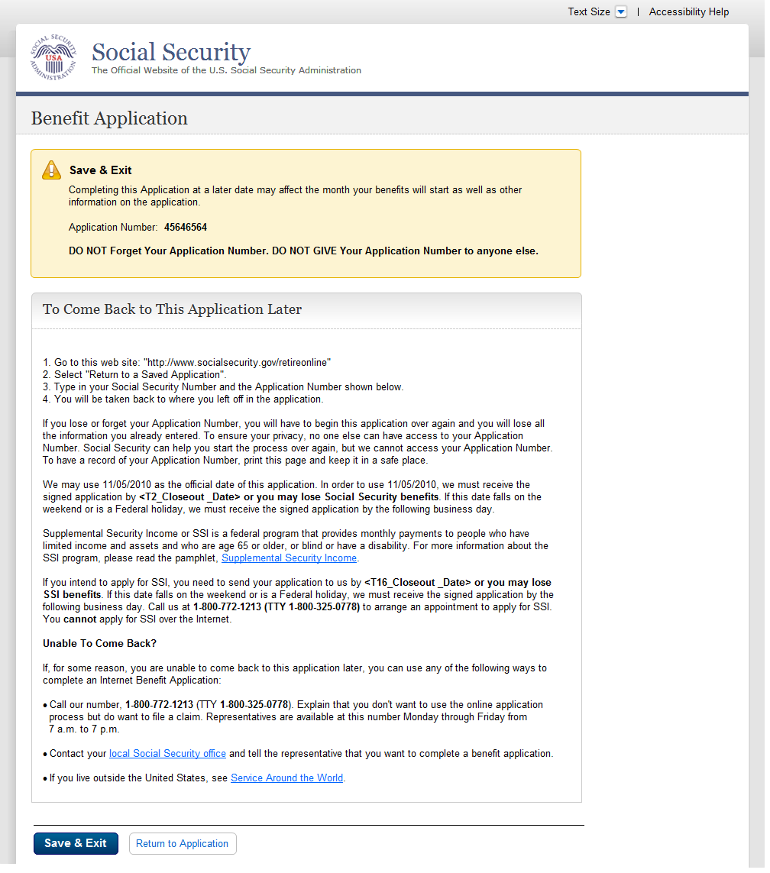
  - Bank Info Msg - Where can I find this?
