In the back of each attachment, there is an “appendix A.” Appendix A lists the changes that were made during the OMB review period to address comments during the 30 public comment period and editorial changes that we made. We added a sentence in the introduction of each document explaining appendix A.

No changes were made to Attachment B-3 (Explanation of EDFacts), B-8 (Dispute Resolution), or F (Public comment and response during the 30 day period).

Attachment B-1 – Overview
Since the version we gave to OMB, we
- reformatted the table at the end of the summary of EDFacts section
- change capitalized on DG10 on page 16

Attachment B-3 – Data groups
Since the version we gave to OMB, we
- Changed capitalization throughout the document
- Deleted the collection at the school level of DG688 which is one of the three AMAOs for Title III – This was a typographic error. We don’t collect the AMAOs at the school level.
- Deleted the word “regular” in the reporting period for DG695 Regulatory four-year adjusted cohort graduation rate table – This was a typographic error. With this change, the reporting period for this data groups will match the reporting periods of the other three data groups for the cohort graduation rate.
- Added the word “table” to the name of DG694 School Improvement Funds allocation table – This was to conform to ED’s naming convention.
- Add file specification numbers – The file specification numbers were assigned after OMB approved the collection. States use the file specification numbers so adding the numbers to the documents makes it more useful to the states.
- Fixed the name of DG744 in the table that lists the technology data groups. – The table wasn’t updated when the data group was replaced.
- Changed the numbering of subtotals for DG647 – The numbers were switched.
- Corrected the permitted value for DG603 – The permitted value was listed as “integer” but this has always been a status with permitted values of yes, no, etc.
- Changed reporting period of DG694 to match DG693 – This was mentioned in Attachment E as a resolution to a comment but the change was missed.
- Add grand total to DG 670 – The removal of the grand total was a typographic error. This deletion was not mentioned in Attachment C which explained the changes. Below are copies of the page of previous clearances for this data group. These documents show that DG 670 has had a grand total.

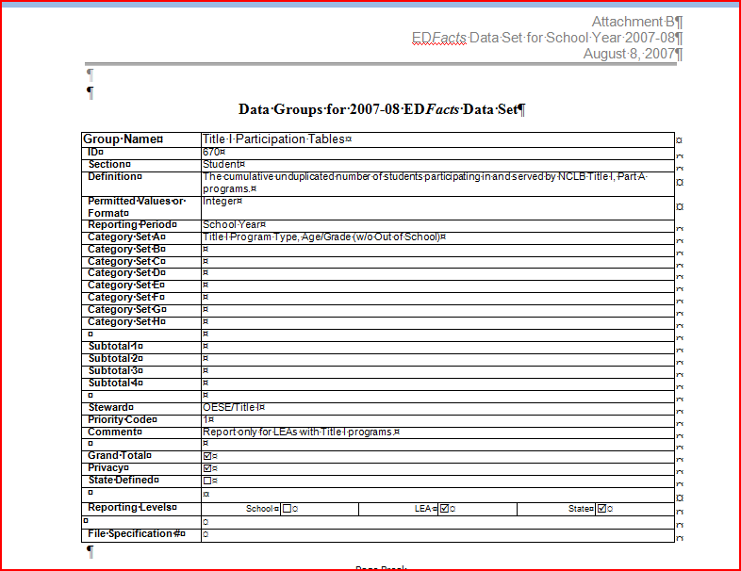
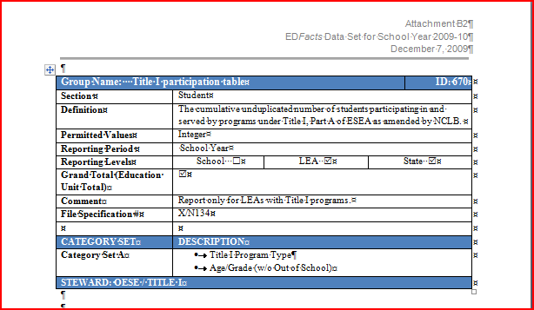
Other than the changing of the capitalization, these changes are listed in appendix A.
Attachment B-4 – Categories
Since the version we gave to OMB, we
- Changed the capitalization in the document
- Changed some names and IDs so that they matched exactly to the names used in the other attachments
- Removed permitted value in the category “assessment administered” – the permitted value is not used
- Added category “equipment” which was omitted – this category is used by DG744 which was in attachment B-3
- Fixed the “X”s in the columns of the table on the permitted values of the age categories. The “X”s for the category “exiting” were in the column for the category “early childhood.”

Attachment B-5 – CRDC
Since the version we gave to OMB, we
- Renumbered the data groups
- Moved some data groups so that they were in order alphabetically
- Change the reference from computer table to internet access table because the one replaced the other in the collection

I also change the formatting. The version we gave OMB had some blank page because we had page breaks in the wrong places.

Attachment B-6 – SIG
Since the version we gave to OMB, we
- Redesigned the data groups that support metric 8. The description of metric 8 called for two measures: 1) average scale scores for all students and each subgroup, and 2) the scale scores at the cut points for three specific achievement percentiles for all students by grade level at the school. DG730 (Average scale score table), as designed, went beyond the data needs of metric 8 to collect scale scores at the percentile cut points by grade level for each subgroup instead of collecting them only for all students. To reducing the burden required to report data to correct the unnecessary collection of data, we revised DG 730 and added a new data group. As revised, DG 730 now collects a single number (the average scale score) for all students and each subgroup. The new data group DG 751 (Achievement percentile table) collects three numbers for all students only (the scale scores at the cut points for the 25th, 50th, and 75th percentiles).
- Added the word “table” to the name of DG730

Attachment B-7 – SFSF
Since the version we gave to OMB, we
- Added the word “table” to the name of DG737, 747, 738, 748, 739, and 740
- Deleted school level from DG748
- Moved the sentence about how there being blank space in the document to the introduction. The sentence had been in the section on new data groups.

Attachment E – Public comment and response during the 60 day period
Since the version we gave to OMB, we fixed the header. The header had gotten changed to “30 day” instead of “60 day.”

