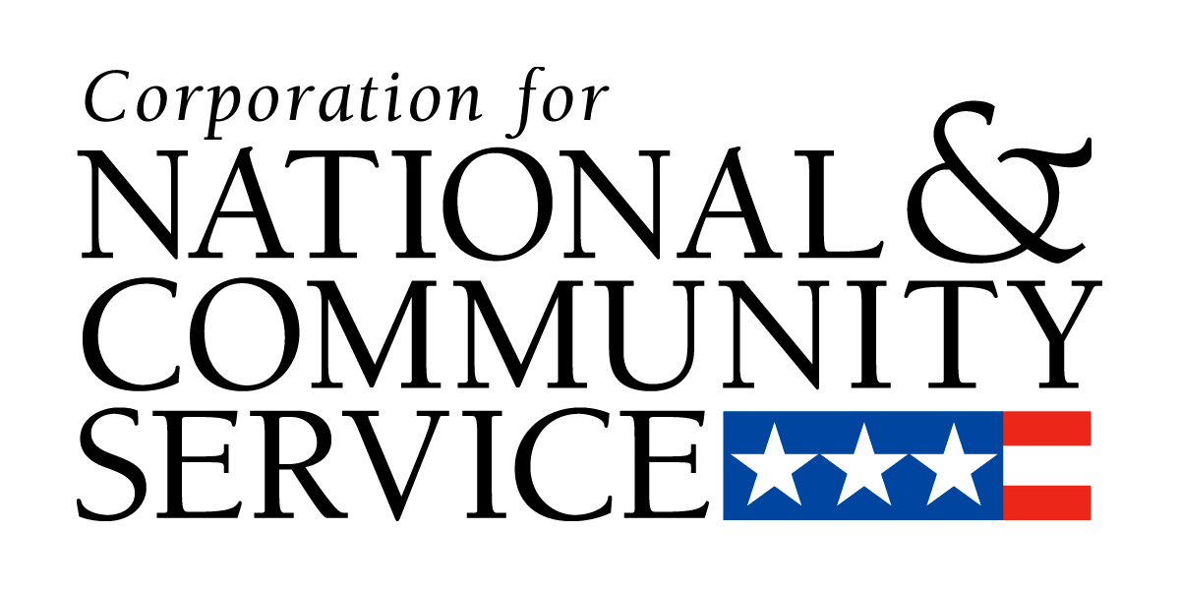


Financial Management Survey

This survey is intended to collect information about the capacity of organizations to manage federal grant funds. Information from the report will be used to assess an organization’s structure and capacity-building needs and identify any appropriate technical assistance and/or resources to strengthen operations. Completion of this report is required, but is independent from the competitive grant process. Responding organizations are advised to make sure that the person or persons completing this form are those responsible for and knowledgeable of the organization’s financial management functions.

Please complete all items on this report.

Organization Name:

EIN: DUNS Number:

I. Documents, policies and procedures
Instructions for Part I:
- Provide copies of the most recent versions of the requested documents; check boxes if documents are attached.
- If any listed documents are not available please explain; attach additional sheets if necessary.
- Note, some additional documents are identified and requested in other parts of this survey.

- Public Disclosure Documents

IRS Determination letter, and any amendments, reflecting approval or denial of tax-exempt status
Internal Revenue Service Form 990 "Return of Organization Exempt from Income Tax" including all applicable schedules and attachments; if Form 990 filing can be downloaded, provide the website address: ____________________________________________________________________________________
Schedule of federal awards from IRS Form 990 (if not included above)
Audited financial statements including auditor's Management Letter (A-133 or other audits if not subject to OBM Circular A-133)
List of federal grants, contracts, and subgrants/sub-contracts using federal funds awarded to the organization in the last two years including the contract numbers, amounts and awarding agencies

- Governance

Articles of Incorporation and By-Laws
Roster(s) of the Board of Directors, including professional titles, officers and committee membership
Organizational Chart identifying key staff by title

- Organizational Policies and Procedures

The list of policies below is designed to identify some of the most critical policies for administration of a federal grant. Your organization may not yet have these and other appropriate policies in place if you are a first-time recipient of federal funds. You will be required to have a full complement of financial, programmatic, and administrative polices as well as internal controls in place, as applicable, within 60 days of receiving any grant award from the Corporation.

Please indicate whether the organization has written policies and procedures in the following areas. If yes, attach the document and report the date it was implemented or most recently updated.

Availability |  |  |  | Item | As of Date
 | Yes |  | No | Table of Contents for Personnel/Employee Handbook/Manual | _____________
 | Yes |  | No | Table of Contents for Financial/Internal Controls Policy Manual | _____________
 | Yes |  | No | Delegations of Authority | _____________
 | Yes |  | No | Timekeeping Guide or Policy | _____________
 | Yes |  | No | Travel Guide or Policy | _____________
 | Yes |  | No | Procurement Guide or Policy | _____________
 | Yes |  | No | Standards for Use of Federal Funds Policy | _____________
 | Yes |  | No | Staff Code of Conduct / Statement of Ethics | _____________
 | Yes |  | No | Document Retention Policy | _____________

II. General Information

- What year was the organization established? _________________________________

- What year did the organization receive its first federal grant or contact? _____________________

- How many employees work for the organization (in full-time equivalents)?

 | Fewer than 10 |  | 10-49 |  | 50-99
 | 100-249 |  | 250-500 |  | > 500

- What was the organization's total budget for the last completed fiscal year?

 | $0 - $499,000 |  | $500,000 - $999,999 |  | $1 M - $4,999,999
 | $5 M - $9,999,999 |  | $10 M - $24,999,999 |  | $25 M or more

- What percentage of the total budget for the last completed fiscal year came from federal and state grants and contracts?

 | 0 – 10% |  | 11 – 20% |  | 21 – 30%
 | 31 – 40% |  | 41 – 50% |  | 51 - 60%
 | 61 – 70% |  | 71 – 80% |  | 81% or more

III. Financial Management

- Indicate whether the Board has the following committees, and whether they are permanent (per By-Laws) or ad-hoc.

 | Executive Committee |  | Permanent |  | Ad-Hoc
 | Finance Committee |  | Permanent |  | Ad-Hoc
 | Audit Committee |  | Permanent |  | Ad-Hoc
 | Other – Please Specify:  ________________________  ________________________  ________________________ |  | Permanent  Permanent  Permanent |  | Ad-Hoc  Ad-Hoc  Ad-Hoc

- Do any paid employees serve as voting members of the Board of Directors?

 | Yes |  | No

- Do position descriptions exist for key financial management positions?

 | Yes |  | No

- Describe the background education, and years of experience in financial management, for key staff identified below. Also, provide copies of their position descriptions, indicating if attached Yes or No:

Position | Education | Years Experience | Position Description Attached?
8a. Chief Financial Officer or equivalent | _____________________ | ________________ | _________
8b. Bookkeeper / Accountant or equivalent | _____________________ | ________________ | _________
8c. Other key financial staff positions, list below:
____________________________ | _____________________ | ________________ | _________
____________________________ | _____________________ | ________________ | _________
____________________________ | _____________________ | ________________ | _________

- Who is responsible for approving / accepting the annual independent audit? (Check all that apply)

 | Audit Committee |  | Board Chair |  | Board of Directors |  | Chief Executive
 | Chief Financial Officer |  | Finance Committee |  | Other (Specify):

- How often are financial reports prepared for executive staff?

 | Quarterly |  | Monthly |  | Weekly |  | Daily |  | Other specify: ____________________

- How often does the Board of Directors or a committee of the Board compare financial reports or other updates against budget projections and/or cash flow projections?

 | Quarterly |  | Monthly |  | Weekly |  | Daily |  | Other specify: ____________________

- Did the Board of Directors vote to adopt the current annual operating budget?

 | Yes |  | No

- Does the board approve an annual fundraising plan?

 | Yes |  | No

IV. Financial Controls

- Does the organization maintain a chart of accounts?

 | Yes |  | No
 | Copy of chart of accounts is attached.

- Does the organization perform job cost center accounting? |  | Yes |  | No

(A job cost accounting system allows you to record budgets, revenues and expenses by cost centers, jobs, grants, and activities)

- How often do you post transactions to the general ledger?

 | Daily |  | Weekly |  | Monthly |  | Annually |  | Other: _______________

- Are at least two original signatures required on checks written above a dollar threshold (determined by the organization) from any bank account(s) that are used for the receipt and/or disbursement of organizational funds, including those from federal sources?

 | Yes |  | No

If yes, what is the dollar threshold? ____________________________________

- Are different staff members responsible for the distinct functions of reconciling cash receipts and cash disbursement? |  | Yes |  | No
- Do distinct staff members authorize and maintain records of financial transactions? |  | Yes |  | No
- Does the organization use an automated payroll system? |  | Yes |  | No
- Does the organization follow a review and approval procedure when disbursing payroll? |  | Yes |  | No
- Is there a maximum amount that can be withdrawn from petty cash? |  | Yes |  | No
- Are receipts required for petty cash expenditures? |  | Yes |  | No

- Is Board approval required for any of the following financial transactions?

Opening / Closing Bank Accounts |  | Yes |  | No | Buying / Selling Property |  | Yes |  | No
Opening Lines of Credit |  | Yes |  | No | Financial Investment / Divestment |  | Yes |  | No
Assigning Credit Cards |  | Yes |  | No | Other specify: ________________________________

- Has the organization issued any loans to an employee or officer of the organization, or forgiven or written-off any loans or debts of any type in the past 12 months?
 | Yes |  | No

- Who is authorized to write-off any debt owed the organization as a bad debt?

 | Accountant |  | Chief Financial Officer |  | CEO/Executive Director |  | Board Committee
 | Board Chair |  | Other, specify: ______________________________________________________

- How often does the organization experience cash flow deficits?
 | Yes |  | No

 | Weekly |  | Monthly |  | Quarterly |  | Annually |  | None in last 2 years

VI. Organizational Policies and Procedures

- How are the organization’s policies and procedures shared with employees? (Check all that apply)

 | eMail |  | Memorandum |  | Employee Handbook |  | Management Informs
 | Orientation and training |  | Intranet |  | Staff meeting |  | Other: ____________
 | There is no existing procedure

- When has training for relevant staff been provided in the following areas?

Subject Area |  | Within 1 year | Within 2 years | Within 3 years | > 3 years ago | Never
 | Financial/Accounting
 | Fundraising
 | Personnel/HR Issues
 | Risk Management
 | Other: _______________
 | Other: _______________
 | Other: _______________

- What would increase the financial capacity and expertise of the organization? (Check all that apply)

 | Additional Staff |  | Computerized Accounting System |  | Financial Training |  | Professional Certifications
 | Other, specify:______________________________________________________________

- What training and technical assistance do you believe would benefit your organization and enhance its ability to administer federal grant awards? (Check all that apply)

OMB Circulars and Corporation Regulations
Basic federal grant administration requirements
Programmatic performance metrics and management
Budget development and execution
Federal cash management
Documenting in-kind and matching contributions
Avoiding common audit findings

The completed Financial Management Survey, with attachments, is to be submitted in hard copy form to the following address:

Attention: Kim Hammonds
Office of Grants Management
8th Floor, OGM
Corporation for National and Community Service
1201 New York Avenue, NW
Washington, DC 20525

You may contact Ms. Hammons on 202-606-6968 if you have any questions.

Preparer’s Comments/Explanations: Please present any clarifications or similar remarks/information here:

The total number of attachments is ______. Please number attachments in sequence.

Preparer Certification

By my signature below, I certify that the above information is complete and correct to the best of my knowledge and ability.

Signature of
Preparer:
Name of Preparer: |  | Date:
title of Preparer:
Telephone:
e-Mail:
Identify anyone else involved in the preparation of this survey by name and position title:

Corporation receipt record:

Received on: __________________
Date

Received/Logged by: ________________________________________________________________
Name/Title of Corporation Staff

