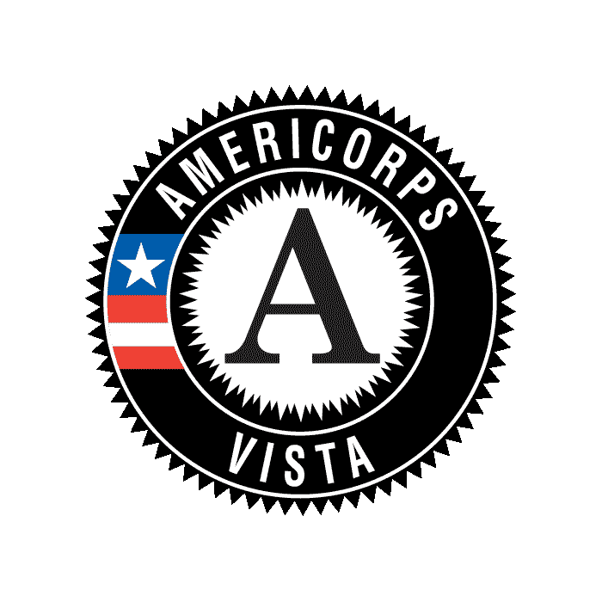
AmeriCorps*VISTA
Progress Report Supplement

BACKGROUND & PURPOSE
The Corporation for National and Community Service provides the VISTA Progress Report Supplement (VPRS) as an addendum to the regular quarterly progress report required of organizations approved to sponsor a VISTA project. The VPRS is submitted on an annual basis and is intended to cover activities over a single fiscal year, regardless of the individual program year. The VPRS is the vehicle through which projects submit specific data elements needed by the Corporation to report on performance. Corporation personnel will use the reports to track Corporation and VISTA specific performance measures on an annual basis.

COMPLETION AND SUBMISSION GUIDELINES
- All VISTA projects are required to submit the VPRS once per year
- The project supervisor should complete the VPRS
- AmeriCorps VISTA members should be allowed to review the completed reports, but should not be required to complete the report

REPORTING PERIOD
All VPRS submissions are due upon completion of the fiscal year.
Reporting period covers October 1 through September 30. The due date is October 31.

KEY DEFINITIONS
Economically Disadvantaged: definition of this beneficiary population or community may vary by program and focus area.

Economic Opportunity: must be receiving or meet the income eligibility requirements to receive:
TANF, Food Stamps/SNAP, Medicaid, SSDI, SCHIP, Section 8 housing assistance, or HUD homeowner assistance programs.
Education: must be receiving or meet the income eligibility requirements to receive:
K-12: free (at or below 130% of poverty) or reduced (between 130% to 185% of poverty) lunch; may or may not actually be accessing free/reduced lunch.
Early childhood education programs: The Child and Adult Care Food Program (CACFP) subsidize the cost of providing nutritious food in child care centers. In this program children qualify for free meals if their families earn less than 130% of the Federal Poverty Guidelines, while they qualify for reduced-price meals if their families earn between 130% to 185% of the Federal Poverty Guidelines.
Healthy Futures: must be receiving or meet the income eligibility requirements to receive:
Medicaid or SCHIP in the state where the individual/family accessing services resides; do not have to meet other eligibility criteria.
Sponsors can also define economically disadvantaged service recipients as those who have an income level below 200% of the Federal Poverty Guidelines, or some local/regional adjustment to it.
Wrap-around Supportive Services: Intervention services that include the delivery of coordinated, individualized services to address a variety of human needs which may include services in a variety of areas such as housing, healthcare, food security, job training, etc.

Leveraged Volunteers: Individuals who are recruited, coordinated or supported by your program. Do NOT include VISTA members or other CNCS program participants in this count.

OMB 3045-0043, 9/30/2011

AmeriCorps*VISTA
Progress Report
Legal Applicant:________________________  Address: ______________________________  City/State/Zip:_________________________  Telephone:____________________________  Fax:__________________________________ | Project Name:__________________________  Project Director:________________________  Telephone:_____________________________  Fax:__________________________________  Email:________________________________
Project/Grant Number:___________________ | Period Covered by this Report:  From:_____________ To: _____________
Data Updates

Please refer to the Key Definitions above before responding to the following questions:

Economic Opportunity
# of economically disadvantaged persons receiving financial services-related assistance from CNCS-supported members, participants and/or volunteers

%’age of economically disadvantaged persons receiving financial services-related assistance from CNCS-supported members, participants and/or volunteers who show improvement in their financial literacy

# of homeless persons who are provided with emergency shelter and/or related services with assistance from CNCS-supported members, participants and/or volunteers

# of housing units developed, repaired or otherwise made available for economically disadvantaged persons/households with assistance from CNCS-supported members, participants and/or volunteers

# of economically disadvantaged persons receiving housing placement services with assistance from CNCS-supported members, participants and/or volunteers

%’age of economically disadvantaged persons receiving housing placements services with assistance from CNCS-support members, participants and/or volunteers who transitioned into safe, healthy, affordable housing (with wrap-around supportive services)

# of economically disadvantaged persons receiving job training and other skill-development services with assistance from CNCS-supported members, participants and/or volunteers

# of economically disadvantaged persons placed in jobs with assistance from CNCS-supported members, participants and/or volunteers

# of economically disadvantaged students who receive services related to improving their academic performance with assistance from CNCS-supported members, participants and/or volunteers
Healthy Futures
# of economically disadvantaged persons who are homebound and or have disabilities who received food, transportation, or other services from CNCS-supported members, participants and/or volunteers

# of economically disadvantaged persons who received access to nutritious food resources provided with the assistance of CNCS-supported members, participants and/or volunteers

# of economically disadvantaged persons connected to and utilizing preventative and primary healthcare services and programs through support from CNCS-supported members, participants and/or volunteers
Veterans & Military Families
# of economically disadvantaged veterans and military service members and their families who are served by CNCS-supported programs
Capacity Building
Dollar value of cash resources leveraged by CNCS-supported members, participants and/or volunteers

Dollar value of non-cash resources leveraged by CNCS-supported members, participants and/or volunteers

# of community-volunteers leveraged by CNCS-supported members and participants

# of hours served by those volunteers

# of volunteers leveraged by CNCS-supported members and participants who are economically disadvantaged

Signature of Certifying Official:_______________________________ Date: _________________

Signature of Project Supervisor:________________________________ Date: _________________
_____________

OMB 3045-0043, 9/30/2011

