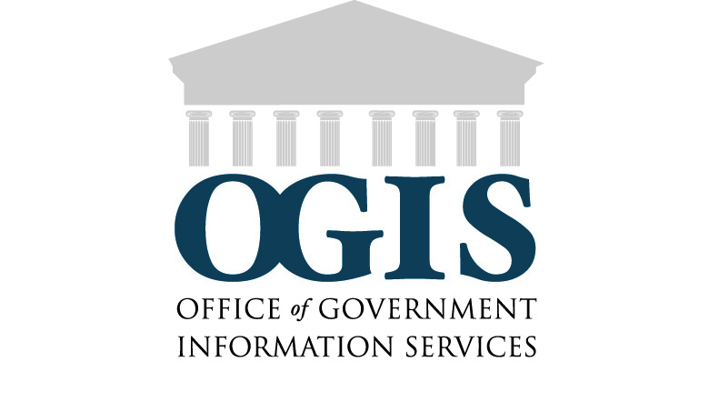
Request for Assistance and Consent to Make Inquiries and
Release of Information and Records

Name:

Current Address: Email address:

Telephone Number: ( ) -

Request for Assistance:

Agency to which request was made:

Original FOIA/Privacy Act Request and Appeal Number:

Brief description of the issue or dispute for which you need OGIS assistance:

NOTE: Please attach or send in any correspondence or documents that can assist OGIS to understand the issue.

In accordance with the Privacy Act of 1974 as amended, I hereby authorize the Office of Government Information Services to make inquiries on my behalf, including the right to review all documentation that OGIS deems necessary regarding the Freedom of Information Act and/or Privacy Act request/administrative appeal that is the subject of my request for OGIS assistance. I understand that any documents I provide to OGIS, except those provided in confidence, may be copied and forwarded to agency officials as a part of the mediation/resolution process. I also authorize any Federal department, agency or component to release to OGIS information and records related to my Freedom of Information Act and/or Privacy Act request/administrative appeal.
Name (print) | Signature | Date

SEND COMPLETED FORMS TO:
Office of Government Information Services
8601 Adelphi Road
Room 2510
College Park, MD 20740

Privacy Act and Paperwork Reduction Act Public Burden Statements
are on the reverse of this page.

Privacy Act Statement. In compliance with the Privacy Act of 1974 as amended, the following information is provided: Collection of the requested information is authorized by 44 U.S.C. § 2104. The information provided will be used by the Office of Government Information Services (OGIS) to prepare an internal case file, to make inquiries on your behalf in order to facilitate your request for mediation services to resolve disputes between yourself and other Federal agencies to which you have made request(s) under the Freedom of Information Act, and the Privacy Act of 1974 as amended. This information may be provided to an expert, consultant, volunteer, or contractor of OGIS or to other Federal agency personnel on a need to know basis in order to assist OGIS in the performance of its statutory duties. Furnishing the information requested is voluntary. However, failure to provide this information will make it impossible for OGIS to assist you.

Paperwork Reduction Act Public Burden Statement. You are not required to provide the information requested on a form that is subject to the Paperwork Reduction Act unless the form displays a valid OMB control number. The information requested on this form is being collected and used by the Office of Government Information Services to ensure compliance with the Privacy Act of 1974 as amended. Public burden reporting for this collection of information is estimated to be one minute per response, including time for reviewing instructions and completing and reviewing the collection of information. Send comments regarding the burden estimate or any other aspect of the collection of information, including suggestions for reducing this burden, to National Archives and Records Administration (NHP), 8601 Adelphi Road, College Park, MD 20740-6001. DO NOT SEND COMPLETED FORMS TO THIS ADDRESS.

