April 21, 2011

«FIRST_NAME» «LAST_NAME»

«MailAdd1»

«MailCity», «MailSt» «MailZip»

Dear «FIRST_NAME» «LAST_NAME»,

As a commercial fisherman, you know rules and regulations are routinely enacted affecting how you fish and, as a result, how much money you can make. These regulatory decisions are made based on the best fishing-related information available at the time. To improve the quality of this information, the National Oceanic and Atmospheric Administration (NOAA) selects individual fishermen at various times to ask for economic and other information. Currently, we are seeking survey information from fishermen who harvest golden crabs.

This survey is strictly confidential. Your answers will be combined with the answers of everyone who participates. At no time will your name ever be linked to any of your individual answers. The combined results of all participants will be included in a written report and made available to anyone interested in commercial fishing within this survey area.

You will receive a survey form with a return envelop shortly. If you have concerns, I will always be most happy to answer any questions you may have. My telephone number is (305) 361-4468.

Thank you for your assistance.

Sincerely,

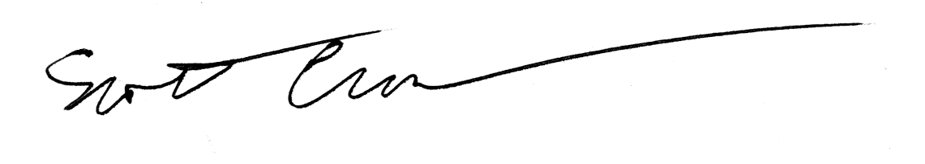

Scott Crosson, Ph.D.

Economist, National Oceanic and Atmospheric Administration (NOAA)