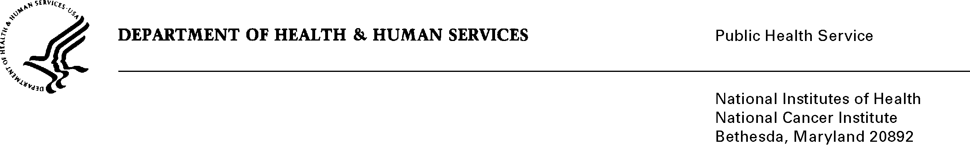

Date: May 4, 2011

TO: Office of Management and Budget (OMB)

Through: Mary Reynolds, Report Clearance Officer, HHS
Mikia Currie, Program Analyst, OPERA, NIH
Vivian Horovitch-Kelley, OMB Project Clearance Liaison, OMAA, NCI

FROM: Mike Montello, CIRB Co-Project Officer
National Cancer Institute/NIH

SUBJECT: NIH NCI Central Institutional Review Board (CIRB) Initiative (NCI)
Nonsubstantive Change Request
OMB Control No. # 0925-0625, Expiry Date 1/31/2014

The NCI CIRB is requesting a non-substantive change request to previously approved application forms and the inclusion of a new form. All these forms are consistent with the purpose that was previously described in the August, 2010 Supporting Statement A, page 4 and 7.
The following forms have been revised to facilitate understanding of instruction and make necessary updates to clarify important information for public use:
- Attachment 2L: Facilitated Review Acceptance Form and.
Attachment 2M: Study Review Responsibility Transfer Form.
The instructions on these forms were revised to be more clear and easier to understand for the public. No additional burden to the public.

- Attachment 5A: NCI Adult CIRB Application for Treatment Studies and
Attachment 5B: NCI Pediatric Central IRB (CIRB) Application for Treatment Studies.
Section L. was added to include Amendment-Specific Information. This change is necessary to clarify necessary information to the public for the CIRB. The additional time to complete this section is minimal and overall there is no additional burden to the public.

- Attachment 5E: NCI Adult/Pediatric CIRB Application for Continuing Review.
The instructions on this form were revised to be more clear and easier to understand for the public. No additional burden to the public.

- Proposed New Attachment 5F: NCI Adult/Pediatric CIRB Application for Treatment Studies.
A new form was created, combining Forms 5A and 5B, to minimize and simplify form process. The questions being asked are the same for both Adult and Pediatric Applications for Treatment Studies and will be introduced for new studies. The application form must be completed for either Adult or Pediatric Trial; therefore, there is not an increase or decrease in burden. The effort of burden remains the same.
The old and new versions of the form language are attached for OMB’s review and approval.

