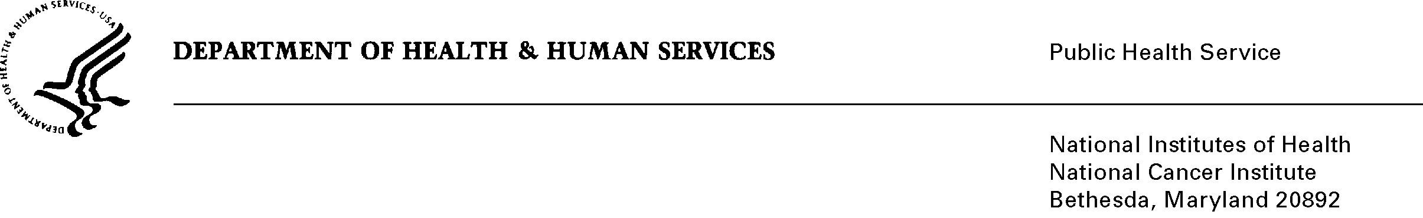
Date: 02/09/2011

To: Office of Management and Budget (OMB)

Through: Seleda Perryman, Report Clearance Officer, HHS
Mikia Currie, Project Analyst, OPERA, NIH
Vivian Horovitch-Kelley, OMB Project Clearance Liaison, NCI

From: Margaret Beckwith, Ph.D., Acting Branch Chief,
International Cancer Research Databank Branch (ICRDB)
Office of Communications and Education (OCE)
National Cancer Institute (NCI)/NIH

Subject: NCI Cancer Genetics Services Directory Web-based Application Form and Update Mailer

This is a request for OMB to approve the Existing Collection In use Without an OMB Number, “NCI Cancer Genetics Services Directory Web-based Application Form and Update Mailer” for 3 years. This information collection has been ongoing since 1996 and was discontinued in February, 2011. As a result of a change in branch chiefs, the submitter was not aware that this application form and annual mailer needed OMB clearance until recently. The submitter took immediate steps to discontinue the collection of information until OMB clearance is approved.

The NCI Cancer Genetics Services Directory on NCI’s Web site Cancer.gov is a searchable collection of information about professionals who provide services related to cancer genetics. These services include cancer risk assessment, genetic counseling, and genetic susceptibility testing. The professionals have applied to be in the directory using an online application form and have met basic criteria outlined on the form.

There are currently 567 genetics professionals listed in the directory. Approximately 30-60 new professionals are added to the directory each year. The applicants are nurses, physicians, genetic counselors, and other professionals who provide services related to cancer genetics. The information collected on the application form includes name, professional qualifications, practice locations, and the area of specialization. The information is updated annually using a Web-based update mailer that mirrors the application form.

The NCI Cancer Genetics Services Directory is a unique resource for cancer patients and their families who are looking for information about their family risk of cancer and genetic counseling. Collecting applicant information and verifying it annually by using the NCI Cancer Genetics Services Directory Web-based Application Form and Update Mailer is important for providing this information to the public and for keeping it current.

